Report:
Residents Management Strategy

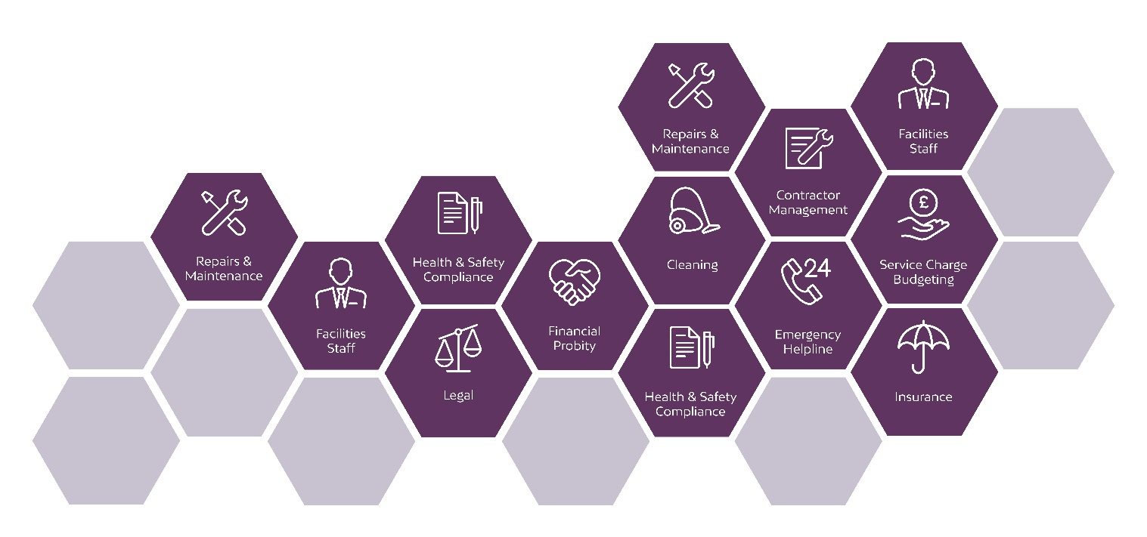

Condition 31
Condition to be met:
The residential apartments shall not be occupied until a Residents' Management Strategy has been submitted to, and approved in writing by, the City
Council, as local planning authority. The Residents' Management Strategy shall include details of maintenance, security, energy management, janitorial
services, common parts cleaning, exterior services, and building policies in relation to waste disposal, storage and deliveries. The Residents' Management
Strategy shall be fully implemented, prior to first occupation of the building, and shall be kept in operation at all times thereafter.

Reason - To ensure the development is managed in the interests of the general amenities of the area, pursuant to policies SP1 and DM1 of the Core Strategy.

Overview
The purpose of this report is to detail the arrangements for the ongoing management and maintenance of the residential building. The report will detail how various tenant services will be operated and how tenant amenity and accommodation quality will be maintained throughout the life of the buildings.
The effective management and operation of mixed-use developments is crucial to the long-term success of any scheme. The importance of well thought out design cannot be overstated, as all too often consideration for the management process is inadequate, this in turn leads to an unsatisfactory result for all parties.
The importance of placemaking and stewardship must not be underestimated when assessing the suitability of a development and its strategy. Residents who feel engaged and part of a community will have a far more positive experience in their homes.
Zenith Management are TPI accredited Managing Agent specialising in large city centre residential schemes. This design has been reviewed, and the report prepared, based on the experience and knowledge of schemes of a similar nature in the Manchester and Salford area as well accepted industry best practice.

Report Contents

- Introduction

- Staff

- Refuse Strategy

- Car Parking & Cycle Parking

- Access Arrangements & Security

- Cleaning & Maintenance

- Resident Management & On-going Management

- Retail Management Strategy

- Service Charge Strategy

- Conclusions and Overview

- Introduction
This report is prepared by Zenith Management Ltd to outline the management strategy for the residential led development known as One Victoria. The development consist of two blocks, of which both will be delivered at the same time.
In summary, the development comprises:
- Two buildings
- 129 Apartments
- 3 Commercial Units

- Staff

  - Concierge

Each building has a reception area which is immediately adjacent to the main residential entrance.

Block A, the largest block, has welfare facilities, and ‘Back of House’ facilities via the Comms Room where the CCTV rack will be located.

The Concierge will form an active part of the scheme and duties will include regular resident liaison, safety and building inspections, on-site statutory testing and security monitoring.

  - Cleaning and Maintenance Operatives

The scheme will necessitate the appointment of a part-time cleaning operative who will be responsible for ensuring that the residential common parts and all outdoor areas remain in a clean and safe condition for residents, visitors and members of the public.

- Refuse Strategy

  - Refuse Strategy Overview

The scheme has been designed such that all residents have access to a bin store, with a bin store in each building on the ground floor near the lifts.

The strategy proposed will enable residents to segregate and dispose of waste in a reasonable and sustainable way to minimize environmental impact.

  - Refuse Management

The scheme has been designed so that residents self-manage their own waste. There is a bin store in Block A which contains 14 x 1100 litre Euro bins that will be mixed general waste and recycling. Block B contains a bin store with 8 x 1100 litre Euro bins, also mixed. The Commercial Unit have their own bin store to manage within Block A and they make their own arrangements for disposal.

Both bin stores will be sited on an impermeable surface to aid cleaning and general good housekeeping and site team will have responsibility for ensuring cleaning is carried out routinely and the bins are rotated for ease for the residents.

Notices will be installed prominently in the bin stores communicating to residents the refuse/recycling policy and clearly promoting the procedures. Advice on how to dispose of larger items such as mattresses/washing machines etc. in line with the requirements of Manchester City Council will also be communicated.

  - Refuse Collection – Residential Apartments

The site team will ensure that the residential waste containers are placed in the designated collection points on the appointed days for collection by the Local Authority. Once emptied by the Local Authority the units will be returned to the bin stores for re-use.

    - Additional Private Refuse Collection
It is expected that the collection and capacity of refuse containers is sufficient for the size of the development however, should the management team feel additional collections would be beneficial then this will be undertaken via an approved private collector that can be used to supplement Local Authority collections.

  - Recycling

Recycling is an integral element of effective Waste Management and is increasingly important to residents of high-rise developments who have historically found inadequate provisions to be in place. It is important that at design stage this concern is addressed in any new development to allow residents to engage in a meaningful and responsible recycling regime.

At the development residents will be provided with the correct infrastructure to recycle all streams of waste in accordance with Manchester City Council guidance. The different refuse containers will allow waste to be segregated into general, paper and glass recycling waste.

  - Refuse Collection – Commercial Units
Commercial units will be responsible for ensuring that they have a separate and adequate collection arrangements in place with a 3rd party collection service.

- Car Parking & Cycle Parking

  - Car Parking

There are 3 standard parking bays and 2 disabled bays located in Block B.
The car park will be well lit, maintained and monitored (including CCTV coverage relayed back to the Comms Room) to deter any anti-social behaviour.
  - Cycle Parking

Cycling is becoming increasingly recognised for the contribution it can make as a sustainable and healthy form of transport for trips within large cities. It is particularly important that adequate provisions are made in large residential developments to make the choice to cycle a more convenient one for residents.

Cycle parking needs to be considered early in the project process, as space needed to accommodate cycles can be significant. The current scheme has provided cycle capacity of:

Block | Spaces
A | 61
B | 26

The cycle stores are within secure rooms and will be well lit, maintained and monitored (including CCTV coverage relayed back to the Comms Room) to deter theft and trespass. Adequate cycle storage is crucial within residential developments to discourage bikes from being kept within apartments due to the issues associated with fire safety and cleanliness.

The process of gaining access will be communicated to all residents by Zenith and the Concierge.

- Access arrangements & Security

  - Communal Security Management
The main residential entrances of each block will operate via a programmable fob. The fobs will be monitored and programmable by the Concierge.
In the event of lost/stolen fobs replacements can be provided and the original removed from the system ensuring that security is not compromised.
  - Apartment Security Management
Residents will access their apartments with individual keys provided at the point of purchase. The Concierge team will not hold any apartment keys.
Apartment doors will have a dead lock, door viewer and door closer. Doors will be opened/locked via a key and will not self-lock. A thumb turn will be on the inside of the door. All doors will be PAS 24:2022 compliant.
  - CCTV
CCTV will be in operation across the development and signage will be displayed in prominent locations. In addition, there will be discrete CCTV cameras in the external areas that will relay to Comms Room. A Privacy Impact Assessment will be carried out by the Managing Agent to ensure that the scheme is proportionate, and this will be supported by an annual review of the system.
The CCTV rack will be in the Comms Rooms of each block to allow for private viewing by law enforcement and other agencies.
Appropriate signage will be displayed for benefit of residents, public and visitors and to deter anti-social behaviour.
  - Visitor Pedestrian Access and Egress

Visitors/deliveries will gain access by contacting the apartment resident directly via the intercom system allowing residents the opportunity to screen visitors before permitting access.

  - Post and parcel delivery

    - Residential Post: Post will be delivered directly to the post boxes located within the reception areas of each building. Royal Mail will be provided with a fob access to allow them to gain entry to post areas. Fobs will not be issued to couriers.

    - Residential Parcels: for parcels that are unable to be delivered directly to the post boxes these can be stored in the secured Parcel Room in each building, adjacent to the reception, for later collection by the residents.

  - Access and Security Evaluation
Large residential developments in city centres are particularly prone to unauthorised access from individuals, this is particularly prevalent in schemes with no on-site staff and/or many entrance points. As such a robust and cohesive approach to access and security is crucial in large residential and mixed-use developments to ensure that security is maintained, and residents feel secure in their homes.
The provision of a Concierge combined with the physical design (i.e. programmable fob access, CCTV, two secure lines and limited access/egress points) will give the development a naturally high level of security whilst still ensuring an inviting and friendly experience for residents and visitors.

- Cleaning, Repair & Maintenance

  - Internal Cleaning of Common Areas

    - Residential corridors will be cleaned by fulltime cleaners to ensure the highest standard of cleanliness. Sufficient cleaning facilities (power and water outlets) will be provided throughout the communal areas.
    - Refuse rooms will have water connection to allow them to be hosed down and cleaned regularly.
    - Landscape/amenity areas will be subject to a regular cleaning regime carried out by the contract cleaner.

  - External Cleaning and Maintenance

    - Window Cleaning
The external windows from ground up to level 5 can be cleaned by reach and wash pole system. The higher levels above level 5 will be cleaned through the use of a rope access abseil system. This mansafe system and and abseil points will be inspected and tested regularly to ensure a safe working system.
External cleaning will be carried out quarterly; this will be monitored by the Concierge and the Managing agent for adequacy. Residents will also be able to open some windows inwards to allow for individual cleaning on an ad-hoc basis.
Low level and internal glass will be cleaned periodically from ground level directly via reach and wash method.
An external contractor will be appointed to carry out these works and will provide safe operating procedure.
    - External glazing/facade repairs and replacements
External facade and glazing elements to be maintained using MEWP access where possible. The use of MEWP will require a temporary road closure.
The main contractor has provided details on the safe replacement methodology for the external glazing and facade.
    - External Landscaping
There is no external landscaping or public realm to maintain.
    - Planting & Landscaping
On the Rooftop terrace there will be planters that will be maintained, as well as astroturf. The Concierge will include a walkaround of this area as part of their daily check.
    - External Litter Picking
The development will have a part-time cleaner whose duties will include a regular external litter pick routine. The cleaning contractor will be responsible for ensuring that external areas are free from litter and debris. It is also expected of the Concierge to litter pick when required in the absence of the cleaner. Where large items of rubbish are found these will be removed by an external contractor.
    - Contractors and Repair specialists
To ensure both quality of workmanship and safety of residents and visitors only suitably qualified and competent contractors will be engaged having due regard for the size and nature of the work.

- Resident Management & On-going engagement

The residents in both buildings will have access to the podium terrace. This area will provide focal social points for the building and provide an opportunity for residents to meet and engage as part of a community.

  - Resident Amenity Areas

    - Roof Terrace Amenity Space – Block A has its own roof terrace for residents use.

A robust management regime will be implemented covering, amongst other elements, operating hours and permitted activities. This area will also be monitored by Concierge through regular inspections and indirectly via CCTV to ensure that it is being effectively operated and any rules/regulations for its use will be enforced by the Concierge and Managing Agent. The rules/regulations will be created to deter any anti-social behaviour and should be incorporated with the residential leases.

The Management regime will include:
    - Hours of operation
    - Regular inspection during hours of the use
    - Controlled access for residents
    - CCTV monitoring
    - Clearly displayed ‘Roof Terrace Rules’

  - Resident Welcome Pack

Each new apartment owner will receive a Welcome Pack document to help residents understand the key elements of apartment living and what they can expect from the management team. It will also help to explain the often-confusing lines of responsibilities for repair/maintenance that exist in leasehold developments.

  - Regular Newsletter

The Managing agent will prepare a quarterly newsletter that is distributed to all residents to keep them informed of news/events and any health, safety and maintenance bulletins.

- Conclusion & Overview
We feel that the scheme proposal will be well placed to deliver a comprehensive service to future residents and visitors.
The strategy and design anticipate and account for the operational needs of the management team and will ensure that a robust service is delivered to the resident as the ultimate end user.

