Report:
Planning Condition 14: One Victoria

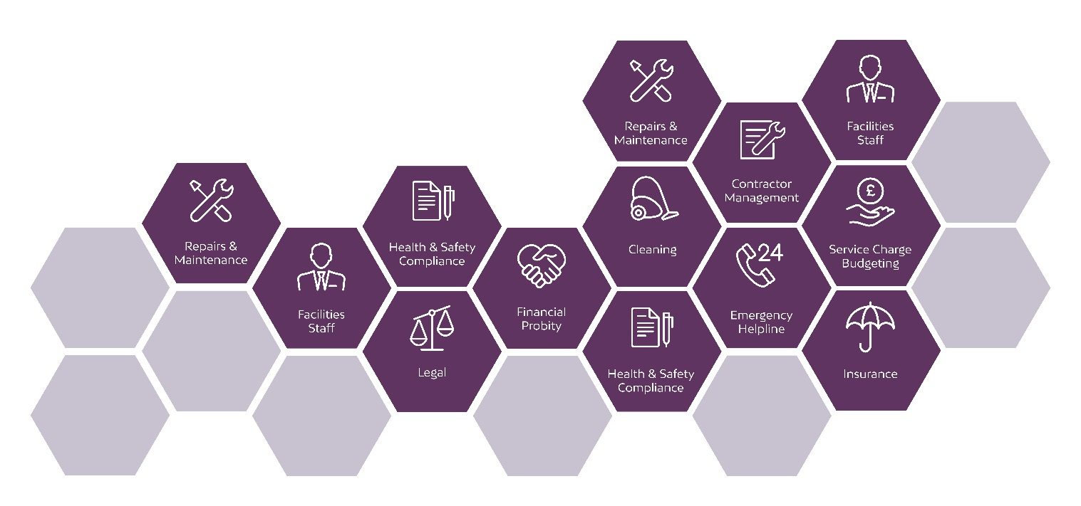

Overview
The purpose of this report is to review the planning conditions contained within 12280/FO/2019.

It is hoped that by following this management plan we will ensure a sound basis for the management of the scheme and best practice, uniformity and transparency in our management.

It is expected that the site staff will carry out their duties and management of the One Victoria development in line with this management plan, any departure from this document must be agreed with the Local Authority and must be justifiable to our Clients and stakeholders.

Zenith Management are TPI accredited Managing Agent specialising in large city centre residential schemes. This design has been reviewed, and the report prepared, based on the experience and knowledge of schemes of a similar nature in Manchester as well accepted industry best practice.
- Condition 14
Condition to be met
The external roof terrace amenity area shall not be used until the hours of use for the terrace and details of its management and how it would be used have been submitted to and approved in writing by the City Council as Local Planning Authority. The roof terrace shall be used in accordance with the approved hours and details thereafter.
Reason - In order that the local planning authority can achieve the objective of protecting the amenity of local residents in accordance with saved policy DC26 in accordance with the Unitary Development Plan for the City of Manchester and policies SP1 and DM1 of the Core Strategy.
Roof Terrace Management Strategy
Access is available to all Residents by fob and their guests must be accompanied by a Resident. The opening times for the Roof Terrace is to be 8.30am to 10pm, Monday – Sunday and the access control to be limited to these hours. The Roof Terrace will have CCTV coverage and the lighting will be operated by timers.
Whilst we want to ensure Residents can enjoy the use of these areas, there are a few restrictions in place when using these amenities:
- Pets are not permitted on the Roof Terrace
- Residents are expected to treat the area with respect and tidy up after use
- There is a maximum capacity of 60 people
- BBQ’s or fireworks are not permitted
- Sound systems are not permitted
- The maximum number of persons within one party at any one time is 6
- Private functions are not available to Residents in this space unless agreed with the Managing Agent
- Should there be any anti-social behaviour or breaches of the lease activity, the Managing Agent should reserve the right to end a booking at any time and with immediate effect

