Scaffold Method Statement (Form 11)

Intelligent Scaffolding

Customer: - | Concrete Repairs Limited | Date: - | 13.01.25
Site: - | Gotham Hotel, 100 King Street, Manchester M2 4WU | Prepared by: | Mr King
Description of Work: | External to Building | Page No | Page 1 of 26
Design Ref: - | TBC | Revision No: - | 01
TG20: Current Version  Reference: - |  | Revision No: -

Contents
- Introduction
- Type of Scaffold
- Boarding of scaffolds
- Loading of scaffolding
- Beams to be used
- Customer Site Induction
- Customers operations
- Erection pre-start
- Protection of the public
- Scaffold ties
- PPE
- Equipment to be used and conformity requirements
- Unloading and loading arrangements
- Raising and lowering materials
- Segregation of work area
- Emergency Procedures
- Erection procedures for ladders
- Erection and Dismantling procedure for: Independents, Table lifts, Beams, Erction of sheeting and netting, Loading towers, Bird cages
- Safety of Work working to SG4: Current Version

Intelligent Scaffolding Operatives to carry out works from 9am, first elevation to be fully blocked off in the layby in erection and dismantle for Intelligent Scaffolding Operatives to carry out the works safely plus Brown Street.

Other elevations to erect Crashdecks and unload vehicles onto Crashdecks and vehicle to then leave site.

Tie points to be agreed as per design.

Item 001 – King Street Elevation

Tubular materials together with ancillary fittings and scaffolding boards and ladders erected to form access to the above location.

1no Independent Scaffolding @ 24m x 1.6m x approx. 20m high

The above scaffold will be completed with all lifts boarded, ladder access, and all the necessary guardrails and toe boards.

Item 001A – King Street Elevation

Tubular materials together with ancillary fittings and scaffolding boards and ladders erected to form access to the above location.

1no U Shaped Step in Independent Scaffolding @ 18m x 1.6m x approx. 9m high at 20m level

The above scaffold will be completed with all lifts boarded, ladder access, and all the necessary guardrails and toe boards.

Item 001B – King Street Elevation

Tubular materials together with ancillary fittings and scaffolding boards and ladders erected to form access to the above location.

1no Independent Scaffolding @ 12m x 1.6m x approx. 6m high at 29m level

The above scaffold will be completed with all lifts boarded, ladder access, and all the necessary guardrails and toe boards.

Item 001C – King Street Elevation

Tubular materials together with ancillary fittings and scaffolding boards and ladders erected to form access to the above location.

1no Protection Tunnel Scaffolding @ 24m x 1.6m x approx. 3m high

The above scaffold will be completed with 1no lift boarded, ladder access, and all the necessary guardrails and toe boards.

Item 001D – King Street Elevation

Tubular materials together with ancillary fittings and scaffolding boards and ladders erected to form access to the above location.

1no Protection Fan Scaffolding @ 24m x 2m at 4m level

The above scaffold will be completed with 1no lift boarded, ladder access, and all the necessary guardrails and toe boards.

Item 001E – Corner of King Street Elevation/Spring Gardens Elevation

Tubular materials together with ancillary fittings and scaffolding boards and ladders erected to form access to the above location.

1no K-Lok Staircase @ 4.4m x 1.6m x 24m high

The above scaffold will be completed with 1no lift boarded, ladder access, and all the necessary guardrails and toe boards.

Item 002 – Chancery Lane Elevation (Compound Area)

Tubular materials together with ancillary fittings and scaffolding boards and ladders erected to form access to the above location.

1no Independent Scaffolding @ 24m x 1.6m x approx. 20m high

The above scaffold will be completed with all lifts boarded, ladder access, and all the necessary guardrails and toe boards.

Item 002A - Chancery Lane Elevation (Compound Area)

Tubular materials together with ancillary fittings and scaffolding boards and ladders erected to form access to the above location.

1no U Shaped Step in Independent Scaffolding @ 18m x 1.6m x approx. 9m high at 20m level

The above scaffold will be completed with all lifts boarded, ladder access, and all the necessary guardrails and toe boards.

Item 002B - Chancery Lane Elevation (Compound Area)

Tubular materials together with ancillary fittings and scaffolding boards and ladders erected to form access to the above location.

1no Independent Scaffolding @ 12m x 1.6m x approx. 6m high at 29m level

The above scaffold will be completed with all lifts boarded, ladder access, and all the necessary guardrails and toe boards.

Item 002C – Chancery Lane Elevation (Compound Area)

Tubular materials together with ancillary fittings and scaffolding boards and ladders erected to form access to the above location.

1no Protection Tunnel Scaffolding @ 24m x 1.6m x approx. 3m high

The above scaffold will be completed with all lifts boarded, ladder access, and all the necessary guardrails and toe boards.

Item 002D – Corner of Chancery Lane Elevation (Compound Area)/Brown Street Elevation

Tubular materials together with ancillary fittings and scaffolding boards and ladders erected to form access to the above location.

1no K-Lok Staircase @ 4.4m x 1.6m x 24m high

The above scaffold will be completed with all lifts boarded, ladder access, and all the necessary guardrails and toe boards.

Item 003 – Spring Garden Elevation

Tubular materials together with ancillary fittings and scaffolding boards and ladders erected to form access to the above location.

1no Independent Scaffolding @ 28m x 1.6m x 20m high

The above scaffold will be completed with all lifts boarded, ladder access, and all the necessary guardrails and toe boards.

Item 003A – Spring Garden Elevation

Tubular materials together with ancillary fittings and scaffolding boards and ladders erected to form access to the above location.

1no U shaped Step in Independent Scaffolding @ 18m x 1.6m x approx. 9m high at 20m level

The above scaffold will be completed with all lifts boarded, ladder access, and all the necessary guardrails and toe boards.

Item 003B – Spring Garden Elevation

Tubular materials together with ancillary fittings and scaffolding boards and ladders erected to form access to the above location.

1no Independent Scaffolding @ 12m x 1.6m x 9m high at approx. 29m high

The above scaffold will be completed with all lifts boarded, ladder access, and all the necessary guardrails and toe boards.

Item 003C – Spring Garden Elevation

Tubular materials together with ancillary fittings and scaffolding boards and ladders erected to form access to the above location.

1no Protection Fan Scaffolding @ 28m x 2m at 4m level

The above scaffold will be completed with all lifts boarded, ladder access, and all the necessary guardrails and toe boards.

Item 004 – Brown Street Elevation

Tubular materials together with ancillary fittings and scaffolding boards and ladders erected to form access to the above location.

1no Independent Scaffolding @ 28m x 1.6m x 20m high

The above scaffold will be completed with all lifts boarded, ladder access, and all the necessary guardrails and toe boards.

Item 004A Brown Street Elevation

Tubular materials together with ancillary fittings and scaffolding boards and ladders erected to form access to the above location.

1no U shaped Step in Independent Scaffolding @ 18m x 1.6m x approx. 9m high at 20m level

The above scaffold will be completed with all lifts boarded, ladder access, and all the necessary guardrails and toe boards.

Item 004B – Brown Street Elevation

Tubular materials together with ancillary fittings and scaffolding boards and ladders erected to form access to the above location.

1no Independent Scaffolding @ 12m x 1.6m x 9m high at approx. 29m high

The above scaffold will be completed with all lifts boarded, ladder access, and all the necessary guardrails and toe boards.

Item 004C - Brown Street Elevation

Tubular materials together with ancillary fittings and scaffolding boards and ladders erected to form access to the above location.

1no Protection Fan Scaffolding @ 28m x 2m at 4m level

The above scaffold will be completed with all lifts boarded, ladder access, and all the necessary guardrails and toe boards.

1.Introduction
This document serves as the scaffold plan of works, including the health and safety arrangements for the works proposed by the Customer. The document aims to provide the Customer and all other interested parties with the confidence that the standard of work and commitment towards health and safety by our Company is of the highest level, as well as meeting all legal obligations for the proposed scaffolding works.
The information contained within this document was correct at the time of writing. However, the information may be subject to change and amendments along with the scope of works. In this instance, the plan of works shall be amended by an authorised person and re-issued to all interested parties.

Competency of scaffolders :- Scaffolding is for ever evolving there is no CISRS course or internal training course that could ever prepare a scaffolder for every situation there may face on site.
Even experienced scaffolders may come a cross a situation were they have to use their initiative safely.
There are no scaffolders who have the perfect skill set for every situation they may face on site.

Special Briefing Notes prior to commencement of works on this project that must be fully explained to all Scaffolders/Trainees/Labourers/Drivers:

- Do not commence work until instructed by your supervisor or Site Manager.
- There must be no Working Alone on site when undertaking high-risk activities such and scaffolding.
- Do not allow any Scaffold Labours or System Base Operatives to Erect/Dismantle any scaffolding or be issued with Safety Harnesses.
- Never climb up or down the scaffold structure at any time always use a System Staircase or correctly tied ladders
- Never leave a scaffold in an unsafe condition (Even at Break Times) always ensure materials are safe to prevent Slip, Trips and Falls to our operatives and others.
- No Trainee scaffolders must be allowed to undertake any scaffold operations unless they are working with an experienced scaffolder.
- All beams must be lifted by at least two men.
- Inspect all your PPE before you start work
- Inspect all the materials you will be using, any damaged materials ensure it is returned to the yard.
- Check the ground conditions, check for soft ground, excessive slopes or uneven ground.
- If wind speed feel unsafe to work safely or your Supervisor instructs you to cease work ensure you secure all materials and leave the scaffold safe.
- Do Not Hemp/Top Out any tube longer than 16 foot (5m)

- Deny any unauthorised access to the scaffold structure until the scaffold is complete and the scaffold has been handed over to the customer.
- Establish a safe exclusion zone around your work area to prevent other contractors and members of the public entering the work area Warning Signs and Solid Barriers must be in place. Never work overhead when third parties are below.
- There must be no bombing of materials.

- There must be no scaffold materials left stood up against the scaffolding or the building you are working on.
- No materials must be left on the ground that present a risk to members of the public or other contractors.
- All scaffolders must work to SG4: Current Vision when erected or dismantled scaffolding.
- There will be no Protected Traversing for erecting or dismantling any scaffold.
- Scaffolders must work within the Scaffolders Safety Zone, Fully Boarded Platform with a Single Handrail.
- For big lifts follow the SG4: Current Version safe system of work.
- All top handrails on the completed working platforms must be double handrails 950mm high no gap greater than 470mm to all elevations.
- All ladders must be tied with 4m of blue rope or the correct size ladder tie, all ladders must be tied twice.
- Clear all materials from the roof and the working platform at the end of the shift.

Significant Risks
- Work at Height
- Manual handling
- Protection of others not in our employment
- Over head cables and underground services
- Lifting and lowering of materials
- Site and road Traffic Management
- Weather conditions
- Falling objects
- Slips, Trips and Falls
- Inexperienced operatives
- Working above water
- Working on railways
- Working on fragile roofs
- Asbestos
- Confined space working

Environmental Protection
Scaffolding activities inherently have a minimal environmental impact we will endeavour:
Keep nuisance noise and dust minimised with careful handling of materials and equipment.
Keep shouting to a minimum, only use Impact Wrenches with permission of you Supervisor.

No works will be undertaken of out of normal working hours without permission from the Customer/Local Council.

2. COVID 19

Special Briefing Notes prior to commencement of works on this project that must be fully explained to Scaffolders/Trainees/Labourers/Drivers:

- The must be no more that six people working together or standing around together on site
- If members of the public enter the area where you are working stop work and move to a safe location keep 2m apart
- Follow the Induction information with regards how many people can enter the toilets/canteen
- Frequent hand washing reduces the potential for coronavirus to spread and is a critical part of keeping you and other contractors safe
- Follow the information from the site induction with regards to COVID 19 site safety measures that must be in place
- Extra PPE required to comply with COVID 19.
- Masks should not be use when undertaking any scaffold operations it will put the scaffolders under more pressure and increase their risk level.
- FFP3 Dust Mask/Boiler Suit/Spit Visor

3. Type of Scaffolding to be erected Tube and Fitting or System

Scaffold Type | YES/NO | Tube and fitting or System scaffolding | Design/TG20:  Compliance Sheet
Independent Scaffold | Yes | Tube and fitting | TG20: Compliance Sheet
Bird Cage Scaffold
Tower Scaffold
Cantilever Scaffold
Roof Stack Scaffold
Loading Tower Scaffold
Edge Protection Scaffold
Heavy Duty Support scaffold
Ramp Scaffold
Protection Walkway Scaffold
Public Protection Over Doors
Ladder tower
Internal Bird Cage
External Bird Cage
Scaffold with hop-ups
Drop Scaffold
Other
Other types of scaffolds:
Ladder Tower Scaffolds
System Staircases

4. Boarding of Scaffolds

Type of scaffold | Boarding of scaffold
Independent scaffold
Ladder tower

5. Loading of scaffold

Type of scaffold | Loading on the scaffold
Independent scaffold
Loading tower

6.Beams to be used within the scaffold

Type of beams | Yes | No
Ladder Beams
Unit beams
450 Alloy Beams
750 X Beams
Other

7. Customers site induction
Site Induction

The Customer must carry out an induction prior to starting of any works.

We should be informed of: -
- The Customers site Management team
- Explain their Scaffold Standard
- Explain their Scaffold Brief that they have submitted for the works on site
- Explain the loadings on the floors for internal scaffolds
- Working hours on site
- COVID 19 Site Rules and Safety Measures
- Scope of the project
- Site contact phone numbers
- Site layout, site boundaries, notice boards
- The Customers rescue plan
- Site First Aiders and location of first aid box/accident procedures
- Welfare facilities COVID19 Safe
- Toilet and washing facilities, drying room COVID 19 Safe
- Method of consultation on site RAMs briefing, toolbox talks etc.
- The Client must notify us of any risk associated with sub-contractors’ works where we are put at risk.
- We must be notified of electrical hazards associated with the works we will be undertaking on site, and precautions will be in place for are safety
- Working close to a live railway
- Working over water
- We must be notified of any C.O.S.H.H. materials or Asbestos that may put us as at risk with our works
- We must be notified of the traffic management plan for unloading and loading our materials for the site conditions
- Schedule for delivery and collections of scaffold materials
- We must be notified of what protective measures will be in place and required for members of the public children and other contractors
- We must be notified of noise on site that will put us at risk
- We must be notified of the site evacuation and rescue procedures
- We must be notified of procedures for smoking on site

- We must be notified of procedures for the use of mobile phones on site
- We must be notified of procedures for the use of cameras on site
- Check all scaffold operatives competency for tube and fitting and system scaffolding
- Check all scaffolders have the correct Safety harness/Lanyard and safety step
- All scaffolds will only be dismantled when a dismantle plan has been prepared
- Housekeeping and safe storage of materials
- Personal responsibilities conduct and use of foul language on site and disciplinary measures
- Procedures for reporting unsafe act’s, near misses and safety infringements that require attention
- Site permits to work
- Client must notify us of all PPE required to carry out our works safely within their environment
- All scaffolders must sign the induction register and sign in and out of site at all times
- All scaffolders must produce CISRS and CSCS cards before commencing work on site
- The scaffolders must inform the site manager if they have any concerns relating to health and safety matters that may affect the safe method of work
- The scaffolders must inform the site Manager if they are on any medication
- The scaffolders must inform the Site Manager if they have any COVID 19 symptoms

8. Customers Operations

Detail | Location
COVID 19 safety on site to comply with Government Guidelines | Responsibility of all parties working on site
Asbestos | Responsibility of Client, Asbestos Plan must be on site when we undertake work.
Electricity | Responsibility of Client
Ground Conditions | Responsibility of Client
Traffic Movement | Responsibility of Client
Site Induction | Responsibility of Client
Smoking Areas | Responsibility of Client
Responsible for undertaking 7 day inspections | Responsibility of Client
Controlling Sub-contractors | Responsibility of Client
Smoking Areas | Responsibility of Client
Safe Areas for using mobile phones | Responsibility of Client
Site welfare | Responsibility of Client
Responsible for undertaking 7 day scaffold inspections | Responsibility of Client
Compliance with CDM 2015, Regulation 19 | Responsibility of Client
Work at Height Regulations 2005 Regulation 4 | Responsibility of Client to plan all work at height including rescue
Controlling third party interference with scaffolding | Responsibility of Client

Legal Requirements and Scaffolding Standards all scaffolds will be erected in accordance with: -
- Health and Safety at Work Act 1974
- The Work at Height Regulations 2005.
- CDM Regulations 2015
- SG4: Current Edition
- TG4: Current Edition
- TG20: Current Edition
- PPE Regulations

GUIDANCE FOR CUSTOMERS
Pre-erection: The Customer must provide a firm and level base for the scaffold and ensure the work area is clear and capable of withstanding any imposed loads from scaffold that are erected internal or externally.
Pre-Use Checks: Every user must check the structure before use as per Regulation 13 of the Work at Height Regulations 2005.
Scaffold Use: Scaffold users are responsible for ensuring that the structure is used only for its intended purpose and within its specified loading limits (CDM Regulations 2015 Regulation 19 Stability of Structures).
Interference: Modifications to scaffolding must only be carried out by our competent scaffolders.
The Customer is responsible for ensuring that scaffolding is not interfered with, e.g. overloaded with materials, removal of ties, guardrails or scaffold boards, etc.

RESOURCES & COMPETENCE
Site Induction |  | All operatives will attend the Clients site safety induction prior to commencement of works on site. Scaffolders must present competence cards for inspection.
Minimum Training Level For Competence Of Scaffold Operations
Lead-hand Operative |  |  | Yes | No | Scaffold Operative (BASIC) | Yes | No
Advance Scaffold Level (CISRS) |  |  | √ |  | Advance Scaffold Level (CISRS) | √
Basic Scaffold Level 2 (CISRS) |  |  | √ |  | Basic Scaffold Level 2 (CISRS) | √
Basic Scaffold Level 1 (CISRS) |  |  | √ |  | Basic Scaffold Level 1 (CISRS) | √
Anchor Tie & Pull Test Training. |  |  | √ |  | Anchor tie & pull test training. | √
SUPERVISION | Supervisor to be SSSTS (minimum) or SMSTS/ CISRS Scaffolding Advanced/Supervisor.
PLANT OPERATIONS | Operatives to have relevant CPCS/ ALLMI/IPAF card of training and competence.
INSPECTORS | Scaffold inspectors will hold Two Day Advanced scaffold inspection card/certificate  .
MOBILE PHONES | Operatives are not permitted to use mobile phones when working on the scaffold.
TOOL BOX TALKS | Delivered to operatives weekly when on site.

9. Erection pre-start
Erection pre-start check: please tick appropriate box as you move through the checks
 | Y | N | N/A |  | Y | N | N/A
Has the gang leader been briefed by the appropriate line manager supervisor? |  |  |  | Have you read the standard RA to ensure all risks are covered, if they aren’t, have you updated site specific RA?
Have environmental conditions been assessed and deemed safe to continue e.g weather, lighting, other contractors, public etc? |  |  |  | Do members of the gang have the correct PPE identified by the RA is it fit for purpose?
Do the scaffolders have ability to create a safe zone e.g. scaffolders safety steps and or double lanyard (beam work only)? |  |  |  | Is the gang able to create an exclusion zone to prevent others entering the working area?
Does the gang have a copy of the compliance sheet or design drawing/system manual? |  |  |  | Are ground conditions suitable for erecting a scaffold, do you have the correct sole boards?
Do have the correct ratio of operatives to undertake the works safely? |  |  |  | Is there safe means of access for all works? Staircase/ladders
Are materials being used for erection in good order and fit for purpose? |  |  |  | A Dismantle Plan must be prepared?
Addendum to main method statement:
This addendum must be used to update the main document with any changes on site:
All operatives must be briefed on any changes to the main document:

10. Protection of the public
Erection pre-start check: Protection of the public please tick appropriate box as you move through the checks
 | Y |  | N |  | N/A |  |  |  | Y | N | N/A
First lift will be double boarded with waterproof sheeting sandwiched in between the boards over Doors and Vehicle entrance routes. Toe boards/ brick-guards and a single handrails  must be installed? |  |  |  |  |  |  | Protection form on standards?
Class A Scaffold Protection fan single boarded compliant with TG20: Current version? |  |  |  |  |  |  | Designed Scaffold Protection Fan?
Designed protective walkway? |  |  |  |  |  |  | Combisafe safety net fans?
Brick guards secured to the scaffold with 5 fixings? |  |  |  |  |  |  | Exclusion zone with Warning Signs and Solid barriers?
Scaffold sheeting to be used |  |  |  |  |  |  | Scaffold netting to be used
Flame retardant sheeting to be used |  |  |  |  |  |  | Flame retardant netting to be used
Road closure with Local Council Permission? |  |  |  |  |  |  | Pavement closure with Local Council Permission?
11. Scaffold Ties

All pull testing of scaffold anchors ties must be undertaken by a Trained Competent Person

Preliminary Testing

5 tests in each base material to 2 x the working load (WL) i.e. an anchor with a SWL of 6.10 kN will be tested to 12.20 kN. Note: PA6 and PA66 nylon anchors are tested to 2 x times the SWL, other nylon anchors are tested to 3 x times the SWL. The SWL will be stated on the scaffold design.

Proof Testing

Minimum of 5% of the total or 3, whichever is the greater. Anchors to be selected randomly across the whole structure. The minimum number to be repeated to every discreet area where different fixings are used, where the base material/condition is different and where there is a different installer. The proof load applied to the anchor will be 1.25 x the working load (SWL) i.e. an anchor with a SWL of 6.10 kN will be proof loaded to 7.625 kN.

Note: Test figures may be rounded upwards to the next whole figure i.e. 12.20 kN becomes 13 kN, 7.625 kN becomes 8 kN.

Erection pre-start check: please tick appropriate box as you move through the checks for the type of test and type of tie to be used. No scaffold must commence work until it has been confirmed that the ground conditions are Safe to take the imposed load that the scaffold structure will put on the ground. Ties will fail if the ground conditions are Unsafe.
 |  | Y |  | N |  | N/A |  |  | Y | N | N/A
Will preliminary ties tests be required? |  |  |  |  |  |  |  | Will proof tie tests be required?
Drilled anchor ties? |  |  |  |  |  |  |  | Through Ties?
Raker ties up to a maximum of 4m with one lift above the raker tubes? |  |  |  |  |  |  |  | Designed buttress scaffold?
Platipus ground anchors? |  |  |  |  |  |  |  | Kentledge?
Grovlock steel ties? |  |  |  |  |  |  |  | Box ties?
Will the loading towers act as a buttress |  |  |  |  |  |  |  | Will the Staircase ladder tower act as a buttress
Notes:

12. Personal Protective Equipment

Personal Protective Equipment
Safety Boots | X | Gloves | X | Hi Viz Vest, | X | Full Hi Viz Clothing long sleeves | X
Hard Hat 4 Point | X | Safety Glasses | X | Hearing Protection |  | Fall Arrest Harness / Lanyard | X
Twin Tail Lanyard |  | Retrieval Winch |  | RPE |  | Safety Steps

13. Equipment to be Used and Conformity Requirements.

Equipment to be Used and Conformity Requirements
The scaffold will be constructed of scaffold tube, scaffold fittings, scaffold boards, ladders and ancillary equipment.
- All materials will be in accordance with a relevant British Standard or its equivalent i.e. scaffolds tube to S355JOH grade, scaffold boards BS2482 (MG), scaffold fittings BS EN 74, ladders BS1129, BS2037 or BS EN 131 etc.
- Materials will be free from visual damage that will foreseeably affect its performance whilst in use.
- Materials are visually inspected as there are being erected.
- Materials will be visually inspected prior to use by the operative, defective materials will be segregated to prevent use.
- Fittings will be contained and lifted using fitting bags SWL 40 KG
- Scaffolder Safety Step

14. Unloading and loading Arrangements

Unloading and Loading Arrangements
Materials will be unloaded/loaded utilising the following methods: - All vehicles can be parked as close to the works as possible to reduce the distance the operatives have to carry the materials
The times for deliveries and collection will be co-ordinated with the site team.
These times may change depending on the site conditions.
- As per the requirements of the risk assessment section Vehicle/ Plant Movements
- The driver will access the vehicle by the means of a short ladder that must be footed at all times.
- No scaffolders will access the vehicle without permission.
- All materials will be stacked on the vehicle in the yard so it is possible to reach the materials from the ground.
- The driver will pass the fittings and short materials from the vehicle to the scaffolders.
- All fitting will be moved from the vehicle in fitting bags with a SWL of 40 KG or by the site forklift or crane.
- All long materials will be removed from the vehicle only when it is safe to do so, there must be no risk to any contractors or members of the public in the location when moving materials.
- When the vehicles are being reversed there must be a trained banks-man in place at all times.
- The vehicle must always be parked in a safe location.
- The vehicle must never be left with the engine running.
- The keys must never be left in the vehicle.
- If materials are lifted off by fork only trained drivers can operate the forklift.
- If materials are being lifted by crane only trained operatives will sling all loads.
- When materials are being moved by forklift truck or crane the area around the scaffold vehicles must be protected to prevent any third parties from entering the lifting area and being exposed to any risk of falling materials.

15. Raising and Lowering materials

Raising and Lowering Materials
All materials will be raised and lowered in a controlled manner by: -
- Do not leave any materials on the ground that may present a risk of people tripping.
- All beams will be lifted into place by a minimum of two scaffolders
- All materials will be passed hand-to-hand up and down the scaffold.
- Do not leave any materials stood up against the scaffold or the building.
- Chaining from person to person or using a rope and gin wheel utilising good manual handling techniques up to the scaffold lifts.
- For small materials they will be lifted using a Rope and Gin Wheel and fitting bags, the person using the wheel must stand outside of the fixed barrier so they move to a safe location in the event of materials falling out of the rope.
- The weight of the materials stored on the scaffold must comply with the loading of the scafftag.
- If materials are being hand balled up or down the scaffold to operatives involved in the handballing must be working from a fully boarded lift and be clipped on or work from a fully boarded lift and a double handrail section of scaffold.
- Materials must never be stored on a protection fan.
- Never overload any lift with materials.

16. Segregation of the work area

Segregation of the Work Area
- The working Change-hand must check each morning that the work area is safe to commence work.
- Allocated work area to be segregated by physical barriers to the perimeter, warning signs will be displayed.
- Operatives will be allocated a designated work area prior to erection, dismantling commencing.
- Do not block designated walkways.
- Work will stop if there is any risk to other contractors or members of the public who are close or below the scaffold.

17. Emergency Procedures

Emergency Procedures
- Site emergency procedures as detailed in the site induction.
- In the event of fall involving a safety harness, refer to the fall recovery plan accompanying this document.
- Operatives will initially report any incident/accident to their supervisor or the site management team.
- All scaffolders must be briefed on the site rescue plan, the Customer also have legal responsibilities under the CDM Regulations 2015 to ensure they’re a site specific rescue plan on site.

18. Erection procedure for ladders

Erection procedure for ladders

- Ladders to extend min. 1.05m above the platform levels, All internal ladders must be tied to the transom at lift height and to a butt fixed at the top handrail.
- All ladders must be footed be or tied when a person is on the ladder that is not tied.
- All ladders must be tied with 4m of blue rope or the correct size ladder clip.
- Scaffold clips must not be used to tie any ladder they are dangerous.
- Plastic zip ties must not be used to tie any ladder they are dangerous.
- Option 1: - Ladders should be installed on the internal of the scaffold for one lift only.
- The ladder opening in the platform should be 450mm wide by 600mm long, the 600mm starts from the front of the ladder.
- The ladder must extend at least 1m above the platform tied at lift height and tied to a butt on the top handrail with 4m of blue rope or ladder ties.
- There should be a handrail and ladder gate installed around the opening in the platform.
- When the ladder is being tied or untied it must be footed by a second person.
- There must be a third handrail between the top handrail and the ledger.
- Option 2: - Erecting ladders to the external of the scaffold up to the first lift only.
- When the ladder is being tied or untied it must be footed by a second person.
- There should be a scaffold tube and fitting frame around the external of the ladder.
- There must be ladder gate installed at the access point onto the platform.
- Option 3: - This option must only be used when it is impossible to use options 1 or 2.
- Installing a ladder from the ground floor to the first and second lifts of the scaffold.
- The ladder must be tied at two points, first lift and top handrail of second lift.
- When the ladder is being tied or untied it must be footed by a second person.
- There must be a ladder gate at each access point onto the scaffold.
- There should be a scaffold tube and fitting frame around the external of the ladder.
All ladders must be tied with blue ladder rope. The scaffolders will need a length of rope approximately 4m long to tie the ladder correctly.

LADDERS MUST NOT BE TIED WITH SCAFFOLD CLIP

All ladder gates must be inspected before being fixed in position.
- The ladder gate must be prevented from opening outwards from the platform.

Post-Erection/ Adaption
- On completion of the task all excess materials must be cleared away.
- Competent person to inspect structure and ensure fit for use.
- Dismantle exclusion zone and warning signage.
- Submit completed Hand-Over Certificate to Client for joint inspection.
- Add scaffold to Scaffold Register. Insert completed green tag.

19. Erection/Dismantling Procedure

Erection /Dismantling Procedure
Please note that dismantling of all scaffolds will only be allowed once a site specific Dismantle Plan has been prepared by the Lead Scaffolder/Manager/Supervisor.
The dismantling of any scaffold will not commence until a Dismantle Plan has ben prepared and issued to the Site Manager.

Erection Procedure
Select what scaffold will be erected on this site.
Independent Scaffold:
- The Supervisor will issue a TG20: Current Version Compliance Sheet or Design for the Independent Scaffold.
- The TG20: Compliance Sheet issued on the day will state ALL measurements for length, width and height of the scaffold the scaffolders are to apply these measurements when basing out and erecting the scaffold.
- There must be no deviation from the Compliance Sheet stop work and inform your Manager/Supervisor if you have to deviate from the TG20; Compliance Sheet.
- Scaffolds to be erected will be in accordance with the: Compliance Sheet at all times.
- The Customer will provide a safe foundation for the weight of the scaffold to be erected onto.
- Scaffolders will not base out the scaffold if the ground is not safe stop work inform your Manager/Supervisor.
- The scaffolders will erect an exclusion zone around their working area to prevent any third parties entering the area.
- Once the first frame of scaffold is erected fix a DO NOT USE tag to the scaffold.
- Sole pads (Size 450mm x 225mm) will be positioned running parallel with the ledger where required. Larger pads to be used for soft / uneven ground. The Customer is responsible for preparing the ground prior to scaffolding commencing.
- Bracing will be erected: Face bracing every six bays/Ledger bracing every other set of standards (where determined by compliance sheet or design (All braces must be set between 35 and 55 degrees, this includes Rakers).
- Rakers will be fixed at the 4m lift next to a standard
- All braces must be fixed at the bottom of the standard and within 300mm of the node point under the ledger.
- Joints in standards to be staggered.
- Joints in handrails and ledgers to be staggered.
- All transoms to be installed at 1200mm centres for GP 2Kn loading all bay sizes will be 1.8m from standard to standard.
- All working lifts will be fully boarded with a double handrail, toe-boards and brick-guards fixed on working platforms.
- Lapped boards are to be kept to corners only.
- Brick-guards to be fitted to all lifts where there is a risk of falling objects (All brick-guards to be attached to the scaffold to prevent any movement).
- On completing the base lift the scaffolders will proceed to erect the first lift, again this will be achieved by using the measurements provided on the Design/ Compliance Sheet.
- Erecting and levelling ledgers first and then erecting transoms to ledger to carry the boards.
- Before all transoms are put in place the scaffolders will brace the scaffold, this will allow the standards (verticals) to be plumbed and will give the scaffold stability.
- Again, this will be in accordance with the scaffold Compliance Sheet issued for the scaffold being erected. Note; transoms are not to be left loose on the ledgers without clips securing them (There must be a transom next to each set of standards on all lifts).
- The first set of ties will be installed at the second lift 4m high then every other lift, the ties will be installed at alternative bays next the to the ledger brace.
- All ties must be fixed with load baring fittings from the inside standard to the outside standard.
- Through ties will be installed when drilled ties cannot be installed. The through will be fixed from two ledgers or two sets of standards fixed with doubles. There will be a tube fixed in the room at lease 1m of tube each side of the window and a tube fixed on the outside of the window to prevent any movement.
- No ties will be moved or removed without consultation with the scaffolders and the site team.
- Scaffolders are to use the scaffold step to install the double guardrail.
- Toe boards must be installed to all elevations where there is a risk of falling materials, all toe boards must be fixed with a minimum of two clips (All Clips Must Be Fastened, IT PREVENTS THE BOARDS MOVING AND MATERIALS FALLING)
- The above method will be repeated for all lifts.
Erection of Table Lifts 2m high: NO
- Top out the standards if required to gain the appropriate height for the working lift and the double handrail.
- Install the ledgers.
- Install the face brace front and back level the standards.
- Install the two end transoms.
- Install the two end ledger braces, level the standards.
- Install the remaining transoms.

- Working from the Safety Steps attaching to the back ledgers at all times, install the double handrails on the working lifts using only doubles.
- Place the boards on the lift from the fully boarded lift be low.
- The maximum over sail is 150mm the minimum is 50mm.
- The ladder must be footed before climbing the ladder to secure it to the top handrail.
- The ladder gate can be fixed in position to the opening.
- Toe boards must be installed to all elevations where there is a risk of falling materials, all toe boards must be fixed with a minimum of two clips (All Clips Must Be Fastened, IT PREVENTS THE BOARDS MOVING AND MATERIALS FALLING)
- Brick-guards to be fitted to all lifts where there is a risk of falling objects (All brick-guards to be attached to the scaffold to prevent any movement).
- Option 1:- Working from the Safety Step install the Ladder Gate,
- Fully board out the table lift.
- The ladder must be footed when the ladder is tied onto the top handrail.
- Option 2:- Working from the lift below the table lift board out the table lift.
- Leave a gap on the outside of the platform 450mm wide 600mm long to allow the ladder to be installed within the working platform, install a third handrail between the top handrail and the ledger.
- The ladder must be footed when the ladder is tied onto the top handrail.
- Install a double handrail around the ladder opening with a ladder gate fixed to the handrail to allow access onto the platform.
Erection of Scaffold Beams: NO Beams will not be used in this scaffold, but this section will remain in this document and will be used if required.
- The Supervisor will issue a TG20: Current Version Compliance Sheet or Design for the Independent Scaffold.
- The beams must be moved to the location where they will be lifted into position.
- The scaffolders will erected the correct size beam as shown in the Scaffold Design on the ground using the correct fittings for each beam.
- The location where the beams will be attached too will be fully boarded with handrails installed.
- When lifting the beams into position the scaffolders will be attached at all times to an attachment point as high as possible.
- The beams will be fixed onto the standards of the main scaffold using doubles as shown on the design.
- Once the beams have been fixed and levelled, the scaffolders will install transoms and tie tubes from the main scaffold as much as possible working from behind the handrail.

- Once this section is complete the scaffolders will access the beams using twin tail lanyards.
- Install the Beam bracing tie tubes and transoms as per the design.
- Once the beam section is complete install the handrail puncheons.
- Working from the beams installs the double handrail from the main scaffold onto the puncheons.
- Working from the main scaffold the scaffolders will be attached to a ledger above head, height fully board out the beams.
- Install the toe boards fixed with a minimum of two clips (All Clips Must Be Fastened, IT PREVENTS THE BOARDS MOVING)
Erection of Sheeting: NO
- Sheeting will be fixed on all working lifts.
- Sheeting will be fixed to the external of the scaffold at all times.
- Scaffolding Design When scaffold sheeting is to be installed, the structure must be designed to all relevant standards & codes of practice to accommodate the increase in wind loadings. A qualified scaffold designer, or structural engineer should always obtain guidance before any sheeting is installed, and not before a full risk assessment has been carried out.
- The building will be occupied this will required the sheeting to be flame retardant in line with the HSE Document HSG168 Fire Safety In Construction and LSP 1215.
- For Weather Protection If the prime purpose is to protect personnel against wind and rain, then upper sheets must overlap the lower sheets externally to ensure rain runs down the outside of the sheeting.
- For Containment If the prime purpose is to protect the surrounding area from the impact of demolition then the upper sheets must overlap lower sheets internally to contain debris within the sheeting.
- Only qualified Scaffolders should undertake the installation of scaffold sheeting.
- When installing the sheeting no third parties must below the areas where the scaffolders will be working.
- The rolls of sheeting will be heavy, the scaffolder holding the roll should out 2m at a time to allow the other scaffolders to fix the sheeting to the scaffold.
- Once a 2m section is fixed continue until the section of scaffold is complete.
- Eyelets must face outwards.
- Use only original branded fixings.
- A minimum of one fixing per metre in each direction should be achieved.
- All scaffold ends should be sheeted.
- Do not over-stretch fixing straps/ties.

- The eyelets and bands have been positioned on the sheeting with a view that sheeting is installed horizontally. However the performance of the sheeting will not be impaired if installed vertically provided the one fixing per metre in each direction is achieved.
Loading Tower/s: NO
- The Supervisor will issue a TG20: Current Version Compliance Sheet or Design for the Independent Scaffold.
- The Compliance Sheet issued on the day will state ALL measurements for length, width and height of the scaffold the scaffolders are to apply these measurements when basing out and erecting the scaffold.
- There must be no deviation from the Compliance Sheet stop work and inform your Manager/Supervisor if you have to deviate from the Compliance Sheet.
- Scaffolds to be erected will be in accordance with the: Compliance Sheet at all times.
- The Customer will provide a safe foundation for the weight of the scaffold to be erected onto.
- Scaffolders will not base out the scaffold if the ground is not safe stop work inform your Manager/Supervisor.
- The scaffolders will erect an exclusion zone around their working area to prevent any third parties entering the area.
- Once the first frame of scaffold is erected fix a DO NOT USE tag to the scaffold.
- Sole pads (Size 450mm x 225mm) will be positioned running parallel with the ledger where required. Larger pads to be used for soft / uneven ground. The Customer is responsible for preparing the ground prior to scaffolding commencing.
- If double sole pads are required, two pads must be securely fixed in position the third pad will be positioned across the first two pads in the opposite direction.
- There must be a locking lift install on all loading towers approximately 300mm above the sole pads, only doubles will be used on the locking lifts.
- Bracing will be erected: Face bracing will fixed on three side of the loading tower/Ledger bracing every set of standards shown on the Compliance Sheet (All braces must be set between 35 and 55 degrees).
- All braces must be fixed as close as possible to the node points.
- Joints in standards to be staggered.
- Joints in handrails and ledgers to be staggered.
- All transoms to be installed at 300mm centres on loading towers all bay sizes will be as shown on the scaffold design.
- There must be an Aberdeen transom tube fixed from the main scaffold to each standard directly under the ledger doubles, the Aberdeen transom will tie the loading tower into the main scaffold and support the working lift.
- All working lifts will be fully boarded with a double handrail, toe-boards and brick-guards fixed on working platforms.
- The gap between the main scaffold and the loading tower must be covered over to prevent any materials falling through the gap.
- Brick-guards to be fitted to all lifts where there is a risk of falling objects (All brick-guards to be attached to prevent any movement in the brickguards).
- On completing the base lift the scaffolders will proceed to erect the first lift, again this will be achieved by using the measurements provided on the Design Drawing.
- Erecting and levelling ledgers first and then erecting transoms to ledger to carry the boards.
- Before all transoms are put in place the scaffolders will brace the scaffold, this will allow the standards (verticals) to be plumbed and will give the scaffold stability.
- Again, this will be in accordance with the scaffold Design Drawing issued for the scaffold being erected. Note; transoms are not to be left loose on the ledgers without clips securing them (There must be a transom next to each set of standards on all lifts).
- The Aberdeen transoms will be installed at the locking lift then every lift, the ties will be installed on all standards.
- All ties must be fixed with load baring fittings from the inside standard to the outside standards.
- No ties will be moved or removed without consultation with the scaffolders and the site team.
- Scaffolders are to use the scaffold step to install the double guardrail.
- Place the boards on the lift from the fully boarded lift be low.
- The maximum over sail is 150mm the minimum is 50mm.
- Toe boards must be installed to all elevations where there is a risk of falling materials, all toe boards must be fixed with a minimum of two clips (All Clips Must Be Fastened, IT PREVENTS THE BOARDS MOVING AND MATERIALS FALLING)
- A single handrail can be install from the safety steps from the lift below until the loading tower up and over gate is installed.
- Working from a fully boarded lift the scaffolders will attach the lanyard to a safe anchor point to install the loading tower up and over gate.
- Once the loading tower up and over gate is fixed in position, the front single handrail can be removed.
- When the loading tower up and over gate is being lifted to the lift above, the scaffolders must reinstate the single handrail.
- The above method will be repeated for all lifts.

Bird Cage Scaffold NO
Internal Birdcage NO
External Birdcage NO
- The Supervisor will issue a TG20: Current Version Compliance Sheet or Design for the Independent Scaffold.
- When the scaffolders are erecting or dismantling any birdcage they must work from a fully boarded lift with a minimum of a single handrail to all exposed elevations.
- Maximum heights The first lift may be provided at a maximum height of 2.5 m, with subsequent lifts at no more than 2.0 m intervals
- The maximum height of a TG20 compliant birdcage is 10.5 m, although the base dimensions may limit this if the scaffold is freestanding, as described below.
- The site wind factor and the birdcage loading and dimensions may also limit the maximum height of an external birdcage.
- Methods of stability
- Birdcage scaffolding may be:
- Free-standing;
- Securely butted against a permanent structure;
- Tied to a permanent structure.
- Note that a birdcage may be freestanding in one direction and secured by tying or butting in the other.
- The maximum height of a freestanding internal birdcage, from the base to the top platform level, is limited to 3 times its least base dimension to prevent overturning.
- For an external birdcage, the height is limited to no greater than the least base dimension, for a maximum height-to-base ratio of 1:1. This height-to-base ratio should not be exceeded at any time during the life of the scaffold, including during erection and dismantling.
- Alternatively, a birdcage may be securely butted against a permanent structure at the top lift, with butts provided at a maximum interval of two bays.
- When installing a butted restraint, the ledgers or the principal transoms are normally extended to butt against the permanent structure at one end. Contact at the other end is normally achieved with a reveal pin or jack, or short butt tube connected with load-bearing couplers.
- Timber packing may be required to protect the surfaces.
- Timber packs should be secured in place so they do not fall out, due to shrinkage or rough usage, and should be checked as part of the statutory scaffolding inspections.
- The required tie duty and tie pattern are stated by the relevant TG20 compliance sheet and depend on the birdcage dimensions and wind exposure.
- A tied internal birdcage should be tied at the top lift at alternate standards, including the end standards.
- A tied external birdcage may require ties at alternate lifts or every lift, at alternate standards or every standard, depending on the dimensions and wind exposure, as stated by the TG20 compliance sheet.
- If the birdcage is to be stabilised by butting or tying, it may be necessary to progressively install butting tubes or temporary ties during erection and dismantling to maintain stability unless the scaffold is braced as a freestanding structure.
- A tied or butted birdcage with perimeter boards.
- Internal and external birdcages
- The differences between TG20 compliant internal and external birdcages can be summarised as follows.

Feature | Internal birdcage
Maximum height
Maximum free-standing height to base ratio
Tie pattern
Foot lift

- Foundations
- Adequate foundations maintained throughout the life of the scaffold should support the birdcage.
- The Customer must provide information in their scaffold brief to our Company for Internal Birdcage that will be erected on floors in new builds.
- The Customers must state in their scaffold brief if the floors will require propping.
- The Customer must state in their scaffold brief what weight will be loaded on the Bird Cage platforms.
- Ledgers and principal transoms
- The birdcage lifts are formed from ledgers and principal transoms, both connected to the standards with right-angle couplers (Aberdeen Transoms).
- The principal transoms are fixed directly below the ledgers so as not to interfere with the uniform bearing surface for the boards with doubles or band and plates.
- Board transoms will then be fixed above the ledgers with clips or band and plate.
- Alternatively, the principal transoms at the top lift only may be connected to the ledgers with band and plate fittings if they are securely butted at both ends or tied at one end to the permanent building structure with push-pull ties.
- For top lifts supporting load class 2 or 3, the fittings connecting the ledgers to the internal standards should be EN 74 Class B couplers or, if class A fittings are used, a supplementary (Check) fittings should be fixed below each main coupler.
- The fittings connecting the principal transoms will act as supplementary fittings if fixed to the standards directly below the ledgers.
- If the birdcage is supported by a sloped or stepped floor it may be necessary to step the ledgers in the lower lifts. In these cases the stepped ledgers should be attached to the same standard so there are no bays without ledgers.
- Board-bearing transoms
- Board-bearing transoms are fixed above the ledgers with clips to provide level support for the decking.
- For birdcages of load class 1 (0.75 kN/m²) and all boarded perimeter bays, ladder-access platforms, and temporarily boarded bays required during erection and dismantling below the top lift, the board-bearing transoms may be provided at 1.2 m spacing’s to suit the board placement without reference to the positions of the standards
- For the board transoms at the boarded lifts of a birdcage of load class 2 or 3 should be placed at 0.9 m spacing to avoid over-stressing the ledgers.
- Joints
- Any joints in the standards, ledgers and principal transoms should be made with sleeves. Any joints in the standards should be staggered so they do not occur in adjacent bays within the same lift or in adjacent lifts within the same bay.
- Joints in ledgers at the top lift should be avoided in the end and penultimate spans. If such joints are unavoidable they should be positioned within 300 mm of the standard.
- Bracing
- Bracing should be provided in each direction to stabilise the scaffold.
- Bracing tubes are typically fixed to the standards with swivel coup.
- Alternatively they may be fixed ledger-to-ledger or transom-to-transom with doubles, provided that the transoms are also fixed with doubles or band and plates.

- All bracing should be fitted within 300 mm of a standard-to-ledger intersection (Node Point), with the first lift bracing connected to the standards not more than 300 mm above the base plates.
- Foot lifts
- A foot lift should always be provided for single-lift birdcages, comprising ledgers and principal transoms at the base of the scaffold connected with doubles.
- The foot lift should be provided in at least alternate bays in both directions to form boxes and should include the braced bays.
- A foot lift should also be provided for an external birdcage that is freestanding in one or both directions.
- Foot lift ledgers can also be used intermittently to attach the bracing at the lowest lift if connected to the ledgers and principal transoms with doubles, rather than to the standards with swivels.
- Decking
- Birdcages are boarded at the top lift to form an access platform and may be boarded on the lifts below where required.
- Perimeter boarding may be used at the intermediate lifts where required to provide access to surrounding walls.
- Temporary boarding and supporting board transoms are also required at the lower lifts for safe erection and dismantling in accordance with NASC publication SG4: Preventing falls in scaffolding operations.
- The platform should be formed with the requirements for the placement of transoms, arrangement of boards, tying down of short or loose boards and covering of gaps. Overlapping boards should be avoided, where reasonably practical to do so, which requires careful planning when positioning the transoms and boards.
- Where standards are allowed to protrude through the decking (The standards must be a minimum of 1m above the platform), gaps between the boards will be necessary to accommodate the standards and the principal transom fittings alongside.
- Where the risk assessment concludes that such gaps are unacceptable, 9 mm thick plywood, metal plates or proprietary gap fillers may cover them.
- These must be securely fixed against displacement.
- Care should be taken to ensure that gap fillers and protruding standards do not themselves introduce a trip hazard.
- An uninterrupted boarded surface can be provided at the top lift by cutting off the protruding standards just below the underside of the boards, in which case sufficient length of standard must be provided to make the connections to the ledgers and principal transoms.
- This can also be achieved by leaving the top lift standards short and splicing puncheons to the correct height.
- Each puncheon should be connected to the existing standards with two swivel or band and plate couplers set about 1.0 m apart if possible.
- Alternatively, puncheons may be connected to ledgers on the second and third lifts from the top, with doubles, provided that they are fitted tight against the standards.
- If the standards are to protrude they should extend to at 1m to minimise trip and impact injury hazards where practicable.
- Edge protection
- The top decked lift should be protected around the perimeter with double guard rails and toe boards, except wherever the birdcage is securely butted against a wall and the risk assessment has concluded that the service gap is insufficient to allow personnel or materials to fall and cause injury.
- Any decked sections of the intermediate lifts, such as decked perimeter bays or intermediate ladder access landings, must be protected on all sides with double guard rails, unless the risk assessment permits sections to be omitted.

- Unboarded lifts should include a single handrail around the perimeter to protect scaffolders during erection and dismantling. These single hand rails should remain in place throughout the life of the scaffold.
- Further single handrails may be left in place within the interior of the birdcage depending on the safe system of work employed during erection, modification and dismantling.
- Toe boards should be provided on all decked sections of the scaffold where handrails are present except where deemed unnecessary by the risk assessment.
- All toe boards must be tied in position with a minimum of two clips.

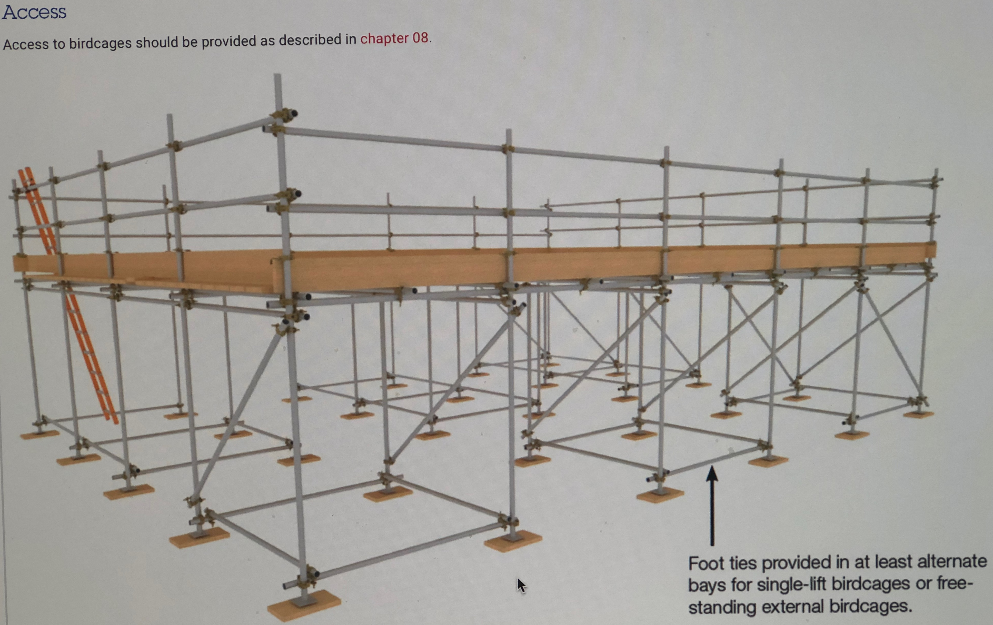

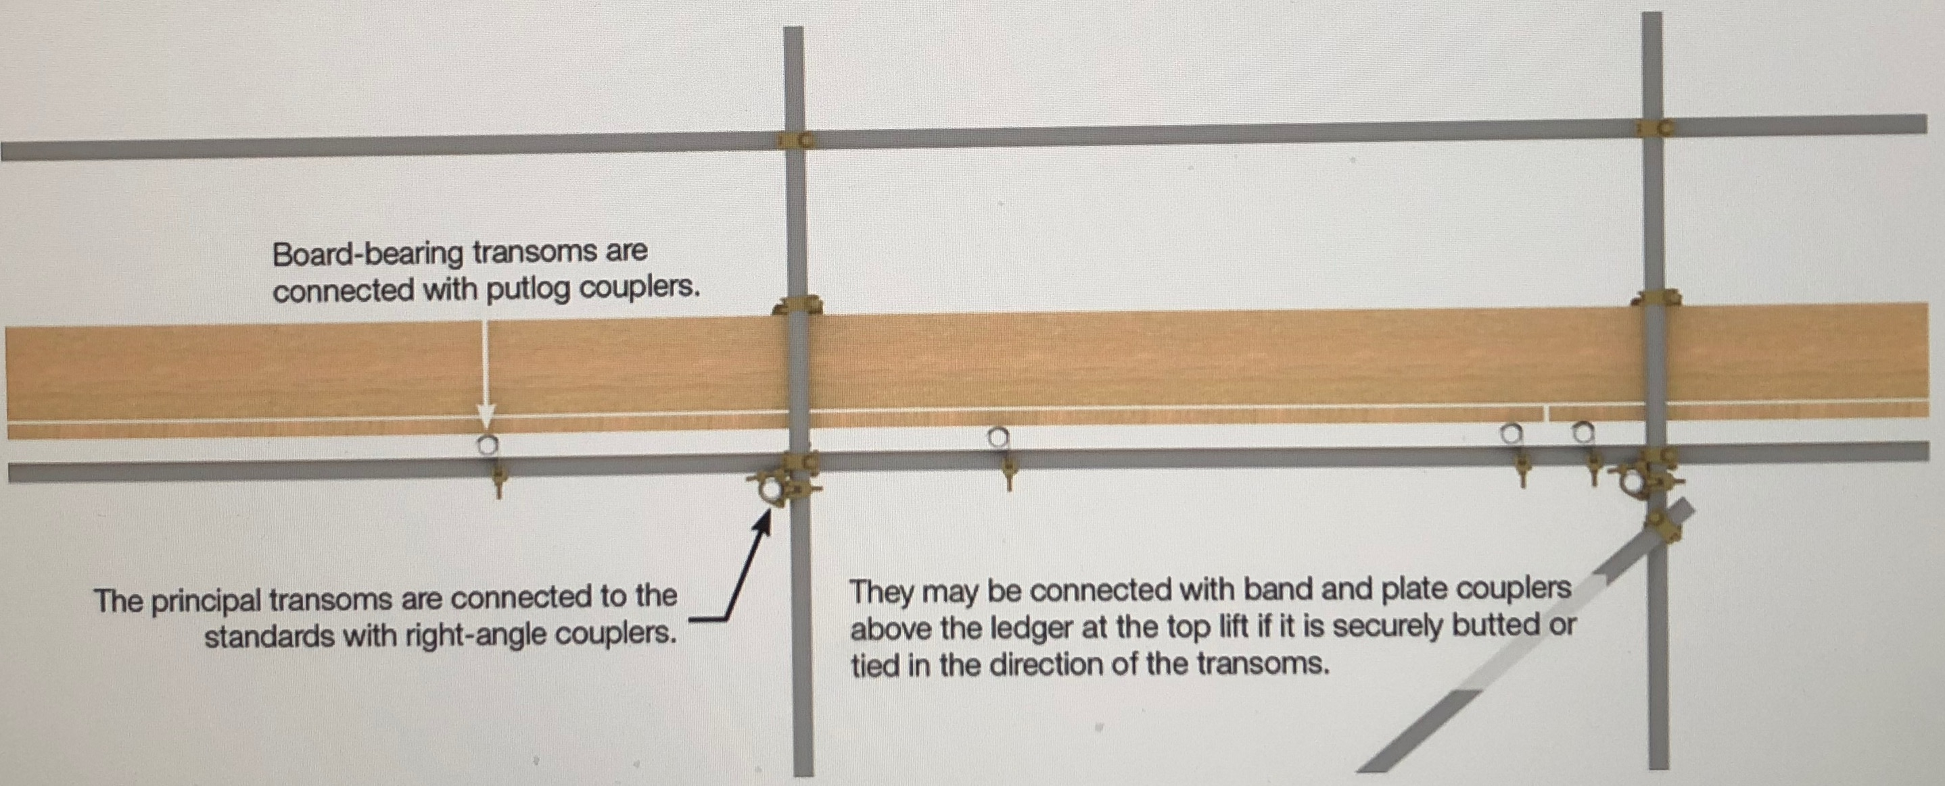

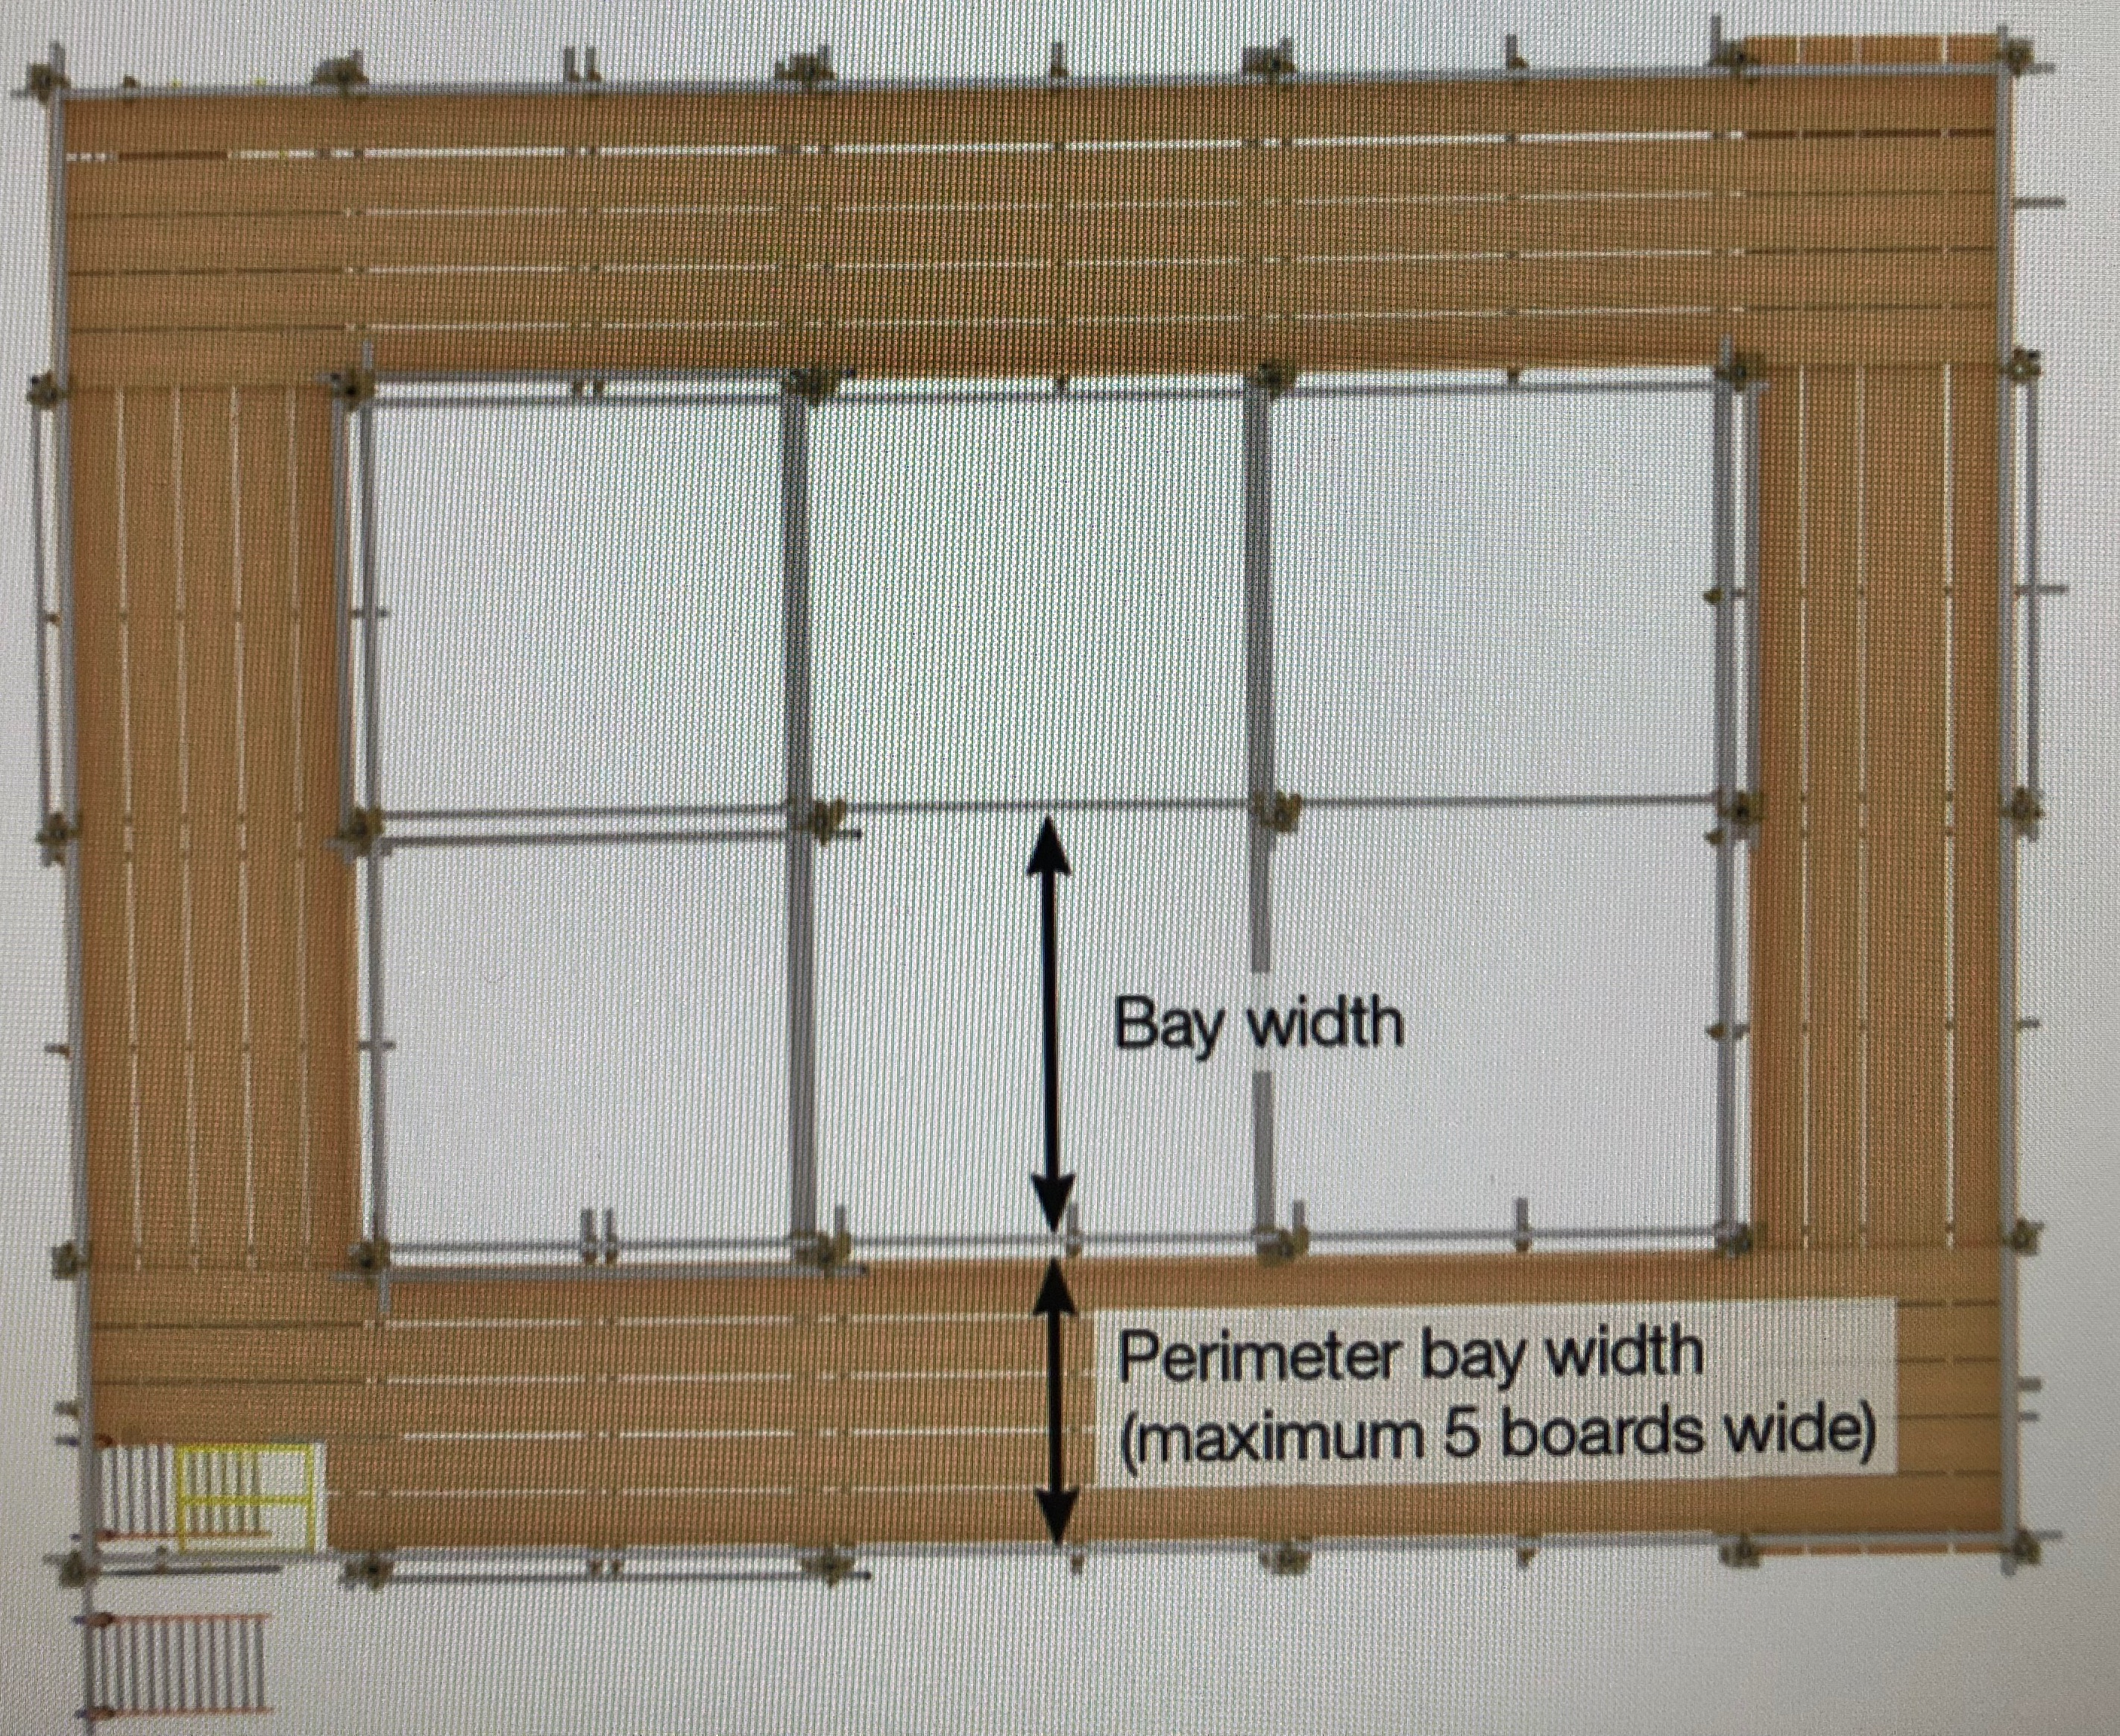

SG4: Current Edition Preventing Falls in Scaffolding
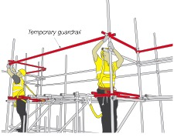
Loading tower Safe System of work above and below.
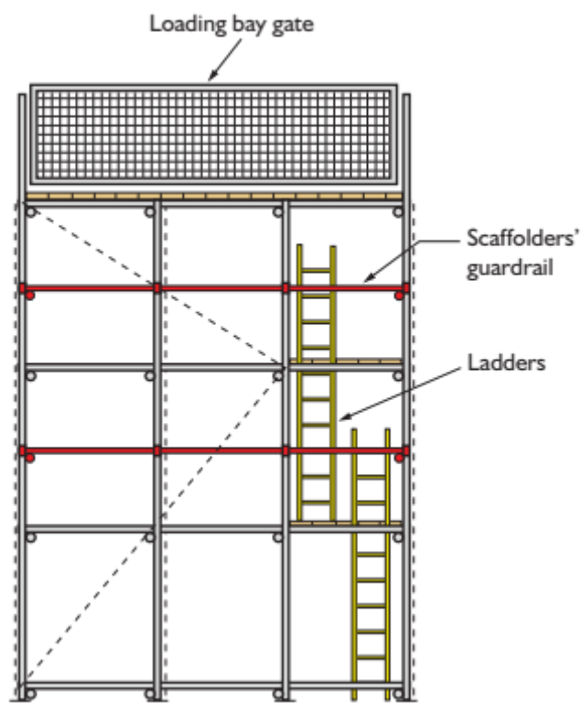

Safe System of work using the using SG4: Current Version
Select the correct safe system of work that will be applied to these works
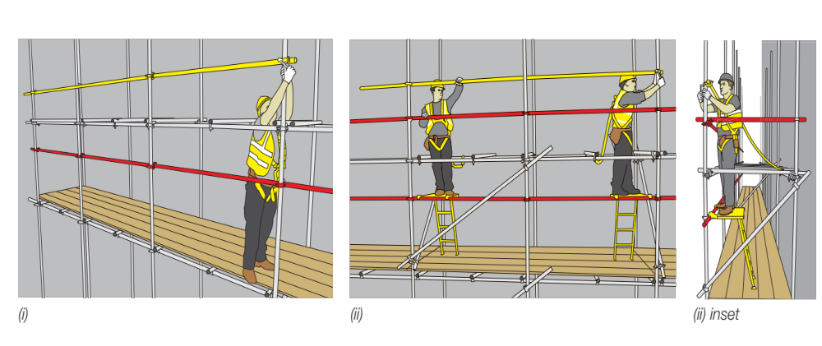
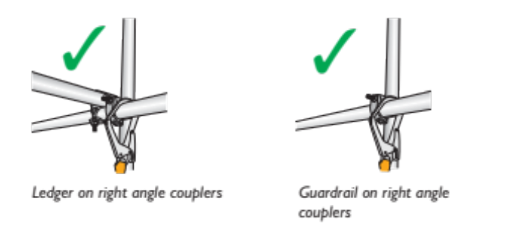

Working to SG4: Current Edition:

- No scaffolder or scaffold operative is allowed to climb up or down any scaffold at any time.
- All access up and down any scaffold must be by means of a System Staircase or correctly tied ladders.
- Only scaffolders are allowed to Erect/Dismantle or Alter any Scaffold.
- All scaffolders must hold a CISRS Card and have been trained in SG4: Current Version.
- No sub-contractor scaffolders are allowed to use their own Harness and Lanyard unless it has been checked and registered by the company.

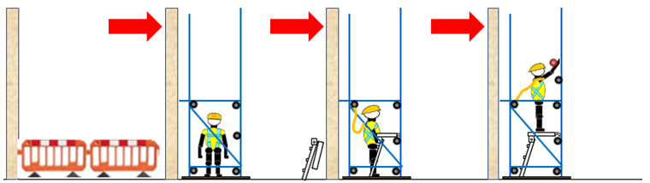

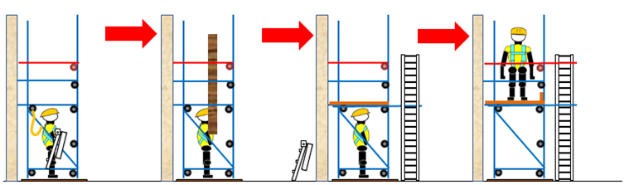

Scope: The Scaffolders Step Harness and Lanyard should be used to ensure that the operative operates from a place of safety in line with the requirements of SG4: Current Edition whilst erecting, adapting or dismantling scaffolding structures.

Step 1 – Erect the base lift of scaffold ensuring that a single guardrail is fitted 950mm above ground level.

Step 2 – Unfold the Scaffolders Step, taking care to avoid placing fingers in a trap area.

Step 3 – Connect Scaffolders Step to guardrail ensuring that the claws are fully engaged as shown.

Place the step carefully on the boarded lift. Ensure the step is at the correct angle (75°) and that the feet are placed squarely on the platform.

Erecting 2m lifts must work from the Scaffold Safe Zone fully boarded lift with a single handrail to all elevations of the scaffold where there is a risk of a fall inside face of the building/Front elevation of the scaffold.
The scaffolders could erect scaffolds using the short lift system where they could reach the advanced handrails still being clipped on at all times.

Step 4 – Connect lanyard to the ledger above and behind the step position, or to the side if using on a stop-end guardrail.
Grip either the transoms or ledgers overhead or the Scaffolders Step and ascend.

Step 5 – Install intermediate transoms either side of the working position to prevent sideways falls.
Install upper and lower guardrails to the next level whilst standing on the Scaffolders Step, relocating as necessary to make any horizontal joints that may occur in the middle of a bay.

Step 6 - Reposition the Scaffolders Step by releasing both claws at the same time by pulling the rings together.
Continue progressively installing guardrails to the lift above for the full length of the scaffold.

Board out platform from below to complete the lift.

Step7- Clip onto the top back ledger (Without a joint/sleeve in the bay) when bending below the top single handrail.

Step 9- Clip onto the top back ledger (Without a joint/sleeve in the bay) when hand-balling or install a double handrail.

All scaffolders must be clipped when working below the handrail.

Step 11- When moving boards up or down you must be clipped on at all times.
- Clip on points:
- Ledger (Without a joint/sleeve in the bay).
- Transom above head height.
- Plan brace fixed with weight bearing fittings.
- Tie tube fixed across two standards with weight bearing fittings

Scaffolder Safety Zone fully boarded platform with a single handrail

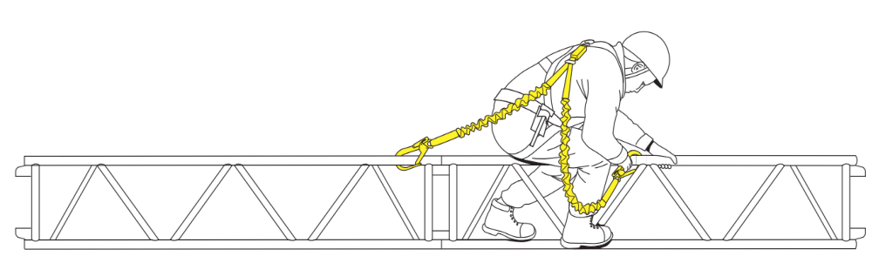
Scaffolders working from beams using twin tail lanyards to attach to the beams in line with SG4: Current Version.
You must be clipped on at all times when working from beams.

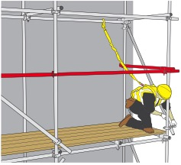
You must always be clipped on when work below the handrail

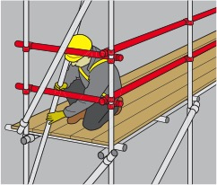
Two options when handballing equipment, double
Handrail this section of scaffolding or clip on at all times

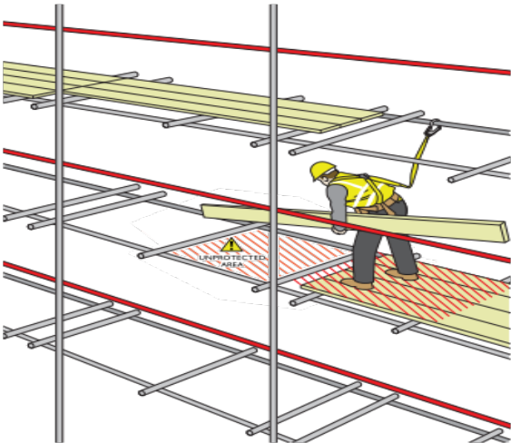
Always clip on when moving boards

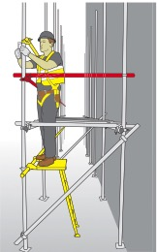
Always use your safety step when erecting and dismantling tube and fitting scaffolding

21. Handing over the scaffold to the user
- Scaffold Request - Requirements must be requested by Customer on the Scaffold Request and issued to the Supervisor.
- When the scaffolders erect the first scaffold frame the must attach a DO NOT USE tag.
- When the scaffold is completed the Charge Hand/ Lead Scaffolder must undertake a full inspection of the scaffold.
- The Customer/User will then undertake a joint inspection of the scaffold with our Charge Hand/ Lead Scaffolder.
- Defects will be rectified prior to hand over to Customer if required.
- If it is agreed that the scaffold is compliant with specification and fit for purpose the Charge Hand/ Lead Scaffolder will Issue a completed hand-over certificate.
- The scaffold will be entered into the site Scaffold Register.
- The Charge Hand/ Lead Scaffolder will complete a scafftag with its unique number that will be fixed in the holder next to the access point for the main scaffold.
- Control of the scaffold has now been transferred to Customer/ main Contractor.
- Scaffold User Access - Access to scaffold can now be permitted for other users.
- Scaffold Inspections - All scaffolding must be inspected by a competent person in accordance with the requirements of the Work at Height Regulations 2005 and a record of the findings will be made.
- Inspection frequency – before 1st use; at intervals not exceeding 7 days; after modification or significant alteration; After an event, likely to have affected the scaffold, e.g. high wind, snow, undermining, impact, etc.
- Records – maintain on site for the duration of the construction work for at least 3 months following.

The Customer can request that our Scaffold Inspectors undertake the 7 Day Inspections.

Respect: There will be no smoking on site at any time, this also means when you are erecting/dismantling or altering the scaffolding. There will be an interface with the public at all times when working on site. Please refrain from using any foul language when working on site and refrain from shouting. The PC’s site team will be monitoring the behaviour of all contractors on site at all times. Please show respect to everyone when working on site.
Do not use a phone when working on the scaffold move to a save location to use the phone.

Section 6 Communication of Control Measures
I confirm that I have been instructed and understand the control measures required for this work, as detailed in this risk assessment.
I also confirm that if the work situation changes or additional hazards are identified I will bring it to the attention of my immediate Supervisor.
Print Name | Signature | Date | CISRS Card Type | CISRS Card Number |  | Time
Supervisors Name: |  |  |  | Date: Time
Supervisors Signature: |  |  |  | Date: Time
Supervisors Name: |  |  |  | Date: Time
Supervisors Signature: |  |  |  | Date: Time
Supervisors Name: |  |  |  | Date: Time
Supervisors Signature: |  |  |  | Date: Time

