

19.007
Land Adjacent to 17 Great Jones Street, Manchester
Proposed Residential Development

Applications to discharge conditions appended to full planning consents
132856/FO/2022
136412/FO/2023
HIGHWAY AND FOOTWAY DILAPIDATION SURVEY

Walk over. Mid December 2024
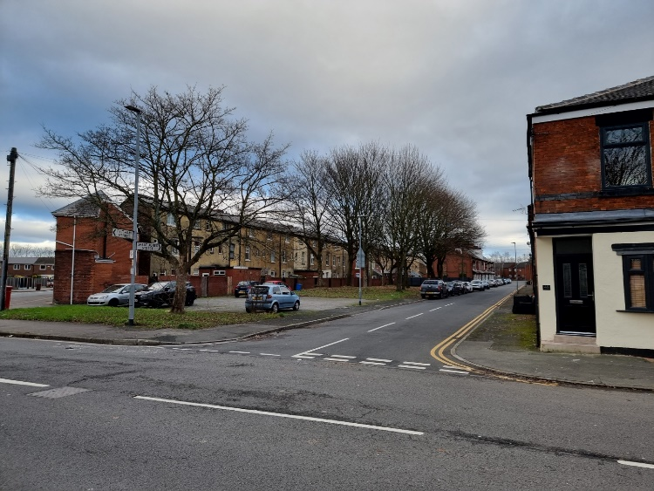
View down Great Jones Street from junction with Pottery Lane
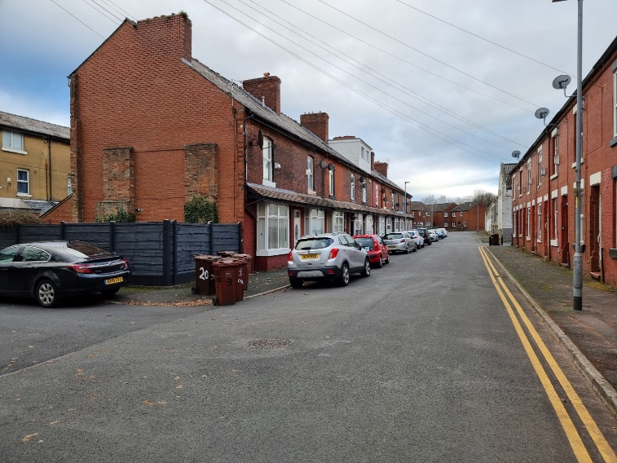
View East along Great Jones Street
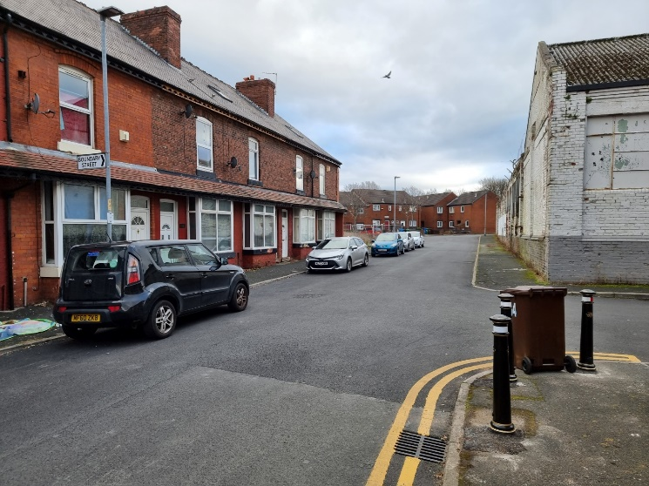
View East along Great Jones Street at Junction with Boundary Street

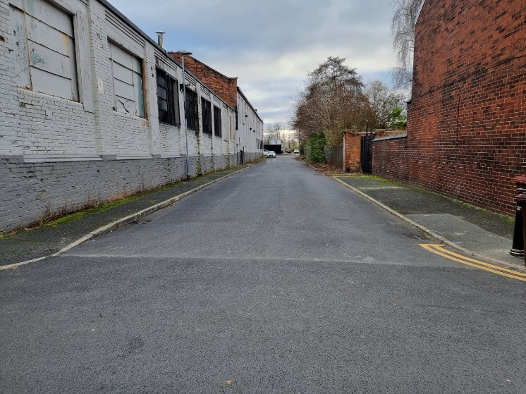
View South down Boundary Street
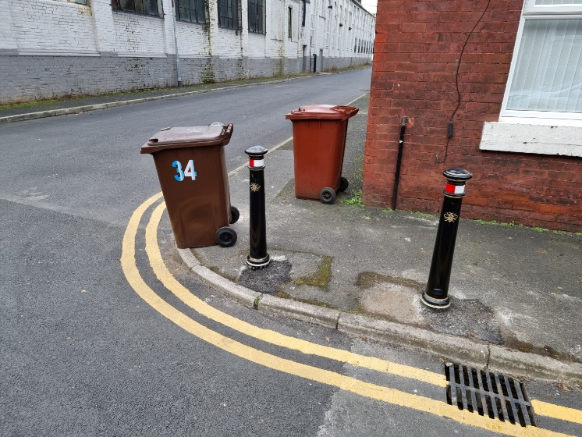
View at junction with Boundary Street. Bollards and footway/kerb damage
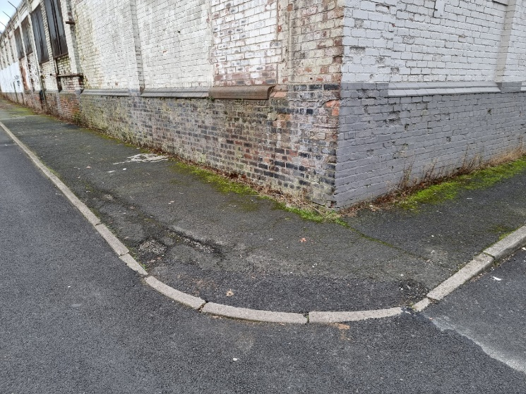
View at junction with Boundary Street. Footway and kerb damage
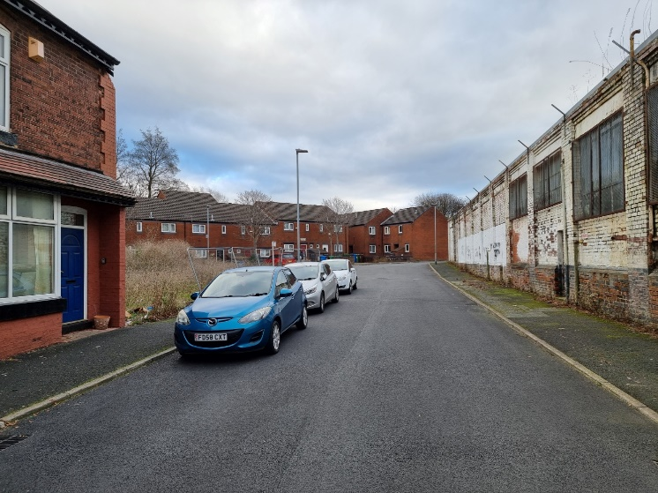
View East with site on the left. Damage to both footways
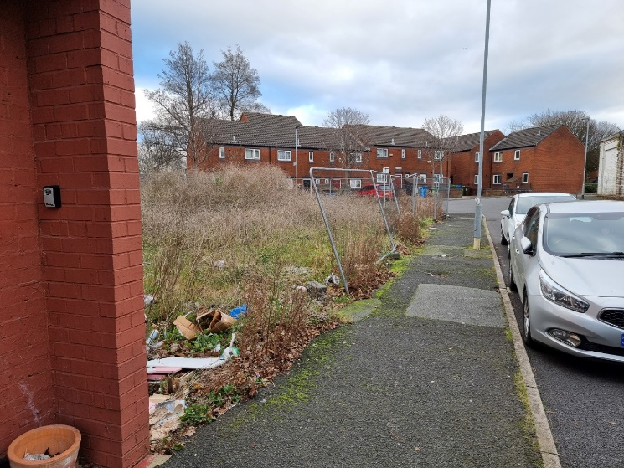
View East. Site frontage footway and kerbs disrepair
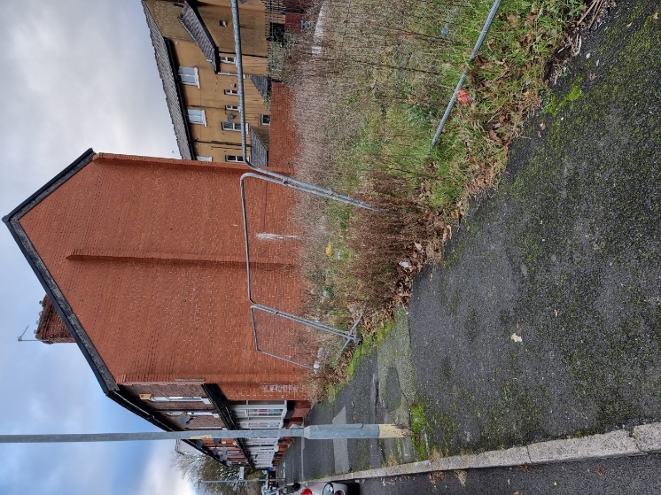
View West. Site frontage footway and kerbs disrepair

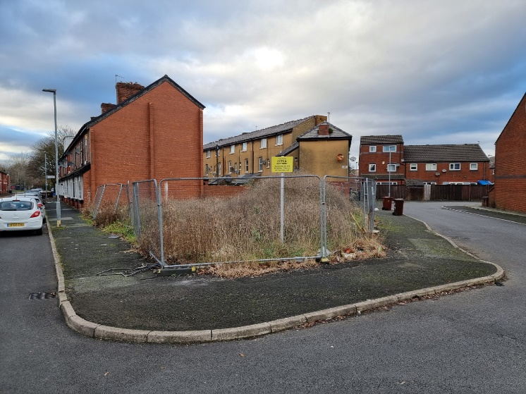
View East. Site frontage footway and kerbs disrepair around junction with Milne Close

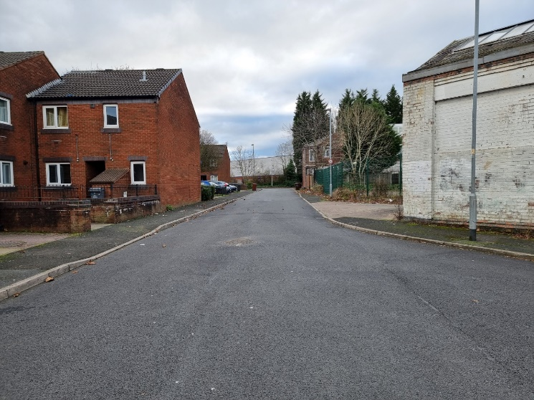
View South down Milne Close with back to the site. Footway and kerbs disrepair

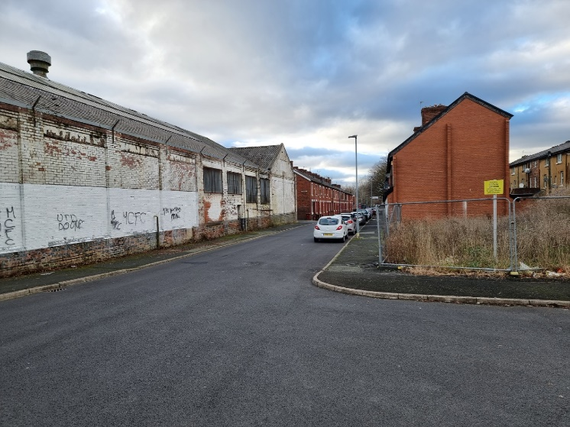
View West. Footway and kerbs disrepair to Great Jones Street and Milne Close
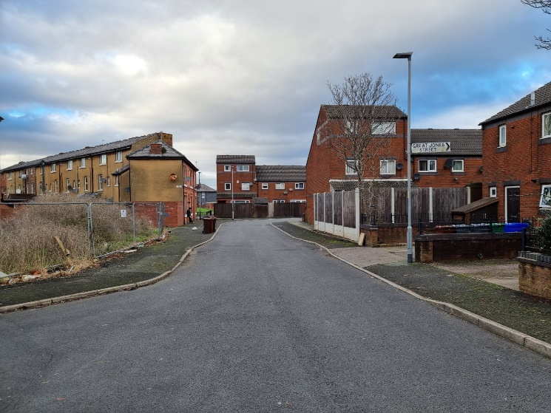
View North down Milne Close. Footway and kerbs disrepair to both sides
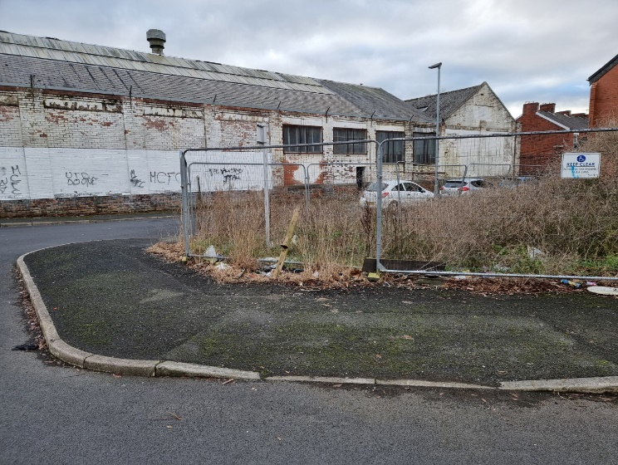
View around junction of Great Jones Street and Milne Close. Footway and kerbs disrepair
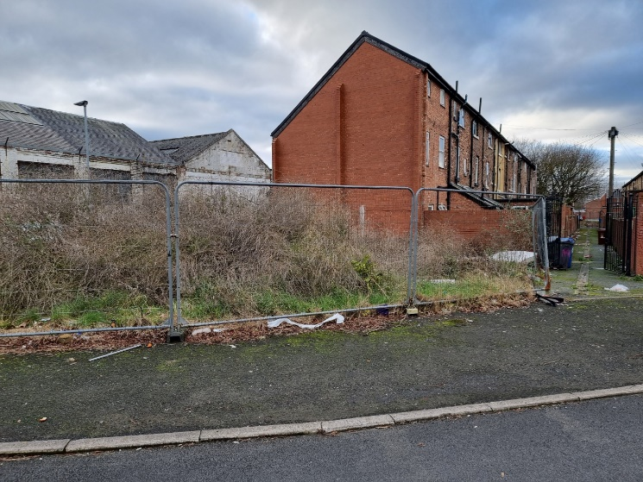
View around junction of Milne Close. Footway and kerbs disrepair

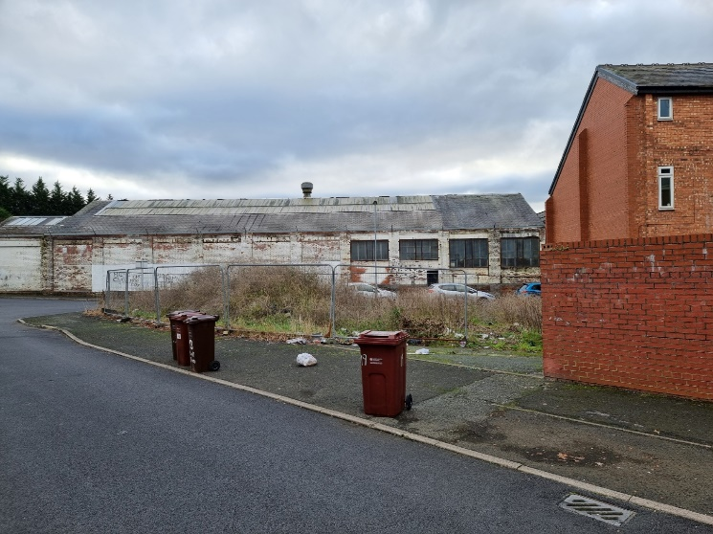
View around junction of Milne Close. Footway and kerbs disrepair
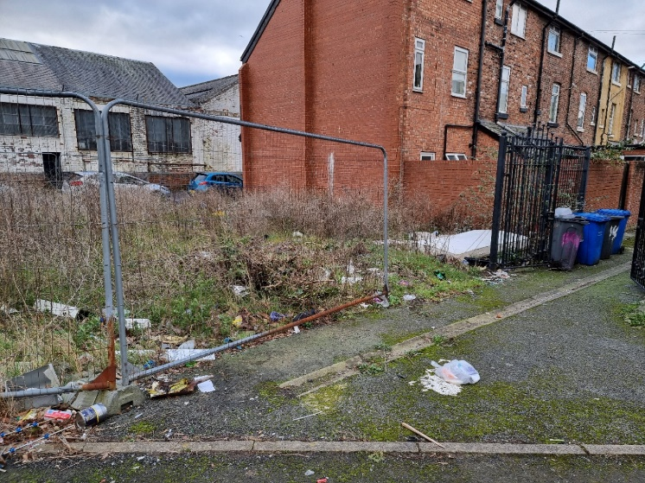
View down rear access off Milne Close. Footway, kerbs and drainage channel disrepair
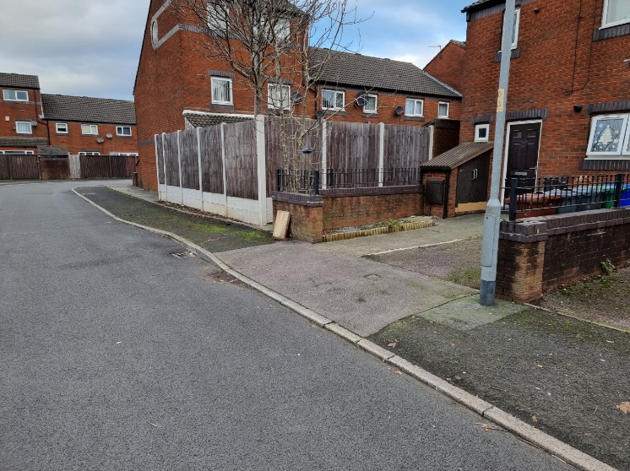
View of opposite side of Milne Close. Footway and kerbs disrepair
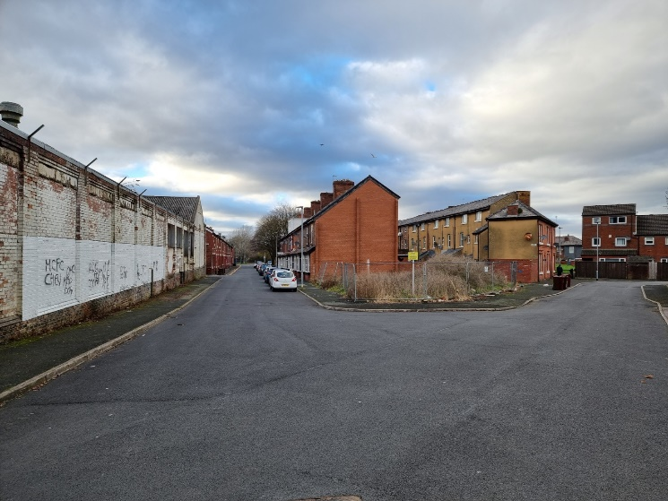
View around junction of Great Jones Street and Milne Close. Footway and kerbs disrepair
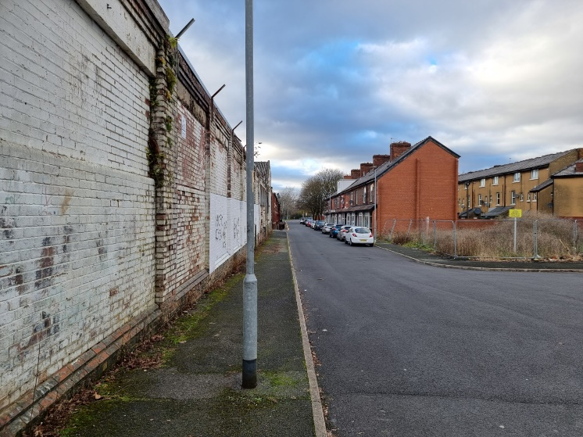
View from junction of Great Jones Street and Milne Close. Footway and kerbs disrepair opposite site
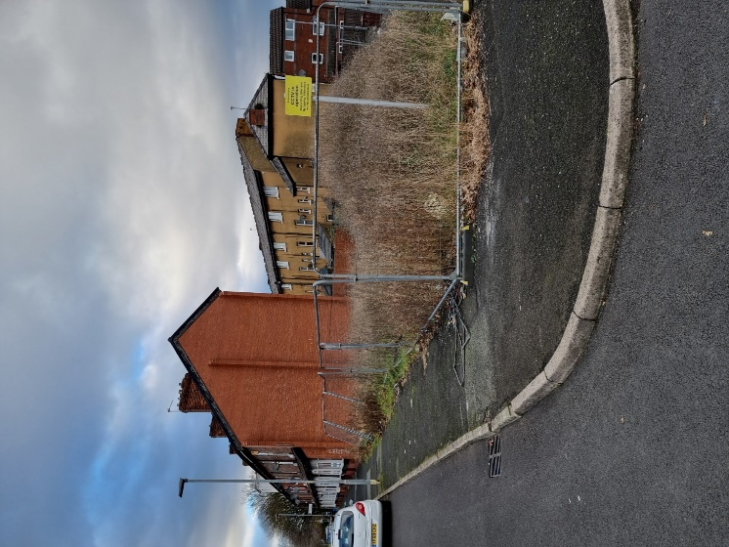
View from junction of Great Jones Street and Milne Close. Footway and kerbs disrepair
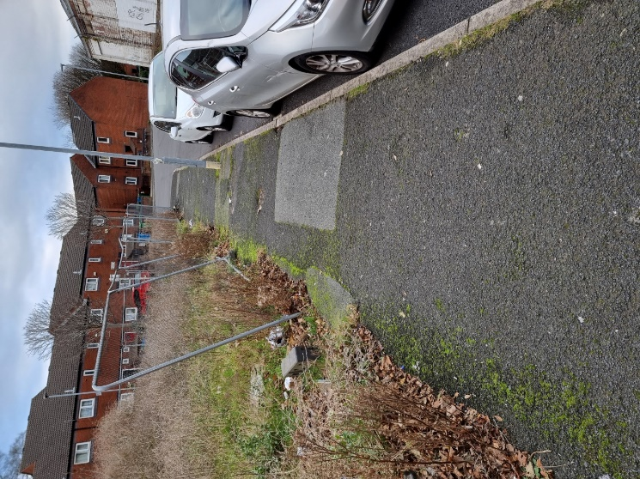
View of site frontage footway. Footway and kerbs disrepair
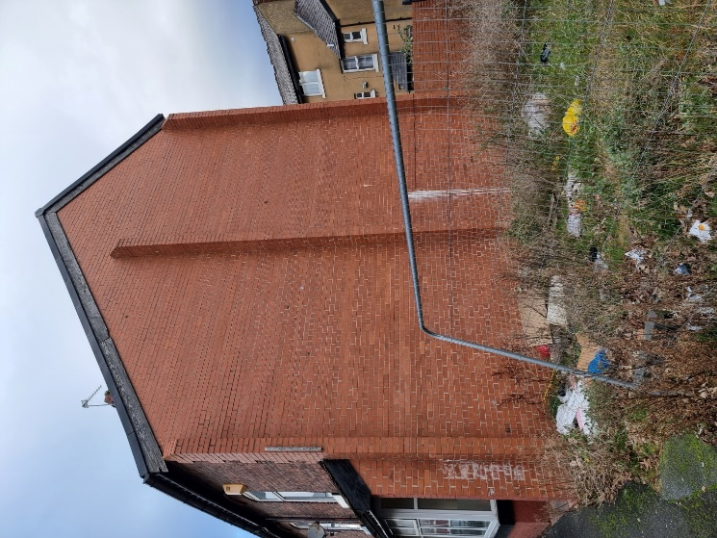
View of existing gable to 17 Great Jones Street. Footway disrepair

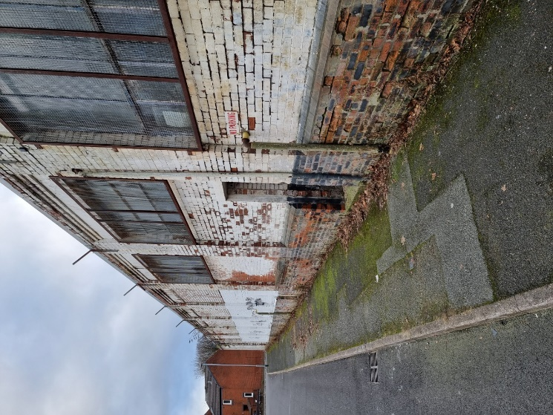
View of Great Jones Street industrial units opposite the site. Footway and kerbs disrepair
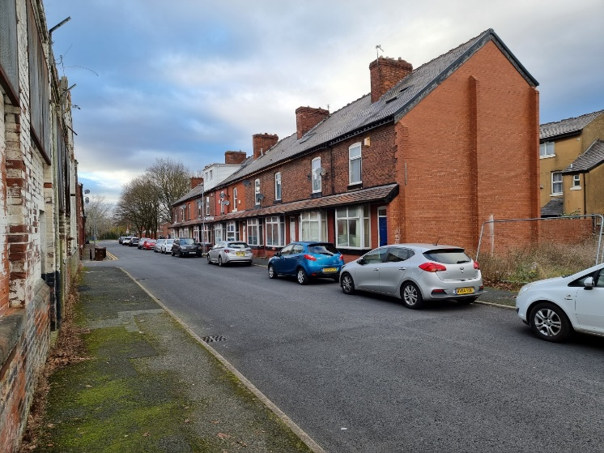
View of Great Jones Street industrial units opposite the site. Footway and kerbs disrepair
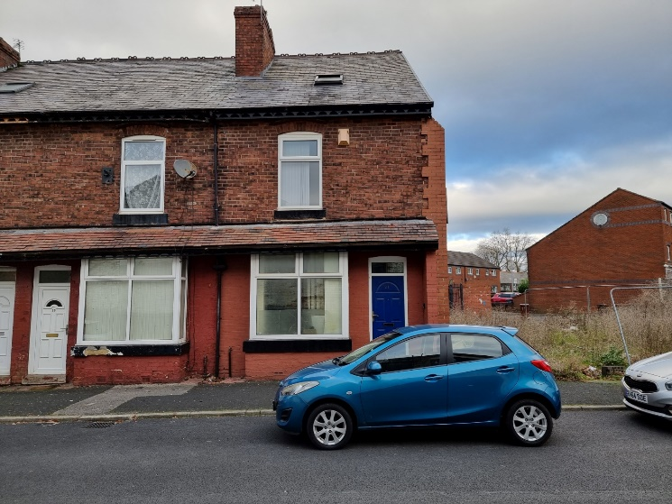
View of Great Jones Street existing adjacent houses. Footway and kerbs disrepair

