CONSTRUCTION MANAGEMENT PLAN
SITE: 55 SLACK ROAD , MANCHESTER, M9 8NJ
PROPOSAL: ERECTION OF TWO-STOREY, DETACHED DWELLINGHOUSE (CLASS C3) WITH ASSOCIATED PARKING, LANDSCAPING AND BOUNDARY TREATMENT
APPLICATION NUMBER: 134434/FO/2022
APPLICANT: Mr NURUL HAQUE and Ms FOUJIA AKTHER
DATE: JUN 2024

By CTA DESIGNS LTD

Introduction

Planning Reference Number
The planning reference number for this development is 134434/FO/2022

Site Address
The proposed development is a vacant space adjacent to the applicant’s property located on 55 Slack Road, Manchester, M9 8NJ.
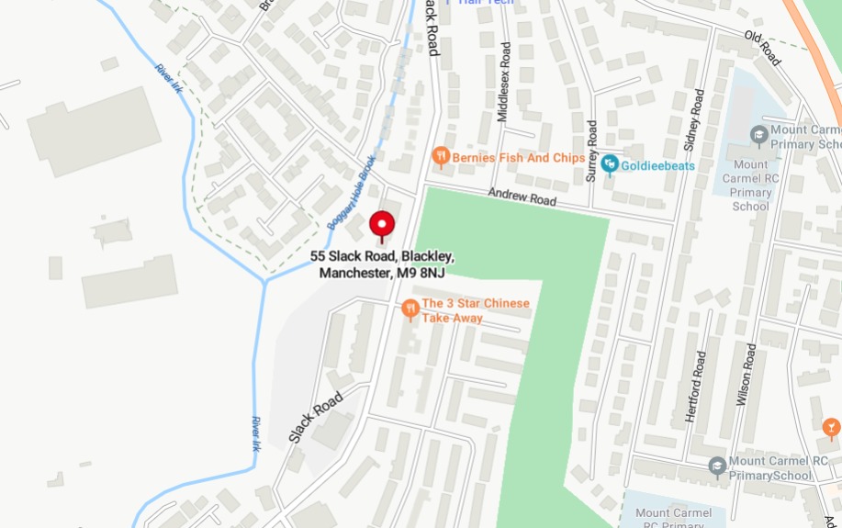
Figure 1: Site Plan of Proposed development
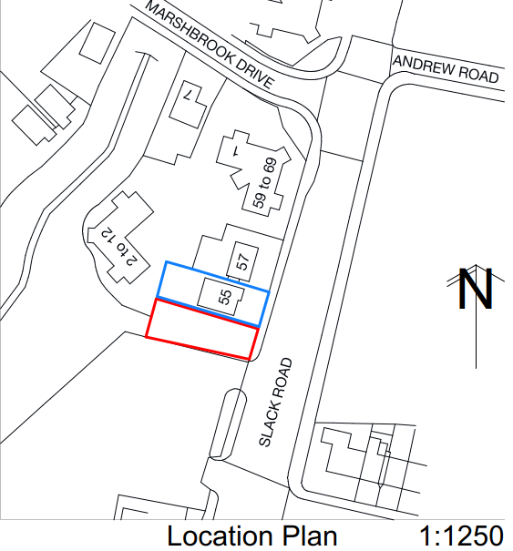
Figure 2: Location Plan of Development

Project Details and Overview
This Construction Management Plan has been prepared to support the planning application, 134434/FO/2022, which seeks to develop the vacant space adjacent to 55 Slack Road into a residential development falling within a Class C3 detached dwelling house with associated parking, landscaping and boundary treatment.
Typical construction activities include the following:
- Site establishment
  - Installation of site security fencing.
  - Land clearance
- Demolition
  - Disconnection of existing services.
  - Soft strip of existing building.
  - Demolition of Cell blocks to rear of building.
  - Removal of demolished material.
- Ground works
  - Installation of retention wall
  - Excavations for and casting of concrete foundations
  - Ground floor construction
  - Excavations for installation and connection of new utility services
- Super structure works
  - Masonry external wall construction
  - Scaffolding
  - Carpentry
  - Roof tiling
  - Cladding and rendering
  - Plumbing and electrics
  - Plastering
  - Flooring and tiling
  - Decoration
- External works
  - Fencing
  - Landscaping

Site Description and Context
The proposed development site, adjacent to 55 Slack Road, is vacant space approximately 480m² in area, surrounded by to the south by a redundant commercial land, residential properties to the north and west and enclosed by Slack Road to the east.
Due to the vacant nature of this site, no demolition works are anticipated, however a level of land clearance and retention along the southern boundary is required to enable works to proceed safely. However, it must be noted that this location was previously developed and situated within a curtilage of an former chemical works. No restrictions such as Tree Preservation Orders, nearby watercourses and/or existing buried utility services have been identified at this stage. The main challenges related to site accessibility and the level change between proposed development site and redundant land to the south.
The proposed development is surrounded by a few key receptors, immediately residential properties adjacent and to its rear with multiple commercial properties within 500mm, located primarily on Slack Road. All measures will be undertaken to reduce the impact of construction works on these receptors so far as practicable.

Site Management

Site Personnel
The Construction Management Plan was prepared and submitted by CTA Designs Ltd on behalf of the applicant Mr Nurul Haque and Ms Foujia Akther.
The following individuals will be involved during the implementation of this construction project:
Role | Name | Contact Number | Responsibilities
Production of Construction Management Plan | CTA Designs Ltd |  | Production and submission of Construction Management Plan
Project Manager | Nurul Haque | 07963 522 531 | 1. Responsible for compliance with the construction  management plan.  2. responsible for community liaison and dealing with any complaints from members of the public, regulatory bodies, and occupiers of other adjacent premises
Site Manager | Nurul Haque | 07963 522 531 | Day-to-day responsibility for the development
Goodchild Design  Partnership - Designers | Nick Goodchild | 0161 850 8586 | Production of Planning Documentation
Wrays Plant Hire and Aggregates | Ben Mitchell | 0161 536 2065 | Undertake WAC testing of excavated material prior to its removal
Add others as required

Site contact details will be displayed on the site perimeter hoarding/fencing to visibility. This will enable both site personnel as well as the general public to contact site manager where necessary as well as outline the requirements for entry into the construction site.

Development Site Layout and Welfare Arrangements
Due to the proposed work scope and the limited size of proposed development, a lean and efficient programme of works is anticipated to overcome the space restrictions. Site is expected to be transient, with limited footprint for contractors and delivery vehicles to avoid build-up of development traffic. Nonetheless, the following site map provides an indication the segregated work site.
The site perimeter will be secured using perimeter hoarding/fencing to segregate the worksite and prevent unauthorised access, predominately from Slack Road, as boundary demarcation currently exists via timber fences and brick front boundary walls. The perimeter hoarding/fencing will be secured in place to ensure the segregation of pedestrians.
Materials/storage areas are restricted to the front area of the site which is to the rear of the designated vehicle ingress and egress points. Vehicle loading/unloading will also be managed at these locations, scheduled to occur outside of peak rush hour, to mitigate disruption and traffic build up on Slack Road.

Site Personnel and Visitors
All site personnel and visitors will be provided with a site induction that details the proposed development, highlights the key risks and outlines main contacts including security, first aid and other emergency arrangements.
Upon initial arrival, all site operatives will be briefed on the contents of the Construction Management Plan as well as the known SHE hazards and risks identified under the general headings of:
- Air Quality & Emissions;
- Noise & Vibration;
- Use of hazardous materials;
- Waste management;
- Ground conditions/ contamination;
- Protection of the public.
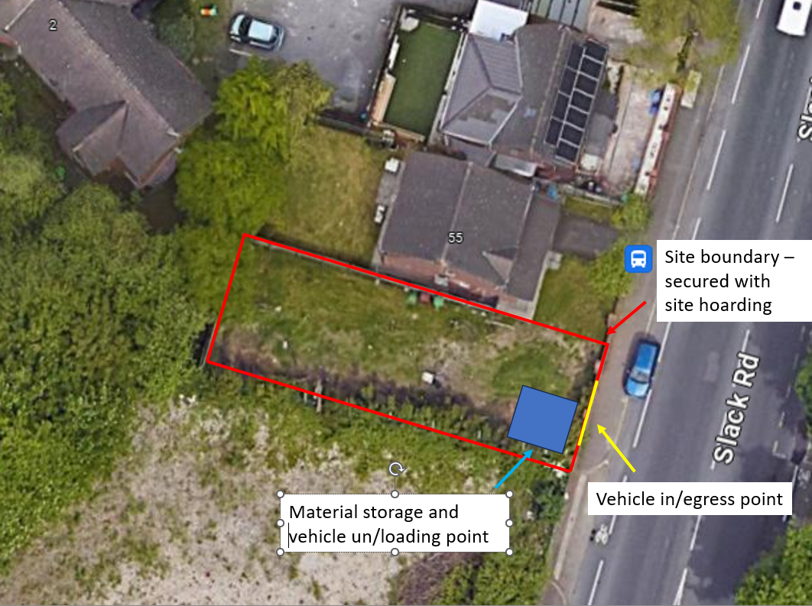
Figure 3: Site Layout Plan
Contractors and visitors wishing to access the site work environment must wear the following Personal Protective Equipment (PPE): - Safety helmets, hi visibility clothing and safety footwear as minimum. Site Safety signage will be on display at all times, located at the entrance/exit nodes, example of signage can be seen in Appendix B.
As the records reveal that the proposed development lies on the curtilage of a former chemical works, additional precautions are required in the event of encountering ground contamination. Prior to works commencing, soil and waste clarification testing will be undertaken to determine if any contaminates are present within the soil as well as informing the waste category. If samples taken are found to contain contaminated/hazardous waste, the PPE requirements will be determined through risk assessment process, example provided in Appendix C, and will be strengthened if required to incorporate whole body protection via way of overalls, suits or similar.

Managing materials, site storage and housekeeping
As aforementioned, due to site size limitations the project will be managed under lean delivery and build mechanism, with only small areas dedicated to material storage (including waste) at the front of the site.
Loading and unloading of plant and materials shall take place only within the boundaries of the construction site. Loading and storage areas will be created on site allowing sufficient area for the requirements of the project. Lorry movements will be fully considered, ensuring safe reversing / manoeuvring, access and egress.
When materials are delivered to the work area they shall be positioned so as not to obstruct vehicular or pedestrian routes or reduce visibility of site traffic and pedestrians. All materials to be secured within the site perimeter hoarding to prevent unauthorised access and use.

Site Security
Prior to commencement on site all site boundaries shall be made secure. The site will be enclosed hoarding to Slack Road, which shall be maintained in position and good repair throughout the development, with lockable gated access to allow for vehicle ingress/egress.

Community Liaison and Communication
A pre commencement letter drop shall be carried out notifying all direct neighbouring properties of the site start date, following with updates at key stages.
Suitable out-of-hours contact arrangements shall be in place in the event that an incident occurs outside of normal working hours (e.g. an alarm sounds, or a break-in is reported). Contact details shall be displayed outside the site. Contacts shall be reviewed and updated in relation to annual leave or other absence of site staff.
The Project Team will communicate proactively with any local residents / businesses and other members of the public that may be affected by construction activities. Where construction activities could cause nuisance to the local community, the Project Manager shall contact local residents and any affected businesses, residents etc. prior to the activity taking place. The project team shall then ensure that these parties are kept up to date with the progress of the works and the measures that will be put in place to minimise any potential nuisance that may arise as a result of these.
Site display material shall provide the potentially affected parties with contact details of a member of the management team, should they have any issues or complaints they wish to discuss. The project team staff are encouraged to build and maintain a positive relationship with the local community to avoid the need for nuisance related complaints. All subcontractors are expected to minimise the impact of their works on the local community.
All complaints received will be investigated and a response (even if pending further investigation) is to be given to the complainant as soon as reasonably practicable. Incidents relating to nuisance (e.g. complaints relating to noise, dust, vibration, mud on roads etc. made by the public, clients or Environmental Health Officers) shall be reported and actioned as practicable.

Site Operations

Working works
The construction site working works as legislation and further determined by Manchester City Council to suite local needs, adopted to provide specific provisions with mitigating disruption are as follows:
- Monday to Friday 9am to 5pm.
- Saturdays 9am to 1pm.
- Sundays and Public Holidays - no working These hours relate to noisy works which are audible beyond the site boundary.
No plant, machinery or equipment associated with such works shall be started up or operational on the development site outside of these permitted hours.
Bank and Public holidays are as follows: Christmas Day; Boxing Day; New Year’s Day; Good Friday; Easter Monday; May Day; spring Bank Holiday Monday and August Bank Holiday Monday. All subcontractors including suppliers shall be made aware of the permitted working hours as the restrictions also apply to deliveries.

Highways and Traffic Management
Deliveries and loading areas as aforementioned will be via the site perimeter hoarding ingress/egress point on Sack Load. It is anticipated that reversing of large vehicles will be required to enable ingress/egress, this is to be managed locally by the site manager. Where reversing has to be carried out then this will be under the control of a trained banks man where the vehicle has not been fitted with 360-degree vision aids. During this process, normal traffic operations on Slack Road may be temporarily disrupted to facilitate access for these vehicles, site manager to schedule any large deliveries outside of peak rush hour times where practicable.
Pedestrian and cycle routes on Slack Lane are to remain throughout the duration of the project, however limited interruptions may occur during the delivery/loading activities involving large vehicles. Where this occurs, site manager is to ensure that disruption is minimised where possible and that banksman are in place to redirect vehicles, pedestrians and cycles to safety where required.
Alternative routes for vehicles, pedestrians and cyclists are not required for this scheme as occupation of the public highway is not required to delivery this development. Furthermore, no temporary or permanent structures will overhang onto the public highway/pavements. No blinds spots will be created as part of these works.
The existing highways leading to the site shall be kept free from mud, dirt, debris and other deleterious matter as much as possible.
Road sweeping shall be implemented as required to prevent build-up of mud / dust on site roads and to ensure it is not deposited on adjoining public roads. This will be managed locally by the site team to ensure that the roads around the site are kept clean at all times.

Noise and Vibration
All vehicles and plant used during the development will be maintained in good and efficient working order, and in accordance with manufacturer’s specification.
All vehicles, mechanical plant, and machinery used during the development shall be fitted with proper and effective silencers and shall be maintained in good and efficient working order.
All plant and machinery in intermittent use shall be shut down in the intervening periods between works. Plant and machinery capable of generating significant noise and vibration levels will be operated in a manner to restrict its duration.
Static plant and machinery shall be sited as far away as possible from inhabited buildings or other noise sensitive locations.
Wherever possible mains electricity or battery powered equipment shall be used instead of diesel- or petrol-powered generators.
The handling of materials shall be conducted in such a manner that minimises noise, including minimising drop heights into hoppers and lorries.

Dust
All plant and equipment shall be maintained in accordance with manufacturer’s recommendations to ensure emissions to atmosphere are minimised.
Engines of plant, machinery, and lorries shall be turned off at all times when not in use.
Delivery activities, plant, stockpiled materials and/or any other activities liable to significant dust generation shall be located as far away as possible from the development site boundaries and neighbouring properties.
Stored materials liable to dust generation shall be dampened down, covered with tarpaulin, or otherwise contained as far as reasonably possible. Drop heights from conveyors, loading shovels, hoppers, and other loading or handling equipment shall be minimised, and fine water sprays should be used on equipment where necessary.
Skips, chutes, and conveyors shall be covered and if necessary enclosed to ensure that dust does not escape. All vehicles carrying dusty materials shall be securely covered.
Water suppression shall be used in dry conditions to reduce dust emissions (e.g. mobile bowsers or fixed sprayers as appropriate). Areas where there is regular vehicular movement should have a consolidated surface which shall be kept in good repair.

Other Amenity
Measures to minimise and avoid creating visual impacts during construction.
- unnecessary vegetation removal will be avoided;
- materials and machinery will be stored tidily during the works in order to minimise impacts on views;
- lighting of compounds and working areas will be restricted to agreed working hours and those which are necessary for security;
- public roads providing access to the construction site will be maintained free of dust and mud;
- keep clear and clean all working areas and accesses as work proceeds and when no longer required for the works;
- on completion of the project, remove all structures, equipment, surplus soil and materials, waste, notice boards and temporary fences used during the construction with minimum damage to the surrounding area.

Emergency and Incident Procedures
Given the nature of the works and the environmental sensitivity of the site it is possible, although unlikely, that environmental incidents could occur. Such incidents could include:
- Hydrocarbon spillages into surface or groundwater;
- Silty contaminated runoff into surface or groundwater;
- Fires; and / or
- Extreme dust events.
In order to minimise the risk of a pollution incident, subcontractors must ensure all operatives understand the environmental risks associated with their work activity and what control measures are in place to eliminate or reduce negative environmental impact.
All site operatives are to be brief that if medical emergencies occur, this Site Manager is to access the situation and dial 999 where required.
The nearest hospital with A&E to the location of the proposed development is:
North Manchester General Hospital, Delaunays Road, Crumpsall, Manchester, M8 5RB
Tel: 0300 3309444
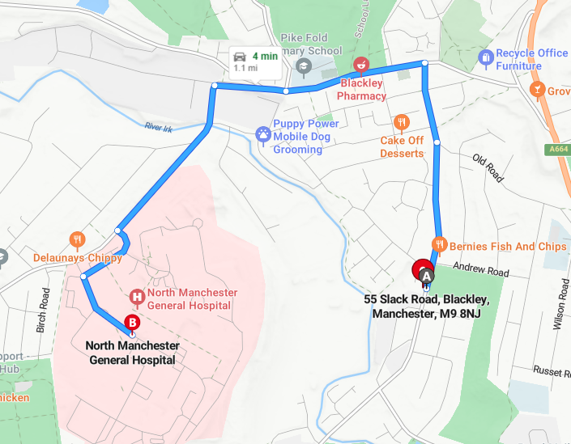
Figure 4: Hospital route from proposed development

Waste Management
There shall be no burning of waste at any time on development sites.
The Project Team will have an appropriate means of waste disposal in place for the duration of the development works. Appropriate waste transfer and/or disposal documentation shall be made available for inspection by the local planning authority on request.
The project team will ensure that any waste materials stored on the site are adequately secured to prevent unnecessary and unsightly dispersal of the materials around the site and public areas (streets, laneways, footpaths and reserves).
As the records reveal that the proposed development lies on the curtilage of a former chemical works, additional precautions are required in the event of encountering ground contamination. Prior to excavation works commencing, soil and waste clarification testing will be undertaken to determine if any contaminates are present within the soil as well as informing the waste category. Once confirmed the aforementioned licensed waste contractor will attend site and remove the excavated material to the appropriate waste treatment facility.

Monitoring and Control
It shall be the responsibility of the Site and CTA Design Ltd to monitor and control the construction Environmental Management plan and ensure its implementation.

Appendices
Appendix A – Site Contact Details
Appendix B – Site Safety Signage
Appendix C – PPE Risk Assessment

Appendix A- Site Contact Details
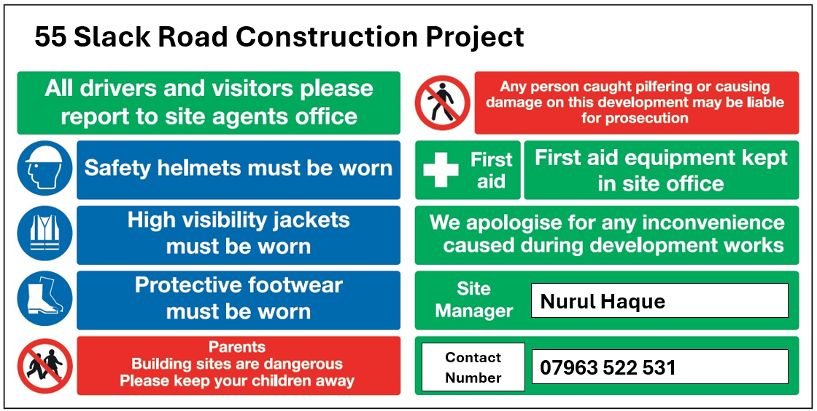

Appendix B – Site Safety Signage
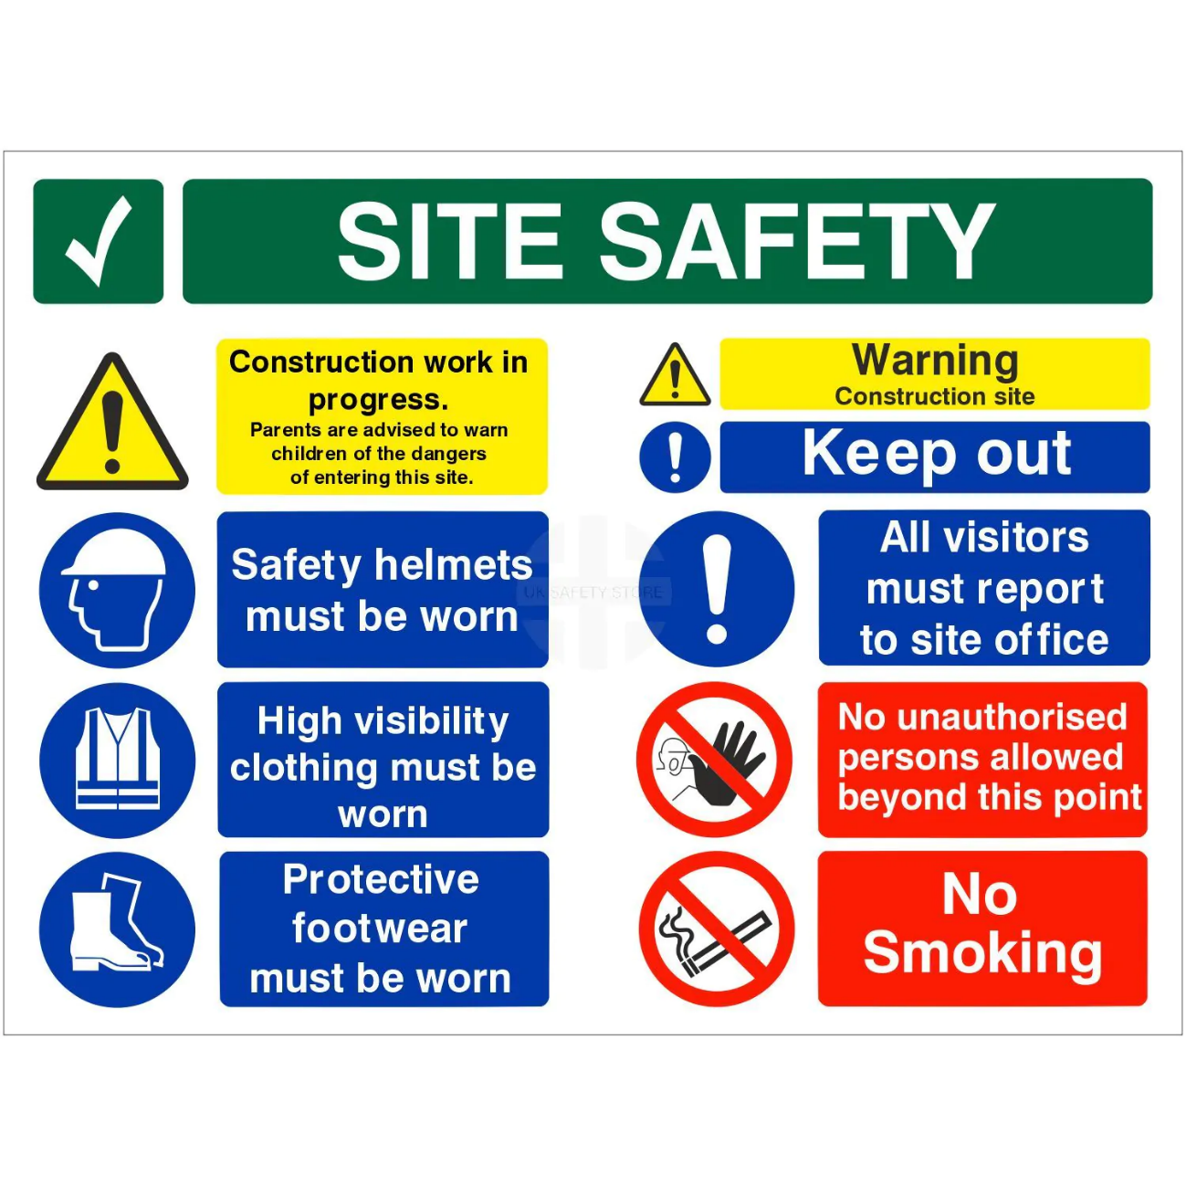

Appendix C – PPE Risk Assessment

RISK ASSESSMENT RECORD
ACTIVITY and/or ENVIRONMENT TO BE ASSESSED: Selection and use of Personal Protective Equipment (PPE)
DATE:
KEY (People at risk) | Likelihood (L) | Severity (S) | Risk Calculation | Risk Rating
E = Employee YP = Young Persons  P = Public  C = Contractors  V = Visitors  EM = Expectant Mothers | 1. Very Low (rare/very unlikely)  2. Low (unlikely)  3. Medium (could occur/possible)  4. High (likely to occur/probable)  5. Very High (near certain to occur) | 1. Insignificant (nuisance/discomfort)  2. Minor (no lost time)  3. Moderate (time loss)  4. Significant (serious/incapacity to work)  5. Major (Death) | Likelihood x Severity  =  Rating | 1- 6 LOW RISK Monitor  - MEDIUM RISK Monitor, review & reduce risk where possible  14-25 HIGH RISK Further Action Required

1.Hazards Identified and potential harm it could cause | 2. People  At Risk | 3.Controls in Place | 4.Risk Rating |  |  |  | 5. Further Action Required/ Recommendations | 6.Target Date for Completion
1.Hazards Identified and potential harm it could cause | 2. People  At Risk | 3.Controls in Place | L | S | Score | Risk | 5. Further Action Required/ Recommendations | 6.Target Date for Completion

Worker(s) this risk assessment covers: | Works | - Can the risks be controlled by other means e.g. ensuring machine guards are fitted correctly, safer products/ substances used etc.?  - PPE should be kept in good order and stored and cleaned correctly in line with manufacturers / suppliers instructions and replaced when necessary. (Employees have a duty to look after / clean their PPE).  - Is there a need for information, instruction, training or supervision to enable the employee to use specific PPE correctly and safely? |  |  |  |  | Has a need for PPE been identified YES / NO  NB: Under the requirements of health and safety legislation if PPE is required to enable a worker to do their job safely it must be provided by the employer free of charge.  PPE required to enable the worker/s to work safely:  Are there any training requirements to enable workers to use selected PPE correctly?
Where significant risks to workers cannot be controlled by other means the employer has a legal duty to provide PPE to minimise the risk. |  | - Is the PPE selected effective in controlling the risks e.g. steel toe caps protect toes from the risk of dropping heavy items on to foot, slip resistant soles reduce the risk of slipping etc.?  - Is PPE selected appropriate for the risks involved e.g. is it comfortable to wear / not restrictive etc.?  - Is PPE selected compatible with other PPE or workwear?  - Ensure selected PPE doesn’t create other risks e.g. restricts movement, grasp etc.

ppendixD– Site Contact Details

