Prospect House School, Higher Blackley

Preliminary Ecological Appraisal & Biodiversity Net Gain Assessment
2024

Client | Prospere Learning Trust
Project Title | Prospect House School, Higher Blackley
Project Reference | RHE.4404
Project Leader | Joel Crossthwaite
Contact Details | joelcrossthwaite@rachelhackingecology.co.uk
 | Name | Position | Date
Author | Joel Crossthwaite | Junior Ecologist | 15/11/2024
Reviewer | Simon Holden | Associate | 19/11/2024
Revision



The Stables, Paradise Wharf, Ducie Street, Manchester, M1 2JN
0161 465 8971

www.rachelhackingecology.co.uk
mail@rachelhackingecology.co.uk



Report Contents
Executive Summary 3
1. Introduction 4
2. Methods 6
3. Results 8
4. Assessment 10
5. Conclusion and Recommendations 12
Appendix 1: Planning Policy & Legislation 13
Appendix 2: Habitat Map 16
Appendix 3: Target Notes 17
Appendix 4: Headline Results 19

Executive Summary
Development Details
The client is proposing recreational development at Prospect House Primary School, Higher Blackley, hereafter referred to as the ‘site’.
This report describes the ecological features of the site and assesses the potential impacts of the development on the ecological interest. Recommendations are provided so that the development is compliant with biodiversity policy and legislation.

Ecological Interest
The site has a negligible level ecological interest, with its features restricted to small patches of intensively managed, species-poor grassland divided by asphalt pathways.

Biodiversity Impact Assessment
The baseline habitats on site provide 0.22 habitat units. The development proposals achieve 0.18 habitat units. This represents a net loss of -0.04 habitat units (-17.66%).

Outcomes
The site functions as a play area for a specialist school and currently offers negligible ecological value. The addition of any habitat features within the site is not possible, as it would negatively impact its function.
Applying the Mitigation Hierarchy, there is no room to provide 10% BNG on site nor to satisfy the Trading Rules (loss of grassland) and provide a viable development. Recommendations regarding habitat provision are detailed within the report.

Introduction

Project Brief
    - Rachel Hacking Ecology Limited was commissioned in 2024 by Prospere Learning Trust to carry out an ecological appraisal of land at Prospect House School, Higher Blackley, hereafter referred to as the ‘site’. The site is located at O.S. grid reference: SD 85145 03508 (see Figure 1).

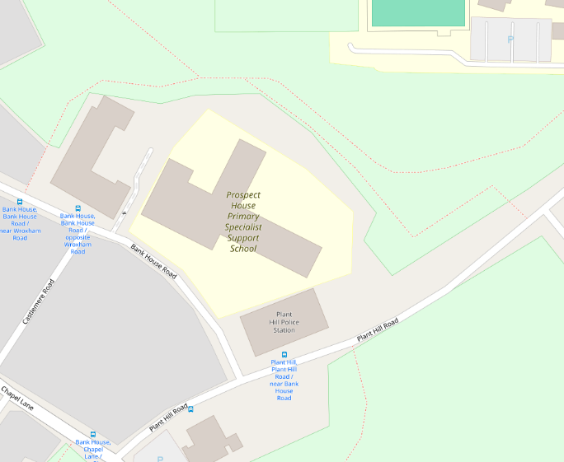
Figure 1. Map showing the location of the site. Courtesy of OpenStreetMap

    - The site is a specialist support school situated in an urban area, surrounded by mostly residential housing.

Description of Development
    - The site will be the subject of a planning application proposing the conversion of small parcels of grass into a play area, with two of the parcels set to be replaced with artificial grass.

Scope of Work
    - The Client commissioned Rachel Hacking Ecology to carry out the following works:
- Record the extent, type, and condition of habitats within the site
- Calculate the baseline and post-development biodiversity units

Site Visit Information

Surveyor Details
    - Joel Crossthwaite (Junior Ecologist) visited the site on 18th November 2024. Joel is fully trained in undertaking ecological surveys.

Weather
    - The weather at the time of the survey was dry and overcast.

Methods

Desk Study
    - It was not deemed proportionate to undertake a desk study given the very small extent of the site and habitats present.

Field Survey

Extended Phase 1 Habitat Survey
    - In accordance with JNCC guidelines the site was walked over and the habitats and features of ecological interest were mapped and described. Habitats and features of particular interest were target noted.
    - During the walkover habitat and features were assessed for their suitability to support protected and notable species in accordance with CIEEM guidelines. Field signs of protected, notable, and invasive non-native species, if encountered, were mapped, and described.

Bats
    - The exterior of the site was surveyed from the ground using binoculars and a high-powered torch. Features offering potential access to roosting bats were recorded. Such features may include suitable gaps in roof coverings, gaps behind external cladding/facia and gaps in masonry.
    - Evidence indicating the presence of roosting bats was also searched for. This may include bat droppings on walls, windows or on the ground below roost entrances or staining from fur oil around roost entry points.
    - Any trees on the site that are to be affected by the proposals were given a ground-level assessment, searching for Potential Roosting Features (PRF’s), such as flaking bark, woodpecker holes, knot holes and limb splits.

Biodiversity Net Gain
    - During the site walkover the ecological condition of each habitat was assessed in accordance with the Defra (2024) guidelines. Habitat types were recorded and mapped using the UK Habitat Classification system.
    - Habitat data including type, area (or length), condition and strategic location were uploaded to the Defra Statutory Biodiversity Metric Calculator spreadsheet to determine the baseline value of the site. The extent of any habitats to be retained or enhanced was also entered into baseline worksheets.
    - The post-development masterplan was interrogated to determine areas of hard standing, buildings, and associated infrastructure. New, retained and enhanced habitats were classified and allocated a target condition, based on habitat type, location and management input. This information was uploaded to the metric spreadsheet to obtain a post-development value.
    - The pre- and post-development values were compared to determine whether the yield of biodiversity units achieved a deficit or gain.

Mitigation Hierarchy
    - Mitigation measures should be embedded within the masterplan design and planning application process. Measures during the construction phases should be included in a Construction Environmental Management Plan: Biodiversity (CEMP). This process from proposal to implementation needs to consider the ‘mitigation hierarchy’ of avoid, reduce, compensate, and enhance:
      - Aim to avoid negative effects through the design process.
      - Mitigate if negative effects cannot be avoided.
      - Use compensation measures to offset residual impacts.
      - Identify and implement opportunities to enhance biodiversity.

Results

Survey Constraints
    - Field survey results are valid for a limited duration and no investigation can provide a complete description and characterisation of a site. The composition of habitats and species can change depending on environmental variables and the mobility of species, so the results of a study become less reliable over time. In some cases, surveys that are 3 years old may be acceptable for a project assuming that habitats have not significantly changed in the intervening period, but for protected species it is likely that survey data will need to be no more than 18 months old.
    - The site was fully accessible, with no constraints.

Baseline Habitats
    - Target Notes and photographs are contained in Appendix 3 and the habitats map is contained in Appendix 2. Please refer to the Statutory BNG Metric and the Statutory habitat condition assessment spreadsheet.

Grassland; Modified Grassland
    - The dominant habitat on site is amenity grassland dominated by Perennial Rye-grass Lolium perenne and Yorkshire Fog Holcus lanatus (TN1), extending to 0.075ha. The grassland is regularly mown, ensuring a consistently low sward height. This habitat achieves 0.15 habitat units.
Urban; Sealed Surface
    - The remainder of the site is made up of asphalt pathways (TN2), extending to 0.026ha. This habitat achieves zero habitat units.

Individuals Trees
    - There are four small individual Cherry Prunus sp. trees planted within some of the grass patches (TN3).
    - These trees cover an area of 0.0163ha and deliver 0.07 habitat units.

Species
    - The habitats on site offer negligible potential to support any notable species. Faunal species are not considered further in this assessment.

Invasive Species
    - No invasive species were found during the survey.

Assessment

Development Context
    - The following assessment assumes that a new play area is to be constructed on the site with two of the grassland parcels to be replaced with artificial grass and all trees retained.

Impacts on Designated Sites
    - No impacts to any statutory or non-statutory designated sites are anticipated due to the absence of impact pathways.

Impacts on Habitats
    - Two small parcels of amenity grassland totalling 200m² will be lost as part of the proposed development. The remaining grass and sealed surfaces will be retained.
    - The habitat types on site are of negligible ecological value and are widespread throughout the UK. Habitat loss will be of negligible significance.

Biodiversity Net Gain
    - A summary extract of the BNG assessment can be seen in Appendix 4.

Baseline score
    - The baseline habitat units within the redline development total 0.22 habitat units.

Retained habitats
Grassland; Modified Grassland
    - 0.056ha of the modified grassland is to be retained. This retained habitat brings 0.11 habitat units.

Urban; Sealed surface
    - All the 0.026ha of sealed surface is to be retained. This retained habitat brings 0.00 habitat units.

Individual Trees
    - All the trees on site are to be retained. This retained habitat brings 0.07 habitat units.

Proposed habitats
Urban; Sealed surface
    - 0.22ha of sealed surface is to be created as part of the development. This habitat brings 0.00 habitat units.

Summary
    - To achieve 10% net gain on or off-site, 0.24 habitat units are required overall.
    - The post-development habitat units are 0.18 (-17.66%).
    - To achieve 10% net gain on or off-site, 0.06 habitat units are required overall.

Conclusion and Recommendations

Conclusions
    - The proposed development is to install play equipment to a specialist school. This will result in the loss of 200m² of modified grassland of negligible ecological importance.
    - The proposals will result in a minor loss of biodiversity units (0.04 units).
    - This would have a negligible effect on the biodiversity of the site.

Recommendations
    - If at all possible, the proposed development should not be required to demonstrate 10% biodiversity net gain.
    - If the LPA determines that it is necessary to demonstrate 10% biodiversity net gain, it is questionable whether it is feasible to mitigate through the use of an off-site parcel of land within the blue line boundary of the school. This habitat will be difficult to maintain within a primary school environment where children should be allowed to play in open areas.
    - Additionally, any parcel used for mitigation will be committed for 30 years, meaning future expansion of the school into these areas will not be possible.
    - It is advised the provision of habitat units should be sought through third party providers to mitigate for the loss of habitat units.

Appendix 1: Planning Policy & Legislation
National Policy
The National Planning Policy Framework (NPPF 2023) describes the Government’s planning policy for England and how it should be applied. Within this framework, the requirements in relation to biodiversity are included within several policies. The two most relevant to individual planning decisions are Paragraphs 180 and 186, shown below:

- 180. Planning policies and decisions should contribute to and enhance the natural and local environment by:
a) protecting and enhancing valued landscapes, sites of biodiversity or geological value and soils (in a manner commensurate with their statutory status or identified quality in the development plan);
b) recognising the intrinsic character and beauty of the countryside, and the wider benefits from natural capital and ecosystem services – including the economic and other benefits of the best and most versatile agricultural land, and of trees and woodland;
c) maintaining the character of the undeveloped coast, while improving public access to it where appropriate;
d) minimising impacts on and providing net gains for biodiversity, including by establishing coherent ecological networks that are more resilient to current and future pressures;
e) preventing new and existing development from contributing to, being put at unacceptable risk from, or being adversely affected by, unacceptable levels of soil, air, water or noise pollution or land instability. Development should, wherever possible, help to improve local environmental conditions such as air and water quality, taking into account relevant information such as river basin management plans; and
f) remediating and mitigating despoiled, degraded, derelict, contaminated and unstable land, where appropriate.
- 186. When determining planning applications, local planning authorities should apply the following principles:
  - if significant harm to biodiversity resulting from a development cannot be avoided (through locating on an alternative site with less harmful impacts), adequately mitigated, or, as a last resort, compensated for, then planning permission should be refused;
  - development on land within or outside a Site of Special Scientific Interest, and which is likely to have an adverse effect on it (either individually or in combination with other developments), should not normally be permitted. The only exception is where the benefits of the development in the location proposed clearly outweigh both its likely impact on the features of the site that make it of special scientific interest, and any broader impacts on the national network of Sites of Special Scientific Interest;
  - development resulting in the loss or deterioration of irreplaceable habitats (such as ancient woodland and ancient or veteran trees) should be refused, unless there are wholly exceptional reasons and a suitable compensation strategy exists; and
  - development whose primary objective is to conserve or enhance biodiversity should be supported; while opportunities to improve biodiversity in and around developments should be integrated as part of their design, especially where this can secure measurable net gains for biodiversity or enhance public access to nature where this is appropriate.

Legislation
The Wildlife and Countryside Act 1981 (as amended by the CRoW Act 2000) includes the notification and confirmation of Sites of Special Scientific Interest (SSSIs). SSSIs can be notified for their floral, faunal, geological, or physiographical features. Protection against damaging operations and management of SSSIs is also included within the Act. Impact Risk Zones (IRZs) are zones around an SSSI account for the particular sensitivities of the features for which it is notified and identify development proposal which could have adverse impacts.

The Wildlife and Countryside Act 1981 (as amended by the CRoW Act 2000) protects native animals, plants and habitats. Under the Act it is an offence to intentionally kill, injure or take any wild animal listed on Schedule 5 and it is an offence to interfere with places used for shelter or protection, or intentionally disturb animals occupying such places. The Act prohibits picking, uprooting or destroy any wild plant (or any attached seed or spore) listed in Schedule 8.

Section 40 of the Natural Environment and Rural Communities (NERC) Act 2006 places a duty on every public authority to have regard to conserving biodiversity. Section 41 of the same Act requires the Secretary of State to publish a list of the living organisms and types of habitats that are of ‘Principal Importance’ for the purpose of conserving biodiversity. The Secretary of State must take steps, as appear reasonably practicable, to further the conservation of those living organisms and habitats in any list published under this section. The list of species and habitats of principal importance currently includes 943 species and 56 habitats. These are the species and habitats found in England which are regarded as conservation priorities under the UK Post-2010 Biodiversity Framework

The Hedgerows Regulations 1997 protect ‘important’ hedgerows from destruction or damage. A hedgerow is ‘important’ if it (a) has existed for 30 years or more; and (b) satisfies at least one of the criteria listed in Part II of Schedule 1 of the Regulations. Under the Regulations, it is against the law to remove or destroy ‘important’ hedgerows unless permitted by the local planning authority.

The Environment Act 2023 makes it mandatory for housing and development, subject to some narrow exemptions, to achieve at least a 10% net gain in value for biodiversity – a requirement that habitats for wildlife must be left in a measurably better state than before the development. Developers must submit a ‘biodiversity gain plan’ alongside usual planning application documents. The local authority must assess whether the 10% net gain requirement is met in order to approve the biodiversity gain plan.
The Environment Act 2023 strengthens the duty on public authorities (NERC Act, 2006) to have regard to the conservation of biodiversity.
The Environment Act 2023 amends the Wildlife and Countryside Act 1981 to introduce an additional purpose for granting a protected species licence in relation to development, ‘for reasons of overriding public interest’, and two additional tests for the granting of such licences: that there is ‘no other satisfactory solution’ and that granting the licence is ‘not detrimental to the survival of any the population of the species concerned’. These changes will reduce the scope for unlicensed activities to provide clear safeguards before licences can be granted, providing legal certainty and clarity to developers about their environmental obligations.

Appendix 2: Habitat Map
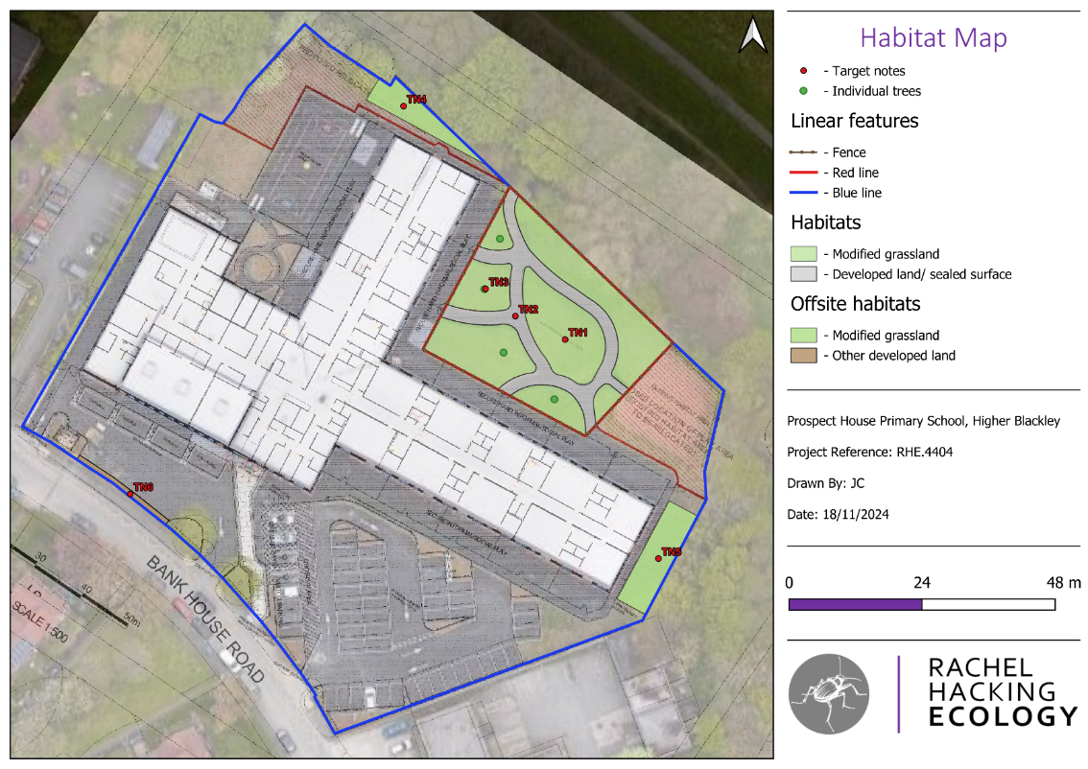

Appendix 3: Target Notes
Reference No. | Habitat | Photograph
TN1 | Modified Grassland | 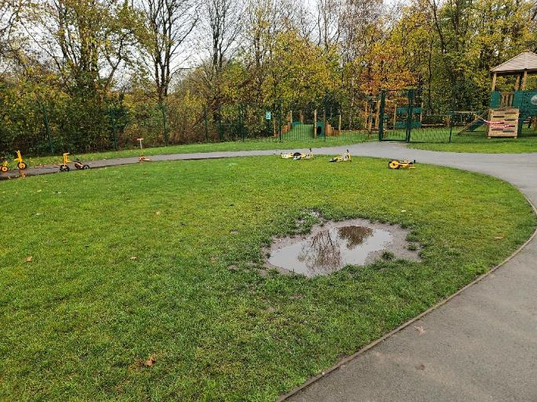
TN2 | Sealed Surface | 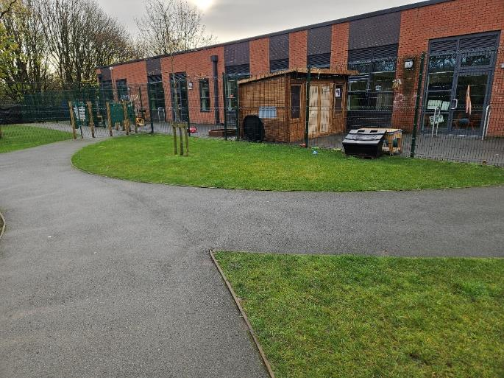

Appendix 4: Headline Results
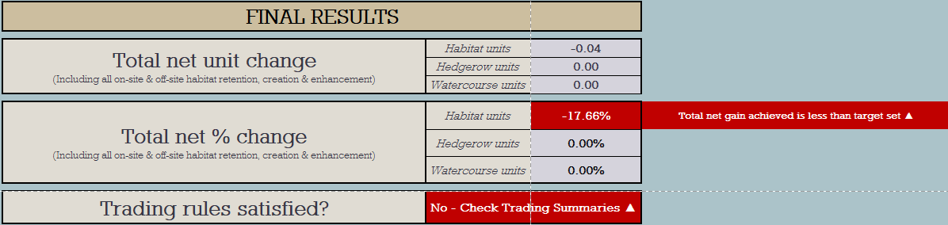

JNCC (2010). Handbook for Phase 1 Habitat Survey: A Technique for Environmental Audit. Joint Nature Conservation Committee, Peterborough
CIEEM (2017). Guidelines for Preliminary Ecological Appraisal. Chartered Institute of Ecology and Environmental Management, Winchester.
The_Statutory_Biodiversity_Metric_-_User_Guide_.pdf (publishing.service.gov.uk)
Butcher, B., Carey, P., et al. (2020). UK Habitat Classification – Habitat Definitions V1.1. at http://UKhab.org
RHE.4404 – Prospect House School – BNG Calculation - 2024
RHE.4404 – Prospect House School – Condition Assessments -2024

