Flat 514 Victoria Mill, 10 Lower Vickers Street, Miles Platting, Manchester

Proposed Replacement windows

Combined Design, Access and Heritage Statement

This Statement is prepared to support the Listed Building Consent for 8 proposed replacement windows

Purpose

The purpose of this document is to illustrate the design considerations and how the scheme proposals have responded to the Listed Building status of the existing building.

- Context & Assessment of Heritage Significance

The property to which the Planning Application relates is a 5th floor flat in the South West half of Victoria Mill, located off Lower Vickers Street, Miles Platting. The mill is a Grade II* listed building, and was converted into apartments around 1989. There are currently works ongoing to convert the North East part of the mill into apartments.

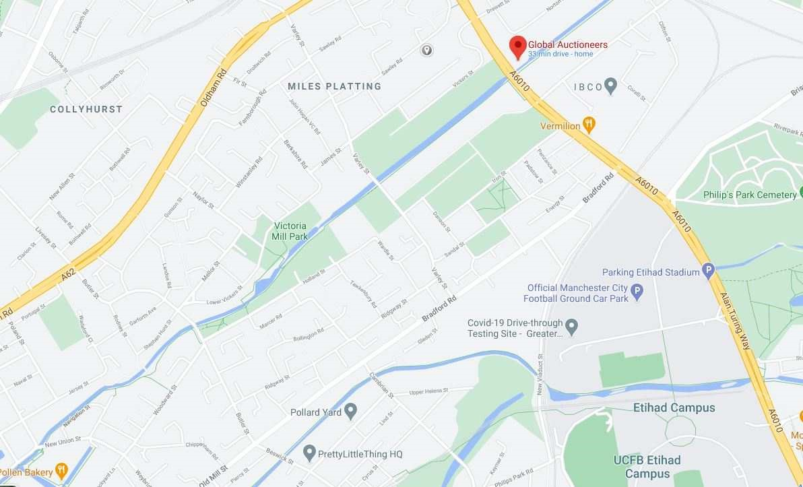

Fig i) Victoria Mill site plan

Victoria Mill

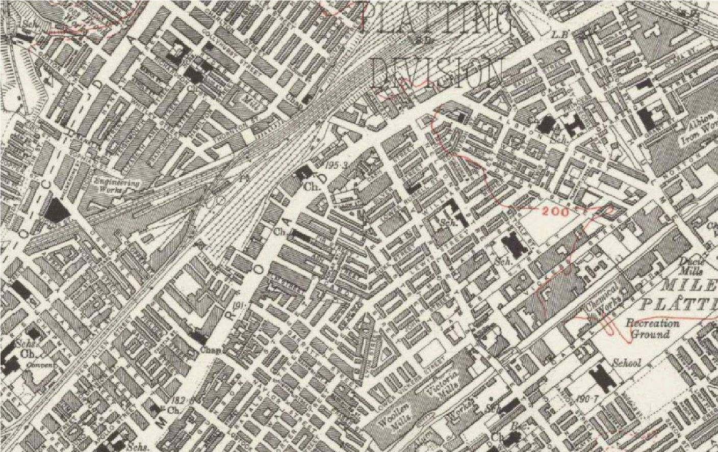

Fig ii) Victoria Mill historic map

Victoria Mill

- Historical background.

Victoria Mill was a cotton spinning mill built by William Holland between 1867 and 1873 to a design by the reputable mill architect George Woodhouse.

The double mill is 6 stories high constructed in red brick with some stone detailing in the “Italiante” style which was popular for large mills during the 19th century.

In the 1890’s and 1900’s there were various additions and alterations as a result of fire damage, then in 1960 the mill was closed and sat vacant until 1989 when the South West half of the building was converted into apartments, and the North East into offices.
At this time the original windows were replaced with painted softwood windows with uniform fenestration to all the dwellings copying the original 6 pane arrangement visible in the picture below.

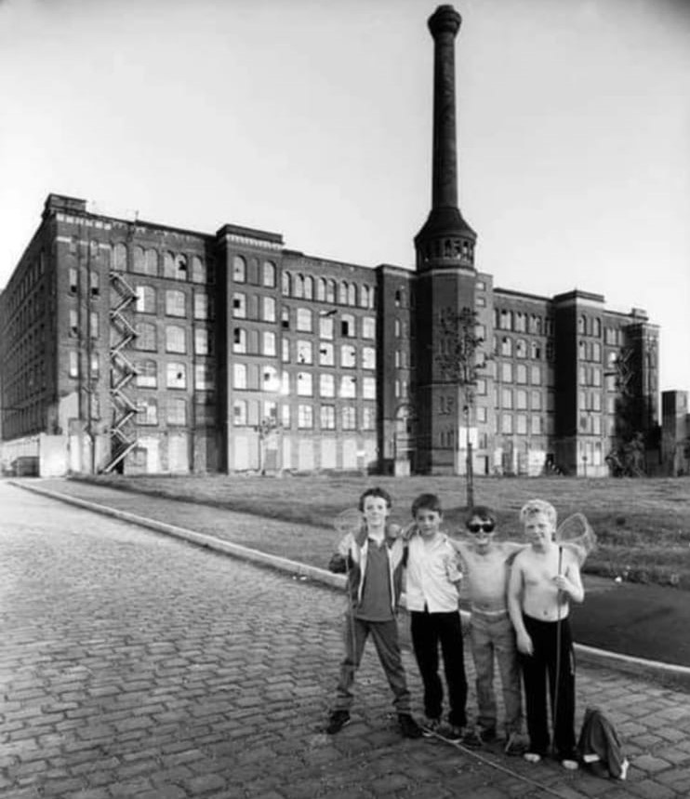 Fig iii) Victoria Mill - derelict in the 1980’s

3. Historical record of the mill
MANCHESTER
SJ8599 LOWER VICKERS STREET, Miles Platting
698-1/15/747 (South side) 29/11/88 Victoria Mill
GV II*
Cotton spinning mill, now disused; a double mill built in 2 phases in 1869 and 1873. George Woodhouse, architect, for William Holland. Red brick with yellow brick dressings; roof not visible but probably slate. Fire-proof internal structure. U-plan formed by 2 large rectangular spinning mills, joined by a central engine house. Symmetrically planned about a central stair turret wrapped around the chimney with engine house (rebuilt in 1902 on conversion to rope drive) and boiler house to the rear, in the centre of a narrow courtyard formed by the 2 mill ranges to either side of the stair tower, a 3-window range, that to left with former internal engine house marked by partially blocked round-arched window; the right hand range obscured by a brick shaft of 1920. This central block is flanked by the 2 spinning mills, each a 6-storey, 11x10 bay block, with stressed angle pilasters (extended as privy towers to N elevation). Italianate detail of spinning mills, which have segmentally headed windows to 5 storeys, and coupled round-headed windows to the upper storey, arcaded with shafts and continuous sill band. 2-window towers towards centre of each mill appear to be later additions. Interior not inspected, but constructional system almost certainly transverse brick arches carried on cast iron columns. Ancillary buildings survive to NW of site, but former blowing rooms and offices, which were built parallel to the front of the mill across a narrow yard, and a range of ancillary buildings to the SE are no longer extant.
A very large double mill for its date, which makes striking use of a distinctive industrial architectural vocabulary (especially in the economical design of combined stair tower and chimney). An excellent example of the development of a specifically industrial architecture, and of the work of George Woodhouse.

Listing NGR: SJ8590999261

- Proposed minor alteration to the Listed Building

The Planning application seeks approval to replace the existing windows with matching double glazed polyester powder coated aluminium windows. The colour is RAL 3005 which has been matched to the existing windows on site.

- Assessment of Impact

The current character of the converted mill will not be affected by the replacement of the 2 No windows as they are a direct copy of the existing windows both in terms of fenestration pattern, frame section sizes and colour.

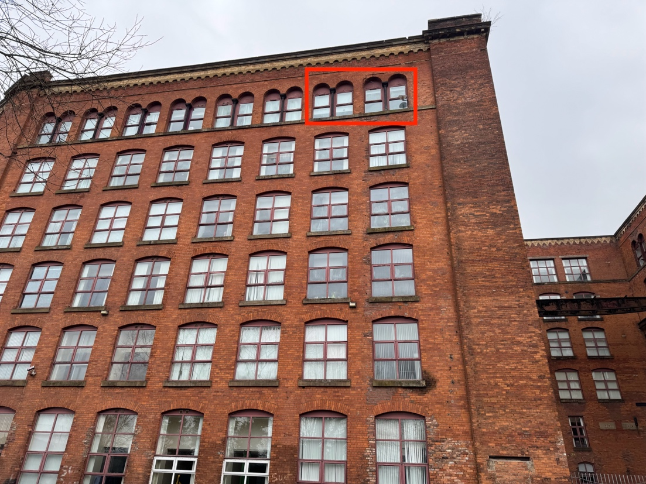
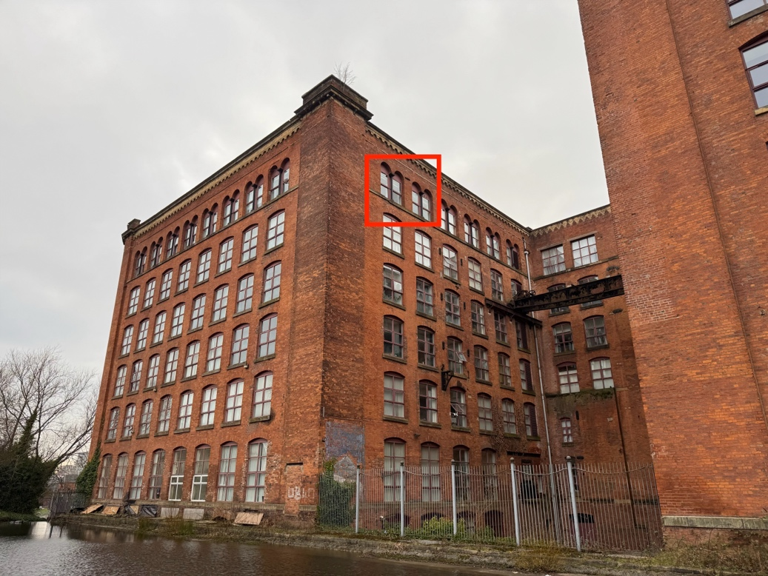Fig iv) Existing windows

- Proposed Alterations and Justification for the design

The replacement of the windows is urgently needed for the following reasons;

  - Due to the exposed location and lack of maintenance, the existing timber window frames have rotted.

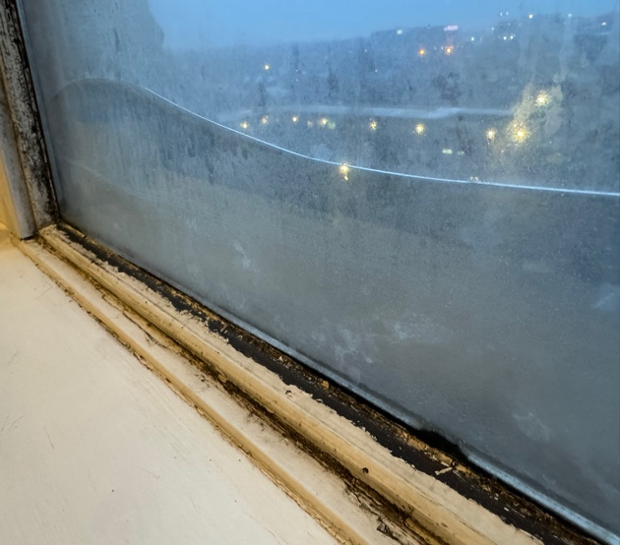
Cracked glass panes

Failed double glazing unit
Rotten timber throughout

  - The double glazing units have failed. The stunning view from the flat is permanently obscured by condensation between the panes of glass

  - As well as being unsightly, there is a massive heat loss from the dwelling due to the failed double glazing and the fact that some of the panes are still single glazed.

  - The glass in one of the rooms has cracked on the outside pane.
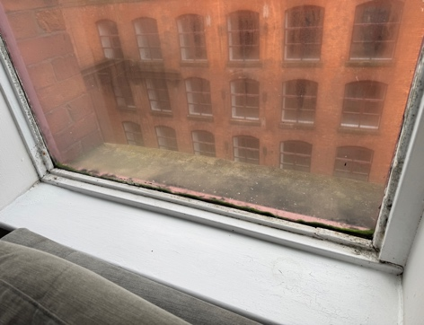

Single glazing = heat loss &
draughts

  - Due to the amount of condenstation in the flat from the windows, there has been serious issues with black mould in the flat.

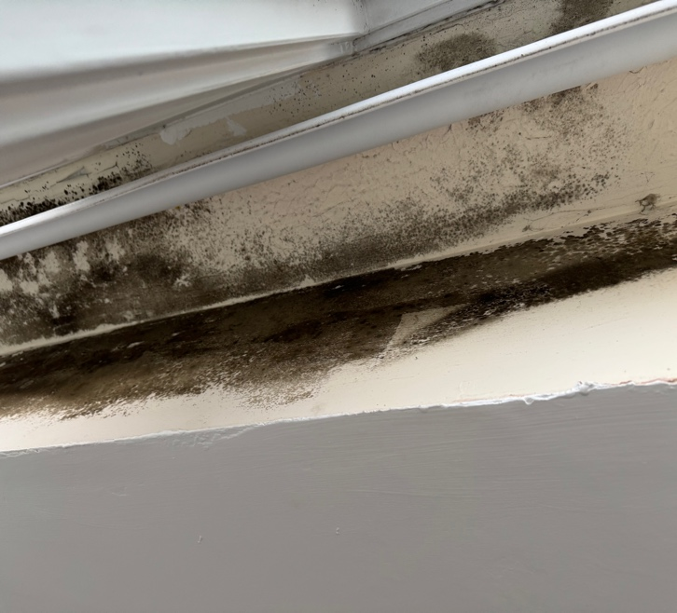

Mould on inside

  - The condition of the windows is so poor that the stability and safety of the frames may be in question.

The proposal is for the replacement windows to be in softwood timber to match the current style, with more efficient double glazing.

