Planning

Growth & Development

Delegated officer report for planning application

Application no. 141692/FH/2024
Date registered valid: 3 February 2025
Proposal: Erection of a single storey side extension

Address: 2 Newlands Drive, Manchester, M20 5NW
Ward(s): Didsbury East Ward
Applicant: David Kenny
Agent (if any): Philip Holmes, PHA Architects

Case officer: Joshua Lee
Tel: 0161 219 2851
Email: joshua.lee@manchester.gov.uk

Recommendation: Approve
Date of recommendation: 12 March 2025

Application details
Type of application: Full Householder Application
Development type: Householder
Date of site visit: 06 February 2025
Standard consultations: Printed: 5 February 2025 Expired: 26 February 2025
Neighbour notifications: Printed: 5 February 2025 Expired: 26 February 2025
Site notice: No site notice has been produced
Press advert: No press advert had been published
Departure from Development Plan: No
Environmental Statement: Not required
Listed building: Not applicable
Conservation area: Not applicable
Tree Preservation Order: Not applicable

Description of site/building
The proposal relates to a two storey semi-detached dwellinghouse on the corner of Newlands Drive and Kingsway. The property features an existing detached garage, off street parking and garden to front, side and rear.
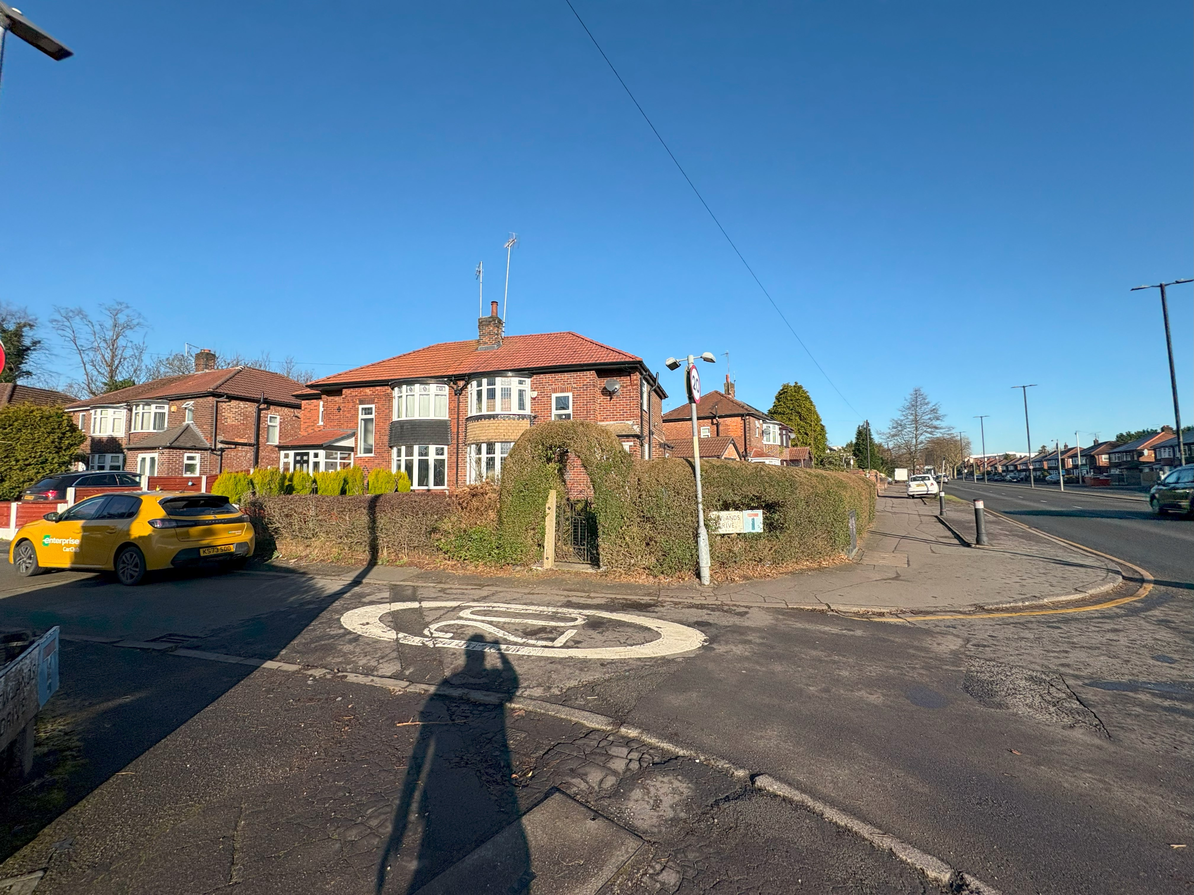
Figure 1. Street scene

Description of area
The proposal is in a mostly residential part of the Didsbury East ward of Manchester. The property sits within Flood Zone 2.
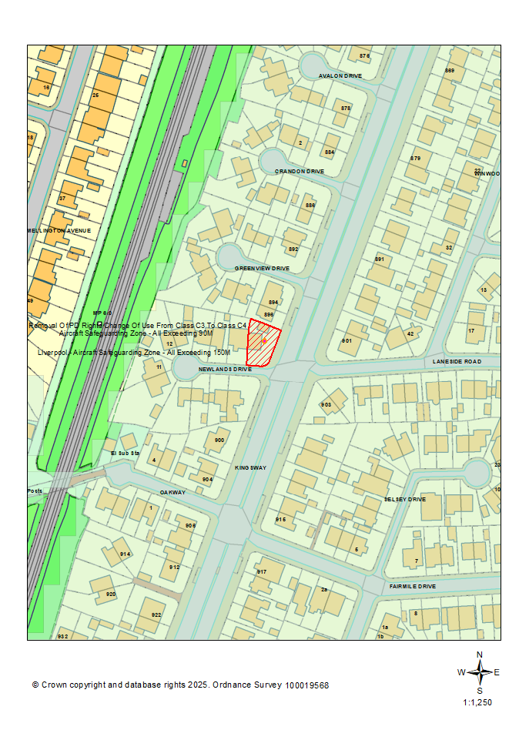
Figure 2. Location plan

Description of development
Erection of a single storey side extension
The proposed side extension projects 2150mm from the existing side extension and runs 8565mm to meet the existing detached garage to the rear. The proposed side extension is finished with matching brick, sloping tiled roof and 3no roof lights. The proposal also features new windows to the front and side elevations.
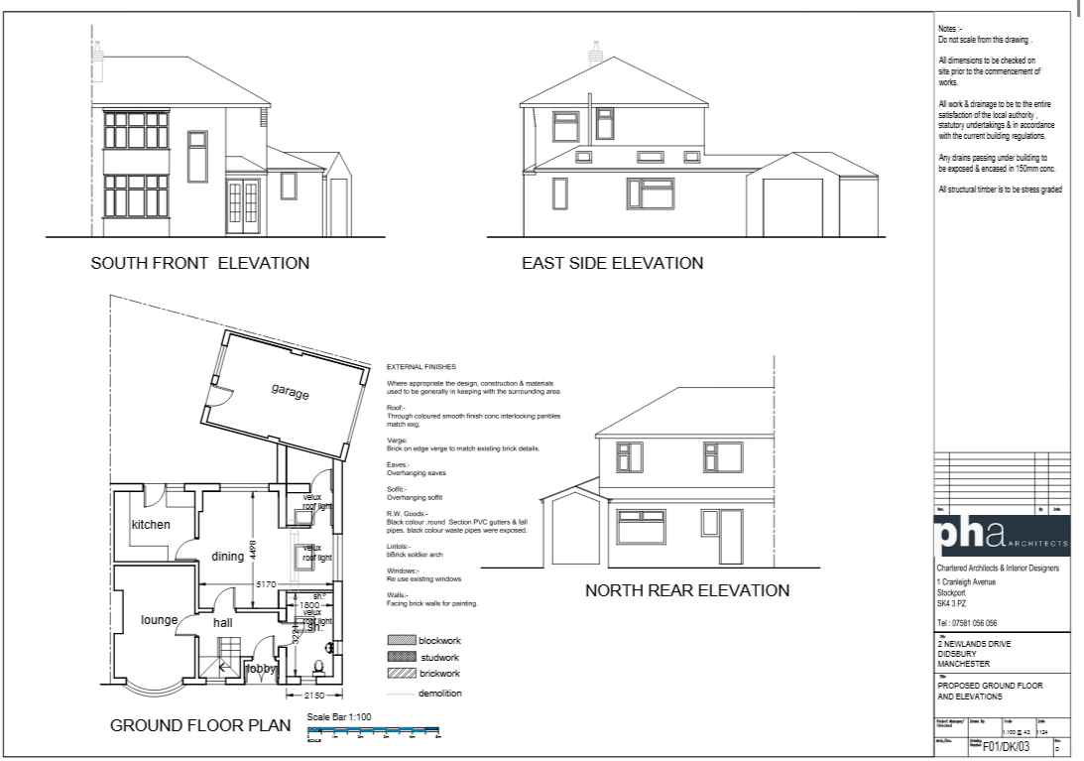
Figure 3. Proposed plans and elevations.

Planning History
There is no planning history at the address.

Consultation, notification & publicity responses

Consultations

Manchester City Council Flood Risk Management
Manchester City Council Flood Risk Management were consulted on this application at the proposal sits within Flood Zone 2 and after reviewing the submitted documents had no further comments.

Notifications

Local Residents
No representations received.

Relevant policies & the principle of development

Relevant Policies
Section 38 (6) of the Town and Country Planning Act 2004 states that applications for development should be determined in accordance with the adopted development plan unless material considerations indicate otherwise.
The following policies are considered relevant.
- The Manchester Core Strategy Development Plan Document 2012-2027
  - Development Management and Planning Obligations
    - DM 1 - Development Management
  - Objective 1 - Spatial Principles
    - SP 1 - Spatial Principles (Partially replaced by PfE Policy JP-S 1)
  - Objective 6 Environment
    - EN 1 - Design Principles and Strategic Character Areas
    - EN 14 – Flood Risk (partially replaced by PfE Policy JP-S 4)
    - EN 19 - Waste
- Extant Unitary Development Plan (UDP) –
  - Citywide Development Control Policies
    - DC1 - Residential extensions
    - DC26 - Development and Noise
  - Environmental Improvement and Protection
    - E3.3 – City major radial and orbital roads and rail routes.
- Places for Everyone Plan Joint Development Plan Document 2022-2039-
  - Strategy
    - JP-Strat9: Southern Areas
  - Sustainable and Resilient Places
    - JP-S1: Sustainable Development
    - JP-S4: Flood Risk and the Water Environment
  - Places for People
    - JP-P1 Sustainable Places
- The National Planning Policy Framework (The NPPF) –
  - Section 2 - Achieving sustainable development
  - Section 4 – Decision-making
  - Section 12 – Achieving well-designed places
  - Section 14 - Meeting the challenge of climate change, flooding and coastal change

Principle
The City Council recognises many people prefer to extend and develop their existing homes rather than move. The principle of a residential extension is accepted.

ISSUES

Appropriate siting, layout, scale, form, massing, materials, and detail
The new addition is designed to match the style and features of the current building by using, matching brick, tile and window fenestrations.
The proposal is designed to be subservient to the original dwelling house being entirely at ground level and to the side elevation.
The side extension faces into Kingsway so the massing impacts to local neighbours are minimal with the existing garage facing into 896 Kingsway.

Impact on the surrounding areas in terms of the design, scale, and appearance of the proposed development.
The proposal can be seen from the street however its size, massing and materials minimise any harm to the street scene.
The proposal is similar in size, scale, design and materiality to others nearby, notably large extension to the adjacent No.4. Therefore, it can fit on the property site and won't disrupt the area's existing features.

Effects on amenity, including privacy, light, noise, vibration, air quality, odours, litter, vermin, birds, road safety and traffic generation.

Privacy
The proposal includes adding glazing to the front, and side. It doesn't unduly affect privacy because there are other windows to these elevations and are all at ground level.

LIGHT
The proposal is entirely and ground floor and has minimal effect on local light especially given its location adjacent Kingsway.

NOISE
The proposed extension is not expected to generate any noise beyond what would be reasonably expected of a residential dwelling.

Accessibility
The proposal does not change how people can get in and out of the building.

Adequacy of internal accommodation and external amenity space.
The proposal adds space inside the property with minimal effect to the outdoor area retaining a good amount of external space post development.

Refuse storage and collection.
The applicant has confirmed that access to the rear will be maintained through the garage with the bins proposed to be moved through the garage on collection days.

Vehicular access and car parking
The proposal doesn't change how vehicles access and park at the property.

Green Infrastructure including open space, both public and private
The dwelling benefits from a garden beyond the siting of the proposed development. The proposal would minimally affect green infrastructure and would balance new development with existing green space.

Flood risk and drainage.
The site is in Flood Zone 2. The applicant provided a Minor Extension Flood Risk proforma and EA product 4 data for assessment. Flood Risk Management had no further comments.
The proposal has a negligible impact on drainage using the existing drainage on site.

Other Legislative Requirements

Equality Act 2010
Section 149 (Public Sector Equality Duty) of the Equality Act 2010 requires due regard to the need to: Eliminate unlawful discrimination, harassment and victimisation and other conduct prohibited by the Act and; Advance equality of opportunity between persons who share a protected characteristic and persons who do not share it. The Equality Duty does not impose a legal requirement to conduct an Equality Impact Assessment. Compliance with the Equality Duty involves consciously thinking about the aims of the Equality Duty as part of the process of decision-making.

Human Rights Act 1998 considerations
This application needs to be considered against the provisions of the Human Rights Act 1998. Under Article 6, the applicants (and those third parties, including local residents, who have made representations) have a right to a fair hearing and to this end the local planning authority must give full consideration to their comments.
Protocol 1 Article 1, and Article 8 where appropriate, confer(s) a right of respect for a person’s home, other land and business assets. In taking account of all material considerations, including Council policy as set out in the Core Strategy and saved polices of the Unitary Development Plan, the Director of Planning, Building Control & Licensing has concluded that some rights conferred by these articles on the applicant(s)/objector(s)/resident(s) and other occupiers and owners of nearby land that might be affected may be interfered with but that that interference is in accordance with the law and justified by being in the public interest and on the basis of the planning merits of the development proposal. She believes that any restriction on these rights posed by the recommendation given is proportionate to the wider benefits of and that such a decision falls within the margin of discretion afforded to the Council under the Town and Country Planning Acts.

Conclusion
The proposed single storey side extension at 2 Newlands Drive, Manchester, has been thoroughly assessed and found to be in compliance with relevant planning policies and guidelines. The extension is designed to match the existing property in terms of materials and style, ensuring minimal impact on the surrounding area and local amenities. No objections were received from local residents or consulted agencies, and the proposal does not pose significant risks in terms of flood management, privacy, light, noise, or accessibility. Therefore, the recommendation is to approve the application, subject to the specified conditions.

Recommendation: Approve

Article 35 Declaration
Officers have worked with the applicant in a positive and proactive manner based on seeking solutions to problems arising in relation to dealing with the planning application. The proposal is considered to be acceptable and therefore determined within a timely manner.

Condition(s) to be attached to decision for approval

3-year time limit
The development must be begun not later than the expiration of three years beginning with the date of this permission.
Reason - Required to be imposed pursuant to Section 91 of the Town and Country Planning Act 1990.

Specified plans
The development hereby approved shall be carried out in accordance with the following drawings and documents:
  - Application Form 06 Dec 2024 APPLICATION FORM
  - Drawing - Proposed 06 Dec 2024 F01/DK/04 PLANS AND ELEVATIONS
  - Drawing - Existing 06 Dec 2024 F01/DK/01 PLANS AND ELEVATIONS
  - Drawing - Location Plan 06 Dec 2024 F01/DK/02
  - Drawing - Proposed 06 Dec 2024 F01/DK/03 PLANS AND ELEVATIONS
  - Flood Risk Assessment or Drainage 03 Feb 2025 FLOOD RISK MINOR EXTENSION PROFORMA
  - Flood Risk Assessment or Drainage 07 Mar 2025 EA PRODUCT 4 DATA

Reason - To ensure that the development is carried out in accordance with the approved plans, pursuant to policies DM 1, SP 1 and EN 1 of the Core Strategy and JP-P1 & of Places for Everyone.

Specified materials
The materials to be used on the external surfaces hereby permitted shall match those as specified on the application form in type, size, colour, and texture.
Reason - To ensure the appearance of the building to be extended is not adversely affected by the materials to be used in the construction of the structure. Pursuant to policies DM 1, SP 1 and EN 1 of the Core Strategy and JP-S1 and JP-P1 of Places for Everyone.

Appendix 1 – List of consultees & neighbours notified
MCC Flood Risk Management
1 Newlands Drive, Manchester, M20 5NW
903 Kingsway, Manchester, M20 5NU
896 Kingsway, Manchester, M20 5NR
4 Newlands Drive, Manchester, M20 5NW
901 Kingsway, Manchester, M20 5PB
2 Laneside Road, Manchester, M20 5PD

Appendix 2 – Planning constraints
Article 4 Direction - Removal Of PD Rights Change Of Use From Class C3 To Class C4
Flood Zones Type 2 (low to medium risk) -
Susceptible to Surf Water Flood (Less) -
Area Team Boundary - Name: SOUTH AREA

