Site: | The Rylands Building 052
Document submitted by: | Deloitte
Document produced by: | Megan Dinsley, Sam Jacklin
Date/reference: | 11/11/24 /001
Organisation:
Calibre Metalwork / Cheshire Stained Glass
Supervisor: |  | Telephone/ email: | No. of Operatives:
Sam Jacklin |  | 0161 427 4603  s.jacklin@calibremetalwork.co.uk | xxxxx  Training Requirements/Standards: CSCS Card
Task, Process or Activity to be undertaken:
Justification:

Restoration of the 2no Sunburst Horizontal Laylights

Sequence and Method of Work:
Proposed Methodology for removing the 2no Circular horizontal ‘sunburst’ stained glass laylights under cupola roofs (approx. 8m diameter)

The two number laylights are of similar design. However, the ‘East Wing’ being made up from 9no metal crittall style sub frames fixed into the main metal framework and the ‘West Wing’ being made up from 10no. The decorative glass is then directly glazed into the crittall style frames - no lead has been used. The panes have been bedded and back pointed in putty.

The glass types used, based on the inspection from the crash deck carried out on our initial survey were variations on “cathedral” glass, therefore we have allowed for utilising antique cathedral glass from ‘Pearsons Glass’ only in the replacement panes.

We have envisaged that 75% of glass will need to be replaced. Taking into consideration those panes already broken, along with those that are likely to be damaged during careful de-glaze.
Our specialist heritage glazier, Cheshire Stained Glass, will make every effort to remove all of existing glass as the building is listed and the conservation of as much of the original fabric as possible is paramount and at the forefront of our minds. We have a wealth of experience in working on such structures and saving glass is difficult as the putties appeared to be very hard and are adhered strongly in places to both the glass and frames. It is very time-consuming and as such expensive.

METHODOLOGY GENERAL (See CSG Glazing Comments Below In Italics):

We plan to survey on site, off a suitably positioned full crash deck provided. We will label existing panes, carefully de-glaze the panes from crittall style frames on site. We will then remove the panes to floor level and pack safely and securely for transport.

Our team will tag and record the iron glazing bars by note and photograph and then remove the securing bolts from the iron frames and using correct manual handling techniques lift the iron frames down to the floor level and then to a suitable goods lift on site.

Each frame will then be carried to our waiting transport and secured with soft straps and remove from site to our works.

Once in our workshop we will sandblast clean to SA2.5 the iron frames and clean the glass, then undertake a condition survey, assess their current condition and quantify and price any unforeseen repairs. The report will be issued to yourselves for your approval.

Following the cleaning processes we will template the missing panes and source the nearest coloured glass available, cutting the shapes as required. Currently the glass is assumed to be a mixture of ‘hammered’ ‘muffled’ ‘corella’ and ‘cathedral’ types.

If required, the frames will be straightened and prepared for installation. Using our heritage-approved paint system, we will finish paint all ironwork in a single BS or RAL colour of your choice using our own high quality, factory applied, heritage approved paint system.

We will suitably pack and deliver the ironwork in manageable sections and lift to the area of works ( a reverse of the removals). We will then install the ironwork into prepared masonry provided by others using new fixings to closely replicate those originally used.

Following installation of the iron frames, we will then re-glaze the laylights to the original specification using a mixture of new and conserved glass.

CSG Comments:

The 2.5-3mm coloured glass is bedded into the metal frames using putty, there is no top point, they putty is largely cut back flush with the glass with some areas where this hasn't been done to the highest standard and the putty is bulging.

De-Glaze:
- Label individual panes of glass to agreed location references (permanent pen and adhesive glass label), including damaged panes as these can possibly be re-used in smaller apertures.
- Clear top side of rebate of any excess putty.
- Ease the glass out of the rebate, using a flat glazing knife, working along the rebate.
- If pane breaks, label all sizeable sections with relevant reference.
- Clear rebates of remaining putty.

How much damage occurs, will be affected by:

- How well the glass was cut initially - if it was poorly surveyed and poorly cut it may have been "nibbled in" by glass pliers and have rough edged that provide nick points for breaks to run from.
- How hard the glazing putty has set - metal casement putty should never truly harden, remaining slightly malleable and flexible. Putty that has set hard will put pressure on the glass and make breaks more likely.
- What movement has occurred in the metal frame over time (warping, twisting, bellying), this could be due to settling of the structure or lamination expansion caused by corrosion, but either may place the glazing under excessive stress, with any additional vibration through the glass causing runs / breakages.

Programme Time and Duration:
Anticipated that the works will be agreed with Calibre Metalwork and Domis to align with the building programme.

Supervisory Arrangements including Deputy:
Detail the operatives involved in the project and list their relevant competencies (e.g., CSCS, IPAF, PASMA, 18th Edition Electrician)

Craftsmen all possess current relevant qualifications, CSCS CCNSG SMSTS IPAL CPCS NPORS IPAF PASMA Manual Handling, Abrasive wheels, Basic Disclosure etc.

Monitoring Arrangements:
Quality monitoring to be conducted by Calibre throughout the procedure.
Plant and Equipment:
Mobile workshop (Van), hand tools

Lifting / Handling:

Movement of bags of debris.

Health Hazards / Controls / CoSHH :
CoSHH – N/A

Written risk assessments for associated tasks are enclosed. Working on a tube and fitting scaffold, abrasive wheels, use of power tools, use of hand tools, working on a scaffold, working in close proximity to rats.

PPE Requirements:

Access / Egress & Workplace:
Our workers and the equipment they are to use will gain access to the work area via the main site entrance located on High Street and then the access routes to the main external scaffold via the designated pedestrian walkways within the confines of the site.

First Aid:
Main Contractor to provide suitable access both internally & externally, welfare facilities and medical area.

Emergency Procedures:
Site Evacuation: As stated by the Principal Contractor in the site induction given at the start of the project and can be found in the Principal Contractors Construction Phase Health & Safety Plan.
Appendices:
Before and After Photographs
Before:

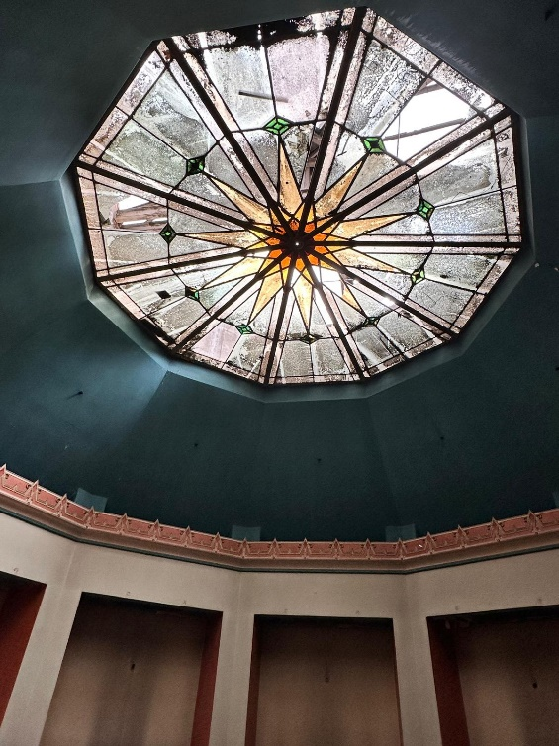

Amendments:

Any change in the operation or deviation from the above method and system of work found by personnel on site is to be discussed with Sam Jacklin prior to the change being made and at the earliest opportunity. Amendments are to be confirmed by them and distributed as below.
Record of Communication

By signing this register, you confirm that the contents of this Method Statement revision No: One has been made known to you, that you understand the contents and that you will report any deviation from the safe system of work in a timely manner.

Please ensure that if this document is amended or reviewed the document must be re-circulated to the people listed below.
Register:
Signed: |  | Name: |  | Date:

Method Statement Prepared by: Megan Dinsley / Sam Jacklin
Signed: | MDinsley | Name: | Megan Dinsley | Date: | 11/11/24
Evaluation outcome and sign-off SLHA:
The Method Statement has been accepted:
Signed: |  | Name: |  | Date:
Evaluation outcome and sign-off Deloitte:
The Method Statement has been accepted:
Signed: |  | Name: |  | Date:

