

STATEMENT OF PURPOSE

Registered Office
101 Wellington Road North, Stockport, SK4 2LP
England and Wales Company Registration No 10402138
Tel: 0161 376 3530
Web: www.icare-soultions.co.uk
Email: admin@icare-stockport.org

Manchester:
2 Queenhill Rd
Northenden,
Manchester M22 4HW

England and Wales Company Registration No 10402138
Tel: 0161 376 3530
Web : www.icare-soultions.co.uk Email : admin@icare-stockport.org

All staff at Queenhill Haven will be made fully aware of the contents of the Statement of Purpose, which must be readily accessible at all times. The Registered Manager is responsible for formally approving the Statement of Purpose and ensuring it is reviewed, updated, and modified as necessary, at least annually. Any significant changes or modifications to the Statement of Purpose must be notified to Ofsted prior to implementation.
In accordance with The Children’s Homes (England) Regulations 2015/2018, a written Statement of Purpose is required for our children’s home. A copy of this document must be provided to Ofsted and made available upon request for inspection by:
- Any person employed at the home
- Any child accommodated in the home
- The parent of any child accommodated in the home
- The placing authority of any child accommodated in the home
- Any placing authority considering placing a child in the home

- Quality and Purpose of Care

1.1 : A statement of the range of needs of the children for whom it is intended that the children’s home is to provide care and accommodation:

Queenhill Haven will offer a home from home environment with a holistic and therapeutic approach, providing a safe, secure, enjoyable, warm, and caring environment which will nature their education, development, and their well-being. It will provide care and accommodation for up to 2 young people of mixed gender, race and ethnicity between the ages 7–17 years who identify as being in need of residential care due their vulnerabilities and difficulties with behaviours.

The young people will have experienced a level of trauma and present with Emotional and Behavioral difficulties, which may include Mild to Moderate Autism, ADHD, ODD, conduct disorder, Attachment disorders, eating Disorders, Tourette’s, Selective Mutism, Anxiety disorders, sleep disorders, mood disorders, gender identity disorder, adjustment disorder. Coupled with Mild learning disabilities, for example Dyslexia, Dyspraxia, Dysgraphia. Dyscalculia, Auditory processing disorder and Visual processing issues.

Queenhill Haven will have robust compatibility assessments in place and a transitional/independence plan for young people aged 16-17 depending on the young person. Each young person will have their own risk assessments, Internal placement plan and behaviour management plan, which will be regularly reviewed as a team and with other professionals and any updates shared.

1.2 : Details of the home’s ethos, the outcomes that the home seeks to achieve and its approach to achieving them:

Home’s manager and the staff team at Queenhill Haven aim to Provide a warm, safe, stable & nurturing environment where each child is able to develop & have their individual needs addressed; cultural, emotional, spiritual, educational & social – In a positive & progressive manner.

Safety: We will educate our children the importance of safety and equip them with the skills on how to keep themselves safe. We will carry out comprehensive risk assessments and will keep them under review, we will ensure that everybody involved in the care of the individual child is aware of these assessments and understand their roles in keeping them safe. We will keep our policies under review and will update them with the changes to the legislation. We will use sensible approach to safeguarding and child protection by taking calculated risks.

Health: We will prioritise the health of children by registration them with the local medical professionals, ensuring their physical and mental health needs are met, we will educate our children about the importance of healthy living and equip them with the skills to look after their health and wellbeing.

Learning: We will prioritize education and training for our children, we will work with the professionals to ensure that our children receive the education they are entitled to. Where children do not have an education placement, we will support them through informal learning (Educational activities).

Independence: We will promote independence at every step, this could be as simple as making a cup of tea to booking and attending health appointments. We will ensure that every child receive appropriate independence training specified in their independence plan.

Family: We understand the importance of family in our children lives. Where appropriate we will encourage and facilitate family time weather it is to do with transporting our children to and from their family homes or keeping in contact with their families for important things.

Community: We will educate our young people the importance of belonging to the community. Where appropriate we will encourage them to take part in community events. We will regularly use the local services for leisure and community events.

Diversity: Our staff team reflect the culturally and ethnically diverse community and provide care and support to young people who may have experienced abuse, neglect and exclusion in the past or may still be deemed to be at risk. Additional services will be accessed to support a young person’s communication need-this may take the form of interpreters and extra training. Staff will provide support for the young people for any cultural or religious needs. Queenhill Haven will ensure that young people can engage in diverse activities & festivals to increase their awareness of equality and diversity issue.

1.3 : (a,b,c) A description of the accommodation offered by the home including –
- There are 2 separate bedrooms for children
- One bedroom has been converted into staff office; this room will also be used for one staff member to sleep at night, there is a shower room/toilet attached to this room for staff and visitors use
- One bedroom will be used solely for staff sleep in
- Both front and rear doors have an alarm that will be activated during staff sleeping hours to alert staff of any entry or exit from the home
- Evacuation route lights are in the ceiling so that in the event of a fire young people, staff and visitors can be guided to the nearest exit
- Bedroom doors have alarms as an option should this be required to help safeguard children
- All doors are fire rated to meet the current legislation
- Staff office has a secure medication cabinet to safely store medication for young people
- Communal areas consist of kitchen/diner, lounge, conservatory and games room.
- 2 x Bathrooms with W.C on the first floor 1 x bathrooms on second floor
- 1 x bathrooms downstairs
- Garden to the front and back
- Ample parking facility in the yard of the property

Each child bedroom comprises of:
- Bed and appropriate furniture with lockable storage
- Decorated room with bed linen and blinds
- Each bedroom is lockable from the outside with a key and with a thumb lock from the inside
- Each young people will be provided with their own key where appropriate. However, staff will have keys for each room and will be able to access the room in emergencies.

  - : A description of the location of the home:

2 Queenhill Road in Northenden is a fantastic place for families with children, offering plenty of nearby schools, parks, and friendly spots to enjoy together. Parents will love the selection of schools close by, where children can learn and grow in safe, welcoming environments. Northenden Community School and St. Wilfrid's Primary School are both nearby and have great reputations for helping kids thrive. Older children can attend Manchester Health Academy, which has all sorts of interesting classes and activities to keep them engaged.
When it comes to family health, having Wythenshawe Hospital nearby is a big plus. For check-ups and minor health needs, Northenden Group Practice is close and ready to help, giving parents peace of mind knowing quality care is just around the corner.
For a bit of fun or grabbing something to eat, Northenden’s Palatine Road has lots of options. Here, families can explore local shops, stop for a treat at cozy cafes, or enjoy meals together at nearby restaurants. Northenden Retail Park is also nearby, so getting all your essentials is easy and quick.
The neighborhood is packed with wonderful outdoor spots perfect for kids to play and explore. Wythenshawe Park is nearby, with big green spaces, gardens, and even some sports areas, where kids can run around, have picnics, and enjoy a sunny day. Northenden Riverside Park along the River Mersey offers peaceful walking paths and beautiful scenery, ideal for family strolls, bike rides, or a quiet afternoon by the river.
Living at 2 Queenhill Road brings families into a warm and friendly community with everything needed to enjoy a happy, healthy life—great schools, parks for outdoor fun, convenient shops, and welcoming neighbors. It's a place where kids can grow, play, and feel right at home

We have a location risk assessment which explores this further.

  - : The arrangements for supporting the cultural, linguistic, and religious needs of children:

Queenhill Haven staff will support young people to attend religious services in response to their needs and wishes, given their age and understanding.

Care Plans will always clearly state what, if any religion, the young person has an association with. Any specific religious or cultural issues will always be incorporated into their written care plan and consideration will be given to such issues, including any specific dietary, dress requirements or worship facilities.

Arrangements will be made for young people to meet their linguistic needs (interpreters etc). Staff have access to the internet that can be used to translate documents.

  - : Details of who to contact if a person has a complaint about the home and how that person can access the home’s complaint policy:

Young persons will be informed of the home’s complaints procedure during their admission process, ensuring they understand how to raise any concerns.
Professionals working with young persons, their parents, or any other individuals can make a complaint directly to the home's manager using the contact details provided below. A copy of the complaints policy can be requested from any staff member or directly from the home’s manager.
External individuals, such as neighbours, may lodge complaints through the following methods:
- Visiting the home and speaking to staff directly
- Calling the home's contact number
- Emailing complaints@icare-stockport.org
To ensure transparency and accessibility, staff will distribute a leaflet to residential properties in the vicinity of the children’s home, outlining the complaints process. This process is detailed in the complaint’s policy/procedure, which includes a template leaflet for distribution.

Victoria Gallagher – 0161 376 3530
Victoria.gallagher@icare-stockport.org

If a person is not happy with the outcome or if the complaint is about the home’s manager, then they can make their complaint directly to the responsible individual on the details below:
Bahisa Khojani – 0161 376 3530 bee@icare-stockport.org
Any person wanting to make their complaint to an external party can report their concerns directly to:
Ofsted or children commissioner see details below.
OFSTED
03001231231
Piccadilly Gate, Store Street Manchester M1 2WD
Dame Rachel de Souza, Children’s Commissioner for England on Free Phone: 0800 528 0731 http://www.childrenscommissioner.gov.uk/
or by post at: -
The Office of the Children's Commissioner
Sanctuary Buildings, 20 Great Smith Street, London. SW1P 3BT info.request@childrenscommissioner.gov.uk

Young people also have access to other services such as child line on 0800 1111.

1.7 : Details of how a person, body or organization involved in the care or protection of a child can access the home’s child protection policies or the behaviour management policies:

All the company policy’s including the Safeguarding and child protection policy and Behaviour support policy are available upon request from either the registered manager or the responsible individual. All staff have access to these on the staff computer where these are placed on the desktop PC.

2: Views, wishes and feelings

2.1 : A description of the home’s policy and approach to consulting children about the quality of their care:
Within Queenhill Haven there are many ways the staff team may consult with our young people placed at the home with regards to their day-to-day routine. Examples include:
- House meeting
- Key working sessions
- LAC Review Reports / consultation papers
- Multi-agency working i.e. Community Support Officers
- Clothing / toiletry purchasing
- Menu planning
- Obtaining wish lists for special events
- Working with families
- Day-to-day conversations with the young people
- Visits by independent person
- Consequence book / Rewards

Staff will aim to complete House meeting fortnightly in order to get young people input on quality of care, home décor, food menu and activities. They will also be given a chance to give indirect feedback to the home’s manager through these meetings.
These meetings will be normally held on the same day of the week to encourage all young people to attend. The registered Manager /Deputy will leave their feedback and action any tasks/requests made. During the next meeting, the young people are given feedback to the previous issues raised, ensuring that issues are addressed and dealt with accordingly.

Where the admission is planned young people will be allocated with a key worker before their admission to the home who can discuss the likes and dislikes with the young person. Key working sessions are held regularly, and these are opportunities for the young people to discuss their wishes and feelings.
Through building successful strong and stable relationships with young people, the team will be consulting with young people on a day-to-day basis through working practices. All young people will be reminded that they are listened to and that their views, issues or concerns are listened to, and action is taken.

2.2 : A description of the home’s policy and approach in relation to:
a) anti-discriminatory practice in respect of children and their families / b) Children’s Rights:
Everyone at Queenhill Haven will be treated fairly and with respect, no matter what their gender, race, religious views, sexuality, age, disability, or nationality as required by the Equalities Act 2010. This is applied to staff and young people. Should any issues arise, they will be dealt with appropriately and immediately. Work with young people will be completed in relation to what constitutes an ant discriminatory issue and the consequences of such behaviours, should they display this.
We promote this through practice be ensuring we have the following in place:
- Safer recruitment
- Equal Opportunities
- Safe living environments
- Complying with Children’s Home Regulations 2015
- Complying with the Children’s Homes Quality Standards
- Providing Children with information about their rights and advancing Children’s Rights
- Providing children with access to external bodies i.e. Child-line, Ofsted, independent advocate etc.
- Responding positively and thoroughly to any complaints and representations they may make ensuring no one suffers reprisals.
- Responding positively to any staff concerns about any practice concerning the service to young people we accommodate
- Enforcing our Disciplinary Procedure
- Advising the child’s placing authority of any matters that affect the child’s welfare, including staff concerns, child complaints and individual staff disciplinary matters
- Working to improve outcomes for young people
- Actively listening to children gaining their wishes and feelings
- Therapy and therapeutic interventions, in a child centred approach
- Providing positive care, accommodation, food, education, leisure opportunities etc.
- Staff at Queenhill Haven are required to promote good practice with regard to Children’s Rights.
- Progressive and appropriate staff training, supervisions and appraisal
- The care team have access to the Equality policy.

3: Education

3.1 : Details of provision to support children with special educational needs:
Staff at Queenhill Haven will collaborate closely with schools and professionals to address the educational needs of the young persons living in the home. Where a young person has an Education, Health, and Care Plan (EHCP), a copy of the plan will be obtained from the responsible authority. The home’s internal plans will be updated to reflect all actions outlined in the EHCP, ensuring alignment and consistency. Staff will also ensure that the EHCP remains relevant and up to date by requesting regular reviews from the responsible authority.
Additionally, Queenhill Haven is an ASDAN member, providing young persons aged 11 to 17 access to ASDAN’s short courses. These courses offer opportunities to build practical skills and enhance independence, supporting their personal development and preparation for adulthood

3.2 : If the home is registered as a school, details of the curriculum provided by the home and the management and structure of the arrangements for education:
The home is not registered as a school provision, however, will be support and facilitate on home education if required.

3.3 : If the home is not registered as a school, the arrangements for children to attend local schools and the provision made by the home to promote children’s educational achievements:
Queenhill Haven has sourced educational materials, including a variety of reading books and a dedicated workstation equipped with a computer to support young persons with their homework. The care team is committed to ensuring young person’s attend their educational placements, providing bus fare or accompanying them on public transport when necessary.
Queenhill Haven will work collaboratively with local authorities, schools and colleges, designated teachers, placing authorities, key partners, parents, and the young person’s themselves in developing and maintaining active Personal Education Plans (PEPs) and Education, Health, and Care Plans (EHCPs). Where professionals fail to respond adequately to the educational needs of the young persons in our care, Queenhill Haven will challenge them appropriately to ensure every child receives the education and training facilities they are entitled to.
As an ASDAN member, Queenhill Haven offers young persons aged 11 to 25 access to ASDAN's recognised courses and programmes. ASDAN, a registered charity and awarding organisation, provides accredited curriculum programmes and regulated qualifications designed to engage, elevate, and empower young persons with diverse needs. These include individuals living in poverty, those with emotional and social challenges, special educational needs or disabilities, or those at risk of becoming NEET (Not in Education, Employment, or Training). ASDAN’s programmes aim to motivate young persons to achieve meaningful learning outcomes, prepare them for further education, training, or employment, and empower them to take control of their lives.
ASDAN offers a variety of programmes, including:
- Short Courses (various titles)
- Accelerating Progress
- Lifeskills Challenge
- Lift Off
- Key Steps
- Employability Skills Development
- Focus
- Raising Aspirations
In addition, iCare Stockport is an approved centre for NCFE, enabling the care team to undertake NCFE CACHE Level 3, 4, and 5 Diplomas in Residential Childcare (England). This accreditation also allows young persons aged 16 and above to apply for apprenticeships and pursue a range of NVQ qualifications, enhancing their educational and vocational opportunities.

4: Enjoyment and achievement

4:1: The arrangements for enabling children to take part in and benefit from a variety of activities that meet their needs and develop and reflect their creative, intellectual, physical and social interests and skills.
Queenhill Haven is equipped with books, board games, computers, and televisions.
This list is not intended to be prescriptive or finite.
- Voluntary/Community action groups
- Weekend, holiday & evening outdoor education
- Health & fitness access
- Personal leisure pursuits
- Participation in local sports clubs
- Festival support & participation
- Youth clubs
•
Each young person has the opportunity to select an activity they want to concentrate more upon, which helps us to understand the individual interest of the young person. Staff support the young person with researching such activities and making necessary contact to commence the activity.
All young people are encouraged to engage in activities that promote happiness, comfort, security, effective citizenship, and their general well-being, including fitness, sports clubs and teams, outdoor pursuits, personal health, community links, cultural connections, education and learning, work experience, training, the arts, leisure, spiritual worship & holidays.

Activities:

We provide a range of experiences, opportunities, and activities to meet individual physical, emotional, social, behavioural and educational needs of our young people in placement. Birthdays, cultural and religious festivals are also celebrated where appropriate. All our young people are encouraged to plan their own weekly activity program with support and guidance from staff. Where required support staff will research activities requested by the young people and organize such activities if deemed appropriate and subject to risk assessment.
Trips out to events for enjoyment or interest are also promoted and encouraged and are organized by staff and young people when necessary.
All activities are planned by the young people and staff encourage any hobbies or to attempt new activities.

5: Health

5.1: Details of any healthcare or therapy provided, including –

- Details of the qualifications and professional supervision of those involved in providing any healthcare or therapy.

- information about how the effectiveness of any healthcare or therapy provided is measured, the evidence demonstrating its effective and details of how the information or evidence can be accessed:
Health and well-being are fundamental to the care provided to young persons at Queenhill Haven, encompassing both physical and mental health. The home will actively promote a healthy lifestyle through planned nutritious meals, regular exercise, and opportunities for relaxation.
The care team at Queenhill Haven is trained and competent in BEACON, a therapeutic model that offers an alternative to PACE. This training equips staff with the skills to support young persons using a holistic, reflective approach. The BEACON framework includes the following modules:
Beginnings
- Self-reflection on personal beginnings, including family, environment, education, and peers
- Understanding child psychology, brain development, attachment formation, and the impacts of privation, deprivation, bereavement, grief, and divorce
- Exploring the developmental impacts of these factors
Experiences
- Understanding the child’s experiences, including family, home environment, peer pressure, and witnessed or learned behaviours
- Reflecting on outward and inward behaviours and their impact on self-esteem, self-worth, choices, and consequences
- Self-reflection on personal experiences and behaviours
Acknowledge & Accept
- Supporting young persons in acknowledging and accepting their experiences
- Exploring Maslow’s hierarchy of needs and ACEs triangle
- Providing a safe and secure environment while helping young persons express their emotions
- Recognising how personal beliefs, experiences, and behaviours influence caregiving
Communication
- Enhancing communication through various approaches and reflective practices
- Addressing language barriers and promoting positive language
- Differentiating empathy, compassion, and understanding, and learning when and how to use them
- Understanding the negative impacts of poor communication and fostering approachable, positive behaviours

Openness
- Embracing open discussion, challenge, and change
- Promoting positive behaviours, setting boundaries, and demonstrating expectations
- Encouraging self-awareness and understanding the impact of behaviours on oneself and others
Nurturing
- Fostering growth, development, and learning
- Understanding the difference between chronological age, experiential age, and cognitive ability
- Developing care and learning plans, setting achievable goals, and celebrating milestones
- Coaching, problem-solving, and decision-making
Each young person will receive tailored guidance, advice, and support on health and personal care, with services provided through local community resources to meet all identified health needs. Each young person will have a written health plan addressing their medical needs, which will be regularly updated (at least monthly) and will include records of all appointments, illnesses, ailments, accidents, or injuries.
Queenhill Haven ensures that all medicines brought into the home are properly recorded and managed in line with the home’s medication policy and procedures. The care team will register young persons with local health services, including a dentist, optician, and GP, within two weeks of admission. For those wishing to remain with existing health providers, decisions will be made collaboratively with the young person’s social worker, considering factors such as distance and appropriateness.
Young persons with particular health needs or disabilities will be provided with the necessary support and assistance. The care team will also facilitate transportation to health appointments as required, ensuring continuity and accessibility of care.

- Positive Relationships

6.1) The arrangements for promoting contact between children and their families and friends:
Queenhill Haven fully understand the importance of family for young people in our care and we will support this where appropriate. Contact arrangements will be discussed prior to admission so that all parties (including family) are aware of arrangements. At all times possible, family time will be a ‘good’ experience for both young person and the family member/friend to form positive relationships. In the cases where the family time needs to be supervised then arrangements of how this will be best met will be detailed fully in the young person’s care plan.
Where obvious issues arise in relation to the family contact the relevant people will be notified and action will be taken to reduce further disruption.
All young people have access to emailing and private telephone contact via a computer and telephone where appropriate.
Enhanced Allowance monies are made available to enable purchase of birthday and Christmas presents for immediate family.
- Protection of Children

  - A description of the home’s approach to the monitoring and surveillance of children:
The home will be supervised 24 hours a day to ensure the safety and well-being of the young persons in our care. All bedroom doors are equipped with alarms; however, their activation will be determined through individual risk assessments and used solely for safeguarding purposes. The use of this surveillance will be regularly reviewed by the home’s manager to ensure it remains appropriate and proportionate.
The front and back exit doors are also fitted with alarms to alert the care team if anyone leaves the building, supporting effective monitoring and safeguarding practices.
CCTV is in operation externally for the safety of the home, the care team, and the young persons. There is no CCTV within the interior of the home, ensuring the privacy and dignity of the young persons in our care.

  - Details of the home’s approach to behavioural support, including information about –

a) the homes to approach to restraint in relation to children:
. At Queenhill Haven, young persons have the right to be treated with dignity and respect at all times, including when they require support in regulating their emotions or are given a consequence for behaviours they have chosen to engage in, which may have resulted in negative outcomes. This approach ensures that the rights and safety of everyone within Queenhill Haven are upheld at all times.
Each young person will have a comprehensive behaviour support plan, which will be regularly reviewed and updated. These plans outline strategies for managing risky behaviours appropriately, with the aim of reducing their occurrence. The plans will detail triggers, de-escalation strategies, and the steps to take if behaviours escalate. The content of behaviour support plans will also be discussed during team meetings as part of reviewing the progress of the young persons.
Consequences for behaviours will be discussed with the young person, who will be encouraged to share their views on the outcome. This ensures that the process is transparent, reflective, and supportive.
At Queenhill Haven, we strongly believe in the power of praise and positive reinforcement. Recognising and rewarding positive behaviours helps to build self-esteem and fosters a sense of achievement. This proactive approach is designed to encourage positive behaviour while reducing the frequency and intensity of challenging behaviours.

7.2 b) How persons working in the home are trained in restraint and how their competence is assessed:

All staff at Queenhill Haven undergo training in the management of aggressive and threatening behaviour, with a focus on de-escalation techniques and safe methods of physical intervention when necessary. The organisation utilises the ARC (Assess, Respond, Care) Model, which is CPD-accredited, to equip staff with the skills needed to manage potentially violent or risky situations effectively.
Staff are trained to employ a range of interventions to diffuse situations before they escalate. These strategies include diversion, calming techniques, negotiation, problem-solving, consideration of alternatives and their consequences, and maintaining non-threatening body language.
ARC training emphasises Positive Behaviour Support (PBS) principles, prioritising proactive strategies and adopting a ‘least restrictive and last resort’ approach. The model integrates BILD’s Positive Behaviour Support Principles (PBSP) and Core Competency Framework, as well as the Restraint Reduction Network (RRN) Training Standards 2020.
The ARC model promotes PBS principles and is designed for use with both adults and children. It encompasses a comprehensive framework aligned with the Public Health Model, focusing on Primary, Secondary, and Tertiary Interventions. The training includes RRN-approved de-escalation strategies, personal protection techniques, and safe holding methods. This ensures that the approach is consistent with supporting children across Health, Social Care, and Education sectors with dignity, respect and compassion.

8) Leadership and Management
8.1: The name and work address of:
a) The registered Provider
ICare Solutions Stockport LTD: 101 Wellington Road North, Heaton Norris,
Stockport, SK4 2LP.

    - Responsible Person: Bahisa Khojani – Contact Number: 0161 376 3530,
Email: bee@icarestockport.org

    - Home Manager: Victoria Gallager – Contact Number: 0161 376 3530
Email: Victoria.gallagher@icarestockport.org

    - Regulation 44 Independent Visitor:
Grahams consultants: https://www.grahamsconsultants.co.uk/
Joanne Booth joanne@grahamsconsultants.co.uk
Office 01524 548461 regulation44reports@grahamsconsultants.co.uk

Through its robust recruitment and selection policy, Queenhill Haven is committed to employing individuals who possess the requisite skills, education, training, prior work experience, and attitude to complement and enhance the quality of care provided.

All staff are required to complete an induction training programme upon joining, with additional ongoing training, appraisals, supervision, and support provided to ensure continued professional development and high standards of care.

As part of the recruitment process, all job applicants are required to obtain an enhanced disclosure from the Disclosure and Barring Service (DBS). This ensures the home can verify that applicants are suitable and appropriate to work with children and young persons, maintaining the safety and well-being of those in our care.

  - : Details of the experience and qualifications of staff, including any staff commissioned to provide education or Healthcare:
See Annex A Staffing

  - : Details of the management and staffing structure of the home, including arrangements for the professional supervision of staff that provide education or healthcare:
The Registered Manager will report directly to the Responsible Individual of the home. Currently, the team consists of one Senior Practitioners and 8 Residential Childcare Practitioners, who work alongside the Senior Practitioner and Registered Manager to deliver round-the-clock care.

Staffing levels will be tailored to the needs of the young persons in our care. Typically, two staff members will be assigned to each shift, with the provision for a third staff member to be added if risk assessments indicate this is necessary to ensure safety and support. This flexible approach ensures that the care provided is responsive to individual needs and risk factors
Staffing supervision structure

Responsible individual Registered Manager 1X Deputy Manager

2X Senior practitioners

6X Care Practitioners

The staffing deployment allows for handover meetings, team meetings and training. All members of staff at Queenhill Haven receive an induction and training guide, in line with Regulation 33 of children homes regulation. External agencies will also Provide additional training in specialist areas and a full training matrix is updated regularly with staff qualifications.

At Queenhill Haven, we have a supervision policy, and all employees receive regular supervision. Staff requiring additional support may be supervised more frequently.

Staff are to hold the Level 3 Diploma Health & Social Care / NVQ Level 3 Children and Young People. New Staff who have not worked within the industry before, are required to attain the Level 3 Diploma within 2 years of commencement of employment with Queenhill Haven.

Induction and Training

All core staff are expected to complete mandatory training within 2 weeks of their start date if not before.
Our mandatory training is as follows:

The Stockport learning pool mandatory training:
- Safeguarding Children - level 3 training
- Child Abuse
- Self-Harm
- Modern Slavery and Human Trafficking
- Fire Safety
- Equality
- Restorative Practice eLearning
- Emergency Planning
- Food Safety, Fluids & Nutrition and Infection Prevention & Control for Opportunities Together service
2023
- Manual Handling 2024
- Basic Life Support 2024
- Control of Substances Hazardous to Health (COSHH) 2024
- Introduction to Health and Safety

ELFH mandatory courses: -
- Female Genital Mutilation (FGM)
- Child Sexual Exploitation (CSE)

Face to Face:
- BEACON (alternative to PACE) Social care and parenting training model
- Anti-ligature training
- First aid
- Medication training
- ARC model (Assess, Respond, Care) ARC training places a strong emphasis on Positive Behaviour Support and the principles of ‘proactive support’ ‘least restrictive and last resort’ strategies
- Room searches
- County Lines and CCE
- Level 2 Therapeutic Skills for Trauma Informed Practice in Health and Social Care
- Level 3 How to Build a Therapeutic Environment

8.4 : If the staff are all of one sex, or mainly of one sex, a description of how the home promotes appropriate role models of both sexes:
Queenhill Haven is actively recruiting a diverse care team and aims to achieve a balanced male-to-female staffing ratio. This approach ensures that young persons in our care are provided with appropriate role models of both sexes, promoting healthy relationships and diverse perspectives

8.5: Whistleblowing
Queenhill Haven upholds a culture of openness, operating within its moral and statutory responsibilities to foster transparency and accountability. Whistleblowing is recognised as a vital part of this culture, playing a critical role in identifying and addressing illegal or unethical activities, preventing harm, and ensuring justice.
Whistleblowing involves reporting information or activities that are:

- A criminal offence, such as fraud
- Risks to health and safety
- Risks of or actual damage to the environment
- A miscarriage of justice
- Non-compliance with legal obligations (e.g., lack of required insurance)
- Suspicions of wrongdoing being concealed, including safeguarding concerns

Note: Personal grievances, such as bullying, harassment, or discrimination, are not classified as whistleblowing unless they are in the public interest. Such matters should be addressed through the employer’s grievance policy.
Staff should initially raise whistleblowing concerns with their line manager or director, where appropriate.

Alternatively, concerns can be escalated to the Responsible Individual by staff or other professionals.
If the concern is not satisfactorily addressed, staff can escalate the matter to Ofsted through the following methods:

Telephone: 0300 123 3155 (Monday to Friday, 8:00am to 6:00pm)
Email: whistleblowing@ofsted.gov.uk
Post: WBHL, Ofsted, Piccadilly Gate, Store Street, Manchester, M1 2WD

This process ensures that all concerns are managed responsibly and transparently, safeguarding the well-being of the young persons in our care.

9:1: Any criteria used for the admission of children to the home including any policies and procedures for emergency admission:
Queenhill Haven will consider children presenting all risks

This may include:
Missing from Care
Exhibit verbal/physical aggression
    - Vulnerable to harm
    - Are victims of abuse
    - Self-harm
    - Are in a cycle of criminal offending
    - Have poor life skills and are approaching independence
    - Mld learning needs such as but not limited ASD, ADHD, neurodiverse

Queenhill Haven will provide care and accommodation for up to 2 young people of mixed gender, race and ethnicity between the ages 7–17 years who identify as being in need of residential care due their vulnerabilities and difficulties with behaviours and will be matched accordingly. Although, emergency admission is not ideal and one that we would like to avoid it is noted that in certain times this may occur

9.1(A): Planned Admission Procedure:

- Homes Manager and Responsible individual will have access to the referral portal
- Homes Manager will complete Impact assessment based on referral documents and where required discussions with professionals to decide if placement can be offered
- Homes Manager/Deputy Manager will visit the young person
- Complete an ‘all about me’ exercise for the young person.
- Young person will visit the home and talks about likes/dislikes
- Placement Agreement Meeting will take place to confirm admission date. Paperwork will be requested in this meeting; Key worker is assigned to ensure admission preparations are completed
- Admission
- Local authority is informed of the admission if different to the placement authority
- Post placement meeting booked within 72 hours

9.1(B): Emergency Admission Procedure:
It is anticipated that some placements will be emergency admissions. In these circumstances, the Manager will obtain the fullest information possible from the referrer to allow a decision to be made and ensure the following conditions are agreed / met.

- Emergency admissions will be subject to a 28-day assessment period.

- Planning meeting arranged within 72 hours

- There must be a named social worker with case responsibility

- All appropriate paperwork is provided

Wherever possible, the young person can visit the home prior to admission and / or be introduced to some of our staff team. On admission, each young person will receive a young person’s welcome Pack. This Pack includes everything the young person needs to know about the home and their rights whilst in our care.

10. Therapeutic Care

Young people become involved in problematic behaviour due to their fundamental needs not being met in prosocial ways. In most services these young people are managed and contained but if these underlying needs are not identified and addressed, once back in the community, the young person is highly likely to continue with behaviours that led them to need intervention.

Queenhill Haven has access to bMindful Psychology’s Clinical Team to support a phased recovery. This is led by the Clinical Director who is supported by a team of Clinical, Forensic and Educational Psychologists, Psychotherapists, Creative Psychotherapists, Occupational Therapists, Assistant Psychologists and Psychological Practitioners. The care team will liaise with the clinical team for guidance when working in areas of need with each young person, this ensures there is a whole team approach to supporting the best outcomes for the young people in our care.

At Queenhill Haven, the clinical interventions are delivered via a blended model of team consultation, training and tailored interventions delivered jointly by a team of clinicians allocated to the home.

Clinical Director – Dr Stuart Hepworth

Stuart is bMindful Psychology’s Clinical Director. He is a Clinical Psychologist with over fifteen years post qualification experience working with young people with complex mental health presentations, developmental difficulties and adverse childhood experiences. Since 2007, Stuart has worked specifically within provisions providing residential care to children and young people.

Stuart is registered as a Practitioner Psychologist with the Health Care professionals Council (HCPC) and is also a member of the British Psychological Society (BPS), including the Division of Clinical Psychology. Stuart is passionate about improving the lives of children and adolescents who have experienced trauma and/or social exclusion.

Clinical Psychologist – Dr Julia Gale

Juilia is a Clinical Psychologist registered with the Health Care Professions Council (HCPC) and a member of the British Psychological Society (BPS)., Division of Clinical Psychology. Julia has over 10 years’ experience in working with adults and young people with mental health difficulties. Julia has worked within an NHS, Local Authority, Fostering and Adoption Psychology service and within independence practice. Julia is experienced in undertaking complex assessments and formulations, as well as delivering interventions with individuals underpinned by evidence-based approaches.

Clinical Psychologist and Regional Operational Lead – Dr Giulia Pagnotta

Giulia is a Clinical Psychologist registered with the Health Care Professions Council (HCPC) and has over 15 years’ experience within the health and social care sector. Giulia graduated in Milan, Italy and worked within their CAMHS service for some 10 years. Specialising in childhood psychoanalysis psychotherapy she continued in her role as a Clinical Psychologist within the children’s CAMHS service before moving to the UK. During her time, she has specialised in the support of children with ADHD, Autism and has trained in the use of EMDR. Since moving to the UK Giulia has continued to support children and young people working alongside residential care providers.

Clinical Psychologist – Dr Marie Robinson

Dr Marie Robinson is a Specialist Psychologist who is registered with the Health Care and Professionals Council (HCPC). Marie graduated from the University of Teesside in 2012 and has over 15 years of experience working clinically with children and young people within the public and private sectors. Marie has worked within CAMHS services in a range of teams for several years. This has been working within specialist roles including, complex trauma, ADHD, Autism, Crisis and Eating disorders to name a few. Additionally, she has worked with young people and children in a residential setting and has been involved in training and lecturing within local universities in the Northeast. Marie has completed advanced further training in areas including, Dialectical Behavioural Therapy (DBT), Eye Movement Desensitization reprocessing (EMDR), Interpersonal Psychotherapy (IPT) and Compassion Focused Therapy (CFT).

Child and Educational Psychologist – Dr Alice Cavalhio

Alice is a Child and Educational Psychologist who specialises in working with children and young people who have experienced developmental trauma and supporting their families, carers, and educators. Alice has worked for local authority Educational Psychology Services in mainstream and specialist educational settings, delivered trauma-informed services to Virtual Schools for Children in Care and Social Care teams, and supported children and young people in Out of County Provision (day and residential placements), who are often the most vulnerable children within a local authority. Since 2021, Alice has worked with residential care services, providing psychological support to young people in residential care and their carers.

Alice is both a Chartered Psychologist with the British Psychological Society and a registered Practitioner Psychologist with the Health Care Professionals Council. She completed a doctorate in Child, Community and Educational Psychology at the University of Exeter in 2010. Her doctoral dissertation explored the aspirations of young people in care and their perspectives on resilience.

Senior Educational and Child Psychologist and Regional Operational Lead – Dr Louise Knox

Louise is an experienced Practitioner Psychologist registered with the Health Care Professionals Council. She completed a doctorate in Educational and Child Psychology in 2011 and since qualifying has worked in Local Authority and 3rd sector contexts, both developing and delivering Educational Psychology services to support children, young people and young adults with a range of needs in mainstream and specialist educational settings.

Louise works with others to support children and young people at an individual, group and organisational wide level, and has been involved in a number of large-scale systemic change projects. She is accustomed to working in multi-disciplinary teams and is an experienced supervisor, having previous led a psychology service. She has a sound knowledge of Special Educational Needs Code of Practice, a specialist in autism and has a particular interest of trauma and neurodiversity.
Louise is ADOS 2 trained and is experienced in completing neurodevelopmental assessments and provision of post diagnostic support for parents and carers. She has published research relating to emotionally based school non-attendance and has led in the development of borough-wide early intervention practice and specialist Education Other Than in Schools packages to support anxious children and young people to re-access education and meaningful opportunities beyond this.
Louise is a flexible and creative psychologist who enjoys co-production and using applied psychology in innovative ways.

Clinical Psychologist – Dr Mair Edwards

Mair is a HCPC registered Practitioner Psychologist (Clinical) and Associated Fellow of and Chartered with the British Psychological Society with over 30 years clinical experience. Having initially worked within CAMHS teams and as a Teaching Fellow in Bangor University she developed expertise in Expert Witness work assessing children, young people, and their families within proceedings in the Family Court and working therapeutically with children, young people, and their parents, guardians, and/or carers, and offering consultation to those working with families. Mair has also served on the adult panel advising the Children’s Commissioner for Wales, and as a School Governor with responsibility for pupil’s welfare and additional needs. She believes that effective therapy with children and young people, particularly with those who have experienced significant trauma, can only be achieved through a holistic approach that ensures that the child or young person feels sufficiently safe and secure to begin to trust that a brighter future is possible.

Counselling Psychologist – Lucy Wheen

Lucy is a Counselling Psychologist registered with the Health Care Professions Council (HCPC). She has over 13 years’ post qualification experience across assessment, formulation, and a wide range of therapeutic approaches with children and adults. Lucy has experience working with young people with complex presentations, including developmental difficulties, complex trauma and adverse childhood experiences. Lucy has worked within NHS CAMHS services, Local Authority Safeguarding Teams, Autism Diagnostic and Support Services, specialist residential care provision and within Private Practice.

Lucy is trained in additional therapeutic approaches including Dyadic Developmental Psychotherapy (DDP) to Level 2, Eye Movement Desensitisation and Reprocessing (EMDR) and Dialectical Behaviour Therapy (DBT). She has completed BPS Approved Training in Psychometrics A&B Level Testing and additional training in Autism Assessments; ADOS-2 and ADI-R.

Consultant Forensic Psychologist – Emma-Jayne Williams

Emma is a Consultant Forensic Psychologist, registered with the Health Care Professions Council (HCPC) and an Associate Fellow and chartered member of the British Psychological Society (BPS), including the Division of Forensic Psychology. She has experience across assessment incorporating complex formulation, this includes acting as an Expert Witness in criminal and family law cases, and intervention that is informed by evidence-based practice. In addition, Emma has significant experience of developing and delivering a range of bespoke training programmes including therapeutic parenting, harmful sexual behaviours and working with adults with a learning disability who have a forensic history.

Emma’s expertise spans multiple specialties, including adult mental health, children and young people who are looked after, specialist education, learning disabilities, and forensic services for adults and young people. From an organisational perspective, Emma has previously held the role of Group Director of Therapeutic Services for a national childcare company where she developed and embedded a bespoke therapeutic model across residential homes and education. Emma is an experienced supervisor; she is listed on the BPS Register of Applied Psychology Practice Supervisors (RAPPS) and she also holds the role of Assessment Deputy for the British Psychological Society Qualification in Forensic Psychology (Stage 2).

Forensic Psychologist & Social Worker – Jennifer Allotey

Jennifer is a Social Worker registered with Social Work England and alongside a BSc in Psychology, and MSc in Forensic Psychology she has recently completed the professional doctorate in Forensic Psychology and is awaiting qualification and registration.

Jennifer has extensive experience in clinical practice and leadership in child protection and forensic settings. This has included providing clinical leadership to a specialist NHS service working with children and young people that have sexually harmed and/or displayed other risk behaviours (in youth custody and the community). Jennifer has significant experience in providing consultation, assessment, and therapeutic interventions to children and adults and is also skilled in a range of formulation models. Jennifer has facilitated reflective practice in a range of settings including inpatient, custody, and community environments. Jennifer’s clinical practice has involved working with children with a range of complex needs, presenting with high levels of vulnerability and risk.

Jennifer has experience of developing and delivering training courses, including training and presenting at conferences nationally and internationally. Jennifer also has extensive experience of providing clinical supervision and involvement in strategic and operational planning.

Forensic Psychologist – Dr Alexandra Lilley

Alex is a Forensic Psychologist, qualifying in 2024. She is registered with the Health Care Professions Council (HCPC) and a chartered member of the British Psychological Society (BPS), including the Division of Forensic Psychology. Alex trained in forensic sectors including male medium secure, low secure intellectual disabilities, and HM Prison Service, where she gained experience in risk assessment, formulation and intervention.

Alex’s first qualified post was in a CAMHS inpatient service working with young people aged 12-18 who were experiencing acute mental health difficulties. This has enabled her to obtain experience in assessing, formulating and developing/ delivering evidence-based interventions for young people’s mental health and trauma-based symptoms. In this role, Alex saw the importance of having therapeutic care in the support system around a young person to help promote their recovery and psychological wellbeing.

Alex has also had experience working with children in voluntary sectors including being an Appropriate Adult, supporting to safeguard the rights of children who were suspected of a criminal offence.

Psychotherapist and Regional Operational Lead – Melanie Smith

Melanie is a Psychotherapist at bMindful Psychology and has over 14 years of experience in working with children & young people with attachment and trauma difficulties and complexed mental health issues.
Melanie has a BA (hons) in Counselling and Psychotherapy from the University of Lancaster and graduated in early 2019, Melanie is registered with the British Association of Counselling and Psychotherapy (BACP.) Since graduating she has worked as a Psychotherapist within the looked after children’s setting working with young people who have experienced adverse childhood experiences.
Prior to Melanie graduating she worked within the residential homes as a senior and deputy manager supporting young people with complexed mental health needs. Melanie also holds a Diploma in Leadership and Management and has completed an extended course with the University of Salford on Cognitive Behaviour Therapy (CBT).
Psychotherapist – Danny Cottrell

Danny qualified as a Psychotherapist in 2007, holds a First-Class Degree in Professional Counselling Studies and is a qualified Counselling Supervisor. Within the Residential Care sector, Danny has previously worked as Therapist, Senior Mental Health Practitioner, Supervisor, and Regional Manager for Clinical Services in Lancashire. Danny has supported many children within Residential Homes and Specialist Schools who have suffered from adverse experiences and have a wide range of needs, from attachment difficulties, trauma, Autism, emotional and behavioural challenges and so on.

Psychotherapist – Holly Fewtrell

Holly is a person-centred Psychotherapist and registered member of the BACP. Holly graduated from Salford University and then went on to complete a post-graduate certificate with The University of Manchester in Evidence Based Psychological Treatments to support children and young people's mental health.
Holly has previously worked with the charity sector, residential care and for the NHS within schools. This has enabled Holly to obtain vast experience of assessing children’s mental health difficulties and generating formulations for the implementation of evidence-based therapeutic interventions. Holly has a passion to provide trauma-informed systemic approach to the therapeutic care of children and young people.

Art Psychotherapist - Tiffany Maksymow

Tiffany is a HCPC registered Art Psychotherapist. She has a BA (Hons) degree in Art and Design and a master’s degree in art Psychotherapy. Tiffany has experience working with young people aged 0-18 years old, within community services and education. She has worked with young people with learning difficulties, neuro divergency, selective mutism, dyspraxia, dyslexia and other developmental issues. Tiffany also has experience working with looked after children and within a school behavioural unit. With her experience Tiffany enjoys working collaboratively with parents, careers, and school to achieve a therapeutic plan to support the young person in their life. Tiffany is very passionate about developing a young person’s relationship with the world and helping them to realise and reach their potential in life with their own innate vibrancy.

Art Psychotherapist and Regional Operational Lead – Gemma Leathley
Gemma is a qualified Art Psychotherapist, registered with the HCPC and BAAT and has experience of working with young people involved with social care for over six years. She is also a trained Clinical Supervisor and utilises the skills learnt from this within her work with professionals around the young person. Her experience has led her to work alongside multiagency teams, including CAMHS, education, social services, health care and police. Gemma has also gained training in EMDR Therapy and is currently registered through EMDR Association UK, she topped up this course with a specific training on using EMDR with Children and Adolescents. Gemma has several years’ worth of experience supporting professionals understanding of trauma, including offering consultation, training programmes and reflection spaces. Gemma has worked with children as young as 4, offering connecting sessions with carers as this felt imperative and as old as 25, offering therapeutic support for care leavers.
Psychotherapist – Katie Peter
Katie is a highly skilled and compassionate CBT psychotherapist with over 10 years of experience. Specialising in the treatment of complex trauma, anxiety disorders, depression, and attachment difficulties, Katie uses an individualised and formulation-driven approach to therapy. She has extensive experience working with adults and young people, including children within residential care. She specialises in formulating and planning intervention for those with offending histories particularly harmful sexualised behaviour in adolescents. Katie has a proven ability to build therapeutic relationships that facilitate growth and insight. With a friendly and empathetic approach, she empowers clients to take control of their own healing journey. Qualified to master’s level in Cognitive Behavioural Psychotherapy in 2011 and accredited by the BABCP, Katie has also received additional training in EMDR therapy, adding to her expertise in treating trauma. She is dedicated to helping her clients achieve lasting positive change and improve their overall well-being. She has extensive experience of facilitating supervision and reflection in addition to bespoke training. She excels at empowering staff to utilise up to date research and observations to develop their practice.

Dance / Movement Psychotherapist – Anastasia Moraiti
Anastasia is a Dance/ Movement Psychotherapist specialising in body-based interventions. She is a member of the ADMPUK and a UKCP trainee. She is great supporter of the body-mind connection and working holistically to address both equally. Her experience with both children and adults is coming from her work at the NHS, schools, care homes, residential homes, charities, and community centres. Over the last 7 years, she had been working with people who have experienced trauma, anxiety, depression, unexplained body pains, relationships, attachment issues, autism, ADHD, and work-related issues like burn-out. One of the main areas is working with the nervous system and the tension that it holds. She incorporates different tools in her sessions from mindfulness, body- scans, meditation to integrative psychotherapy elements. She is focused on embodiment and somatic practises.

Psychotherapist – Jordanna Saunders

Jordanna works as a psychotherapist at bMindful Psychology. She is a registered member of the BACP (MBACP) and graduated with a first-class BSc degree in counselling and psychotherapy in 2016. Jordanna then went on to complete a PGDip in cognitive behavioural psychotherapy (CBT), in 2017.
Before starting at bMindful Psychology, Jordanna set up a company providing an independent counselling and psychotherapy service, for students in educational settings. She worked as an integrative counsellor and counselling service manager for the company and established this service within several settings across Greater Manchester, from 2017-2022. Jordanna also works within the private sector and has a passion for providing a holistic, evidence-based approach to working therapeutically with children, young people and their families/ carers.

Psychotherapist – Zakariya Mulcahy

Zakariya is an experienced Psychotherapist with a BSc (Hons) in Counselling and Psychotherapy from the University of Salford and is a Registered member of the BACP. Zakariya has multiple years' worth of experience working with children and young people, along with supporting adults through their mental health. This includes experience working with Looked after Children in residential placements who are struggling with their attachment and mental health. Zakariyas experience has ranged from working with low level anxiety, CSE, Trauma, Depression and much more. With a Person-Centred and Trauma informed approach Zakariya has aided young people through their personal journeys with an aided passion in a holistic approach working with the adults in their lives to promote an overarching sense of security and support for each young person.

Creative Psychotherapist – Janet French

Janet is a Creative Psychotherapist at bMindful Psychology. Janet received her Master's in Dramatherapy at the University of Derby, gaining over 7 years’ experience working with children, young people and adults with attachment and trauma difficulties and other complex mental health issues.

Prior to this, Janet trained at the Liverpool Institute for Performing Arts earning a BA hons in Community Arts with 20 years of experience working with children, young people and adults with various abilities and backgrounds. The creative workshops and projects she facilitated, and project managed were aimed at benefiting individuals and communities throughout the northwest.
Janet has over 9 years’ experience as a carer and support worker, working within care homes, domiciliary care and private settings with young people and adults with special needs and trauma- related difficulties.

Drama Psychotherapist - Holly Moyse

Holly is a HCPC registered Drama Psychotherapist. She has a BA (Hons) in Creative Expressive Therapies (2018) and a MA in Dramatherapy (2021) both from the University of Derby. Since graduating, Holly has worked in Complex Trauma Services, working with Looked After Children aged 6-16 years old, who have experienced attachment issues, mental health difficulties, and trauma. Alongside this, Holly would support carers, by working collaboratively to explore the underlying causes of a young person’s behaviour. Holly enjoys providing carers with knowledge, tools and strategies to support the young person outside of the therapeutic setting and the continual improvement of the young person’s care. With a deep passion for enhancing the well-being of children and young people through creative therapeutic means, Holly is eager to bring her expertise and commitment to bMindful Psychology.

Art Psychotherapist – Jodie Luk

Jodie is a qualified Art Psychotherapist with over 7 years of experience working within special educational need settings with children and young people with profound and complex learning disabilities, sensory impairments and behaviour that challenge.

Qualified in Art Psychotherapy Master’s degree in 2021 and accredited by HCPC and BAAT, Jodie has also begun to provide training on behalf of bMindful to support workers to aid in more therapeutic informed practice. She is an advocate for collaborative working to best support clients and develop multi-disciplinary team working. Jodie uses an individualised and person-centred approach to therapy and to each session. With a proactive and empathetic approach, she specialises in formulating and delivering intervention with a focus on best accessibility and regulation for the client.

Psychotherapist – Karen Eves

Karen Eves is a qualified Psychodynamic Psychotherapist, registered with the British Psychoanalytic Council [BPC] and British Association of Counsellors and Psychotherapists [MBACP] and a Qualified Social Worker registered with Social Work England. Karen holds a Masters in Psychological Therapies from the world-renowned Tavistock & Portman NHS Foundation Trust. Since qualifying Karen has worked with some of the most vulnerable children in our communities, those that have experienced considerable abuse, neglect, and loss. From 2015 to 2021 Karen worked in a busy Local Authority supporting foster parents, social workers and other professionals working with children and young people with Complex Developmental Trauma. Since moving to private practice, she has worked with Residential Children’s Home, an Adoption Support Agency, a children’s mental health charity and many other organisations. Karen’s motivation is to help support the adults providing reparative, therapeutic care to children that have endured adverse life experiences in order to get the best outcomes. Karen has been working with young people for 20+ years, engaging some of the most ‘hard to reach’ young people including young people in the prison system, gang-affiliated and those who engage in harmful sexual behaviours.

Drama Psychotherapist – Shelley Smith

Shelley is a qualified Drama Psychotherapist registered with both HCPC and the British Association of Dramatherapists (BADth). Shelley has a wealth of experience working with young people aged 5 to 18 in school settings, private therapy settings and within both the private health care sector and charity sector. Shelley also has experience working with parental therapeutic support. Shelley has worked closely with various multi-disciplinary agencies such as social care, school, the police, adoption support and children’s care home workers to ensure the best possible care if offered to young people forging their way in the world. Shelley has experience working with neurodivergence, child sexual abuse, domestic violence, bereavement and loss, anxiety, and self-harming behaviour. Shelley has previous experience of designing and delivering women’s therapeutic empowerment groups, outdoor therapeutic drama groups and drama and movement sensory workshops for children with high and low support needs.

Shelley is particularly passionate about embodiment, projection and role within her work. Shelley believes that creativity and artistic development, whatever the skill or stage a client is at, can offer a set of cathartic tools to better understand a client’s emotions. She encourages the use of imagination, drawing and movement in her work to better allow clients to connect to their bodies and make connections to their world.

Dance Movement Psychotherapist – Jennifer Soares

Jennifer is a highly motivated and skilled Dance Movement Psychotherapist (RDMP), registered with ADMP UK and UKCP. She holds a MA in Dance Movement Psychotherapy (DMP) and has since gained experience of providing support, one-to-one and group psychotherapy to children, young people, and adults who suffer from traumatic experiences. Jennifer’s clients have presented with the following difficulties, autism, ADHD, OCD, self-harm, insecure attachment, trauma, loss, anxiety, depression, body dysmorphia, eating disorders, abuse (physical, domestic violence, sexual, and emotional), terminal illness, fear of dying, loss and bereavement.

Jennifer’s expertise is analysing client’s movement profile and connecting the mind and body by gaining an awareness of how lived experiences can hold tension within the body. She incorporates embodied interventions through creative exploration such as movement, breathing, gestures, artwork, visualisation techniques, roleplay, therapeutic play, and verbal and non-verbal reflection. Jennifer applies the PACE (Playful, Acceptance, Curiosity, Empathy) model within her practice, which is developed by Dr Daniel Hughes.

Jennifer is passionate about using a holistic and integrative approach to support her client’s in expressing their feelings and emotions when they cannot put it into words. She looks forward to supporting professionals to understand what trauma is and how it affects children, young people and adults by offering consultations, bespoke interventions, and delivering training programmes.

Psychotherapist – Rhys Yaxley

Rhys is a Psychotherapist and Registered member of the British Association of Counselling and Psychotherapy (BACP) and registered with The United Kingdom Association for Transactional Analysis (UKA4TA). He has a background working as a care practitioner, and as a psychotherapist working with children and young people in care, and in the wider community. Combined, he has over 7 years’ experience in working with children and young people who have experience adverse childhood experiences and trauma. This includes working with adult survivors of childhood trauma.
He currently holds an Advanced Diploma in in Transactional Analysis Psychotherapeutic Counselling and is working towards becoming a Certified Transactional Analyst (CTA). Alongside this he holds a Dip HE in Forensic Psychology and is certified to have met the New Haven Competencies for the Treatment of Trauma.
Rhys is passionate about supporting young people to form safe and trusting relationships to support the recovery of trauma and thrive.

Psychotherapist – Conor Mulholland

Conor holds a professional diploma in advanced psychotherapeutic practice and is a registered member of the National Counselling and Psychotherapy Society. Before qualifying as a psychotherapist, he worked as a teacher and director of learning (SEN) for 16 years. He holds several postgraduate qualifications including the National SENCO Award, Advanced Educational Practice (SEN) and most recently, a post-graduate certificate in Specialist Clinical Practice in Autism and LD from the University of Manchester (Psychological Therapies Training Centre). He also runs education and training courses for parents/carers/ and foster parents designed to firstly manage, then ultimately change, some of the more difficult behaviours exhibited by young people on occasion. Lastly, as a qualified pluralistic psychotherapist, he can tailor the therapeutic approach to best suit the needs of the young person.

Dance Movement Psychotherapist – Aayliah Knight

Aayliah is a Dance Movement Psychotherapist specialising in body-mind connection. Upon qualifying Aayliah became registered with the Association of Dance Movement Psychotherapy UK (ADMPUK) and worked within education settings, establishing a mental health service for both children and adults. Aayliah’s mode of work comes under the humanistic and integrative psychotherapy umbrella, thus placing importance of the therapeutic relationship, connection and adapting approaches to individual needs. This approach allows for her clients to gain understanding on a deeper more embodied level, understanding our body and how it holds its trauma both mentally and physically. Aayliah has specialised in supporting young people who have experienced complex trauma, depression, anxiety disorders, autism and ADHD, and attachment difficulties. Dance Movement Psychotherapy can plan an important role in the successful treatment of childhood trauma-related disorders. It does not solely rely on explicit memory and verbal processes which often may be difficult or even impossible to access by traumatized young people. Dance Movement Psychotherapy can be used to ameliorate the symptoms of trauma, support positive reconnection with the body and promote integration and healing.

Psychotherapist – Samantha Hill

Samantha is a Psychotherapist at bMindful Psychology and have over 18 years’ experience working with children and young people within a variety of settings with a diverse range of presenting and emerging difficulties.

Qualifying as a Person-centred therapist in 2005, Samantha is a registered member with the British Association of Counselling and Psychotherapy (BACP). Samantha has been dedicated to her ongoing professional development to specialise in providing support within the children looked after settings within both fostering and residential homes. With a passion and dedication to a team around the child approach Samantha shares her knowledge and understanding of therapeutic parenting using PACE, the impact of adverse childhood experiences, attachment disruptions and the impact of Trauma upon the child with the carers allowing them to be agents of change in the child’s life through therapeutic parenting.

Psychotherapist – Emily Jordan

Emily is a psychotherapist at bMindful Psychology and has experience in working with children & young people with emerging mental health difficulties and attachment and trauma difficulties.

Emily has a Bsc (hons) in Counselling and Psychotherapy from the University Of Salford and graduated in early 2023. Emily is a member of the British Association of Counselling and Psychotherapy (BACP). Since graduating, she has worked as a Looked After Child Teaching Assistant, supporting young people; who have experienced adverse childhood experiences and an Emotional Wellbeing Worker; delivering CBT informed interventions to support young people struggling with emerging mental health needs. Alongside her Emotional Wellbeing Worker role, Emily also delivered Talking Therapy sessions to children and young people, empowering them to explore their struggles and implement helpful strategies to support their wellbeing.

Prior to Emily graduating, she worked within a mental health charity as a Mental Health Practitioner, supporting both adults and young people with emerging mental health needs through social prescribing.

Emily has also had experience in the delivery of staff and young people workshops, group work and 1-1 sessions to empower them through psychoeducation and activities in understanding their struggles and relevant strategies to support their mental health.

Integrative counsellor - Fiona Henry

Fiona is a qualified integrative counsellor, registered with the BACP. Fiona mainly uses a person centred approach encompassing humanistic and psychodynamic. This eclectic style ensures that there is /an understanding of past trauma’s which effect the present moments, which will ultimately impact the future in some way, shape or form.

Fiona has extensive experience working with young people in various capacities. From supporting in residential homes, teaching assistant in schools, to counselling in 1-2-1 sessions with both young people and children. Fiona has gained a lot of insight through these positions regarding different mental health states, behavioural challenges and emotional difficulties, which has allowed her to put all experience and qualifications together to now become a compassionate, understanding, empathetic counsellor, taking the journey of growth, healing and betterment seriously, for both herself and clients.

Psychological Practitioner – Claire Simpson

Claire holds a BSc (hons) Psychology with abuse studies and is a graduate member of the British Psychological Society (BPS).
Claire has experience within local authority children’s social care, on the edge of care team. Working with young people and their families and looked after children in foster placements and residential care. Claire has provided therapeutic parenting within residential settings, and short break respite care for young people with autism, developmental delay and those presenting with trauma related behaviours, providing trauma informed care and using the PACE model.
Claire has worked in education settings, delivering Lego Therapy, planning interventions, and providing individualised support for children with autism, social, emotional and mental health and those finding it difficult to be in an education setting. Claire has supported young women staying in a mental health unit, who have experienced adverse childhood experiences and had been given diagnoses of personality disorder.
Claire is passionate about trauma informed and attachment aware practice and encouraging therapeutic interactions between young people and those who care for them.

Psychological Practitioner & SEN Advisory Teacher – Katy Reynolds

Katy holds an MEd in Psychology of Education from the University of Manchester and is a graduate member of the British Psychological Society (BPS). She has experience of conducting research amongst autistic children and holds a special research interest in neurodiversity and school transition.

Katy is also a qualified teacher and holds a PGCE in Primary Education, having over 13 years’ experience of working within schools, teaching children of all ages from 3 to 11. She has worked extensively with children with SEND and is skilled at providing individualised curriculum and teaching dependent on need. She is experienced at understanding the needs of and providing individual support for children with autism, particularly those with SEMH and mental health difficulties and has supported children struggling with EBSA. She has been responsible for developing whole school PSHE provision and for planning intervention and support for children with SEMH difficulties.

Katy has a real interest in supporting neurodiversity and inclusion and in understanding anxiety and trauma in relation to education.

Assistant Psychologist – Emaan Khan

Emaan has recently completed a master’s in clinical and health Psychology following the completion of her BSc Psychology degree. Emaan has worked with children and young people between the ages of 8-16 in foster care and residential settings. Emaan’s role as an assistant psychologist allows her to work within clinical teams. Once completing psychological assessments with looked after children Emaan can report back to the team of qualified psychologists and therapists to complete formulation plans to identify areas that require support.

Assistant Psychologist – Amy Faulkner

Amy is a BSc (Hons) Psychology Graduate who is currently studying for a MSc in Developmental Psychology. After graduating with her Undergraduate degree, she worked in a 7-bedroom residential children’s home in the Wakefield area. This has provided her with a thorough understanding of the residential system and experience of working with young people who have experienced trauma. Amy is particularly interested in the effects of long-term trauma and trauma responses within young people. She works under the direct supervision of a qualified psychologist to administer assessments and formulations to identify the cognitive and individual needs of young people with adverse experiences. Amy is passionate about the need for residential care to foster a trauma-informed and person-centred environment to best support young people.

Assistant Psychologist – Josh Williams

Josh holds a BSc (Hons) in Biology and Chemistry and an MSc in Psychology. After completing his undergraduate degree, he worked in the oil industry before leaving to travel the world for over five years. During this time, he lived in Asia, Australia, and New Zealand. Upon returning to the UK, he completed his master's degree while volunteering at Headway North Staffs, where he worked with individuals with acquired brain injuries. Following his graduation, he worked in residential care with Cambian, assisting in homes across Stoke. He then joined Cygnet, where he served as a support worker in a secure residential setting for adults with learning disabilities and autism. Josh later became an Assistant Psychologist at Cygnet Delfryn in North Wales, a facility specialising in complex needs and rehabilitation for individuals with schizophrenia and personality disorders. Throughout his career, he has gained a comprehensive understanding of the residential care system and has experience working with young people who have faced trauma. Under the direct supervision of a qualified psychologist, he administers assessments and formulates plans to identify the cognitive and individual needs of young people with adverse childhood experiences. Josh is dedicated to ensuring that residential care environments are trauma-informed and person-centred to effectively support young individuals.

Assistant Psychologist – Tegan Ashworth

Tegan holds a BSc (Hons) and an MSc Psychology. Whilst completing her master’s degree, she volunteered with a mental health charity, Cherished, where she supported young people with a range of emotional and mental health difficulties. Following her graduation, she worked in residential care with Outcomes First, assisting in homes across Shropshire. She then started as an Assistant Psychologist at Phoenix Psychology, a company specialising in supporting individuals with complex trauma and the professionals around them. Throughout her career, she has supported individuals with a variety of backgrounds including those with neurodevelopmental conditions, learning disabilities, those involved in child protection matters and those that have experienced significant trauma. Under the direct supervision of a qualified psychologists, she administers assessments and formulates plans to identify the cognitive and individual needs of young people with adverse childhood experiences. Tegan is dedicated to ensuring those supporting looked-after children adopt a trauma-informed and individualised approach to effectively support young people.

Assistant Psychologist – Benjamin Foster

I have completed a BSc psychology degree and a master’s degree in applied psychology. Most of my experience is based with children and young people in academic/pastoral settings and community/forensic settings. I also have over 4 years of experience working within both the NHS (out of hour services) and private psychiatric services, which has given me a Biopsychosocial perspective of mental health. I am particularly interested in self-help strategies and how negative stigmatised mental health difficulties such as anxiety can be reframed as opportunities for growth and self-determination. I am passionate about music and I am a singer-song writer.

Blended model of delivery

Clinical interventions are delivered via a blended model. The team will support residential care teams within consultations to therapeutically inform how best to support the young people within Queenhill Haven and will also deliver individual therapy to the young people if this is identified as needed for the young person.

Our qualified clinical staff are supported by a team of assistant psychologists who promote the use of a three-phase recovery model within the homes and support care teams in delivering these approaches when appropriate to do so.

bMindful Psychology - Three-Phase Recovery Programme

Phase 1 – Safety and Containment

The young person will undergo a comprehensive psychological assessment in order to produce a clinical formulation of their presenting behaviours while being contained within a supportive environment. This phase is aiming to establish a general therapeutic alliance between the young person and the care staff. Due to life histories of the young people, their relationships with others tend to be characterised by anxiety that, upon admission is likely to manifest in destructive, acting out behaviours or unhealthy over compliance. The young person will be allowed to make tentative steps towards exploring boundaries and expectations of the staff whilst they will make efforts to engage the young person in emotionally meaningful relationships.

Phase 2 – Resilience and Relationship Building

Initial assessments will have identified the young person’s underlying needs, such as unresolved trauma and dysfunctional attachment relationships. The expectation of the young person to have settled in the home, including attending education regularly, participating in the daily routines and structure of the home, taking care of themselves, and making relationships with staff and other residents. Specific therapeutic interventions designed to address those needs are delivered. The context within these interventions will incorporate the ongoing development of secure attachment relationships with care staff. During phase 2, consideration will be given to the transition plans for the young person to ensure that interventions support future moves.

Phase 3 – Restoration and Lifelong Learning

The young people will be preparing for their next transition whether this is return to family home or starting their own life as part of a community. Young people will be actively involved in the planning of their next placement. Young people will learn to recognise their own triggers to unmet needs and dysfunctional behaviour and practice/implement prosocial strategies to meet those needs. Abilities to develop stable loving relationships, positive self-esteem, autonomy; a sense of self-determination and self-efficacy and an ability to gain pleasure, enjoyment, and stimulation in prosocial activities.

To maintain optimum therapeutic impact, all care staff will be trained in the therapeutic models used and will receive regular clinical consultation with a qualified clinician.

Care teams will be trained in the key aspects of the programme and worksheets/resources provided for each part of the programme, guidance will be available for care teams to discuss the keyworker sessions/conversations they complete with young people in order to develop the young people’s understanding of their own individual circumstances and future.

How we measure Outcomes

A range of assessment tools are used that are nationally recognised and specific to children/adolescents. This allows for us to measure progress through the recovery phases and regularly review children’s progress.

We admit to our homes with a transition plan in mind so that children and young people's recovery programme is bespoke. We see care as an episode in a child's life and recognise that a significant proportion of looked after children return to their family and community. We aim to prepare them for that.

Below are some of the aspects included with the therapeutic care utilised. The list is not exhaustive and not all listed may be applicable to specific individuals: -

- Training to workforce
- Consultation to carers
- Development of key-work modules, support to carers in implementation
- Low-arousal environments
- Self-regulation
- Individual work / group work where indicated.
- Life-story work
- Risk assessment / support for risk management
- Liaison with multi-agency colleagues

Qualifications & Supervision Arrangement for Healthcare and Therapeutic Care

In line with Schedule 1 Regulation 14

All psychology staff are registered with the HCPC and psychotherapy staff with a relevant professional body, e.g. BACP. All clinical staff receive supervision in accordance with the guidelines specified by the relevant professional body.



Bahisa Khojani

Responsible Individual

25/03/2025

Our Commitment to Child-Centered Support and Community Empowerment

At ICARE Solutions Stockport Limited, we take immense pride in our extensive experience and unwavering dedication to delivering child-centred programmes that enrich the lives of children and their families. In
collaboration with our esteemed partner, Bee Cared 4 Housing CIO, we offer a comprehensive range of services designed to foster growth, independence, and social inclusion. Our inclusive football sessions,
partnered with Sport England, provide children of all abilities with the opportunity to develop their skills, build confidence, and engage in teamwork within a supportive environment. Additionally, our accessible cycling programmes, created in partnership with Cycling UK, empower children with disabilities to enjoy cycling, promoting physical well-being and independence from an early age.
We also run specialised ladies’ cycling sessions that support young girls and their mothers, guiding them from learning to ride to becoming confident and self-sufficient cyclists. This initiative not only promotes personal
growth but also strengthens family bonds in a nurturing setting. Education is a cornerstone of our mission at
ICARE, which is why we offer free English and Maths Functional Skills sessions for both children and adults, delivered by our team of qualified tutors at our NCFE-accredited centre. These educational programmes are designed to enhance academic abilities and build essential life skills, setting children up for future success.
A testament to our commitment to excellence, ICARE boasts a strong track record with Ofsted, consistently achieving good ratings in our children’s residential services. Additionally, ICARE has been rated 'Good' by the
Care Quality Commission (CQC), further demonstrating our dedication to providing high-quality care and support. This recognition underscores our commitment to ensuring that every child in our residential programmes receives a safe, nurturing, and empowering environment to thrive.
Beyond these initiatives, ICARE is committed to promoting community independence and employability through a variety of supportive activities. Our “Chai and Chat” sessions provide a welcoming space for
meaningful conversations and connections, creating a sense of belonging and social inclusion among participants. Our short breaks and outreach services offer essential respite and support for families, creating safe and joyful environments where children can relax, play, and thrive.

By partnering with Bee Cared 4 Housing CIO, ICARE enhances its ability to deliver transformative and inclusive programmes that cater to the diverse needs of the community. Together, we are dedicated to creating empowering and supportive environments where every child has the opportunity to grow, learn, and succeed. Our holistic and collaborative approach ensures that ICARE remains a beacon of hope and support, committed to building a brighter future for children and their families.
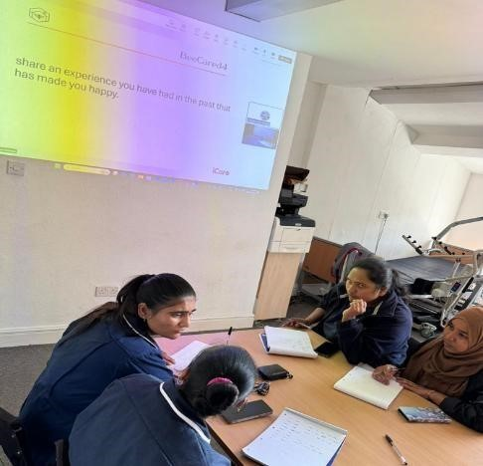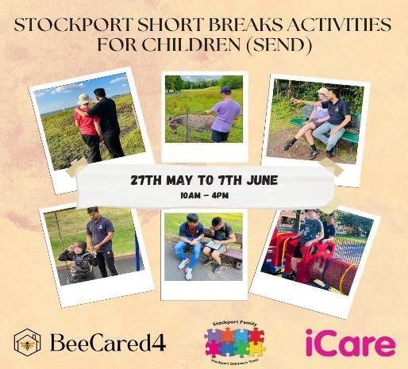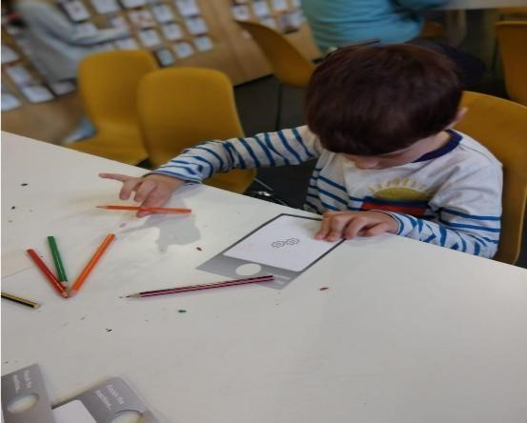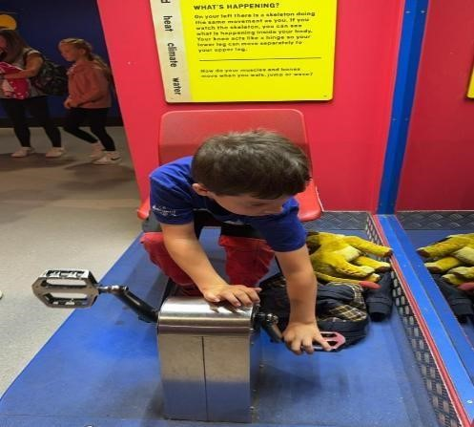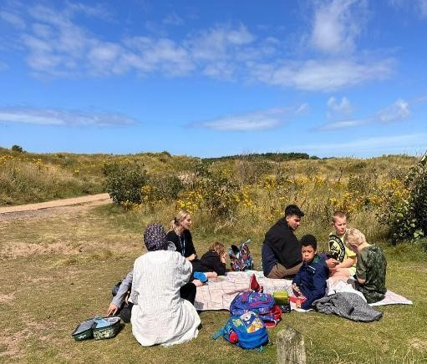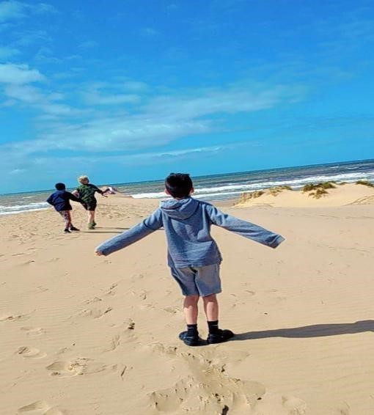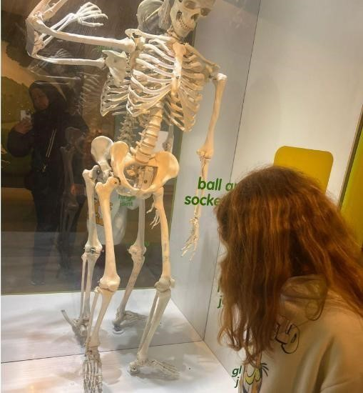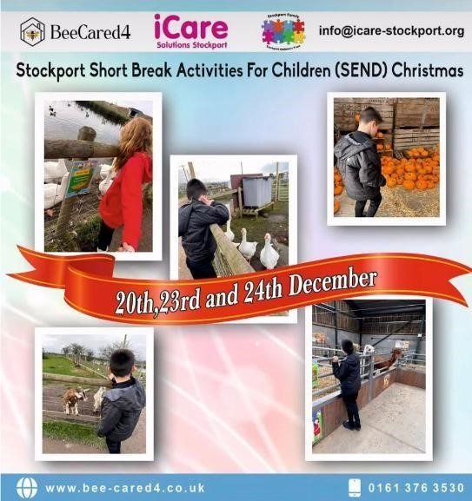

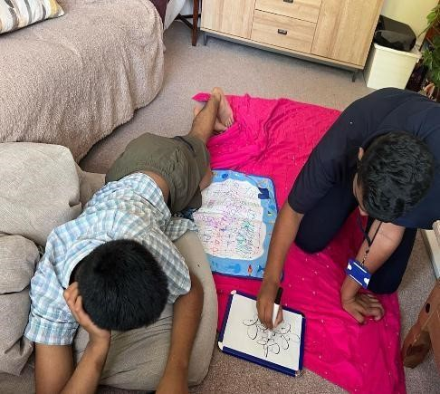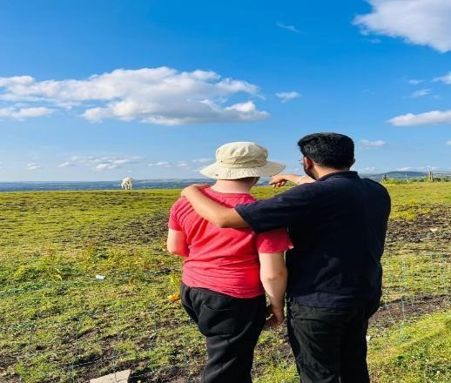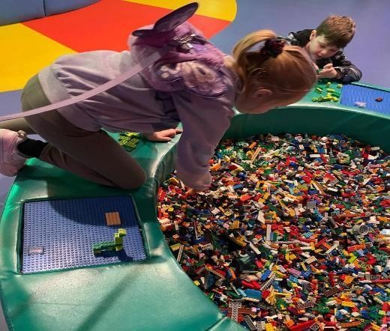

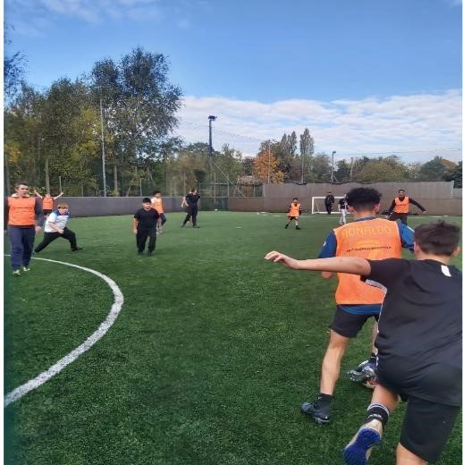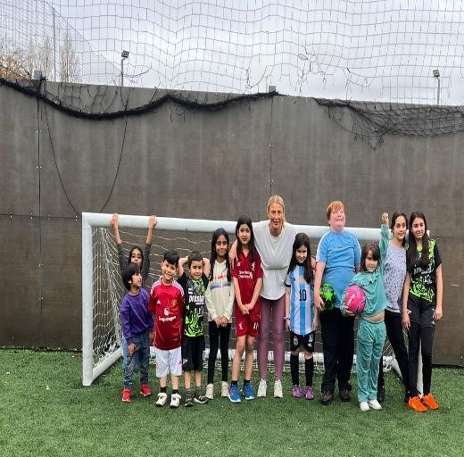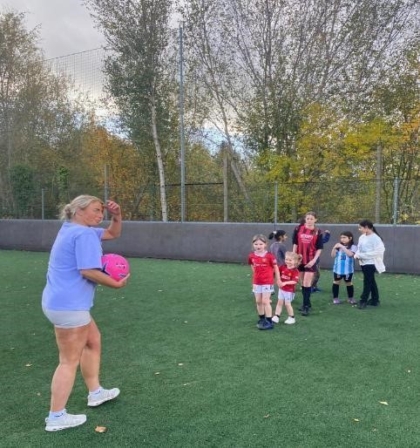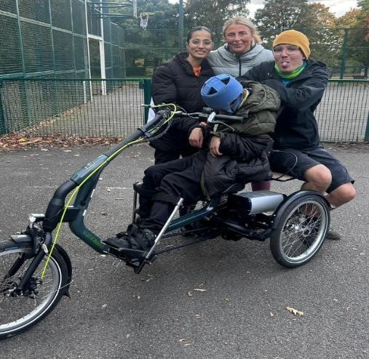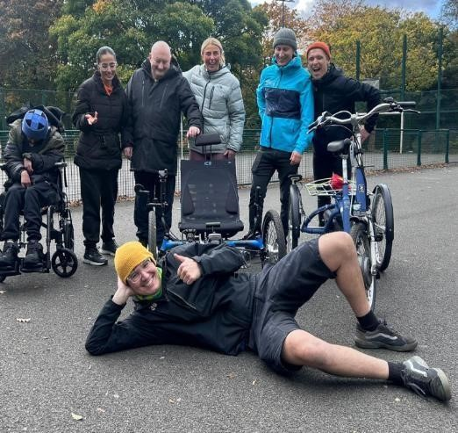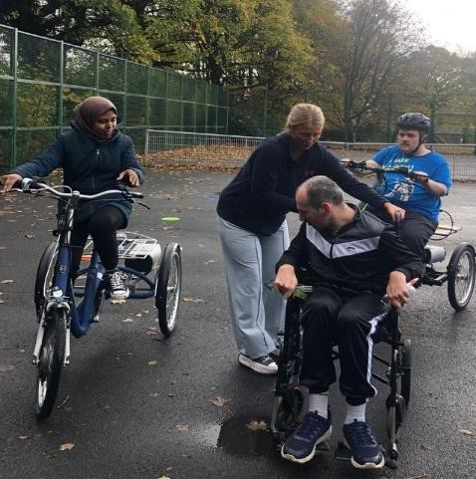



Bahisa Khojani
Responsible Individual
25/01/2025

