VRV Selection
  - Project Report

Report details
Produced on: 3/6/2024
Application version: 2024.3.4.3
Project details
Project name: 7152773 - BMG Manachester
Solution name: VRV HR
Client Name: Chapman Ventilation Ltd
Customer reference:
Quotation reference:
Project number: 1356720/1669675
The output of the VRV Xpress software is based on Daikin-genuine capacity tables that relate to the Japanese Industry Standard. The VRV Xpress software provides a selection of outdoor and indoor units with optimal efficiency to fit cooling and heating load requirements.

Material list
Model | Quantity | Description
REYQ12U | 2 | REYQ-U (VRV IV)
REYQ14U | 1 | REYQ-U (VRV IV)
REYQ10U | 1 | REYQ-U (VRV IV)
BS4Q14AV1B | 1 | Branch selector unit
BS6Q14AV1B | 1 | Branch selector unit
BS10Q14AV1B | 1 | Branch selector unit
FXAQ32A | 1 | FXAQ-A - Wall mounted unit
FXSQ80A | 2 | FXSQ-A - Concealed ceiling unit with medium ESP
FXSQ100A | 4 | FXSQ-A - Concealed ceiling unit with medium ESP
FXSQ125A | 3 | FXSQ-A - Concealed ceiling unit with medium ESP
FXZQ40A | 7 | FXZQ-A - Fully flat cassette
BHFQ23P907A | 1 | Outdoor unit multi connection piping kit for 2 modules HR
BRC1H52W | 17 | Remote controller (white)
BYFQ60CW | 7 | New decoration panel (white)

Indoor unit details

Table of abbreviations
Abbreviation | Description
Name | Logical name of the device
FCU | Device model name
Tmp C | Indoor conditions in cooling
Rq TC | Required total cooling capacity
Max TC | Available total cooling capacity
Rq SC | Required sensible cooling capacity
Tevap | Evaporating temperature of indoor unit coil
Max SC | Available sensible cooling capacity
PIC | Power input in cooling mode @ 50Hz
Tmp H | Indoor temperature in heating
Rq HC | Required heating capacity
Max HC | Available heating capacity
PIH | Power input in heating mode @ 50Hz
Sound | Sound pressure level low and high
PS | Power supply (voltage and phases)
MCA | Minimum Circuit Amps
MFA | Maxium Fuse Amps
WxHxD | WidthxHeightxDepth
Weight | Weight of the device

CU 1-1 - REYQ12U
Capacity data at conditions and connection ratio (104) as entered
Name | FCU | Cooling
Name | FCU | Tmp C | Rq TC | Max TC | Rq SC | Tevap | Max SC | PIC
Name | FCU | °C  (DBT/RH) | kW | kW | kW | °C | kW | kW
AC 1-1 | FXZQ40A | 23.0/50% | n/a | 3.7 | n/a | 6.0 | 2.9 | 0.029
AC 1-2 | FXAQ32A | 23.0/50% | n/a | 3.0 | n/a | 6.0 | 2.4 | 0.030
AC 1-3 | FXZQ40A | 23.0/50% | n/a | 3.7 | n/a | 6.0 | 2.9 | 0.029
AC 1-4 | FXZQ40A | 23.0/50% | n/a | 3.7 | n/a | 6.0 | 2.9 | 0.029
AC 1-5 | FXZQ40A | 23.0/50% | n/a | 3.7 | n/a | 6.0 | 2.9 | 0.029
AC 1-6 | FXZQ40A | 23.0/50% | n/a | 3.7 | n/a | 6.0 | 2.9 | 0.029
AC 1-7 | FXZQ40A | 23.0/50% | n/a | 3.7 | n/a | 6.0 | 2.9 | 0.029
AC 1-8 | FXZQ40A | 23.0/50% | n/a | 3.7 | n/a | 6.0 | 2.9 | 0.029
 |  |  | 0.0

Name | FCU | Heating
Name | FCU | Tmp H | Rq HC | Max HC | PIH
Name | FCU | °C | kW | kW | kW
AC 1-1 | FXZQ40A | 20.0 | n/a | 5.0 | 0.029
AC 1-2 | FXAQ32A | 20.0 | n/a | 4.0 | 0.040
AC 1-3 | FXZQ40A | 20.0 | n/a | 5.0 | 0.029
AC 1-4 | FXZQ40A | 20.0 | n/a | 5.0 | 0.029
AC 1-5 | FXZQ40A | 20.0 | n/a | 5.0 | 0.029
AC 1-6 | FXZQ40A | 20.0 | n/a | 5.0 | 0.029
AC 1-7 | FXZQ40A | 20.0 | n/a | 5.0 | 0.029
AC 1-8 | FXZQ40A | 20.0 | n/a | 5.0 | 0.029
 |  |  | n/a

Name | FCU | Room | Sound | PS | MCA | MFA | WxHxD | Weight
Name | FCU | Room | dBA | PS | A | MFA | mm | kg
AC 1-1 | FXZQ40A |  | 28 - 37 | 220V 1ph | 0.4 | Factory Std | 575 x 260 x 575 | 16.5
AC 1-2 | FXAQ32A |  | 29 - 38 | 230V 1ph | 0.4 | Factory Std | 795 x 290 x 266 | 12.0
AC 1-3 | FXZQ40A |  | 28 - 37 | 220V 1ph | 0.4 | Factory Std | 575 x 260 x 575 | 16.5
AC 1-4 | FXZQ40A |  | 28 - 37 | 220V 1ph | 0.4 | Factory Std | 575 x 260 x 575 | 16.5
AC 1-5 | FXZQ40A |  | 28 - 37 | 220V 1ph | 0.4 | Factory Std | 575 x 260 x 575 | 16.5
AC 1-6 | FXZQ40A |  | 28 - 37 | 220V 1ph | 0.4 | Factory Std | 575 x 260 x 575 | 16.5
AC 1-7 | FXZQ40A |  | 28 - 37 | 220V 1ph | 0.4 | Factory Std | 575 x 260 x 575 | 16.5
AC 1-8 | FXZQ40A |  | 28 - 37 | 220V 1ph | 0.4 | Factory Std | 575 x 260 x 575 | 16.5

Outdoor vs. indoor position
Outdoor unit placed at the same level as the indoor units.

CU 2-1 - REYQ22U = REYQ12U + REYQ10U
Capacity data at conditions and connection ratio (102) as entered
Name | FCU | Cooling
Name | FCU | Tmp C | Rq TC | Max TC | Rq SC | Tevap | Max SC | PIC
Name | FCU | °C  (DBT/RH) | kW | kW | kW | °C | kW | kW
AC 2-1 | FXSQ80A | 23.0/50% | n/a | 7.3 | n/a | 6.0 | 5.6 | 0.135
AC 2-2 | FXSQ80A | 23.0/50% | n/a | 7.3 | n/a | 6.0 | 5.6 | 0.135
AC 2-3 | FXSQ100A | 23.0/50% | n/a | 9.2 | n/a | 6.0 | 7.1 | 0.173
AC 2-4 | FXSQ100A | 23.0/50% | n/a | 9.2 | n/a | 6.0 | 7.1 | 0.173
AC 2-5 | FXSQ100A | 23.0/50% | n/a | 9.2 | n/a | 6.0 | 7.1 | 0.173
AC 2-6 | FXSQ100A | 23.0/50% | n/a | 9.2 | n/a | 6.0 | 7.1 | 0.173
 |  |  | 0.0

Name | FCU | Heating
Name | FCU | Tmp H | Rq HC | Max HC | PIH
Name | FCU | °C | kW | kW | kW
AC 2-1 | FXSQ80A | 20.0 | n/a | 10.0 | 0.135
AC 2-2 | FXSQ80A | 20.0 | n/a | 10.0 | 0.135
AC 2-3 | FXSQ100A | 20.0 | n/a | 12.5 | 0.173
AC 2-4 | FXSQ100A | 20.0 | n/a | 12.5 | 0.173
AC 2-5 | FXSQ100A | 20.0 | n/a | 12.5 | 0.173
AC 2-6 | FXSQ100A | 20.0 | n/a | 12.5 | 0.173
 |  |  | n/a

Name | FCU | Room | Sound | PS | MCA | MFA | WxHxD | Weight
Name | FCU | Room | dBA | PS | A | MFA | mm | kg
AC 2-1 | FXSQ80A |  | 29 - 35 | 220V 1ph | 1.9 | Factory Std | 1,000 x 245 x 800 | 36.5
AC 2-2 | FXSQ80A |  | 29 - 35 | 220V 1ph | 1.9 | Factory Std | 1,000 x 245 x 800 | 36.5
AC 2-3 | FXSQ100A |  | 31 - 36 | 220V 1ph | 2.4 | Factory Std | 1,400 x 245 x 800 | 46.0
AC 2-4 | FXSQ100A |  | 31 - 36 | 220V 1ph | 2.4 | Factory Std | 1,400 x 245 x 800 | 46.0
AC 2-5 | FXSQ100A |  | 31 - 36 | 220V 1ph | 2.4 | Factory Std | 1,400 x 245 x 800 | 46.0
AC 2-6 | FXSQ100A |  | 31 - 36 | 220V 1ph | 2.4 | Factory Std | 1,400 x 245 x 800 | 46.0

Outdoor vs. indoor position
Outdoor unit placed at the same level as the indoor units.

CU 3-1 - REYQ14U
Capacity data at conditions and connection ratio (107) as entered
Name | FCU | Cooling
Name | FCU | Tmp C | Rq TC | Max TC | Rq SC | Tevap | Max SC | PIC
Name | FCU | °C  (DBT/RH) | kW | kW | kW | °C | kW | kW
AC 3-1 | FXSQ125A | 23.0/50% | n/a | 11.5 | n/a | 6.0 | 8.8 | 0.237
AC 3-2 | FXSQ125A | 23.0/50% | n/a | 11.5 | n/a | 6.0 | 8.8 | 0.237
AC 3-3 | FXSQ125A | 23.0/50% | n/a | 11.5 | n/a | 6.0 | 8.8 | 0.237
 |  |  | 0.0

Name | FCU | Heating
Name | FCU | Tmp H | Rq HC | Max HC | PIH
Name | FCU | °C | kW | kW | kW
AC 3-1 | FXSQ125A | 20.0 | n/a | 16.0 | 0.237
AC 3-2 | FXSQ125A | 20.0 | n/a | 16.0 | 0.237
AC 3-3 | FXSQ125A | 20.0 | n/a | 16.0 | 0.237
 |  |  | n/a

Name | FCU | Room | Sound | PS | MCA | MFA | WxHxD | Weight
Name | FCU | Room | dBA | PS | A | MFA | mm | kg
AC 3-1 | FXSQ125A |  | 33 - 39 | 220V 1ph | 2.6 | Factory Std | 1,400 x 245 x 800 | 47.0
AC 3-2 | FXSQ125A |  | 33 - 39 | 220V 1ph | 2.6 | Factory Std | 1,400 x 245 x 800 | 47.0
AC 3-3 | FXSQ125A |  | 33 - 39 | 220V 1ph | 2.6 | Factory Std | 1,400 x 245 x 800 | 47.0

Outdoor vs. indoor position
Outdoor unit placed at the same level as the indoor units.

Outdoor unit details

Table of abbreviations
Abbreviation | Description
Name | Logical name of the device
Model | Device model name
▼ | Optimized selection: Smaller outdoor model selected than standard proposed model
CR | Connection ratio
Tmp C | Outdoor conditions in cooling
WFR | Water flow per outdoor unit module
CC | Available cooling capacity
Rq CC | Required cooling capacity
PIC | Power input in cooling mode
InC | Water inlet temperature in cooling mode
OutC | Water outlet temperature in cooling mode
Tmp H | Outdoor conditions in heating (dry bulb temp. / RH)
HC | Available heating capacity (integrated heating capacity)
Rq HC | Required heating capacity
PIH | Power input in heating mode
InH | Water inlet temperature in heating mode
OutH | Water outlet temperature in heating mode
Piping | Largest distance from indoor unit to outdoor unit
Bse Refr | Standard factory refrigerant charge (16.4ft actual piping length) excluding extra refrigerant charge. For calculation of extra refrigerant charge refer to the databook
Ex Refr | Extra refrigerant charge
PS | Power supply (voltage and phases)
MCA | Minimum Circuit Amps
MFA | Maxium Fuse Amps
FLA | Fan Motor Input
RLA | Nominal Running Amps
WxHxD | WidthxHeightxDepth
Weight | Weight of the device
EER | EER value at nominal condition
EER2 | EER2 value at nominal condition
IEER | IEER value at nominal condition
COP47 | COP value at nominal condition and at ambient temperature of 8°C
COP17 | COP value at nominal condition and at ambient temperature of -8°C

Outdoor details
Name | Model | CR | Cooling |  |  | Heating |  |  | Piping
Name | Model | CR | Tmp C | CC | Rq CC | Tmp H | HC | Rq HC | Piping
Name | Model | % | °C | kW | kW | °C  (DBT/RH) | kW | kW | m
CU 1-1 | REYQ12U▼ | 103.8 | 35.0 | 27.4 | 20.1 | -5.0/80% | 26.5 | 27.3 | 7.5
CU 2-1 | REYQ22U▼ | 101.8 | 35.0 | 49.3 | 51.4 | -5.0/80% | 50.2 | 70.0 | 7.5
CU 3-1 | REYQ14U▼ | 107.1 | 35.0 | 33.7 | 24.2 | -5.0/80% | 32.6 | 33.6 | 7.5

Name | Model | PS | MCA | MFA | RLA | FLA | WxHxD | Weight
Name | Model | PS | A | A | A | A | mm | kg
CU 1-1 | REYQ12U | 400V 3Nph | 24.0 | 32.0 | 13.8 | 1.5 | 930 x 1,685 x 765 | 230.0
BC 1-1 | BS10Q14AV1B | 230V 1ph | 1.0 | 15.0 |  |  | 820 x 298 x 430 | 42.0
CU 2-1 | REYQ22U | 400V 3Nph
A | - REYQ12U |  | 24.0 | 32.0 | 13.8 | 1.5 | 930 x 1,685 x 765 | 230.0
B | - REYQ10U |  | 22.0 | 25.0 | 10.5 | 1.3 | 930 x 1,685 x 765 | 230.0
BC 2-1 | BS6Q14AV1B | 230V 1ph | 0.6 | 15.0 |  |  | 580 x 298 x 430 | 28.0
CU 3-1 | REYQ14U | 400V 3Nph | 27.0 | 32.0 | 15.6 | 1.8 | 1,240 x 1,685 x 765 | 314.0
BC 3-1 | BS4Q14AV1B | 230V 1ph | 0.4 | 15.0 |  |  | 370 x 298 x 430 | 22.0

Sound Data
Name | Model | Sound Power |  | Sound Pressure
Name | Model | Cooling | Heating | Cooling | Heating
Name | Model | dBA | dBA | dBA | dBA
CU 1-1 | REYQ12U | 83 | 65 | 61 | -
CU 2-1 | REYQ22U | 85 | 68 | 63 | -
CU 3-1 | REYQ14U | 81 | 68 | 60 | -

Seasonal Efficiency
Name | Model | η_{s,h} heating | η_{s,c} cooling | SCOP | SEER | CSPF
Name | Model | % | % | SCOP | SEER | CSPF
CU 1-1 | REYQ12U | 183.8 | 257.0 | 4.70 | 6.50 | -
CU 2-1 | REYQ22U | 178.5 | 260.4 | 4.50 | 6.60 | -
CU 3-1 | REYQ14U | 168.3 | 255.8 | 4.30 | 6.50 | -

For more information go to: https://energylabel.daikin.eu/.

Refrigerant information
Name | Model | Refrigerant type | GWP | Base charge  kg | Extra charge  kg | Total refrigerant charge  kg | Total CO2 equivalent  tonnes
CU 1-1 | REYQ12U | R410A | 2087.5 | 9.90 | unknown | unknown | 20.67
CU 2-1 | REYQ22U | R410A | 2087.5 | 19.70 | unknown | unknown | 41.12
CU 3-1 | REYQ14U | R410A | 2087.5 | 11.80 | unknown | unknown | 24.63
The system(s) contain fluorinated greenhouse gases.
TCO2 equivalent is calculated only considering the base refrigerant charge. Depending on the field pipe length extra refrigerant needs to be added which will increase the TCO2 equivalent.

CU 1-1 - REYQ12U
Model | Quantity | Description
REYQ12U | 1 | REYQ-U (VRV IV)
BS10Q14AV1B | 1 | Branch selector unit
FXAQ32A | 1 | FXAQ-A - Wall mounted unit
FXZQ40A | 7 | FXZQ-A - Fully flat cassette
BRC1H52W | 8 | Remote controller (white)
BYFQ60CW | 7 | New decoration panel (white)

Refrigerant information
Refrigerant type | GWP | Base charge  kg | Extra charge  kg | Total refrigerant charge  kg | Total CO2 equivalent  tonnes
R410A | 2087.5 | 9.90 | unknown | unknown | 20.67
The system(s) contain fluorinated greenhouse gases.
TCO2 equivalent is calculated only considering the base refrigerant charge. Depending on the field pipe length extra refrigerant needs to be added which will increase the TCO2 equivalent.

Remarks
Chosen outdoor unit size differs from default proposed size. Be aware that this might lead to reduced comfort levels, increased noise levels, wear and tear. In case of doubt, contact your sales representative.

Pipe capacities
Maximum Connection Index | Diameters
149.9 | 3/8"x5/8"x1/2"
199.9 | 3/8"x3/4"x5/8"
289.9 | 3/8"x7/8"x3/4"
419.9 | 1/2"x1 1/8"x3/4"
639.9 | 5/8"x1 1/8"x1 1/8"
919.9 | 3/4"x1 3/8"x1 1/8"
> 919.9 | 3/4"x1 5/8"x1 1/8"
Main pipe size up | 5/8"x1 1/8"x3/4"

Remarks
Please make sure to provide a drain pipe connection to each multi BS-box in the system.

Piping limitations
Description | Value
Maximum total length | 1,000.0m
Maximum longest actual length | 165.0m
Maximum longest equivalent length | 190.0m
Maximum main pipe length (size up of main pipe required if longer) | -
Maximum length first branch to indoor unit(size up of intermediate pipes required if longer) | 40.0m
Maximum length first branch to indoor unit | 90.0m
Maximum length of indoor units to nearest branch | 40.0m
Maximum length difference between longest and shortest distance to indoor units | 40.0m
Maximum height difference, outdoor unit below indoor units | 90.0m
Minimum connection ratio, outdoor unit below indoor units | -
Maximum height difference, outdoor unit above indoor units | 90.0m
Minimum connection ratio, outdoor unit above indoor units | -
Maximum height difference in technical cooling, outdoor unit below indoor units | 90.0m
Maximum height difference in technical cooling, outdoor unit above indoor units | 90.0m
Maximum height difference between indoor units | 30.0m
Connection ratio range | 50.0% - 200.0%
Refrigerant pipe diameters | 5/8" (liquid) x 1 1/8" (gas) x 3/4" (discharge)
Maximum equivalent length from BP unit or VRV indoor to VRV REFNET (size up of intermediate pipes required if longer) | -
Maximum equivalent length from BP unit or VRV indoor to VRV REFNET | 90.0m
Maximum actual length between CM and HM | -
Maximum height difference between CM and HM | -

CU 2-1 - REYQ22U = REYQ12U + REYQ10U
Model | Quantity | Description
REYQ12U | 1 | REYQ-U (VRV IV)
REYQ10U | 1 | REYQ-U (VRV IV)
BS6Q14AV1B | 1 | Branch selector unit
FXSQ80A | 2 | FXSQ-A - Concealed ceiling unit with medium ESP
FXSQ100A | 4 | FXSQ-A - Concealed ceiling unit with medium ESP
BHFQ23P907A | 1 | Outdoor unit multi connection piping kit for 2 modules HR
BRC1H52W | 6 | Remote controller (white)

Refrigerant information
Refrigerant type | GWP | Base charge  kg | Extra charge  kg | Total refrigerant charge  kg | Total CO2 equivalent  tonnes
R410A | 2087.5 | 19.70 | unknown | unknown | 41.12
The system(s) contain fluorinated greenhouse gases.
TCO2 equivalent is calculated only considering the base refrigerant charge. Depending on the field pipe length extra refrigerant needs to be added which will increase the TCO2 equivalent.

Remarks
Chosen outdoor unit size differs from default proposed size. Be aware that this might lead to reduced comfort levels, increased noise levels, wear and tear. In case of doubt, contact your sales representative.

Pipe capacities
Maximum Connection Index | Diameters
149.9 | 3/8"x5/8"x1/2"
199.9 | 3/8"x3/4"x5/8"
289.9 | 3/8"x7/8"x3/4"
419.9 | 1/2"x1 1/8"x3/4"
639.9 | 5/8"x1 1/8"x1 1/8"
919.9 | 3/4"x1 3/8"x1 1/8"
> 919.9 | 3/4"x1 5/8"x1 1/8"
Main pipe size up | 3/4"x1 1/8"x1 1/8"

Remarks
Please make sure to provide a drain pipe connection to each multi BS-box in the system.
Sufficient distance should be respected between the modules according to the service & operation space rules as mentioned in the databook.

Piping limitations
Description | Value
Maximum total length | 1,000.0m
Maximum longest actual length | 165.0m
Maximum longest equivalent length | 190.0m
Maximum main pipe length (size up of main pipe required if longer) | -
Maximum length first branch to indoor unit(size up of intermediate pipes required if longer) | 40.0m
Maximum length first branch to indoor unit | 90.0m
Maximum length of indoor units to nearest branch | 40.0m
Maximum length difference between longest and shortest distance to indoor units | 40.0m
Maximum height difference, outdoor unit below indoor units | 90.0m
Minimum connection ratio, outdoor unit below indoor units | -
Maximum height difference, outdoor unit above indoor units | 90.0m
Minimum connection ratio, outdoor unit above indoor units | -
Maximum height difference in technical cooling, outdoor unit below indoor units | 90.0m
Maximum height difference in technical cooling, outdoor unit above indoor units | 90.0m
Maximum height difference between indoor units | 30.0m
Connection ratio range | 50.0% - 200.0%
Refrigerant pipe diameters | 3/4" (liquid) x 1 1/8" (gas) x 1 1/8" (discharge)
Maximum equivalent length from BP unit or VRV indoor to VRV REFNET (size up of intermediate pipes required if longer) | -
Maximum equivalent length from BP unit or VRV indoor to VRV REFNET | 90.0m
Maximum actual length between CM and HM | -
Maximum height difference between CM and HM | -

CU 3-1 - REYQ14U
Model | Quantity | Description
REYQ14U | 1 | REYQ-U (VRV IV)
BS4Q14AV1B | 1 | Branch selector unit
FXSQ125A | 3 | FXSQ-A - Concealed ceiling unit with medium ESP
BRC1H52W | 3 | Remote controller (white)

Refrigerant information
Refrigerant type | GWP | Base charge  kg | Extra charge  kg | Total refrigerant charge  kg | Total CO2 equivalent  tonnes
R410A | 2087.5 | 11.80 | unknown | unknown | 24.63
The system(s) contain fluorinated greenhouse gases.
TCO2 equivalent is calculated only considering the base refrigerant charge. Depending on the field pipe length extra refrigerant needs to be added which will increase the TCO2 equivalent.

Remarks
Chosen outdoor unit size differs from default proposed size. Be aware that this might lead to reduced comfort levels, increased noise levels, wear and tear. In case of doubt, contact your sales representative.

Pipe capacities
Maximum Connection Index | Diameters
149.9 | 3/8"x5/8"x1/2"
199.9 | 3/8"x3/4"x5/8"
289.9 | 3/8"x7/8"x3/4"
419.9 | 1/2"x1 1/8"x3/4"
639.9 | 5/8"x1 1/8"x1 1/8"
919.9 | 3/4"x1 3/8"x1 1/8"
> 919.9 | 3/4"x1 5/8"x1 1/8"
Main pipe size up | 5/8"x1 1/8"x7/8"

Remarks
Please make sure to provide a drain pipe connection to each multi BS-box in the system.

Piping limitations
Description | Value
Maximum total length | 1,000.0m
Maximum longest actual length | 165.0m
Maximum longest equivalent length | 190.0m
Maximum main pipe length (size up of main pipe required if longer) | -
Maximum length first branch to indoor unit(size up of intermediate pipes required if longer) | 40.0m
Maximum length first branch to indoor unit | 90.0m
Maximum length of indoor units to nearest branch | 40.0m
Maximum length difference between longest and shortest distance to indoor units | 40.0m
Maximum height difference, outdoor unit below indoor units | 90.0m
Minimum connection ratio, outdoor unit below indoor units | -
Maximum height difference, outdoor unit above indoor units | 90.0m
Minimum connection ratio, outdoor unit above indoor units | -
Maximum height difference in technical cooling, outdoor unit below indoor units | 90.0m
Maximum height difference in technical cooling, outdoor unit above indoor units | 90.0m
Maximum height difference between indoor units | 30.0m
Connection ratio range | 50.0% - 200.0%
Refrigerant pipe diameters | 5/8" (liquid) x 1 1/8" (gas) x 7/8" (discharge)
Maximum equivalent length from BP unit or VRV indoor to VRV REFNET (size up of intermediate pipes required if longer) | -
Maximum equivalent length from BP unit or VRV indoor to VRV REFNET | 90.0m
Maximum actual length between CM and HM | -
Maximum height difference between CM and HM | -

Piping diagrams

Piping CU 1-1
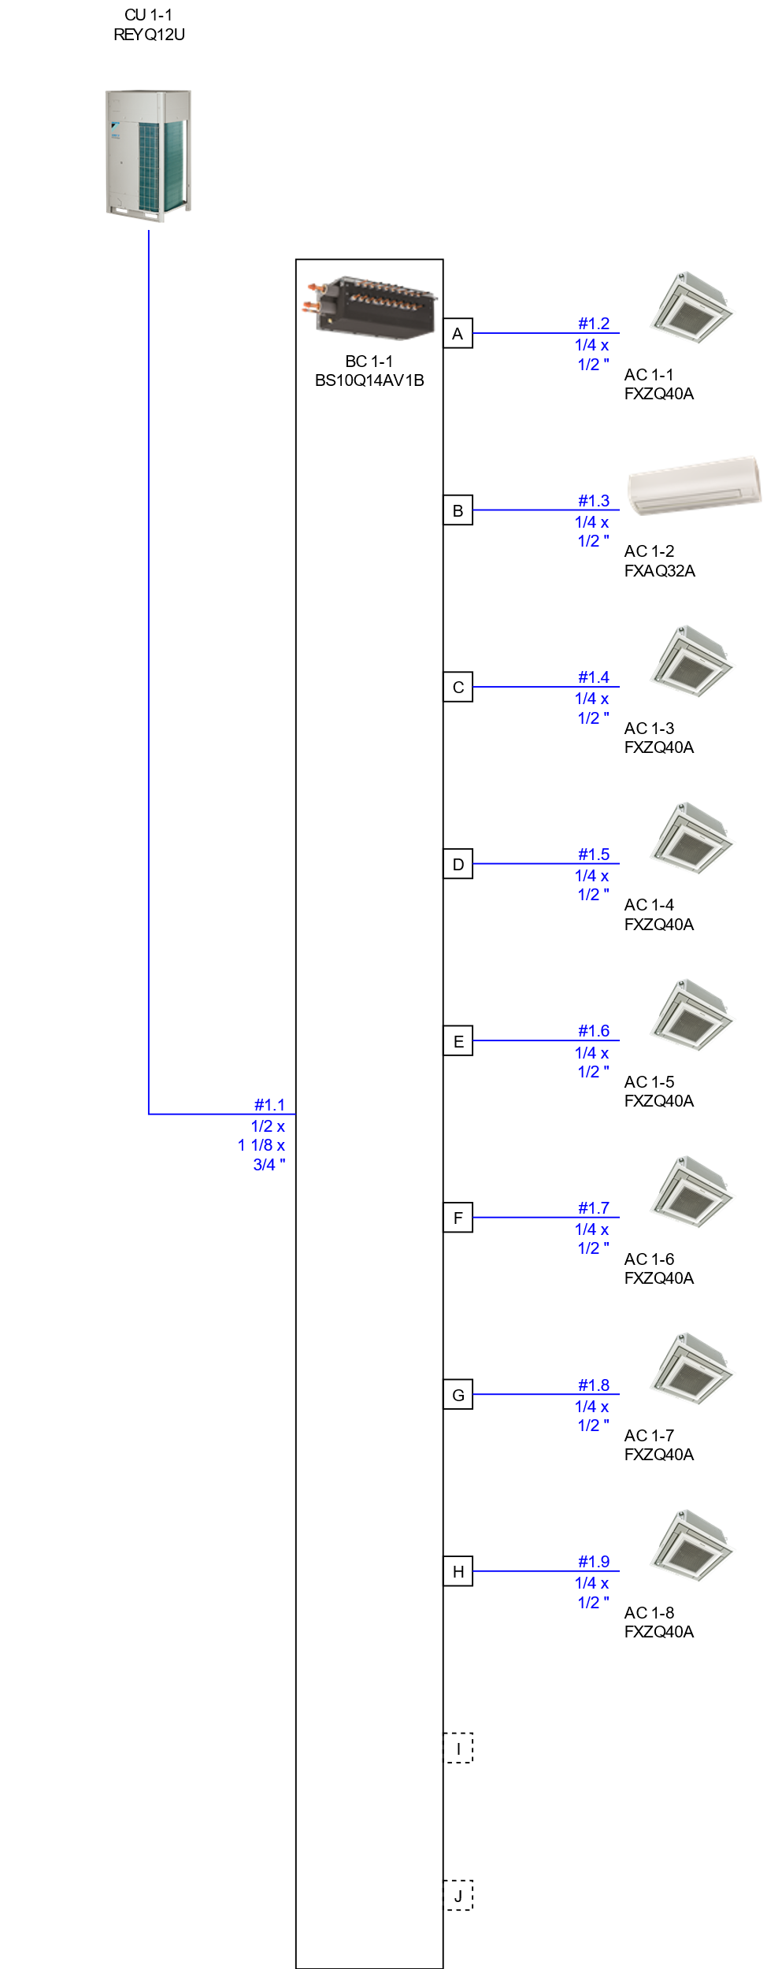

Piping
Warning: The pipe diameter values are purely indicative. Depending on the required pipe lengths, a different pipe diameter might be required.

Piping CU 2-1
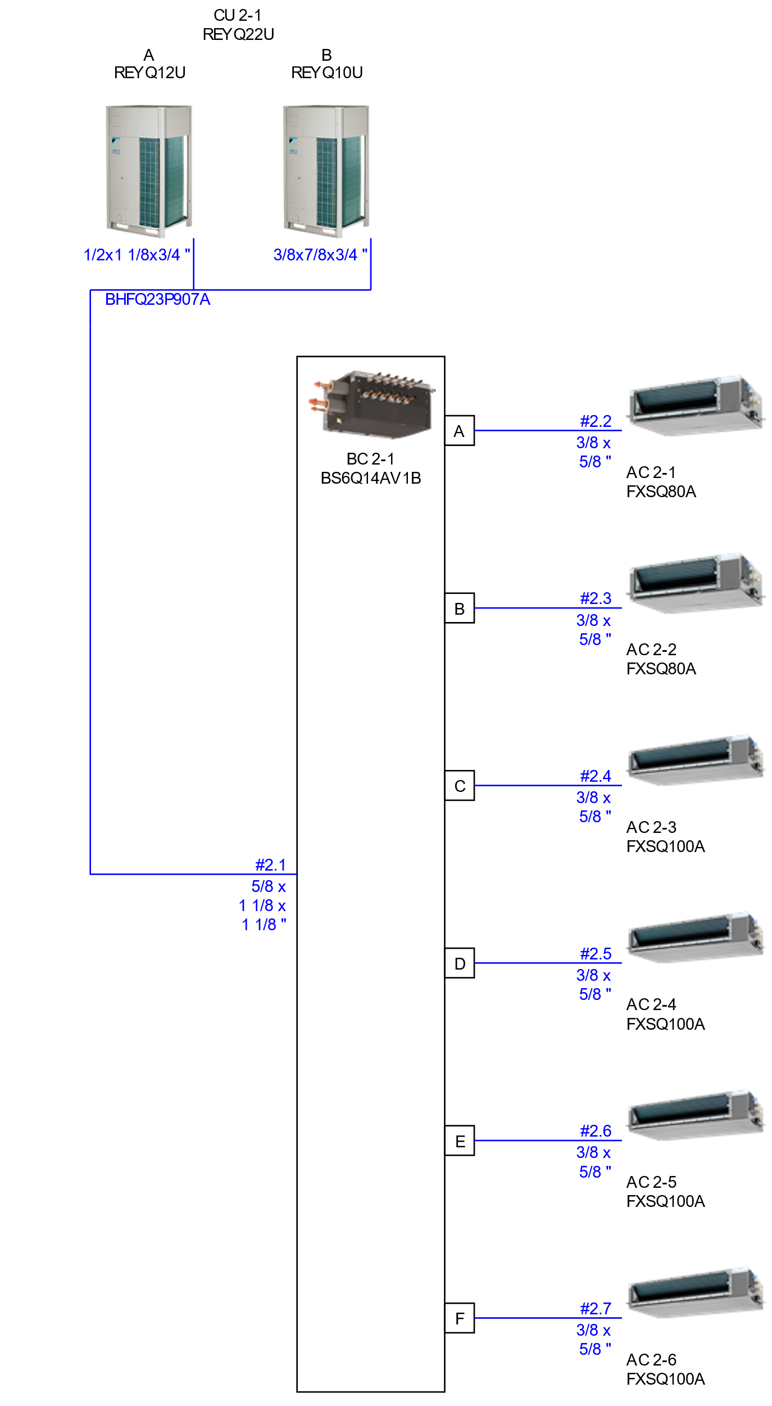

Piping
Warning: The pipe diameter values are purely indicative. Depending on the required pipe lengths, a different pipe diameter might be required.

Piping CU 3-1
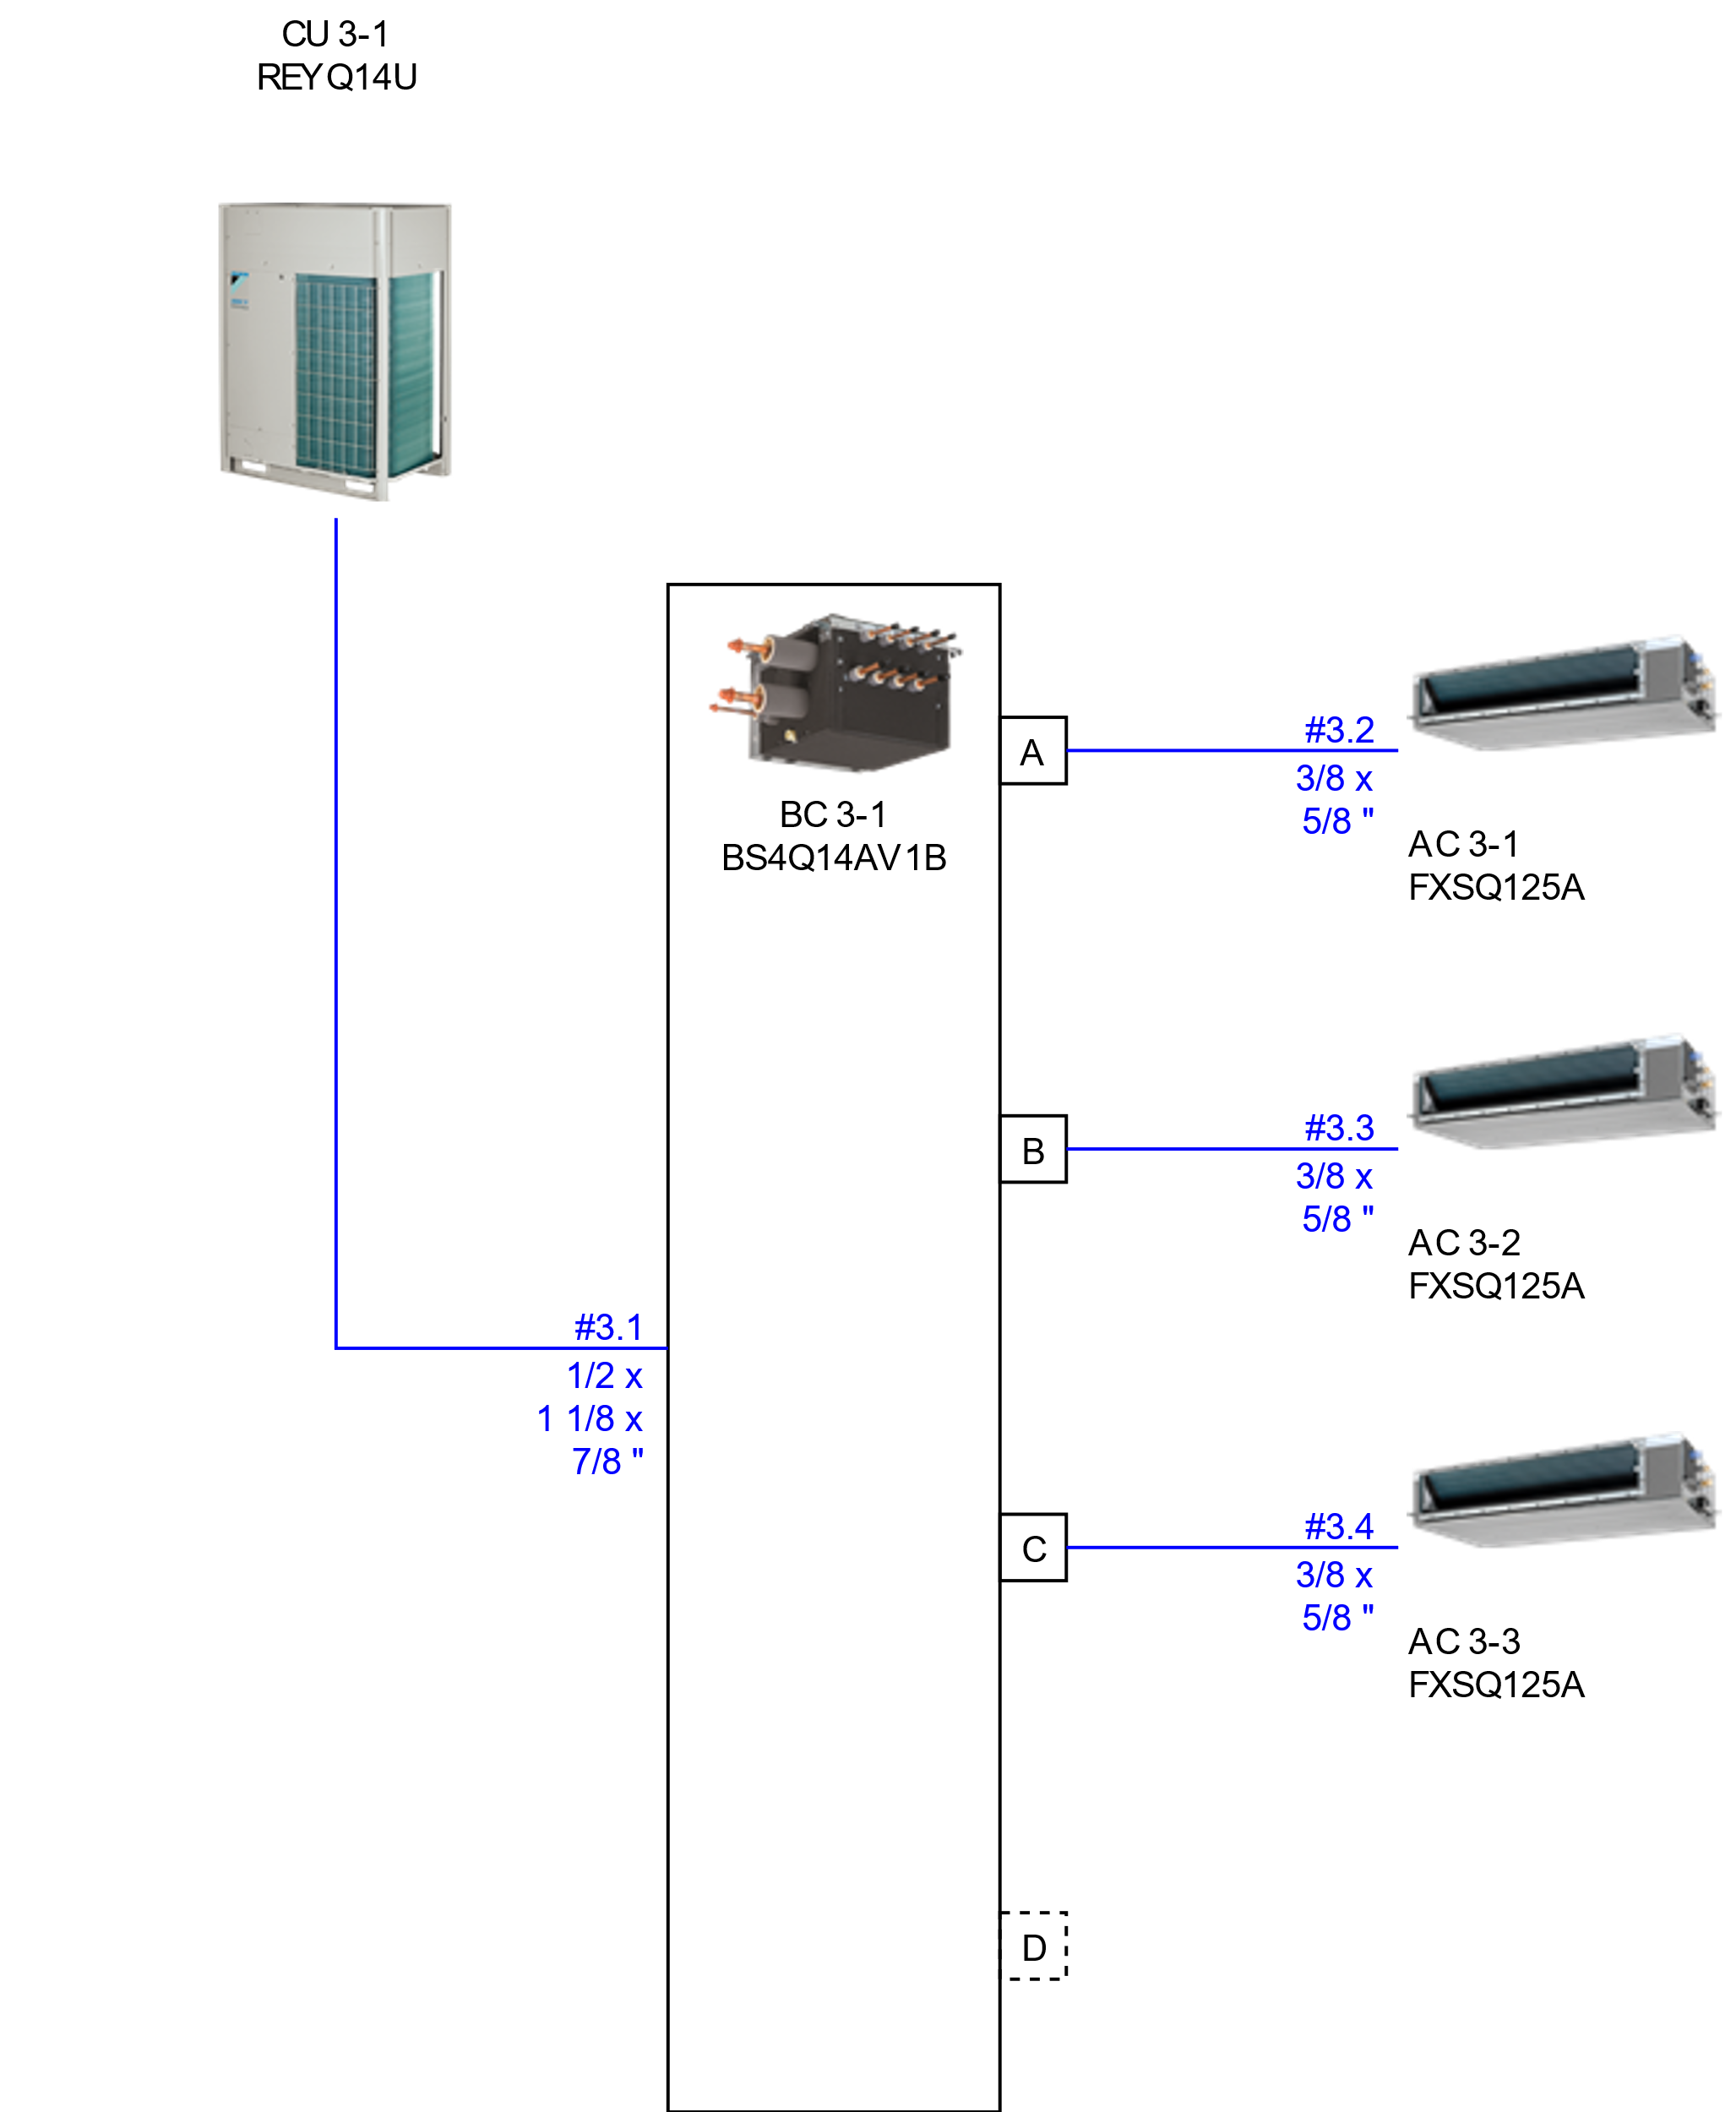

Piping
Warning: The pipe diameter values are purely indicative. Depending on the required pipe lengths, a different pipe diameter might be required.

Wiring diagrams

Wiring CU 1-1
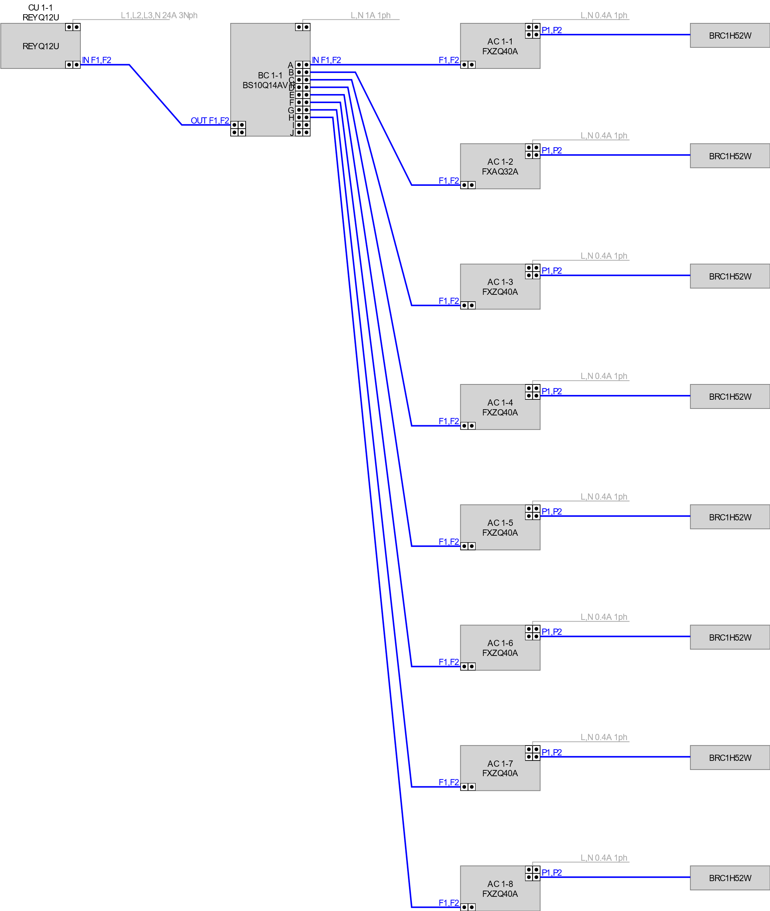

Remarks
P1P2 = 0,75 - 1,25 mm2, max 500m length - always refer to local code for further information.
F1F2 IN/OUT transmission wiring, use 2-core wires of 0,75 to 1,25 mm² size cables, without shield (but shielded cable can be used if required by local regulations and standards).
Note: The shield should only be earthed at outdoor unit side, not at the indoor units!

Wiring CU 2-1
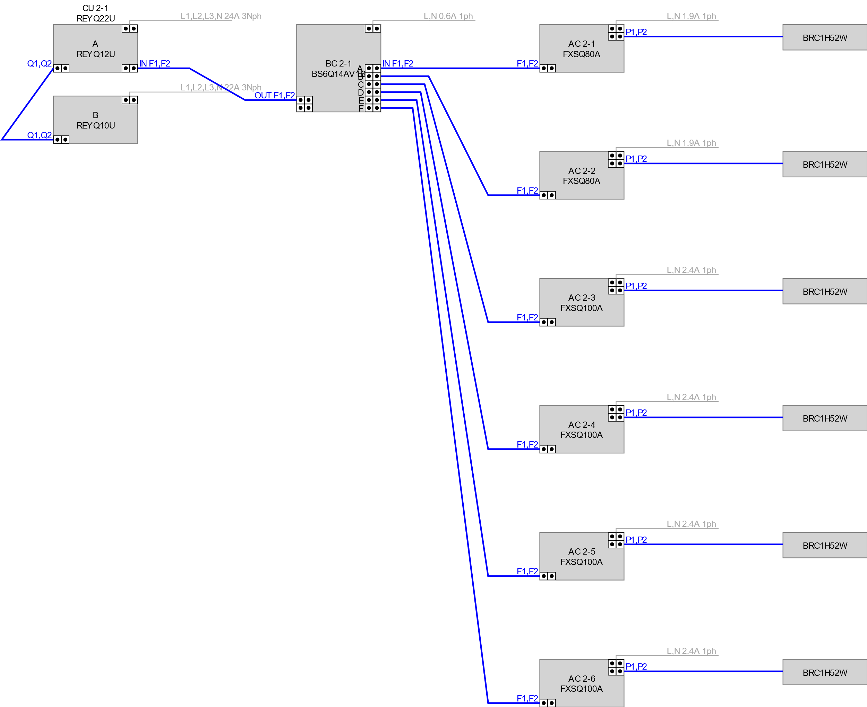

Remarks
P1P2 = 0,75 - 1,25 mm2, max 500m length - always refer to local code for further information.
F1F2 IN/OUT transmission wiring, use 2-core wires of 0,75 to 1,25 mm² size cables, without shield (but shielded cable can be used if required by local regulations and standards).
Note: The shield should only be earthed at outdoor unit side, not at the indoor units!

Wiring CU 3-1
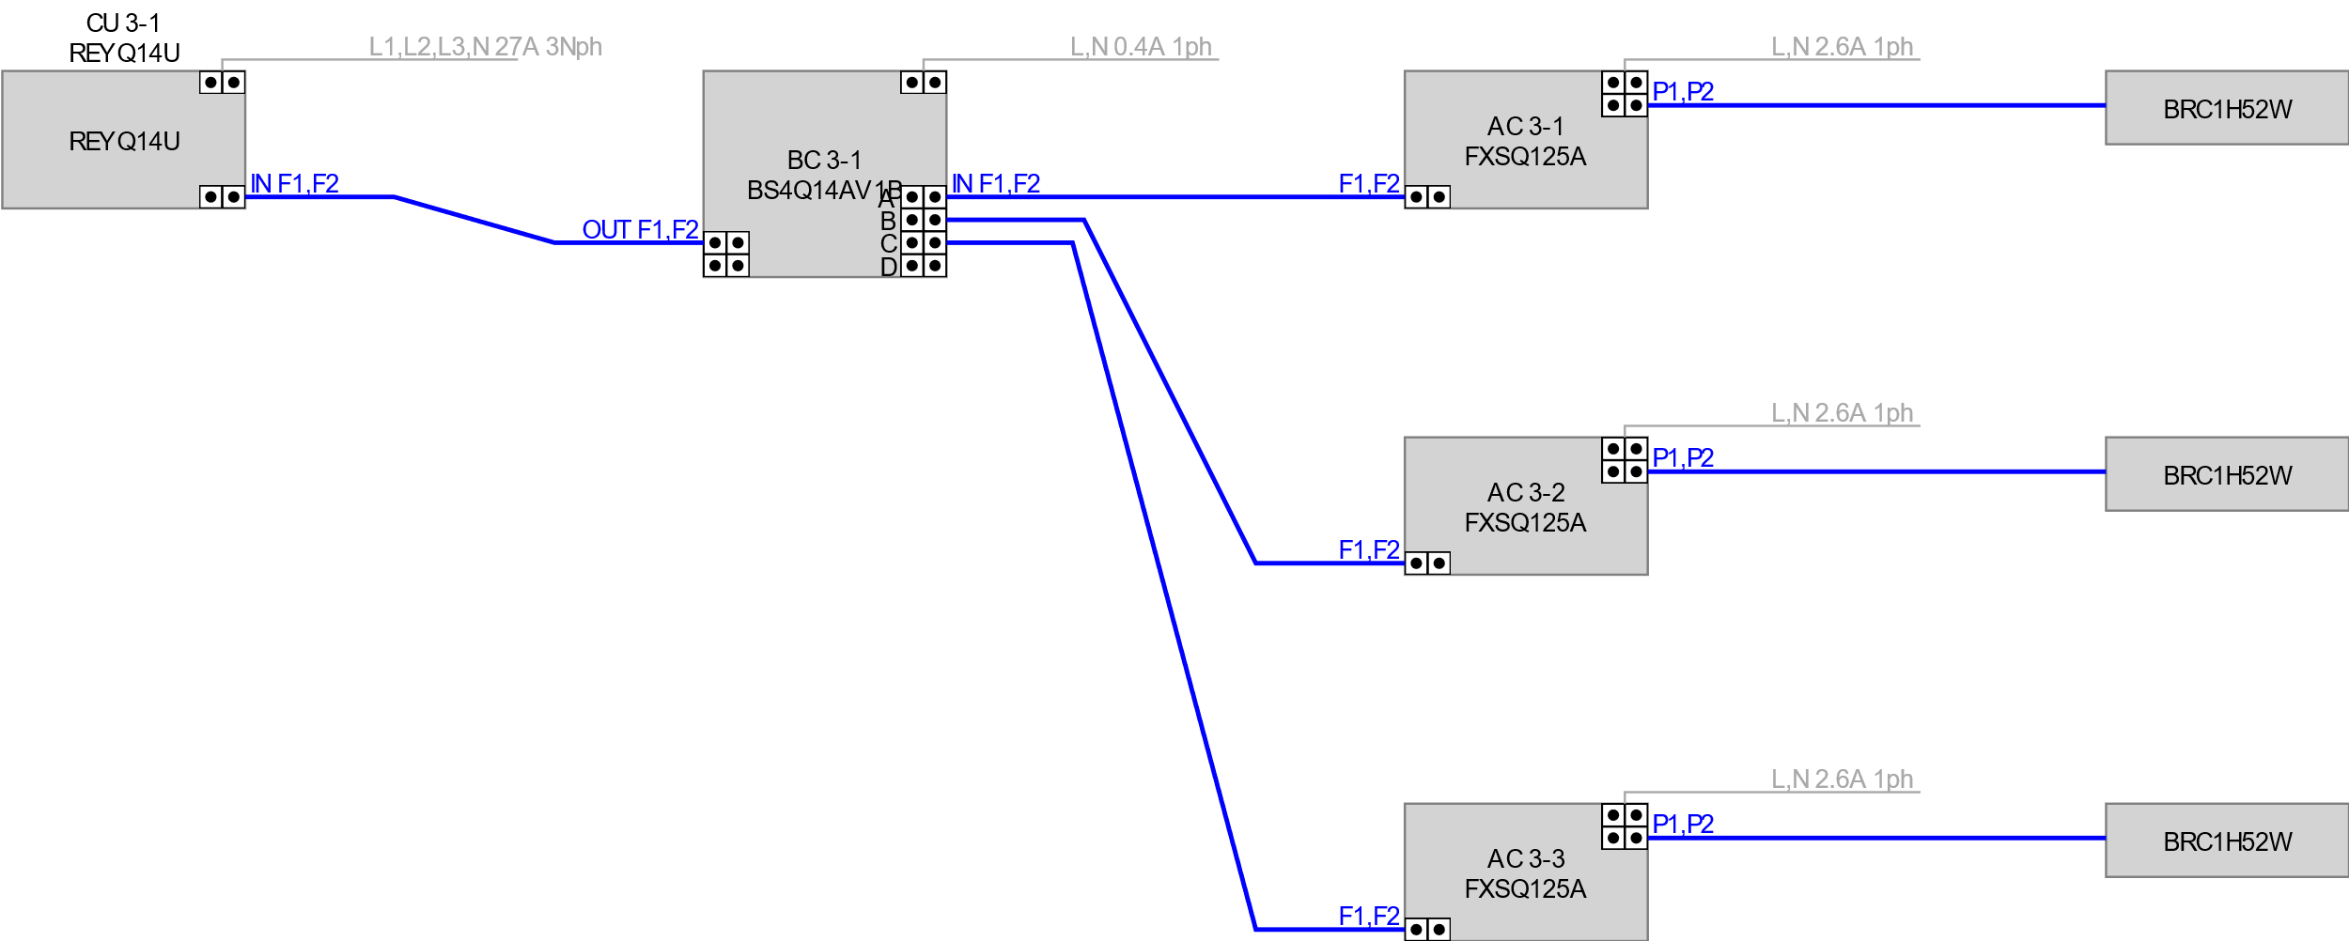

Remarks
P1P2 = 0,75 - 1,25 mm2, max 500m length - always refer to local code for further information.
F1F2 IN/OUT transmission wiring, use 2-core wires of 0,75 to 1,25 mm² size cables, without shield (but shielded cable can be used if required by local regulations and standards).
Note: The shield should only be earthed at outdoor unit side, not at the indoor units!

Best Practices

Multi BS-box
- Install the multi BS-box on a location where the refrigerant noise cannot disturb the room occupants
- To avoid that refrigerant noise disturbs the people in the room, keep at least 5m piping length between the occupied room and the multi BS unit (See figure)
- If there is no false ceiling in the occupied room, please add sound insulation around the piping between the multi BS-box and indoor unit, or keep much longer length between multi BS-box unit and occupied room (See figure)
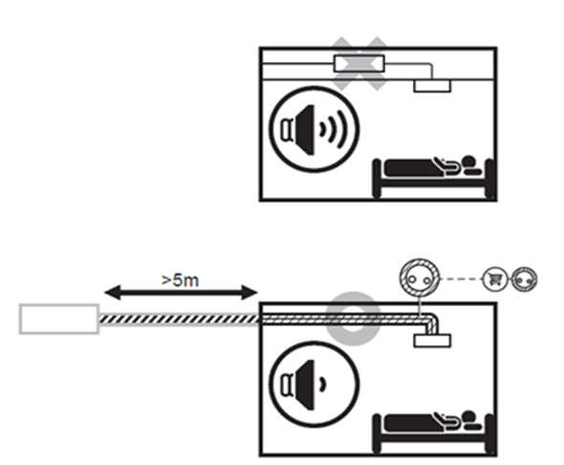

Residual Current Circuit Breaker
For better protection of installations against the risk of fire, power supply of indoor and outdoor units must be protected with a Residual Current Circuit Breaker. For protection against fire, we recommend a sensitivity of 300mA. The selected RCCB should be of the type B, suitable for inverter devices and indicated by the symbols here below. Further electrical characteristics of the RCCB must be selected in accordance with local regulation.
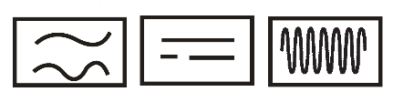
For a complete list of all required safety precautions, warnings and attention points, please consult the “general safety precautions manual” delivered with the unit.

