15M POLE AT ASHTON OLD ROAD, MANCHESTER

Application for Prior Approval under Para A.3 of Schedule 2, Part 16, of the Town and Country Planning (General Permitted Development) (England) Order 2015 for the addition of antennae to an existing 15m pole to support the installation of a wireless gigabit capable broadband network

Ribble House
Ribble Business Park
Blackburn, BB1 5RB

T: 08726 245000
E: planning@ixwireless.co.uk
W: www.ixwbuild.co.uk

Company Registration Number 11009144
REPORT CONTROL

Document | Application for Prior Approval Ashton Old Road, Manchester
Project
Client | IX Wireless Ltd

Document Checking

Primary Author: | Joanne Kay | Initialled: | JK
Contributor: |  | Initialled:
Reviewer: | Deborah Grogan | Initialled:

Revision Status

CONTENTS

1 | INTRODUCTION
2 | RELEVANT LEGISLATION
3 | PRE-APPLICATION ADVICE
4 | PLANNING CONSIDERATIONS
5 | PLANNING CONSIDERATIONS AND CONCLUSIONS

INTRODUCTION
  - IX Wireless Ltd (‘the Applicant’) is making an application for Prior Approval for the addition of antennae to an existing pole, to support the rollout of a high-speed wireless internet network. For reasons that will be expanded upon below, this application is made strictly without prejudice to the Applicant’s position that on a proper interpretation of the GPDO there is no requirement to seek prior approval in for the addition of antennae to an existing pole structure.
  - The Applicant is a registered company with powers under the Electronic Communications Code. See the below link to the Ofcom register:
https://www.ofcom.org.uk/phones-telecoms-and-internet/information-for-industry/policy/electronic-comm-code/register-of-persons-with-powers-under-the-electronic-communications-code
  - This statement consists of Section 2 – Relevant Legislation, Section 3 – Pre-Application Advice and Planning History, Section 4 – Planning Considerations and Section 5 - Conclusions. It should be read and considered alongside the accompanying forms, location plans, pole details and elevation plans which have been submitted with the application.
  - Should the Local Planning Authority (LPA) require any further information to enable the positive and speedy determination of the application, it is requested to contact the Applicant using the contact details provided.

2 RELEVANT LEGISLATION

  - As a Code Operator the Applicant has the benefit of Schedule 2, Part 16, Class A of the Town and Country Planning (General Permitted Development) (England) Order 2015 (as amended), states that: -
- Development by or on behalf of an electronic communications code operator for the purpose of the operator’s electronic communications network in, on, over or under land controlled by that operator or in accordance with the electronic communications code, consisting of—
- the installation, alteration or replacement of any electronic communications apparatus,
Development not permitted: ground-based apparatus
A.1— (1) Development consisting of the installation, alteration or replacement of electronic communications apparatus (other than on a building) is not permitted by Class A (a) if—
- in the case of the installation of electronic communications apparatus (other than a mast), the apparatus, excluding any antenna, would exceed a height of 15 metres above ground level;
- in the case of the installation of a mast, the mast, excluding any antenna, would exceed a height of –
- 25 metres above ground level on unprotected land; or
- 20 metres above ground on article 2(3) land or land which is on a highway.
Development not permitted: ground or base area
(7) Development consisting of the installation, alteration or replacement of any electronic communications apparatus other than —
- A mast;
- An antenna;
- A public call box;
- Any apparatus which does not project above the level of the surface of the ground; or
- Radio equipment housing.
Is not permitted by Class A(a) if the ground or base area of the structure would exceed 1.5 square metres.
Conditions
A.2 – (2) Class A development is permitted subject to the condition that –
(a) Any electronic communications apparatus provided in accordance with that permission is removed from the land or building on which it is situated –
- If such development was carried out in an emergency, at the expiry of the relevant period; or
- In any other case, as soon as reasonably practical after it is no longer required for electronic communications purposes; and
- Such land or building is restored to its condition before the development took place, or to any other condition as may be agreed in writing between the local planning authority and the developer.
(3) Subject to sub-paragraph (5), Class A development –
(a) on article 2(3) land, excluding development specified in sub-paragraph (4)
(b) on land which is, or is within, a site of special scientific interest; or
(c) on unprotected land where that development consists of –
- The installation of a mast;
Is permitted subject, except in the case of emergency (in which case only paragraph A.3(12) applies), to the conditions set out in paragraph A.3 (prior approval).
  - In summary, the above provisions of the GPDO allow for the erection of poles (ground-based apparatus), so long as they do not exceed a height of 15 metres above ground level. Any ancillary housing equipment can be provided adjacent to the poles, if this does not exceed 1.5 square metres. The poles must be removed, and land returned to its original state when no longer needed for communications proposes. Such rights do not involve the need for any ‘Prior Approval’ process with the LPA and are permitted development.
  - Prior Approval is required where the proposal is to erect a mast, or where the application site relates to protected land, including conservation areas, national parks, areas of outstanding natural beauty or sites of special scientific interest.
  - Where Prior Approval is required, the requirements for the application and determination process are set out under Para A.3. Importantly, it is clarified at Para A.3- (4) that the scope of assessment is limited only to the siting and appearance of the development.
  - ‘Mast’ is defined in the GPDO as being a ‘radio mast of a radio tower’ and a structure that supports the apparatus capable of transmitting or receiving radio signals. A structure that supports an overhead cable or line falls outside the definition or a ‘mast’ and is ground based apparatus.
/3 PRE-APPLICATION ADVICE AND PLANNING HISTORY

  - The Applicant first approached the LPA in late 2018 and early 2019, seeking pre-application advice regarding the rollout of the wireless network across the Borough. In addition to written correspondence with officers, this has included several presentations with Councillors and the Chief Planning Officer. It was explained by the Applicant how the roll-out would involve the provision of poles carrying suspended fibre cables, which would in turn connect to poles with antenna for the transmission of radio signals.
  - A Lawful Development Certificate for the erection of poles up to 15m in height to
support the carrying of fibre internet cables was approved by the LPA on 31 July 2019
under Ref: 124384/LP/2019. This confirms that except for structures to be erected on
protected land, the poles of up to 15m in height can be erected by the Applicant
without the need for further consent. In other words, it is permitted development under
Class A of GPDO because the pole does not exceed the height of 15m (the limitation
exclusion introduced by section A.1(1)(a)). The LPA has no control over the siting and
appearance of these structures provided they do not exceed 15m above ground level

  - By application under reference number 134035/LP/2022 the Applicant sought a Lawful Development Certificate to add antenna to an existing 15m pole. The application was determined by a decision dated 30 August 2022 that confirmed the LPA’s position that the works are lawful.
  - Since June 2023 the Applicant has engaged closely with both the Local Authority’s Planning and Highways Departments in relation to its proposed network roll out and has provided proposed Street Pole locations to the Planning and Highways Departments for consideration and feedback to determine suitable locations. The Proposed Development is one of these locations.
  - During the engagement process the LPA confirmed their position that the pole could be erected under simple permitted development rights and requested Prior Approval be sought for the addition of antenna where required.

/4 PLANNING CONSIDERATIONS

  - As stated above, the Applicant is an electronic communications code operator and therefore benefits from provisions of Schedule 2, Part 16, Class A of the GPDO.
  - A Lawful Development Certificate (under reference 124384/LP/2019) confirms the principle of the erection of a 15m high pole to support fibre cable on unprotected land as being permitted development. The pole to which this application relates was constructed on or about 26 April 2024 and is operational supporting fibre cable and forms part of the Applicant’s distribution network. This development falls squarely within permitted development rights being ground-based apparatus not more than 15m above ground level.
  - Without prejudice to the Applicant’s position that antennae can be added to the existing structure under simple permitted development rights, prior approval is now sought for the addition of antennae to the pole to make wireless user connections to the existing physical fibre distribution network.
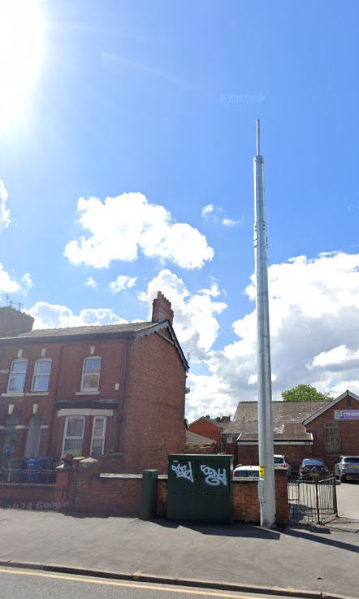
Figure 1: Photograph of the existing pole

  - The potential scope for an assessment of the ‘siting and appearance’ through a Prior Approval application is limited, given the size of the antennae and fall-back option of continuing to use the structure as a pole for the carrying of fibre cables. The assessment should, therefore, relate only to the introduction of the antennae and not an assessment of the existing host structure, which has already been erected by lawful means. Very exceptional justification would then be required for the LPA not to issue ‘Prior Approval’ given the very limited impact associated with the proposed antennae and associated equipment, which is illustrated on the drawing below.
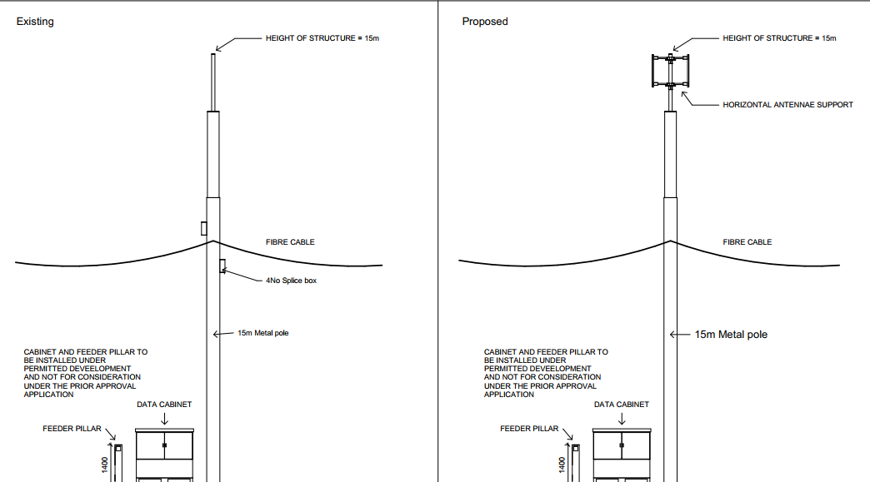
Figure 2: Extract from the existing and proposed elevation plans
  - In respect of the current application, the submitted plans and elevations demonstrate that the proposed antennae would be located between 12 and 15m from the ground. It is considered that the features are so small that their siting and appearance cannot be considered material and hence unacceptable by virtue of their prominence or impact on amenity. The Applicant submits that this has previously been confirmed by the decision dated 30 August 2022 in respect of application 134035/LP/2022 and 141033/TEL/2024
  - Indeed, the additions are no greater in terms of their impact than the existing splice boxes on the pole. It is therefore considered that it would be wholly unreasonable for the LPA to present objections or believe there are exceptional reasons for the LPA to object to the additions.
  - Even with the antennae, the structure continues to be very similar to, if not less intrusive than other forms of vertical structures which are already evident across the local authority area and country more generally; including poles carrying CCTV equipment and telegraph poles of varying types. These are also most often erected under the provisions of the GPDO (and will continue to be erected) without any application having been made to the LPA. This alone forms an important material consideration in favour of the application.
  - Under the provisions of the GPDO, there are no other material considerations to assess.
  - In accordance with Para A.3 – (1), Evidence has also been provided to confirm that notice has been served on the landowner.

/5 PLANNING CONSIDERATIONS AND CONCLUSIONS

  - The Applicant is a registered electronic communications code operator and therefore benefits from provisions of Schedule 2, Part 16, Class A of the GPDO.
  - It has been demonstrated, with the LPA decisions, that the existing pole has been erected lawfully. Whilst the Applicant’s position is that prior approval is not required, and making this application without prejudice to that position, the scope of assessment in considering this application should be properly limited only to the siting and appearance of the antennae to be added to the pole. It is not an opportunity for the LPA to consider the appropriateness of the host structure.
  - Given the small size and sleek design of the antennae and the extremely limited changes to the pole as a result of their addition, the impact of the development in terms of siting and appearance is extremely minimal. Indeed, the fall-back for the continued use of the pole for carrying the suspended fibre cable also represents an important material consideration in favour of the proposal as the fact an existing host structure is to be used to support the antenna will avoid the need for a further host structure/pole to support the apparatus. The structure will moreover continue to be comparable to other street furniture that can often be erected without the prior consent of the LPA.
  - The suite of plans and documents submitted in support of the application is sufficient to enable the positive assessment of the application. Therefore, it is requested that consent is provided at the earliest opportunity.
  - Whilst not referred to within the GPDO, the Applicant has also voluntarily provided a copy of the ICNIRP Certificate relating to the antennae. Should any further information be considered necessary and justified, then the Applicant is willing to discuss this with the LPA. Evidence has also been provided that the owner of the land has been notified of the application.

