Planning

Growth & Development

Delegated officer report for planning application

Application no. 142121/FO/2025
Date registered valid: 11 February 2025
Proposal: Installation of shopfront canopy

Address: 102 Great Western Street, Manchester, M14 4RA
Ward(s): Moss Side Ward
Applicant: Mr Masuod Abubeker
Agent (if any): Mr Mohamed Muse, Muse Architects

Case officer: Joshua Lee
Tel: 0161 219 2851
Email: joshua.lee@manchester.gov.uk

Recommendation: Approve
Date of recommendation: 12 March 2025

Application details
Type of application: Full Application Consent
Development type: Minor Other
Date of site visit: 26 February 2025
Standard consultations: Printed: 18 February 2025 Expired: 11 March 2025
Neighbour notifications: Printed: 18 February 2025 Expired: 11 March 2025
Site notice: No site notice has been produced
Press advert: No press advert had been published
Departure from Development Plan: No
Environmental Statement: Not required
Listed building: Not applicable
Conservation area: Not applicable
Tree Preservation Order: Not applicable

Description of site/building
The proposal related to a two-storey mid terrace property on Great Western Street. The property features a commercial premises at ground floor (currently in use as a convenience store ‘Marsa mini market’) and a residential dwelling accessed from the rear. The property features a full height outrigger to the rear with a small yard space. The property features an existing unauthorised canopy structure to the shopfront.
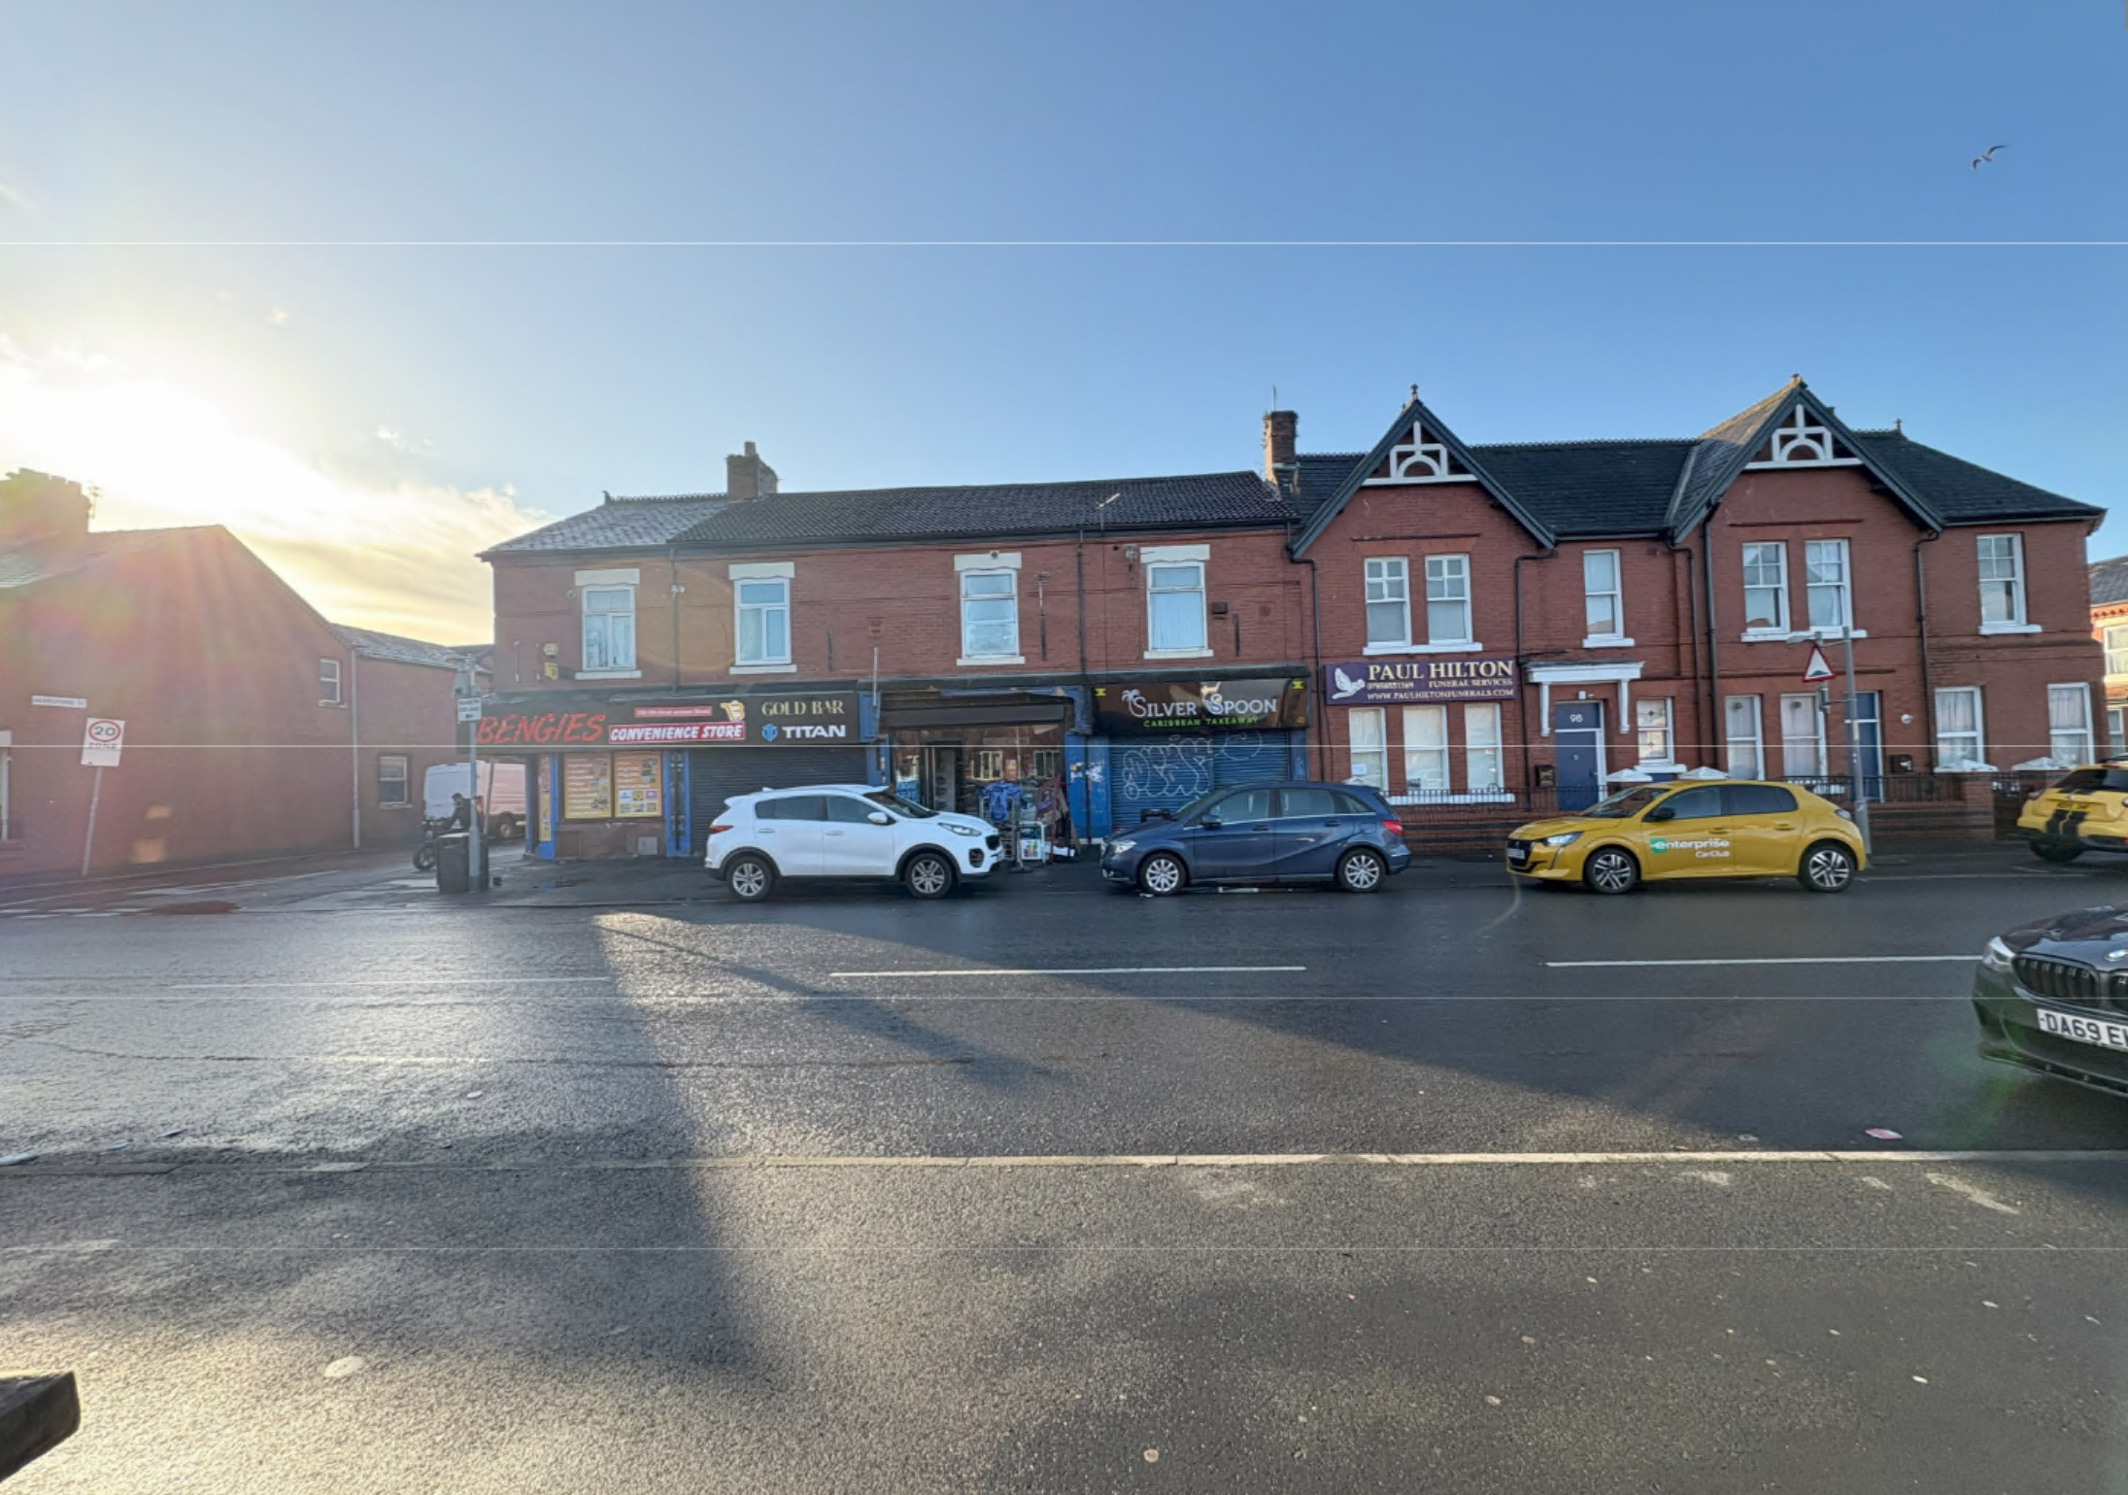
Figure 1. Street scene

Description of area
The application is in a mostly residential part of the Moss Side Ward of Manchester. The property sits within a small row of 5 retail premises which sits either side of residential properties with residential dwellings to front and rear.
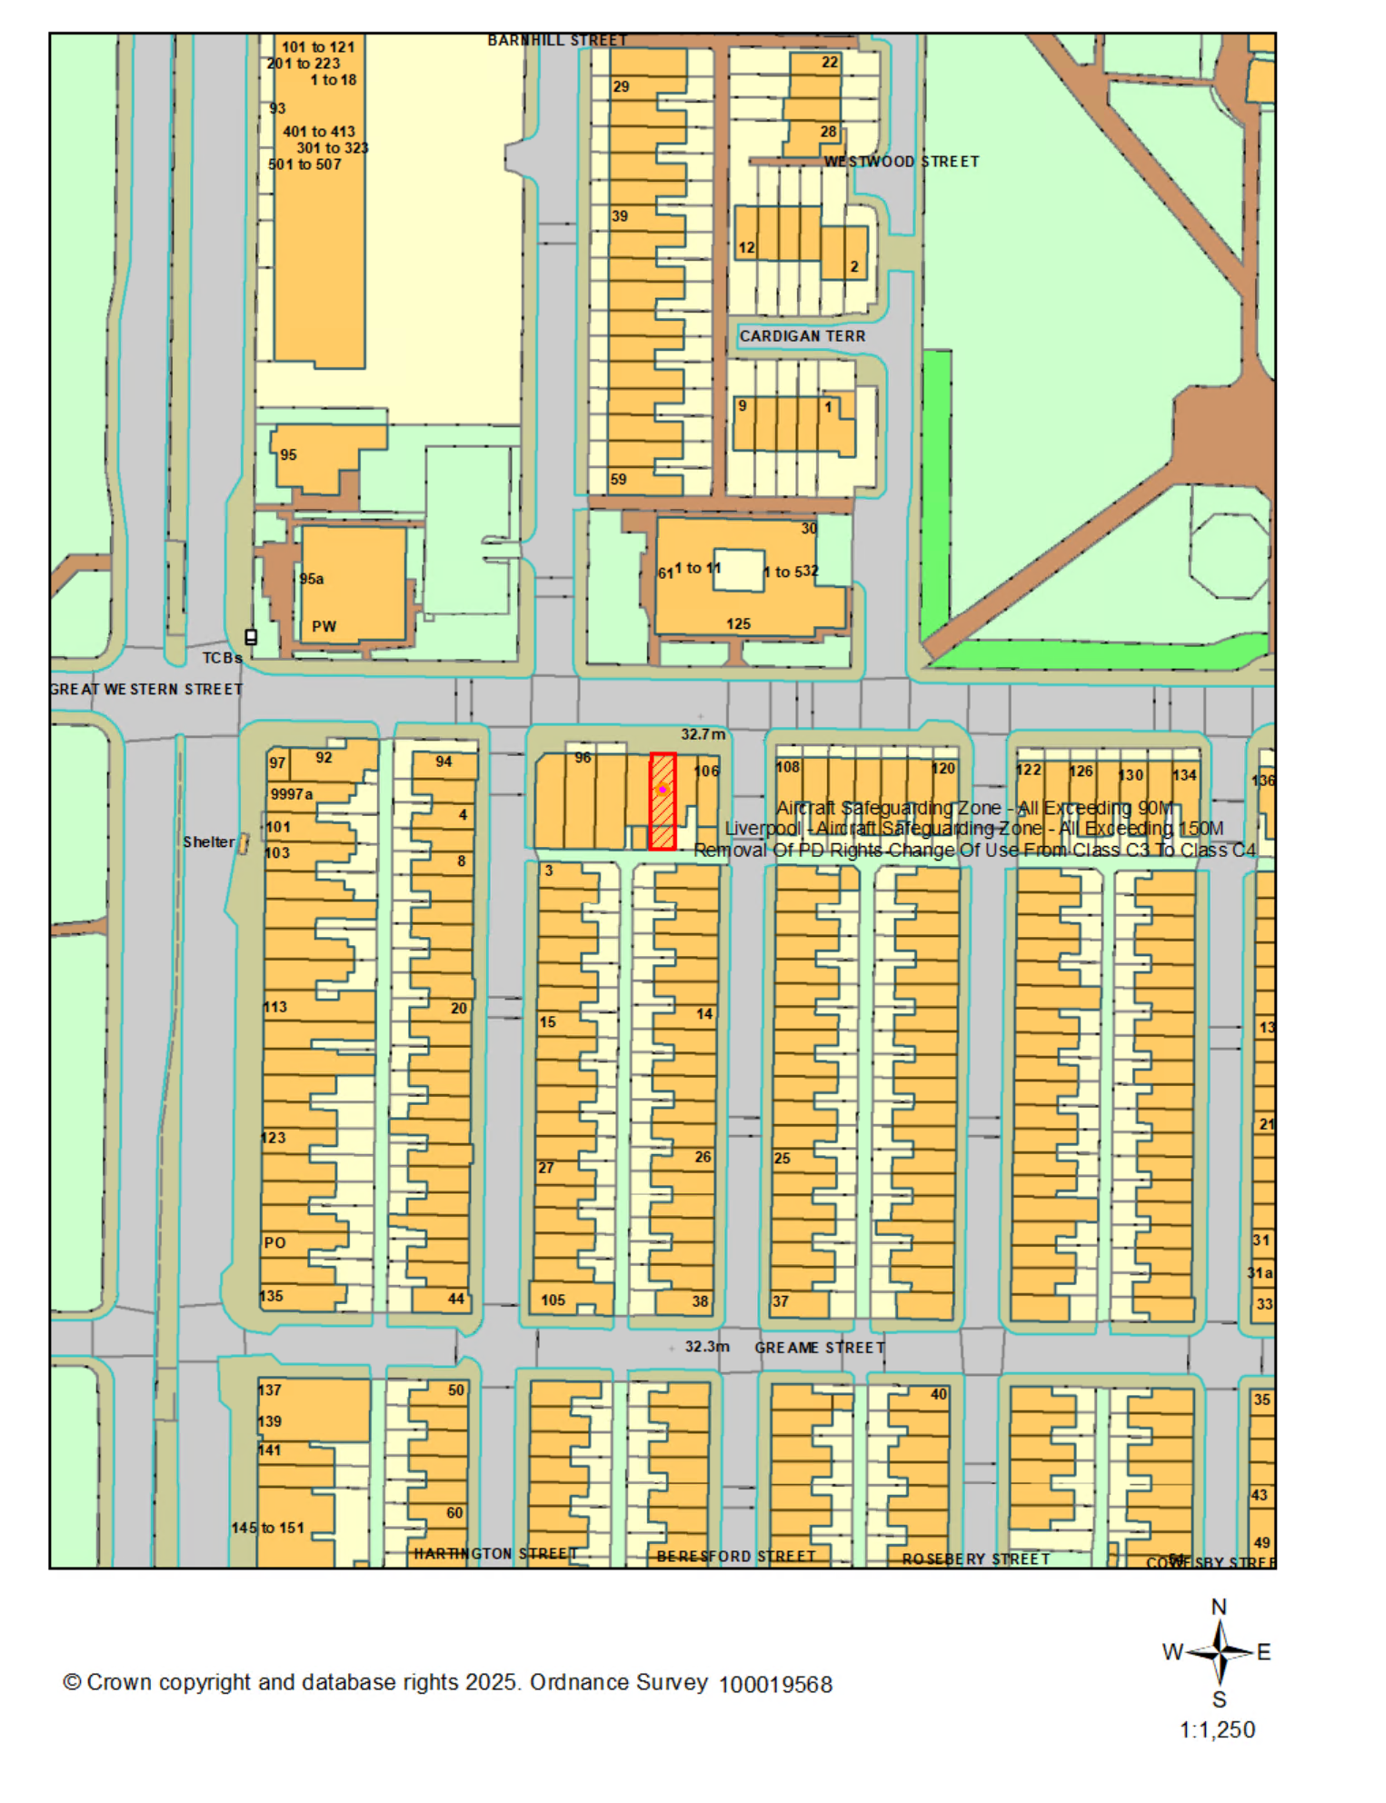
Figure 2. Location plan

Description of development
Installation of shopfront canopy.
The proposed canopy projects 2000mm from the principal elevation and spans 4300mm across the shopfront. The proposed canopy is fixed at 2950mm above ground level.
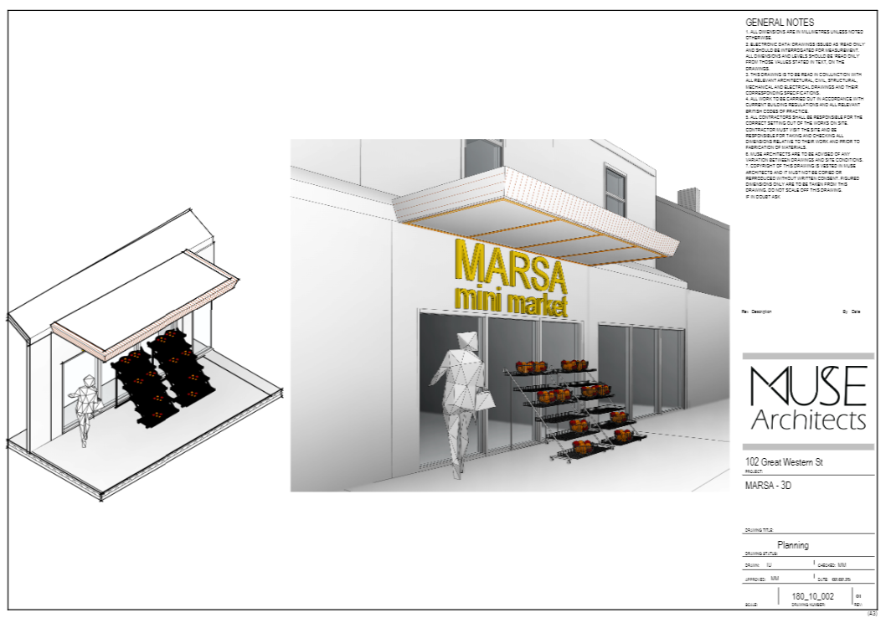
Figure 3. proposed 3D visuals

Planning History

142122/AO/2025
Description: Advertisement consent for the display of internally illuminated fascia sign
Decision: Pending
This is the accompanying advertisement consent.

ENF/15848/24
Description: Enforcement Enquiry - Unauthorised erection of signage to shop front
Decision: Pending consideration.
The current application is to rectify the unauthorised canopy.

036457
Description: Change of use from a shop to a take-away hot food shop
Decision: Approved 20/06/1990

Consultation, notification & publicity responses

Consultations

Manchester City Council Highways Services
Manchester City Council Highways Service were consulted on this application and asked for assurance that to confirm that the canopy will not overhang the adopted footway and carriageway. If the proposed canopy extends over the adopted highway more than 350mm a projection over license will be required. Further clarification is sought regarding the headroom clearance of the canopy, a height of 2.3m, from the ground to the canopy, is recommended.

Notifications

Local Residents
No representations received.

Negotiations
Issues have arisen in the consultation phase which required negotiations in positive and proactive manner.
A permanent fixed canopy is not a feature of properties in the area with mostly residential frontages and would be visually intrusive given the location.
The applicant was asked to consider a rollaway awning which could be stowed during closing ours and that had minimal impact to the front elevation. (New awnings and canopies should be retractable into a blind box and fitted flush with or behind the fascia or shopfront edge.)

UPDATED PROPOSED DEVELOPMENT.
The updated scheme features a retractable canopy which projects a maximum of 1600mm and spans 3950mm across the front of the premises. The awning fully retracts flush into the fascia.
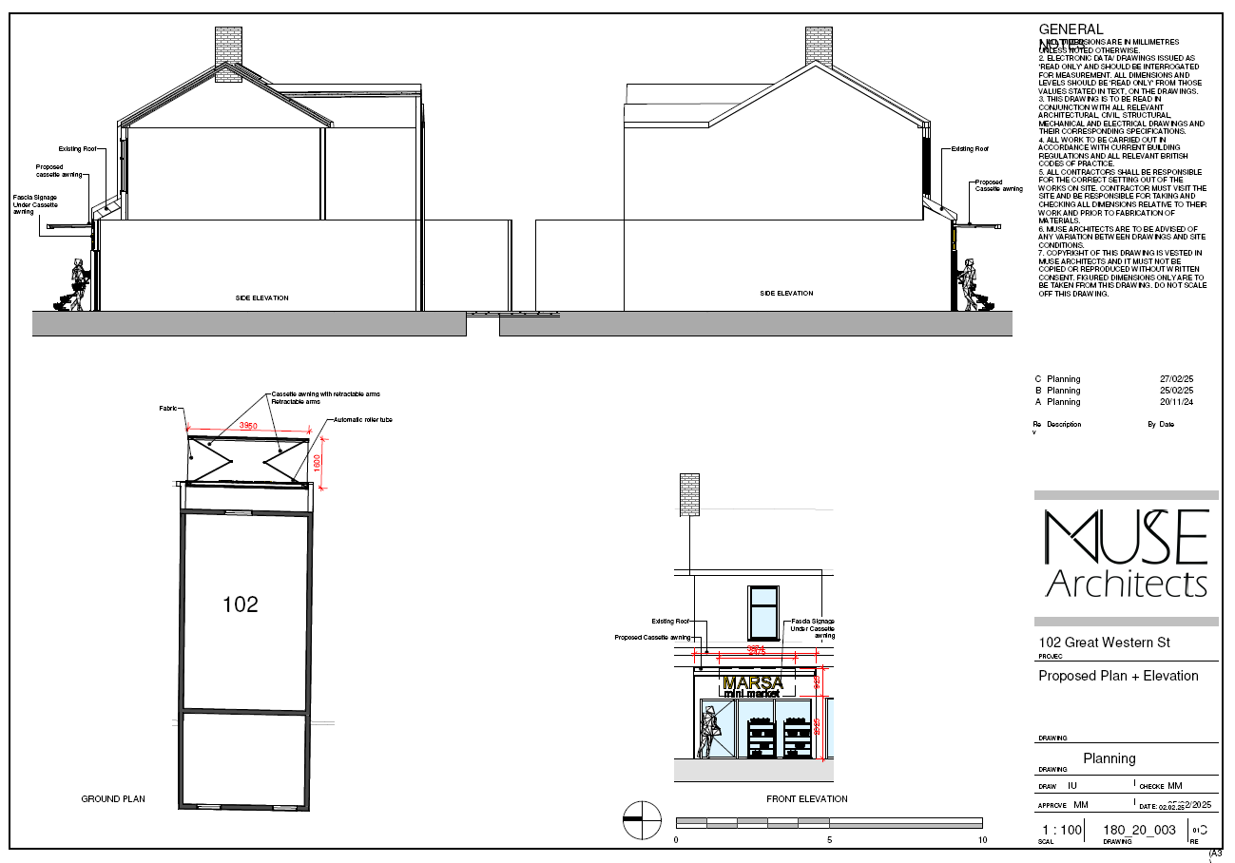
Figure 4. Updated proposed plans and elevations

Consultation, notification & publicity responses to updated descritpion of development
Not required due to reduction in massing.

Relevant policies & the principle of development

Relevant Policies
Section 38 (6) of the Town and Country Planning Act 2004 states that applications for development should be determined in accordance with the adopted development plan unless material considerations indicate otherwise.
The following policies are considered relevant.
- The Manchester Core Strategy Development Plan Document 2012-2027
  - Development Management and Planning Obligations
    - DM 1 - Development Management
  - Objective 1 - Spatial Principles
    - SP 1 - Spatial Principles (Partially replaced by PfE Policy JP-S 1)
  - Objective 2 - Economy and the City Centre
    - EC 1 - Employment and Economic Growth in Manchester
    - EC 2 – Existing Employment Space
    - EC 8 – Central Manchester
  - Objective 6 Environment
    - EN 1 - Design Principles and Strategic Character Areas
- Extant Unitary Development Plan (UDP) –
  - Citywide Development Control Policies
    - DC14 - Shop fronts and related signs
- Supplementary Planning Documents –
  - Shopfront and signage design guide
- Places for Everyone Plan Joint Development Plan Document 2022-2039-
  - Strategy
    - JP-Strat5: Inner Areas
  - Sustainable and Resilient Places
    - JP-S1: Sustainable Development
  - Places for Jobs
    - JP-J1: Supporting Long-Term Economic Growth
    - JP-J2: Employment Sites and Premises
  - Places for People
    - JP-P1 Sustainable Places
- The National Planning Policy Framework (The NPPF) –
  - Section 2 - Achieving sustainable development
  - Section 4 – Decision-making
  - Section 6 – Building a strong, competitive economy
  - Section 12 – Achieving well-designed places

Principle
The City Council recognises retailers want to update and modernise their shopfront to attract new business. This must be done in a way that minimises visual harm to the area. In this case the principle is excepted.

ISSUES

Appropriate siting, layout, scale, form, massing, materials, and detail
The proposed retractable awning is of a size, design and material not uncommon to retractable awnings over shopfronts and provides a way of covering the frontage of the premises whilst respecting the original premises.
The awning is to be stowed away when not required and when the premises is closed. It would be likely that if the awning was branded then it would only require advertisement consent.

Impact on the surrounding areas in terms of the design, scale, and appearance of the proposed development.
The retractable awning is a good balance between provided a feature of the shopfront yet maintain the character of the street scene.
The area is not a designated district centre or local centre so additions to shop frontage must be carefully considered. In this case the awning provides a method of covering the shopfront whilst ensuring the character of the area is not heavily changed with a permanent structure.

Effects on amenity

LIGHT
Given the awning is at ground floor level, only projecting 1600mm and is retractable, the impact to local light would be minimal especially given the adjacent premises are commercial frontages.

ROAD SAFETY AND TRAFFIC GENERATION
The pedestrian access points are acceptable to Highways. For the avoidance of doubt, all external entrance doors (except for fire doors) should be inwardly opening in order to prevent obstruction on the adjacent footway. The changes to the shopfront are not expected to impact local traffic.

Accessibility
The proposal does not change how people can get in and out of the building.

Vehicular access and car parking
The proposal doesn't change how vehicles access and park at the property.

Flood risk and drainage.
The site is not located in a flood risk area and therefore does not require a flood statement or assessment using the existing drainage on site.

Other Legislative Requirements

Equality Act 2010
Section 149 (Public Sector Equality Duty) of the Equality Act 2010 requires due regard to the need to: Eliminate unlawful discrimination, harassment and victimisation and other conduct prohibited by the Act and; Advance equality of opportunity between persons who share a protected characteristic and persons who do not share it. The Equality Duty does not impose a legal requirement to conduct an Equality Impact Assessment. Compliance with the Equality Duty involves consciously thinking about the aims of the Equality Duty as part of the process of decision-making.

Human Rights Act 1998 considerations
This application needs to be considered against the provisions of the Human Rights Act 1998. Under Article 6, the applicants (and those third parties, including local residents, who have made representations) have a right to a fair hearing and to this end the local planning authority must give full consideration to their comments.
Protocol 1 Article 1, and Article 8 where appropriate, confer(s) a right of respect for a person’s home, other land and business assets. In taking account of all material considerations, including Council policy as set out in the Core Strategy and saved polices of the Unitary Development Plan, the Director of Planning, Building Control & Licensing has concluded that some rights conferred by these articles on the applicant(s)/objector(s)/resident(s) and other occupiers and owners of nearby land that might be affected may be interfered with but that that interference is in accordance with the law and justified by being in the public interest and on the basis of the planning merits of the development proposal. She believes that any restriction on these rights posed by the recommendation given is proportionate to the wider benefits of and that such a decision falls within the margin of discretion afforded to the Council under the Town and Country Planning Acts.

Conclusion
The proposed installation of a retractable shopfront canopy at 102 Great Western Street has been carefully considered in terms of its design, scale, and impact on the surrounding area. The updated proposal, which features a retractable awning, addresses initial concerns regarding visual intrusion and compatibility with the predominantly residential character of the area. The canopy will provide functional benefits to the commercial premises while ensuring minimal disruption to the street scene. The application has received no objections from local residents, and consultations with relevant authorities have confirmed that the proposal meets necessary standards. Therefore, the recommendation is to approve the application, subject to the specified conditions.

Recommendation: Approve

Article 35 Declaration
Officers have worked with the applicant in a positive and proactive manner based on seeking solutions to problems arising in relation to dealing with the planning application. There were minor changes required to meet the requirements for approval and the officer and applicant worked together to find an amicable solution.

Condition(s) to be attached to decision for approval

3-year time limit
The development must be begun not later than the expiration of three years beginning with the date of this permission.
Reason - Required to be imposed pursuant to Section 91 of the Town and Country Planning Act 1990.

Specified plans
The development hereby approved shall be carried out in accordance with the following drawings and documents:
  - Drawing - Location Plan 04 Mar 2025 180_00_001 C THE LOCATION PLAN
  - Drawing - Existing 04 Mar 2025 180_00_002 C SITE PLAN
  - Drawing - Existing 04 Mar 2025 180_10_001 C PLANS AND ELEVATIONS
  - Drawing - Visuals 11 Feb 2025 180_10_002 01 3D
  - Drawing - Location Plan 04 Mar 2025 180_20_001 C PROPOSED LOCATION PLAN
  - Drawing - Proposed 04 Mar 2025 180_20_002 C SITE PLAN
  - Drawing - Proposed 04 Mar 2025 180_20_003 C PLANS AND ELEVATIONS
  - Drawing - Visuals 04 Mar 2025 180_20_004 PROPOSED 3D VIEW
Reason - To ensure that the development is carried out in accordance with the approved plans, pursuant to policies DM 1, SP 1 and EN 1 of the Core Strategy and JP-P1 & of Places for Everyone.

Specified materialS
The materials to be used on the external surfaces hereby permitted shall match those as specified on the application form in type, size, colour, and texture.
Reason - To ensure the appearance of the building to be extended is not adversely affected by the materials to be used in the construction of the structure. Pursuant to policies DM 1, SP 1 and EN 1 of the Core Strategy and JP-S1 and JP-P1 of Places for Everyone.

Appendix 1 – List of consultees & neighbours notified
Highway Services
Flat Above, 104 Great Western Street, Manchester, M14 4RA
106 Great Western Street, Manchester, M14 4RA
125 Great Western Street, Manchester, M14 4AW
Flat Above, 106 Great Western Street, Manchester, M14 4RA
104 Great Western Street, Manchester, M14 4RA
Flat Above, 102 Great Western Street, Manchester, M14 4RA
Flat Above, 100 Great Western Street, Manchester, M14 4RA
96 - 98 Great Western Street, Manchester, M14 4RA
100 Great Western Street, Manchester, M14 4RA

Appendix 2 – Planning constraints
Article 4 Direction - Removal Of PD Rights Change Of Use From Class C3 To Class C4
Area Team Boundary - Name: SOUTH AREA

