Planning

Growth & Development

Delegated officer report for planning application

Application no. 142122/AO/2025
Date registered valid: 11 February 2025
Proposal: Advertisement consent for the display of internally illuminated fascia sign

Address: 102 Great Western Street, Manchester, M14 4RA
Ward(s): Moss Side Ward
Applicant: Mr Masuod Abubeker
Agent (if any): Mr Mohamed Muse, Muse Architects

Case officer: Joshua Lee
Tel: 0161 219 2851
Email: joshua.lee@manchester.gov.uk

Recommendation: Approve
Date of recommendation: 12 March 2025

Application details
Type of application: Advertisement Consent
Development type: Advertisements
Date of site visit: 26 February 2025
Standard consultations: Printed: 18 February 2025 Expired: 11 March 2025
Neighbour notifications: Printed: 18 February 2025 Expired: 11 March 2025
Site notice: No site notice has been produced
Press advert: No press advert had been published
Departure from Development Plan: No
Environmental Statement: Not required
Listed building: Not applicable
Conservation area: Not applicable
Tree Preservation Order: Not applicable

Description of site/building
The proposal related to a two-storey mid terrace property on Great Western Street. The property features a commercial premises at ground floor (currently in use as a convenience store ‘Marsa mini market’) and a residential dwelling accessed from the rear. The property features a full height outrigger to the rear with a small yard space. The property features an existing unauthorised canopy structure to the shopfront.
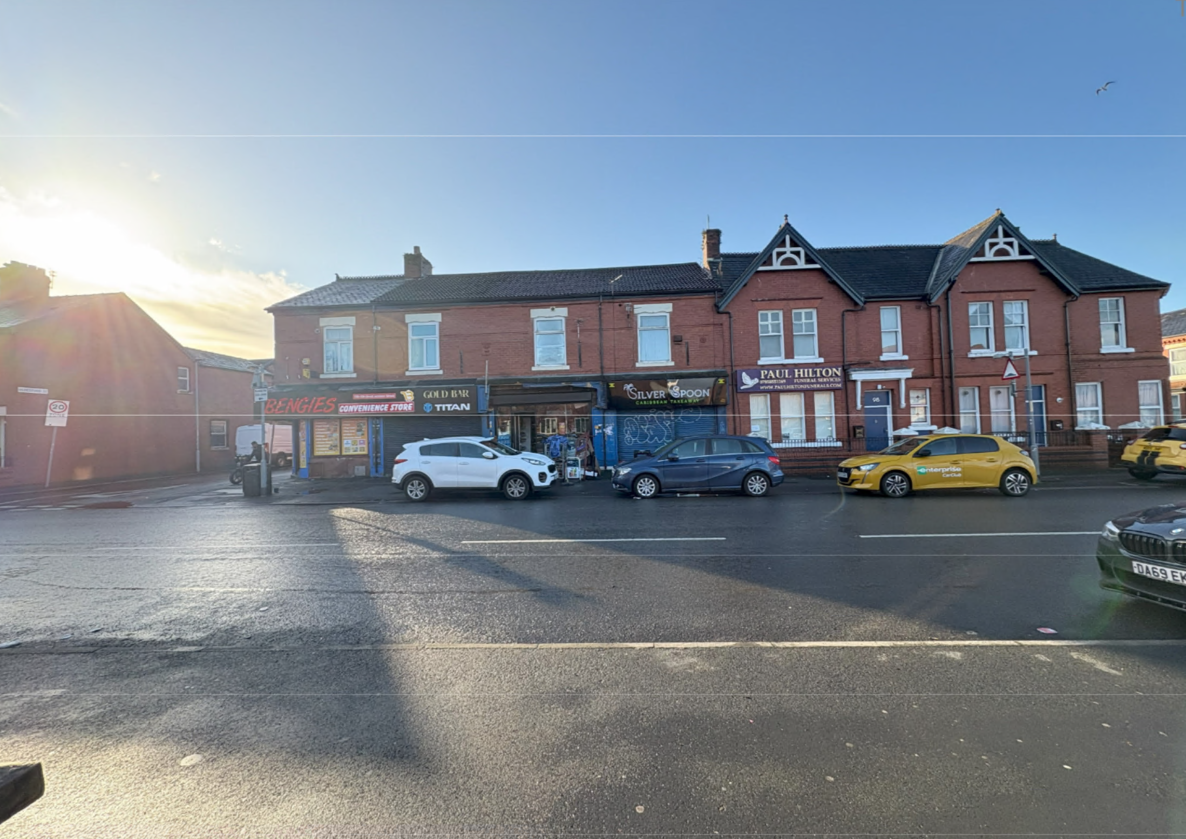
Figure 1. Street scene

Description of area
The application is in a mostly residential part of the Moss Side Ward of Manchester. The property sits within a small row of 5 retail premises which sits either side of residential properties with residential dwellings to front and rear.
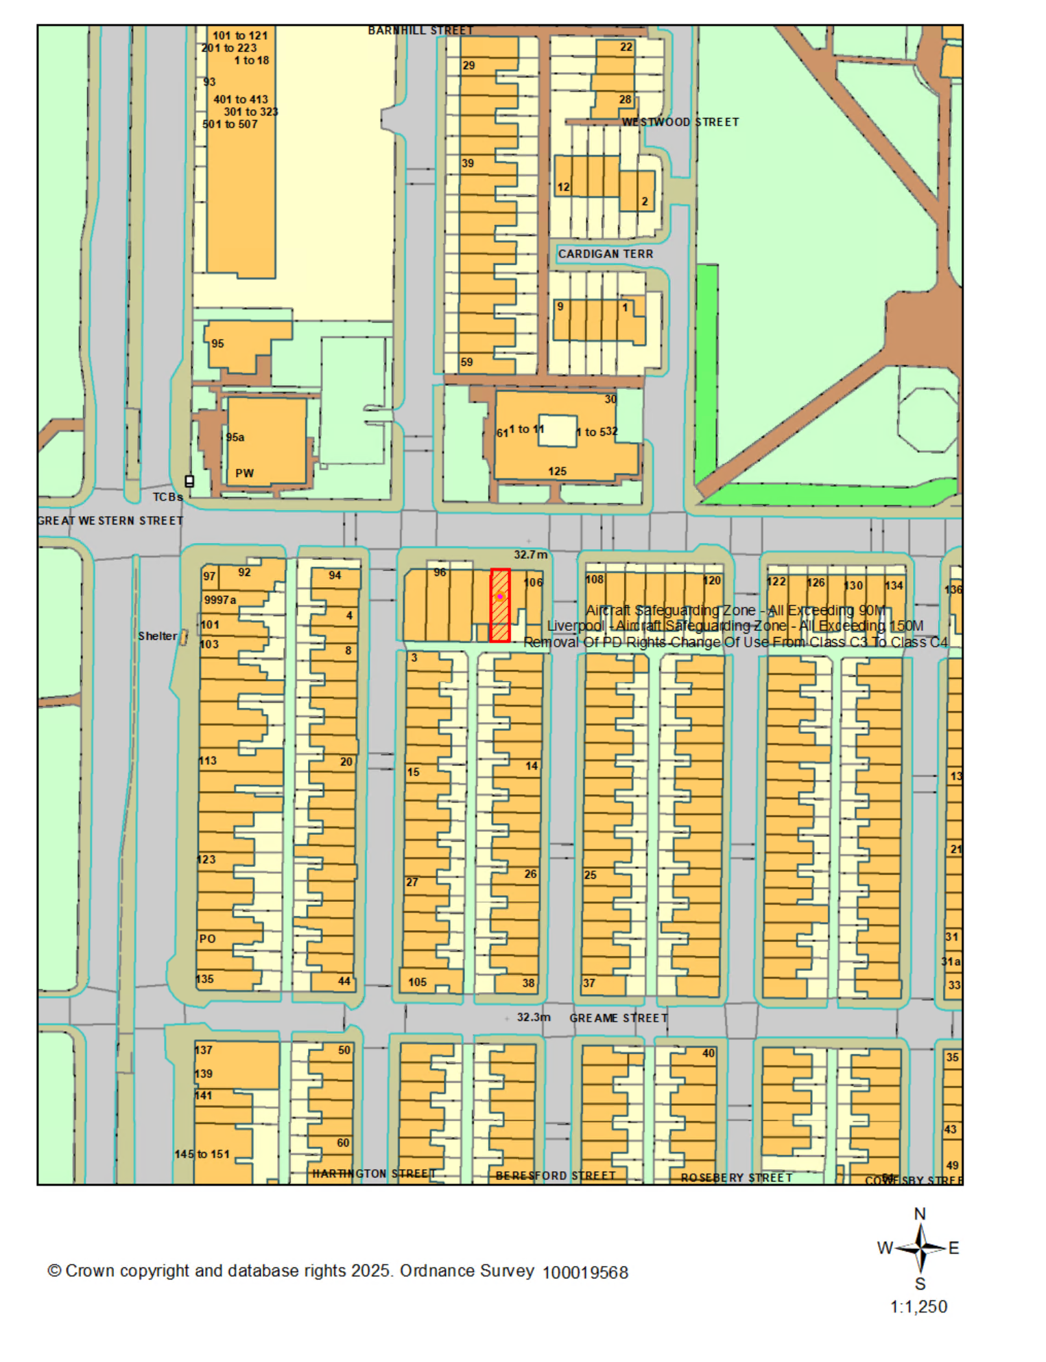
Figure 2. Location plan

Description of development
Advertisement consent for the display of internally illuminated fascia sign
Located on the front of a building (above shopfront). Illuminated as shown in proposed drawings.
Advertisement Type: Fascia Sign Height: 0.92 metres Width: 2.475 metres Depth: 0.2 metres
What is the height from the ground to the base of the advertisement? 2.025 metres
What is the maximum projection of the advertisement from the face of the building? 0.2 metres
What is the maximum height of any of the individual letters and symbols? 9.25 centimetres
What materials will the advertisement be made of? Aluminium illuminated letters. LED Lighting around letters.
The colour of text and background: text in orange, lighting in white.
Will the advertisement be illuminated? Yes
Will the advertisement be illuminated internally or externally? Internally
Illuminance levels: 400 cd/m
Will the illumination be static or intermittent? Static
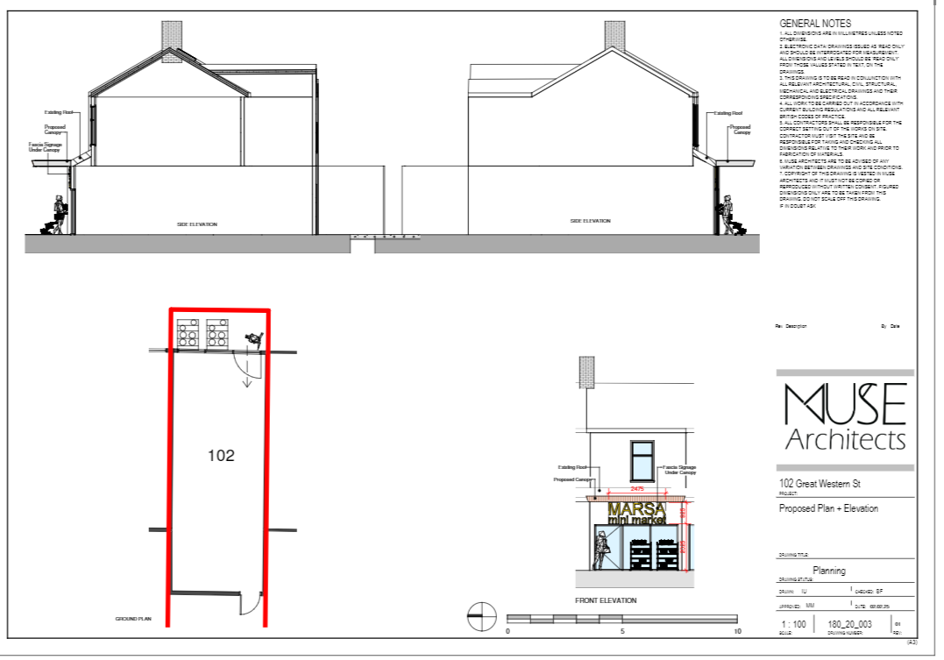

Planning History

142121/FO/2025
Description: 142121/FO/2025
Decision: Installation of shopfront canopy
This is the accompanying consent for the canopy..

ENF/15848/24
Description: Enforcement Enquiry - Unauthorised erection of signage to shop front
Decision: Pending consideration.
The current application is to rectify the unauthorised canopy.

036457
Description: Change of use from a shop to a take-away hot food shop
Decision: Approved 20/06/1990

Consultation, notification & publicity responses

Consultations

Manchester City Council Highways Services
Manchester City Council Highways Service were consulted on this application and had no objections.

Notifications

Local Residents
No representations received.

Negotiations
Issues have arisen in the consultation phase which required negotiations in positive and proactive manner.
A permanent fixed canopy is not a feature of properties in the area with mostly residential frontages and would be visually intrusive given the location.
The applicant was asked to consider a rollaway awning which could be stowed during closing ours and that had minimal impact to the front elevation. (New awnings and canopies should be retractable into a blind box and fitted flush with or behind the fascia or shopfront edge.)

UPDATED PROPOSED DEVELOPMENT.
The updated scheme features a retractable canopy which projects a maximum of 1600mm and spans 3950mm across the front of the premises. The awning fully retracts flush into the fascia.
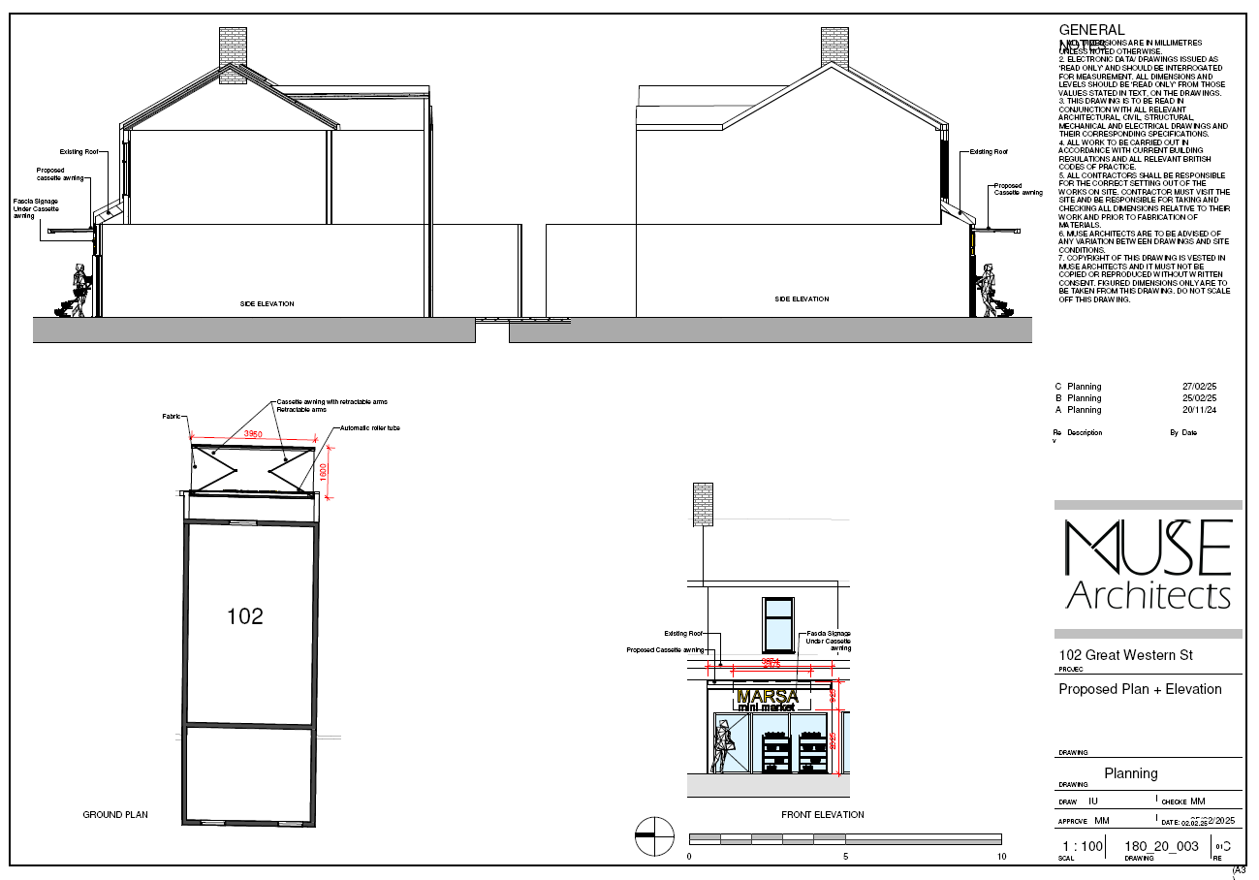
Figure 3. Updated proposed plans and elevations

Relevant policies & the principle of development

Relevant Policies
Section 38 (6) of the Town and Country Planning Act 2004 states that applications for development should be determined in accordance with the adopted development plan unless material considerations indicate otherwise.
The following policies are considered relevant.
- The Manchester Core Strategy Development Plan Document 2012-2027
  - Development Management and Planning Obligations
    - DM 1 - Development Management
  - Objective 1 - Spatial Principles
    - SP 1 - Spatial Principles (Partially replaced by PfE Policy JP-S 1)
  - Objective 2 - Economy and the City Centre
    - EC 1 - Employment and Economic Growth in Manchester
    - EC 2 – Existing Employment Space
    - EC 8 – Central Manchester
  - Objective 6 Environment
    - EN 1 - Design Principles and Strategic Character Areas
- Extant Unitary Development Plan (UDP) –
  - Citywide Development Control Policies
    - DC14 - Shop fronts and related signs
    - DC15 - Advertisements, hoardings and posters
- Places for Everyone Plan Joint Development Plan Document 2022-2039-
  - Strategy
    - JP-Strat5: Inner Areas
  - Sustainable and Resilient Places
    - JP-S1: Sustainable Development
  - Places for Jobs
    - JP-J1: Supporting Long-Term Economic Growth
    - JP-J2: Employment Sites and Premises
  - Places for People
    - JP-P1 Sustainable Places
- The National Planning Policy Framework (The NPPF) –
  - Section 2 - Achieving sustainable development
  - Section 4 – Decision-making
  - Section 6 – Building a strong, competitive economy
  - Section 12 – Achieving well-designed places

Principle
The City Council recognises retailers want to update and modernise their shopfront to attract new business. This must be done in a way that minimises visual harm to the area. In this case the principle is excepted.

ISSUES

Appropriate siting, layout, scale, form, massing, materials, and detail
The proposed signage is appropriately sized and designed to fit on the host premises. The signages sits on above the main windows.
The material is of appropriate use and the design is would not be out of place considering the context in the row of shops.
Existing signage is present at the property and has been an accepted feature on the premises.

Impact on the surrounding areas in terms of the design, scale, and appearance of the proposed development.
The proposed signage is on a Class E premises. There are existing advertisements on the premises and local premises of a similar, style and size, notably the shops adjacent.

Effects on amenity

LIGHT
The proposed luminance of the sign is noted as not exceeding 400cd/m2, which is below the 600cd/m2 maximum recommended for Urban/Suburban advertising illumination as set out in the Institute of Lighting Professionals Professional Light Guide 05 for The Brightness of Illuminated Advertisements. All illumination is noted as static. The illuminated signage would be no more harmful than existing street lighting and fascia illumination in the vicinity.

ROAD SAFETY AND TRAFFIC GENERATION
The proposed signage is not expected to impact road safety and traffic generation with luminance below the recommendation and the projecting sign having sufficient headroom clearance and not requiring a projection over footway license. The applicant is reminded that any construction impacts to the Highways should be discussed with the relevant Highways teams (see informatives)

Other Legislative Requirements

Equality Act 2010
Section 149 (Public Sector Equality Duty) of the Equality Act 2010 requires due regard to the need to: Eliminate unlawful discrimination, harassment and victimisation and other conduct prohibited by the Act and; Advance equality of opportunity between persons who share a protected characteristic and persons who do not share it. The Equality Duty does not impose a legal requirement to conduct an Equality Impact Assessment. Compliance with the Equality Duty involves consciously thinking about the aims of the Equality Duty as part of the process of decision-making.

Human Rights Act 1998 considerations
This application needs to be considered against the provisions of the Human Rights Act 1998. Under Article 6, the applicants (and those third parties, including local residents, who have made representations) have a right to a fair hearing and to this end the local planning authority must give full consideration to their comments.
Protocol 1 Article 1, and Article 8 where appropriate, confer(s) a right of respect for a person’s home, other land and business assets. In taking account of all material considerations, including Council policy as set out in the Core Strategy and saved polices of the Unitary Development Plan, the Director of Planning, Building Control & Licensing has concluded that some rights conferred by these articles on the applicant(s)/objector(s)/resident(s) and other occupiers and owners of nearby land that might be affected may be interfered with but that that interference is in accordance with the law and justified by being in the public interest and on the basis of the planning merits of the development proposal. She believes that any restriction on these rights posed by the recommendation given is proportionate to the wider benefits of and that such a decision falls within the margin of discretion afforded to the Council under the Town and Country Planning Acts.

Conclusion
The proposed internally illuminated fascia sign at 102 Great Western Street has been carefully reviewed and found to be appropriately sized and designed to fit the host premises. The sign's luminance levels are within acceptable limits, ensuring minimal impact on the surrounding area and road safety. The updated scheme, featuring a retractable canopy, aligns with local visual standards and minimizes intrusion. Given the positive consultation responses and adherence to relevant policies, the recommendation is to approve the application.

Recommendation: Approve

Condition(s) to be attached to decision for approval

3-year time limit
The development must be begun not later than the expiration of three years beginning with the date of this permission.
Reason - Required to be imposed pursuant to Section 91 of the Town and Country Planning Act 1990.

Specified plans
The development hereby approved shall be carried out in accordance with the following drawings and documents:
  - Drawing - Location Plan 04 Mar 2025 180_00_001 C THE LOCATION PLAN
  - Drawing - Existing 04 Mar 2025 180_00_002 C SITE PLAN
  - Drawing - Existing 04 Mar 2025 180_10_001 C PLANS AND ELEVATIONS
  - Drawing - Visuals 11 Feb 2025 180_10_002 01 3D
  - Drawing - Location Plan 04 Mar 2025 180_20_001 C PROPOSED LOCATION PLAN
  - Drawing - Proposed 04 Mar 2025 180_20_002 C SITE PLAN
  - Drawing - Proposed 04 Mar 2025 180_20_003 C PLANS AND ELEVATIONS
  - Drawing - Visuals 04 Mar 2025 180_20_004 PROPOSED 3D VIEW
Reason - To ensure that the development is carried out in accordance with the approved plans, pursuant to policies DM 1, SP 1 and EN 1 of the Core Strategy and JP-P1 & of Places for Everyone.

Advertisement mandatory condition
  - No advertisement is to be displayed without the permission of the owner of the site or any other person with an interest in the site entitled to grant permission.
  - No advertisement shall be sited or displayed so as to:
- endanger persons using any highway, railway, waterway, dock, harbour or aerodrome (civil or military);
- obscure, or hinder the ready interpretation of, any traffic sign, railway signal or aid to navigation by water or air; or
- hinder the operation of any device used for the purpose of security or surveillance or for measuring the speed of any vehicle.
  - Any advertisement displayed, and any site used for the display of advertisements, shall be maintained in a condition that does not impair the visual amenity of the site.
  - Any structure or hoarding erected or used principally for the purpose of displaying
advertisements shall be maintained in a condition that does not endanger the public.
  - Where an advertisement is required under these Regulations to be removed, the site shall be left in a condition that does not endanger the public or impair visual amenity.
Reason - In the interests of pedestrian and highway safety, pursuant to Policy DM 1, SP 1 and EN 1 of the Manchester Core Strategy (2012) and The Town and Country Planning (Control of Advertisements) Regulation 2007.

Appendix 1 – List of consultees & neighbours notified
Highway Services
Flat Above, 104 Great Western Street, Manchester, M14 4RA
106 Great Western Street, Manchester, M14 4RA
125 Great Western Street, Manchester, M14 4AW
Flat Above, 106 Great Western Street, Manchester, M14 4RA
104 Great Western Street, Manchester, M14 4RA
Flat Above, 102 Great Western Street, Manchester, M14 4RA
Flat Above, 100 Great Western Street, Manchester, M14 4RA
100 Great Western Street, Manchester, M14 4RA

Appendix 2 – Planning constraints
Article 4 Direction - Removal Of PD Rights Change Of Use From Class C3 To Class C4
Area Team Boundary - Name: SOUTH AREA

