
Albany Road, Chorlton - Schedule of Materials

PROJECT No: | 30-AR | PROJECT NAME: | Albany Road, Chorlton

Author | RAH | Version | 1.0

Notes | Image
Brickwork  Red Smooth Splash Course  Red facing brickwork- Manchester Brick - Calderwood Claret | 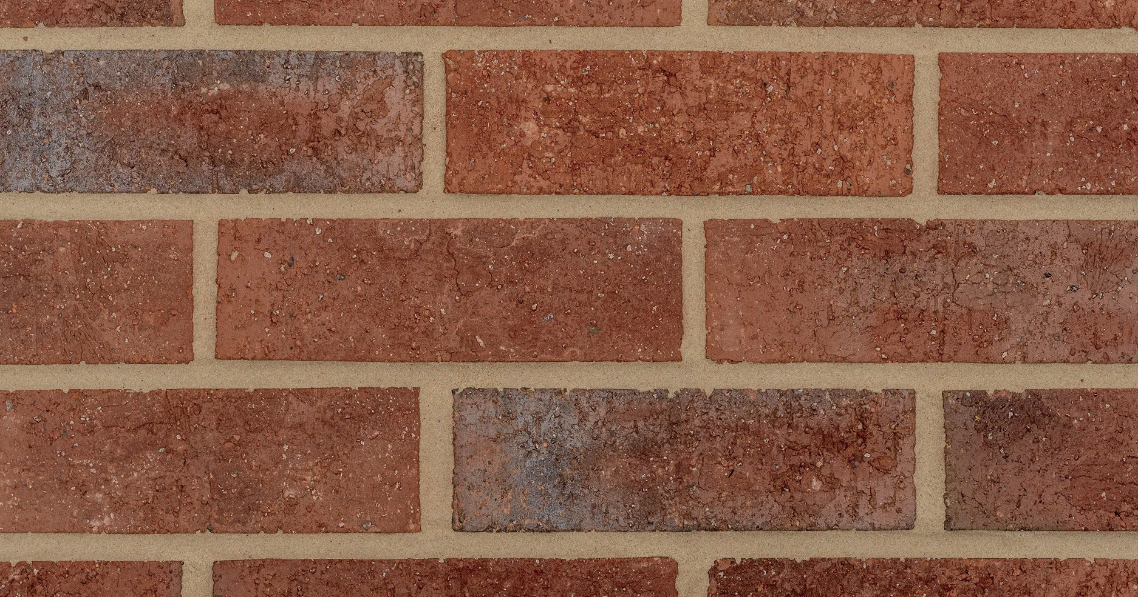
Mansard Roof  Dark grey roof with standing seam single ply | 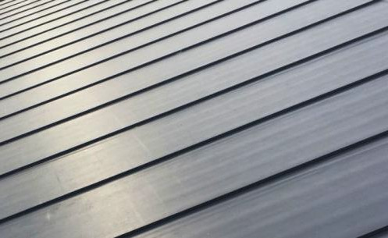
Rainwater Goods  Black round rainwater goods.  Soffit & Fascia & Cappings Grey  RAL 7016. | 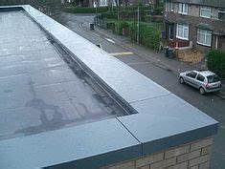

Window Frames  Dark grey UPVc window frames. RAL 7016. | 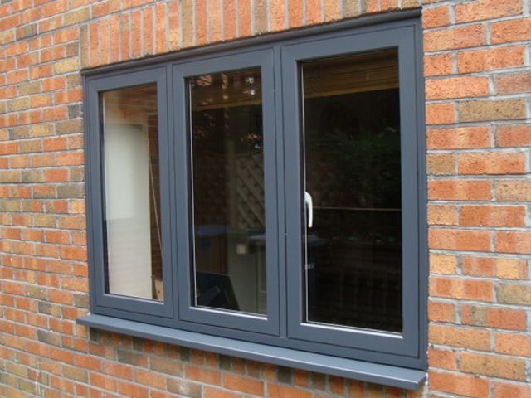
Balcony / Walk out Decking | 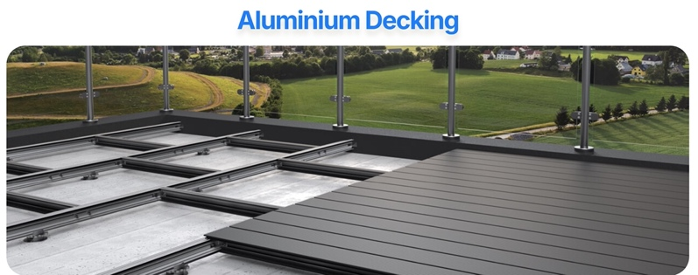
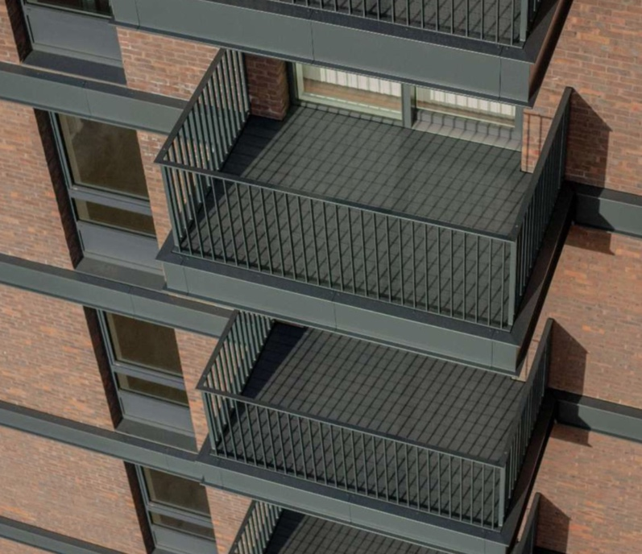 | 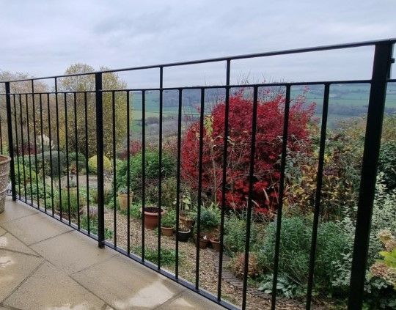
Balcony / Juliette Balustrades

Carpark – Black Tarmac

Parking Bays – Black Tarmac – White lining demarcation.

Apartment Footpaths – Buff Concrete Paving

