

Affordable Housing Statement – Albany Road, Chorlton – April 2025

Proposed scheme
100% affordable housing development compromising 40 x new build apartments for Shared Ownership sale.

Southway Housing Trust
Southway Housing Trust is a community-based housing provider and social enterprise established in 2007, working in Greater Manchester. Southway owns 5,880 properties and all Southway homes exceed the Decent Homes Standard. Our core landlord services achieve above average performance and tenant satisfaction ratings. Southway employs around 200 staff, the majority of whom live in the wider Greater Manchester area and spends around £25million a year to benefit local communities.
Southway Housing Trust are a committed and forward thinking not for profit local housing company and are passionate about providing excellent homes and outstanding customer care. Our Primary Purpose is to provide high quality affordable homes in desirable neighbourhoods where people are happy to live and can reach their potential.
Southway will be the registered provider for Albany Road, which is a 100% affordable scheme in Chorlton, Manchester with all 40 apartments being developed for shared ownership. This is significantly more than the Council’s 40% affordable housing policy requirement the development of the site would normally generate and will help the Authority achieve its annual targets to bring forward new affordable homes each year.
For these Shared Ownership units, the qualifying criteria for nomination to the homes will be as follows:
• Be a first-time buyer or no longer have any interest in any property
• Be in full time employment
• Have a local connection to the area
• Any others
Applicants will need to satisfy an affordability assessment and will only be assessed as eligible on the basis that they require assistance through either shared ownership or rent to buy and that we are satisfied that they are not able to purchase a suitable home outright, at that point in time. The aim of the affordability assessment is to ensure the applicant can sustain their lease/tenancy and afford to make rent payments whilst saving towards a deposit or make rent payments on the unsold equity.

Affordable Housing – Shared Ownership
Home ownership is often beyond the reach of many people in Manchester and especially in high value areas such as Chorlton. Shared Ownership provides the opportunity for would-be purchasers to afford a home which would otherwise be beyond reach given the inflated property values which prevail.
The Shared Ownership model allows people to buy a minimum equity stake of 10% in their new home although the average is typically circa 35%; it is possible to buy as much as 75% at first purchase. A low rent is paid on the remaining equity and the Registered Provider helps with essential repairs for the first 10 years. Shared Owners have the flexibility to buy further equity at their discretion and ultimately the ability to staircase to outright ownership.
A long lease implements the Shared Ownership model which also helps to ensure that the properties are not sublet and remain well managed.

Albany Road, Chorlton
The average age in Chorlton is 36 and most people were born in the UK and Ireland. Employment categories are predominantly professional, including business and media, education, health, science and engineering, admin and secretarial.
Many Chorlton inhabitants will have the aspiration to buy a home and the secure income with which to support a mortgage, however without access to additional funds from family and/or friends they may struggle to raise the necessary.
The area immediately surrounding Albany Road is predominantly large, terraced houses, purpose-built flats and light industrial units. The main neighbourhood centre has a strong retail and leisure offer and is a 5-minute walk from the site. The Metrolink and bus stops are closer still. This locational profile indicates a high level of sustainability in respect of new housing provision.
The land is currently a vacant light industrial unit. The owner has agreed terms with Bowsall Construction who themselves have agreed terms with sale and development of the land for a 40-unit affordable housing scheme which SWHT will own and manage.
The scheme will be funded by a capital grant from Homes England which as a condition of funding obligates SWHT to follow Homes England’s guidance on the development and implementation of Shared Ownership housing.
A good mix of 1- and 2-bedroom flats provides choice for purchasers, who on the one hand might be making the first purchase whilst on the other down-sizing given the easy access to Chorlton centre and public transport.

The proposed new scheme
The proposal is to develop a 100% affordable residential development of 40 new apartments as follows:

No of units | Description | Size (m2)
21 | 1 bedroom 2 person flat
19 | 2 bedroom 3 person flat

- All homes meet or exceed MCC’s Emerging Space Standards and Nationally Described Space Standards.
- 50% of the flats will meet the M4(2) accessibility standard i.e.
- A secure, internal bike store will accommodate 41no. standard bicycles and 2no. cargo bikes.
- Parking will be provided at a rate of 50%. This exceeds the requirement indicated by MCC Planning in pre-application discussions. There will be no right to a space. Most spaces will be sold to flat purchasers. A limited number of spaces will be set aside for EV car charging.
- An EPC energy rating of ‘B’ will be achieved. The scheme will be all electric, no gas. The building fabric insulation and details will be enhanced, and renewable technology will be employed.
- There will be a biodiversity net gain with the inclusion of bat and swift bricks and bird boxes. The communal spaces will have native planting including a native hedge and there will be good pollinators.

The dwellings will be let to eligible households in accordance with Homes England guidance (in particular the Capital Funding Guide) and will meet the definition of affordable housing for rent as set out in Annex 2: Glossary of the National Planning Policy Framework set out below:
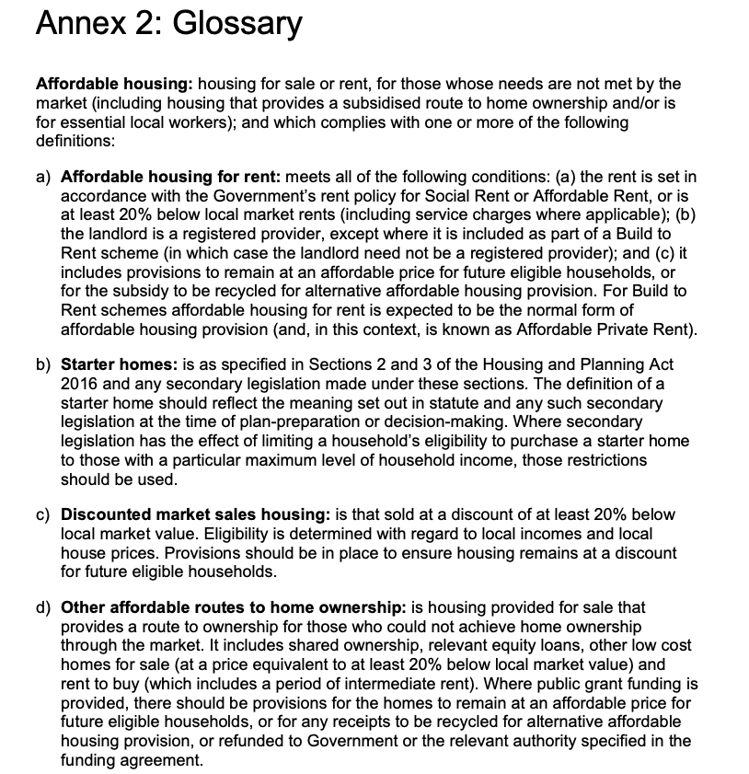
The confirmation at limb (ii) of Condition 33 is hereby given subject to the exceptions and releases set out in this Affordable Housing Statement
In the event of a conflict between the requirements of this Affordable Housing Scheme and the requirements or policies within the Homes England Capital Funding Guide or the terms of any grant funding agreement with Homes England, the requirements or policies within the Homes England Capital Guide and the terms of any grant funding agreement with Homes England shall prevail.
Without prejudice the generality of the paragraph immediately above, the terms of Condition 33 and the terms of this Affordable Housing Scheme and the requirement to observe and perform the contents of this Affordable Housing Scheme are subject to the following exceptions and exclusions:
(a) Condition 33 and this Affordable Housing Scheme shall not be binding upon a mortgagee, chargee or any receiver (including an administrative receiver) appointed by such mortgagee or chargee or any other person appointed under any security documentation to enable such mortgagee or chargee to realise its security or any administrator (however appointed) including a housing administrator (each a Receiver) of the whole or any part of the affordable housing or any persons or bodies deriving title through such mortgagee or chargee or Receiver.
(b) Condition 33 and this Affordable Housing Scheme shall cease to apply (and shall be of no further effect) to any dwelling that has been acquired by an the individual owner/purchaser and/or their mortgagee OR any dwelling in respect of which a statutory or voluntary right to buy or acquire has been exercised.
Conclusion
The proposed scheme delivers against a number the key objectives set out in the Manchester Housing Strategy 2022-2032, including:
- Increasing the housing supply
- Meeting increasing demand of social and affordable housing
- High density developments in sustainable locations
- Delivering low/zero carbon newbuild housing
- Out of the 10,000 new affordable homes (2022-2032) over a third of these will be for Shared Ownership.
The scheme demonstrably contributes to these multiple drivers and is a genuinely rare opportunity to deliver a significant number of low-cost home ownership dwellings at an extremely desirable and sustainable location.

Penny Ridgway
Development Officer
Southway Housing Trust

