TRACKER- CDN/25/0084- Former White Moss Road Day Care-Discharge of Conditions 11 (flood risk management), 17 (cycle storage) 21 (external plant) & 22 (acoustic enclosures) attached to planning permission 135788/FO/2022.

Previous attempts to discharge such conditions: CDN/24/0991

11 (flood risk management)

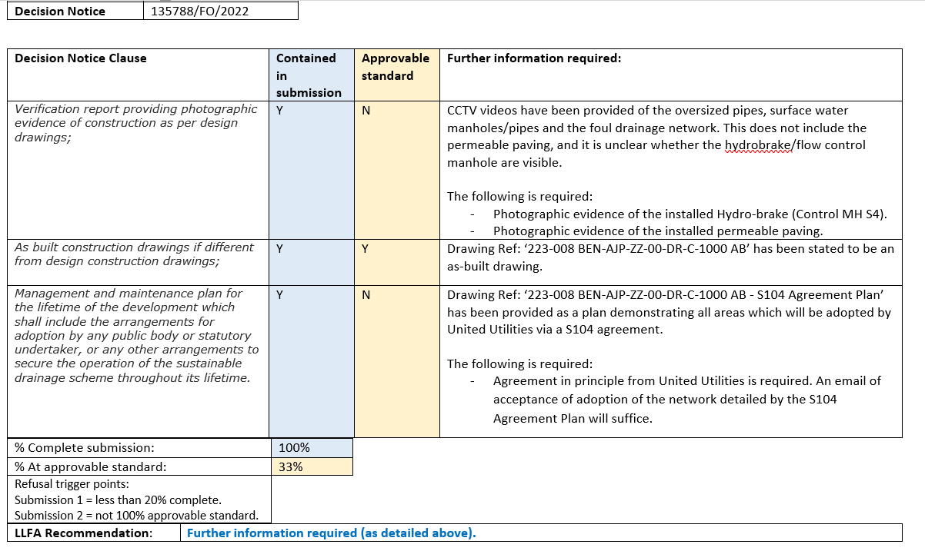

21/3- Further information supplied by agent and sent to LLFA for review.

25/3- Further Flood comments:
The below is sufficient to satisfy the first clause (Verification report providing photographic evidence of construction as per design drawings), however the applicant has still not provided evidence of agreement in principle from United Utilities for adoption of the surface water drainage network.

17 (cycle storage)

CDN/24/0991: The outstanding evidence is required:
-A plan clearly identifying the secured cycle storage and its position on site

CDN/25/0084:
-Location plan and bike store specification provided for review.

Happy to recommend discharge of condition.

21 (external plant)

CDN/24/0991: The outstanding evidence is required:
-The assessment doesn't include assessment of cumulative noise impact of more than 1 unit in operation which is likely, especially at those properties and blocks where the units are in very close proximity to each other, as requested within previous Environmental Health comments.
-Environmental Health request sight of the cumulative rating at the 1st floor bedroom windows at night and when considering that the predicted rating is currently the same as the target, the cumulative noise level of more than 1 unit in close proximity may lead to an exceedance of the criteria and mitigation measures may be required. Until such details are received and agreed, condition 21 cannot be discharged.

CDN/25/0084:
Environmental Health response:
I have had a look at the above discharge application and it doesn’t look like anything additional has been submitted from my previous comments to address conditions 21 and 22 and the same E3P report dated 6th January 2025 reference 50-477-Tn3 has been submitted which I have already responded to.

I have included my previous comments below for ease:
Condition 21
The assessment indicates that the noise level from the proposed units will not exceed the criteria in the garden spaces during the day and will meet the target of 35dB at the façade of 1st Floor bedroom windows at night. The assessment includes a 2dB feature correction penalty which we agree with.

However, the assessment doesn’t include assessment of cumulative noise impact of more than 1 unit in operation which is likely, especially at those properties and blocks where the units are in very close proximity to each other as requested in our earlier comments.

We will need a cumulative rating at the 1st floor bedroom windows at night and when considering that the current predicted rating is currently the same as the target, the cumulative noise level of more than 1 unit in close proximity may lead to an exceedance of the criteria and in which case mitigation measures will be required.

21/3- Further information supplied by agent and sent to EH for review.

22 (acoustic enclosures)

CDN/24/0991: The outstanding evidence is required:
-Any acoustic enclosures to be used will need to be specified and recommended by the consultant and provided for review by the LPA

CDN/25/0084:
Environmental Health response:
Nothing seems to have been submitted to addresses this condition and there hasn’t been any comment in the report with reference to any acoustic enclosures

LPA:
Please give written confirmation as to whether any acoustic enclosures are required and if so provide details. Please make explicit reference to this within the acoustic report.

21/3- Further information supplied by agent and sent to LLFA for review.

