ARR/C/3905.01

28th February 2025

Four Pillars Investment (Manchester) Ltd

Assessment of noise at Potato Wharfe for proposed development as Air BnB Units

Prepared for :-

Four Pillars Investment (Manchester) Ltd
c/o 40 Potato Wharf
Manchester
M3 4BB

Prepared by :-

Andrew Raymond

CONTENTS

- SUMMARY

- INTRODUCTION

- ASSESSMENT STANDARDS

- NPPF, NPSE and NPPG
- BS 8233
- Local Authority

- GUIDE TO MODELLING

- SURVEY DETAILS

- Site Times and Personnel
- Instrumentation
- Measurement Positions
- Survey Conditions

- RESULTS AND DISCUSSIONS

- Basic Results
- Assessment
- Modelled Levels and Mitigation
- Ground Floor Commercial Uses

- CONCLUSIONS/RECOMMENDATIONS

Appendix 1: Definition of Acoustic Terms
Appendix 2: Measurement and Calculation Details
1.0 SUMMARY

The dominant noise sources during the daytime and evening were road traffic on the surrounding roads and the train and tram lines at the rear. During the later evening period and night the noise had reduced to the occasional vehicle, train and tram passing by, with some trains stationary.

Ignoring changes to room layouts and fit out, the levels are all well within criteria. By taking account of these changes, the predicted levels in the most exposed living rooms are 1 to 2 dB rooms higher but still well within all criteria. The predicted levels in the most exposed bedrooms are 1 dB lower, so obviously well within all criteria.

Ground floor uses cannot be assessed but basic standards of sound insulation required by Building Regulations should be more than adequate for most uses, such as shops, cafes and takeaways. Any mechanical equipment associated with commercial uses will need to be considered separately.

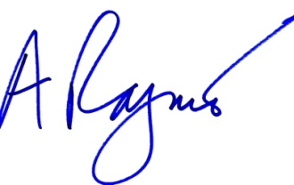
--------------------------------------- ---------------------------------------
A R Raymond P J Durell
2.0 INTRODUCTION

ADC was asked to carry out an independent assessment of the above site with regards to its suitability for residential development from a noise perspective.

This report begins by summarising assessment standards and, where appropriate, discusses alternative interpretations.

After a brief statement of survey details we discuss basic results and the resulting assessment, along with any mitigation which might be implied. We sum-up and conclude at the end, along with brief recommendations.

3.0 ASSESSMENT STANDARDS

3.1 NPPF, NPSE and NPPG

The National Planning Policy Framework (NPPF), the Noise Policy Statement for England (NPSE) and the National Planning Practice Guidance (NPPG) provide nothing in the way of quantitative criteria but instead provide general policy aims and statements and some guidance on how certain situations can be interpreted.

The NPPF’s main statement on noise is to be found in paragraph 198:-

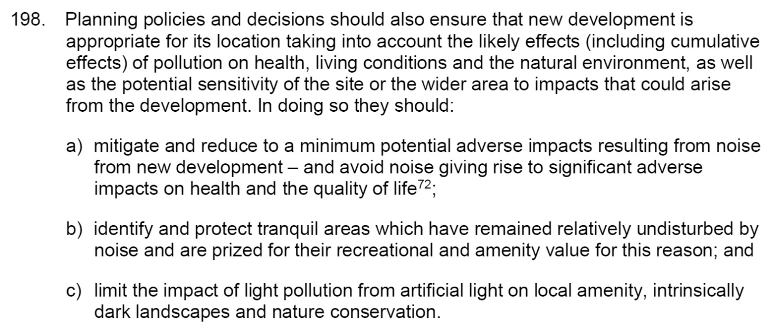

Paragraph 200 is also relevant:-

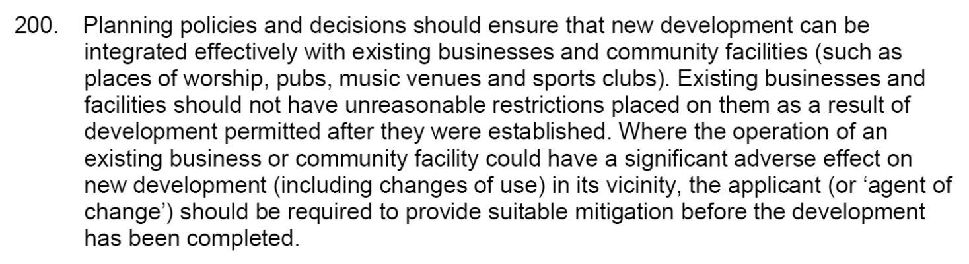

The NPPF refers to the NPSE which sets out the following aims:-

- avoid significant adverse impacts on health and quality of life;

- mitigate and minimise adverse impacts on health and quality of life;

and

- where possible, contribute to the improvement of health and quality of life.

It also introduces the concepts of:

- NOEL – No Observed Effect Level. In simple terms, below this level, there is no detectable effect on health and quality of life due to the noise.

- LOAEL – Lowest Observed Adverse Effect Level. This is the level above which adverse effects on health and quality of life can be detected.

- SOAEL – Significant Observed Adverse Effect Level. This is the level above which significant adverse effects on health and quality of life occur.

SOAEL is clearly something the policy seeks to avoid in aim 1. Aim 2 represents situations between SOAEL and LOAEL, and seeks to minimise and mitigate the effects.

The NPPG section on noise adds some further detail, much of it reproducing the NPPF and NPSE, but some useful qualitative guidance is provided Noise Exposure Hierarchy, as follows:-

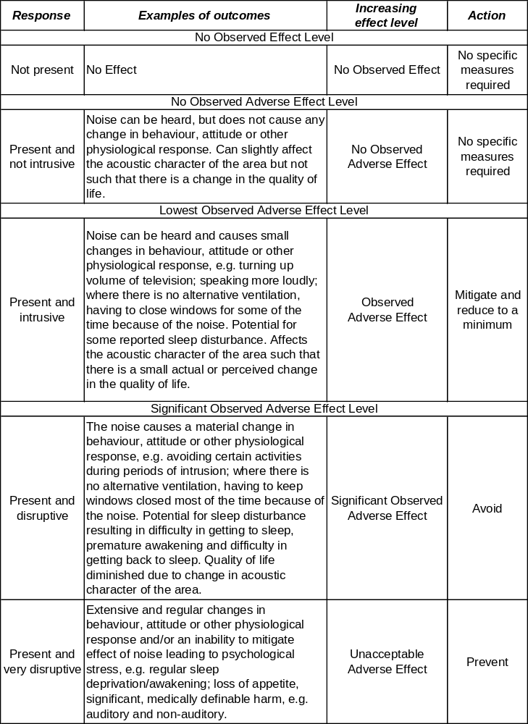

It also makes the point that the subjective nature of noise means that there is not a simple relationship between noise levels and the impact on those affected. This will depend on how various factors combine in any particular situation, including the level of the noise in absolute terms and how it might compare with the underlying background noise, the impulsiveness or intermittence pattern of the noise, its spectral content, and the time of day. It discusses in very general terms the issues to consider when introducing noise sources to existing noise sensitive area, new residential development in areas affected by existing noise sources (most of which have their own specific guidance, such as BS 4142, BS 8233, etc.) and the potential impact on wildlife.

3.2 BS8233 and WHO

BS 8233 was updated in March 2014. Its guidance is primarily intended for new buildings, but the criteria are routinely referred to for putting general noise climates into context.

The criteria in Table 4 of BS 8233 are based on WHO guidance and give the desirable criteria for indoor ambient noise levels for dwellings as follows:-

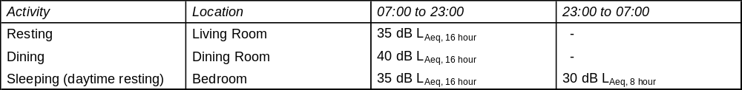

The standard does not explicitly state criteria for bedroom noise in terms of dB L_{Amax} but the WHO Guidelines for Community Noise (or similar) are widely used with a recommendation that the noise inside bedrooms should not typically exceed 45 dB L_{Amax}, for instance no more than 10 to 15 times a night.

BS 8233 goes on to state that, where necessary, the criteria can be relaxed by up to 5 dB and still achieve reasonable conditions.

Note that the standard accepts the widely used rule of thumb that, for a partly open window, the levels just outside will be 15dB higher than those just inside. Other more recent research suggests a difference of 13 dB. The latter brings us to an external equivalent of the above table, as follows:-

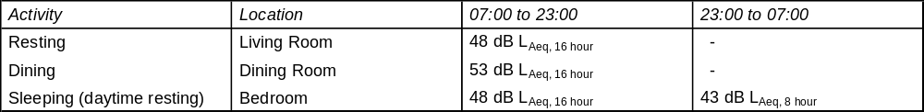

Garden area criteria are 50 dB L_{Aeq} and 55 dB L_{Aeq} being considered desirable and reasonable respectively.

3.3 Local Authority

As far as we are aware no planning conditions have been proposed.

4.0 GUIDE TO MODELLING

Full details of calculations are given in Appendix 2. The basic approach is as follows.

- The external noise break-in is based on the level of external noise just outside the façade(s), the area of the façade(s), the sound insulation properties of the façade(s) and the internal absorption of the room.

- Measurements were made within two of the worst affected. At face value, the measured levels should be reasonably representative of the proposed internal levels. However, we also need to incorporate changes, such as room sizes and layouts, glazing, vents, carpeting, etc.

- We begin by analysing the existing room, and then comparing it to the proposed room(s) where different. The first input to the calculation process is the area of the exposed façade. Where more than one façade is exposed, then they can all be entered. The room depth is also entered so as to derive the room volume. Where the room is not a straight forward rectangular shape, an “effective depth” is sometimes entered so as to derive the approximate room volume. Judgement may occasionally be used if the room is not simple, such as a very unusual shape or a multi-use room such as a through-kitchen/dining room/living room, or studio-style area.

- The reverberation time (RT) is entered. Usually this is a standardised 0.5 seconds for a completed and fitted out room and represents the absorption properties of the room. For an undeveloped site it is usually longer due to the absence of carpets and furnishings.

- Two corrections result from the above inputs. Firstly, we have the Area Correction. Put simply, the greater the exposed area, the more noise will break in. The correction is 10 x log(Effective Area) and is usually a positive number. Note that the “Effective Area” takes account of the method of modelling vents – see later. The Room Correction takes account of the room absorption (more absorption reduces the noise) and the room volume (a larger volume disperses, and so reduces, the noise). The correction is 10 x log(RT/0.163/Volume) and is usually a negative number.

- These corrections, together with the sound insulation properties of the façade(s) give us the basic outside-to-inside level difference. The sound insulation properties of the façade(s), known as the Sound Reduction Index (SRI or just R) are effectively the sound insulation of 1m² of material (apart from vents – see later). Of course, a façade is usually made up of more than one element – windows and walls for instance. The overall SRI or R is referred to as the Composite SRI or composite R and is related to the SRI or R or the individual elements and their respective areas. SRI or R figures are usually based on laboratory tests and therefore somewhat idealised.

- An additional complication is that performance data for vents is generally standardised to 10m². The area of a vent is therefore usually entered as 10m², even though its actual area will usually be nowhere near that much.

- So, the composite SRI or R, combined with the areas and room corrections gives us the basic level difference to be expected under perfect (laboratory) conditions. However, actual site conditions are affected by workmanship, which can never be guaranteed to be perfect, and flanking paths (noise paths other than straight through the façade(s)). Here, however, the measured internal noise includes these and so a correction is not usually required.

- The calculated inside-to-outside level difference for the existing rooms is set against the actual measured levels when looking at the proposed rooms so that any changes (room sizes and layouts, glazing, vents, absorption (fit-out), etc.) can be taken into account and used to calculate the proposed internal levels.

- The process is repeated in octave bands across the frequency range to derive the predicted internal levels.

5.0 SURVEY DETAILS

5.1 Site Times and Personnel

The measurements were carried out by Mark Pimlett of ADC Acoustics.

Measurements were carried out on 3rd February 2025 from approximately 15:30 hours to 11:50 hours the following day. The measurements were periodically attended.

5.2 Instrumentation

Instrumentation used was a Rion NL-52 Class I sound level meter which holds a current calibration certificate and which was field-calibrated as necessary with no drift noted. The meter was set up to measure continuous 5 minute samples in terms of dB L_{eq}, dB L_{max} and dB L₉₀ in overall A-weighted terms, and in octave bands across the frequency range. See Definition of Acoustic Terms in Appendix 1.

5.3 Measurement Positions

The main measurement position was as shown on the following plan.

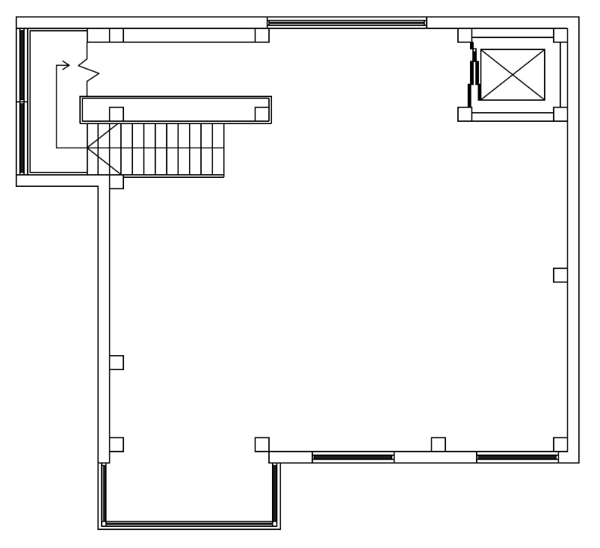

The position represents by far the most exposed position, being just inside the bay area at first floor level. The microphone was 1.3 m above floor.

5.4 Survey Conditions

We have no reason to believe that the conditions we found on the survey were anything other than representative of normal conditions. As the measurements were internal, the weather was not crucial but, for the record, there was no rain and roads were dry, and there was negligible wind. The area was uncarpeted, unfurnished and open-plan, and was quite reverberant.

6.0 RESULTS AND DISCUSSIONS

The dominant noise sources during the daytime and evening were road traffic on the surrounding roads and the train and tram lines at the rear. During the later evening period and night the noise had reduced to the occasional vehicle, train and tram passing by, with some trains stationary.

6.1 Basic Results

Results are presented graphically as follows:-

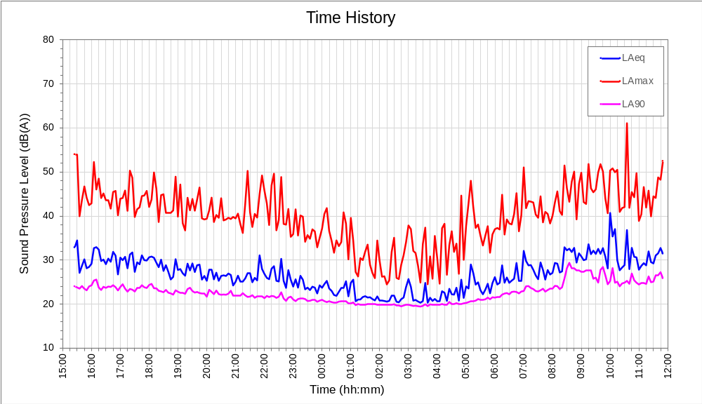

A summary of overall levels is as follows:-

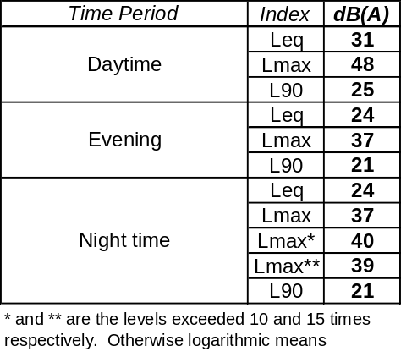

6.2 Assessments

The above results give the following assessments.

In terms of BS 8233, we are mainly concerned with the dB(A) L_{eq} values, or the dB L_{Aeq} levels. See definition of Acoustic terms in Appendix 1. The current version of BS 8233 no longer has night time criteria in terms of dB(A) L_{max} values, or dB L_{Amax} values, but MCC generally prefer the levels to be within 45 dB L_{Amax} no more than 10 times a night.

So, ignoring for now changes to windows, ventilation, room layouts and fit out, the levels are all well within criteria.

6.3 Modelled Levels and Mitigation

The measurements were made with closed windows. In fact the windows were not openable. We are advised that the windows will remain as they are and that mechanical ventilation will be provided, and specified on the basis of closed windows. The design will be self-contained and will not involve trickle vents.

A summary of the predicted levels is as follows:-

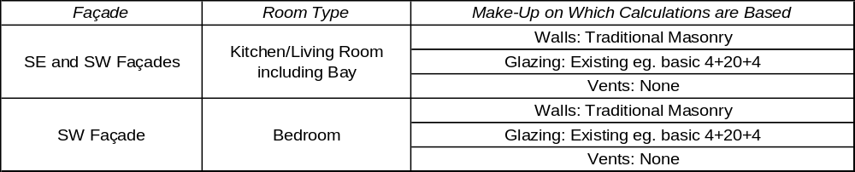

The rooms are used as worst case examples as they are exposed on two facades and/or have large window areas and/or short room depths. Other rooms on the same façade with the same glazing and vent specification can be expected to perform better.

Note that the prediction calculations work on the basis of differences in the glazing (current versus proposed). As the glazing is to be unchanged then the exact specification makes no difference to the calculations but we have used basic thermal double glazing for both.

Full calculation details are shown in Appendix 2 and a summary of predicted internal noise levels is as follows:-

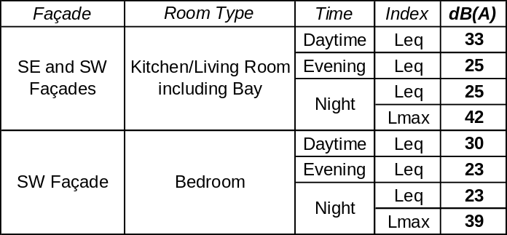

Of course, these assessments are very robust as they use what should be the worst affected rooms. All are well within criteria.

6.4 Ground Floor Commercial Uses

It is not known what uses the ground floor will be put to but basic standards of sound insulation required by Building Regulations should be more than adequate for most uses and particularly retail. It is usual for prospective tenants who seek a noisier use to implement additional sound insulation as part of their fit-out. Our only recommendation is that future tenants should be required to ensure that levels in apartments do not exceed the criteria discussed here and that details of any mechanical equipment is submitted for approval.

7.0 CONCLUSIONS/RECOMMENDATIONS

Ignoring changes to room layouts and fit out, the levels are all well within criteria. By taking account of these changes, the predicted levels in the most exposed living rooms are 1 to 2 dB rooms higher but still well within all criteria. The predicted levels in the most exposed bedrooms are 1 dB lower, so obviously well within all criteria.

Ground floor uses cannot be assessed but basic standards of sound insulation required by Building Regulations should be more than adequate for most uses, such as shops, cafes and takeaways. Any mechanical equipment associated with commercial uses will need to be considered separately.

Our only recommendation is that you issue this report to planners and that Officers are encouraged to contact us with any queries.

Appendix 1

Definition of Acoustic Terms

The Decibel

The decibel is the basic unit of noise measurement and is denoted dB. Technically, it is a means of expressing the difference in noise level between the measured noise and a standard level of noise. Most often the threshold of human hearing is used as the standard reference but is really should be stated. The threshold of human hearing is a sound pressure of 20μPa or a sound power of 1pW.

A sound pressure level or SPL should be expressed in dB(re. 20μPa). A sound power level or SWL should be expressed in dB(re. 1pW). If the reference levels are omitted, it will often (but not always) be safe to assume that they are referenced to the threshold of human hearing.

A-Weighting and dB(A)

The human hearing system responds differently to different frequencies. The A-weighting system takes account of this by emphasising mid and high frequencies more than low frequencies to given an overall level. An A-Weighted noise level, therefore, reflects the way normal, healthy hearing would perceive the overall level of the noise. The basic unit is dB(A), although other systems of expressing an A-weighted level are discussed below.

Other weighting systems, such as C-Weighting, denoted dB(C), reflect the human hearing system’s response at higher noise levels.

Equivalent Continuous Sound Level, L_{eq}

This is a kind of mean noise level.

The unit is dB L_{eq}. For A-weighted levels the unit is dB(A) L_{eq} or, in more modern units, dB L_{Aeq}. The Noise at Work Regulations use L_{eq(s)} which refers to a sample level.

Maximum Level, L_{max}

This is the maximum level reached (usually for a fraction of a second) in the measurement period.

The unit is dB L_{max}. For A-weighted levels the unit is dB(A) L_{max} or, in more modern units, dB L_{Amax}.

Statistical (Percentile) Levels, L_{n}

During a measurement of fluctuating noise, it is often useful to establish the levels exceed for a percentage of the time. L_{n} is the index representing the level exceeded for n% of the measurement period.

The unit is dB L_{n}. For A-weighted levels, the unit is dB(A) L_{n} or, in more modern units, dB L_{An}.

Common examples are as follows :-

dB L_{A90} is the A-weighted level exceeded for 90% of the time and is often used to describe the underlying background noise.

dB L_{A50} is the A-weighted level exceed for 50% of the time. Mathematically, it is the median, another kind of average.

dB L_{A10} is the A-weighted level exceeded for 10% of the time and has traditionally been used to describe the intermittent highs in the noise climate such as passing cars or aircraft.

Frequency Analysis

Here the audible frequency range is divided up into bands and the noise level is expressed in each frequency band form low pitches to high pitches.

Octave Band analysis is where the frequency range is divided into 8 bands from 63 Hz to 8kHz, or sometimes into 10 bands from 31.5 Hz to 16kHz.

1/3 Octave Band analysis provides more detailed subdivision into 24 bands from 50 Hz to 10kHz, or sometimes into 30 bands from 20Hz to 20kHz.

Narrow Band analysis takes this further with the possibility of many thousands of bands, possibly only 1Hz wide, or even less.

In all types of frequency analysis, the level in each band can be expressed in terms of L_{eq}, L_{max}, L_{n}, etc. as defined above.

Appendix 2

Measurement and Calculation Details

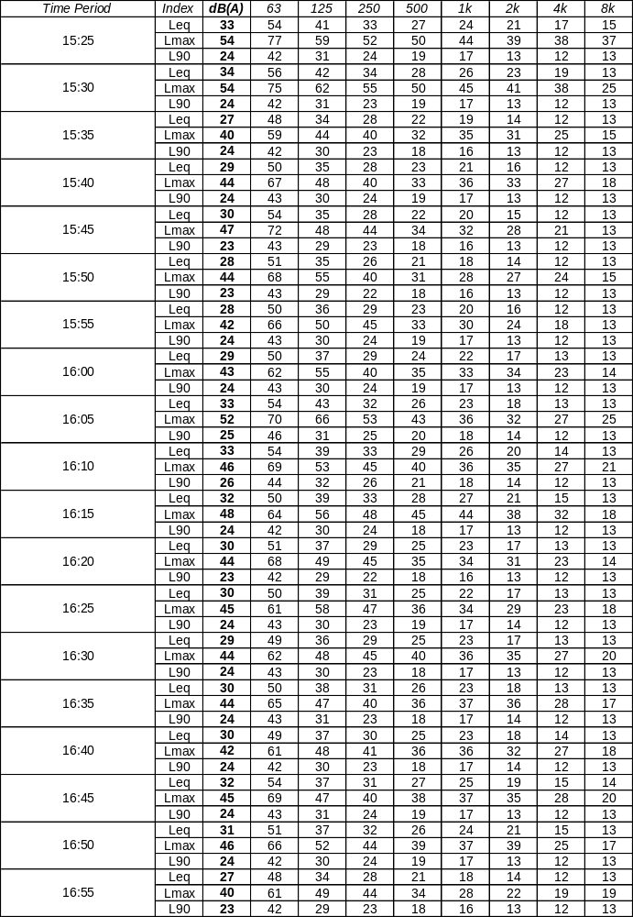

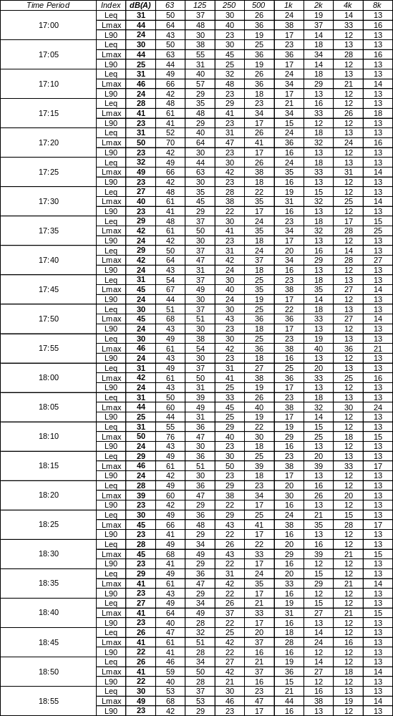

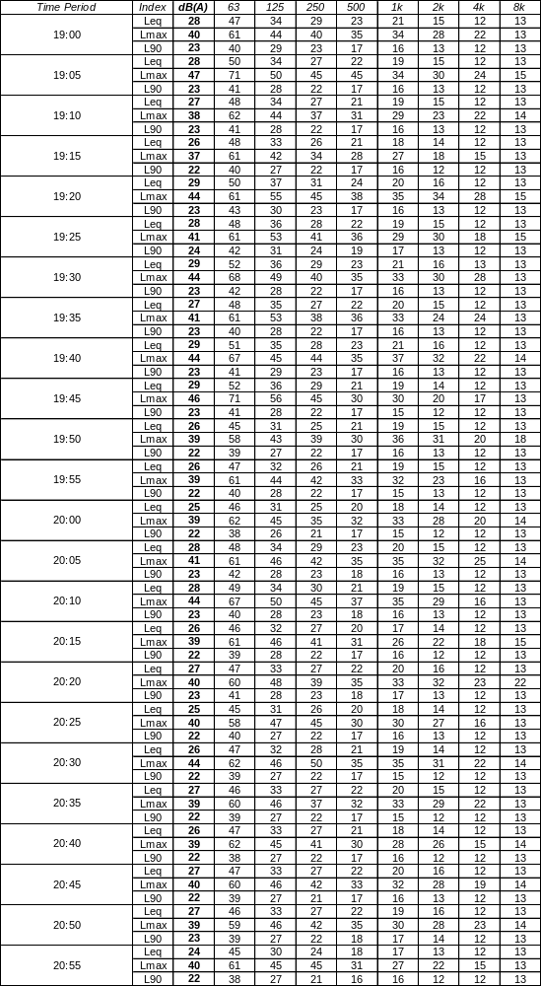

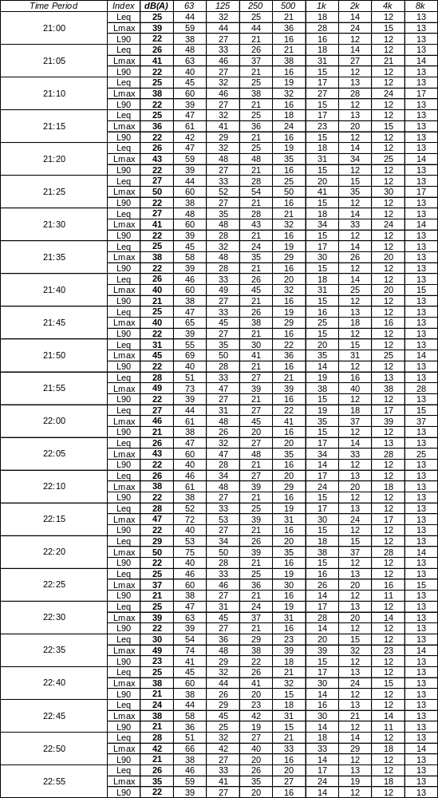

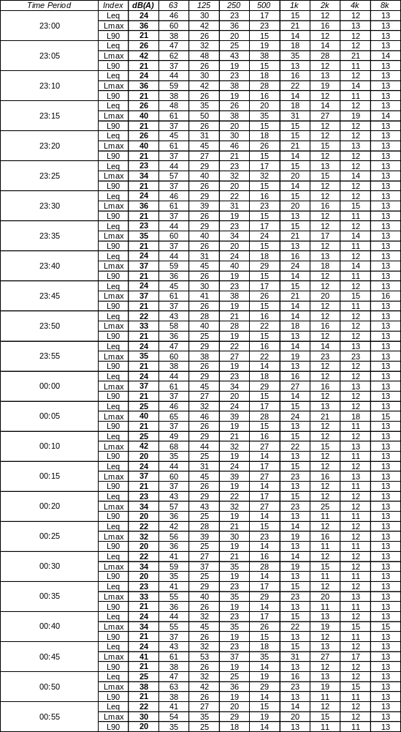

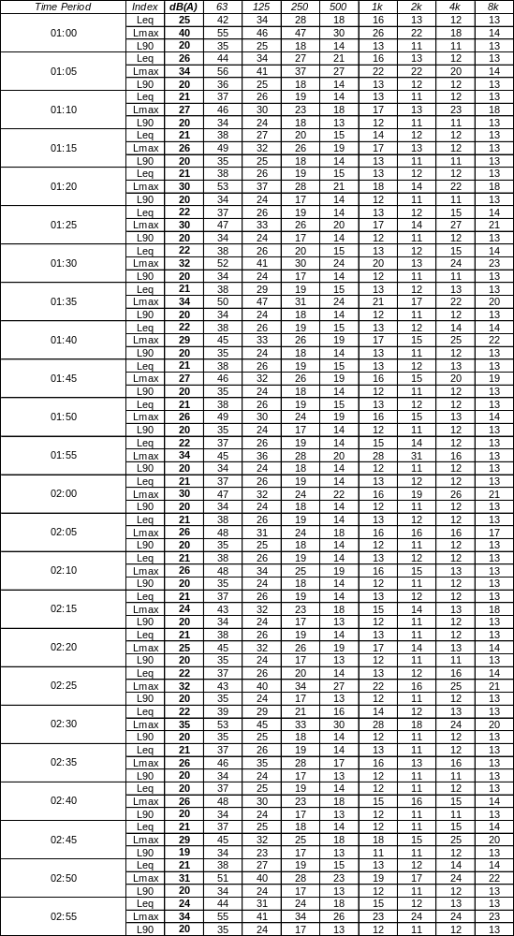

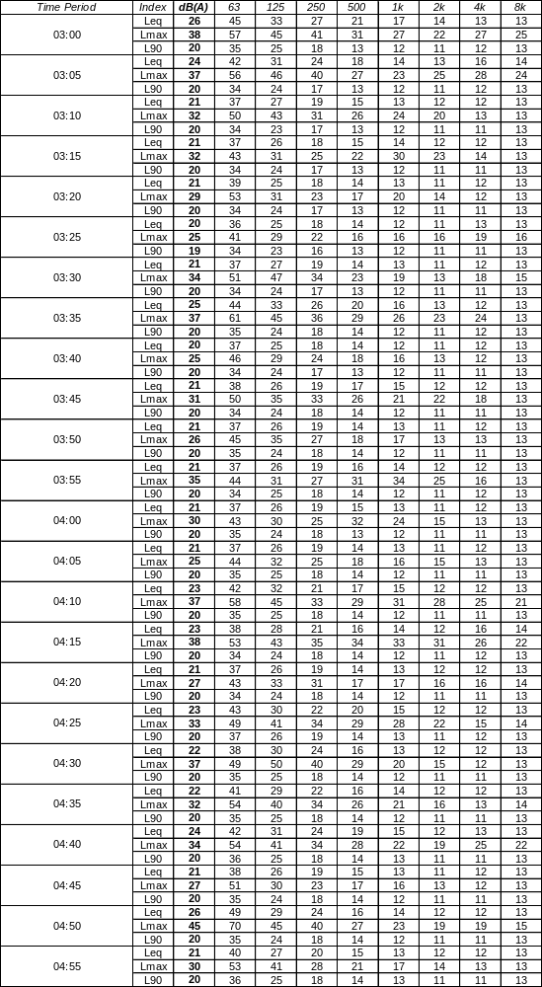

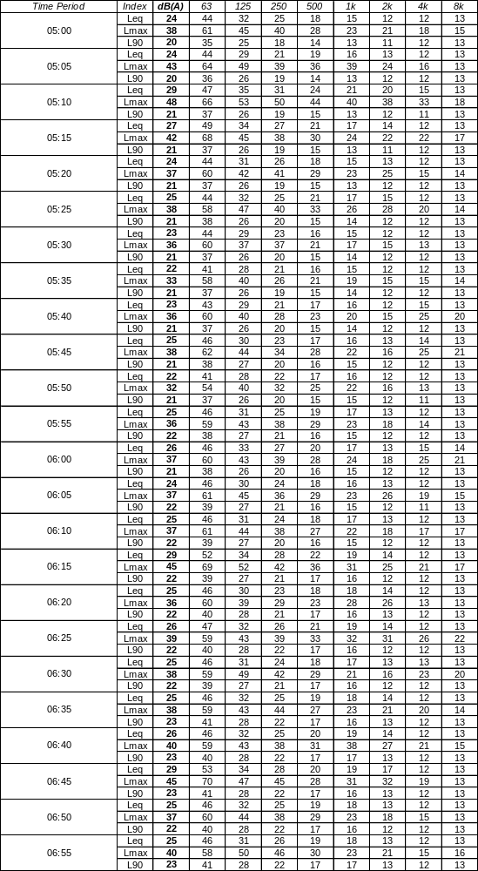

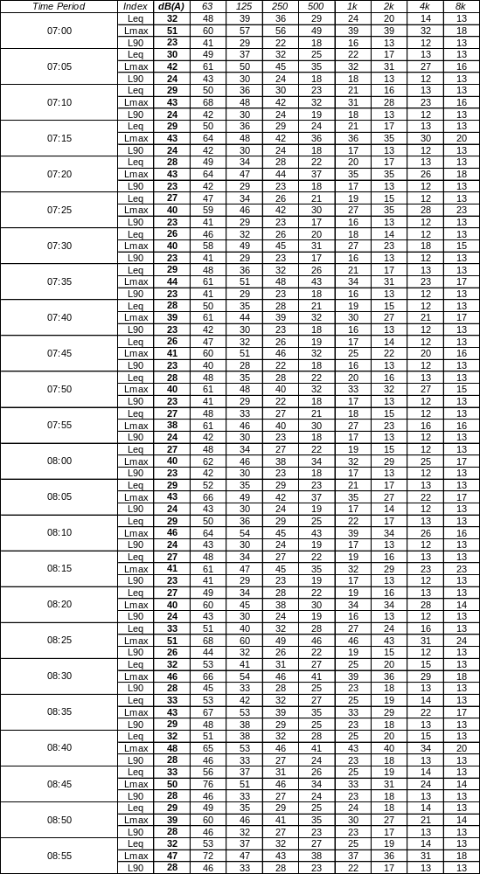

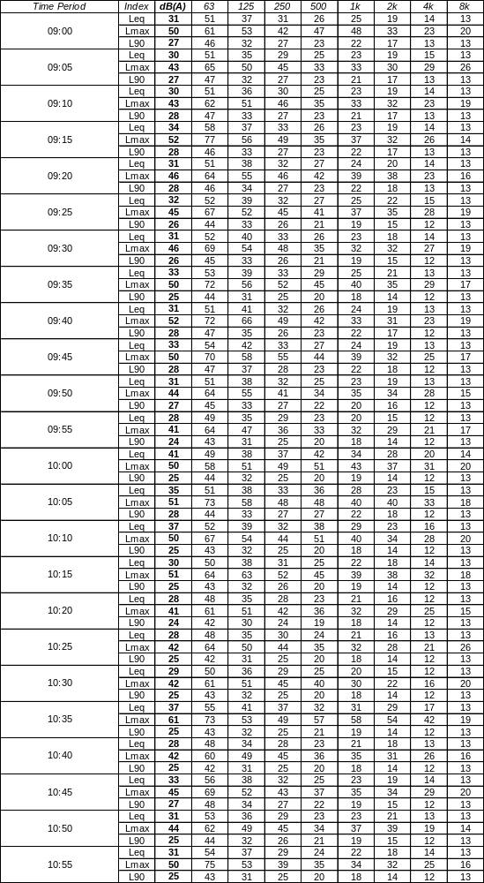

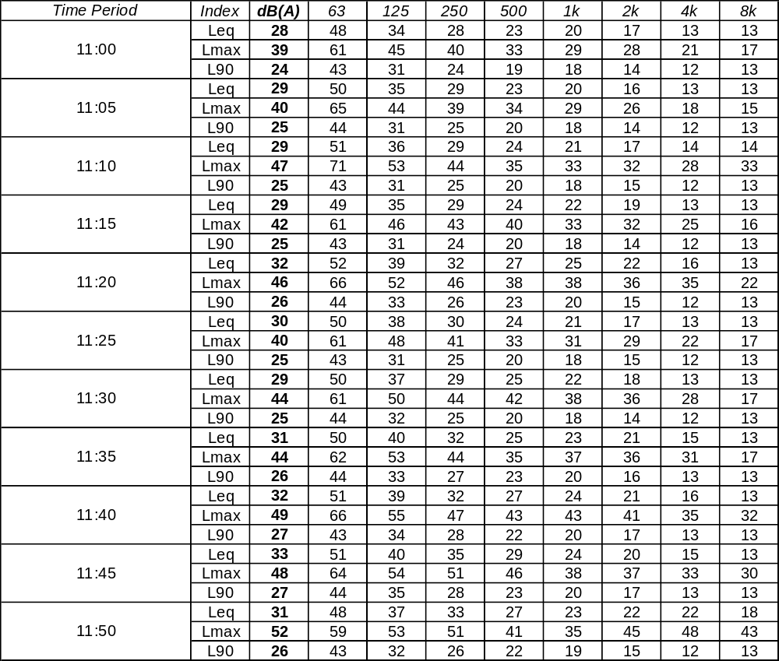

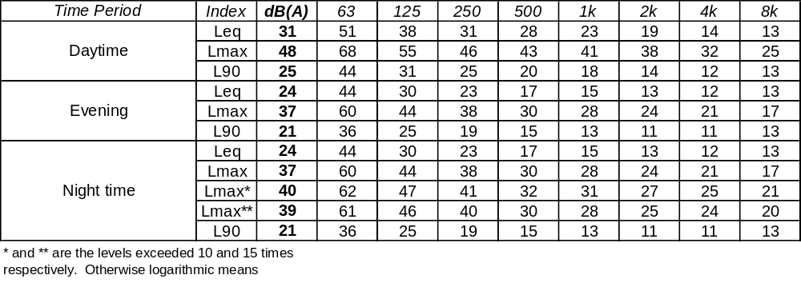

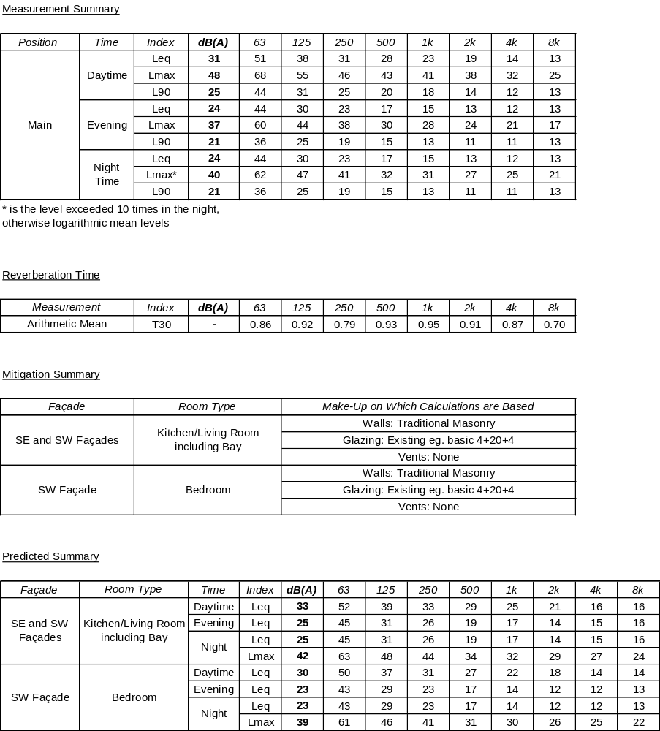

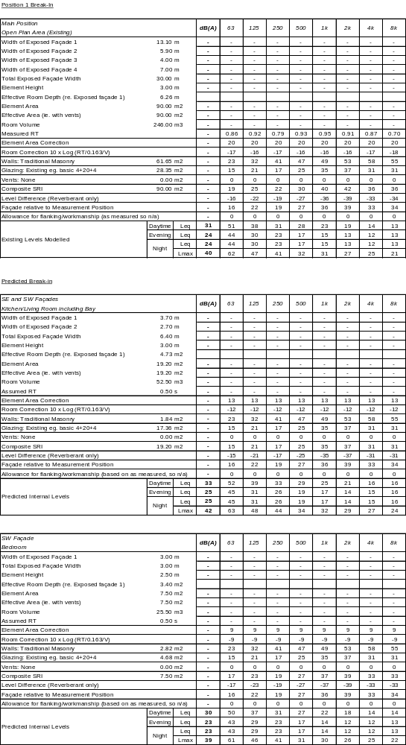

To put this into perspective, a party floor which just meets Building Regulations standards would provide insulation of around 45 to 50 dB. This means that noise generation within the commercial units of 80 to 85 dB(A) daytime and evening, and 75 to 80 dB(A) at night, would still be within criteria. It is highly unlikely that levels will be anywhere near these figures.

