
GOULD STREET IP>MP PRI

Dresser Noise Calculations


Anticipated noise levels at the IP>MP site located off Billbrook Street, Manchester.

- Arial View
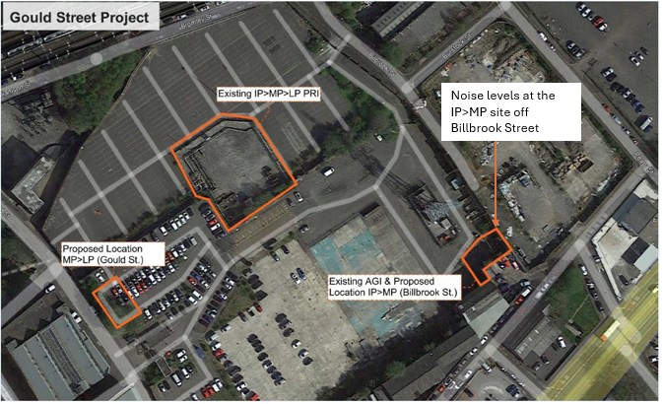

- Manufacturers Information
The information provided below was received from the governor manufacturer, Dresser and is based on the worse case maximum flow for the site located off Billbrook Street, Manchester.
The sizing for the regulators is below. A silencer has also been installed on the outlet of the active regulator which negates ~15dBa. At absolute worst case (Max flow & max differential) you will see 76.12dBa @ 1m from the regulator.
An acoustic kiosk has been supplied - the noise reduction offered by the kiosk is also shown below.
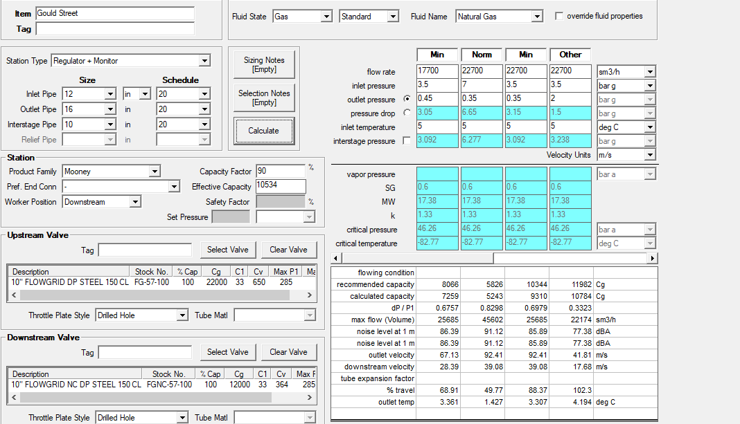
Kiosk Noise Reduction:
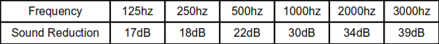

- Existing ambient noise levels.
Cadent has assessed the impact of the new PRI on the local environment by comparing the anticipated sound pressure levels 1m away from the governor unit at a maximum 76dB(A) to typical noise levels taken from Figure 1 – HSG260 in Health and Safety Executive guidance, HSG260 Sound Advice (Control of noise at work in music and entertainment) as indicated below. As the development works have not been started the noise levels can not be determined at the nearest proposed property.

- Impact of new PRI
The existing PRI has been in situ in the car park off Gould Street for many years and Cadent have installed noise attenuating matting to the pipeline and fencing of the site to reduce the noise levels.
The anticipated sound pressure level generated by the new PRI at 1m away from the governor unit at a maximum 76dB(A) and is deemed to be between moderate to quiet and loud as per HSG260 per Figure 1 below.
The noise level generated from the operation of the PRI will be mitigated by the installation of an acoustic kiosk and silencer installed on the governor unit.

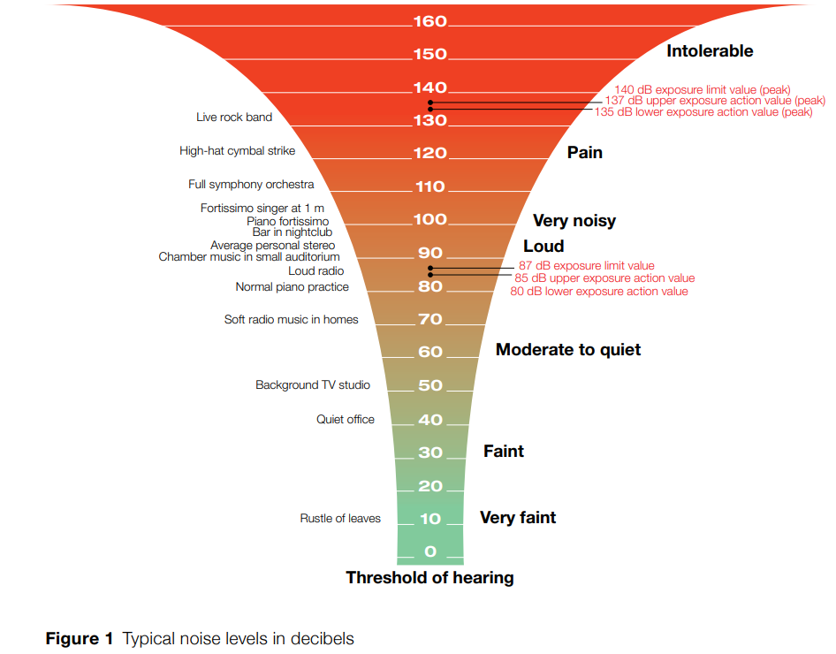



 | Cadent Gas Limited
 | @CadentGasLtd
 | @Cadentgas
 | 0800 389 8000
 | wecare@cadentgas.com

cadentgas.com

