Scaffolding Fall from Height Rescue Plan and Medical Emergency Evacuation Plan, Complying with the COVID 19 Rules (Form 8)

Intelligent Scaffolding
Site Address: Gotham Hotel, 100 King Street, Manchester M2 4WU
Location on site: External to Building
Customer: Concrete Repairs Limited
Time: TBC
Date: 13.01.25
Attached a copy of the Customers Site Rescue plan before work can commence:
Fall from height Rescue Plan and Medical Emergency Evacuation Plan - Without Specialist Rescue Equipment using full body harness with single lanyard or twin tail lanyards.
The main point to remember since the introduction of SG4:00 Current Edition in 2000 there is no official report of any scaffolder falling from a scaffold using the Safety Step and Advanced Handrail having to be rescued, but there have been numerous cases of people having to be rescued from scaffolds who have sustained serious injuries or have become ill and been unable to egress the scaffold without the assistance of the emergency services.
The main priority to protect the person who as fallen or been injured or become ill, you must not put any person at further risk by using unsafe methods to rescue a person.
The reason why there have been no recorded incidents of scaffolders being rescued are because if scaffolders are complying with SG4: Current Edition they will not fall.
The scaffolders who have fallen in the last twenty years may not have complied with SG4: Current Edition. A number of scaffolders and labourers have been killed or sustained very serious injuries. In some cases these injuries have been life changing.
This plan is for the arrest of a person wearing a full body harness with a single or twin tail lanyard or a person who has a sustained serious injury or have become ill and been unable to egress the scaffold they are working on such as an independent, tower, or birdcage scaffold or any other structure where there is access adjacent to the suspended person.
This plan is also for the rescue of persons who may have suffered a Medical Emergency such as heart attack, stroke, broken leg, broken arm or other serious injury, which will prevent the casualty form being able egress the scaffold without assistance.
If a person has to have a Medical Evacuation from a scaffold a staircase, passenger hoist or man safe crane basket would be the safest method for Scaffold/Site Trained Aiders to undertake the evacuation.
If there is no scaffold staircase or passenger hoist attached to the scaffold the site Scaffold/Site First Aiders must not attempt to Evacuate the casualty using specialist rescue equipment unless the have received the correct training for the equipment.
The Scaffold/Site First Aiders must attend to the casualty until the Emergency Services arrive on site to treat the casualty and undertake the evacuation.
Scaffolders Working over Water/Working on Beams/Working on Overhead Power Lines/Working in Confined Spaces/Working on Suspended Scaffolds (Drops)/Working on Roofs with Safety Nets below/Working in MEWPS must have a site specific Rescue Plan in place before work commences
The information required below must be completed before this Plan can be submitted to the Client
Must be completed by hand on site.
Location of local A & E Department to Site:
Location of local Ambulance Station to Site:
Location of local Fire and Rescue Station to Site:
Contact details of Clients Site Rescue Team: N/A

All Scaffolders are trained and competent for the works to be undertaken: Yes/No
All scaffolders have been trained to use and inspect the harness and lanyard: Yes/No
All harnesses and lanyards have been inspected within the last three months: Yes/No
All harness and lanyards have been issued by the company: Yes/No
SCOPE:
This rescue plan is for the recovery of personnel following an arrested fall whilst wearing a full body harness with single or twin lanyard attached to a suitable anchorage point or a person who has a sustained serious injuries or have become ill and been unable to egress the scaffold they are working on.
Each scaffolding operation shall be risk assessed prior to work commencing and the chosen recue option will be outlined on the risk assessment / method statement.
All operatives on site shall be briefed on the method of rescue to be adopted on this site.
OBJECTIVE OF THE PLAN: Is to rescue a person who has fallen from a scaffold suspended in a safety harness or to rescue a person had been injured or become ill and is unable to egress the scaffold themselves
The objective of this procedure is to outline to all supervisors, operatives and Clients Management the proposed means of performing a rescue of a person in a fall arrest situation as quickly and safely as possible taking into consideration the COVID 19 Rules. The rescuers and the first aiders must use a facemask or face coverings before commencing the rescue.

Be aware of the risks to yourself and others
When approaching a casualty there is always a risk of cross contamination – especially when you may have to get close to the casualty to assess what is wrong or to check their breathing. It is always important to be aware of the risks of how this cross contamination has occurred. According to NHS 111 we do not know exactly how coronavirus spreads from person to person but similar viruses are spread in cough droplets
Keep Yourself Safe
In line with government advice, make sure you wash your hands or use an alcohol gel, before and after treating a casualty also ensure that you don’t cough or sneeze over a casualty when you are treating them.
The Resuscitation Council (UK) provides some useful advice of how to keep yourself safe when providing CPR. You can read their full advice on their website here.
Don’t lose sight of other cross contamination that could occur that isn’t related to COVID-19.
- Wear gloves or cover hands when dealing with open wounds
- Cover cuts and grazes on your hands with waterproof dressing
- Dispose of all waste safely
- Do not touch a wound with your bare hand
- Do not touch any part of a dressing that will come in contact with a wound.
Where using collective means of fall prevention as per SG4: Current Edition shall prevent possible falls: (e.g. safety steps, advanced guardrails).
Important Note: Rescue is only to be attempted if it does not endanger the person carrying out the rescue or endanger the faller any further during the rescue attempt. The Person undertaking the rescue must be working from a fully boarded platform, using full body harness and lanyards attached at all times throughout the rescue to a safe anchor point.
Important Note: If the suspended person was a member of a two-man or three gang it would be impossible for the other scaffolder to lift and pull the suspended person back onto the platform if they are positioned below the lift. A cantilever platform must be erected to allow the Suspended Person to be placed on the platform.

Scope of Works: Erection of Independent Scaffolds

Rescue Plan No.1 relates to scaffolding activities where, in the unwanted event of a fall from height, a scaffolder is suspened in his safety harness.
The scope of this rescue plan is limited to working from basic scaffold structures and as such the casualty would be suspended adjacent to the scaffold structure. This would require a rescue technique known as 'Pulling onto Boards or Building a Cantilever under the Suspended Person' using tube and fitting or for system scaffolding hop up brackets.

Equipment:

Tube and fitting and System Scaffolding

TRAINING.

Scaffold operatives will be competent in the erection of both conventional tube and fitting and system scaffold structures. They will hold a CISRS card and will have received SG4:Current Edition and TG20:Current Edition training. In addition, Risk Assessment and Manual Handling training will have been completed during company HS&E induction training. Site induction training must be completed successfully before commencing work on site by the PC or the Client.

EMERGENCY PROCEDURES

In the event of a suspended casualty the alarm will be raised immediately via the nearest call point or emergency telephone by calling 999 and your Manager/Supervisor stating the exact location and nature of the incident. Before work commences a gang member must check to ensure that the local phone is operating properly and they have a signal for their mobile phones. The emergency servies may not respond immediatley. We must commence the rescue.

- The company must be aware of the location of the local emergency services and the local hospital.
- The distance the emergency services would have to travel to site to respond to an emergency.

Sequence of rescue using hop-up brackets or tube and fitting cantilever platform with to undertake the rescue

Check the condition of the scaffolder who has fallen, if they are injured or can not self rescue call for assistance:-
PRE-RESCUE ACTIONS:
As soon as a fall takes place the scaffold team must put the rescue plan into effect.
The scaffold team must follow the process below:
Inform site management and contact the Emergency Services immediately by dialling 999 and requesting both Fire Brigade request (Work at Height Team) and Ambulance Services. They must state to the operator the following:
  - Address and Postcode.
  - Location on site.
  - Contact phone number.
  - Nature of the incident.
  - Casualty name/age/sex/medical history
  - Signs and symptoms of the Suspended Person.
  - How the accident occurred.
  - What are you doing for the Suspended Person?
  - Length of time the operative has been suspended.
  - What condition the operative is in (i.e. conscious/ unconscious) type of injuries.
  - Height above ground or nearest landing platform the operative is suspended from.
  - Type of access onto the scaffold Ladder or Staircase

- Ensure that the dispatcher is made aware that this is a WORK AT HEIGHT INCIDENT CASUALTY SUSPENDED IN A HARNESS
- The priority MUST be to recover the Suspended Person from suspension as quickly as possible, without endangering, unnecessarily, the safety of the rescuer(s) or the casualty.
- If able to do so, the suspended scaffolder should be encouraged to use the following techniques to reduce the risks:
  - If the person is un-injured and fully conscious, they should be encouraged to mobilise all four limbs, i.e. by flexing the leg muscles to help maintain circulation.
  - Frequent ‘pumping’ of the legs against a firm surface will also activate the muscles and improve blood circulation.
  - They should be helped to stand on the scaffold to allow them to take the pressure off the body, if possible help them to climb back onto the scaffold. Under no circumstances must their lanyard be released or cut until the fallen scaffolder is safely back on the scaffold.
  - A designated member of the rescue team should continuously monitor the suspended scaffolder reassuring them at all times and if necessary talk them through the rescue process.
Important Note: Rescuer must ensure that they work from within a ‘Safe Zone’ at all times as SG4: training. This is defined as ‘a fully boarded and correctly supported platform with a single guardrail (at least 950mm high) clipped on at all times through the rescue, where there is a risk of a fall’.

- For system scaffolding or tube and fitting scaffolding, board out the bay adjacent to where the scaffolder is suspended and the bay above where the lanyard is attached.
- Attach your lanyards to a secure anchor point as far back from the edge of the platform where the scaffolder is suspended.
- Fix two hop up brackets or two tubes onto the standards each side of the fallen scaffolder, just below their backside or as close as possible.
- Place the first board on the hop up brackets or tube by pusing the fallen scaffolder away from the scaffold, repeat by placing the second board on the hop up brackets, for system boards fix them down using the board fixing.
- For tube and fitting scaffold the cantilever must be three boards wide doubled up correctly supported, fix the boards in place to prevent any movement of the boards, fix a tube on each standard across the top of the boards.
- If the Suspended Person is using twin tail lanyards, attached their second lanyard back onto the scaffold if possible before commening the rescue.

- Drag and lift the Suspended Person onto the cantilevered boards, he/she will be sitting on the boards then lift their legs onto the boards.
- The scaffolder will now be sitting or laying on the boards.
- Once the Suspended Person is safely on the platform and secure, access the top lift where their lanyard is attached. Clip on to a secure anchor point, then carefully release their lanyard lowering them onto the boards.
- Try and place the Suspended Person in the recovery position if possible on the platform.
- All you can do now is wait for assistance to arrive.
- A designated member of the rescue team should continuously monitor the Suspended Person reassuring them at all times and if necessary talk them through the rescue process.
- Only if it is safe to do so remove the handrail and bring the suspended scaffolder onto the main platform, once they are safely on the platform replace the handrail.
- Ensure there is safe access for the emergency services to accesss the platform, if they arrive on site.

A person has become ill or been injured when working the scaffold platform
- Inform site management and contact the Emergency Services immediately by dialling 999 and requesting both Fire Brigade request (Work at Height Team) and Ambulance Services.
- The site first aiders must attend to the person and administer the correct first treatment as appropriate to their illness or injuries.
- Follow the procedures as stated above.
POST RESCUE ACTION:
Anyone suspended in his/her harness must be treated by a medical professional at a local hospital (even if they say they feel OK). First aid treatment alone may not suffice.
All casualties are to be initially assessed by competent First Aider, following the standard First Aid treatment (ABC Management), as below:
First Aider to provide standard First Aid treatment (ABC Management)
  - A & B – Assess casualty’s airway and breathing condition
  - C – Check casualty’s pulse/ signs of bleeding
  - Assess the level of consciousness using AVPU scale
    - A – Are they alert? Are their eyes open? Do they respond to questions?
    - V – Do they respond to Voice? Do they answer questions/ obey commands?
    - P – Do they respond to Pain? Do they open their eyes or move if pinched?
    - U – Are they unresponsive to any stimulus (i.e. unconscious)?
Conscious Casualties:
If the casualty is conscious then the following process should be followed:
Casualty should be encouraged to remain in an upright position and walk around if possible.
First Aider to remain with the casualty and accompany them to hospital for medical assessment.
Unconscious Casualties:
If the casualty is unconscious then the following process should be followed:
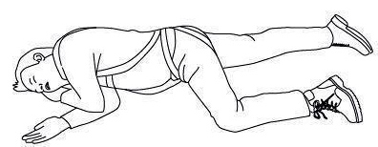
- First Aider to place patient in the traditional recovery position (as pictured) until the emergency services are in attendance.
What to do
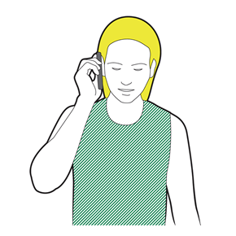
- If you find someone collapsed, you should first perform a primary survey. Do not place your face close to his or hers. If you have established from this that they are unresponsive and not breathing, you should ask a helper to call 999 or 112 for emergency help while you start CPR. Ask a helper to find and bring a defibrillator, if available.
- Ask your helper to put the phone on speaker and hold it out towards you, so they can maintain a 2m distance
- If you are on your own, use the hands-free speaker on a phone so you can start CPR while speaking to ambulance control
- Do not leave the casualty to look for a defibrillator yourself. The ambulance will bring one.
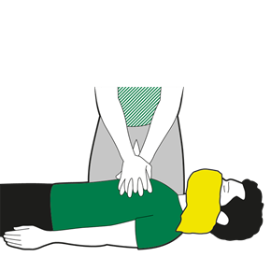
- Before you start CPR, use a towel or piece of clothing and lay it over the mouth and nose of the casualty.
- Start CPR. Kneel by the casualty and put the heel of your hand on the middle of their chest. Put your other hand on top of the first. Interlock your fingers making sure they don't touch the ribs.
- Keep your arms straight and lean over the casualty. Press down hard, to a depth of about 5-6cm before releasing the pressure, allowing the chest to come back up.
- The beat of the song "Staying Alive" can help you keep the right speed
- Do not give rescue breaths
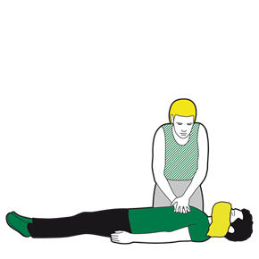
Continue to perform CPR until:
- Emergency help arrives and takes over
- The person starts showing signs of life and starts to breathe normally
- You are too exhausted to continue (if there is a helper, you can change over every one-to-two minutes, with minimal interruptions to chest compressions)
- A defibrillator is ready to be used.
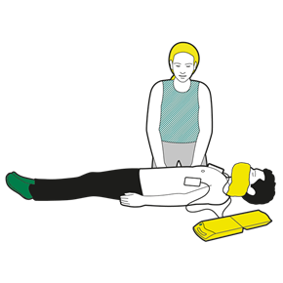
- If the helper returns with a defibrillator, ask them to switch it on and follow the voice prompts while you continue with CPR.
- Wherever possible, the helper should keep a distance of 2m
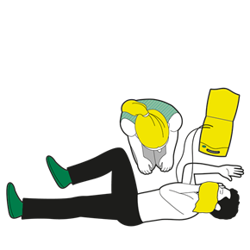
- If the helper returns with a defibrillator, ask them to switch it on and follow the voice prompts while you continue with CPR.
- Wherever possible, the helper should keep a distance of 2m

- Advise the ambulance service that the patient needs to be treated for orthostatic shock or intolerance, which should be treated similarly to crush injuries.
Important Note: Following a fall, any fall protection equipment should be quarantined and retained for inspection as part of the incident investigation process.
At the location where the fall happened the scaffold and ties must be inspected before the scaffold can be used again and a new Hand Over Certificate issued to the Client.

It has been proven by test’s undertaken by Newcastle University that if a person is attached to a scaffold structure when they fall the impact of the fall can damage the scaffold and pull the ties out of the wall.

Communication of Control Measures
I confirm that I have been instructed and understand the control measures required for this work, as detailed in this risk assessment.
I also confirm that if the work situation changes or additional hazards are identified I will bring it to the attention of my immediate Supervisor.
Print Name | Signature | Date | CISRS Card Type | CISRS Card Number | Time

