SITE SPECIFIC SUPPLEMENTARY INFORMATION

- Site Details

Site Name: | Mersey Bank Temp | Site Address: | Mersey Bank Playing Fields,  Mersey Crescent,  West Didsbury,  Manchester,  M20 2YJ
NGR: | E: 383265 N: 391410 | Site Address:
Site Ref Number: | 39053 | Site Type: Macro | Temporary Consent

- Pre-Application Check List

Site Selection

Was an LPA mast register used to check for suitable sites by the operator or the LPA? |  | No
If no explain why: After a phone call to the LPA it was felt that the industry database was a more up to date source of information.

Was the industry site database checked for suitable sites by the operator: | Yes
If no explain why: N/A

Pre-application consultation with LPA

Written offer of pre-application consultation: | Yes
Was there pre-application contact: |  | No
Date of pre-application contact: | Numerous
Name of contact: | The Director of Planning
Summary of outcome/Main issues raised:

The permanent solution is about to legally access and thus allow this to be built. This temp consent is simply to bridge that period. Twelve months might not be required but has been requested as a long stop.

Ten Commitments Consultation

Rating of Site under Traffic Light Model: | Green

Prior to the submission of this application the applicant initiates pre-consultation discussions with the local planning authority. This provides an opportunity for the LPA to discuss development proposals and identify site specific issues.

Summary of outcome/Main issues raised:

No responses had been received at the time of submission.

School/College

Location of site in relation to school/college:

There are no schools in close proximity to the site.

Outline of consultation carried out with school/college: N/A

Summary of outcome/Main issues raised: N/A

Civil Aviation Authority/Secretary of State for Defence/Aerodrome Operator consultation

Will the structure be within 3km of an aerodrome or airfield? |  | No
Has the Civil Aviation Authority/Secretary of State for Defence/Aerodrome Operator been notified? |  | No
Details of response: N/A

Site Provider Letter

Copy of Site Provider Letter enclosed? |  | Yes
Date served: | 6/2/2025

- Proposed Development

The proposed site:
The permanent solution is about to legally access and thus allow this to be built. This temp consent is simply to bridge that period. Twelve months might not be required but has been requested as a long stop. It is imperative to consider that this proposal is to replace an existing installation and is not a new additional mast. The need for this new mast stems from MBNL having been issued with an NTQ (Notice to Quit). This is a temporary installation, (not a permanent solution) and this application is to keep the existing temporary site at Mersey Bank Playing Fields, Mersey Crescent, West Didsbury, Manchester, M20 2YJ in situ for a further 12 months while a permanent solution is sourced and integrated into the network.
The proposal is for the installation of a temporary lattice mast for a further 12 months. The proposal will provide and maintain coverage for EE and H3G LTE and ESN whilst the permanent soliton is addressed. The proposed new facility will require the installation of a limited number of equipment cabinet housing radio equipment at ground level and in close proximity to the base of the pole.
The site has been carefully selected in a position that benefits from some screening effects so as to provide the required new coverage to the area whilst minimising visual intrusion for residential properties. The sharing of base stations between multiple operators is one of the key strategic policy principles contained within the NPPF. H3G and EE and ESN (Emergency Services Network) have a network sharing agreement and thus these installations are fully compliant with the NPPF. The temporary mast is already in situ on site, the proposal has been placed suitable distance away from residential dwellings and thus there will be no adverse impact. Figures 1 & 2 illustrates the existing site and its surroundings.

Figure 1:
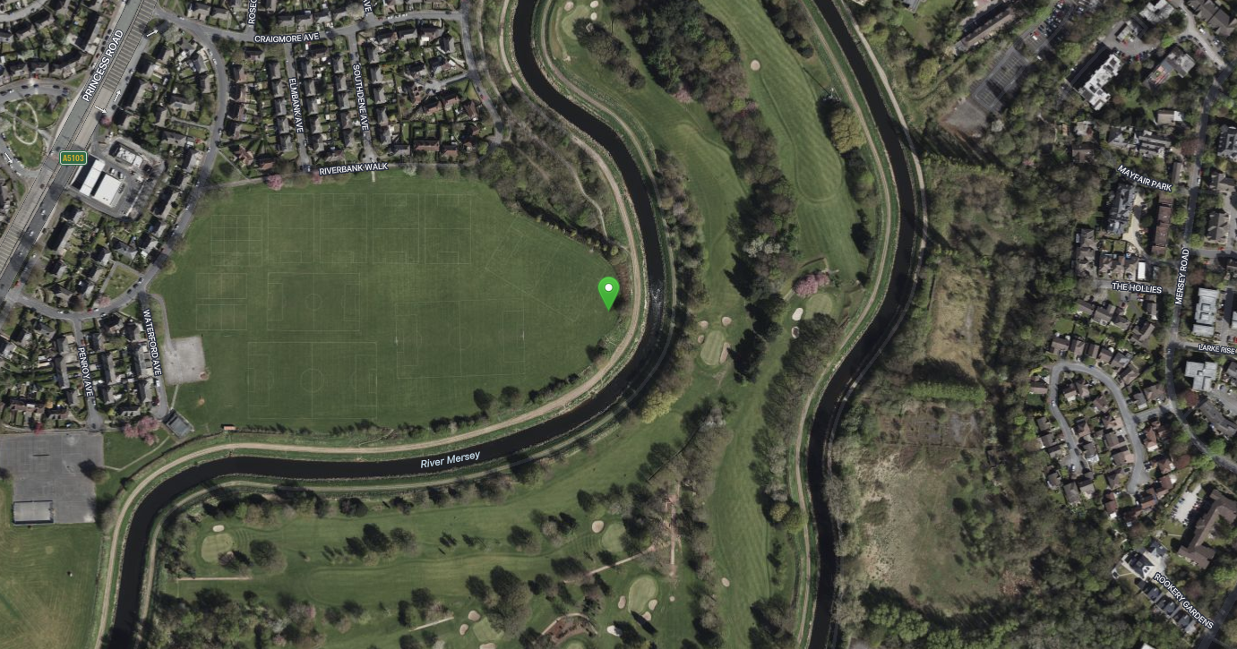

Figure 2:

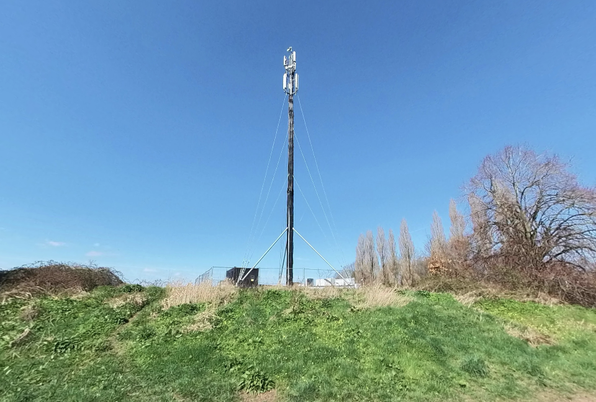

Enclose map showing the cell centre and adjoining cells:
This can be emailed to the LPA upon request.

Type of Structure
Description:

PROPOSED MBNL 30.00m HIGH TEMP MAST ON STEEL FRAME C/W CONCRETE BALLAST BLOCKS. 3No. MBNL ANTENNAS MOUNTED ON HEADFRAME AND 1No. 300Ø DISH 3No. CTIL (VF/TEF) ANTENNAS MOUNTED BELOW.
PROPOSED H3G BOWLER CABINET & RBS 6130 CABINET MOUNTED ON TIMBER SLEEPERS.
PROPOSED EE RBS 6130 CABINET MOUNTED ON TIMBER SLEEPERS & FS FRAME.
PROPOSED CTIL CABINETS TO BE INSTALLED ON TIMBER SLEEPERS.
PROPOSED MBNL 2.0m HIGH HERAS FENCING TO PERIMETER OF COMPOUND.
PROPOSED MBNL Mk5B LINK A/C CABINET & FURO CABINET MOUNTED ON TIMBER SLEEPERS (BEHIND).

Overall Height: 30.50m AGL
Height of existing building |  | N/A
Equipment Housing:
Length:
Width:
Height:
Materials
Tower/mast etc – type of material and external colour: | Galvanised
Equipment housing – type of material and external colour: | RAL7035

Reasons for choice of design:
This application is to extend the temporary consent for the proposal on site for a further 12 months while a permanent solution is addressed.

- Technical Information

ICNIRP Declaration attached  ICNIRP public compliance is determined by mathematical calculation and implemented by careful location of antennas, access restrictions and/or barriers and signage as necessary. Members of the public cannot unknowingly enter areas close to the antennas where exposure may exceed the relevant guidelines.  When determining compliance the emissions from all mobile phone network operators on the site are taken into account. | Yes

- Technical Justification

Reason(s) why site required
The National Planning Policy Framework clearly states that authorities should not question the need for the service, nor seek to prevent competition between operators. Notwithstanding this fact, the Applicant considers it to be important to explain the technical justification for the site and how the facility fits into the overall network.

Notwithstanding this fact, the Applicant considers it to be important to explain the technical justification for the site and how the facility fits into the overall network.

Further detail regarding the general operation of the network can be found in the accompanying document entitled ‘General Background Information on Radio Network Development for Planning Applications’. This information is provided to assist the local planning authority in understanding any technical constraints on the location of the proposed development.

- Site Selection Process – alternative sites considered and not chosen

Discounted Options
In accordance with the sequential approach outlined in the National Planning Policy Framework (NPPF) following search criteria have been utilised. Firstly, consideration is always given to sharing any existing telecommunication structures in the area, secondly consideration is then given to utilising any suitable existing structures or buildings and thirdly sites for freestanding ground-based installations are investigated.

This sequential approach is outlined below:

- Mast and Site Sharing
- Existing Buildings Structures
- Ground Bases Installations

In compliance with its licence and the sequential approach outlined in the NPPF all attempts to utilise any existing telecommunication structures where they represent the optimum environmental solution have been employed. The Ofcom Site Finder mast register is always examined prior to the submission of an application.

If no alternative site options have been investigated, please explain why:

This is a temporary installation to maintain coverage and not a permanent solution.

- Additional Relevant Information

Background to the Proposal
This specific proposal forms part of an integral requirement for EE Ltd, ESN and H3G LTE to expand their respective telecommunications network across Manchester specifically in this instance to enhance coverage levels and network capacity within the M20 area.

This partnership has resulted in the development and production of an array of “dual user” structures and cabinets, which have the ability to accommodate both operator’s antenna systems and radio equipment.

Mobile phone base stations operate on a low power and accordingly base stations therefore need to be located in the areas they are required to serve. Increasingly, people are also using their mobiles in their homes, and this means we need to position base stations in, or close to, residential areas.

A further limiting factor is that the position has to be one that fits in with the existing network. Sites have to form a patchwork of coverage cells with each cell overlapping to a limited degree with the surrounding base stations to provide continuous network cover as users move from one cell to the other. However, if this overlap is too great unacceptable interference is created between the two cells.

DEVELOPMENT PLAN POLICY.

Section 38 of the Planning and Compulsory Purchase Act 2004, it is stated that:

“Where in making any determination under the Planning Acts regard is to be had to the Development Plan, determination shall be made in accordance with the Development Plan unless material considerations indicate otherwise.”

NATIONAL PLANNING POLICY

The Government remain committed to promoting telecommunications and place emphasis on the importance of telecommunications to the wider economy. The National Planning Policy Framework (NPPF December 2024) sets out the Government’s planning policies for England and how these are expected to be applied at the Local level. It provides a framework within which local people and their accountable Councils can produce their own distinctive local and neighbourhood plans, which reflect the needs and priorities of their communities.

The purpose of the planning system is to contribute to the achievement of sustainable development. There are three dimensions of sustainable development, each of which give rise to the need for the planning systems to perform a number of roles including: -

- Economic objective – contributing to building strong, responsive and competitive economy
- Social objective – Supporting strong vibrant and healthy communities; and
- Environmental objective – Contributing to protecting and enhancing our natural, built and historic environment.
The NPPF contains at its core a presumption in favour of sustainable development which runs through both plan-making and decision-making processes. The NPPF recognises the vital importance of high-quality telecommunications and dedicates a whole chapter to this. Chapter 10 of the NPPF outlines the Governments support for high quality communications. The paragraphs below clearly outline the overarching support from Central Government for telecommunications and how Local Planning Authorities should embrace this vital infrastructure:

NPPF Paragraph 119 states:

“Advanced, high quality and reliable communications infrastructure is essential for economic growth and social well-being. Planning policies and decisions should support the expansion of electronic communications networks, including next generation mobile technology (such as 5G) and full fibre broadband connections. Policies should set out how high-quality digital infrastructure, providing access to services from a range of providers, is expected to be delivered and upgraded over time; and should prioritise full fibre connections to existing and new developments (as these connections will, in almost all cases, provide the optimum solution).”

It continues in Paragraph 120:

“The number of radio and electronic communications masts, and the sites for such installations, should be kept to a minimum consistent with the needs of consumers, the efficient operation of the network and providing reasonable capacity for future expansion. Use of existing masts, buildings and other structures for new electronic communications capability (including wireless) should be encouraged. Where new sites are required (such as for new 5G networks, or for connected transport and smart city applications), equipment should be sympathetically designed and camouflaged where appropriate.”

Operators always follow the sequential site selection process. Where an existing site can be shared or upgraded this will always be adhered to before a new proposal is put forward for consideration.

The support for telecoms and the need not to constrain Operators is laid out in Paragraph 123:

“Local planning authorities must determine applications on planning grounds only. They should not seek to prevent competition between different operators, question the need for an electronic communications system, or set health safeguards different from the International Commission guidelines for public exposure.”

Conclusion

We consider that the development is complaint with the council’s policy and that in accordance with Section 38 (6) of the Planning and Compulsory Purchase Act 2004 permission should be granted for the installation.

We consider the development complies with both central government and local planning policy guidance where the underlying aim is to provide an efficient and competitive telecommunication system for the benefit of the community while minimising visual impact.

Taking into account the factors of technical constraints, available sites and planning constraints we consider that this site and design clearly represents the optimum environmental solution.

On the basis of a recognised need to expand and promote telecommunications networks across the region, it is considered that the proposal fully accords with the requirements of the National Planning Policy Framework and Council’s Local Plan Policies.

Damian Hosker BA (Hons) MA MRTPI

Planning Manager
Email: d.hosker@whptelecoms.com

Contact Details

Name: (Agent) | Damian Hosker | Telephone: | Emailed on request
Operator: | EE and H3G LTE | Fax no: | N/A
Address: | WHP Telecoms Ltd  1a Station Court Station Road Guiseley  LS20 8EY | Email Address: | d.hosker@whptelecoms.com
Signed: |  | Date: | 7th February 2025
Position: | Planning Manager | Company:  (on behalf of above operator) | WHP

