
GOULD STREET MP>LP PRI

Honeywell Noise Calculations


Anticipated noise levels at the MP>LP site located off Gould Street, Manchester.

- Arial View
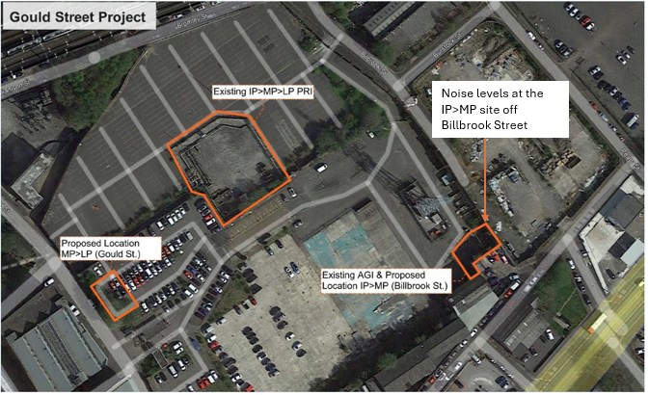

- Manufacturers Information
The information provided below was received from the governor manufacturer, Honeywell and is based on the worse case maximum flow for the medium to low pressure site located off Gould Street, Manchester.
“The Kiosk is acoustic and offers a noise reduction of 28 Dba.
The standard calculation for 12” AFV is showing 75 Dba as a standard noise calculation which is based on 1m away above ground.
With the system being semi submerged and having and incorporating the additional set of GRP covers this will again reduce the noise but there are no specific figures for this.
As a worst-case scenario with the 75 Dba and 28 Dba reduction as a max noise I would expect predicted Noise level to be approx. 47 Dba one meter away from the governor unit.”
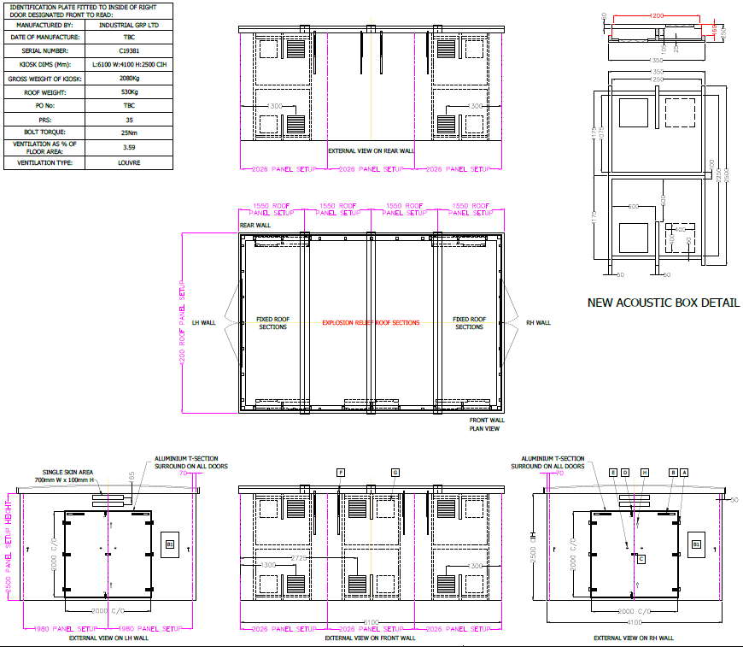

- Existing ambient noise levels.
Cadent has assessed the impact of the new PRI on the local environment by comparing the anticipated sound pressure levels 1m away from the governor unit at a maximum 47dB(A) to typical noise levels taken from Figure 1 – HSG260 in Health and Safety Executive guidance, HSG260 Sound Advice (Control of noise at work in music and entertainment) as indicated below. As the development works have not been started the noise levels can not be determined at the nearest proposed property.
- Impact of new PRI
The existing PRI has been in situ in the car park off Gould Street for many years and Cadent have installed noise attenuating matting to the pipeline and fencing of the site to reduce the noise levels.
The anticipated sound pressure level generated by the new PRI at 1m away from the governor unit at a maximum 45dB(A) and is deemed to be between moderate to quiet and faint as per HSG260 per Figure 1 below.
The noise level generated from the operation of the PRI will be mitigated by the installation of an acoustic kiosk over the governor unit.
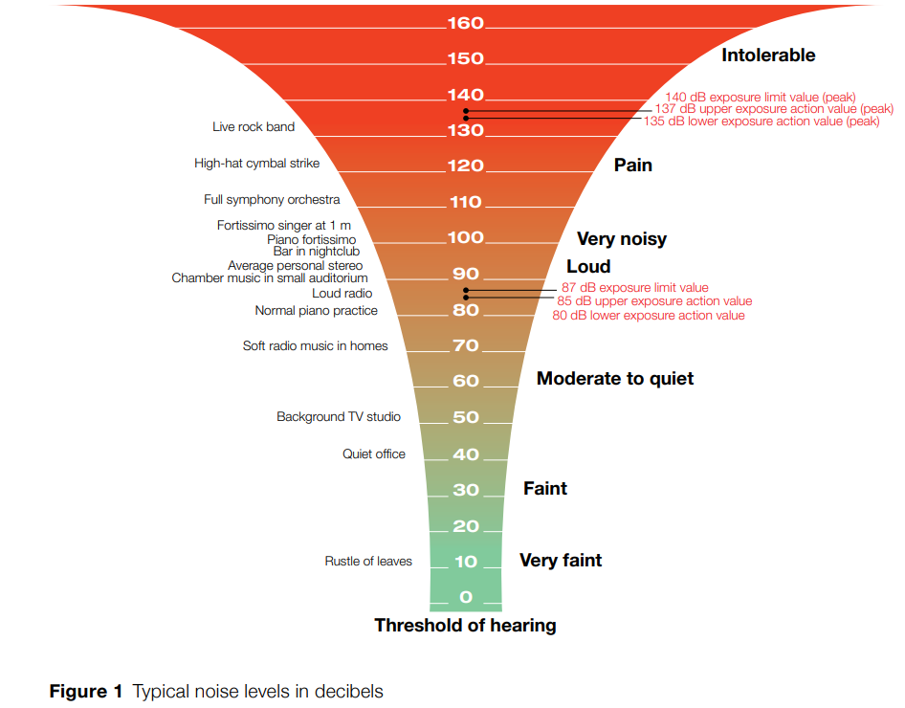



 | Cadent Gas Limited
 | @CadentGasLtd
 | @Cadentgas
 | 0800 389 8000
 | wecare@cadentgas.com

cadentgas.com

