Planning

Growth & Development

Delegated officer report for planning application

Application no. 142221/AO/2025
Date registered valid: 21 February 2025
Proposal: Installation of 1no. illuminated projection sign
Address: 60 Oldham Street, Manchester, M4 1LE
Ward(s): Piccadilly Ward
Applicant: Mr Phil Harrison
Agent (if any): Mr Andrew Barlow Spoke Architectural Design Limited
Case officer: James Bridgman
Tel: 0161 219 6202
Email: james.bridgman@manchester.gov.uk
Recommendation: Approve
Date of recommendation: 10 April 2025

Application details

Type of application: Advertisement Consent

Development type: Advertisements

Date of site visit: 5 March 2025

Standard consultations:
Printed: 10 March 2025 Expired: 31 March 2025

Neighbour notifications
Printed: 3 March 2025 Expired: 24 March 2025

Site notice
No site notice has been produced

Press advert
No press advert had been published

Departure from Development Plan: No

Environmental Statement: Not required

Description of site/building

The application relates to a four storey property at No.60 Oldham Street. The application
property is completed in red brick with sandstone window surrounds and a modern glazed
shopfront coloured black.

Listed building: Not applicable

Conservation area: Stevenson Square Conservation Area 1987

Tree Preservation Order: Not applicable

Description of area

The neighbouring area forms that of the Northern Quarter and Stevenson Square Conservation Area. Neighbouring built development consists of a variety of properties of varying age and design. Properties along Oldham Street are consist predominately of uses such as drinking establishments (Sui Generis), commercial Class E shops and restaurant uses. Advertisements along Oldham Street consist of various fascia signage and projecting signage.

Description of development

Advertisement consent is sought for the installation of 1no. illuminated projection sign.

The proposed sign would be located 3500mm off the ground to the front elevation of the building.

The sign would be a square shape with a height of 0.8m, a width of 0.8m and a depth of 0.03m.

The sign would be externally illuminated by LED static troughs with a maximum luminance of 100 cd/m.

The signage consists of the logo and letters ‘TIKI HIDEAWAY’. This will be painted

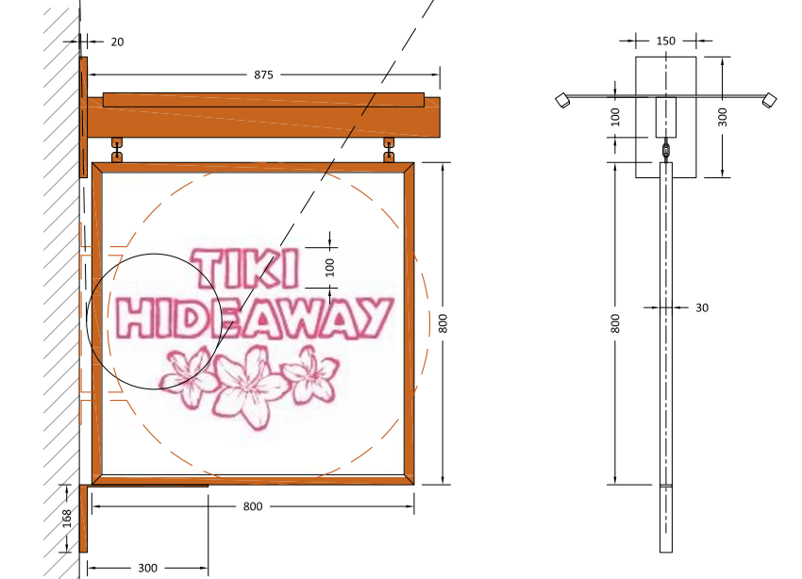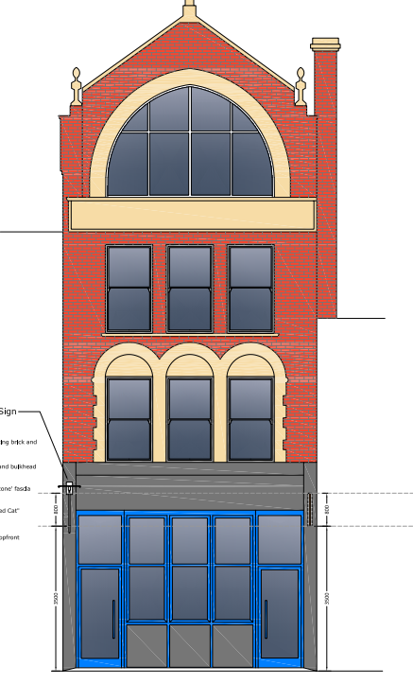
Figure 1 – Proposed front elevation (sign on left side) Figure 2 – Proposed sections of signage

Relevant Planning History

Note – the front elevation shows another projection sign (right hand side) at this address for another unit ‘Mean . This signage has been granted advert consent under the below application.

139867/AO/2024 - Installation of 1no internally illuminated projecting sign. Approved 6 June 2024

Consultations & Notification Responses

Highway Services - No objection subject to an informative relating to the requirement for a projection license.

Environmental Health – No objection subject to a condition controlling the proposed luminance levels.

Publicity – Letters have been sent out to local businesses and residents. One representation have been as part of that process. The comments have been summarised below:

- The site already has an existing sign, and the addition of a second sign will result in clutter.

Policy

The Local planning authority shall exercise its powers under these Regulations in the interests of amenity and public safety, taking into account—
(a)the provisions of the development plan, so far as they are material; and
(b)any other relevant factors.

(2) Without prejudice to the generality of paragraph (1)(b)—
(a)factors relevant to amenity include the general characteristics of the locality, including the presence of any feature of historic, architectural, cultural or similar interest;
(b)factors relevant to public safety include—
(i)the safety of persons using any highway, railway, waterway, dock, harbour or aerodrome (civil or military);
(ii)whether the display of the advertisement in question is likely to obscure, or hinder the ready interpretation of, any traffic sign, railway signal or aid to navigation by water or air; (iii)whether the display of the advertisement in question is likely to hinder the operation of any device used for the purpose of security or surveillance or for measuring the speed of any vehicle.

(3) In taking account of factors relevant to amenity, the local planning authority may, if it thinks fit, disregard any advertisement that is being displayed.

(4) Unless it appears to the local planning authority to be required in the interests of amenity or public safety, an express consent for the display of advertisements shall not contain any limitation or restriction relating to the subject matter, content or design of what is to be displayed.

The Manchester Core Strategy – Development Plan Document 2012 – 2027 (“the Core Strategy”) was adopted by the City Council on the 11th of July 2012:
- Policy SP1 – Spatial Principles
- Policy CC9 – Design and Heritage
- Policy EN1 – Design Principles and Strategic Character Areas
- Policy EN3 – Heritage
- Policy DM1 – Development Management

The Unitary Development Plan for Manchester – For the reasons outlined below the following saved UDP Policies are of relevance to this application:
- Policy DC14 – Shop Fronts and Related Signs
- Policy DC18 – Conservation Areas

The Places for Everyone Plan – Joint Development Plan Document, for nine of the ten boroughs which make up Greater Manchester, adopted by the City Council on 21st of March 2024.
- Policy JP-P2 – Heritage

Other Material Considerations

National Planning Policy Framework (NPPF)
- Chapter 12 – Achieving well-designed places
- Chapter 16 – Conserving and Enhancing the Historic Environment

National Planning Practice Guidance (NPPG)

Issues

Visual amenity

The proposed advertisement would be installed on a prominent elevation within the Stevenson Square Conservation Area. Existing advertisements consists of projecting signs and fascia signs, with both illuminated and non-illuminated signs featuring in the street scene.

The ground floor of this property fronting Oldham Street features two entrances for separate drinking establishments, with one operating under Mean-Eyed Cat Bar and the other being the applicant of this advert consent under Tiki Hideaway.

It is acknowledged there has been an objection in respect to the amount of clutter to the front elevation of the building.

DC14.5 (e) of the Saved Unitary Development Plan advises the Council will normally permit only one projection box sign for each shop unit. Given this application refers to two units within one shopfront, the principle of a projection sign for each unit is considered to be acceptable in this instance as it will not result in any visual clutter as assessed below.

The shopfront does not contain a fascia sign as the applicant unit has a high level internally suspended sign on a railing above the main entrance door.

The proposed projection sign would be in small scale and would have a depth of 30mm. The slim appearance is considered to it blend with the modern ground floor shopfront. The sign is appropriately sited in line with the existing projection sign.

The original proposal included the installation vinyl lettering and logo to the timber back panel. In the interest of visual amenity and with respect to the conservation area, the lettering and logi will be hand painted and sealed with a clear lacquer.

The visual amenity of the proposal is considered the proposal is acceptable in this regard and therefore accords with Core Strategy Policies SP1, CC9, EN1, EN3 and DM1, Saved Unitary Development Plan Policies DC14 and DC18, Places for Everyone Plan Policy JP-P2 and the National Planning Policy Framework.

Residential amenity

The proposed luminance level of 100cd/m2 would be of such a brightness where the sign would not detract from local visual amenity and general neighbouring amenity. The Environmental Health Officer does not object to the proposal.

Subject to a condition that would limit the proposed advertisement’s luminance to that in line with the proposed, it is considered the proposal is acceptable in this regard and therefore accords with Core Strategy Policy DM1 and the National Planning Policy Framework.

Highways

The application proposes the installation of a single projecting advertisement and would overhang the public highway. Highways do object to the proposal subject to an informative relating to the requirement for a projecting sign. The illuminance level for the advertisement would not be so bright as to cause an unacceptable safety risk to highway users. The proposal therefore accords with Core Strategy Policies SP1 and DM1, Saved Unitary Development Plan Policy DC14, National Planning Practice Guidance and the National Planning Policy Framework.

Conclusion

In light of the above, the proposal is considered to be acceptable in respect of both design and highway safety and is thus in accordance with Manchester Core Strategy Policies SP1, CC9, EN1, EN3 and DM1, Unitary Development Plan Policies DC14 and DC18, Places for Everyone Plan Policy JP-P2, the National Planning Policy Framework and National Planning Practice Guidance. The application is therefore recommended for approval.

Other Legislative Requirements

Equality Act 2010
Section 149 (Public Sector Equality Duty) of the Equality Act 2010 requires due regard to the need to: Eliminate unlawful discrimination, harassment and victimisation and other conduct prohibited by the Act and; Advance equality of opportunity between persons who share a protected characteristic and persons who do not share it. The Equality Duty does not impose a legal requirement to conduct an Equality Impact Assessment. Compliance with the Equality Duty involves consciously thinking about the aims of the Equality Duty as part of the process of decision-making.

Human Rights Act 1998 considerations
This application needs to be considered against the provisions of the Human Rights Act 1998. Under Article 6, the applicants (and those third parties, including local residents, who have made representations) have a right to a fair hearing and to this end the local planning authority must give full consideration to their comments.

Protocol 1 Article 1, and Article 8 where appropriate, confer(s) a right of respect for a person’s home, other land and business assets. In taking account of all material considerations, including Council policy as set out in the Core Strategy and saved polices of the Unitary Development Plan, the Director of Planning, Building Control & Licensing has concluded that some rights conferred by these articles on the applicant(s)/objector(s)/resident(s) and other occupiers and owners of nearby land that might be affected may be interfered with but that that interference is in accordance with the law and justified by being in the public interest and on the basis of the planning merits of the development proposal. She believes that any restriction on these rights posed by the recommendation given is proportionate to the wider benefits of and that such a decision falls within the margin of discretion afforded to the Council under the Town and Country Planning Acts.

Recommendation: Approve

Condition(s) to be attached to decision for approval

1) No advertisement is to be displayed without the permission of the owner of the site or any other person with an interest in the site entitled to grant permission.

No advertisement shall be sited or displayed so as to:
(a) endanger persons using any highway, railway, waterway, dock, harbour or aerodrome (civil or military);
(b) obscure, or hinder the ready interpretation of, any traffic sign, railway signal or aid to navigation by water or air; or
(c) hinder the operation of any device used for the purpose of security or surveillance or for measuring the speed of any vehicle.

Any advertisement displayed, and any site used for the display of advertisements, shall be maintained in a condition that does not impair the visual amenity of the site.

Any structure or hoarding erected or used principally for the purpose of displaying advertisements shall be maintained in a condition that does not endanger the public.

Where an advertisement is required under these Regulations to be removed, the site shall be left in a condition that does not endanger the public or impair visual amenity.

2) The development hereby approved shall be carried out in accordance with the following drawings and documents, received by the City Council as Local Planning Authority on 9 April 2025:

- Location Plan, Elevations and Sections: S24475.2 REV C

Reason - To ensure that the development is carried out in accordance with the approved plans. Pursuant to policies SP1 and DM1 of the Core Strategy.

3) The maximum luminance of the signage hereby approved shall not exceed 300 cd/m2 in brightness at any time.

Reason - In the interests of visual and residential amenity pursuant to policies SP1, EN3 and DM1 of the Manchester Core Strategy and saved policies DC14.1 and DC18.1 of the Unitary Development Plan for the City of Manchester.

Informatives

1) The projecting sign extends to a maximum projection of 948mm over the adopted highway. Therefore, a Projection over License will be required and this is obtainable via Contact Manchester on 0161 234 5004.

2) The applicant is required to discuss and agree any requirements for licensing, hoarding / scaffolding, and skips with MCC's Highways Licensing Team via Email to: highwaylicences@manchester.gov.uk.

3) The applicant is required to discuss and agree any requirements for temporary pedestrian and traffic management with MCC's Event and Traffic Management Team via Email to highwaynetworkmanagement@manchester.gov.uk.

Appendix 1 – List of consultees & neighbours notified

Environmental Health
Highway Services

40 Spear Street, Manchester, M1 1AS
60B Oldham Street, Manchester, M4 1LE
Flat 8, Spear Building, 53 Spear Street, Manchester, M1 1DF
Flat 7, Spear Building, 53 Spear Street, Manchester, M1 1DF
Flat 6, Spear Building, 53 Spear Street, Manchester, M1 1DF
Flat 5, 99 Oldham Street, Manchester, M4 1BA
Flat 7, 99 Oldham Street, Manchester, M4 1BA
Flat 9, 99 Oldham Street, Manchester, M4 1BA
Flat 2, 99 Oldham Street, Manchester, M4 1BA
Flat 10, 99 Oldham Street, Manchester, M4 1BA
Flat 1, 99 Oldham Street, Manchester, M4 1BA
Flat 3, 99 Oldham Street, Manchester, M4 1BA
Flat 8, 99 Oldham Street, Manchester, M4 1BA
Flat 6, 99 Oldham Street, Manchester, M4 1BA
Flat 4, 99 Oldham Street, Manchester, M4 1BA
97 Oldham Street, Manchester, M4 1LW
95 Oldham Street, Manchester, M4 1LW
89 Oldham Street, Manchester, M4 1LW
TONI&GUY, Ground Floor And Basement, 60A Oldham Street, Manchester, M4 1LE
First Floor Flat, 58 Oldham Street, Manchester, M4 1LE
60A Oldham Street, Manchester, M4 1LE
93 Oldham Street, Manchester, M4 1LW
Flat 5, Spear Building, 53 Spear Street, Manchester, M1 1DF
Flat 4, Spear Building, 53 Spear Street, Manchester, M1 1DF
Flat 3, Spear Building, 53 Spear Street, Manchester, M1 1DF
Flat 2, Spear Building, 53 Spear Street, Manchester, M1 1DF
Flat 1, Spear Building, 53 Spear Street, Manchester, M1 1DF
91 Oldham Street, Manchester, M4 1LW
Third Floor Flat, 62A Oldham Street, Manchester, M4 1LE
Flat 9, 60A Oldham Street, Manchester, M4 1LE
Flat 6, 60A Oldham Street, Manchester, M4 1LE
Flat 3, 60A Oldham Street, Manchester, M4 1LE
Flat 1, 89 - 95 Oldham Street, Manchester, M4 1LW
Flat 8, 89 - 95 Oldham Street, Manchester, M4 1LW
Flat 6, 89 - 95 Oldham Street, Manchester, M4 1LW
Flat 2, 89 - 95 Oldham Street, Manchester, M4 1LW
Flat 4, 89 - 95 Oldham Street, Manchester, M4 1LW
62A Oldham Street, Manchester, M4 1LE
Spear Building, 53 Spear Street, Manchester, M1 1DF
51 Spear Street, Manchester, M1 1DF
91 - 95 Oldham Street, Manchester, M4 1LW
Basement, 91 - 95 Oldham Street, Manchester, M4 1LW
Second Floor, 62A Oldham Street, Manchester, M4 1LE
First Floor, 62A Oldham Street, Manchester, M4 1LE
Flat 8, 60A Oldham Street, Manchester, M4 1LE
Flat 7, 60A Oldham Street, Manchester, M4 1LE
Flat 5, 60A Oldham Street, Manchester, M4 1LE
Flat 4, 60A Oldham Street, Manchester, M4 1LE
Flat 2, 60A Oldham Street, Manchester, M4 1LE
Flat 1, 60A Oldham Street, Manchester, M4 1LE
Flat 10, 89 - 95 Oldham Street, Manchester, M4 1LW
Flat 7, 89 - 95 Oldham Street, Manchester, M4 1LW
Flat 5, 89 - 95 Oldham Street, Manchester, M4 1LW
Flat 3, 89 - 95 Oldham Street, Manchester, M4 1LW
Flat 9, 89 - 95 Oldham Street, Manchester, M4 1LW
62 Oldham Street, Manchester, M4 1LE
58 Oldham Street, Manchester, M4 1LE
54 Oldham Street, Manchester, M4 1LE
55 - 59 Spear Street, Manchester, M1 1DF

Appendix 2 – Planning constraints

Article 4 Direction - City Centre PD Restriction - Class B1(c) To C3
Article 4 Direction - City Centre PD Restriction - Class B1(a) To C3
Article 4 Direction - Removal Of PD Rights Change Of Use From Class C3 To Class C4
Coal Authority - Development Low Risk - Name: DEVELOPMENT_LOW_RISK_AREA
Conservation Area - Stevenson Square Conservation Area 1987
Susceptible to Surf Water Flood (Less) -
Susceptible to Surf Water Flood (Less) -
Area Team Boundary - Name: CENTRAL

