Existing and Proposed Layout to Convert Back to Family home

Dear Sir or Madam,

This is my propose layout Plans.
I would like to keep Flat 1 and 2 as is(remove front fire doors).
I would like to please keep toilet and kitchens on the ground floor (Flat 1 and 2), if possible. My next-door neighbour has kept 2 of her kitchens. (She has successfully converted theirs back to family home from B&B)

I would like to also remove fire doors on all each flat, and to remove KITCHENS FLAT 3,4 & 5, as suggested by my next-door neighbour. I am hoping this will be sufficient?

Please see below:
- Existing Floor Layout Plans
- Propose Layout Plans

Existing Floor Layout Plans
Flat 1 (Ground Floor)
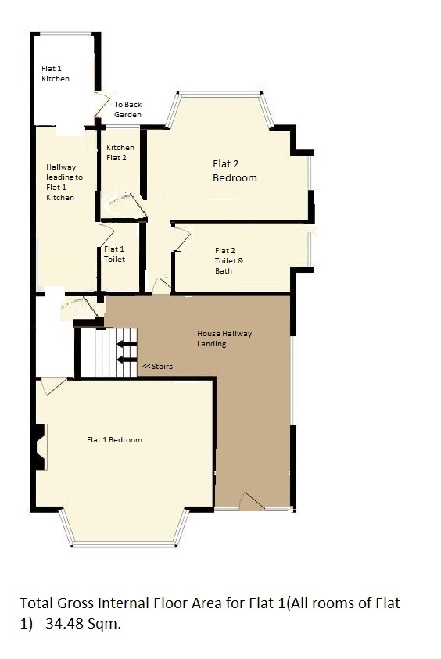

Existing Floor Layout Plans
Flat 2 (Ground Floor)
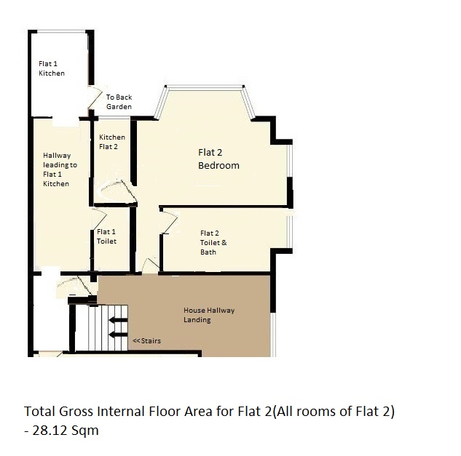

Existing Floor Layout Plans
Flat 3 (First Floor)
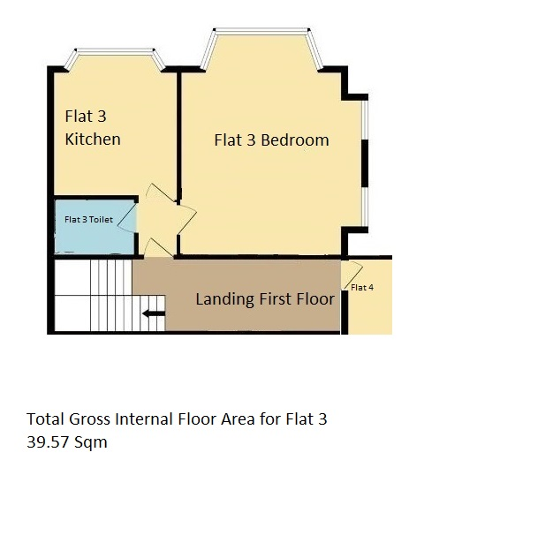

Existing Floor Layout Plans
Flat 4 (First Floor)
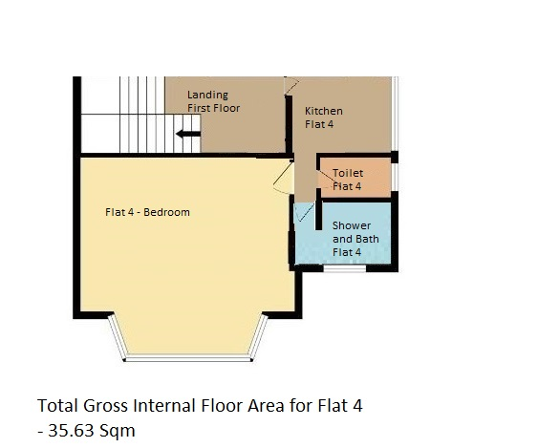

Existing Floor Layout Plans
Flat 5 (Second Floor)
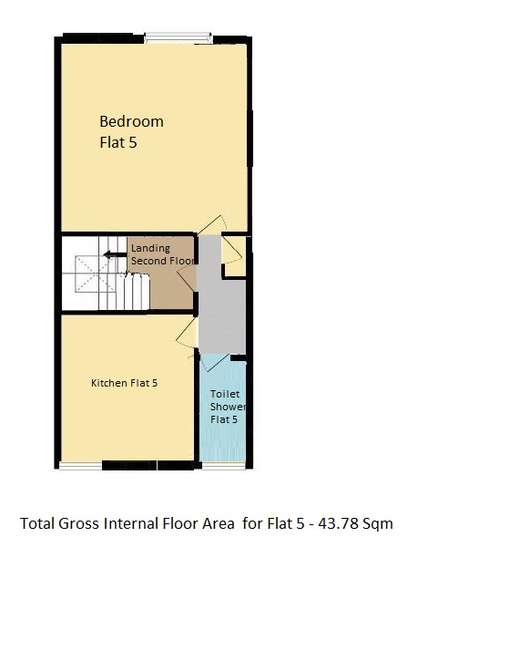

Propose Layout Plans
Flat 1 (Ground Floor) – Remove Front Fire Door

Propose Layout Plans
Flat 2(Ground Floor) – Remove Front Fire Door

Propose Layout Plans
Flat 3 – (First Floor) – Remove Kitchen and Front Fire Door
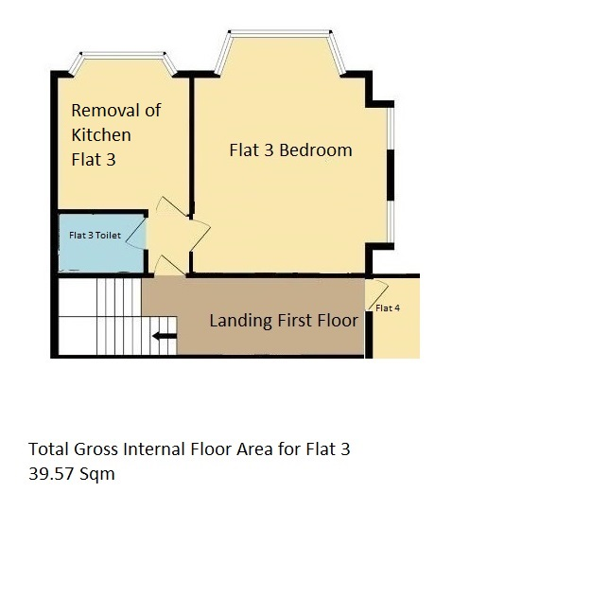

Propose Layout Plans
Flat 4 (First Floor) – Remove Kitchen and Front Fire Door

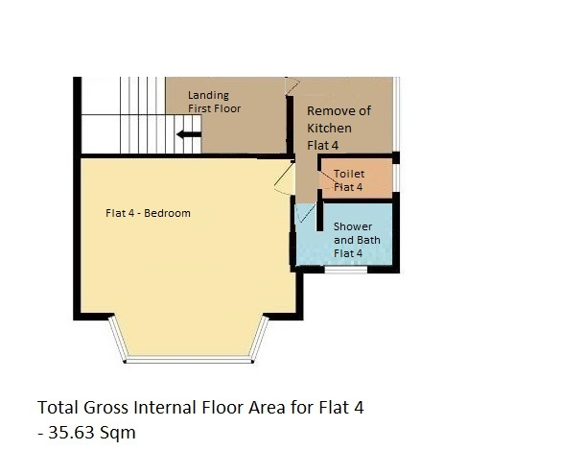

Propose Layout Plans
Flat 5 (Second Floor) – Remove Kitchen and Front Fire Door
