Design and Access Statement

Prepared on Behalf of Lloyds Bank Plc c/o 3 Shires ATM Solutions

Application for Planning Permission and Advertisement consent for the
Replacement of current ATM devices
Lloyds, 42-46 Market Street, Manchester, M1 1PW
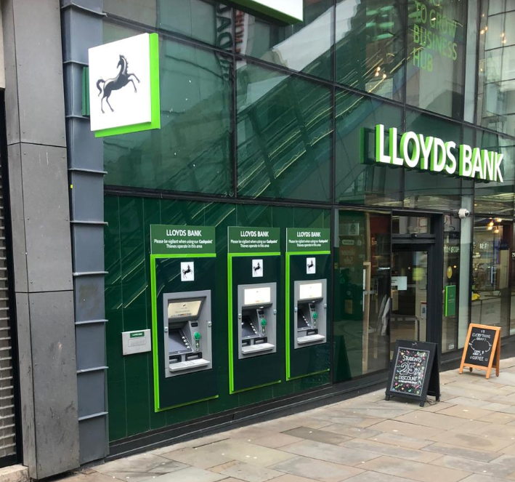

Introduction
Lloyds Bank Plc provides high street, corporate and online banking services. They are looking to future proof 24-hour cash for the local area by retaining and updating their external cash machines. These are accessible from the pavement as an asset to the area.

Proposal
The existing ATMs will be removed. The existing glazing will be replaced and apertures created for the new design ATMs. These 3 new ATMs will be installed and new signage of a similar design and colour fitted around them.

Area
The current ATM location is within the Market Street shopping area in Manchester city centre close to the entrance of the Arndale Centre. This is a pedestrianised area with limited vehicle access.

Site
The building is multi storey and of modern design with a glazed two storey retail area and 2 further storeys with grey cladding. It sits on the corner of Market Street and Pall Mall.
There is a level paved area to the front of the site.

The design will not alter the overall impact of the ATMs on the area as there are currently ATMs at this location

Layout, Scale and Materials
The layout will not alter significantly as the new ATMs will stay in similar locations.
The proposed signage will be of a similar design, size and colour to what is there at present.

Landscaping
There are no elements of landscaping as part of this proposal.

Access
Lloyds is fully committed to providing facilities, which are accessible and safe for abled and disabled customers and intend to ensure that all work carried out complies with all current regulations and good practice.

All access to the ATM has been created to ensure that all people can use the facilities provided by our client. This development is no different and all levels guarantee that this is a user-friendly site for abled and disabled customers and any improvements comply with both the local planning policy and the Equality Act 2020. The proposal is of a design, layout scale and mass compatible with the locality and any neighbouring buildings and spaces to satisfy the terms.

Designing out Crime
Lloyds with 3 Shires ATM solutions design installations to comply with the ATMSWG best practices guide ensuring that the risks to the ATM itself and users have been minimised as far as possible.

Economic, Social and Environmental Impact
Our client believes that it has a responsibility to provide the best possible facilities so its customers can receive the best possible service in a safe and controlled way. Allowing people to have access to cash is beneficial allowing them to spend more conveniently in the area. It provides an additional reason to stay local for amenities and socialising as well as giving easy access to cash to businesspeople working in the area. Replacing the existing machines ensures that they provide the most up to date facilities for customers.

Planning History
Retractable projector screen for out of hours marketing material presentation advertisement screen.
Ref. No: 115032/AO/2017
Status: Application Approved

The installation of signage.
Ref. No: 115656/AO/2017
Status: Application Approved

Installation of 1no. AHU, 2no. VRV AC units, and removal of 1no. existing AHU at roof level.
Ref. No: 116179/FO/2017
Status: Finally Disposed Of

Temporary graphic to external hoarding during construction phase
Ref. No: 117005/AO/2017
Status: Application Approved

Installation of plant equipment at roof level
Ref. No: 119921/FO/2018
Status: Application Approved

To replace the existing side fire escape with a new secure access 'tube lock' door and fire escape door.
Ref. No: 121826/FO/2018
Status: Application Approved

