TRAFFIC MANAGEMENT PLAN
WHITEMOSS ROAD.

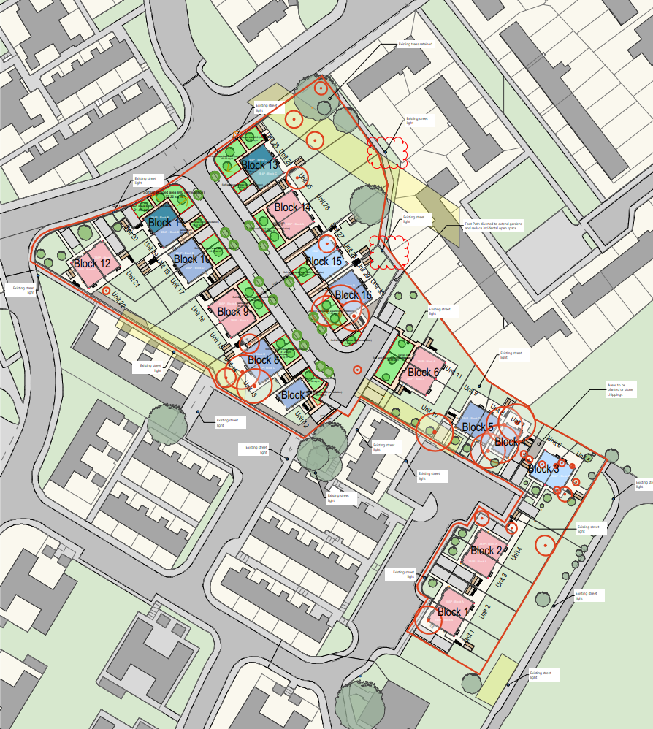
Footpaths within the site including Wankley Walk and Lilstock Walk will be
temporarily closed.

Loading/ unloading.
Turning area.
All materials will be stored
on-site. All waste will be stored in appropriate containers and will be removed from the site
by a licensed waste carrier.

Materials
Site access gates will be installed at new Entrance of section 38 road, Steel gates with displayed safety signage and speed limits.
Perimeter RED line will be Erected with heras fencing securing the whole site from the public. Fig 2

Pedestrian access to site office will be off public footpath.
SITE CABINS AND
SITE ENTRANCE/ ALL DELIVERIERS
SITE GATES
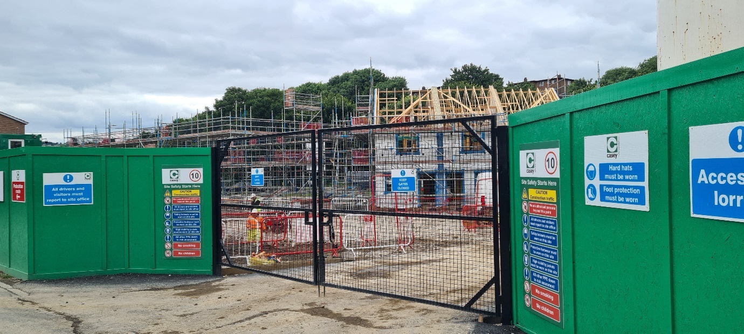
Hoarding and Heras securing site. Fig 2
- SITE ACCESS GATES, Will have restrictors welded on so the gates can only open inward away from the adopted highway.

- UU TEMP CONNECTION, will be completed next to the site cabins, UU will apply for the section 50 footpath closure to complete the connection. (RED dot on TMP plans shows connection area)
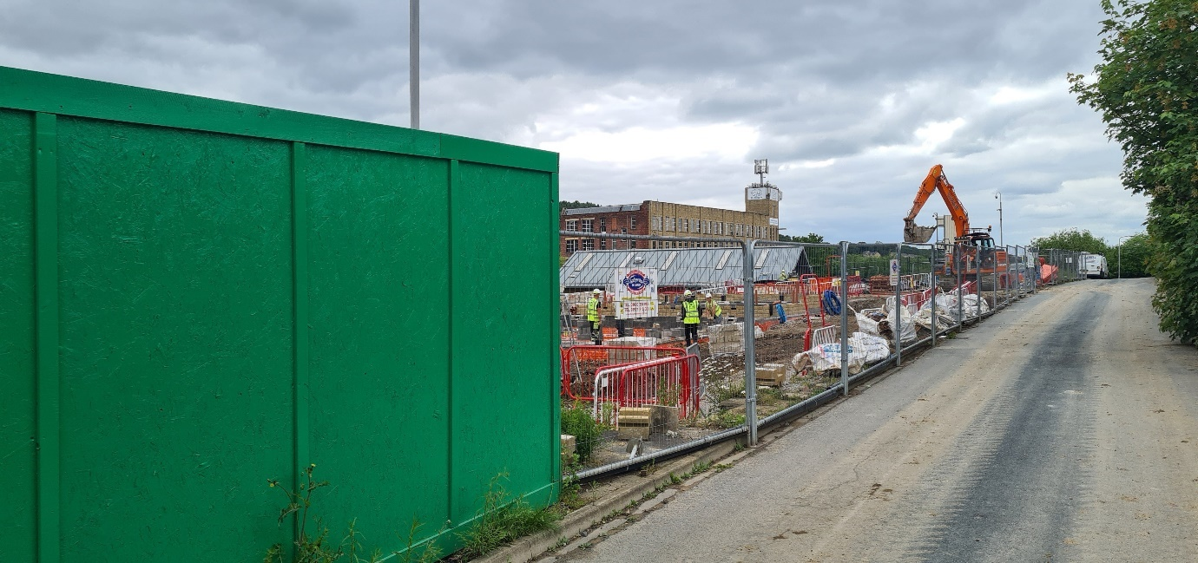

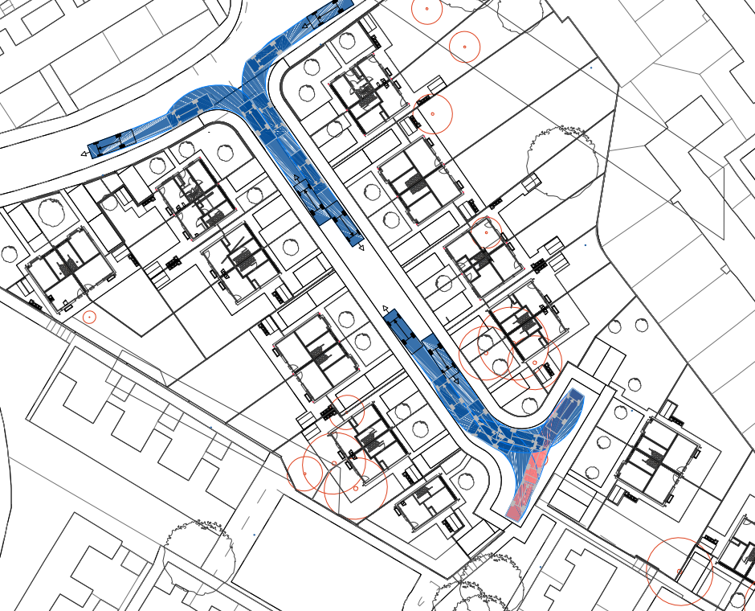
- Vehicle tracking/ Swept path.
Turning area for manoeuvring out of site in forward gear.

- We are expecting 30 to 40 wagons (8-wheel tipper) while RLD is ongoing this number will reduce after two month period to 10 wagons. Delap survey will be completed before the works progress with highways representative.
- All wagons and deliveries will come off Whitemoss Road as shown on tracking plan above.

