Ashfield Lodge TPO Application:

Ashfield Lodge,
229 Palatine Road,
West Didsbury,
Manchester
M20 2UD

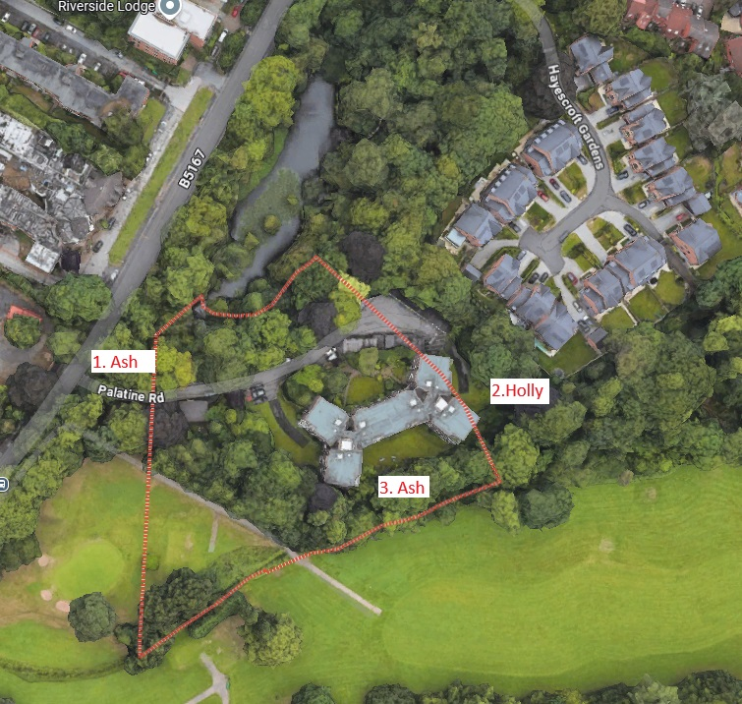

T1 Dying Ash left of the main entrance • Sectional dismantle to ground level.
REASON Heavy Ash dieback.
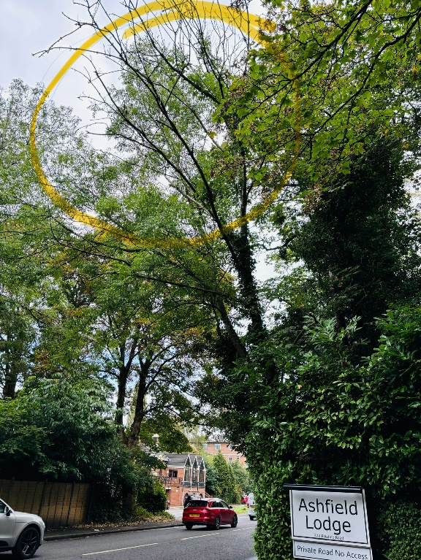

T2. Holly • Remove low dead limbs and shooting branches on the stem.
REASON To tidy the lower crown.
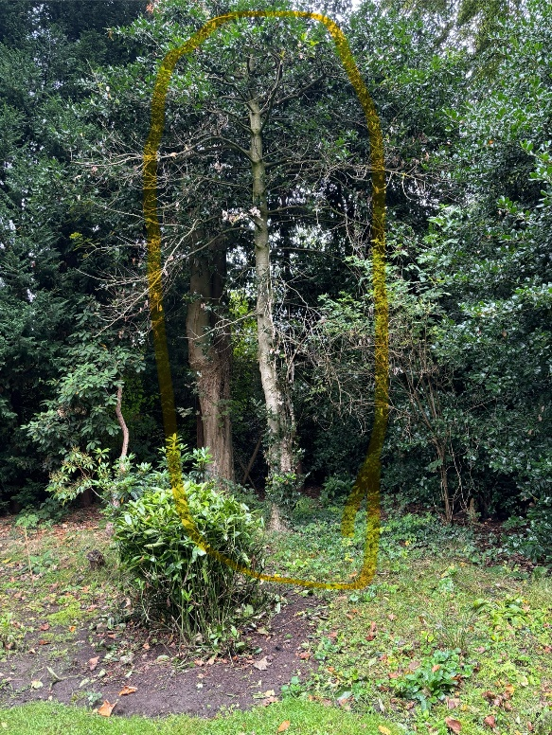

T3 Ash Sectional dismantle to as close to ground level as possible.
REASON Congested tree and Ash dieback present.

