

Segregation Statement
Location: WS106

Compiled on behalf of:
The Casey Group
Benchill Rd,
Wythenshawe,
M22 8LF

DHI Excavations Ltd, 11-13 Church St, Farnworth, Bolton, BL4 8AG
Method of Segregation Statement 10th June 2024
Site Address: Benchill Rd, Wythenshawe, M22 8LF.

Contaminated hotspots on site.
WS106 – Classified as Non-Haz Contaminated due to elevated lavels.

Segregation of WS106.
Location WS106 is not part of the current excavations. WS106 is location right on the boundary on the NW corner of the site (see drawing one).
Location WS106, on the 5th & 6th June 2024 this location has been segregated, excavated and disposed of to a licenced tip facility.
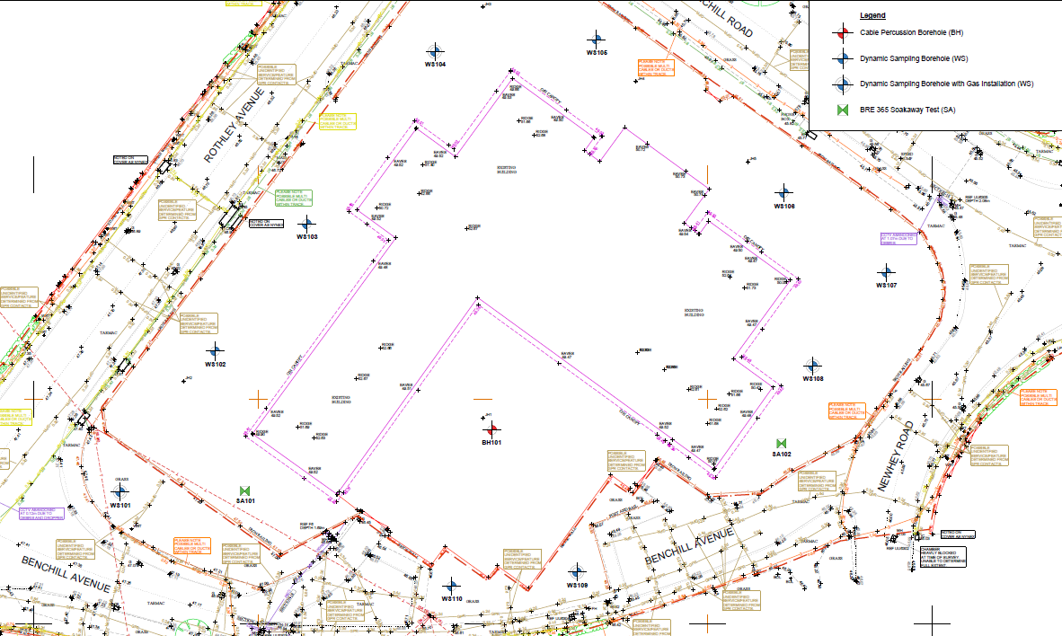

Location WS106

Benchill Rd, Wythenshawe Drawing One

WS106 Segregation & Disposal.
On 5th June 2024 location WS106 was marked out and excavated down to natural clay strata. The material from the excavation was transported to a non-hazardous disposal facility at Whitehead Landfill Astley Manchester. See pictures below and disposal paperwork.
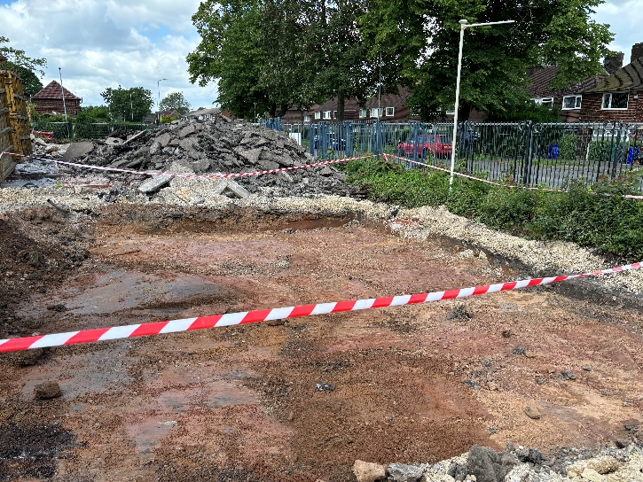
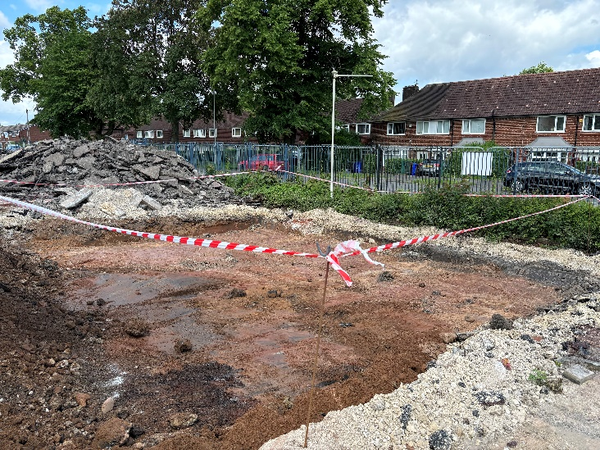

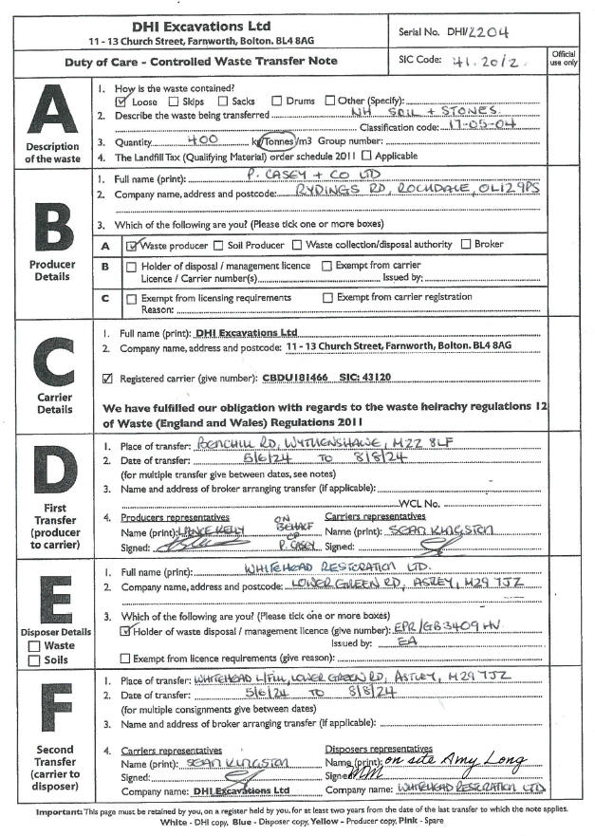

Producer: Casey Group Ltd.
Producer Representative: Jonathan Mills
Haulier: DHI Excavations Ltd
Haulier Representative: Sean Kingston.
Disposal Company: Whitehead Restoration Ltd
Disposal Address: Whitehead Landfill, Lower Green Rd, Astley, Manchester, M29 7JZ.
Permit Ref: EPR/GB3409HV.

Segregation statement compiled by:
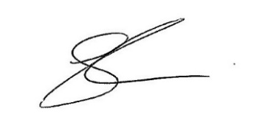
Sean Kingston

