

Segregation Statement
Locations: WS101

Compiled on behalf of:
The Casey Group
Benchill Rd,
Wythenshawe,
M22 8LF

DHI Excavations Ltd, 11-13 Church St, Farnworth, Bolton, BL4 8AG
Method of Segregation Statement 4th June 2024
Site Address: Benchill Rd, Wythenshawe, M22 8LF.

Contaminated hotspots on site.
WS101 – Classified as Unsuitable for Whitehead / Astley

Segregation of WS101.
Location WS101 is not part of the current excavations. WS101 is location right on the boundary on the SE corner of the site (see drawing one). Current excavations are at the northern boundary (see drawing two).
Once any excavations commence around location WS101 then this location will be segregated and disposed of to a licenced hydrocarbon treatment facility.
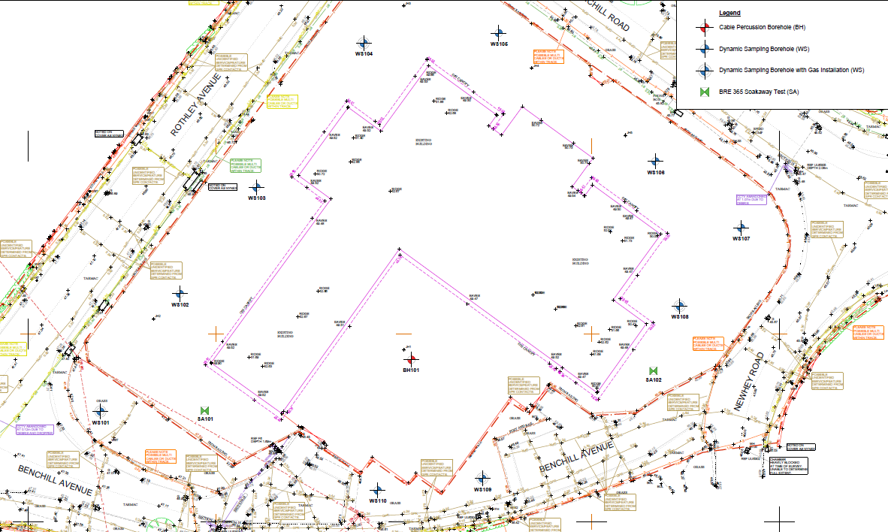

Location WS101

Benchill Rd, Wythenshawe Drawing One

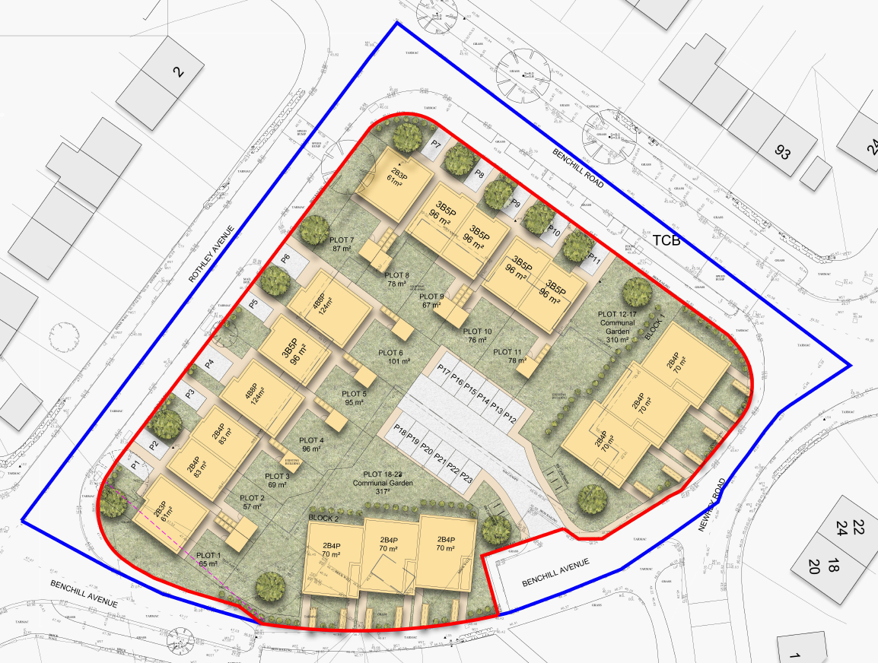

Area of Excavation

Benchill Rd, Wythenshawe Drawing Two

Producer: Casey Group Ltd.
Producer Representative: Jonathan Mills
Haulier: DHI Excavations Ltd
Haulier Representative: Sean Kingston.
Disposal Company: Greenearth Developments
Disposal Address: Whitehead Landfill Site, Lower Green rd, Astley, M29 7JZ.

Segregation statement compiled by:
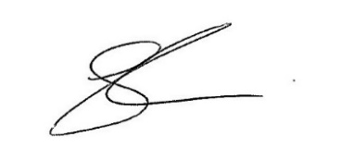
Sean Kingston

