April 9, 2025

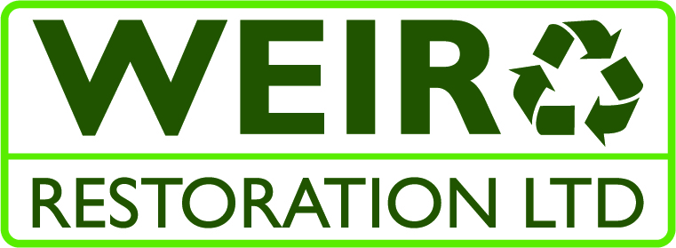
Weir Restoration LtD, Method Statement and Risk Assesment

Method statement, risk assessment for works at

Claremont, Arkwright House, Manchester M3 2LF.

Description of Activity
To repair fixing holes to external stonework, created by the re-location of gas lamps and removal of brass signage.

Location of Activity

External, front elevation. (see the attached front elevation drawing)

Duration of Works
Start date TBC. Duration- x4 days required to complete the work, but will be carried out intermittently over the course of x5 days.

Plant & Equipment
- Hand Tools
- Abrasives

Temporary Lighting & Power
Temporary, Emergency Lighting and Power is supplied by the principle contractor to all Access / Egress points, stairwells, main corridor areas etc.
*Not required

Personnel / Training
There will be 1 technician involved in the works. Technician TBC, suitably trained to carry out the works to be undertaken. holds current CSCS card. (please see below staff competency form).

Sequence of Operations.
- Visit Claremont site office to sit induction.
- Locate areas to be restored.
- Erect mobile tower. Ensure to sign and display scaff tag.
- Mix the repair mortar according to the attached instructions.
- Ensure the fixing holes are free from dust and loose debris.
- Using a water spray bottle, dampen the area to be filled with a fine mist of water, but do not saturate.
- Apply one coat of the mortar, no more than 20mm in thickness/depth, into the fixing holes to back fill and remove any excess mortar from the surrounding areas while still wet. The profile of the skim should be recesses into the hole by approximately 10mm.
- Leave the backfilled fixing holes to fully cure over two nights.
- On return, using the same mixing methods as detailed above, apply a second skim to the areas the final resulting profile sitting 2-3mm proud of the surface of the stonework.
- Leave this to partially cure overnight.
- Upon return, profile the partially cured filler using 80’s grit 180’s grit and 320’s grit sandpaper until flush with the surrounding stonework and with a smooth finish.
- If required, add a little texture to the repair using a carving tool.
- Allow the repairs to fully cure overnight.
- On return using a low pile roller, apply a coat of Stonelux primer to the face of each stone block that has received fixing hole repairs.
- Allow to cure for two hours.
- Once the primer has cured, using a low pile roller, apply a coat of Stonelux stone coating to all of the previously primed areas.
- Allow to cure, and re-coat. Two coats of topcoat should be sufficient but apply a third if deemed necessary.

Inspection & Testing- All electrical equipment will be will be PAT tested and in date. Certificates are available on request.

Access Arrangements/ Working at height-
A mobile tower will be required to complete the work. All Weir operatives are PASMA trained.

Manual Handling Activities- See attached Risk Assessment

Personal Protective Equipment
Weir Restoration Technicians shall wear the following Personal Protective Equipment
- Hard Hat
- Hi Visibility Vest
- Safety Boots
- 3m 6200m Respirator BS EN 140:1998 for use when sanding or spraying paint. (face fit tested, see attached certificate)
- Blue Nitrile gloves
- Tight fitted goggles - Bolle Cobra EN 166 3BT
- Light Eye Protection for general use around site.

Communications
All Weir operatives are to be aware of the Access & Egress routes on/off site.
This is as per site logistics.

Human Factors

N/A

Emergency / First Aid

First Aiders:

Daniel Weir 07506 008007

Declan Moore 07393 170896
Determine the location of the nearest first aid kit. Ensure the identities of all on-site first aiders are known and contact is possible at all times whilst working on site.
Closest Hospital A&E Location:
Manchester Royal Infirmary, Upper Brook St, Manchester.
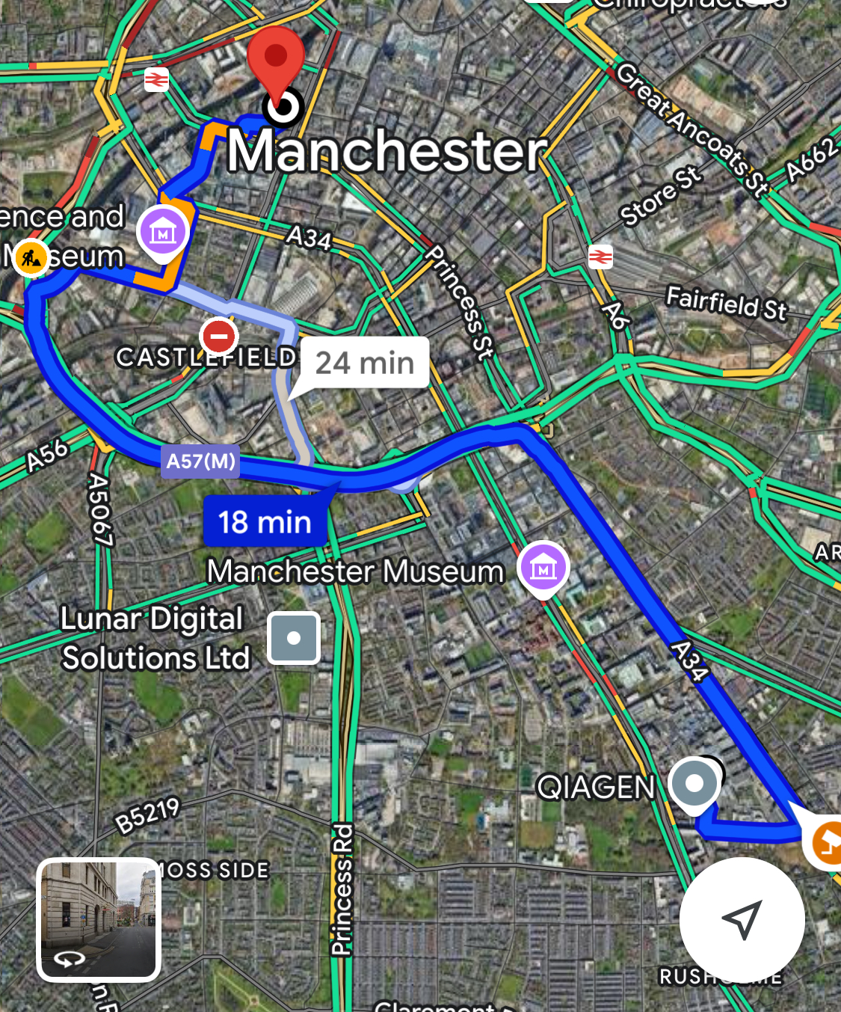

Procedure for changes to planned activities

N/A

Reporting of Accidents and Near Misses
Should any accidents occur, Weir technicians shall report this to the site management to log in the company accident book.

Safety documentation / Permits Required
All operatives are to have read, fully understood and signed the Weir Restoration Method statement and risk assessment prior to works commencing.

Waste Management and Housekeeping
All surplus waste generated while the works have been undertaken will be bagged and disposed of at the company premises

COSHH
Any hazardous materials must be subjected to a COSHH assessment prior to use. Any flammable liquids required on site will only be in small quantities, stored in 200ml bottles and kept in an air sealed box. No flammable liquids are to be left unsupervised and will be kept in the area of work with the technician at all times during works being carried out.
See attached COSHH assessments

Appendices :

Annex 1 : Staff Competency Form

Annex 2 : Risk Assessments

Annex 1 : Staff Competency Form

Y = Yes | CSCS | SSSTS | PASMA | IPAF | Abrasive Wheels | Asbestos Awareness | First Aid
Site Operative:  Daniel Weir | H&S Officer |  | Y | Y | Y | Y | Y
Site Operative:  Declan Moore | Skilled Worker | Y | Y | Y | Y | Y | Y
Site Operative:  Kyle Hewitt | Skilled Worker |  | Y | Y | Y | Y
Site Operative:  George Marsh | Skilled Worker |  | Y | Y | Y | Y

I fully understand and agree to abide by the instructions set out
in this method Statement and risk assessment.

Signed

…..............................................................................

…..............................................................................

…..............................................................................

…..............................................................................

…..............................................................................

