Bowmer + Kirkland Ltd
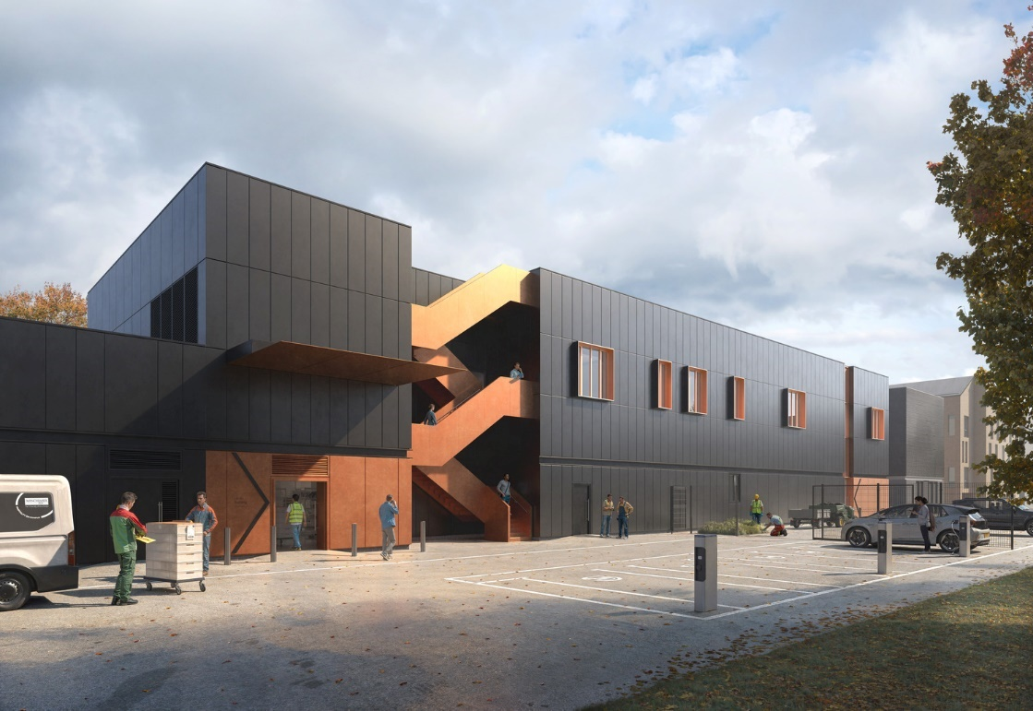
HEALTH & SAFETY PLAN
PROJECT:
Limes Building
University of Manchester

Prepared by……Liam Jones…...………………………………. Date……20/03/25………

Reviewed by…..Mark Hooson………………………………….. Date……27/03/25………

Manager…..………………………………………………………. Date………………………

Manager ….………………………………………………………. Date………………………

Manager…..………………………………………………………. Date………………………

HEALTH & SAFETY PLAN (CONSTRUCTION PHASE)

CONTENTS
Part 1 Description of Project
- Project description and programme details including any key dates.
- Details of Client, Principal Designer, Designers, Principal Contractor, and other Consultants.
Part 2 Arrangements for Controlling Significant Site Risks
- Project Risk Assessment
Part 3 Management of the Work
- Safety risks.
- Health risks.
Part 4 The Health & Safety File
- Layout and format.
- Arrangements for the collection and gathering of information.
- Storage of information.
SPF 114a - Appendix A
Pre-Start Health & Safety Review – To be completed at least 4 weeks prior to mobilisation.

Introduction
This template SPF 114 includes a summary of significant risks relating to the project.
This requirement for a Construction Plan applies to all Bowmer + Kirkland projects, when appointed as Principal Contractor under the Construction (Design & Management) Regulations.
For the purposes of the CDM Regulation the Construction Plan will be developed and updated through the Bowmer + Kirkland Quality Management System, Environmental Management System and Health & Safety Management System processes and procedures:

Inputs in addition to Pre-Construction Information
- Inspections  - Audits  - Records  - Assessments  - Minutes  - Method Statements | - Designs  - Surveys  - Inductions  - Toolbox Talks  - Training  - Test Certificates  - Updates | - Permits  - Licences  - Reports  - Minutes  - Plans / Reviews  - Forms  - Standards etc.

OHSAS 45001 Health & Safety Management System

ISO 9001
Management System
Project Plan

ISO 14001
Environmental Impact Assessment
Site Waste Management Plan

CDM Construction Plan
Final Outputs
Health & Safety File  - As-built information  - O & M manuals and instructions  - Warranties / Test and Inspection Certificates | Archiving and Filing  - RDrive, SmartWaste, WMS, DMS, WorkWallet  - Retention of contract and project documents  - 12-year archive 4P / Clouds
Bowmer + Kirkland Integrated Management System

Part 1 Description of Project and Management Arrangements
Project No.: | 63082
Project Name: | Limes Building, University of Manchester
Full Site Address: | Limes Building,  Chancellors Way,  University of Manchester,  Fallowfield Campus,  Manchester,  M14 6YZ  (Gate 1 : ///fades.snack.pulse)
Location of Project: | Fallowfield, Manchester
Scope of Works: | As part of the redevelopment of Fallowfield Campus the University of Manchester (UoM) have a need to demolish the current Limes building which is a catering and facilities management facility and services the UoM in the Fallowfield campus. B&K have been asked to construct a new building that will provide a large-scale catering facility, staff offices and storage space (The new Limes building).  The new Limes is a 2 storey building with a single storey portal frame on the western side. The building will be constructed on pad foundations with a mixture of a ground bearing slab to the store unit and an insitu suspended slab to the main building. The steelwork frame will be clad in Trimo cladding with a Bauder roofing system. Internally there will be a mixture of catering facilities, staff offices and storage space.
Client Contact: | Ben Smith Capital Projects Manager - UoM  Hayley Kirsh Associate Project Manager - RLB
Site Manager: | Liam Jones Senior Site Manager – B&K
Client H & S Contact: | Gary Ratcliffe Senior CDM Advisor - UoM  Nick Groom Senior H&S Consultant - RLB

CDM Notification Requirements:
Notifiable CDM? | If no use SPF 128 Small Works Plan or RAMS for micro works | Y
- Initial Notification Date: | 12/03/2025
- Construction F10 submitted? | Yes
- Health & Safety File requirements: | Template to be agreed
- HSE Office: | Bootle Headquarters, Redgrave Court, Merton Rd, Bootle, Merseyside, L20 7HS
- Client CDM Advisor: | Gary Ratcliffe (UoM) & Nick Groom (RLB)
- Pre-Construction Information PD | Nick Groom (RLB)
- Construction Phase PD | B&K (Supported by Safer sphere)
- Building Safety Act - PD | Nick Groom (RLB)

Programme Requirements:
- Construction Start Date | 07/07/2025
- Enabling Works Date(s): | Phase 1 – 07/04/2025  Phase 2 – 09/06/2025
- Handover Date(s): | 07/09/2026 Full Project  Early access for decant from existing building TBC
- Completion Date | 07/09/2026
- Client Walk Round / Inspection | Monthly
- Duration (working days): | TBC
- Contractor Working Hours: | Mon – Friday 7:30 – 18:00 (No noisy activities prior to 9am within term time.
- Premises to Continue Trade? | No
- Client / Bowmer + Kirkland  PTW required? | No
- Other concurrent Projects /  works on site: | TBC
- Handover / ‘soft landings’ Dates: | TBC
- Defects Period: | 12 Months

Programme Detail / Dates:
No of Phases: | 1 (Full project)
Phase Dates | NA
Operational Hours  Mon-Fri: | Mon – Friday 07:30 – 18:00 (No noisy activities prior to 09:00 during term time) | Operational Hours  Weekends: | Weekend working to be agreed with MCC and UoM
Client / Occupier Shutdown / days closed: | 5 Days for Revival Week  Date WC 8th September 2025

Considerate Constructors (valid 12 months):
Site registration number 1 | TBC
Site registration number 2 | TBC

Waste (refer to SmartWaste)
Note: Wales and Scotland refer to Paul Smith
Is Hazardous Waste Registration Required?  (required if >500kg produce in 12-month period) | NO | Site registration number  (Valid 12 Months)

First Aiders
- Liam Jones
- TBC

Mental Health First Aiders
- Liam Jones
- TBC

Fire Marshalls
- Liam Jones
- TBC

Updates and Revisions
Date | Details of Changes Made

Part 2 Management of the Work
Management Structure and Responsibilities
The works will be controlled by a full time Site Project Team who is fully experienced in all aspects of the works to be undertaken.
Health & Safety monitoring will be carried out by R G Wilbrey (Consultants) Ltd, Bowmer + Kirkland’s independent Health & Safety Managers, who will normally inspect and audit the site at least once every two weeks.
All operatives and plant operatives employed at the site will be fully trained and should hold a current CSCS / CPCS card or accepted equivalent relevant to their trade or machine.
Health & safety goals for the project are aligned with the Group OHSAS 45001 Health & Safety Management System and Roles and Responsibilities are recorded and allocated via form MPF 9.1

Project Directory
Role | Name | Phone / E-mail
Director: | Paul Sykes | p.sykes@bandk.co.uk
Contracts Manager: | Mark Hooson | m.hooson@bandk.co.uk
Design Team Manager: | Peter Mickleburgh | p.mickleburgh@bandk.co.uk
Project Manager | Liam Jones | Liam.jones@bandk.co.uk
Site Manager: | TBC
M&E Manager | Sam Fryer | s.fryer@bandk.co.uk
B + K Safety Manager: | Rebecca Williams | r.williams@bandk.co.uk
Safety Consultant: | RG Wilbrey Ltd

Key Responsibilities - Site Management
Role Name | Deputy
Role (Appointment) | Name | Deputy
Emergency Response Coordinator | Liam Jones | TBC
First Aider | Liam Jones | TBC
Mental Health First Aid | Liam Jones | TBC
Site Orientation / WMS Registration | TBC | TBC
Fire Safety Coordinator | Liam Jones | TBC
Fire Safety Permit Controller | TBC | TBC
Temp Works Coordinator | Liam Jones | TBC
Temp Works Supervisor | TBC | TBC
Scaffolding Operations | Liam Jones | TBC
Lifting Operations Coordinator | Liam Jones | TBC
Crane Supervisor | Subcontractor Management | TBC
Safety Net Inspector | Subcontractor Management | TBC
Environmental Champion | TBC | TBC
Services Coordinator | Sam Fryer | TBC
Safe Digging (Cat & Signal Generator) | TBC | TBC
Edge Protection | TBC | TBC
Asbestos Management | Subcontractor Management | TBC
R Drive Champion | TBC | TBC
SmartWaste Champion | TBC | TBC
Fire Stopping Champion | TBC | TBC
Package Manager Externals | TBC | TBC
Traffic Management Coordinator | TBC | TBC

Other B + K Staff / Agency | (security / labourer / cleaner etc. - include risk assessment in Section 9)
Hard hat CCTV
Parrell CCTV
Concept cleaning

Outside Agencies: | Address / Phone/ E-mail
HSE: | Bootle Headquarters, Redgrave Court, Merton Road, Bootle, Merseyside, L20 7HS
Environmental Health: | Manchester City Council, Environmental Services, www.manchester.gov.uk/xfp/form/1882
Environment Agency: | National Customer Contact Centre, PO Box 544, Rotherham, S60 1BY / 03708 506 506 / enquiries@environment-agency.gov.uk
Police: | Greater Manchester Police, Longsight Police Station, 2 Grindlow Street, Longsight, Manchester, M13 0LL / 0161 856 4229
Fire: | Withington Fire Station, The Forge, 501 Wilmslow Road, Withington, Manchester, M20 4AW / 0161 908 5402
Hospital | Withington Community Hospital, Nell lane, West Didsbury, Manchester, M20 2LR / 0161 434 5555
Gas Emergency: | National Gas, 0800 111 999.
Electricity Emergency: | ENWL, 0800 195 4141

Development of the Plan
The Plan will be developed through compliance with Bowmer + Kirkland Quality Management System, Environmental Management System and Health & Safety Management System processes and procedures. These will generate plans, actions, checks, and reviews and associated records – see summary of relevant documents below:
Document Title | Reference
Pre-Let Meeting | MPF 3.3
Commercial Status Chart | MPF 3.11
Code of Conduct for Suppliers
Requirements for Suppliers
Contractor Assessment | MPF 3.18
Designer / Consultant Assessment | MPF 4.1
Design Change Notice | MPF 4.6
Design Plan | MPF 4.8
Principal Designer CDM Design Risk Schedule or equivalent | MPF 4.9
Main Designer CDM Design Risk Schedule (if used) | MPF 4.10
Project Plan | MPF 2.2 / MPF 5.0
Project Directory | MPF 5.2
Contractors Report | MPF 5.13
Project Meetings Schedule | MPF 5.16
Standard Meeting Minutes | MPF 5.17
Internal Project Review | MPF 5.26
Risk Register | MPF 5.27
Filing List - Contractor | MPF 5.31
Site Commencement Checklist | MPF 5.4
Filing List – Project | MPF 5.7
Inspection and Test Plan | MPF 5.8 
Water Management Plan | MPF 5.37
Environmental Impact Assessment | MPF 6.3
CEMP – Construction Environmental Management Plan | SmartWaste
Permits, Consents, Permissions
Construction Logistics Plan
Health and Safety Filing List and Responsibilities | MPF 9.1
Method Statement Evaluation Record | SPF 106
CDM Health & Safety Plan | SPF 114 / 128
Pre-Start Meeting | SPF 114a
Fire Risk Assessment | SPF 115
Traffic Management Plan | SPF 116
Small Contractor Competence Assessment Record | SPF 124
Direct Contractor Evaluation Record | SPF 125
Lifting Plans and Reviews | SPF 132 / 511
Induction Records | WMS
Delivery Records | DMS
QA Inspection Records
Management Inspections | 
Site Inspection Activity
Permit to Work
Authority to Proceed
Behaviour / Discipline – Red / Yellow / Green Cards
Event Reports – Accidents, Incidents, Official Visits, Concerns
Consultation / Feedback
Minimum risk control standards are defined in the Health & Safety Management System – Safety Procedures as guidance.

The Procedures Manual sets out arrangements for:
- Regular liaison between parties on site
- Consultation with the workforce
- Selection and control of contractors
- Site security
- Site induction
- On-site training
- Welfare facilities and first aid
- Reporting and investigation of accidents and incidents including near misses
- Production and approval of risk assessments and written systems of work
- Site Rules
- Drug and Alcohol policy
- Fire and Emergency Procedures
Elements of design are considered and can be communicated electronically:
- The exchange of design information between the Client, Designers, Principal Designer and Contractors on site.
- Handling design changes during the project.
- The exchange of health & safety information between contractors.
Site Induction and Orientation
B+K Induction and Registration is on the Workforce Management System (Biosite / M-Site), which record personal information in a secure GDPR compliant system and hosts an annual B+K Safety Induction and supporting materials. A site-specific orientation and registration on biometric access will take place on each site.
At site mobilisation, site should use the App associated with the relevant WMS.
All managers and workers are required to use that system on the site.
Any interim induction or site familiarisation should be reviewed with your Health and Safety Manager and tailored to the specific site works and risks, including any Client rules and requirements.
Worker Consultation and Engagement
Bowmer + Kirkland wish to create an industry where everyone is valued, all views are listened to, and a safe and healthy working environment is the norm and not the exception.
‘Our health and safety pledge’:
Bowmer + Kirkland Ltd understands their responsibilities and wants to make this site as safe as possible for everyone working or visiting here.
We are a family firm with family values.
- The Project Manager has got the full backing of the Company’s Directors to exclude anyone from this site who does not comply with the company’s safety rules.
- Nothing we do is so important that we cannot take the time to do it safely.
- You are not asked or expected to work unsafely.
- The safety of employees, colleagues, and the public in the areas we work in is paramount.
- Help everyone you work with to work safely and prevent unsafe working practices.
- Never knowingly walk past an unsafe act or condition on the site.
- Don’t interfere with anything provided for safety and don’t abuse welfare facilities.
- Use your common sense, be aware of your actions and your surroundings.
- If in doubt, stop and ASK.
The people who can have the biggest effect on safety, are those working on site.
Think safe. Be safe. Stay safe. NO EXCUSES

Bowmer + Kirkland is committed to effective worker consultation on health & safety issues. The following principles are adopted by Bowmer + Kirkland.
- On every project where Bowmer + Kirkland is the Principal Contractor any worker has the right to stop working if he or she is or feels to be at risk.
- No punitive action will be taken against any worker who raises a valid health & safety issue.
- Every person on a construction site will speak to people in a manner in which they would like to be spoken to themselves.
- Aggressive and confrontational language aimed at a worker who has raised a health & safety issue is unacceptable.
- A mechanism will exist for all workers on a project to make their views on health & safety known.
- All workers on site will be informed of the consultation mechanisms.
B+K are committed to CSR - Corporate and Social Responsibility and the Considerate Constructors Scheme.
B+K engage with a variety of stakeholders including our clients, their workforce, customers, students, patients and even inmates, trade bodies, industry bodies, Government, Regulators and Accreditation bodies, as well as the neighbours and wider communities present before, during and after delivery of our Projects.
Client satisfaction is our mantra and to achieve this we must operate in a responsible manner, minimising disruption and negative impacts during construction and leaving a wider legacy from our completed projects of lasting quality, enhancement, and improvement.
Site Rules
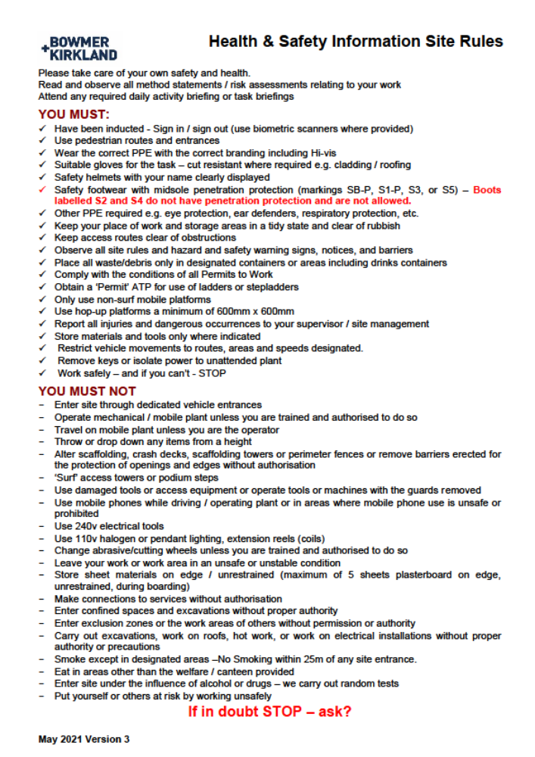

Daily Activity Briefing - MANDATORY
Daily Activity Briefings create an opportunity for subcontractor Supervisors and B+K Managers to discuss the health & safety aspects of a task and a project and allows workers to contribute to their day-to-day method of working, via their trade Supervisors. Significant issues are brought to the attention of the workforce via Supervisors who should cascade the information to their workers.
This is the main mechanism for consultation and coordination of the site activities where different trades and subcontractors may interact.
A daily Activity Briefing Board should be completed and recorded by photograph on  Health and Safety App.
Emergency Arrangements
Health & Safety Procedure SP 6.1 sets out arrangements for emergency response to situations including actual or potential (near miss): fire, pollution, accident, property damage or other incident.
For construction sites we complete a SPF 115 Fire Risk Assessment for the construction area and site accommodation to assess risks of fire and fire loading. A Fire & Emergency Plan will be developed including Emergency Escape Plans for the site accommodation and construction areas. This is supported by regular, recorded check on security measures, fire and emergency equipment and procedures.
Bowmer + Kirkland has developed full emergency and fire procedures to comply with Fire Prevention on Construction Sites (Joint Code of Practice on the Protection from Fire of Construction Site & Buildings Undergoing Renovation) – current edition.
For refurbishment and extension Projects and any Project on a live environment, the Project Manager will be required to complete SPF 115 Appendix 1 to assess the effects of work on the fire integrity and emergency arrangements for staff, customers, visitors, etc.
High risk projects will have an independent assessment and construction fire strategy review.
Standard Hot Works are covered by a Permit to Work in operation from 8am – 3pm Monday – Friday. Higher risk hot works and hot works at other times are subject to a more onerous PTW.
The information is reviewed at an early stage by a Group Health & Safety Manager who has attended the FPA Fire Risk Assessment training.
The Fire & Emergency Action Plan is formally reviewed at least once every month at the internal Project Review Meeting.
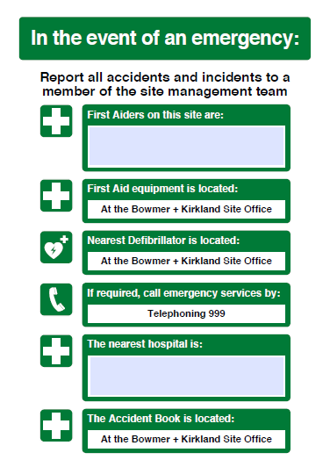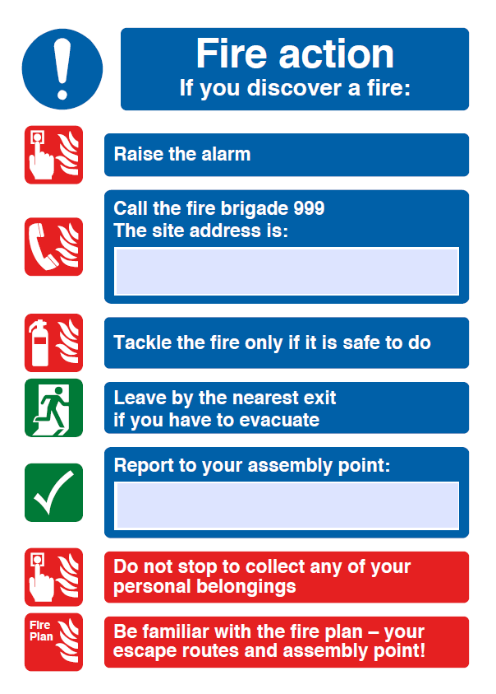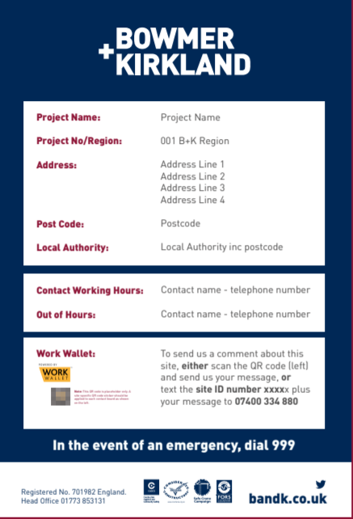

IF THE SITE MANAGER IS UNAVAILABLE THEN CONTACT:
Project Manager: | Liam Jones | 07471962853
Contracts Manager: | Mark Hooson | 07867536931
Construction Director: | Malcolm Robertson | 07825920011
Regional Director: | Paul Sykes | 07766775124

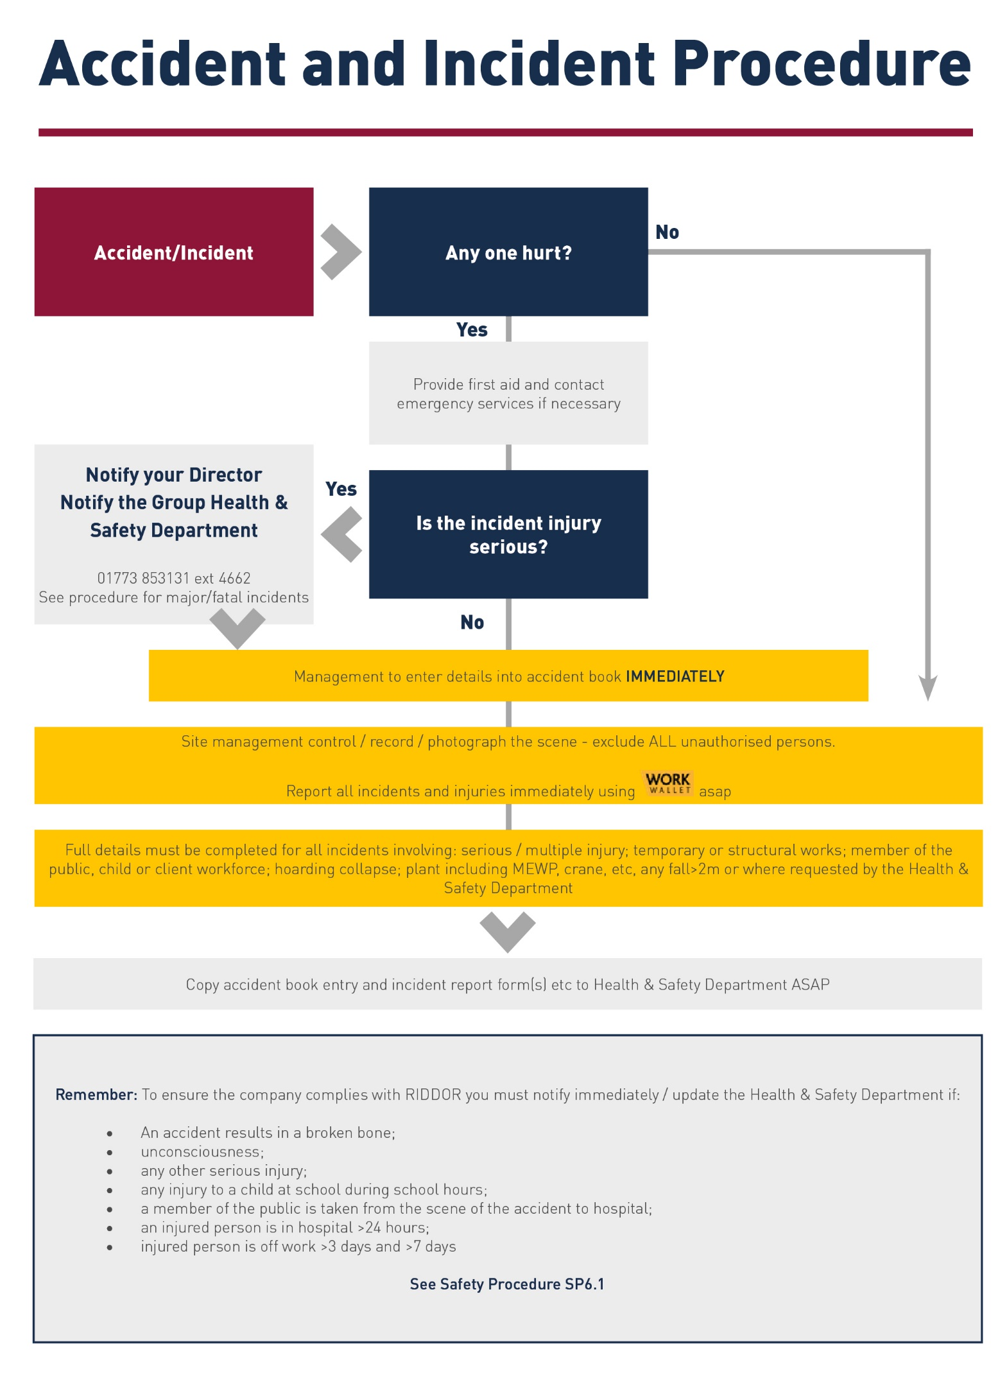
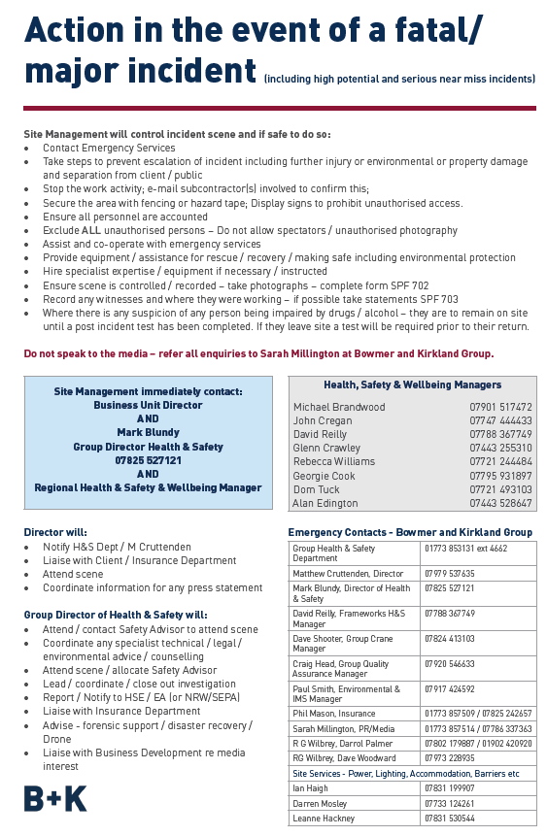

Risks identified through the planning and construction phases should be recorded in the Project Risk Register MPF 5.27 and subject to regular review and update.

Part 2 Arrangements for Controlling Significant Site Risks

(Site Establishment / existing information):

This section requires a review of the site prior to works commencing, the pre-construction information including design risks, supplied by the PD, and requirements to establish the site and then make an assessment of risk (without controls) as High / Medium / Low / N/A.

Standard risk controls are detailed in the Bowmer + Kirkland Health & Safety Procedures Manual. The comments box should record items where there is an elevated risk, requirement for additional information or precautions or special measures have been taken or will be required.
Client Requirements – phasing, working hours, programme |  |  |  |  |  |  |  |  |  | HIGH |  | MEDIUM | LOW |  | N/A
Comments | Working hours for site will be:  Monday to Friday 07:30 – 18:00  No noisy activities prior to 09:00 within term time.  No working on weekends or public holidays without express written permission of the client and project manager and confirmation from the Local Planning Authority.  There will no works at any time on Sundays or Bank Holidays where normal construction activities are expected to exceed these working hours then LPA & EHO will be informed in writing at least 10 days prior to commencing works. Newsletter drops to the local area will also be implemented during construction phase.
Public Protection / Surrounding activities |  |  |  |  |  |  |  |  |  | HIGH |  | MEDIUM | LOW |  | N/A
Comments | The site will be shielded by 2.4m high solid timber/steel mesh panel hoarding. The Northern boundary wall which consists of a 2.4m high green steel fence and a 2.0m high brick wall will be used as the hoarding barrier. The hoarding perimeter will be monitored with 24-hour CCTV coverage.  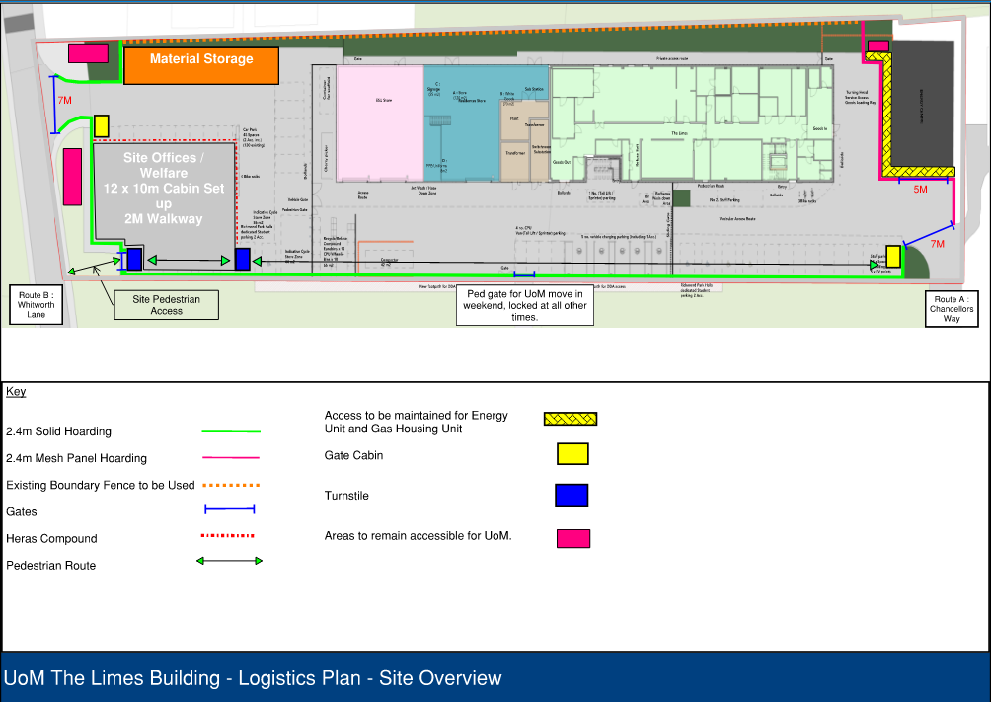
Site Security – CCTV / Manned Guards See SP 9.15 for Guidance
Site Security Risk |  |  |  |  |  |  |  |  | VERY HIGH |  |  | HIGH | MEDIUM |  | LOW
Is the site occupied / live? |  |  |  |  | No |  | Motion Sensor Lighting |  |  |  |  |  |  |  |  | No
Is there a history of arson / theft? |  |  |  |  | No |  | Permanent lighting during darkness |  |  |  |  |  |  |  |  | No
Education project? (ALL High Risk) |  |  |  |  | Yes |  | Permanent CCTV |  |  |  |  |  |  |  |  | Yes
Is the Project using timber frame construction? |  |  |  |  | No |  | Biometric (Face Recognition) access to PPE / Build Area |  |  |  |  |  |  |  |  | Mandatory
Monitored motion activated CCTV |  |  |  |  | Mandatory |  | Visiting / Reactive Guarding |  |  |  |  |  |  |  |  | Yes
Hoarding / Fencing |  |  |  |  | Yes |  | Out of Hours Guard |  |  |  |  |  |  |  |  | No
Full 2.4m Hoarding |  |  |  |  | No |  | 24/7 Guard |  |  |  |  |  |  |  |  | No
Security Risk |  | Boundary / Perimeter | Motion  Sensor lighting | Permanent  Lighting hours of darkness |  | Turnstile Access Control to the build area |  | CCTV |  |  | Monitored motion-activated CCTV surveillance systems |  | Guard  out of hours | Guard  24/7  NOT GATEMAN
Medium |  | Hoarding / Fencing | N | N |  | Y |  | Y |  |  | Y |  | N | N
High |  | Hoarding / Fencing | Y | R |  | Y |  | R |  |  | Y |  | Y | N
Very High |  | 2.4 site Hoarding | Y | Y |  | Y |  | Y |  |  | Y |  | Y | Y

Vehicle and Pedestrian Management including deliveries |  |  |  |  | HIGH |  | MEDIUM | LOW | N/A
Comments | Access and egress will change as the site evolves. Please refer to our logistics document for the various phases of the project and how access and egress will change.  Vehicles will always be met by a traffic marshal at the site gates. Where possible B&K will always try and eliminate the need for reversing deliveries.  Delivery and overall site logistics will be managed by our dedicated logistics manager who will over see all site logistics and make sure Msite delivery software is updated by subcontractors. Part of our Msite delivery software allows subcontractors to book in delivery on specific times slots preventing congestion on site and unproductive working. There is a minimum of 48hours notice for the deliveries meaning that subcontractors need to plan and coordinate their works in advance.  Our logistics manager will also control on site storage of materials and plant implementing the safe systems of works with our subcontractors.  We will have undertaken a swept path analysis prior to works commencing to ensure the routes below work.  Site staff and operative parking is currently being reviewed, due to the lack of local car parking locations we have requested a dedicated space from the UoM. We are reviewing the car park at the front of the campus in front of the playing fields.  Our plan is to ensure the construction site traffic does not take dust and mud off our site onto the local roads, we are looking to base out all tarmac areas and lay a concrete blinding to any concrete areas within our site so that any wagons or delivery vehicles do not drive onto ground other than concrete/tarmac. This will ensure no heavy muck is taken of our site. With regards to dust we will utilise dampening measures during summer months and if required we will jet wash wagon wheels prior to leaving site if it is deemed necessary. B&K also utilise a fleet of road sweepers from two local contractors to ensure all local roads and site access routes are maintained.  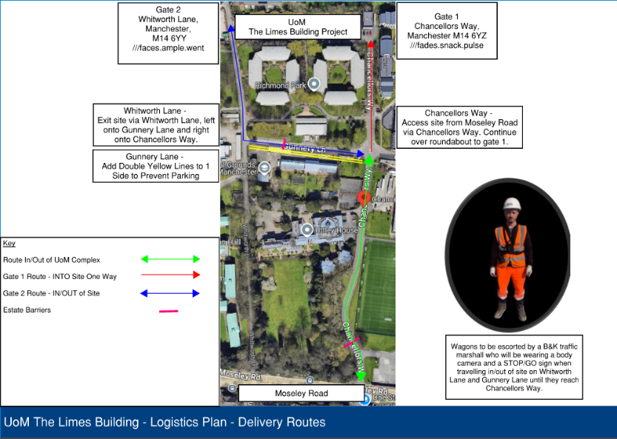
Fire / Emergency including diversions |  |  |  |  | VERY HIGH |  | HIGH | MEDIUM | LOW
Is the site occupied / live? |  |  | NO | Finished Building FRA completed?* |  |  |  |  |  | NO
Information on Client requirements? |  |  | NO | Diversions / Signs / Lighting required? |  |  |  |  |  | NO
Existing fire risk assessment? * |  |  | NO | FPA training required? |  |  |  |  |  | NO
Is there fire engineering protection? |  |  | NO | Are the public affected by works? |  |  |  |  |  | YES
Will works disturb any fire breaks? |  |  | NO | Any vulnerable groups? |  |  |  |  |  | NO
Any high-risk process / activity? |  |  | NO | Existing fire / escape plan obtained? |  |  |  |  |  | NO
Is there a history of arson / theft? |  |  | NO | Is a full Fire RA required? |  |  |  |  |  | YES
Hot Work PTW? |  |  | YES | Can a protected cutting area be provided? |  |  |  |  |  | YES
*Complete SPF 115 in all cases and review with your Safety Manager
Comments | Please refer to our fire risk assessment document.
Site Accommodation including Welfare Facilities / offices etc. |  |  |  |  |  | HIGH | MEDIUM | LOW |  |  | N/A
Existing Toilets? |  | No | Existing Canteen |  |  |  |  |  |  |  | No
Comments | The welfare facilities will be located on site in the southwestern corner.  The welfare will consist of a two-storey stack of cabins.  Ground floor level  Canteen, drying room/changing facilities and toilet facilities including space for a wellbeing room.  Level 1  Site staff and Subcontractor meeting rooms and office space  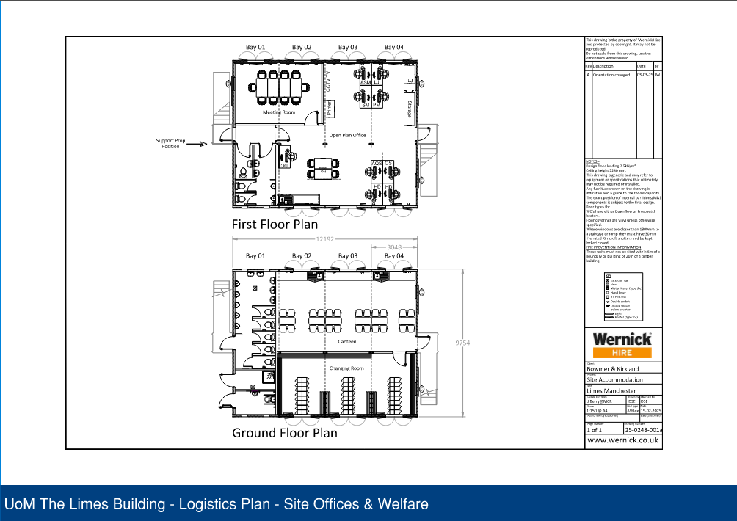
Services – underground / overhead |  |  |  |  |  | HIGH | MEDIUM | LOW |  |  | N/A
Comments | Underground services are always a concern whilst most services are located on existing plans there can be anomalies within services/stats records.  All existing services drawings would be reviewed prior to any works starting. All ground penetrations work would always be under a permit to dig system. Part of our mandatory permit to dig system requires a cat and genie to be used prior to breaking ground to scan for unidentified services. Our specialist subcontractor’s safe system of works always consider the potential of unidentified services.
Highways / Roads – S278 / S36 Works |  |  |  |  |  | HIGH | MEDIUM | LOW |  |  | N/A
Comments | S278 works are not carried out as part of our scope of works.

Surrounding property / land use (Schools, hospitals, shops etc.) |  |  |  |  | HIGH |  | MEDIUM |  | LOW |  | N/A
Comments | Part of this development being the success is the implementation of the Construction Environmental Management Plan which has identified the impacts and relevant mitigation measures that will be implemented by B+K throughout the project to minimise the impact to the local environmental from the construction activities.  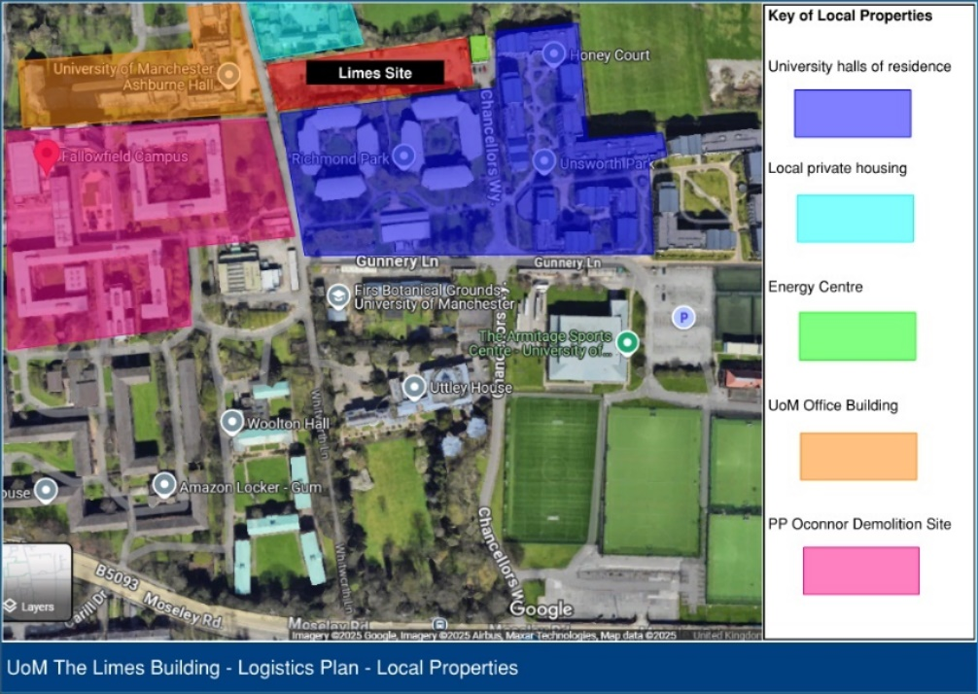
Landlord / party wall issues |  |  |  |  |  | HIGH |  | MEDIUM |  | LOW |  |  | N/A
Comments |  | N/A
Planning or other restrictions e.g. TPO, BAPA etc. |  |  |  |  |  | HIGH |  | MEDIUM |  | LOW |  | N/A
Comments |  | Please review planning tracker document for all planning conditions which have and have not been discharged.
Lighting and temporary lighting |  |  |  |  |  | HIGH |  | MEDIUM |  | LOW |  | N/A
Comments |  | Temporary lighting will be provided across the entire project. This will exclude any task specific lighting.
Fencing and hoarding |  |  |  |  |  | HIGH |  | MEDIUM |  | LOW |  | N/A
Comments |  | The permanent main works site perimeter hoarding will be a minimum of 2.4m high to prevent any unauthorised access on to the project apart from the northern boundary wall which is a mixture of 2.4m high green metal fencing and a 2.0m high brickwork wall. Pedestrian and vehicle gates will be installed where necessary to facilitate the logistics of the project and will be managed by the project team and logistics manager.
Structural Surveys and Dilapidations (inc. Wells, Tunnels or Underground Structures) |  |  |  |  |  | HIGH |  | MEDIUM |  | LOW |  | N/A
Comments |  | N/A
Asbestos |  |  |  |  |  | HIGH |  | MEDIUM |  | LOW |  | N/A
Asbestos Survey available? |  |  | N | Asbestos Identified? |  |  |  |  |  |  |  | Y
Further / additional survey required?* |  |  | N | Is the working area affected? |  |  |  |  |  |  |  | N
Specialist Removals or treatment required? |  |  | N | Highlighted on Risk Board / Induction? |  |  |  |  |  |  |  | Y
* If further survey required who is responsible? |  |  | B + K / Client / Principal Designer / Managing Agent
Comments |  | Please refer to the Site investigation report carried out by Hydrock consulting. It was noted minimal asbestos has been found in one of the samples. But care should always be taken when breaking ground. It is estimated that made ground is created to a depth of 2m so the risk for asbestos being found is still possible. Subcontractors carrying out the ground works will have asbestos awareness training.

Environmental – water, flora, fauna |  | HIGH | MEDIUM | LOW | N/A
Refer to Environmental Impact Assessment (MPF 6.3)
Comments | Please refer to our Construction Environmental Management Plan

Part 3 Management of the Work
Significant Construction Process Risks - Safety risks / Health risks

This section requires a review of the site works including the trades, methods of construction and operations to enable the project to be constructed and then make an assessment of risk (without controls) as High / Medium / Low / n/a. Standard risk controls are detailed in the Bowmer + Kirkland Health & Safety Procedures Manual. The comments box should record items where there is an elevated risk, requirement for additional information or precautions or special measures have been taken or will be required.
Phasing / Programme / Handover |  |  |  |  | HIGH |  |  |  |  | MEDIUM |  |  |  | LOW |  |  |  | N/A
Comments |  | Please refer to the construction programme.
Design – Significant Residual Risks e.g. retained structures / services |  |  | HIGH |  |  |  | MEDIUM |  |  |  |  | LOW |  |  |  | N/A
Comments | Existing gas and openreach service as well as street light supply which need to be diverted. Once diverted these will still be within site and live.
Planning Conditions / Licences / Permits / Consents |  |  | HIGH |  |  |  | MEDIUM |  |  |  |  | LOW |  |  |  | N/A
Comments | No hoarding license is required due to the site being on private land. UoM do not require any license submitting.
Construction Materials, Methodology and Sequence |  |  | HIGH |  |  |  | MEDIUM |  |  |  |  | LOW |  |  |  | N/A
Comments | The construction process will be identified into four phases these are as follows  - Enabling/Early Work Activities  - Groundworks  - Frame and Cladding  - Internal Fit Out  Enabling/Early Works Activities  This phase includes relocating accessible parking bays to release the car park to B&K, carrying out site surveys to firm up the design, carrying out some excavation works for the UoM service diversions and then carrying out the site strip and reduce level dig/ground remediation works along with the main drainage connections.  Groundworks  The groundworks design is based on, for the main building a reduce level dig followed with pad foundations and an in situ suspended floor slab. The stores will be a ground remediation strategy and then a ground bearing slab on pad foundations. In this phase we will also carry out drainage and services installation. All works will be carried out with excavators, dumpers, muck shift wagons and rollers.  Frame and Cladding  A steelwork frame will be constructed off the pad foundations, the steelwork will be delivered on the back of artic wagons and then lifted into place by a mobile crane which will sit in the haul road area shown on the logistics plans. There will be 2-3 MEWPS working off the GF slab to fix the steelwork into position. The MEWPs will work from the east elevation backwards towards the west. The edge protection will be an easi edge system which will be fixed onto the beams at floor level by the steelworkers. Once the steelwork is complete the 1F and roof slab will be constructed using metal decking and concrete. The concrete will be via a concrete pump which will sit in the haul road with concrete wagons entering gate 1 to load the hopper. The cladding and roof will commence shortly after the slabs have cured. The cladding is a composite sheet which will be fixed back to the secondary steelwork. To do this there will be a MEWP on the perimeter of the building and a 360 telehandler will lift the panels into position using a cladboy. The panels will be fixed in position by the operatives in the MEWP. The roofing system is a Bauder system and will be built up in layers.  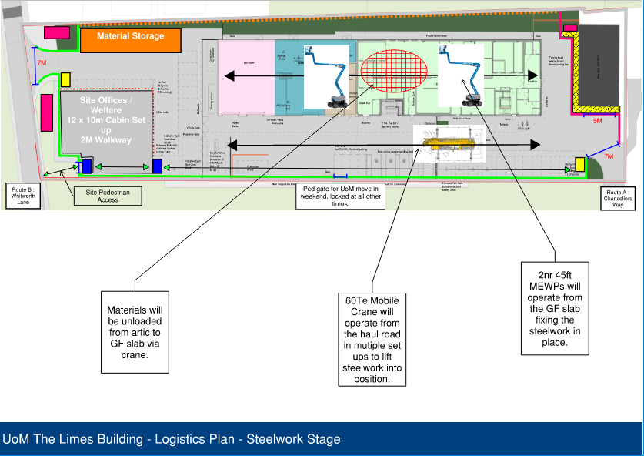  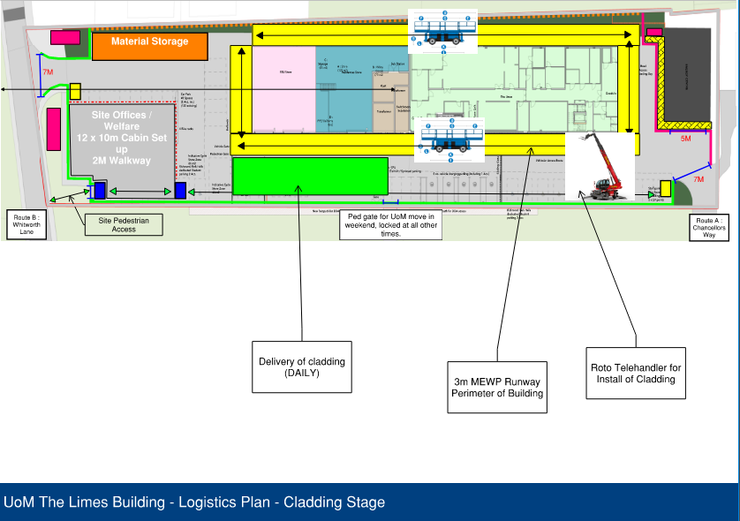  Internal Fit Out  The fit out will commence once the building is substantially watertight which is towards the end of the cladding and roofing fit out. A section of cladding will be left out in order to load the building with materials to 1F. This will be via a scaffold loading bay and telehandler.
Site Investigations / Tests |  |  |  |  | HIGH |  |  |  |  | MEDIUM |  |  |  | LOW |  |  |  | N/A
Comments |  | Site investigation survey have been carried out by Hydrock consulting. It was noted that only one sample indicated asbestos within it. But it is noted that soil samples cannot completely rule out any contamination and or asbestos within the ground so extra is always needed whilst investigating. We are planning on having Hydrock or IODM carry out further testing works.
Ground Remediation |  |  |  |  | HIGH |  |  |  |  | MEDIUM |  |  |  | LOW |  |  |  | N/A
Comments |  | Works will be completed for the store unit only. As this is a ground bearing slab the ground underneath either needs to be excavated and the ground treated before being put back in engineered layers or the ground needs to be removed from site and stone placed in the ground.
Services / Utilities |  |  |  |  | HIGH |  |  |  |  | MEDIUM |  |  |  | LOW |  |  |  | N/A
Comments |  | As part of the works Bowmer and Kirkland will look to install all the necessary ducting and cabling and drainage for the following  BT (Fibre)  Landlords Electrics  Temporary Electrics  CCTV - Fixed to Building  CCTV - Within Site Boundary: part of wider estate  External Lighting to common areas  Foul Drainage  Power (HV)  Power (LV)  Incoming Water
Fire Strategy |  |  | HIGH |  |  |  | MEDIUM |  |  |  |  | LOW |  |  |  | N/A
Comments | The permanent building fire strategy will be that of the architect/design teams overall design as per the fire strategy drawings. However please refer to our fire strategy in our fire risk assessment document for the construction phase. This will highlight the need for temporary fire doors as part of the construction and any necessary fire detection and fire fighting equipment required.
Water Management Plan |  |  | HIGH |  |  |  | MEDIUM |  |  |  |  | LOW |  |  |  | N/A
Comments | Please see attached our site water management plan.
Work at Height e.g. Perimeter Climbing Shield |  |  |  |  | HIGH |  |  |  |  | MEDIUM |  |  |  | LOW |  |  |  | N/A
Comments |  | N/A
Work at Height: Riser Protection – Use of GRP Grid |  |  |  |  | HIGH |  |  |  |  | MEDIUM |  |  |  | LOW |  |  |  | N/A
Comments |  | All risers will be fitted with GRP which will be installed with the metal decking so falls are eliminated at the route cause. We will also review with our MEP subcontractor so we know if secondary steelwork is required in order to avoid later problems with GRP when M&E install commences.
Fall of Materials / Falling Objects |  |  |  |  | HIGH |  |  |  |  | MEDIUM |  |  |  | LOW |  |  |  | N/A
Comments |  | Exclusion zones will be planned managed and coordinated by the B&K site team for various parts of the project these include  - Groundworks  - Steel frame  - Façade installation  - Roof fitout  - M&E plant on roof  Our steelwork specialist subcontractor will install edge protection to every level to mitigate any falling material.
Scaffolding |  |  |  | HIGH |  |  |  | MEDIUM |  |  |  |  | LOW |  |  |  | N/A
Will a scaffolding design be required? |  |  |  |  |  |  |  |  | Yes
Comments | There will be a need for scaffolding designs, but these will be specific to the construction phase. Examples as follows;  - lift shaft cantilever scaffolds  - loading bays  - Birdcage top of staircases
Fragile Materials |  |  |  |  | HIGH |  |  |  |  | MEDIUM |  |  |  | LOW |  |  |  |  |  | N/A
Comments |  | N/A
Plant and Vehicle Movements |  |  |  |  |  | HIGH |  |  |  |  | MEDIUM |  |  |  | LOW |  |  |  | N/A
Comments |  | Plant and vehicle movements around stie will be planned, coordinated and managed by the B&K site team and our specialist subcontractors following a safe system of works. Where possible vehicles and pedestrians will be separated.

 | Footpath / Road / Car Park Works |  |  |  |  |  |  | HIGH |  |  | MEDIUM |  |  | LOW |  |  | N/A
 | Comments |  |  |  | Please refer to Hard landscaping drawings around the building.
 | Manual Handling |  |  |  |  |  |  | HIGH |  |  | MEDIUM |  |  | LOW |  |  | N/A
 | Comments |  |  | Manual handling will be reduced as much as possible across the project with lifting aids and mechanical means being used as much as possible.  Any manual handling on the project will always have a risk assessment carried out reviewing the works in order to access if the works could be carried out in a safer manner and necessary training provided to the operatives.  Examples of mechanical lifting aids which will be used are mobile cranes, spider cranes, cladboy and forklifts.
Cranes / Mechanical lifting |  |  |  |  |  |  | HIGH |  |  | MEDIUM |  |  | LOW |  |  | N/A
Comments |  |  | Mobiles cranes will be required to install the steelwork.  Mechanical lifting will also be required for the cladding, curtain walling works, this is expected to be via 360 forklift, glass/clad boys.
Tower Crane / Crawler Crane / Hoist / MCWP* |  |  |  |  |  |  | HIGH |  |  | MEDIUM |  |  | LOW |  |  | N/A
 |  |  | NA
* Refer to Dave Shooter Group Crane Manager
Materials (COSHH / special hazards) |  |  |  |  |  |  | HIGH |  |  | MEDIUM |  |  | LOW |  |  | N/A
Comments |  |  | B&K will review all Risk Assessments and Method Statements submitted by our subcontractors. Within these there will be detail COSHH assessments which we will manage and monitor to make sure the subcontractors and operatives are adhering to.
Power / Lighting |  |  |  |  |  |  | HIGH |  |  | MEDIUM |  |  | LOW |  |  | N/A
Comments |  |  | Temp electrics  The general power requirements are for the following items:  Welfare facilities  External boundary lighting  External and internal Walkway / access and egress lighting  110v Power supplies across all floor plates  Transformers on every level  Specific task lighting shall be provided by the works contractor  The works contractor is to utilise as many portable hand tools as possible therefore implementing a no trailing leads policy  Battery charging stations will be employed on the project to assist with the trailing leads policy.
Temporary Works / Design – includes planned / considered TW |  |  |  |  |  | HIGH |  |  | MEDIUM |  |  | LOW |  |  | N/A
Comments |  | B&K will create a temporary works schedule which will reflect all temporary works required on site. One of the members of the B&K site team will be a temporary works co-ordinator who will manage the design sign off process and implementation of the temporary works on site.  All temporary works on site will be assigned a category dependant on level of risk associated with the works.  The temporary works schedule will also form part of the weekly site checks by the B&K site management team. They will check that the temporary works are still as per design and being used correctly.

Specific Competence Requirements - Specialist Training |  |  |  |  |  |  |  | HIGH |  | MEDIUM |  |  |  | LOW |  | N/A
Comments |  | TBC
Item requiring Specific Competence? |  |  |  |  | ü | Item requiring Specific Competence? |  |  |  |  |  |  |  |  |  | ü
Temporary Works Co-ordinator |  |  |  |  | ü
Electricity – Authorised Person |  |  |  |  | ü
Electricity – Competent Person |  |  |  |  | ü
Crane Coordinator |  |  |  |  | X
FPA Fire Training |  |  |  |  | X
SPA PFA Petroleum Card |  |  |  |  | X
Gas Safe Domestic Gas |  |  |  |  | X
Temporary Works Inspection |  |  |  |  | ü
Scaffolding Inspection |  |  |  |  | ü
Dust / Fume |  |  |  |  |  |  |  |  | HIGH |  |  |  | MEDIUM |  | LOW |  | N/A
Comments |  |  |  | Dust Management  During construction it is anticipated that the primary air pollution emissions will be associated with  dust generated from construction works and tracking around site during dry periods. This be monitored daily and suppression measures applied if required.
Diving / Works Under Water |  |  |  |  |  |  |  |  | HIGH |  |  |  | MEDIUM |  | LOW |  | N/A
Comments |  |  |  | N/A
Work On, Over or within 10 m of Water |  |  |  |  |  |  |  |  | HIGH |  |  |  | MEDIUM |  | LOW |  | N/A
Comments |  |  |  | N/A
Noise |  |  |  |  |  |  |  |  | HIGH |  |  |  | MEDIUM |  | LOW |  | N/A
Comments |  |  |  | B&K have been instructed by the UoM to not commence any noisy works prior to 9am within university term time.  B&K will carry out noise monitoring daily and on any high noise activities. This will be recorded on work wallet.  If B&K are carrying out activities that generate high levels of noise, hearing protection zones will be set up.
Specialist Plant / Scaffolding / Access Equipment |  |  |  |  |  |  |  |  | HIGH |  |  |  | MEDIUM |  | LOW |  | N/A
Comments |  |  |  | Mobile crane  Spider crane  Lifting equipment for cladding/curtain walling
 | Specialist Trades |  |  |  |  |  |  | HIGH |  |  |  | MEDIUM |  | LOW |  |  | N/A
 | Comments |  |  | Steelwork  Façade  M&E
 | Building Services |  |  |  |  |  |  | HIGH |  |  |  | MEDIUM |  | LOW |  |  | N/A
 | Comments
 | Inspection Test Commissioning – 3rd Party QA – Fire / Façade |  |  |  |  |  | HIGH |  |  |  | MEDIUM |  |  | LOW |  |  | N/A
 | Comments |  |  | We will appoint consultants for the following  a façade consultant  Independent fire stopping consultant  M&E consultants  M&E B&K coordinator
 | Fire Protection |  |  |  |  |  | HIGH |  |  |  | MEDIUM |  |  | LOW |  |  | N/A
 | Comments |  |  | Fire strategy to be determined within stage 4.  B&K will appoint an independent fire stopping inspector, B&K will only use quellfire for internal firestopping.
Ongoing Maintenance Issues |  |  |  |  |  |  |  |  | HIGH |  |  |  | MEDIUM |  | LOW |  | N/A
Comments |  |  |  | N/A
Waste |  |  |  |  |  |  |  |  | HIGH |  |  |  | MEDIUM |  | LOW |  | N/A
Comments |  |  |  | Bowmer and Kirkland will record all waste generated on site in a SWMP, this will be used to report on the performance of waste management on the site.  Waste Hierarchy  Bowmer and Kirkland will manage waste and develop the SWMP in accordance with the waste hierarchy. Specifically, the amount of waste produced will be minimised by consideration in development of the design and, where produced, will be reused before recycling / disposal options are considered.  A general overview for the scheme is  Wheelie bins will be used in the welfare areas  Skips will be used for the superstructure, façade and Ground works  Wheelie bins to will be used for the fit out works.
Commissioning / Testing / Handover |  |  |  |  |  |  |  |  | HIGH |  |  |  | MEDIUM |  | LOW |  | N/A
Comments |  |  |  | NA
Other |  |  |  |  |  |  |  |  | HIGH |  |  |  | MEDIUM |  | LOW |  | N/A
Comments |  |  | N/A

Part 4 CDM Principal Designer /Client
Has the Principal Designer Risk Schedule MPF 4.9 been prepared by the Principal Designer | Yes
If NO – what arrangements are in place to collate design risk assessments from designers and manage design risks during delivery of the project:
N/A

Has the PD reviewed the Design Risk Assessments for the initial design including buildability and construction fire strategy?
No, currently appointing design team and consultants.

The Health & Safety File
The format should be directed by the Principal Designer to satisfy the Client requirements for content and format.
(a) Layout and Format
TBC

(b) Arrangements for the collection and gathering of information
TBC

(c) Storage of information
TBC

Health & Safety Procedures / Forms / Systems Index

 Cloud Based Health and Safety App.
Management Inspections: | Authority to Proceed:
Site Management Safety Inspection | Confined Space
Project leader Safety Tour | Electrical Work - Limitation of Access
Director safety Tour | Use of Leaning Ladders / Stepladders
B+K H&S Advisor Inspection | Lorry Loader
R G Wilbrey Inspection | Excavations / Ground Penetration
RG Wilbrey Development Visit | Tree Protection - Works within Root Protection Area
Sub-contractor Safety Tour | Truck Mounted Concrete Pump
Site Inspection Activity: | Wet Works
Site Activity Log (site diary) includes progress photographs and Good Order tour | Roof Access
Daily Activity Briefing | Behaviour / Discipline:
Toolbox Talk Register / Briefing Register | Red Card – Serious Non-compliance – Immediate Exclusion
Welfare Inspection Record | Yellow Card – Non-compliance – Record of Warning
Site Hoarding and Fencing Inspection Record | Green Card – Positive Behaviour / Good Compliance
Environmental Protection Inspection Record | Event Reports:
Fire Equipment Inspection Record | Incident / Accident Report – Injuries, Near-miss, Dangerous Occurrence, Ill Health, etc.
Permit to Work: | Official Visit – HSE, EHO, etc.
Hot Works – Standard / High Risk | Consultation / Feedback:
Excavation / Ground Penetration Near ‘Live’ Services | Concern Report – QR Code link to Workforce / Public
General Permit to Work
Critical Tasks – Covid Relaxation of Social Distancing Requirements

Inspection TAG system
Ladder / Stepladder / Podium Daily Inspection SPF 316 is withdrawn and replaced with TAG Inspection system

 or  Cloud-based GDPR secure Workforce Management System
Workforce Registration (identity and competence), B+K induction, Supervisor Induction and Demographic anonymised data. Time and Attendance Recording.

Section | Procedure | Section | Procedure
0.0 | Safety Procedures Overview
0.1 | Contents and link to Quality Management System | 9.0 | Site Arrangements
1.0 | Training and Competence | 9.1 | First Aid
1.1 | Training and Competence | 9.2 | Welfare
1.2 | Toolbox Talks | 9.3 | Catering/Food Preparation
1.3 | Apprentices Interns, Placements, etc. | 9.4 | Traffic Management
1.4 | Supervision | 9.5 | Public Protection
2.0 | Consultation and Communication | 9.6 | Visitors
2.1 | Worker Consultation and Site Feedback | 9.7 | Good Order
2.2 | Company Safety Induction | 9.8 | Site Establishment
2.3 | Site Induction Process and Orientation Process | 9.9 | Electricity
2.4 | Non-English-Speaking Workers | 9.10 | Gas Installations
2.5 | Red/Yellow/Green Card | 9.11 | Services
2.6 | Agency Worker Induction | 9.12 | Storage of Hazardous Substances Fuel and Oil
3.0 | Risk Assessment/Method Statements/Permits | 9.13 | Mortar Silos
3.1 | Risk Assessment | 9.14 | Health & Safety Standard Notice Boards
3.2 | Method Statements | 9.15 | Security, Hoarding, Fencing and Barriers
3.3 | Authority to Proceed & Permit to Work Procedures | 9.16 | Safety Signs
3.4 | Hot Works Permit to Work Procedure | 9.17 | ADR Carriage of Dangerous Substances
3.5 | Temporary Works | 9.18 | Lighting
4.0 | Construction Design Management | 9.19 | Site Logistics
4.1 | CDM Overview | 10.0 | Environmental Protection
4.2 | CDM Contractor & Designer Assessments | 10.1 | Archaeology
4.3 | CDM Pre-Construction Information | 10.2 | Ecology and Wildlife
4.4 | CDM Health & Safety Plan | 10.3 | Invasive Species
4.5 | CDM Health & Safety File | 10.4 | Water Pollution Prevention
4.6 | CDM Principal Designer | 10.5 | Vibration
5.0 | Monitoring Audit and Review | 10.7 | Packaging Waste
5.1 | Health & Safety Inspections | 10.8 | Waste Management (England and Wales)
5.2 | Health & Safety Monitoring and Audits | 10.9 | Waste Management (Scotland)
5.3 | Outside Agencies and Official Visits | 10.10 | Weather Conditions
5.4 | Considerate Constructors Scheme | 10.11 | Working on or Near Water
5.5 | Health & Safety Reporting | 10.12 | Trees and Hedgerows
6.0 | Accidents and Incidents | 10.13 | Environmental Dust
6.1 | Accidents and Incidents – Escalation Procedure | 10.14 | Environmental Noise
7.0 | Fire and Emergency | 11.0 | Health Risk Management
7.1 | Emergency Procedures | 11.1 | Asbestos
7.2 | Fire – General Fire Precautions | 11.2 | Confined Spaces
7.3 | Fire - Site Offices and Temporary Accommodation Units | 11.3 | CoSHH
7.4 | Fire – Timber Structures | 11.4 | Dermatitis
7.5 | Fire – Refurbishment & Works in Occupied Premises | 11.5 | Dust
7.6 | Fire – Process Fire Controls | 11.6 | Hand Arm Vibration Syndrome HAVS
8.0 | Personal Health & Safety | 11.7 | Occupational Health
8.1 | Display Screen Equipment Assessments | 11.8 | Lead
8.2 | Driving | 11.9 | Legionella
8.3 | Drugs and Alcohol | 11.10 | Muscular Skeletal Disorders
8.4 | Lone Working | 11.11 | Noise
8.5 | Personal Electronics Phones Etc | 11.13 | Sharps
8.6 | New or Expectant Mothers | 11.14 | Smoke, Fumes and Odours
8.7 | Office / Premises Safety | 11.15 | UV Exposure
8.10 | Mental Health & Wellbeing | 11.16 | Zoonoses

Section | Procedure | Section | Procedure
12.0 | Lifting Equipment and Operations | 14.12 | WaH Equipment – Waste Chutes
12.1 | Lifting Equipment | 14.13 | WaH Equipment – Personal Fall Protection
12.2 | Lift Trucks and Telehandlers | 14.14 | WaH Equipment – Rope Access
12.3 | Lifting Operations | 14.15 | WaH Equipment – Horizontal Mansafe Systems
12.4 | Lifting Operations – Lorry Loader | 14.16 | WaH Equipment – Stilts
12.5 | Lifting Operations – Tower Crane A-F | 14.17 | WaH Equipment – Stairs, Landings, Thresholds and Ramps
12.6 | Lifting Operations – Crawler Cranes | 14.18 | WaH Equipment – Edge Protection
12.7 | Lifting Operations – Hoists | 14.19 | WaH Equipment – Risers, Lift Shafts & Openings
12.8 | Lifting Operations – Self Erect Tower Cranes | 14.20 | WaH – Falls from Vehicles
12.9 | Lifting Operations – Compact Cranes | 14.21 | WaH – Temporary Accommodation Units
13.0 | Plant and Equipment | 14.22 | WaH – Fragile Materials
13.1 | Work Equipment | 14.23 | WaH – Pitched Roofs / Slating & Tiling
13.2 | Mobile Plant | 14.24 | WaH Plant – Suspended Access Units – BMU-Cradles
13.3 | Excavator Safety | 14.25 | WaH – Tool Tethers
13.4 | Site Dumpers | 15.0 | Specific Risks
13.5 | Compressors & Pneumatic Tools | 15.1 | Demolition
13.6 | Deliveries and Tipping of Loads | 15.2 | Refurbishment
13.7 | Road Sweepers & Wheel wash Equipment | 15.3 | Ground Remediation and Stabilisation
13.8 | Proprietary Shoring Equipment | 15.4 | Excavation Works
13.9 | Mobile Crushers | 15.5 | Concrete Works
13.10 | Non-road Mobile Machinery | 15.6 | Piling, Drilling and Pile Caps
14.0 | Work at Height | 15.7 | Road Works
14.1 | Work at Height | 15.8 | Paving Kerbs
14.2 | WaH Safe Systems of Work | 15.9 | Welding
14.3 | WaH Plant – MEWPS | 15.10 | Structural Erection
14.4 | WaH Plant – Mast Climbing Work Platforms | 15.11 | Structural Metal Decking
14.5 | WaH Equipment – Ladders and Stepladders | 15.12 | Precast Concrete
14.6 | WaH Equipment – Low Level Access | 15.13 | UXO – Unexploded Ordnance
14.7 | WaH Equipment – Low Level Working Platforms | 15.14 | Network Rail Requirements
14.8 | WaH Equipment – Mobile Access Towers | 15.15 | Plasterboard
14.9 | WaH Equipment – Safety Nets / Fall Arrest Equipment | 15.16 | EMF - Electromagnetic Frequency
14.10 | WaH Equipment – Scaffolding | 15.17 | Fixings and Fixing Systems
14.11 | WaH Equipment – Loading Platforms | 15.18 | Water Management

Section No | Safety Procedures Forms - Index
SPF 100 | Planning Forms / Templates | Section No | Safety Procedures Forms - Index
SPF 101 | Project Safety Notification/Safety Pack Request | SPF 323 | Mast Climbing Work Platform Daily / Weekly Inspection Record
SPF 106 | Method Statement Evaluation Record | SPF 326 | Day / Night Shift Handover
SPF 109 | Tower Crane/SETC Project Lift Plan & Method Statement | SPF 333 | Tower Crane – Daily Climbing Record
SPF 110 | Tower Crane/SETC Authorisation by Plant Manager | SPF 334 | Radio Checks - Daily Record
SPF 114 | Health & Safety (CDM) Plan Template | SPF 337 | Delivery Vehicle Log
SPF 115 | Fire Risk Assessment | SPF 338 | Tower Crane - Safety Critical Systems Daily Management Checks Record
SPF 117 | Risk Assessment Template | SPF 400 | Permit to Work / Authority to Proceed Forms
SPF 118 | Method Statement | SPF 420 | ATP - Temporary Works .XLS spread sheet
SPF 119 | Method Statement Amendment Record | SPF 422 | ATP - Tower Crane Erection + Appendix TC Erection Tracker
SPF 120 | CoSHH Assessment | SPF 429 | ATP MCWP erection
SPF 124 | Small Contractor Competence Assessment Record | SPF 430 | ATP Hoist erection / SPF 430a continuation sheet
SPF 125 | Direct Contractor Evaluation Record | SPF 432 | Tower Crane Anti-Collision System Impairment
SPF 126 | HEC Contractor Authorisation | SPF 500 | Weekly Forms
SPF 127 | FM Contractor Competence Evaluation Record | SPF 501 | Harness & Lanyard Inspection Record .XLS spread sheet
SPF 128 | Small Works Health & Safety (CDM) Plan Template | SPF 502 | Lifting Equipment & Accessories Inspection Record
SPF 132 | Lifting Plan Evaluation Record | SPF 503 | Scaffolding/Temporary Works Equipment Inspection Record
SPF 133 | Tower Crane Enquiry | SPF 503a | Project Manager’s Weekly Scaffolding Inspection Record
SPF 134 | Hoist Enquiry | SPF 504 | Excavation/Earthworks Inspection Record
SPF 137 | Design Brief - Temporary Works .XLS spread sheet | SPF 505 | Work Equipment Inspection Record
SPF 138 | Tower Crane -SETC Information Request | SPF 507 | Fixed Premises Weekly / Monthly Fire Inspection Record
SPF 200 | Project Commencement Forms | SPF 508 | Site Management Weekly Safety Report .XLS spread sheet
SPF 201 | Site Safety Orientation Record | SPF 510 | Workforce Safety Questionnaire
SPF 202 | Site Safety Orientation Register | SPF 511 | Lifting Plan Review Record
SPF 206 | Plant Authorisation Register .XLS spread sheet | SPF 600 | Management Report Forms
SPF 207 | Lifting Equipment & Accessory Authorisation Register.XLS | SPF 602 | Management Monthly Safety Report . XLS spread sheet
SPF 208 | Portable Appliance Test Register | SPF 604 | DSE User Assessment Record & Eye Test Request
SPF 210 | Telehandler Risk Assessment/Authorisation | SPF 605 | Contractor Health & Safety Inspection Register
SPF 211 | RTFL Risk Assessment/Authorisation | SPF 607 | Procedures Feedback Form
SPF 212 | Counterbalance FLT Risk Assessment/Authorisation | SPF 610 | Weekly Vehicle Inspection Record
SPF 213 | Site Attendance Register | SPF 611 | Waste Transfer Note
SPF 214 | Site Visitor Attendance Register | SPF 613 | Sub-contractor Safety Tour
SPF 216 | Site Safety 5 Minute Induction / Orientation | SPF 615 | Fixed Premises - Offices Monthly Inspection Record
SPF 218 | Agency Manager Orientation Record | SPF 700 | Investigation Forms
SPF 221 | MCWP Inspection Tracker | SPF 702 | Incident Investigation Report
SPF 222 | Temporary Works Register .XLS spread sheet | SPF 703 | Witness Statement
SPF 300 | Daily Forms | SPF 704 | Witness Statement – continuation
SPF 303 | MEWP Daily/Weekly Inspection Record | SPF 800 | H&S Department Forms NOT FOR SITE USE
SPF 304 | Safety Net Inspection Record | SPF 803 | Health & Safety Incident Summary Report
SPF 305 | Telehandler/Forklift/RTFLT Daily/Weekly Inspection Record | SPF 804 | Investigation Report
SPF 307 | Self-Erect Tower Crane Daily Inspection | SPF 805 | Health & Safety Management Briefing
SPF 308 | Lifting Schedule | SPF 806 | Safety Alert Template
SPF 311 | Hire and Manage Lifting Plan | SPF 807 | Best Practice Note
SPF 312 | Load Plan | SPF 809 | FRA Review PAS 79.1 20 Annex D
SPF 313 | Personal Protective Equipment Issue Register | SPF 810 | Management of Tower Cranes Audit
SPF 314 | Personal Protective Equipment Inspection Record | SPF 811 | Monthly Summary
SPF 315 | Hand Arm Vibration Exposure Record | SPF 813 | Workshop Fixed Premises Audit Premises Report
SPF 318 | Mobile Plant Checks Daily Inspection Record | SPF 814 | Fixed Premises Audit Report

