Contract Name | Storage World | Contract Number | 1154
Revision | Rev A | Date | 29/01/25

 | Building Element | Product | Colour/Finish | Image | Notes / Queries
 | Bricks | Manufacturer: Wienerberger  Product: Blue Class B Engineering | Colour: Blue Brick / Black Mortar | 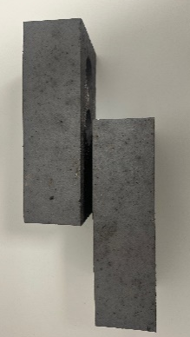
 | Cladding | Manufacturer: Kingspan  Product: Quadcore KS1000MR Wall Panel | Profile: Micro Rib  Colour: Anthracite (RAL – 7016) | 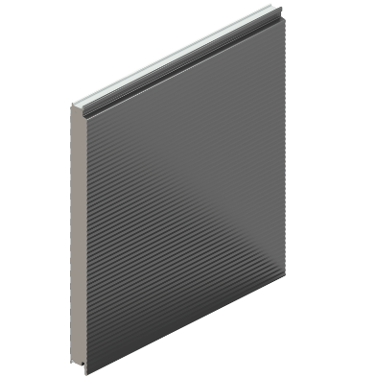
 | Cladding | Manufacturer: Kingspan  Product: Quadcore KS1000FL Wall Panel | Profile: Flat  Colour: Sunflower Yellow (BS 10E55) | 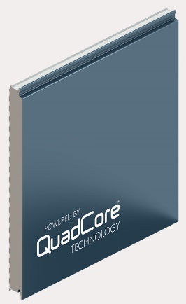  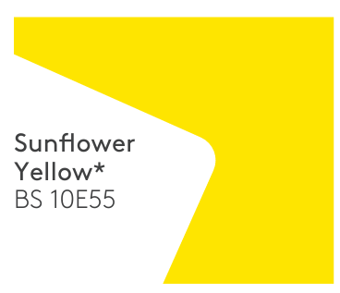
 | Cladding | Manufacturer: Kingspan  Product: Quadcore KS1000RW Roof Panel | Profile: Trapezoidal  Colour: Pearl (RAL 9010) | 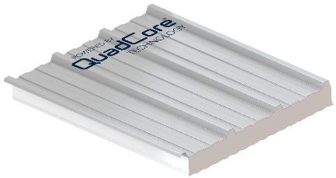
 | Cladding | Manufacturer: Kingspan  Product: Quadcore KS1000MR XL Forte Coating | Profile: Micro Rib  Colour: Pearl (RAL 9010) | 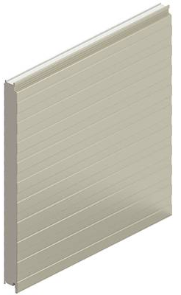  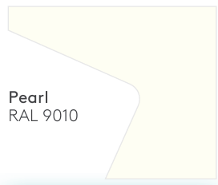
 | Cladding | Manufacturer: Kingspan  Product: Quadcore KS1000MR XL Forte Coating | Profile: Micro Rib  Colour: Adventure (RAL 7000) | 