Heritage, Urban Design and Sustainability
Consultation Response

Address: 58-66 King Street, Manchester, M2 4ND
Application Ref.: 142193/LO/2025
Proposal: Listed Building Consent for installation of roof mounted PV panels
Case officer: Emily Booth
Consultee: Linda Marciniak
Date: 14th April 2025

- Introduction

The application site relates to the rooftops of 2no of 3no buildings at 58-66 King Street. This group comprises of 1no Grade II listed building, no.62 (03.10.74) bookended by 2no. non-designated heritage assets (nos.58-60 and 64-66). All roofs are separated by brick parapets running the length of the buildings, and non-original mansards. It is noted that no development is proposed on the roof at nos.58-60 King Street. These comments therefore concentrate on the buildings at nos.62-66 King Street.

The listing description for no.62, identifies the rich architectural value of its front elevation. At roof level, it has a steep stone gable on the King Street elevation, behind which is an added slate mansard with modern flat asphalt apex. The original pitched roof was altered sometime post-1975. The flat apex includes rooflights, access hatch, service plant and edge protection. The building was constructed in 1877 to a design by Pennington and Bridgen as shops and offices and is currently in use as high end retail at ground floor with permission for residential conversion across the upper storeys (122835, 122836, 129850 & 129851).

Nos.64-66 King Street at the junction with Four Yards, retains an original 36m² pyramidal section of roof with leaded lantern in the NE corner. The remainder of this roof is also a flat modern replacement with service plant, rooflights and edge protection. A modern lift shaft tower extends above roof level on the Four Yards elevation.

The NDHA has a similar mansard roof as no.62 and a common sense of height, mass, scale and ornamental façade design treatment yielding aesthetic and architectural value, with simplified rear elevations overlooking South King Street.

All of the buildings lie within the St Ann’s conservation area, and along with other listed buildings nearby, yield historic and evidential value as examples of Manchester’s growing status and affluence as a successful C19 commercial and retail centre.

- Application

The application is for the installation of 28no. solar PVs on a concrete ballast system shared between the roofs of nos.62 and 64-66 King Street. This is to increase the sustainability of the buildings following recent residential conversion, utilising space that is otherwise limited in city centre historic buildings.

The application was subject to pre-application consideration in June 2024 by the HUDS team which accepted the principle of the proposal albeit without the benefit of a Heritage Statement.

The present application includes a Heritage Statement prepared by Donald Insall Associates. It has identified the significance of the heritage assets in accordance with NPPF para.207, concluding that significance of the roof of no.62 is moderate, and neutral at nos.64-66. The buildings otherwise are significant for their rich architectural and aesthetic interest individually, and as part of a wider group that make up this part of the St Ann’s conservation area.

Considerable weight and importance must be given to preserving heritage assets, including the setting of the site within the conservation area, the impact of the development on those assets, and any public benefits accruing from the proposal. In considering proposals for renewable technologies, a balance must be struck between the statutory duty towards heritage assets and enabling the transition to a net zero future as directed by national planning policy.

- Policy Context

National Planning Policy Framework (NPPF) (December 2024)

Para 8(c) – The environmental objective of sustainable development is to protect and enhance the natural, built, and historic environment, including adapting to climate change and moving to a low carbon economy.
Para 161 – The planning system should support the transition to net zero and support renewable and low carbon energy and associated infrastructure.
Para 167 – Local planning authorities should give significant weight to supporting energy efficiency to existing buildings, including installation of solar panels. Where proposals affect conservation areas, listed buildings or other designated heritage assets, the policies in Chapter 16 should also be applied.
Para 168 – When determining applications for renewable and low carbon energy development, local planning authorities should give significant weight to the benefits, and the proposal’s contribution to a net zero future.
Para 202 - Heritage assets should be conserved in a manner appropriate to their
significance.
Para 207 - Local planning authorities should require an applicant to describe the significance of any heritage assets, including any contribution made by their setting. The level of detail should be sufficient to understand the potential impact of the proposal on their significance.
Para 208 - LPAs should ensure that any conflict between the heritage asset’s conservation and any aspect of the proposal is avoided or minimised.
Para 210 - In determining applications, LPAs should take account of, the desirability of sustaining and enhancing the significance of heritage assets and the desirability of new development making a positive contribution to local character and distinctiveness.
Para 212 - When considering the impact of a proposed development on the significance of a designated heritage asset, great weight should be given to the asset’s conservation.
Para 213 - Any harm to, or loss of, the significance of a designated heritage asset should require clear and convincing justification.
Para 215 - Proposals of less than substantial harm to the significance of a designated heritage asset should be weighed against the wider public benefits of the proposal.
Para 216 – The effect of a proposal on non-designated heritage assets needs to be considered in assessing an application.
Para 219 - Local planning authorities should look for opportunities for new development within Conservation Areas and within the setting of heritage assets, to enhance or better reveal their significance.

Manchester City Core Strategy

Policy CC9 – City Centre Design and Heritage
Policy DM1 – Development Management
Policy EN3 – Heritage
Policy EN4 - Reducing CO₂ Emissions by Enabling Low and Zero Carbon Development

Places for Everyone (2022-2039)

Policy JP-P2 – Heritage – Positive management and integration of heritage can be achieved by exploring opportunities to reduce greenhouse gas emissions that restoration of historic buildings offer.

Policy JP-S1 – Sustainable Development – Includes the 2038 carbon neutrality objective which can be achieved by significantly upscaling solar photovoltaic energy and promoting the retrofitting of existing buildings.

Greater Manchester Five-Year Environment Plan (2025-2030)

Identifies the need for an increased deployment of roof-top and large-scale energy generation and storage assets, including solar PV.

Historic England – Adapting Historic Buildings for Energy and Carbon Efficiency: HEAN 18 (July 2024)

The installation of solar panels will generally be acceptable if hidden from view. Locations which will normally have very minimal, or no impact include valley roofs and behind parapets on flat or low-pitched roofs.

- Discussion
Pre-application consideration by the HUDS team in June 2024 found the proposal acceptable in principle based on the submitted PV panel drawings albeit without the benefit of a Heritage Statement.

The Council accepts the findings within the Heritage Statement that the key special interest of the buildings lies in their architectural and aesthetic value especially of the front elevations, and that the roofs of the designated and non-designated assets yield low significance.

Key mitigating factors are the altered roofs from pitched to flat, the height and density of buildings in the area and the canyon-like character of the surrounding streets affording limited views from key vantage points – King Street, South King Street and Cross Street.

Taking the impact on the listed building first, as the images below demonstrate, there are oblique views of the flat roof at no.62, the edge protection on the front, King Street elevation only just visible from both east and west.

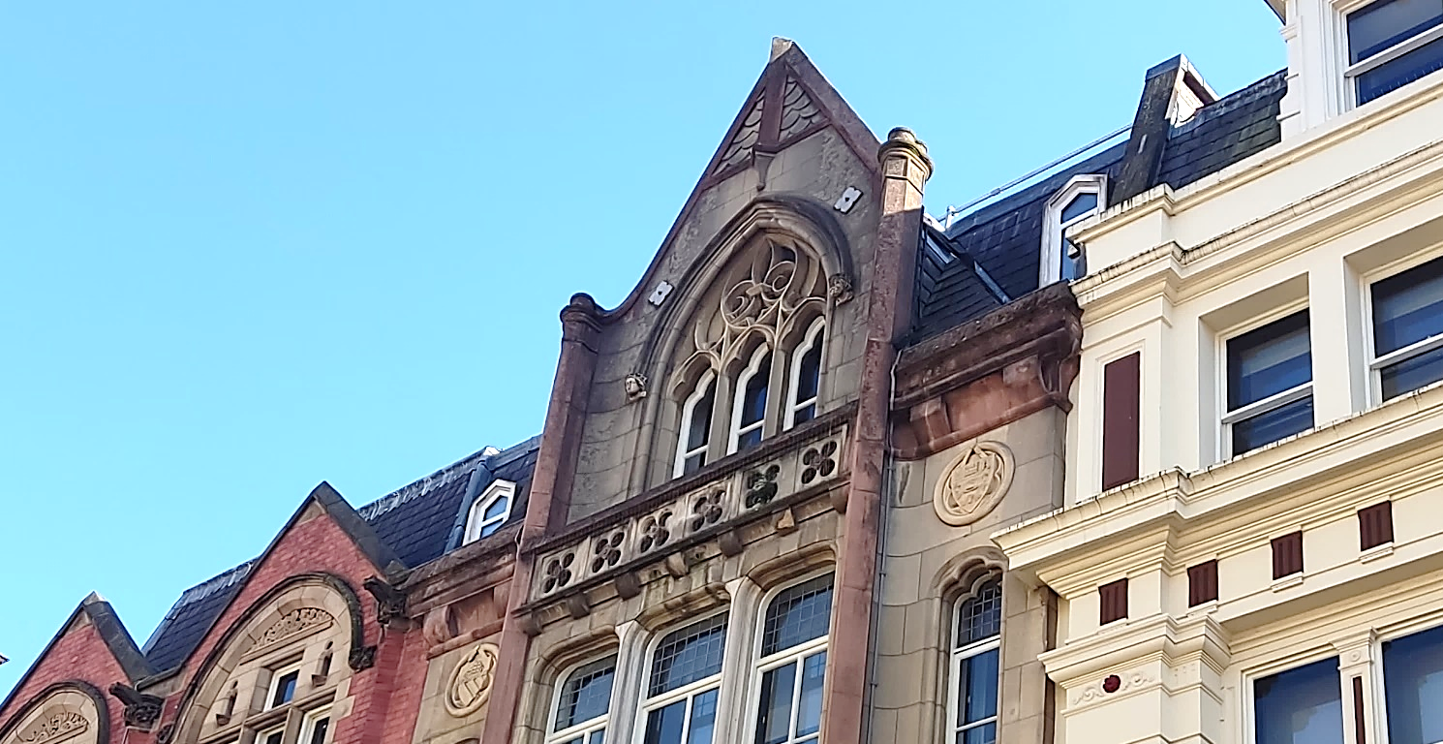

No.62 (with edge protection, centre), 64-66 (left) and 58-60 (right) from King Street

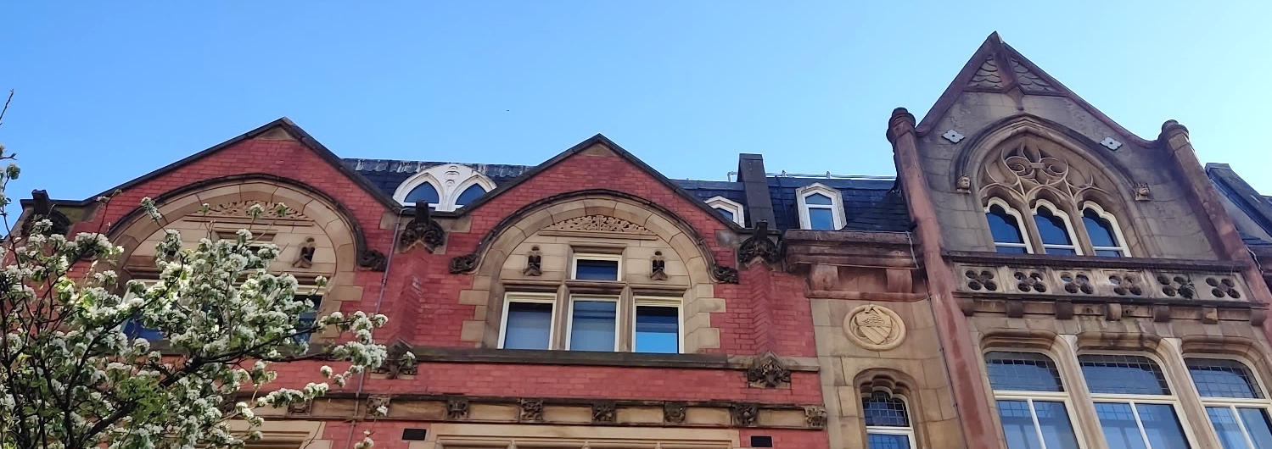

Drawing 12901 Rev PO1 shows 15no. PVs arranged in strings of 4 running from front to rear. They would be sited 622mm behind the edge protection off the front elevation with a maximum tilted upstand of 222mm alongside the eastern parapet with nos.64-66. These variables, together with the height of the building, intervening parapet and tight urban form, would conceal the PVs from within King Street and Cross Street. Moreover, they would not be read in association with the front elevation, assessed as being the element of most significance which contributes to the character and appearance of the building and the St Ann’s conservation area. In this regard, the proposal preserves the special interest of the building and its setting within the conservation area, in accordance with NPPF paras.202, 208, 210 and 212.

Views of the rear elevation from South King Street, Cross Street and Four Yards, would afford no views of the PVs. Drawing 10290 Rev PO2, shows the PVs set in 2.6m off the edge protection and behind the eastern parapet with nos.64-66. Whilst elevation drawing 10490 Rev C00 shows some visibility of the PVs, the tight urban form of the street network, height of buildings and intervening buildings means that there would be no views afforded at ground level.

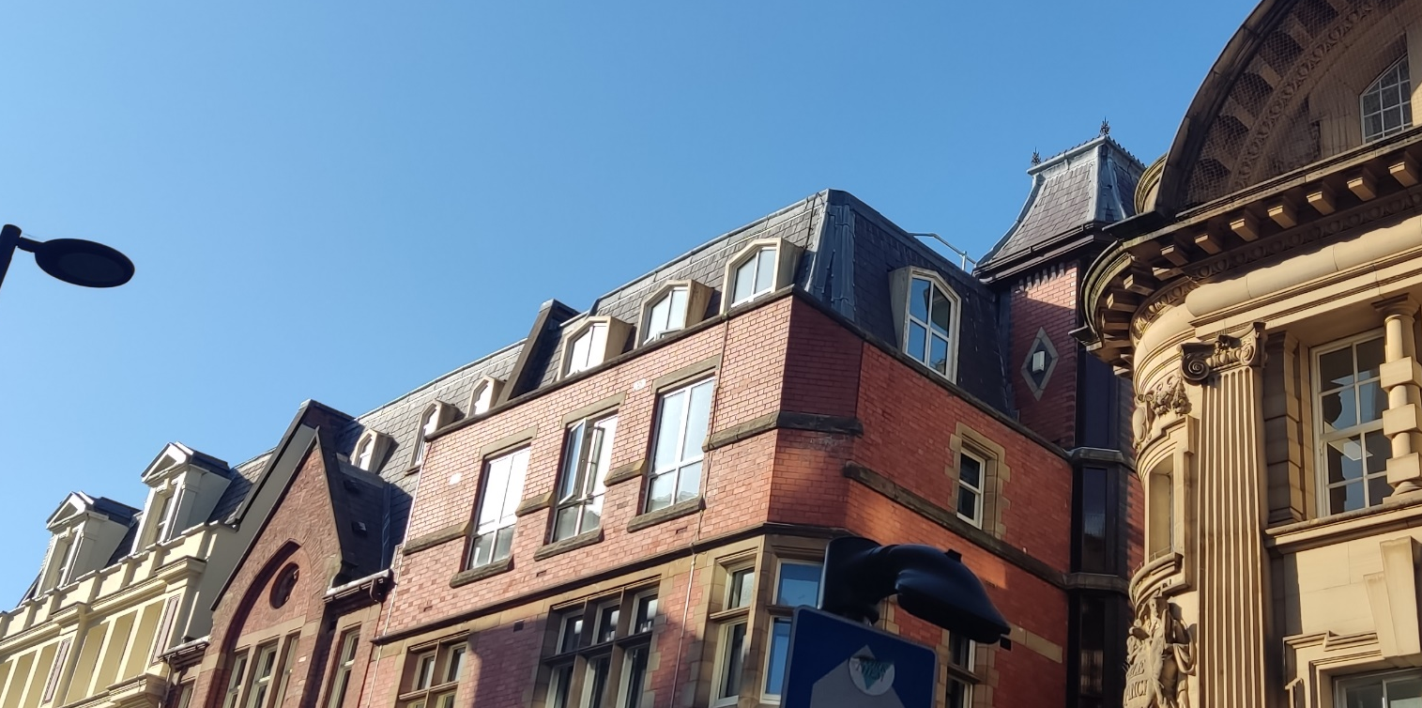
Rear elevations of all buildings from Cross Street/South King Street. Nos.64-66 on the right with lift shaft

NPPF para.216 requires assessment of the impact of a proposal upon non-designated heritage assets. Nos.64-66 are included in the development proposal and its significance described in the Heritage Statement as set out above.

This building adjoins no.64 on its eastern side and has an elevation on Four Yards where a modern lift shaft tower projects above the roof line on the southeastern corner. Its most exposed view is from the junction of King Street and Cross Street to the east where the mansard is clearly visible. As with the roof layout at no.64, the PVs would be set in 2.6m off the rear edge protection which is just visible from the Cross Street/South King Street junction. Considering the bulk of the lift shaft and the off-set from the edge protection, the PVs would be imperceptible from this key vantage point.

Similarly, the PVs would have no visibility from the front elevation due to several mitigating factors; the position of the 36m² pyramidal section of roof with lantern meaning the PVs would be set back over 6 metres from the front elevation, the narrow width of Four Yards and the proximity of this building to Eagle House.

Based on the above, the proposal will have an acceptable impact on designated and non-designated heritage assets. The roofs of the two buildings where development is proposed are of relatively low significance, nonetheless, the proposals are discreet in their siting and off-set from the edges of the non-original mansard roofs, thus preserving their character as existing and the skyline within this part of the St Ann’s conservation area. Any harm to the character or appearance of designated assets would be at the lower end of less than substantial in NPPF para.215 terms which requires assessment of any public benefits.

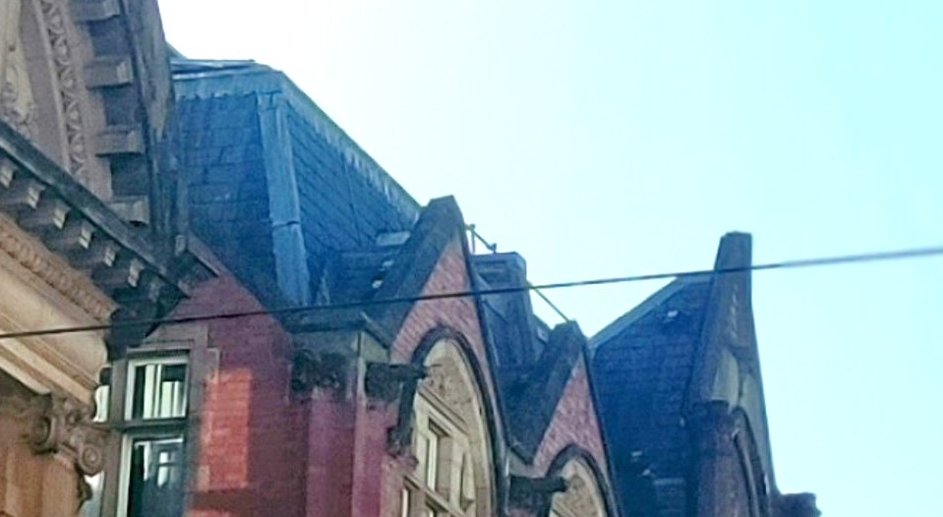
Mansard of nos.64-66 (left) and gable of no.64 viewed from Cross Street

- Public Benefits

The overarching public benefit of the proposal is the reduction in CO₂ emissions from existing buildings, which is the primary contributor to carbon emissions in the city. The PfE document estimates that domestic and non-domestic buildings contribute 33% and 35% of total carbon emission respectively, which is a significant volume, whilst policy JP-S1 – Sustainability within PfE establishes that solar photovoltaic energy will need to be significantly upscaled if the combined authority is to meet its carbon neutrality target by 2038.

Supporting the use of renewable energy in this proposal contributes to decarbonising the building’s energy supply, supporting the transition to clean and sustainable growth. The proposal could offer better thermal comfort for occupiers, whilst the secondary benefits of lower energy costs and reduced energy security risks, places the buildings on a competitive footing with modern energy-efficient developments, thus securing the future longevity of these heritage assets.

The proposal contributes positively to the Council’s own net zero target by 2028 set out in its Climate Change Action Plan and Core Strategy policy EN4. Although relatively small in scale, the proposal makes valuable carbon emissions savings, complementing the city’s cumulative total reduction achieved through its ongoing asset decarbonisation programme supporting the transition to clean and sustainable growth.

- Conclusion

Based on the above, the proposal will have a negligible impact on assets of the highest significance and is supported by clear and convincing justification in accordance with NPPF para.213.

The proposal accords with NPPF para.202 which requires that development preserves heritage assets in a manner appropriate to their significance and meets the objectives of sustaining and conserving heritage assets within Core Strategy policies CC9, EN3 and DM1 and NPPF paras.208, 212, 215 and 216.

The proposal is assessed as having less than substantial harm to heritage assets which is balanced by the valuable carbon emissions reductions accruing from any approval. balance.

Linda Marciniak
Planning Officer (Heritage and Urban Design and Sustainability)

(Lawrence Buildings 2-4 Mount Street, 70 Portland Street, 42-44 Sackville Street)

