

Construction Environmental
Management Plan For

Whitemoss Road.

CONTENTS

1 Considerate Constructors Scheme

2. Construction Site Impacts

3. Phasing and Sequence of Works

4. General Site Management

5. Resource Management

6. Transport Management

7. Water Management

8. Material Procurement, Storage and Handling

9. Waste Minimisation and Management

10. Control of Emissions to Air

11. Noise and Vibration + Statement

12. Pollution Incident Control Procedure

13. Neighbour and Community Liaison and Management of Complaints

14 Environmental Reviews.

CONSIDERATE CONSTRUCTORS SCHEME

Casey will register with the Considerate Constructors Scheme, and they and all sub-contractors will be required to comply with the Scheme. The Code commits those contractors in the Scheme to be considerate and good neighbours, as well as clean, respectful, safe, environmentally conscious, responsible and accountable.

The Scheme is independently audited by the Considerate Constructors Scheme and points are awarded depending upon the level of compliance. For each phase of the construction works registered under the code for sustainable, Casey will be required to commit to achieving at least 36 points under the Considerate Constructors Scheme.

CONSTRUCTION SITE IMPACTS

A sustainable methodology will be adopted for the scheme and include an assessment of construction site management activities which will recognise and encourage construction processes to consider at all times the possible impact of such construction processes on the environment. Casey will demonstrate that there is a commitment to monitor, sort and recycle construction waste on site, and also demonstrate that the following items are being achieved:

  - Monitoring, reporting and setting targets for water consumption arising from site activities;

  - Adoption of best practice policies in respect to air (dust) pollution;

  - Adoption of best practice policies in respect to water (ground and surface) pollution; and

  - Sourcing 80% of the timber for formwork, site hoardings and other temporary site timber uses from sustainably managed (and legal) sources.

PHASING AND SEQUENCE OF WORKS

  - The construction phase will generally adhere to the following sequence of activities:

  - Secure site boundaries

  - Reduced level dig

  - Road and sewer infrastructure

  - Foundations / sub structures

  - S38 road formation

  - Superstructures

  - Hard and soft landscaping

Key Responsibilities, AS PRINCIPAL CONTRACTOR.

To ensure that environmental standards are maintained, every person working on the site must be aware of their responsibilities. The Casey Site (tbc) and Contracts Manager, James Reeveley will have overall responsibility for implementation of the CEMP on this scheme.
Principal Contractor, CASEY Contact details;
Contract Manager James.Reeveley@casey.co.uk 07870826266mobile

Person/Organisation Responsibility: Casey

    - Initial erection/completion of the temporary hoardings/fencing around the site;

    - Ensuring that the requirements of this CEMP are adhered to at all times;

    - TTRO applications will be submitted and approved by highway network management teams for any closures.

    - Ensuring that all site staff and subcontractor(s) undertake their activities in accordance with the site environmental policy, best practice and comply with the requirements of the CEMP;

    - Ensuring that any monitoring required is being undertaken.

    - Ensuring that regular liaison is undertaken with the neighboring landowners, residents and occupier
    - Ensuring that unacceptable levels of environmental pollution including fuel spillages, noise, dust or vibration do not arise from their activities on the site. This includes ensuring that:

      - statutory environmental requirements are met;
      - environmental best practicable means (BPM) and controls are employed;
      - relevant procedures are followed;
      - resources (personnel and financial) are available to meet the environmental Management requirements;
      - corrective actions are implemented; and
      - records and other relevant documentation are maintained.

    - Preparation and implementation of the waste minimisation, recycling and disposal plan.

    - Co-coordinator (nominated by Casey)

    - Co-coordinating deliveries and controlling vehicles accessing and leaving the site.

    - Environmental Monitoring Co-coordinator (nominated by Casey)

    - Monitoring dust, noise and vibration within the vicinity of the site and ensuring that any complaints regarding dust, noise or vibration are appropriately handled. Project Manager (nominated by Casey)

    - Reporting incidents to Casey;

    - Minimising waste;

    - Ensuring that all staff adhere to statutory environmental requirements and the CEMP;

    - Ensuring that resources (personnel and financial) are available to meet the environmental management requirements;

    - Ensuring that corrective actions are implemented; and

    - Ensuring that records and other relevant documentation are maintained and reported to Casey including energy use and water consumption.

Site personnel All site staff are responsible for adhering to the requirements of the procedures outlined in this Construction Environmental Management Plan, ensuring that legislative requirements and good environmental practice are met within their job function; and as part of the site induction, all site staff must be made aware of the importance of maintaining good relations with the local community and neighbours and the sensitive location of the site as a whole.

GENERAL SITE MANAGEMENT

Introduction
This procedure addresses the general site management practices that will be employed throughout all stages of the works to ensure the safe and compliant operation of the site. The Considerate Constructors Scheme requires consideration of surrounding receptors in the general operation of a site.

Procedure

Site Working Hours
In accordance with the requirements of planning all construction works, and ancillary operations, including deliveries to and dispatch from the site will be restricted to the following periods:

  - Between 08:00 and 18:00 Monday to Friday;
  - Between 08:30 and 13:00 on Saturday
  - Not at all on Sundays and public /bank holidays.

Any work outside of the above hours would need to be agreed with the Local Planning Authority with supporting information and justification provided for any request being made fully detailing methods to be employed to monitor the control impacts from noise ,dust and vibration. The Casey management would also communicate this to and with the local residents. We are expecting 30 to 40 wagons while RLD is ongoing this number will reduce after two month period. Delap survey will be completed before the works progress with highways representative.

All deliveries will be outside peak school hours.

Site Security
The Contracts Manager will arrange for site to be securely fenced prior to works commencing on site. Once the works commence, Casey will be responsible for the site hoarding/fencing, ensuring that appropriate and segregated vehicle and pedestrian access are provided and manned during working hours. During working hours, the site access will be kept closed except when vehicles are entering or leaving the site. Out of hours, the site access will be locked. The site entrance and exit will be clearly marked.

Pedestrian Management and Safety
All contractors working on the site will ensure that the pedestrian walkways are kept clear at all times. Casey shall ensure that ramps and signs are provided, and that footpaths and paths are wide enough for wheelchair access. Pedestrians who are mobility impaired or who have sight or hearing difficulties will still be able to gain access to public footpaths and pavements adjacent to the site.

Road signs/names will be able to be clearly seen, or where a sign or name is obstructed, a replacement will be erected.

Site Facilities
In line with the requirements of the Considerate Constructors Scheme, a high level of site welfare facilities will be provided and maintained, and breaks will not be taken in view of the general public. Toilets will be screened, and the site will be cleaned on a regular basis, especially around canteens and toilets. The usage of loud radios is not allowed on site.

Site Floodlighting
Floodlighting in areas adjacent to sensitive receptors, particularly residential properties, will generally be limited to the working hours identified. Where light glare may cause a nuisance, light shielding will be considered. Site lighting will be kept to a minimum, whenever possible, taking into account the needs for site health and safety and security.

Staff Training
As part of the induction process for all staff working on-site, Casey will provide Toolbox Talks to all contractors on environmental topics to be agreed with Casey. These will ensure all staff are aware of the environmental issues on the Development e.g. minimise waste generation, water and energy consumption; maximise recycling; avoid pollution incidents, control of dust, etc.

RESOURCE MANAGEMENT

Introduction
This procedure relates to the minimisation of energy and water use and is closely related to the requirements of the Code for Sustainable credit criteria. This procedure will be adhered to throughout all phases of the development.

Procedure
For all phases of the construction works monthly water usage figures can be recorded and displayed on site, for example a graph showing monthly meter readings against an appropriate target. Monthly water consumption targets will be set by Casey using the Department of Trade and Industry’s Environmental Key Performance Indicator benchmarks or other suitable benchmarks.

More generally, the following measures will be employed in relation to all energy and water consumption during the construction works:

  - Low energy lighting with fluorescent bulbs will be used wherever possible;

  - Where timers are fitted to the heater circuits, they will be set to turn off at 17:30hrs and come back on at 07:00hrs, except for the drying room where the heaters will be set to a lower setting when not in use;

  - External flood lighting will be fitted with PIR (passive infra-red) movement detectors for night security;

  - Plant will be kept maintained and switched off when not in use;Fuel used by subcontractors will be recorded on a spreadsheet from delivery tickets;

  - Energy and water sources will be metered where possible;

  - Thermostats will be fitted to heaters within the site accommodation and welfare facilities;

  - Appliances will be fitted with timers or energy saving settings wherever possible and will be switched off when not in use;

  - Hosepipes will be turned off when not in use.

TRANSPORT MANAGEMENT

Introduction
This procedure applies to the management of vehicles accessing and exiting the site during the construction works and vehicle circulation within the site. The Site Manager appointed by Casey will be responsible for ensuring that drivers adhere to this procedure, through implementation of a Traffic Management Plan.

Section S104/38/278 works relevant temp traffic management of those works will be forwarded under separate document for discharge of condition. Temp Traff management would be submitted by the competent contractor.

All services will be installed under the relevant section 50 permit, will full approval from highways.

Scaffolding will not encroach the Highway or footway for this scheme.

Potential Impacts

The potential impacts as a result of construction traffic are:

  - Congestion on the local road network resulting from vehicle routing and/or queuing to access the site;

  - Pollution as a result of queuing vehicles;

  - Soiling of the local road network through transfer of mud and debris from construction vehicles;

  - Pedestrian safety. Deliveries where practicable will not be booked at peak times, particularly the school start and end times.

  - Noise.- To be kept to a minimum where practical, operatives will not be allowed to use radios whilst on site.

To assist with the Transport discharge condition the Contracts Manager could contact the Highways Network Management Team to review the TMP and surrounding area around the scheme, we believe this will be an on-going relationship throughout the length of the scheme specifically in relation to off-site Contractor parking which is very limited, we will be advocating a shared/buddy up procedure with our procurement of contractors.

Relevant Legislation and Guidance

The Highways Act, 1980;

Environmental Protection Act, 1990; and

Road Vehicles (Construction and Use) Regulations 1986, as amended.

Procedure
Construction vehicles will not wait on the highway to enter site. Provision will be made on site to allow construction traffic to enter site without having to wait on the highway. A holding area on site will be constructed where traffic will be able to wait while they are directed to the appropriate unloading place onsite. A “ring-ahead” process will be requested from suppliers to mitigate multiple simultaneous deliveries, reducing build-up of heavy vehicles in the area.

Vehicles waiting to leave the holding area or leave the site will be required to switch off their engines. Where possible, vehicle movement areas within the site will comprise hard standing to minimise the transfer of mud onto the highway. However, vehicles leaving the site will ensure that they are clean and, if necessary, pressure washing of the wheels and chassis will be carried out. All vehicles leaving site will be assisted via a banksman to check the roads and footway for vehicles and pedestrians.

Road sweeping measures will be employed by Casey to ensure that local public highways are kept clean and free from debris. Mechanical measures for road sweeping will be set up to assist with cleanliness of the surrounding roads.

During construction, material deliveries to the site will be carefully phased to suit the Construction Programme. Casey will coordinate all deliveries or collections to/ from the site. Casey will ensure that deliveries are programmed to avoid local traffic busy periods. The “ring-ahead” process will assist with this measure.

Dedicated access gates for pedestrians and vehicles will be provided to ensure pedestrian safety during arrival or departure of construction vehicles, as per TMP.

All vehicles will be regularly maintained in accordance with the manufacturer's specifications.

Vehicles leaving the site will do so with the assistance of a banksman.

Signage will be posted on site to advise all drivers of these requirements, as well details being incorporated within the site induction documentation and purchase orders with all suppliers.

Documentation
Copies of vehicle maintenance records must be held on site in a designated file.

WATER MANAGEMENT

Potential Impacts
The potential impacts from construction activities to surface and ground waters are:

Reduced surface or ground water quality from the release of mobile contaminants during the construction of the development, particularly during excavations and the construction of foundations;

  - Incorrect disposal of site effluent;

  - Pollution of surface water through chemical, oil and fuel spills;

  - Introduction of other pollutants (e.g. excessive amounts of solid particles) into the surface water drainage system; and

Relevant Legislation and Guidance

Environmental Protection Act 1990;

Water Resources Act 1991;

Water Industry Act 1991;

Ground Water Regulations 1998;

Anti-pollution Works 1999; and

Environment Agency Pollution Prevention Guidelines – General Guidance to the

Prevention of Water

Pollution (PPG01).

Procedure

Site Drainage
Casey will hold a drainage plan on site which shows the location of all surface and foul water drains and will make relevant staff aware of the existing drainage network.

Under no circumstances will waste chemicals, fuels, silt or sediments be discharged to the drainage system or groundwater.

In the event of a blockage, a specialist Trade Contractor will clear out the drains and the waste material disposed of accordingly.

Trade effluent, including dewatering effluent, from the site will not be discharged to surface or foul water drains without obtaining consent from the Environment Agency or United Utilities, respectively.

Casey are responsible for obtaining necessary consents and ensuring compliance with any conditions, for example, the quantity and quality of effluent.

Storage and Handling of Hazardous Materials
Hazardous substance stores (including fuel and chemical stores) and areas at risk of spillage/ leakage of polluting materials will be bunded in accordance with current best practice. Bunded compounds will have an impervious base, which can hold at least 110% of the capacity of the tank or drum it contains to minimise the risk of hazardous substances entering the drainage system.

Labels will clearly indicate the contents of containers.

Delivery of fuel and oil will be supervised at all times and checks will be made to ensure that the correct type and quantity of fuel is being delivered. All pipelines and fueling points will be protected from vandalism and unauthorised interference and will be turned off and locked when not in use.

Drip trays will be used when filling smaller containers from tanks or drums to avoid drips and spills from entering the ground or drainage system.
Works with concrete will be carefully controlled and concrete wagons will be washed out in a safe area.

Documentation
The following documents will be held on site:

Copies of discharge and trade effluent consents held in a designated file by Casey; and

Should a pollution incident occur, a record of the incident, together with the remedial action(s) taken, will be maintained in an environmental incident logbook by Casey.

MATERIAL PROCUREMENT, STORAGE AND HANDLING

Introduction
This procedure applies to the procurement of timber and materials used in demolition and construction, and the storage and handling of all materials, with the exception of waste, which is addressed separately. All staff are responsible for complying with the requirements of the procedure.

Relevant Legislation and Guidance

Environmental Protection Act 1990;

Water Resources Act 1991;

A Green Guide to Materials Specification 2002, Building Research Establishment; and

Procedure Procurement
As a minimum all timber will be sourced in accordance with Casey timber policy. 75% of the timber and timber products used during the construction works should be from a temperate source independently certified by the Forest Stewardship Council (FSC), Programme for the Endorsement of Forestry Certification (PEFC), Canadian Standards Association (CSA), Sustainable Forestry Initiative (SFI) or the Malaysian Timber
Certification Council (MTCC).

Other construction materials will be responsibly sourced wherever possible i.e., suppliers will hold a certified Environmental Management System for both the extraction of the raw materials e.g., stone, clay, aggregate etc. and the process stage. Materials will be sourced locally where possible. HYR approval of materials will be required prior to placement of orders.

Storage
All raw materials will be appropriately stored on site to minimise damage by vehicles, weather or theft.

Secure storage will be provided for items of high value, materials which are hazardous, or which are easily damaged.

Packaging will be retained on goods until the materials are required. Once removed, packaging materials will be stored and returned to the supplier for re- use/ recycling wherever possible.

Goods will be delivered on an “as needed/ just in time” basis to reduce stockpiling on site, damage from vehicles and other causes of wastage.

Documentation
Chain of custody certificates for sustainably sourced timber used during the works will be maintained in a designated file.

WASTE MINIMISATION AND MANAGEMENT

Introduction
This procedure applies to the minimisation, storage and disposal of all wastes generated during the construction works. It is also concerned with the establishment of procedures for complying with statutory and good practice requirements for waste management. Casey are responsible for ensuring that the relevant documentation is completed and held on site. In addition, all staff are responsible for adhering to the requirements of the procedure.

Relevant Legislation and Guidance

Environmental Protection Act 1990, Part II;

Environmental Protection (Duty of Care) Regulations 1991;

Hazardous Waste Regulations, 2005;

Controlled Waste (Registration of Carriers and Seizure of Vehicles) Regulations 1991; and

  - Site Waste Management Plans – Guidance for Construction Contractors and Clients, Department of Trade and Industry; July 2004. The National Construction Best Practice Programme advocates ‘lean production’ methods and the minimisation of accidental on-site material wastage. The reuse of materials will take place wherever possible. Any remaining waste will be considered for recycling.

  - To assist in achieving best practice, Casey ’s attention is drawn to the following initiatives:

  - Waste exchange - electronic waste board where contractors can advertise the availability of various types of waste available and companies can search for materials they need (www.wasteexchange.org);

  - WRAP – The Waste Resources and Action Programme set up to establish markets for buying and selling recycled materials. Includes a guide to specifying sustainable aggregates www.wrap.org.uk

  - Best Practical Environmental Option - Assessment by BRE of methods of demolition, construction and disposal of wastes to enable development of Best Practical Environmental Options for waste management; and
  - Other Building Research Establishment (BRE) and CIRIA current initiatives relating to construction

Procedure

All Site Works Waste Reduction
Over ordering of materials will be avoided, and deliveries of materials will be arranged for the appropriate stage of construction. Packaging from raw materials will only be removed immediately prior to use, to avoid damage to the materials and waste generation.

Initiatives to reduce waste streams will be incorporated where possible. These may include obtaining information on materials packaging from manufacturers and suppliers and avoiding purchase of over-packaged materials, liaison with the suppliers to enable packaging material to be sent back for reuse, use of off- cuts where possible and the recycling of off-cut material by the supplier e.g. plasterboard.

Recycling
Materials to be recycled will be sorted on site and stored in an appropriate container or stockpile ready for collection. The amount of waste reused, recycled or sent to landfill will be recorded by Casey and compared with the targets for waste re-use and recycling.

A detailed waste plan will be developed by Casey to identify methods of waste minimisation and recycling. At least five of the following materials will be recycled:

  - Ceramics such as bricks, tiles.

  - Inert materials such as soils, clays, sand, gravel and natural stone;

  - Metals cables and wires;

  - Packaging such as paint pots, pallets, cardboard, bubble wrap, cable drums and wrapping bands;

  - Plaster/cement such as plasterboard, render, plaster, cement,
fibre cement sheets;

  - Concrete such as kerb stones, paving slabs, rubble and solid blocks.

Chemicals and oils.
Recycling at least five of the waste streams above will ensure maximum credits are achieved for those phases of the development registered under Eco 2005.

Waste Disposal
Waste will be segregated into recyclable, inert, and non-hazardous or hazardous waste and retained in clearly labelled stockpiles, skips or drums in designated areas.

All waste removed from site (including recyclable waste) must be taken to a licensed or exempt waste disposal facility by a registered waste carrier. Casey will ensure that all waste carriers and waste disposal facilities are licensed. Non- hazardous waste will be covered by a Waste Transfer Note. The Transfer Note must include an accurate description of the type, quantity and containment of waste, the European Waste Catalogue Number and details of the waste carrier. Sufficient information must be provided to ensure that the waste disposal operator is aware of any potential hazards of the substance. All documentation must be retained and be available for inspection.

Casey must inform the Environment Agency if they will be producing hazardous waste and obtain a Premises Code. A Hazardous Waste Consignment Note is required for disposal of hazardous waste and copies of the certification must be retained.

Waste Storage
All waste will be stored in an appropriate container to prevent escape of material and the site must be left in a clean and tidy condition at the end of each day. More frequent cleaning will be carried out around canteens and toilets.

Food waste must be collected regularly to avoid attracting vermin to the site. All roads, pavements, construction equipment, temporary structures, materials and machines will be kept clean and tidy at all times with litter and rubbish removed promptly.
On completion of the works, each contractor must clear away, and move from the site, all plant, surplus materials, rubbish and temporary works.

When leaving the site, appropriate measures will be taken to prevent waste escaping onto the public highways, for example containers must be secured and open skips must be covered by sheeting.

Documentation
The following documentation must be completed and held on site by Casey in a designated file:

  - Details of targets for waste minimisation and recycling;

  - Details regarding quantities of waste produced, reused, recycled and sent to landfill;

  - Waste Transfer Notes (Controlled Waste);

  - Hazardous Waste Consignment Notes; and

  - Waste carrier’s registration licenses.

CONTROL OF EMISSIONS TO AIR

This section is to be read in conjunction with the Air Quality Assessment construction phase assessment produced in line with the Air Quality Assessment Guidance on Dust from Demolition and Construction document. Ref 14-4365-R3-3 rewv August 2024.

We are working with IAQM Guidance document on Dust 2024 and 2018

Introduction
This procedure applies to the management of emissions to air during the development works. All staff are responsible for complying with the requirements of the procedure. Dust nuisance occurs more readily during prolonged dry weather and especially in strong winds. Consequently, good site management includes the ability to respond quickly to such conditions.

Good Practice advises that developments will seek to minimise pollution, including that to air, water, land, light and noise. Guidance from the Building Research Establishment states that the most effective mitigation technique for dust control is to prevent dust from becoming airborne, since it is difficult to suppress after this stage. Best practice construction methods will be implemented to control the generation of dust during construction works. and indicates that use of Best Practicable Means to control dust will be sufficient, if properly implemented.

Potential Impacts

  - Nuisance from dust deposition onto surfaces such as clothes, cars or windows;

  - Emissions from site plant and construction vehicles may adversely affect local air quality; and Impact on sensitive individuals from dust inhalation and air pollution.

Relevant Legislation And Guidance

Environmental Protection Act 1990;

Control of Substances Hazardous to Health Regulations 1994;

Control of Pollution Act 1974;

Clean Air Act 1993;

The Health and Safety at Work Act 1974;

The Air Quality (England) (Amendment) Regulations 2002; and

BRE “Controlling particles, vapour and noise pollution from construction sites” 2003.

Procedures
Visual inspection of the site will be undertaken at regular intervals by Casey. If dust clouds are observed, action will be taken immediately, notwithstanding any ongoing dust monitoring measurements.

The following mitigation measures will be implemented by all Contractors at all times to reduce dust and other emissions from site activities and minimise disruption or nuisance to neighboring occupiers:

  - Spraying of water at or on work faces, loading operations and access roads especially during dry conditions;

  - Avoidance of dry sweeping during extended periods of dry weather;

  - Use of designated vehicle routes and restriction of vehicle speeds on site to 10mph;

  - Restricting 'drop heights' during lorry loading;

  - Avoidance of prolonged storage of debris on site or exposure to wind;

  - Storage of materials as far away from the site boundary as possible;

  - Screening, covering or wetting loose material;

  - Sheeting of buildings, chutes, skips and vehicles leaving the site;

  - Turning off the engines of waiting vehicles;

  - Use of properly maintained vehicles and plant

  - The burning of waste materials on site is prohibited and will not be permitted, thus no smoke release; and

  - Ensuring that all site workers are provided with appropriate Personal Protective Equipment (PPE).

  - In addition, Casey will be responsible for:
- Street sweeping;
- Maintenance of hoarding and screening around the site; and
- Liaison with neighbours.

All contractors must ensure that all plant and vehicles are in good repair and conform to the manufacturers’ or legislative standards.
Wherever possible, plant must not be left running for long periods when not directly in use. Site traffic will be routed as far from residential and commercial properties as possible. Where appropriate, gas or electrically powered plant will be used instead of petrol or diesel.

Monitoring
Monitoring would be undertaken in response to nuisance complaints and would be the responsibility of the Environmental Monitoring Co-coordinator, nominated by Casey.

Activities likely to produce high dust levels, e.g. during earthmoving or ground works, with less frequent monitoring required during activities with a lower potential to generate dust.

Documentation
The following must be held on file:

  - Dust monitoring record sheets;

  - Details of corrective action taken if complaints are received or if Action Levels are exceeded; and

  - Plant maintenance and defect reports




Construction dust
Health and Safety Executive

Health and Safety Executive

HSE information sheet
Construction Information Sheet No 36 (Revision 2)
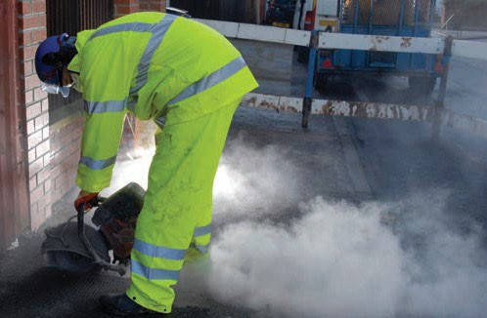
Construction dust is not just a nuisance; it can seriously damage your health and some types can eventually even kill. Regularly breathing these dusts over a long time can therefore cause life-changing lung diseases.

This sheet tells employers what they need to know to prevent or adequately control construction dust risks. It also provides advice for safety representatives and workers.

Construction dust

This is a general term used to describe different dusts that you may find on a construction site. There are three main types:

■■ silica dust – created when working on silica- containing materials like concrete, mortar and sandstone (also known as respirable crystalline silica or RCS);
■■ wood dust – created when working on softwood, hardwood and wood-based products like MDF and plywood;
■■ lower toxicity dusts – created when working on materials containing very little or no silica. The most common include gypsum (eg in plasterboard), limestone, marble and dolomite.

Health risks

Anyone who breathes in these dusts should know the damage they can do to the lungs and airways. The main dust-related diseases affecting construction workers are:

■■ lung cancer;
■■ silicosis;
■■ chronic obstructive pulmonary disease (COPD);
■■ asthma.

Some lung disease, like advanced silicosis or asthma, can come on quite quickly.

Figure 1 Common tasks like cutting can create very high dust levels

However, most of these diseases take a long time to develop. Dust can build up in the lungs and harm them gradually over time. The effects are often not immediately obvious. Unfortunately, by the time it is
noticed the total damage done may already be serious and life changing. It may mean permanent disability and early death.

Construction workers have a high risk of developing these diseases because many common construction tasks can create high dust levels. Over 500 construction workers are believed to die from exposure to silica dust every year. The amounts needed to cause this damage are not large. The largest amount of silica someone should be breathing in a day after using the right controls is shown below next to the penny.



Figure 2 Your maximum daily silica exposure is tiny when compared to a penny

Health and Safety Executive

The law

The Control of Substances Hazardous to Health Regulations 2002 (COSHH) cover activities which may expose workers to construction dust.

There are three key things you need to do:

Control the dust

Even if you stop some dust this way, you may do other work that could still produce high dust levels.
In these cases the most important action is to stop the dust getting into the air. There are two main ways of doing this:

■■ Assess (the risks)
■■ Control (the risks)
■■ Review (the controls)

Assess (the risks)

Assess the risks linked to the work and materials. Examples of high-risk tasks are listed in Table 1. High dust levels are caused by one or more of the following:

■■ task – the more energy the work involves, the bigger the risk. High-energy tools like cut-off saws, grinders and grit blasters produce a lot of dust in a very short time;
■■ work area – the more enclosed a space, the more the dust will build up. However, do not assume that dust levels will be low when working outside with high-energy tools;
■■ time – the longer the work takes the more dust there will be;
■■ frequency – regularly doing the same work day after day increases the risks.

Control (the risks)

Use the following measures to control the risk. Examples of controls for common high-risk tasks are given in Table 1.
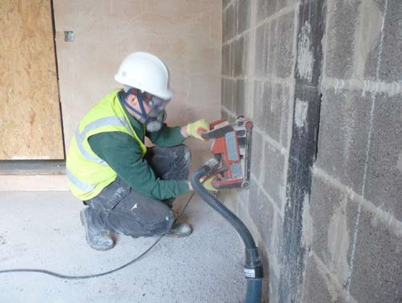
Stop or reduce the dust
Before work starts, look at ways of stopping or reducing the amount of dust you might make. Use different materials, less powerful tools or other work methods. For example you could use:

■■ the right size of building materials so less cutting or preparation is needed;
■■ silica-free abrasives to reduce the risks when blasting;
■■ a less powerful tool – eg a block splitter instead of a cut-off saw;
■■ a different method of work altogether – eg a direct fastening system.

■■ Water – water damps down dust clouds. However, it needs to be used correctly. This means enough water supplied at the right levels for the whole time that the work is being done. Just wetting the material beforehand does not work.
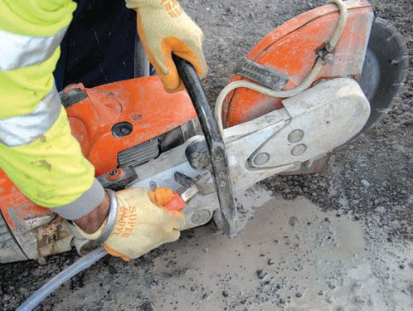

Figure 3 Water suppression on a cut-off saw

■■ On-tool extraction – removes dust as it is being produced. It is a type of local exhaust ventilation (LEV) system that fits directly onto thetool. This ‘system’ consists of several individual parts – the tool, capturing hood, extraction unit and tubing. Use an extraction unit to the correct specification (ie H (High) M (Medium) or L (Low) Class filter unit). Don’t just use a general commercial vacuum.

Figure 4 Wall chasing using on-tool extraction

Health and Safety Executive

Respiratory protective equipment (RPE)

Water or on-tool extraction may not always be appropriate or they might not reduce exposure enough. Often respiratory protection (RPE) has to be provided as well. You will need to make sure that the RPE is:

■■ adequate for the amount and type of dust – RPE has an assigned protection factor (APF) which shows how much protection it gives the wearer. The general level for construction dust is an APF of 20. This means the wearer only breathes one twentieth of the amount of dust in theair;
■■ suitable for the work – disposable masks or half masks can become uncomfortable to wear for long periods. Powered RPE helps minimise this. Consider it when people are working for more than an hour without a break;
■■ compatible with other items of protective equipment;
■■ fits the user. Face fit testing is needed for tight- fitting masks;
■■ worn correctly. Anyone using tight-fitting masks
also needs to be clean shaven.

Remember: RPE is the last line of protection. If you are just relying on RPE you need to be able to justify your reasons for this.

Other controls

Depending upon the work you are doing you may have to combine these measures with other controls. Think about:
Review (the controls)

You may already have the right controls in place, but are they all working properly? Check the controls work by:

■■ having procedures to ensure that work is done in the right way;
■■ checking controls are effective. Does the work still seem dusty? You might need to carry out dust exposure monitoring;
■■ involving workers. They can help identify problems
and find solutions;
■■ maintaining equipment:
- follow instructions in maintenance manuals;
- regularly look for signs of damage. Makerepairs;
- replace disposable masks in line with manufacturer’s recommendations;
- properly clean, store, and maintain non- disposable RPE. Change RPE filters as recommended by the supplier;
- carry out a thorough examination and test of any on-tool extraction system at least every 14 months.
■■ supervising workers. Make sure they:
- use the controls provided;
- follow the correct work method;
- attend any health surveillance where it is needed.

You may have to put a health surveillance programme in place. You may need advice for this from an occupational health professional.

■■ limiting the number of people near the work;
■■ rotating those doing the task;
■■ enclosing the work to stop dust escaping. Use sheeting or temporary screens;
■■ general mechanical ventilation to remove dusty air from the work area (eg in enclosed spaces such as indoors);
■■ selecting work clothes that do not keep hold of the dust.

You also need to make sure workers are doing the job in the right way and are using controls properly. Train workers:

■■ about dust risks and how this can harm their health;
■■ how to use the dust controls and check that they are working;
■■ how to maintain and clean equipment;
■■ how to use and look after RPE and other personal protective equipment (PPE);
■■ what to do if something goes wrong.

Health and Safety Executive

Table 1 Controls for common high-risk tasks

Task | Eliminate or limit the dust by: | Control the dust by using:
Cutting concrete kerbs, blocks and paving with a cut-off saw | ■■ Limiting the number of cuts during design/layout  ■■ Using lower energy equipment like block splitters  ■■ Getting material cut off site and delivered | ■■ Water suppression and  ■■ RPE* with an APF of 20
Chasing concrete and raking mortar | ■■ Limiting the need for chasing at the design/layout stage  ■■ Using a work method that limits/does not need chasing, like over-covering cables | ■■ On-tool extraction using an H or M Class extraction unit and  ■■ RPE* with an APF of 20 – consider powered RPE for longer duration work
Cutting roofing tiles with  a cut-off saw | ■■ Hand cutting natural/fibre cement slates and other tiles where possible  ■■ Using ½ and 1½ tiles  ■■ Correct setting out/design  ■■ Minimising valleys/using dry valleys | ■■ Water suppression and  ■■ A dedicated cutting area with scaffold board protection and  ■■ RPE* with an APF of 20
Scabbling or grinding with hand-held tools | ■■ Specifying architectural finishes that do not need scabbling  ■■ Using (ultra) high-pressure water jetting  ■■ Using chemical retarders and pressure washing  ■■ Casting in proprietary joint formers, eg mesh formwork | ■■ Where possible use on-tool extraction using an H or M Class extraction unit and  ■■ RPE* with an APF of 20
Short-duration drilling totalling 15–30 minutes with hand-held rotary power tools | ■■ Limiting the number of holes during design/planning  ■■ Using direct fastening or screws | ■■ Where possible use equipment that stops dust getting into the air. The larger the holes the better this needs to be. Options range from:  - drilling through a dust ‘collector’ or using cordless extraction attached to the drill (for smaller drill bits) or  - on-tool extraction using an H or MClass extraction unit  ■■ Otherwise use RPE* with an APF of 20
Drilling holes with hand- held rotary power tools  as a ‘main activity’ | ■■ Limiting the number of holes during design/planning  ■■ Using direct fastening or screws | ■■ Where possible on-tool extraction using an H or M Class extraction unit and  ■■ RPE* with an APF of 20
Dry coring | ■■ Limiting the number of holes during design/planning | ■■ On-tool extraction using an H or M Class extraction unit  ■■ Longer duration work (ie over 15–30 minutes accumulated time over the day) will also need RPE.* Use an APF of 20
Wet coring | ■■ Limiting the number of holes during design/planning | ■■ Water suppression  ■■ Long periods of wet coring in enclosed spaces will also need RPE.* Use an APF of  20
Using a hand-held breaker in enclosed spaces with limited ventilation | ■■ Limiting the amount of breaking during design/planning stage  ■■ Bursting, crushing, cutting, sawing or other techniques  ■■ Remote controlled demolition  ■■ Hydrodemolition | ■■ On-tool extraction using an H or M Class extraction unit and  ■■ RPE* with an APF of 20

Health and Safety Executive

Task | Eliminate or limit the dust by: | Control the dust by using:
Abrasive pressure blasting | ■■ Using a different method of work like (ultra) high-pressure water jetting  ■■ Using ‘silica free’ abrasive material | ■■ Wet or vacuum blasting and  ■■ RPE* will depend on silica content of building materials, blasting equipment and length of work:  - In most instances use RPE with an APF of 40  - Use RPE with an APF of 20 for lower risk work (including the ‘potman’ nearby)  ■■ Shrouds or screens to contain the flying abrasive  ■■ Certain restricted/enclosed working places may also need general mechanical ventilation
Soft strip demolition | ■■ Carefully planning the work  ■■ Limiting the number of people that need to be in the work area  ■■ Screening off areas to prevent dust spreading | ■■ Use water suppression or on-tool extraction for those tasks where it is possible and  ■■ RPE* with an APF of 20 – consider powered RPE for longer duration work  ■■ Enclosed spaces may also need general mechanical ventilation to remove dusty air
Removing small rubble, dust and debris | ■■ Limiting waste materials during design/ planning  ■■ Considering where waste material is created and how frequently it needs removing  ■■ Using the correct dust controls when making rubble/debris | ■■ Damping down and using a brush, shovel and bucket for minor/small ‘one-off’ amounts  Or for regular removal/site cleaning:  ■■ Water spray for damping down  ■■ Rake, shovel and bucket/wheelbarrow to remove larger pieces  ■■ Covered chutes and skips where needed  ■■ Vacuum attachments fitted to an H or M Class extraction unit  ■■ RPE* with an APF of 20 depending upon location, duration and type of work
Cutting wood with power tools | ■■ Using a less toxic wood1  ■■ Ordering pre-cut materials  ■■ Using dedicated cutting areas to minimise spread | ■■ On-tool extraction using an H or M Class extraction unit  ■■ Longer duration work (ie over 15–30 minutes accumulated time over the day) will also need RPE† suitable for the wood dust – particularly in enclosed spaces
Sanding wood with power tools | ■■ Using a less toxic wood1  ■■ Using ‘pre-finished’ materials | ■■ On-tool extraction using an H or M Class extraction unit and  ■■ RPE† suitable for the wood dust in most situations
Sanding plasterboard jointing | ■■ Using other finishes/systems | ■■ On-tool extraction using an H, M, or L Class extraction unit

* Table 2 Common RPE types for construction dust

† RPE for wood dust
APF | Common RPE types for construction dust
10 | ■■ FFP2 disposable mask or half mask with P2 filter
20 | ■■ FFP3 disposable mask or half mask with P3 filter  Or for longer duration work:  ■■ Powered RPE such as a TH2 powered hood/helmet
40 | ■■ Abrasive blasting helmet with constant flow airline

The risk from wood dust is specific to different types (species) of wood.¹ Knowing the species is important in establishing the right RPE to use. In general RPE with an APF of 20 is appropriate; particularly for higher residual dust levels, such as when sanding, and for all work with more toxic woods such as hardwoods,
western red cedar and MDF. RPE with an APF of 10 is suitable for work with less residual dust and when the wood is lower risk (eg pine).

NOISE AND VIBRATION

Community relations.

Good relations with people living and working in the vicinity of site operations are of paramount importance. Early establishment and maintenance of these relations throughout the carrying out of site operations will go some way towards allaying people’s fears. It is suggested that good relations can be developed by keeping people informed of progress and by treating complaints fairly and expeditiously. The person, company or organization carrying out work on site should appoint a responsible person to liaise with the public. The formation of liaison committees with members of the public can be considered for longer term projects when relatively large numbers of people are involved. Noise from blasting operations is a special case and can under some circumstances give rise to concern or even alarm to persons unaccustomed to it. The adoption of good blasting practices will reduce the inherent and associated impulsive noise: prior warning to members of the public, individually if necessary, is important

Statement.

Noise Limits In accordance with good practice will be set at the site boundary and will be monitored when undertaking certain activities that could exceed the 65db agreed noise and vibration levels. construction activities that elevate noise levels, measured as LAeq (1hr) by more than 1dB above ambient level at the front of any noise sensitive premises, may not take place outside of normal hours of work. Vibration Limits In accordance with BS 5228, prior explanation shall be given to all potentially affected residents of vibration generating activities to place at site likely to cause vibration up to and in excess of the limit 1.0mm·s-1. If any activities are likely to cause in excess of this level they shall only be undertaken for brief periods, to prevent the vibration impact from becoming intolerable to local residents. A review of the likely vibration effects from construction works will be undertaken once a detailed schedule of equipment, processes and durations are known. This review could indicate a requirement for vibration monitoring at the vibration sensitive receptors whilst certain activities are taking place on site. Monitoring results could subsequently indicate requirements for further mitigation.

Introduction
This procedure applies to the management of noise and vibration during the construction works. All staff are responsible for complying with the requirements of the procedure. The Considerate Constructors Scheme states that the noise of plant, vehicles and radios will be kept down; noise including that from loading of skips will be suppressed using baffles or sound-deadening quilt and the use of radios will be moderated, with the volume maintained at a reasonable level.
Current ambient noise levels are generally dominated by traffic noise. Ambient vibration levels within and around the site are due primarily to nearby movements of vehicles and pedestrians but are low and insignificant.

A newsletter will be circulated before and during the initial stages of heavy civils works, the communication with the local pub manager will be crucial to a good working relationship throughout the scheme.

Vibration Action Levels
With regards to cosmetic damage to buildings, it is highly likely that occupants would complain, and alternative techniques be adopted long before vibration levels reached a level which would give rise to cosmetic damage.

Potential Impacts

- Disturbance to nearby residential properties from site activities;

- Effects of noise and vibration from heavy goods vehicles transporting materials to and from the site during construction.

Relevant Legislation and Guidance

Environmental Protection Act 1990;

Control of Pollution Act 1974 Part IV (Sections 60 and 61);

BS 5228-1:2009+A1:2014 and BS5228-2:2009+A1:2014 Control of Noise on Construction and Open Sites, Part1Noise Part 2 vibration (see Casey Control Procedure Document/Checklists)

BS: 6472: Guide to Evaluation of Human Exposure to Vibration in Buildings (1-80Hz)

- Building Research Establishment (BRE) “Controlling particles, vapour and noise pollution from construction sites”2003.

Procedure
Liaison must be carried out with the occupants of adjacent properties potentially most affected by noise or vibration from on-site activities prior to the commencement of works.

Site activities will be confined to the agreed working hours as detailed in the
planning conditions, for any works requiring extending working hours advance notice would be requested to the Local Planning Authority with relevant information provided as previously noted in S4.

Start up and close down periods shall be included within the agreed working hours there will be no operation of plant or machinery, or deliveries, giving rise to noise likely to disturb local residents. Activities which could be undertaken include: the arrival and departure of workforce and site staff, site inspections and meetings, safety checks prior to commencing work.

The following mitigation measures will be implemented by all contractors at all times to minimise noise and vibration generated from site activities and disruption to neighboring occupiers:

Controlled lorry movements (including minimisation of reversing vehicles fitted with audible warnings);

- Use of modern, inherently quiet plant;

- Offsite prefabrication where appropriate;

- The use, where necessary and practicable, of enclosures/screens and/or acoustic covers around noisy and fixed plant;

- Use of whispering type generators and compressors or noise protection to static noise generators;

- Regular maintenance of plant; This will be provided by Casey.

Monitoring
If Casey commit to action levels sample noise and vibration monitoring, this will be undertaken over 15 minute periods by the Environmental Monitoring
Contractor nominated by Casey, at the locations agreed prior to each phase of construction works.

Where the results of the monitoring exercises indicate that the Action Levels have been exceeded, the following actions will be undertaken:

- The activity or activities causing the Action Levels to be exceeded will be identified through discussions with the contractor(s);

- Investigations will be made to determine whether the activities could be easily changed or other simple actions taken to substantially reduce noise or vibration levels;

- If simple and effective remedial measures are not identified, consideration will be given to the implementation of alternative techniques and/or additional mitigation measures; and

- In all cases where Action Levels are likely to be exceeded, neighborhood liaison will be carried out to the degree that is appropriate for the levels likely to be reached and their estimated duration.

- A threshold value of 65 dB is to be applied to construction noise. This level of noise must not be exceeded at the site boundary with any residential dwelling.

- If levels exceed the limits works will cease till the cause can be identified and levels reduced within tolerance.

Equipment
Noise monitors must conform to a minimum Type 2 integrating sound level meter that simultaneously records LAeq, LMAX, L90 and L10 noise levels. The vibration monitors must continuously sample the vibration levels and record the maximum vertical PPV (Peak Particle Velocity) every 15 minutes for sample vibration monitoring and every 1-minute period for continuous vibration monitoring. The vibration monitors will be capable of measuring 3-dimensional levels of vibration.

Impact Noise and vibration will be caused during construction activities by:

• Traffic movements;
• Plant movements;
• Excavating operations and
• General construction activities. Mitigation To mitigate the potential impacts of noise and vibration the following measures shall be adopted for the general construction activities and site management: • All activities with the potential to cause noise and vibration will be limited to the “core hours” • Where there is a requirement to undertake works on a Sunday or Bank holiday; written approval shall be sought from the Local Planning Authority in advance of the works; • General induction training for site operatives and specific training for staff having responsibility for particular aspects of controlling noise from the site shall be delivered; • Where generators are operated overnight, measures shall be taken to minimize noise levels at the nearest dwellings; • Care will be taken when erecting or striking scaffolds to avoid impact noise from banging steel. All operatives undertaking such activities will be instructed on the importance of handling the scaffolds to reduce noise to a minimum; and • Contractors must use “best practicable means” (BPM) to minimise the nuisance from noise and vibration; this is to include compliance with BS 5228, Noise Control on Construction and Open Sites. Specific mitigation measures shall be adopted to control the potential impact from each site activity, as detailed below. Traffic Movements: • All visitors to site shall be required to adhere to the Traffic Management Plan for the development. The Traffic Management Plan shall be displayed in prominent locations to ensure all visitors are aware of how to navigate the site; and • Deliveries will be programmed to arrive during permitted hours only. Care will be taken when unloading vehicles to minimise noise. Delivery vehicles would be routed so as to minimise disturbance to local residents. Delivery vehicles will be prohibited from waiting on the highway or within the site with their engines running. Plant movements and operation: • Use of most environmentally acceptable and quietly operating plant and equipment appropriate to the works with emission levels limited to relevant EC Directive/ UK Statutory Instrument levels and the levels quoted in BS5228; • Intermittently operating plant will be shut down in the intervening periods between operations (including during breaks and down time of more than 30 minutes); • Any compressors brought on to site would be silenced or sound reduced models fitted with acoustic enclosures; • All pneumatic tools will be fitted with silencers or mufflers; • Where possible, noisy plant shall not be used simultaneously and/or in close proximity to each other, to avoid cumulative noise impacts; and • Site inspections shall be undertaken and will include checks to ensure that plant is being operated with any specified acoustic covers in place. Excessively noisy plant shall be removed from site for repair or maintenance. Quieter construction methods will be used, where required and where considered reasonable and feasible.

Annex B (informative) Noise sources, remedies and their effectiveness B.1 The effectiveness of noise control at source Examples of typical attenuations afforded to various noise sources by equipment modifications, the use of acoustic enclosures and sheds (see B.2 and B.3) or the replacement of inherently noisy plant by less noisy alternatives are given in Table B.1. The degree of attenuation achieved will vary from the typical value quoted depending on such parameters as source size, orientation and noise spectrum characteristics. Furthermore, the effectiveness of any given measure in controlling noise will depend very much on the prevailing circumstances. For example, noise from hammer-driven piling operations can be controlled to a limited extent by the use of the various methods described in Table B.1. However, the attenuations provided are not likely to alleviate totally any disturbance from such high intensity sources. Alternative methods of piling, where practicable, can provide more beneficial reductions in noise levels. Other simple noise control measures can provide useful reductions in overall site noise levels.

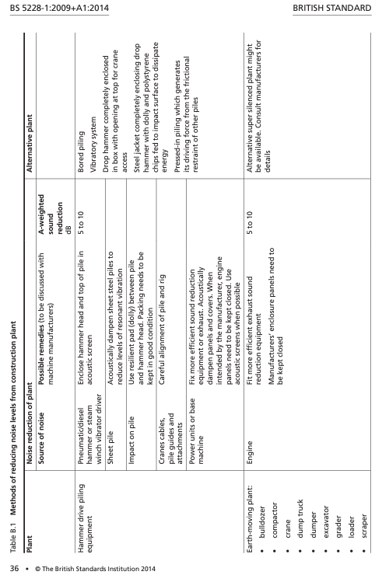

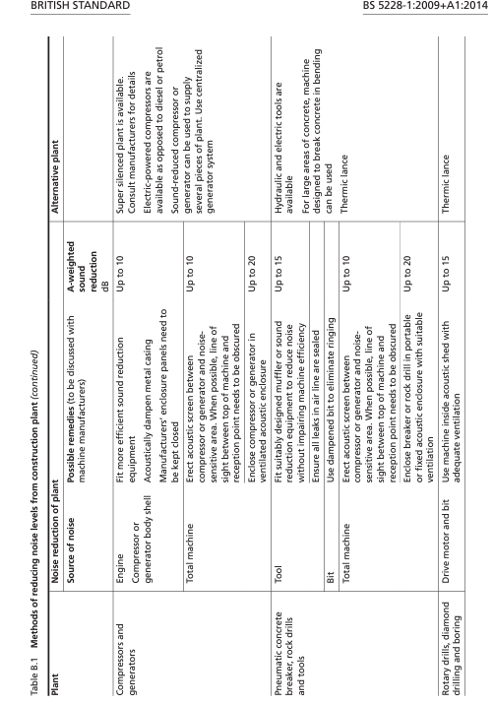

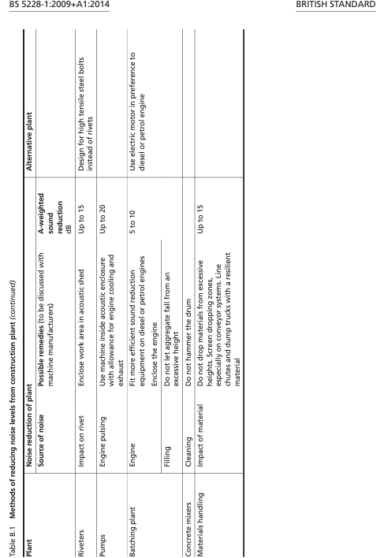


HAND-ARM VIBRATION EXPOSURE CALCULATOR Version 5.6 June 2019

Company name / work area:
Employee ID and/or task name:
Tool or process name | Vibration
Tool or process name | magnitude
Tool or process name | m/s²

Exposure points per hour
Time to reach EAV
2.5 m/s2 A (8)
hours | minutes

Time to reach ELV
5 m/s2 A (8)
hours | minutes

Exposure
duration
hours | minutes

Partial
exposure
m/s² A (8)

Partial
exposure
points

Daily
exposure
m/s² A (8)

Total
exposure
points

Calculation
Exposure calculation by:
Job role:

date:

Health and Safety Executive Control of Vibration at Work Regulations 2005 Printed: 11:34 2019-10-15

Documentation
The following must be held on file: Noise and vibration monitoring sheets.

Community relations

Good relations with people living and working in the vicinity of site operations are of paramount importance. Early establishment and maintenance of these relations throughout the carrying out of site operations will go some way towards allaying people’s fears. It is suggested that good relations can be developed by keeping people informed of progress and by treating complaints fairly and expeditiously. The person, company or organization carrying out work on site should appoint a responsible person to liaise with the public. The formation of liaison committees with members of the public can be considered for longer term projects when relatively large numbers of people are involved. Vibration and air overpressure from blasting operations is a special case and can under some circumstances give rise to concern or even alarm to persons unaccustomed to it. The adoption of good blasting practices will reduce the inherent and associated impulsive noise: prior warning to members of the public, individually if necessary, is important.

Control of Vibrations.

Vibration and persons on site Training NOTE Attention is drawn to Regulation 8 of the Control of Vibration at Work Regulations 2005 [2], which requires employers to provide information and training where the risk assessment indicates a potential risk to the health of employees as a result of exposure to vibration [either hand–arm vibration (HAV) or whole body vibration (WBV)] or where the employees are likely to be exposed to vibration levels above the relevant action levels. The Regulations require all employees to be advised of the following, as part of their training: a) b) c) the organizational and technical measures to be taken in order to comply with the requirements of Regulation 6; the exposure limit values and action values set out in Regulation 4; the significant findings of the risk assessment, including any measurements taken, with an explanation of those findings; 2 • © British Standards Institution 2014BRITISH STANDARD d) BS 5228-2:2009+A1:2014 why and how to detect and report signs of injury; e) f) g) entitlement to appropriate health surveillance under Regulation 7 and its purpose; safe working practices to minimize exposure to vibration; and the collective results of any health surveillance undertaken in accordance with Regulation 7 in a form calculated to prevent those results from being identified as relating to a particular person. Operatives should be trained to employ appropriate techniques to keep site vibration to a minimum, and should be effectively supervised to ensure that best working practice in respect of vibration reduction is followed. A programme of monitoring should be implemented to ensure that condition limits are not exceeded and that all the relevant recommendations are met.

Disturbing effects of vibration Vibrations, even of very low magnitude, can be perceptible to people and can interfere with the satisfactory conduct of certain activities, e.g. delicate procedures in hospital operating theatres, use of very sensitive laboratory weighing equipment. Vibration nuisance is frequently associated with the assumption that, if vibrations can be felt, then damage is inevitable; however, considerably greater levels of vibration are required to cause damage to buildings and structures (see, for example, BS 7385-2) or to cause computers and similar electronic equipment to malfunction. Vibrations transmitted from site activities to the neighbourhood can, therefore, cause anxiety as well © British Standards Institution 2014 • 3BS 5228-2:2009+A1:2014 BRITISH STANDARD as annoyance, and can disturb sleep, work or leisure activities. In any neighbourhood, some individuals will be more sensitive to vibration than others. The significance of vibration effects should be assessed in accordance with Annex B.

Control of vibration.

General Vibration

can be more difficult to control than noise, and there are few generalizations which can be made about its control. It should be borne in mind that vibration can cause disturbance by causing structures to vibrate and radiate noise in addition to perceptible movement.

Substitution

Where reasonably practicable, plant and/or methods of work causing significant levels of vibration at sensitive premises should be replaced by other less intrusive plant and/or methods of working.

Vibration isolation

of plant at source Vibration from stationary plant (e.g. generators, pumps, compressors) can, in some instances, prove disturbing when located close to sensitive premises or when operating on connected structures. In these instances, equipment should be relocated or isolated using resilient mountings.

Controlling the spread of vibration

Where reasonably practicable, vibrating equipment should be located as far from sensitive premises as possible, and, if on a structure, not on one which is continuous with that of the sensitive premises. In some instances it might be possible to reduce transmitted vibration by cutting a structure to separate site work from sensitive premises. It is essential to take account of safety and structural issues before carrying out any work of this nature. The demolition of tall or large structures, especially if explosives are used, can give rise to impulsive vibrations and air overpressure when the felled structures hit the ground. Further advice is contained in BS 6187.

Vibration control targets

All reasonably practicable means should be employed to ensure the protection of local communities and of people on construction sites, from detrimental effects of the vibration generated by construction operations. The means employed should be determined by local circumstances and can include vibration reduction measures for individual items or plant and machinery, the fixing of hours of work, the setting of noise or vibration limits or any other appropriate measures. Those seeking to determine suitable vibration limits for construction operations should be aware of the particular noise problem that can occur when such operations take place in existing buildings that are either occupied or contiguous with occupied buildings. Vibration introduced directly into the structure by equipment such as breakers, hammers and drills might attenuate only slowly as it is transmitted through the structure and might therefore produce unacceptable levels of noise in rooms remote from the source. In particularly sensitive situations it might be necessary to use alternative techniques and equipment.

POLLUTION INCIDENT CONTROL PROCEDURE

Introduction
This procedure applies to public safety, emergency and other unplanned activities during the development works. All staff are responsible for complying with the requirements of the procedure.

Relevant Legislation and Guidance

Resources Act 1991;

Water Industry Act 1991; and

Environment Agency Pollution Prevention Guidance.

Procedure
Incidents that must be reported to Casey are:

  - Spills of chemicals, oils, fuels, unplanned or non- consented discharges;

  - Release of fumes and gases; or

  - Any incident that could lead to local authority or regulatory enforcement, public complaint or media attention.

In the event of a spillage or other pollution incident, Casey shall be notified immediately, and immediate steps taken to prevent environmental pollution, for example:

  - Protection of drains following a spillage of oil or other chemical;
  - Use of spill kits following a spillage of oil or other chemical; and

  - Turning off equipment or other source of fumes, noise or dust.

  - At least two spill kits will be kept on site which, as a minimum contain absorbent granules, sand bags and drain covers. Absorbent pads and booms will preferably be used instead of granules and sand bags where possible.
If it is considered that uncontrolled pollution may have resulted from an incident such as a release of fumes or gases or spillage, the following action will be taken:

  - Ensure that it is safe to remain in the area;

  - Locate and switch any isolation switches, valves or pumps if possible;

  - Contact the following bodies where appropriate and follow their instructions:
- Environment Agency Regional Office
- Fire Brigade -Fire Station, and
- Council Environmental Health Department

  - Where possible undertake damage control measures to prevent dispersion of gases or pollution from entering drains or watercourses. For example, create containment sumps, pump liquid to temporary storage areas such as lined skips and block or clear drains as appropriate.

Documentation
A logbook of environmental incidents and remedial actions taken must be maintained on site and held by Casey.

NEIGHBOUR AND COMMUNITY LIAISON AND MANAGEMENT OF COMPLAINTS

Introduction

This procedure addresses neighbor and community liaison during the redevelopment works. Casey is responsible for ensuring compliance with the procedure. In addition, all staff are responsible for adhering to its requirements.

The Considerate Constructors Code of Construction Practice states the importance of the consideration of the needs of local people, businesses and visitors.

Procedure Liaison
Prior to commencement of the construction works, all neighboring occupiers
will be contacted by the Site Manager, nominated by Casey, to explain the activities to be undertaken, the duration of the works and the working hours. The Site Manager will also be introduced as the main point of contact and a contact telephone number provided.

In accordance with the Considerate Constructors Scheme, a clean, presentable company sign board with relevant telephone number will be maintained. A respectable standard of dress code will be maintained and inappropriate behavior, such as “wolf whistling”, will be addressed in the site induction. Casey will ensure that standards are being adhered to.

The site reception will be clearly signed and staff present in reception will be able to direct unexpected visitors to an appropriate member of staff. During the works, communication with neighbours will occur through newsletters and maintained notice boards. Neighbours will also be specifically informed about any abnormal work or road closures proposed.

All licenses issued by Council must be displayed prominently on hoardings, scaffolds, gantries or fences. The timing of deliveries to adjacent buildings will be considered to avoid conflict with construction vehicles.

Complaints
In the event of a complaint from a neighbour or a member of the public in relation to any activity, it must be recorded by the site or contracts Manager in a designated logbook, stating the nature of the complaint, the cause, the time and date and, where appropriate, the remedial action taken. All site workers shall immediately notify Casey or Site Manager will they receive any complaints.
Should complaints about noise, dust or vibration be received, the monitoring results at the time of the complaint will be reviewed.

The Site Manager or his representative will contact all complainants within 24 hours of receiving the complaint for further discussion and identification of a mutually acceptable resolution. Where possible, measures will be put in place to avoid recurrence of the complaint.

Documentation
All complaints will be recorded in a complaints log book with details of remedial action taken.

Evaluation Documentation
The following documentation must be retained on site for inspection:

- Environmental incident logbook containing details of environmental incidents and corrective action taken;

- Copies of discharge consents and licenses;

- Waste transfer notes, hazardous waste consignment notes and waste carriers’ registrations;

- Any noise and vibration monitoring record sheets with details of corrective actions taken where the action levels are exceeded;

- Any dust monitoring record sheets with details of corrective actions taken where the action levels are exceeded

- Records of waste produced, reused, recycled and disposed of to landfill;

- Records of monthly energy usage and water usage as required;

- Records of distances travelled by each type of vehicle associated with the redevelopment works;
- Chain of custody certificates for timber;

- Plant maintenance and defect records; and Complaints log book with details of the response made to complaints received.

14. Environmental Reviews
Environmental issues must be included as an item on the agenda at Progress Meetings, attended by Employers Agent, Casey, Sub Contractors, relevant Trade Contractors and other members of the project team where appropriate. Where relevant, the following will be discussed:

- Results of the monitoring;

- Complaints, including cause and remedial action;

- Neighborhood liaison;

- Communications with Council and other statutory bodies; and

- Incidents that have taken place.

Independent Environmental Audits
Regular independent environmental audits will be carried out to ensure that the requirements of this CEMP are being implemented. The frequency of the audits will be dependent upon the potential for the works being carried out to give rise to environmental impacts.

Badgers

No evidence of badgers was recorded during the extended Phase 1 habitat survey. The Site consists of predominantly poor semi-improved grassland that is regularly managed by mowing. However, there are areas of scrub and woodland within the south-eastern section of the Site and directly adjacent to the Site which are suitable for foraging and commuting badger, and sett building. Woodland adjacent to the Site has connectivity to suitable habitats for badger in the wider area, including ancient semi-natural woodland.

As suitable habitat for badger has NOT been recorded within the Survey Area.

Addendum to Whitemoss Construction Environmental Management Plan. – 24th June 25.

1. Introduction

1.1 Bailey Wood SBI is in close proximity to the site and the following measures will be taken during construction to minimize environmental impacts.

2. Site Description

2.1 Site Location and Proximity

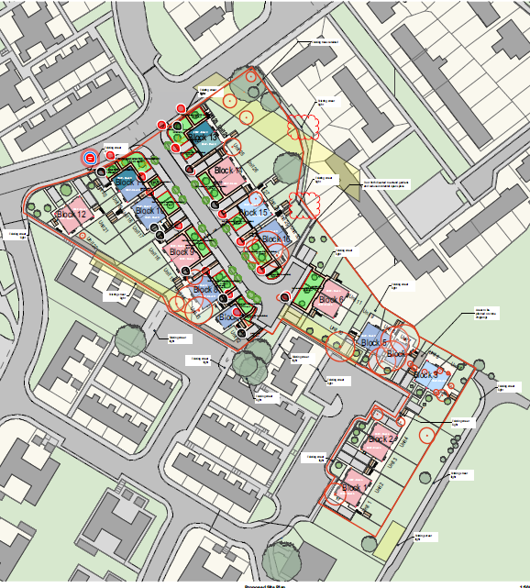
An area of deciduous woodland and Baileys Wood SBI are approximately 35 m to the east of the site boundary. To the rear of the boundary there is a landscaped area and then an existing tarmacadam road that separate the site from the woodland area. This will be retained and will NOT be used to access the site by construction traffic during the works at all. It will act as a buffer between any works and the woodland.

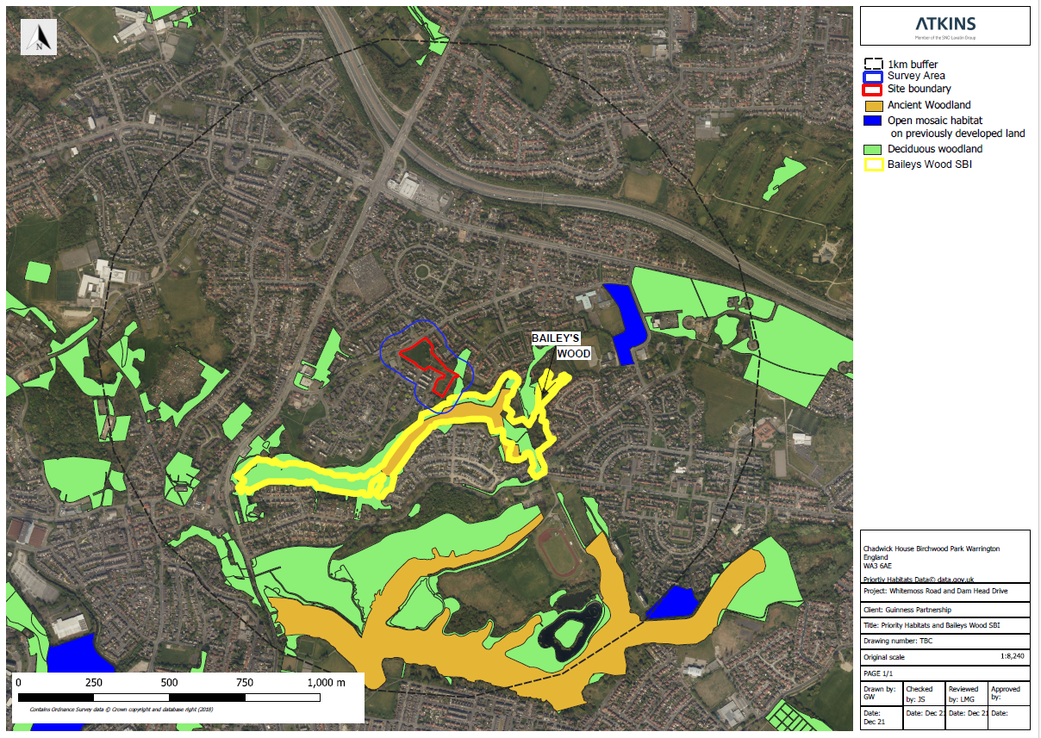

2.2 Environmental Sensitivities
Ensure the construction site has no impact on the adjacent SBI.

3. Environmental Management

3.1 Environmental Objectives and Targets
No habitat loss, pollution incident or contamination to enter the SBI.

3.2 Environmental Control Measures
- No night time working that could disturb nocturnal species.
- Open excavations to be covered or ramped overnight to prevent any wildlife entrapment.
- Waste materials to be removed from site regularly and in a timely manner to prevent any habitat contamination.
- Washout facility with silt trap to be sited well into site away from the Eastern boundary and to be emptied regularly.
- No access off-site at the eastern boundary by workers or machinery at all.
- All fueling areas to be set well away from the boundary and to utilize drip trays.
- Fuel spill kits available at all re-fueling areas.
- The significance of the SBI to be pointed out to all workers & visitors at the site induction.

4. Roles and Responsibilities

4.1 Project Team
Site Manager – David Attwood responsible for implementing the CEMP on a day to day basis.

5. Monitoring and Reporting

5.1 Environmental Monitoring
Any environmental issues should be reported immediately to MCC environmental team.

5.2 Reporting Procedures
Outline the reporting procedures for documenting and addressing environmental incidents or non-compliance.

