Unity Primary School Playzone

CONSTRUCTION
MANAGEMENT PLAN (CEMP)

Prepared by

SIS Pitches

April 2025

CONTENTS

1. Purpose & Scope
2. Management Framework
3. Development and Construction programme
4. Site context, location of facilities and deliveries
5. Recycling and disposing of waste
6. Management and Mitigation
7. Biodiversity
8. Conclusions

1. PURPOSE & SCOPE

Purpose
This document outlines a Construction Environmental Management Plan (CEMP) for the reconstruction of the existing MUGA to a 30 x 22m 2G sand dressed Playzone at Unity Primary School, 41 Allesley Dr, Cheetwood, Manchester M7 4YE on behalf of Unity Primary School and Manchester Active. It sets out the policies and environmental controls required to ensure that the environmental impacts are minimised. It highlights the key activity specific risks, detail control measures.

Scope
This CEMP covers the principal construction activities at the time of Planning Application.
The key elements of this CEMP include
- Overview of the proposed development and associated construction programme
- Prior assessment of environmental impacts
- Minimisation of potential impact through design and other mitigation measures
- Monitoring of effectiveness of mitigation measures
- Corrective action procedure

The Principal Contractor for this development is SIS Pitches who will oversee and manage the construction phase on behalf of Unity Primary School and Manchester Active.
All contractors will be responsible for working in accordance with the construction & environmental controls documented in this CEMP. The overall responsibility for implementation of the CEMP will lie with SIS Pitches. The Project Team will comply with the requirements of this plan.
This CEMP has been designed with the objective of compliance with the relevant environmental legislation and the commitments for mitigation measures.

2. MANAGEMENT FRAMEWORK

The project will comply with the SIS Pitches Environment Policy. The project shall ensure that the policies and their requirements are made known to all relevant personnel. This will be undertaken through a number of methods including site inductions, method statements and risk assessment briefings and toolbox talks. All subcontractors will be provided with a copy of the H & S and Environment Policy.
The Project will comply with all relevant legislation, regulations and will obtain and comply with all necessary consents to ensure legal construction works. The Contracts Manager is responsible for ensuring that the project complies with all applicable environmental legislation, regulations and other requirements
All personnel, whose work may cause a significant impact on the environment, will receive environmental training. Environmental training includes, but is not limited to:
- Environment & sustainability element of company induction (new starters only)
- Environment & sustainability element of site induction
- Pollution Prevention and Emergency Spill Response
- Toolbox Talks on spillage, noise prevention, and other issues relevant to the works
- The Company Environmental Policy will be available on site

3. DEVELOPMENT & CONSTRUCTION PROGRAMME

Development
The proposed development will comprise of a new build MUGA to a 30 x 22m 2G sand dressed Playzone. The site will be excavated, drained and new base installed (stone and macadam layer), a new prefabricated shockpad and the synthetic surface laid and infilled with sand infill. A new fencing and floodlighting system will be installed, and new macadam pathway constructed as part of the works.
Construction Programme
The current expectation is that the development will take approximately 12 weeks.
Allowing sufficient time to receive planning consent and the discharge of expected conditions, it is anticipated that the work will likely commence in July 2025.
Delivery and working hours will be restricted to:
Monday – Friday 08:00 – 18:00
Saturday – 08:00 – 13:00 (Upon prior arrangement)
Sundays and Bank Holidays – No working

4. SITE CONTEXT, LOCATION OF FACILITIES AND DELIVERIES

The address of the site is -

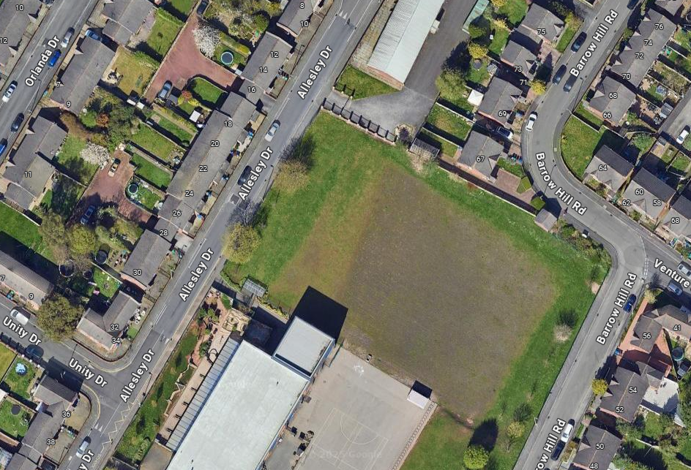
Unity Primary School, 41 Allesley Dr, Cheetwood, Manchester, M7 4YE

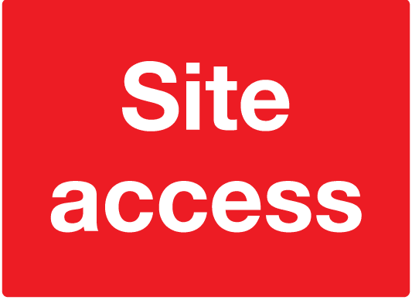

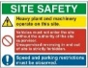

2m high heras fencing to secure site with lockable gates and warning signs around new AGP

Site traffic co-ordinated by Site Manager

Access route off Allesley Drive
Site offices, welfare facilities and materials storage (hazardous materials will be in a separate locked container)

The access is off Allesley Drive, creating a new entrance from the road which will later be used as a pedestrian path. A temporary compound area will be constructed which will be large enough for the site compound, materials storage, vehicle waiting area and turning circle for larger vehicles. Vehicles will unload and turn within the site/ compound area. Parking will be within the site compound, protected by heras fencing, for all site staff and visitors. Any issues arising from parking will be addressed by the site manager and will be reviewed on an ongoing basis. All parking will be at the direction of the site manager.
Site security fencing will be provided and erected around the site compound and work area by SIS and maintained during the construction duration. This will ensure the public is segregated from the works at all times.
Site storage and welfare facilities will be delivered to site and off loaded by Hi-Ab lorries to the designated areas within the site compound. Site office and canteen cabins will be connected to temporary site power and water supply.
Appropriate fencing shall be erected around personnel cabins to segregate pedestrians from site traffic within site compound.
Relevant signage will be erected around the site to inform site operatives and visitors of site procedures and rules etc.
A firefighting post will be setup in the site compound area with relevant signage and information.
All site operatives and visitors will be required to sign in at the site office before entering the work area on a daily basis.
All site operatives and visitors will wear high visibility clothing and safety boots along with other necessary PPE when required.
Construction materials will be delivered to site throughout the construction phase on various sized transportation including stone delivery which vary from 8 wheelers or articulated lorries, rigid 17T lorries and articulated curtain sided vehicles. An unloading and waiting area will be created within the proposed site compound to ensure vehicles can turn around with ample room and be unloaded safely. Materials will be off loaded, either by Hi-Ab or onsite telescopic handler. Plans will be made to stagger deliveries as to avoid traffic congestion. Site deliveries will be timed to avoid busy period at school start & finish times, lunchtimes and pupil movement times, this will be agreed with relevant persons at the school. All deliveries, including plant and machinery will take place away from public areas and will be unloaded into a secure area and stored safely in lockable containers where possible. All vehicles will have sufficient turning space within the site/compound area.
Materials will only be procured and delivered within a few days of those materials being installed as part of the works programme. These materials will be securely stored in lockable areas.
All of our supply chain will be given a briefing which will clearly state the methodology of delivery plant, machinery, and materials to the site, with any time constraints, the route in which they will take, and the protocols that we will have in place for receiving such deliveries. Space for loading/unloading will be allocated.
Due to the nature and the site constraints of this site, there will be very little materials stored within the site, and certainly no materials stored outside of the hoarding line. Materials will only be procured and delivered within a few days of those materials being installed as part of the works programme. These materials will be securely stored in lockable areas
There will be elements of plant that will be parked within the confines of the site, but only for the duration of the works that they are associated with.
At all times, the access road will be kept free from the storage of any plant or materials.
Wheel washing facilities will be available at the site entrance should they be required. Prior to any vehicles leaving the site, they will be inspected by the site manager for any defects associated with their wheels, tyres and undercarriage with regards to their physical appearance, and whether they are free from excessive dirt, mud and obstructions. If they are not free from any of these, then they will be cleaned to remove any dirt, mud or obstructions from their wheels and undercarriage, by an SIS operative. This would likely be an Ecobath wheel wash unit (or similar), that contains the silty water which is then disposed of at various intervals during the construction period. To supplement this operation, there will be a road sweeper engaged as required to clean the immediate roads in, and around the site.
The site accommodation and site storage container shall be locked at the end of each working day. The contractor will install heras fencing or a security gate at the entrance to the works to secure the area at the end of each working day. There is no intention to install decorative displays. The only displays that will be installed will be site safety notice board at the entrance to the site to advise visitors and the general public that they are entering a construction site and the safety rules that apply on the site. There is no intention to have facilities for public viewing.

5. RECYCLING AND DISPOSAL OF WASTE

In order to control the waste on site SIS Pitches will undertake a skip segregation system to separate the main waste streams on site, prior to them being taken to a waste facility for recycling.
Segregated skips will be provided for recycling of construction waste. All contaminated waste, chemical waste and sewage will be disposed of as special waste via a licensed waste contractor.
In order to manage and monitor the waste process, waste streams will be estimated and monitored and goals set with regards to the waste produced.
All waste to be removed from site will be undertaken by fully licensed waste carriers and taken to licensed waste facilities.
The monitoring of construction waste is undertaken through Site Waste Management Plan procedures within the company’s Environmental Management System. This identifies:
- The wastes, and their category, that will be generated by the project
- Opportunities for reuse and / or recycling
- Proposed methods of storage, segregation, handling and transportation of waste
- Means of disposal including licensing requirements of carriers and destination sites
- Recording of all waste movements from the site
- Reporting and monitoring process

6. MANAGEMENT AND MITIGATION

Prior to commencement on site, an Environmental Project Plan will be undertaken to overview the works and any potential environmental impacts and will detail the actions required.

Site Specific Method Statements will be produced to detail the methods under which the highlighted hazards will be controlled. It is also often the case that environmental issues will be included as part of the work task Method Statement depending on the nature of the works. The Project Manager will review environmental issues on a regular basis.
It is anticipated that the likely environmental impacts from activities being carried out on the project will be:
Air Quality
Air pollution, arising from odour, fumes and smoke, may arise from the following activities:
- Use of heavy plant and machinery
- Road vehicles, particularly HGVs
Pollution to air will be managed in order to reduce impacts to a minimum, and to eliminate where practicable. Management will be achieved through:
- No fires permitted on site
- All fuels and oils will be stored in secure, sealed, labelled containers
- Vehicles and plant will be switched off when not in use
- Ensure vehicles and plant are not over loaded to prevent labouring
- Modern, well-maintained plant and equipment is used
- Mains electricity supply will be used in preference to generators where practicable
Dust
Effective planning and management of dust control requires a thorough understanding of the construction programme, the operations and their likely impact due to the changing weather conditions. The control measures that will be introduced reflect the site team’s knowledge of the programme and site operations to combat dust.
To minimise the nuisance of dust generated by the construction operations the following operational constraints will be implemented:
• Sweep public roads regularly when potential traffic movements containing soil, spoil, hardcore, concrete etc. are being taken in or out of the site.
• Ensure that all dust generating materials transported to and from site are covered by tarpaulins which will be securely fitted and will remain in place while the vehicles transit around the site.
• Traffic speed on site to be lowered to prevent the generation of dust, and if necessary routes damped down with water.
• Construction methods will be reviewed to limit the generation of dust i.e. wet cutting in lieu of dry cutting where practicable.
• Control of dust to be implemented on site by the use of a water bowser unit to dampen site access and haul roads.
• Plant and equipment to be selected to minimise the generation of dust.
• Dust migration to adjoining properties to be restricted by the use of debris netting fixed to all the perimeter fences.
• Store materials as far away as possible from sensitive boundaries, whenever possible.
Any work which will involve the production of large amounts of dust/dirt will be carried out away from the general public, and will only be done by trained staff with a first aider present. This will be done at low risk specified times of the day.
Appropriate PPE and face fit masks will be worn.
Protective mesh fencing will installed to the surrounding heras fencing as a further protective measure should any unforeseen dust/dirt issues occur.
The monitoring of operations with the potential to cause airborne dust emissions will be regularly undertaken by the Project Manager or his appointed representative. This will predominantly take the form of personal visual assessments.
Information relating to dust control will be communicated through the site induction, start of work briefing and toolbox talks with supervision on site at all times. Further to this, the Site Manager will be responsible for the management of air quality and daily dust observations.
A site specific dust risk assessment will be carried out prior to work commencing on site.

Noise & vibration
Noise and vibration will be monitored throughout the project by the Site Manager. The following will be implemented:
- Vehicles and mechanical plant will be maintained in a good and effective working order and operated in a manner to minimise noise emissions.
- Compressor, generator and engine compartment doors will be kept closed and plant turned off when not in use.
- All pneumatic tools will be fitted with silencers/mufflers.
- Care would be taken when unloading vehicles to avoid un-necessary noise.
- The use of particularly noise plant will be limited, i.e. avoiding use of particularly noisy plant early in the morning.
- Restrict the number of plant items in use at any one time.
- Reduce the speed of vehicle movements.
- Drop heights will be minimised when loading vehicles with spoil and rubble.
- Vehicles should be prohibited from waiting with their engines running.
- Local hoarding, screens or barriers should be erected to shield particularly noisy activities
- Hours of operation should be strictly enforced and any deviations other than those previously identified will be with the consent of the local authority.

Fuel storage
All oils and fuels will be stored in compliance with the Control of Pollution (Oil Storage) Regulations 2001.
- Fuel shall be stored in dedicated bunded, impervious storage areas, away from drains and watercourses.
- Drums over 200 litres shall be stored on drip trays capable of holding 25% of the drum’s maximum capacity.
- Fuel tanks shall be stored within a bund capable of holding 110% of their capacity. All pipes and gauges shall be within the wall of the bund.
- Bowsers shall be double skinned and shall be stored in a bund capable of holding 110% of the volume of the bowser.
- Small mobile plant shall be placed on drip trays.
- Spill kits will be available at various points around the site and located next to bowsers and drums.

Nuisance
This can be described as Traffic movements, noise by machinery, vibration and dust. The controls for these are described in the relevant sections.

Spillages
Should a spill occur, the following will be immediately implemented:
- Work will be stopped immediately.
- All possible ignitions will be extinguished if the spilt material is flammable.
- The spill will be contained using spill kits.
- The source will be identified and sealed as practical.
- Granules / pads will be used to mop up as much spill as possible.
- The contract manager will be informed of the spill.
- If the spill looks as though it will enter the stream the Health, Safety and Environment consultant must be contacted immediately who will contact the Environment Agency and British Waterways.
- The granular material and pads and any containment items will be treated as hazardous waste and disposed of accordingly.

An incident report form will be produced and sent to the HS&E department within 24 hours of the incident occurring.

Fire
A full fire management plan will be produced and contained in the H & S file kept on site. The Contracts Manager will co-ordinate the following:
- General Housekeeping.
- fire extinguishers fire detection and alarms.
- Hot Work Permit regime.
- Fire escapes and communications (evacuation plans and procedures for calling the fire brigade).
- Fire brigade access, facilities and coordination.
- Fire drills and training.
- Effective security measures to minimise the risk of arson.
- Materials storage and waste control regime.

Vermin
Welfare facilities (canteens, mess rooms, drying rooms, locker rooms, toilets, showers etc) will be provided by the project. These will be cleaned daily and maintained in a good condition. It is expected that the users behave properly towards the facilities provided. Anyone found to be abusing welfare facilities will be dismissed from the site.
Toilets will be located around the site. Anyone found urinating or defecating elsewhere will be dismissed from the site immediately.
All food and drink is to be consumed within the mess rooms / canteens or else off the construction site. Consumption of food outside of welfare facilities encourages the spread of vermin causing further potential occupational health risks, e.g. leptospirosis (Weil’s disease).
All food and drink will be disposed of in a lidded container and emptied on a weekly basis.

As the site is in a rural area it is not expected that there will be a rodent problem. However, this will be monitored as the works progress. If required, rodent control measures will be put in place.

Traffic
Traffic both on and off site will be managed in order to minimise the impact to site operations and the local community. Full Traffic Management Plans will be developed on site, the following would be implemented:
- Switching off vehicle engines when not required
- Parking provided on site
- Use of a form of wheel washing processes as appropriate
- Preparation of access routes
- Preparation of hard-standing
- Scheduling of deliveries
- Site speed limits on access roads
- Removing mud from public roads carried on by construction vehicles; by use of road sweeper
See also Section 4. Site context, location of facilities and deliveries.

Predicted levels of construction traffic based our specification of works:
Site setup expected deliveries based on cabins, fencing, Plant & provisions
- 4nr Double Hi-ab loads (Cabins and toilet facilities) includes collection
- 2nr Loads fencing delivered by rigid Lorry, includes collection
- 2nr Low loader for plant machinery, includes collection
- 1nr Transport 17T Rigid Lorry, provisions.
Earthworks
- 10nr Rigid Bed lorries (material removal)
Drainage
- 1nr 8 Wheeler tipper Lorries (Drainage stone materials)
- 1nr Rigid Bed delivery lorry (Drainage materials)
Stone Subbase & Edging Kerbs
- 20nr 8 Wheeler tipper Lorries (Subbase stone import)
- 1nr Hi-ab loads (Edging kerb materials)
- 2nr Concrete lorries (6m3)
Engineered base
- 8nr 8 Wheeler tipper lorries (Tarmacadam materials for Playzone)
- 2nr Low loader (Plant machinery)
Fencing materials
- 2nr Loads Rigid Lorry (Materials)
- 2nr Concrete Lorries (6m3)
Floodlighting
- 1nr Loads Rigid Lorry (Materials)

Carpet installation works
- 1nr Rigid Bed Lorries (Carpet materials)
- 2nr Curtain sided (Artic) Lorries (Infill materials)
- 1nr Rigid Lorry (Adhesive Materials)
Equipment
- 1nr Rigid Lorry (Delivery of sports equipment)
Summary
- Low Loaders 4nr
- Hi-ab Rigid Lorries 5nr
- Rigid Lorries 16nr
- 8 Wheeler (32T) tippers 28nr
- Concrete (6m3) Lorries 4nr
- Curtain Sided (Artic) Lorries 2nr
Ecology
Please see section 7 - Biodiversity
Landscape & visual
The Project will take measures to control the visual impact of the works, where reasonably practicable.
On completion, all construction materials will be removed and the sites left in a tidy manner, to the satisfaction of the Client

7. BIODIVERSITY

Working hours will be restricted to
Monday – Friday 08:00 – 18:00
Saturday – 08:00 – 13:00
Sundays and Bank Holidays – No working

Any excavations that need to be left overnight will be covered or fitted with mammal ramps to ensure that any animals that enter can safely escape. Any heras security fencing erected as part of the works will ensure the inclusion of hedgehog passes under said fence lines.
Any open pipework with an outside diameter of greater than 120 mm will be covered at the end of each workday to prevent animals entering/becoming trapped.
All contractors should be made aware of any potential presence of wildlife on site during the initial site induction and regular tool box talks.

8. CONCLUSIONS

This CEMP has provided a list of mitigation measures and monitoring procedures for the proposed development.

As part of the monitoring process a site manager will be present onsite throughout the construction process for 5 days a week. The Site manager will observe site activities and report any deviations from this CEMP in a log book, along with the action taken and general conditions at the time. The applicant will be informed of any deviations from this CEMP as soon as possible following identification of such issues.

