Site Approval Form

Site Name: | Spar Princess Street TTG | ATM Location Picture  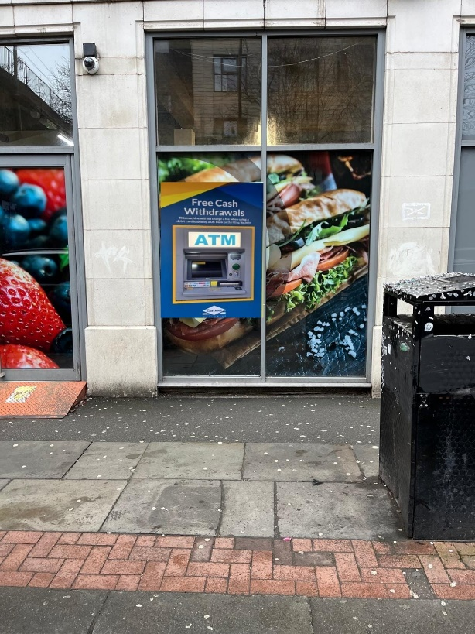  Shop Front Picture  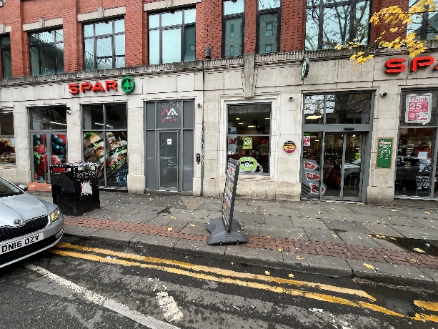
Address: | 88 Princess Street
Site Contact: | Paul Stone
Phone: | 07850019298
Email: | Paulstone572@btinternet.com
ATM Type: | SS26
Opening Hours: | 24hrs 7 Days
Signage: | Wall sign, FTU A-board, window design
Notes:

24 hour store in central Manchester, ATM to be located in stock room

ATM Location Diagram:

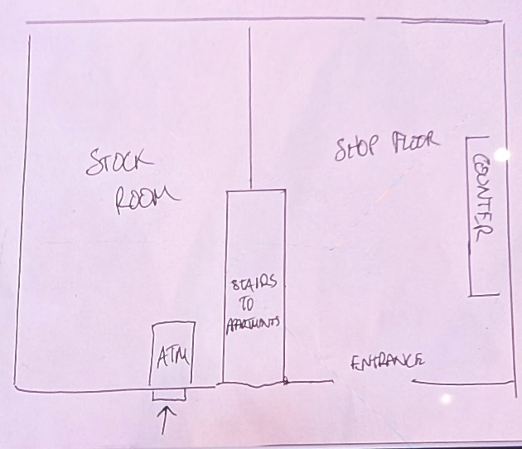

Wall Sign Picture (if required)

