Existing and Proposed Layout to Convert Back to Family home

Dear Sir or Madam,

As receive from email 29th May 2025, I have amended this document and added more information as requested.
The questions being asked as your email as requested:

- Please confirm Proposal Changes:
>> The change of 5 self-contain flats (Class C3) to single dwellinghouse (Class C3).

>> Removal of Fire Doors on Each Flat (added where it’s located on the plans)
I am to remove all fire doors (they were numbered), and replace no doors, as the rooms have internal doors. This will open up rooms as single dwellinghouse.

I was recommended by Mr and Mrs. Scallan of 501 to remove fire doors, we are cojoined semi detached house, and they had theirs converted back to family home from B&B.

>> Removal of Kitchens Flat 3,4 & 5. I would like to retain Kitchens Flat 1 and 2, due to reasons below:

Flat1 >>>> Living Room TV Area, and Antique Collections
Please see photo, retain kitchen, for convenience’s sake to make brews and bring it to the Living Room and watch TV or bring brews and food to outside Garden.
Flat 2 >>>>> Dining Room & Visitor Room
This will be convenient to retain the kitchen, as I want to intend this room as dining room between me and my mother as it is hassle to go back to flat 1 to go to the kitchen, please refer to layout photo. My mother wanted this room as Dining Room where she can eat and gaze from the Bay windows. I also have washing machine and dryer in this kitchen, and would very much prefer to retain it, as it helps with additional washing drying.

This is also where visitors may sit down and discuss personal or business affairs.

Flat 2 has the smallest room of all flats, 28.12 sqm, there is no point removing flat 2 kitchen, as it is quite small room, at 2.92m x 1.81m. It would be great loss if I were to lose this kitchen area.

Also, my neighbour has retained 2 kitchens in their family home, I wish to retain 2 kitchens for myself, please see below:

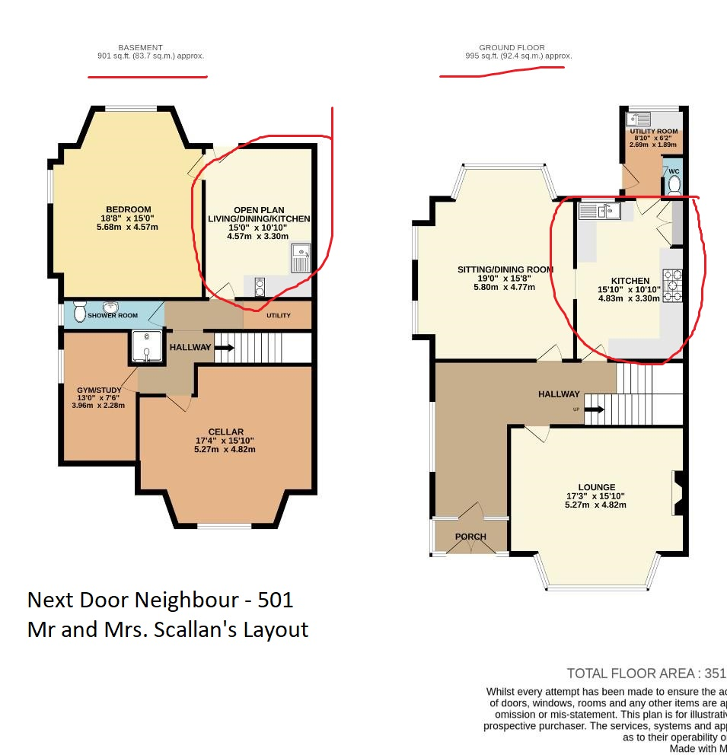

Please note my basement is completely inhabitable, it has damp and mold, and where most of storage goes below.

Floor Layouts on Each Flats
Flat 1 – 34.48 Sqm, 371 Square Feet Area
Flat 2- 28.12 Sqm, 303 Square Feet Area
Flat 3- 39.57 Sqm, 426 Square Feet Area
Flat 4 – 35.63 Sqm, 384 Square Feet Area
Flat 5- 43.78 Sqm, 471 Square Feet Area

Please see below:
- Existing Floor Layout Plans
>> Entrance Door of each flat is identified as requested.

- Propose Layout Plans
>>Indication of what Each Room will be used.
>>Removal of Fire Doors, so as to open all rooms as single house.

I will do the proposal changes of layout once Tenants are gone by estimated October 2025. I have informed them since March 2025, and will be issuing Section 21 by August 2025.
Target changes around mid-2026(once approved by yourselves of proposal changes), builders will remove fire doors on all flats and removal of kitchens Flat 3,4 and 5. My goal is to successfully convert 5 Self Contain Flats back to Single Dwelling House Family Home by mid-2026. Similar to what next door 501 did to theirs.

Existing Floor Layout Plans
Flat 1 (Ground Floor)
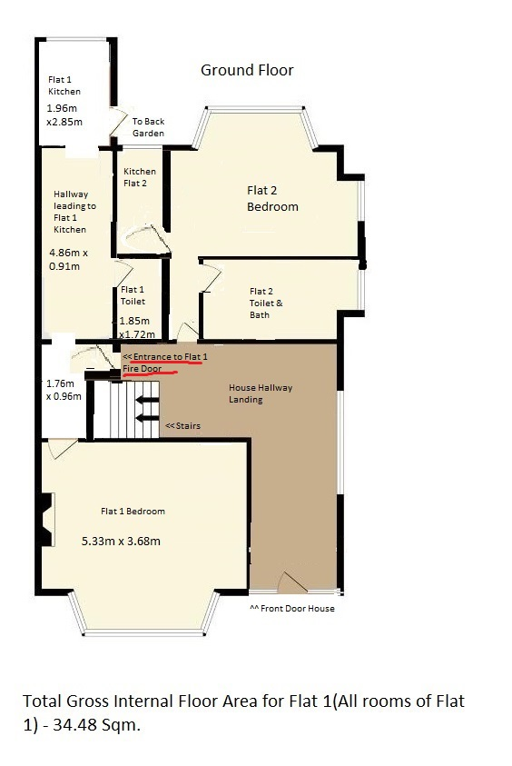
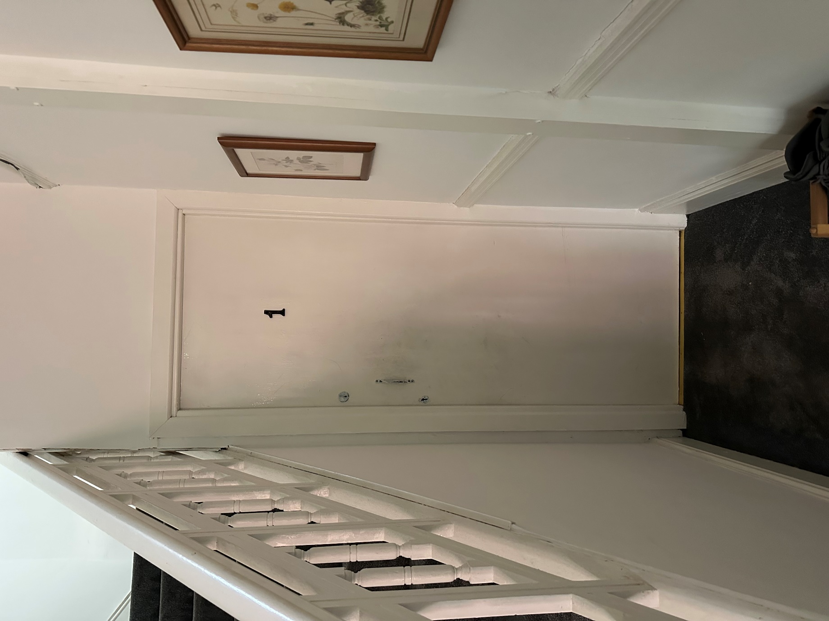

Entrance to Flat 1 – Fire Door

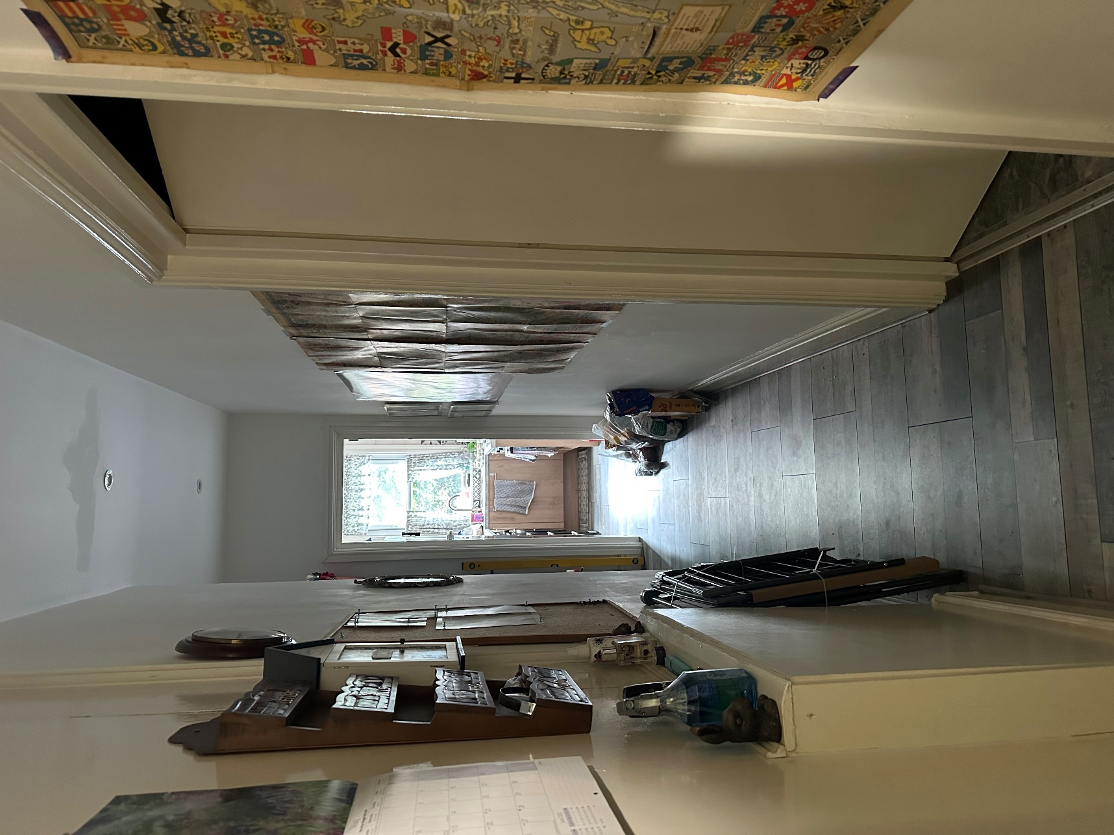

Entrance Flat 1 – Small Hallway leading to toilet and kitchen- Out of photo leads to back garden patio door

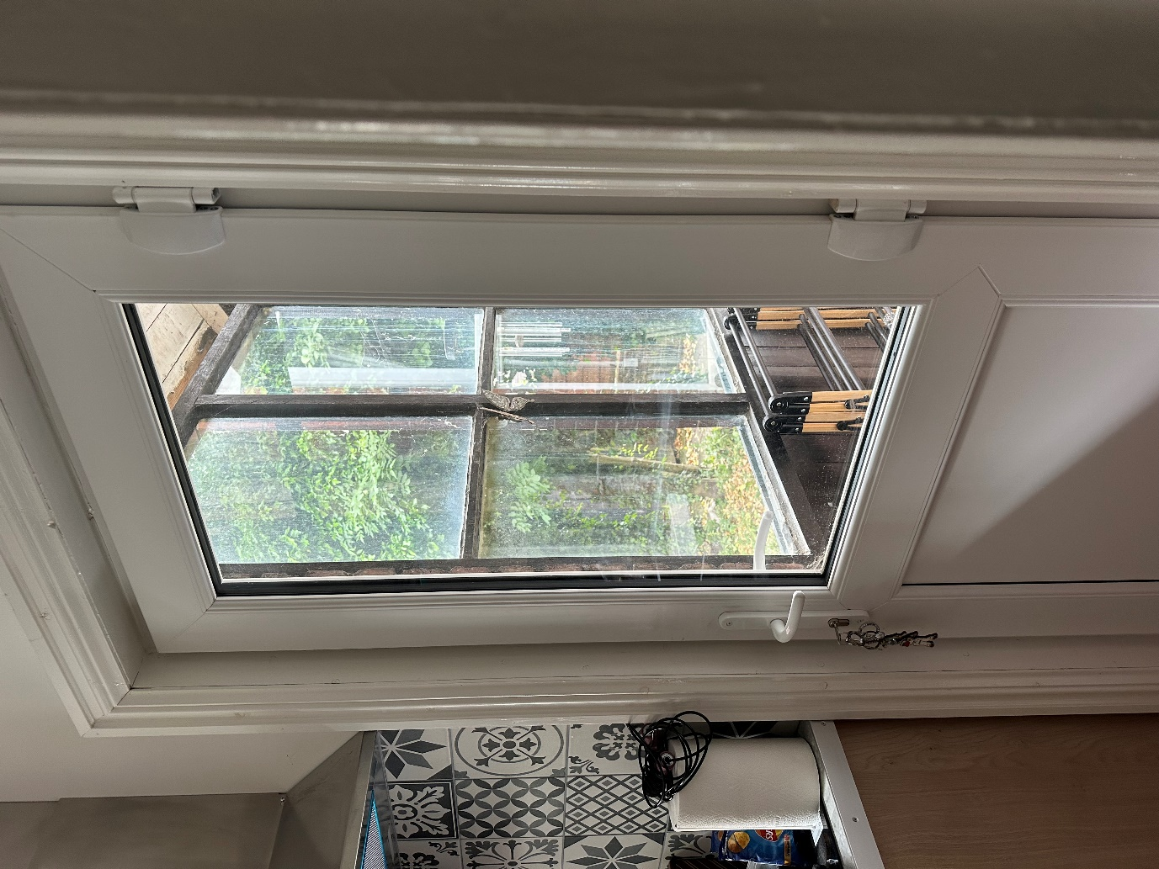

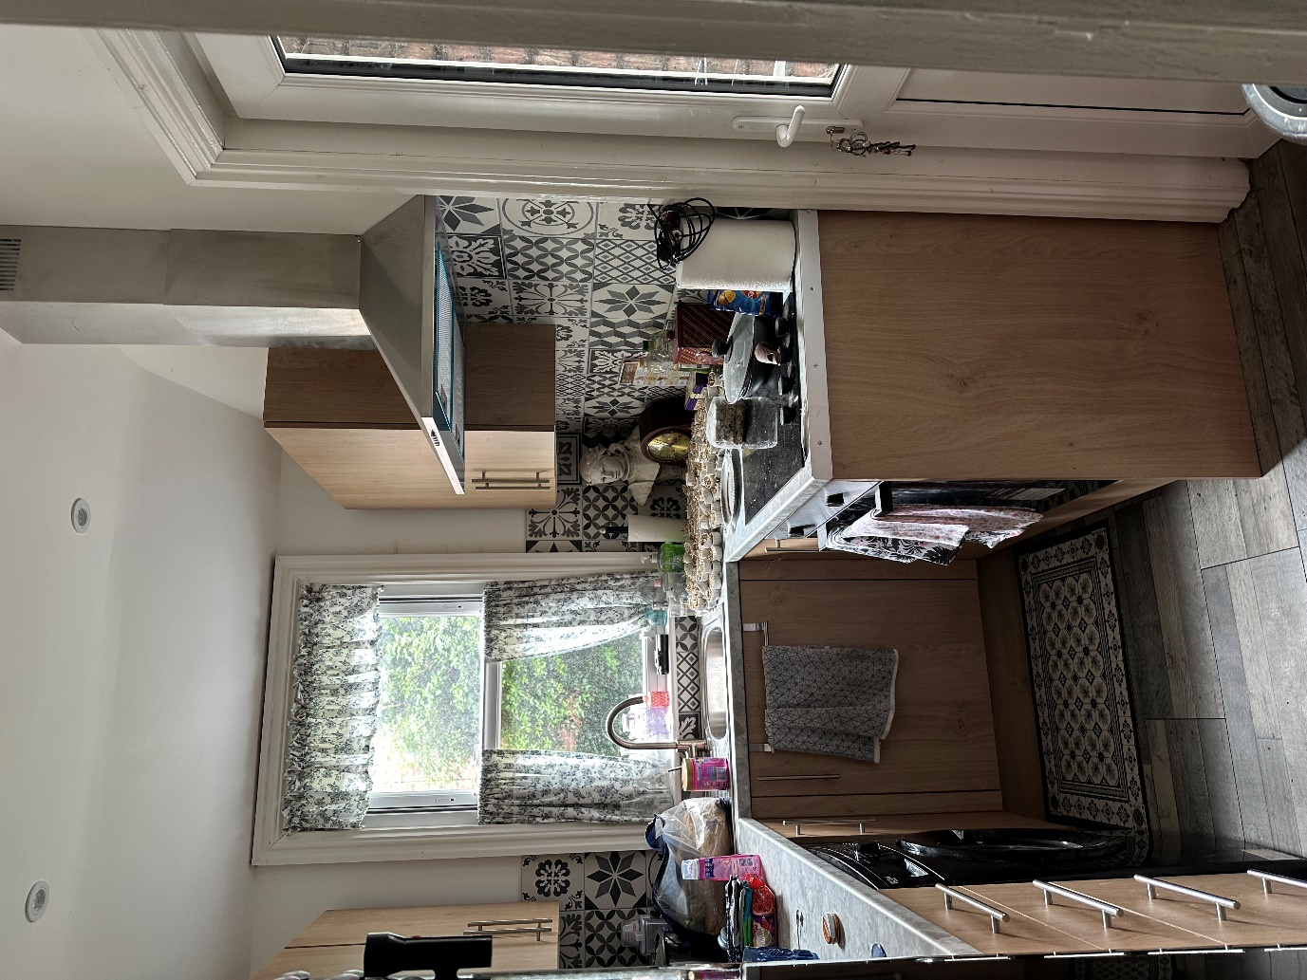
Small Kitchen in Flat 1

Existing Floor Layout Plans
Flat 2 (Ground Floor)
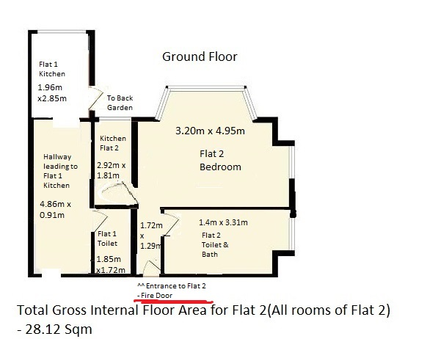

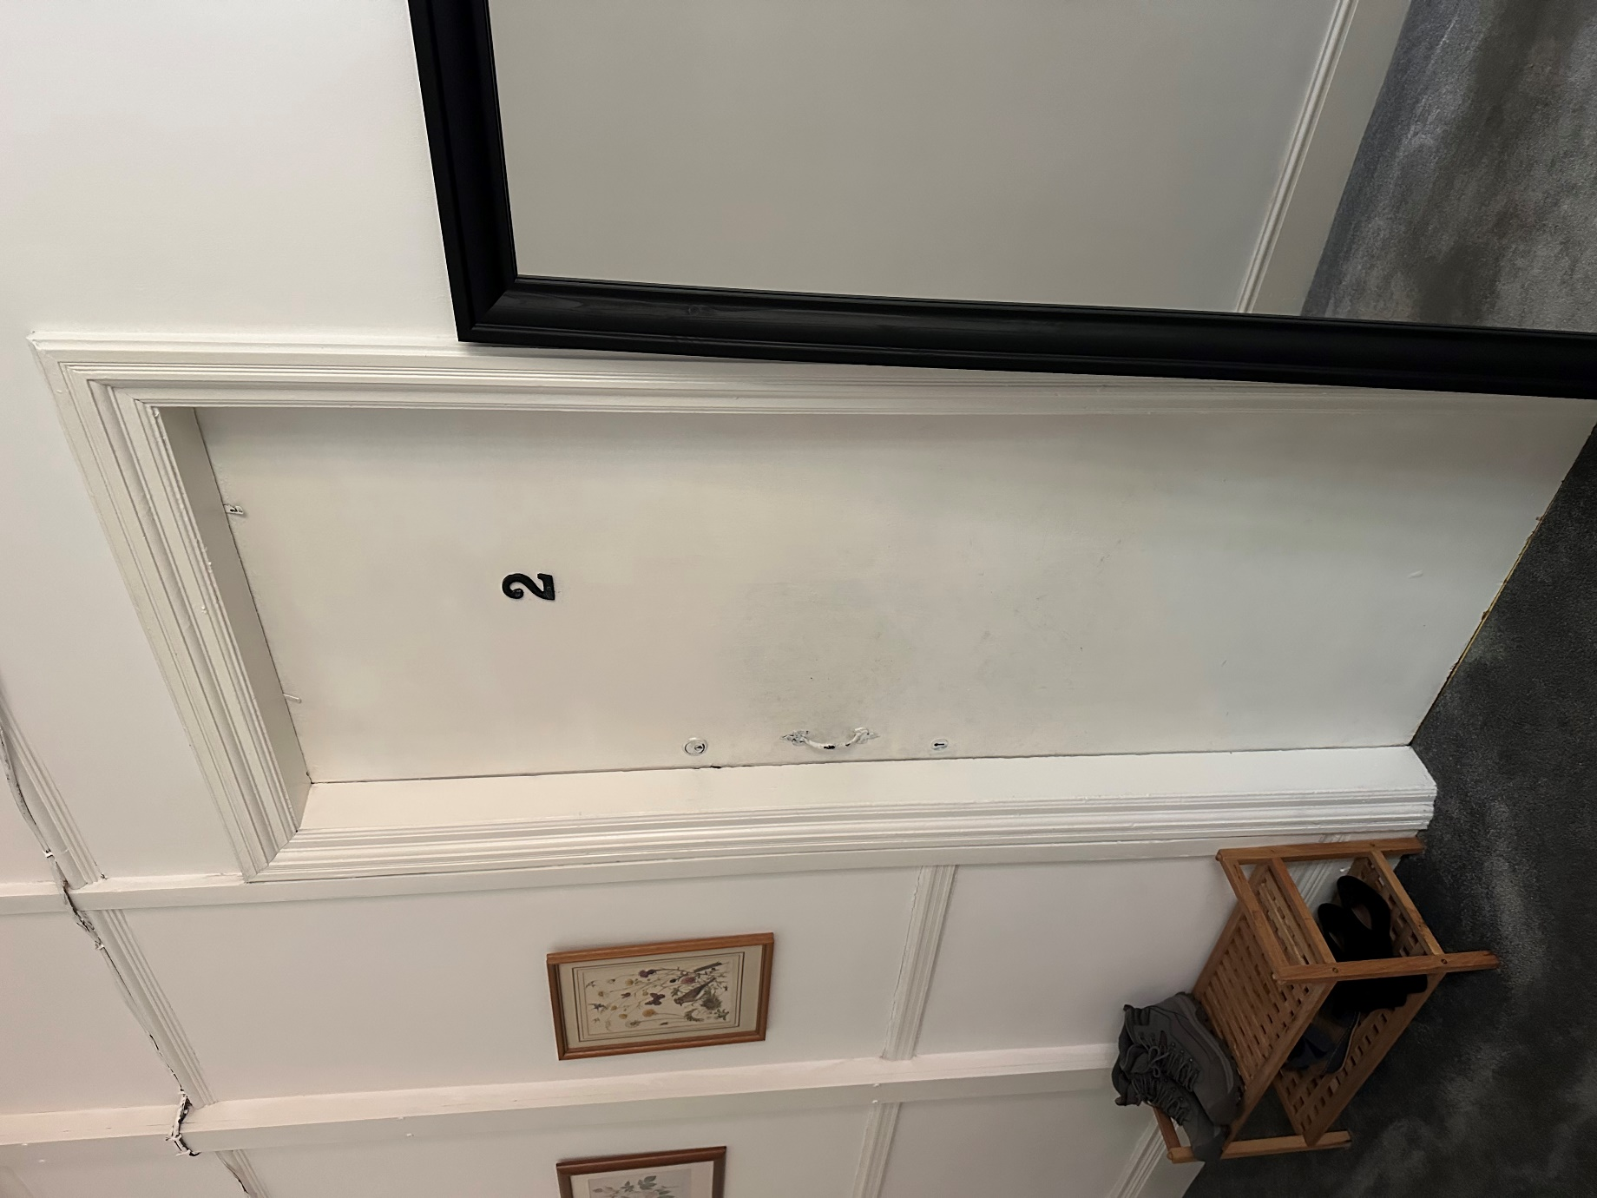

Entrance Fire Door to Flat 2

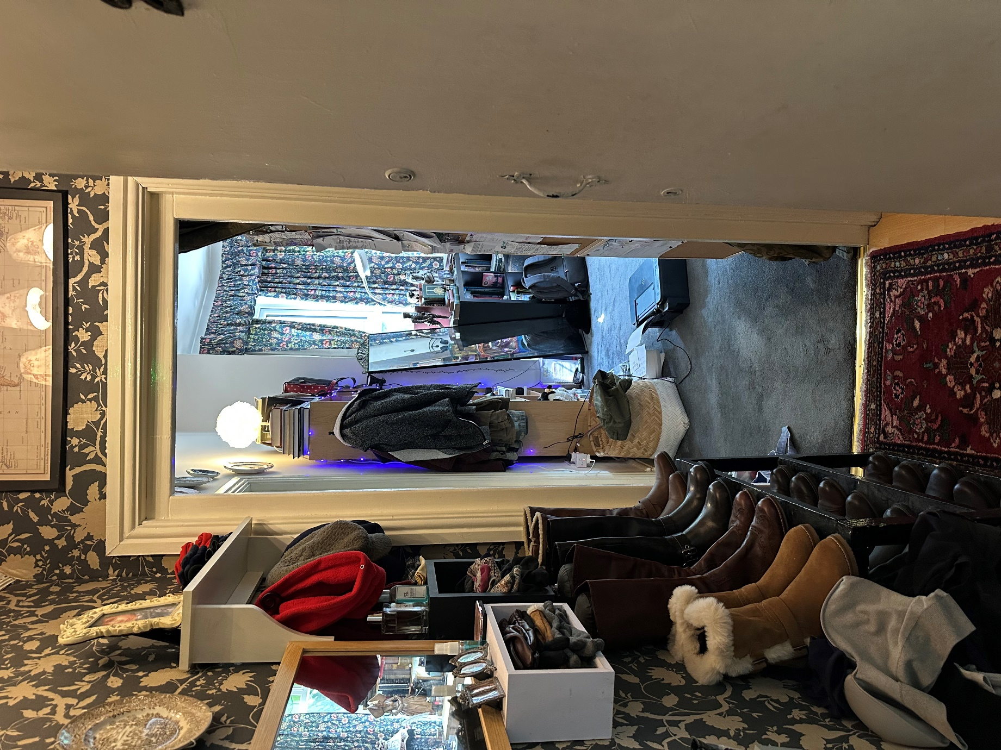

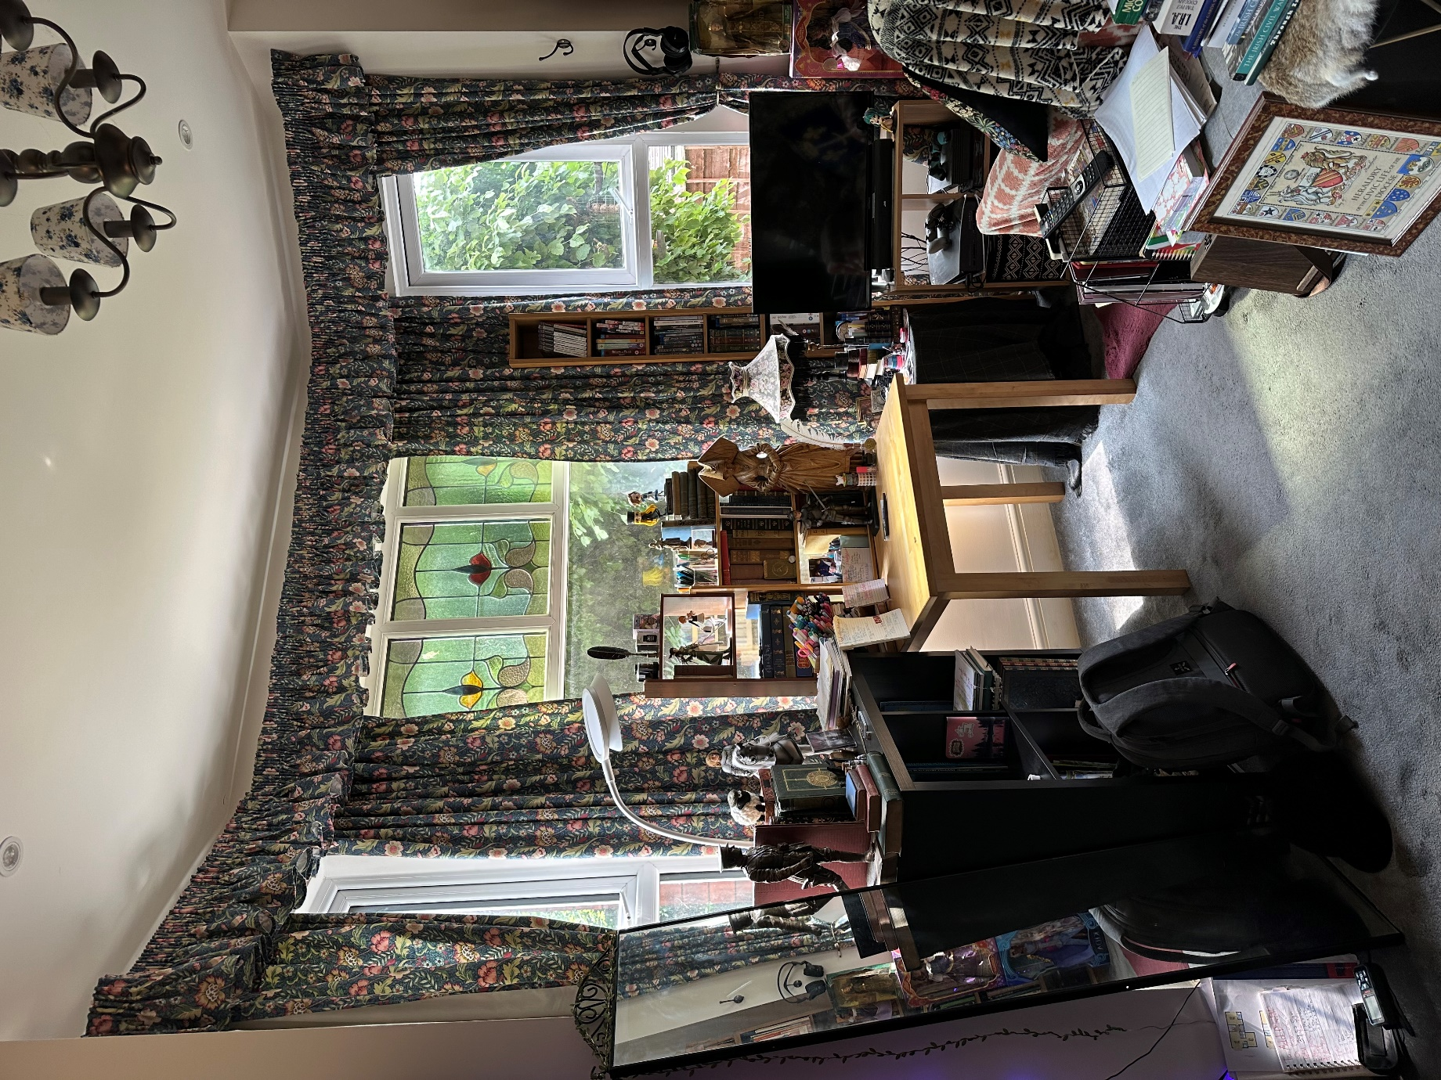

Flat 2 Bedroom

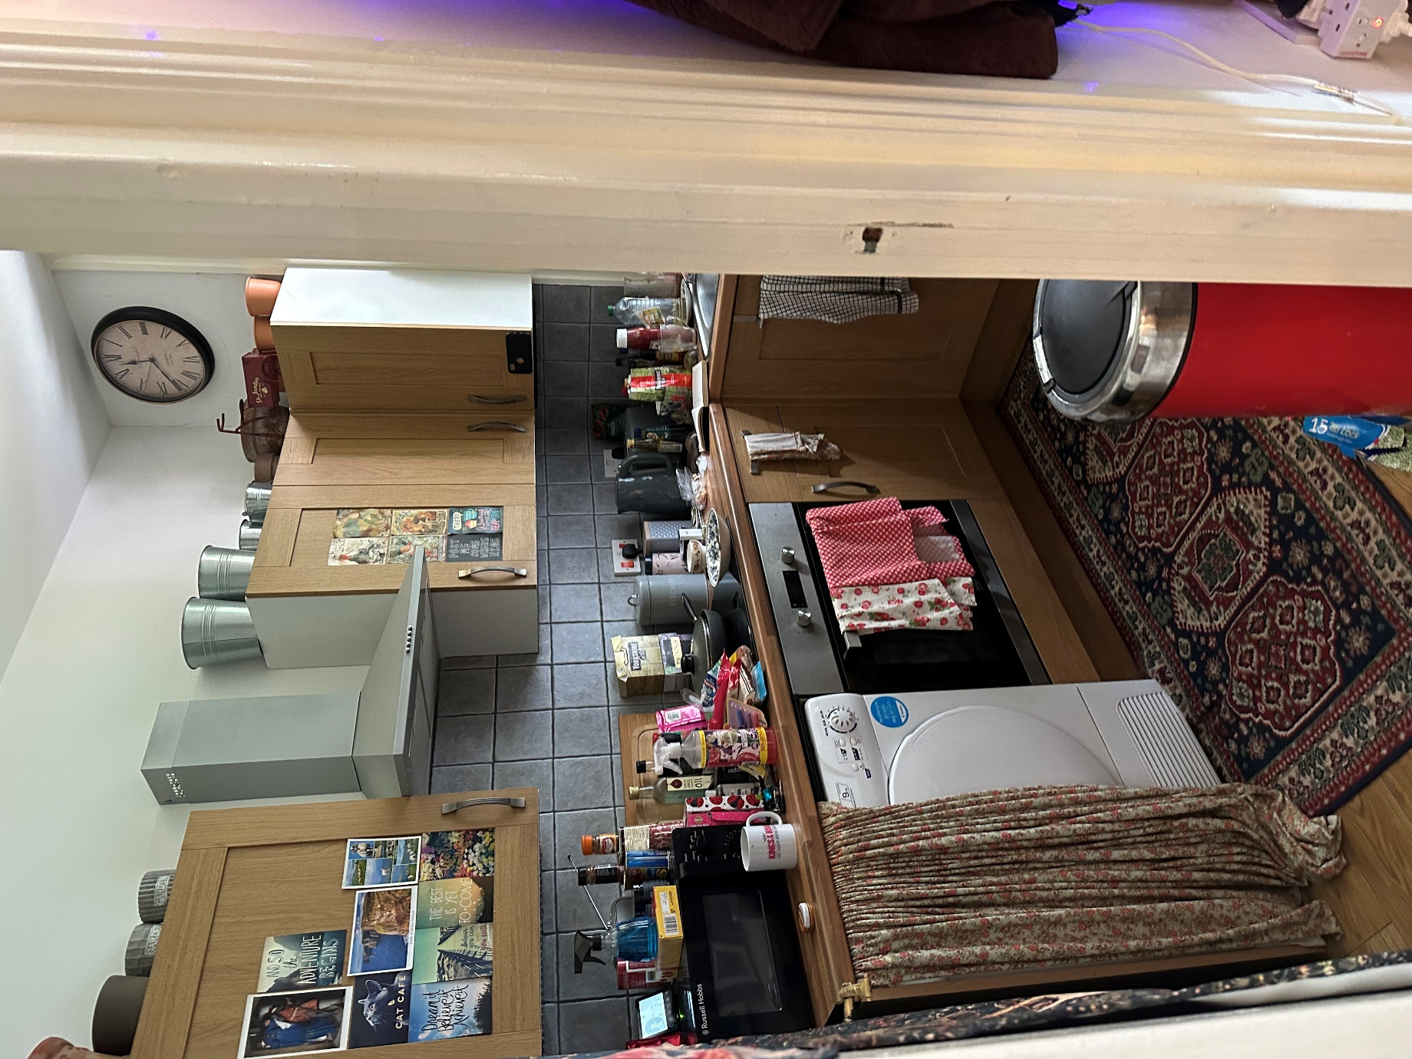

Flat 2 Kitchen

Existing Floor Layout Plans
Flat 3 (First Floor)
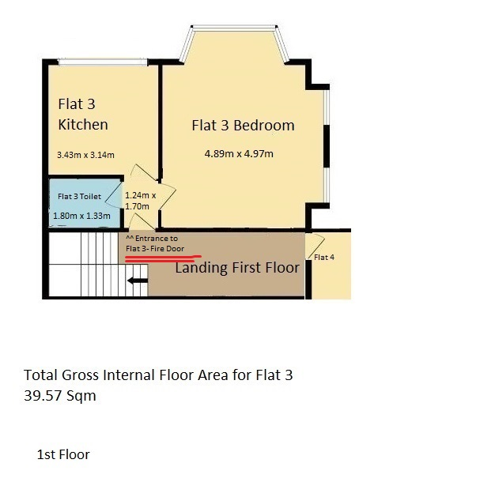

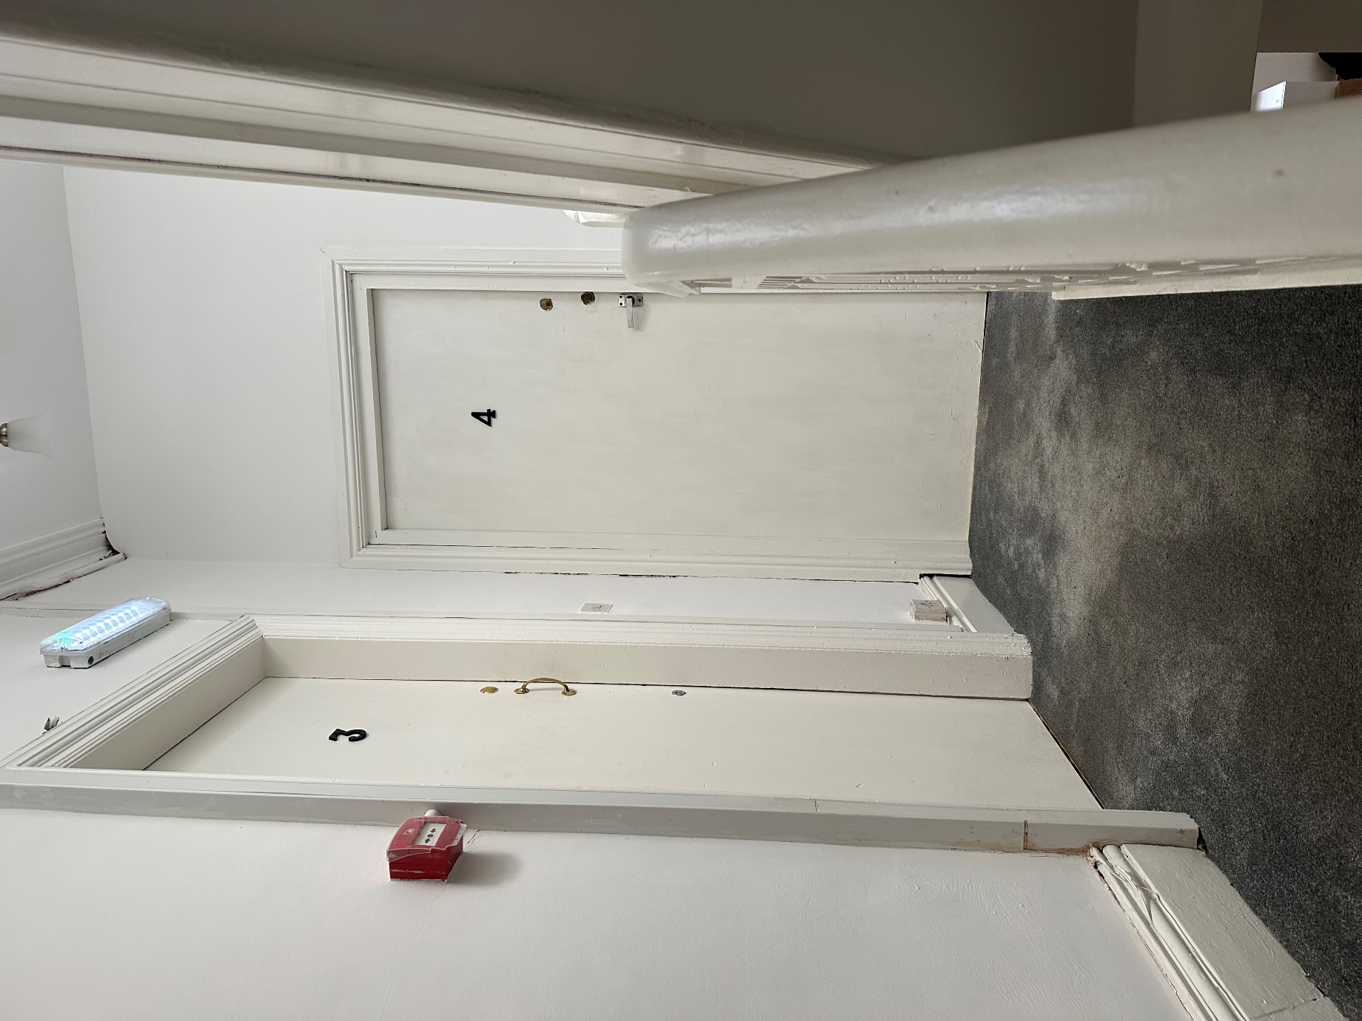
Flat 3 Fire Door Entrance

Existing Floor Layout Plans
Flat 4 (First Floor)
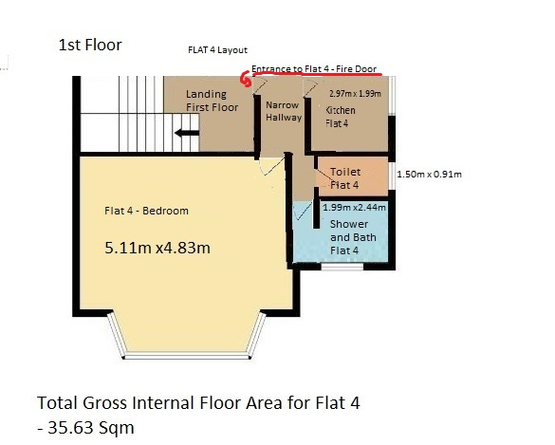

Flat 4 Fire Door Entrance

Existing Floor Layout Plans
Flat 5 (Second Floor)
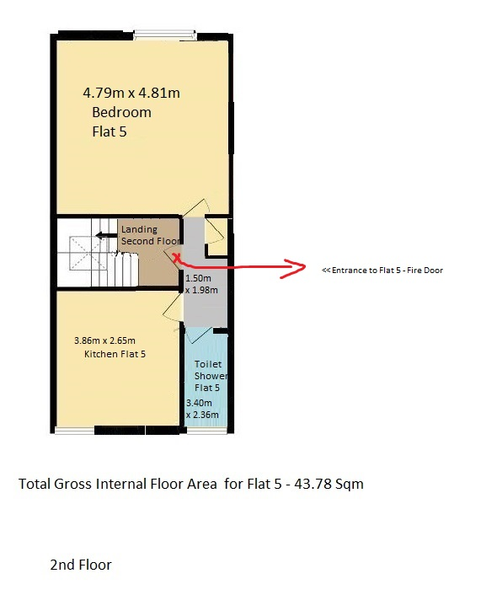

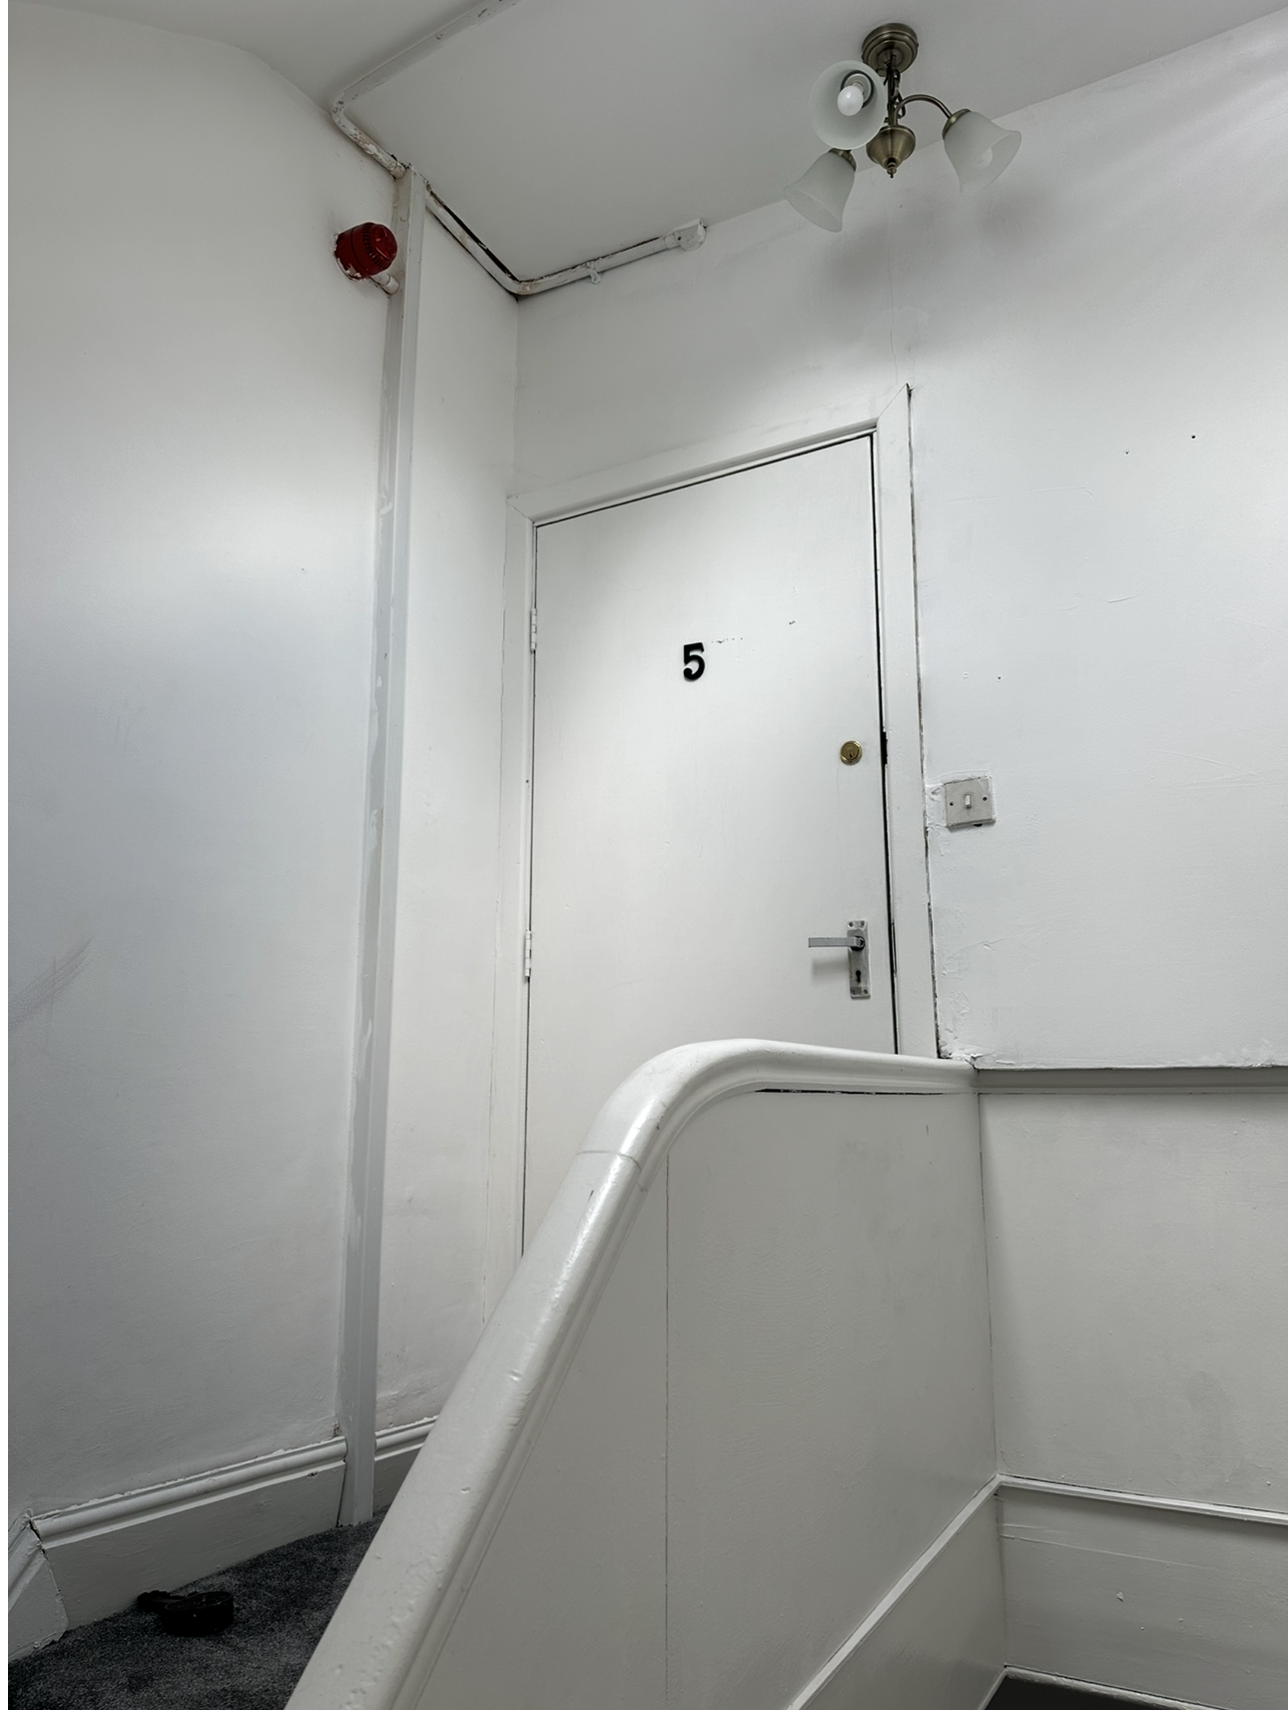
Flat 5 – Fire Door Entrance

Propose Layout Plans
(Ground Floor)
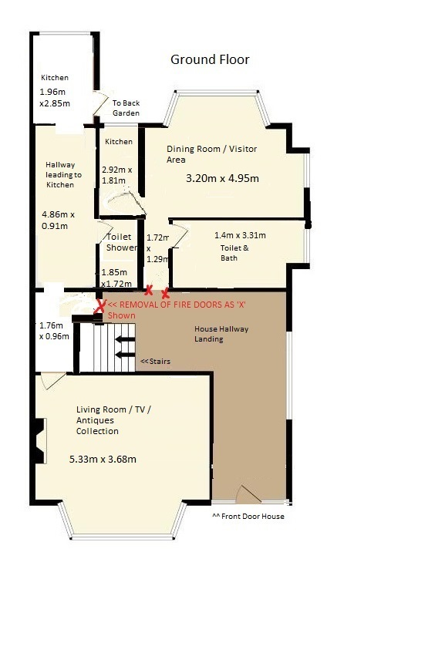
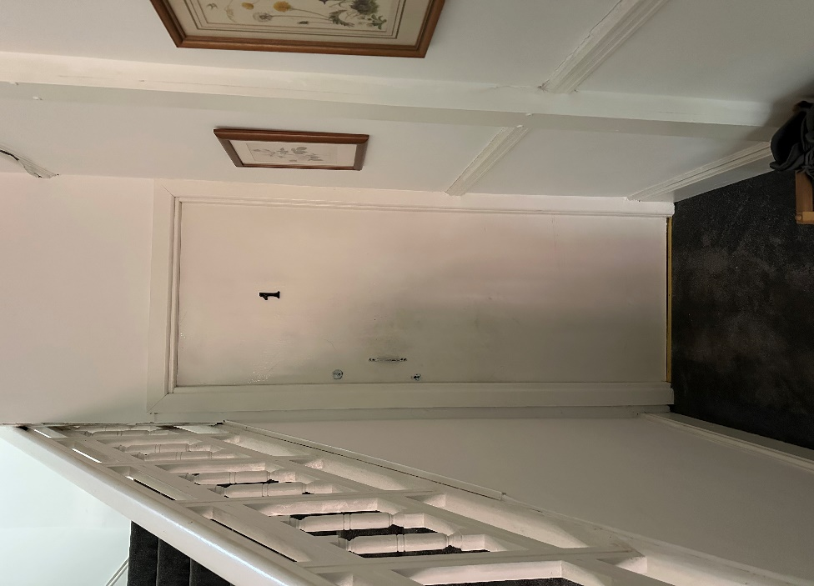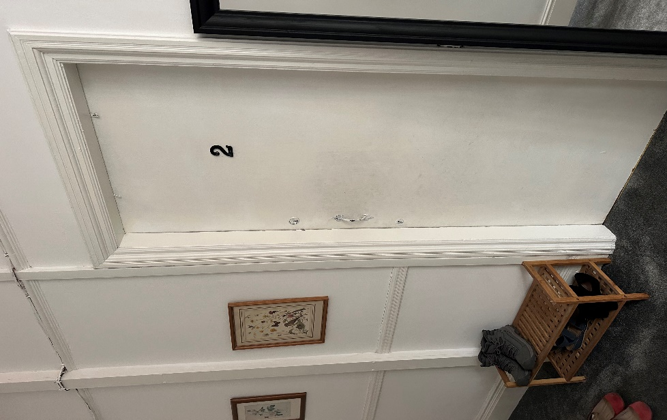
Removal of Firedoors, not replacing any doors so that all rooms will open up and be a single Dwellinghouse. What it will look like as shown below(if without doors):
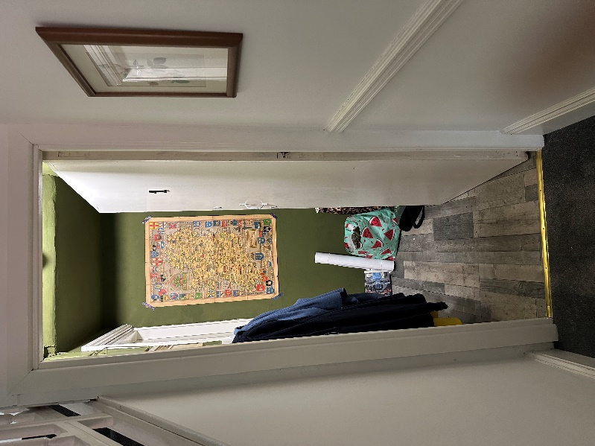
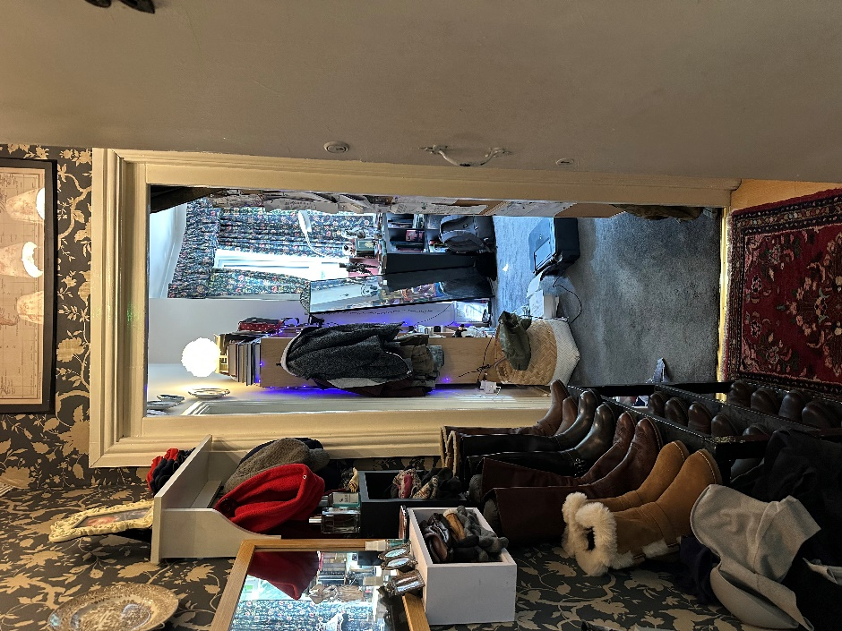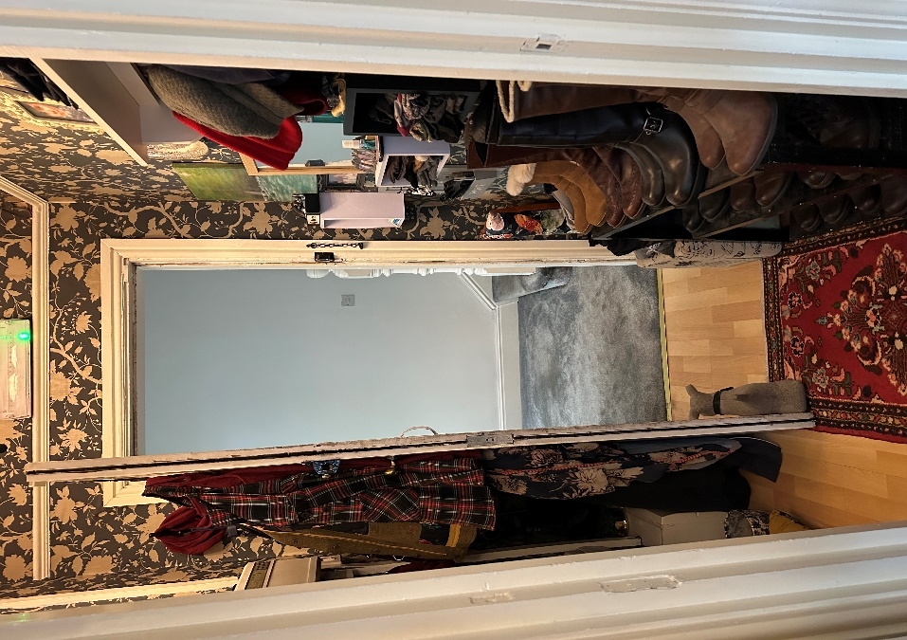

Example shown by removal of Fire Door, this leads easy access to Dining Room / Visitor Area Room from Hallway.

Retain two kitchens ground level, as stated reason Page 1-3(Next Door Neighbours have 2 kitchens, see page 3 of this document.)

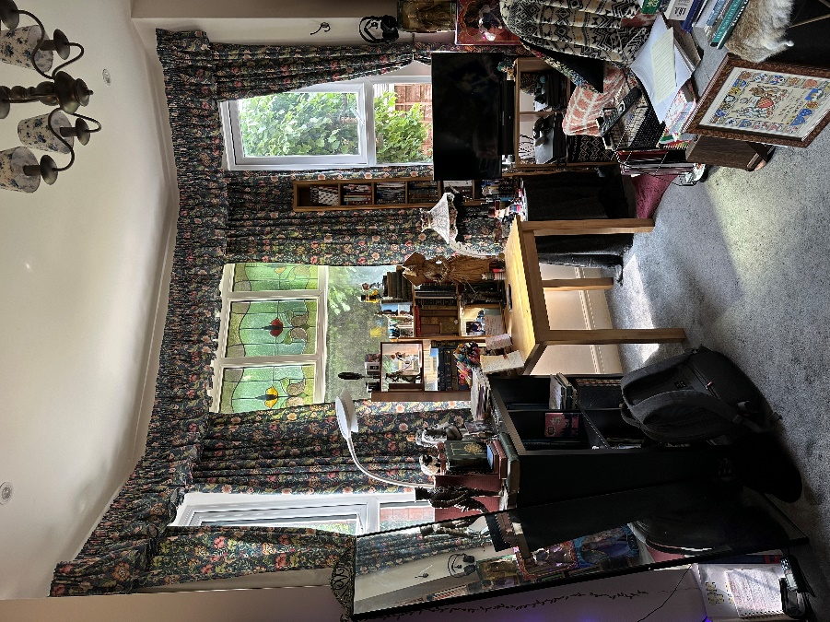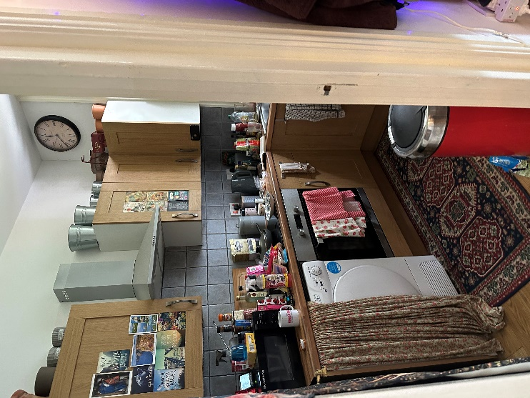

Removal of furnitures to make way as Visitor and Dining Room. I would like to retain the kitchen, as it would be major loss and inconvenience having to go back to the other room to access brews and food.

Living Room, TV Antiques
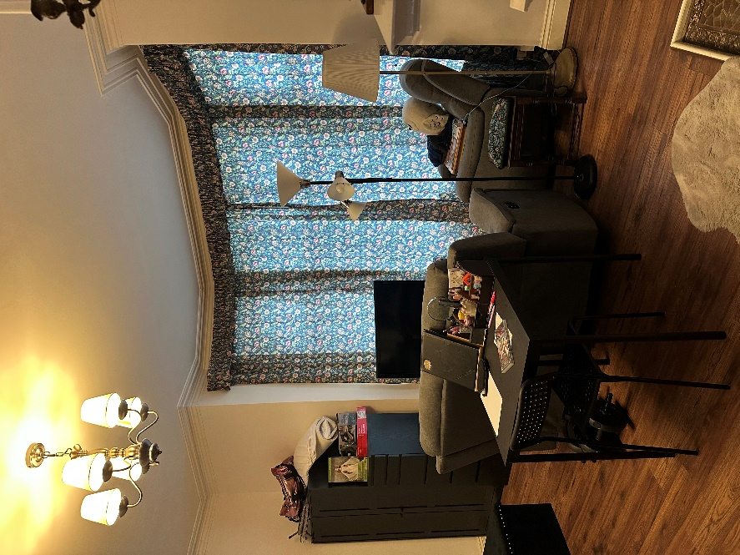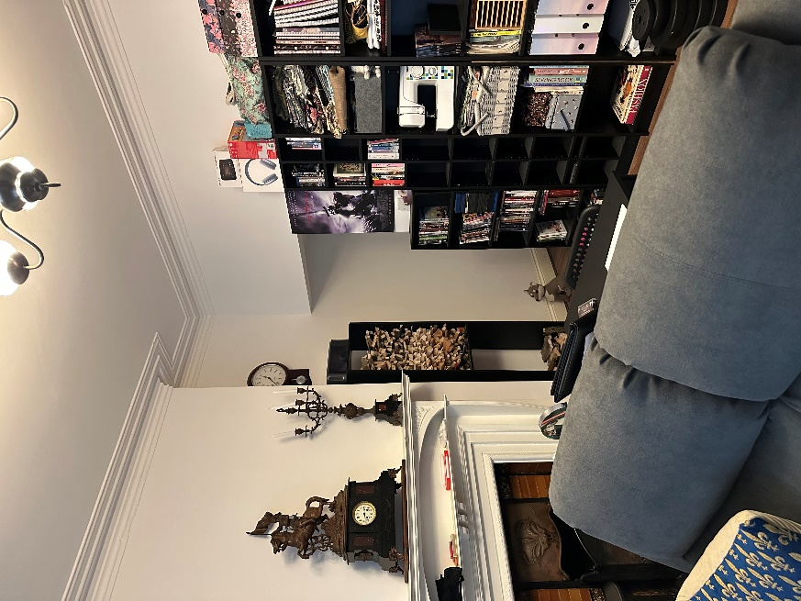
This is where me and my mother socialise. This was where my late father used to live, I never let out this flat.
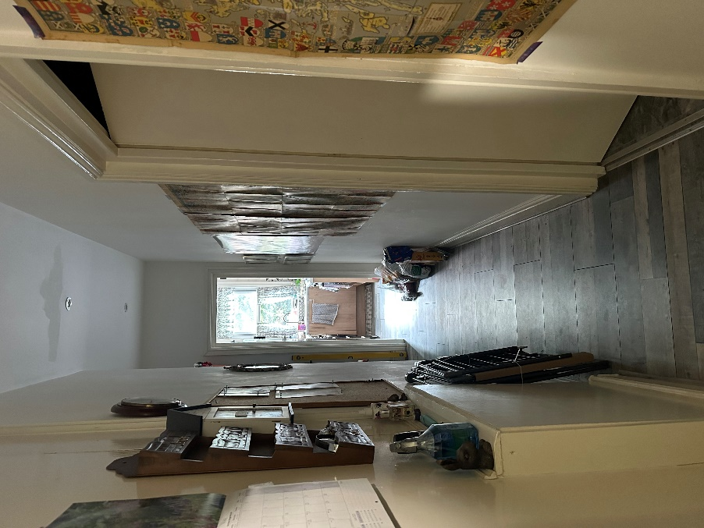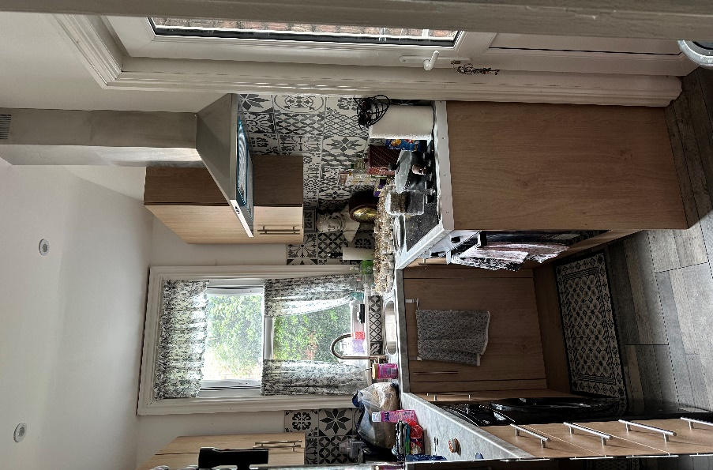
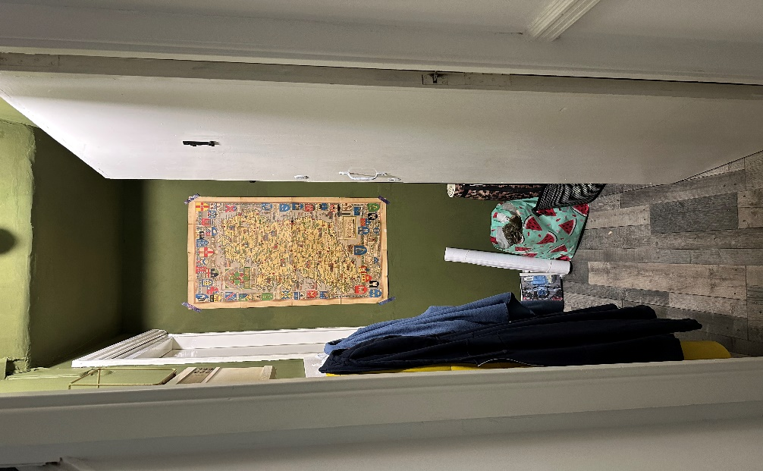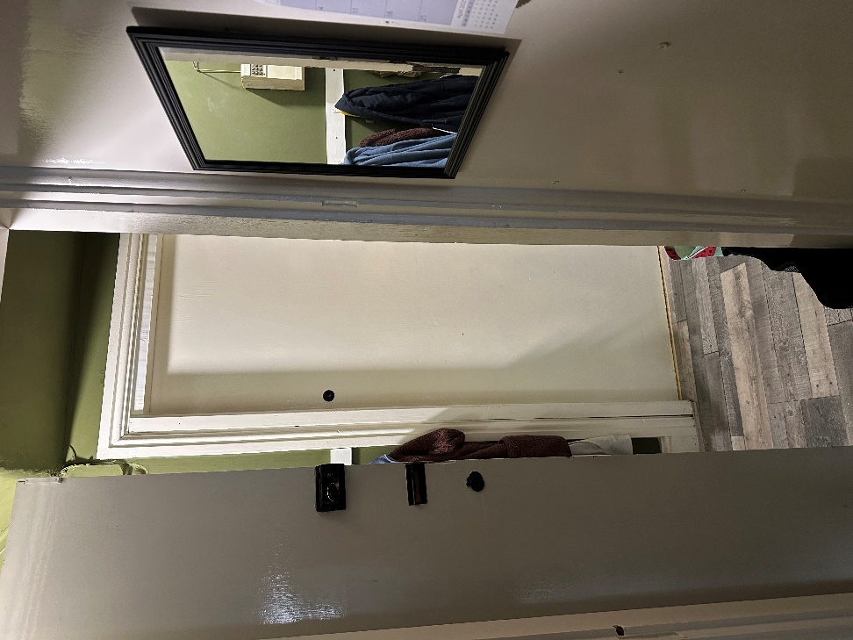
This leads toward Living/TV Room

Next Door Neighbour Plans have two kitchens in their plan. They have much bigger kitchen compared to my house. My basement is completely inhabitable; it is full of storage and not in use.

First Floor – Propose Plans
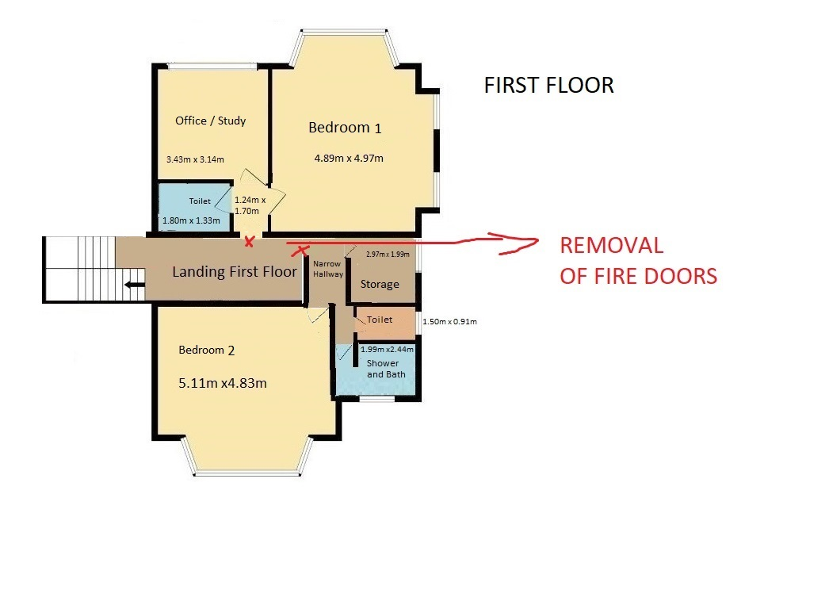
Removal of Fire Doors, to open up rooms as Dwelling House. Please note there is internal doors inside.

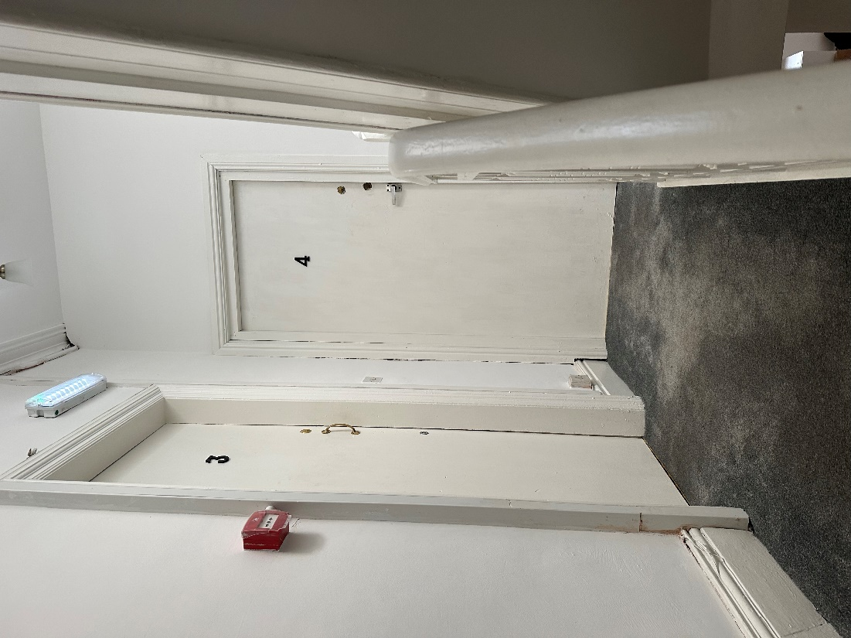
Removal of these Fire Doors, so as to open up all rooms as single dwellinghouse.

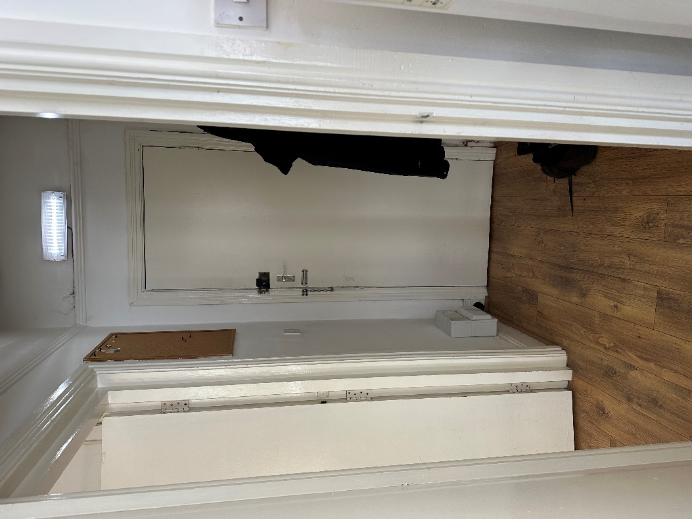
This is ‘3’ Fire Door, this is what’s inside to be Bedroom 1.
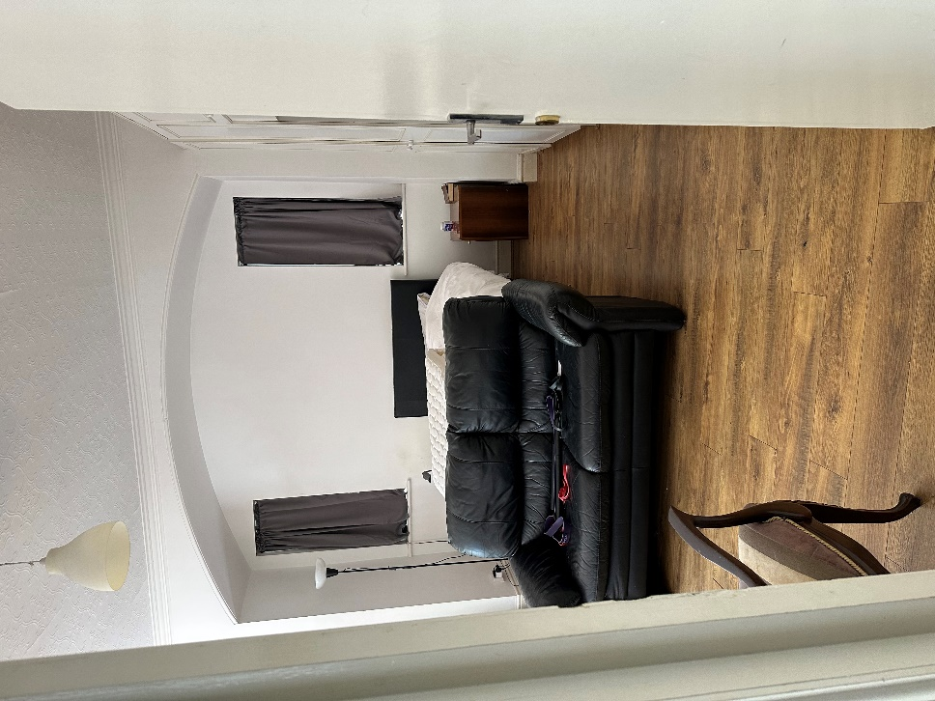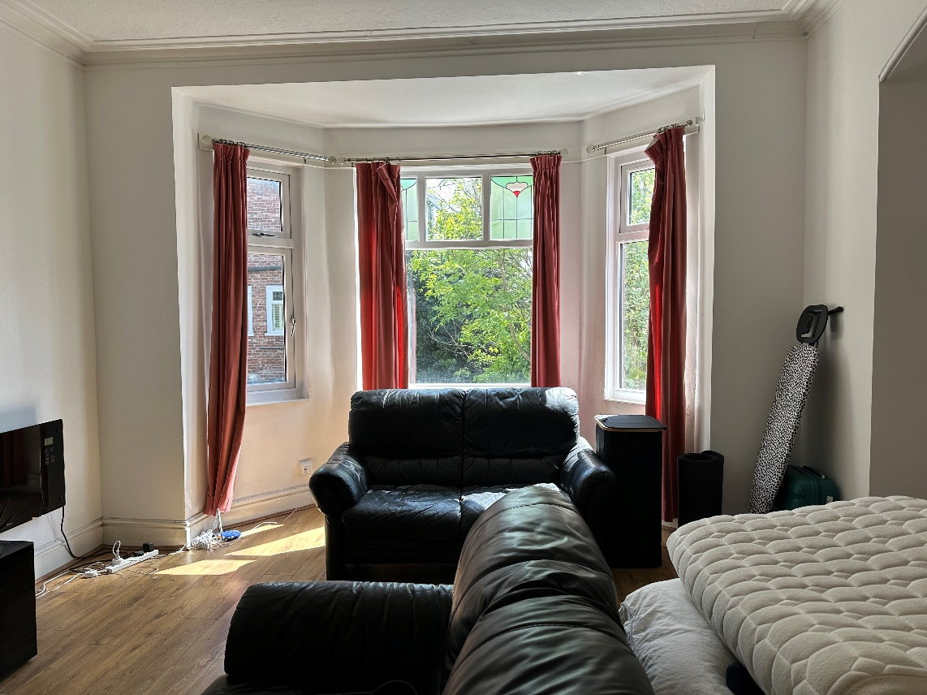

This is Bedroom 1. Removal of Armchair Sofas and old bed.

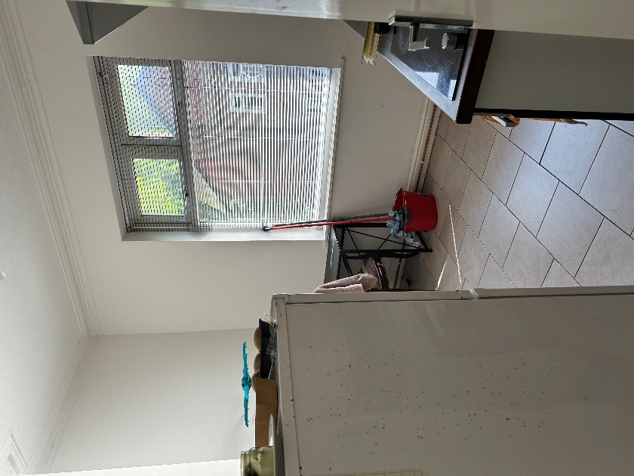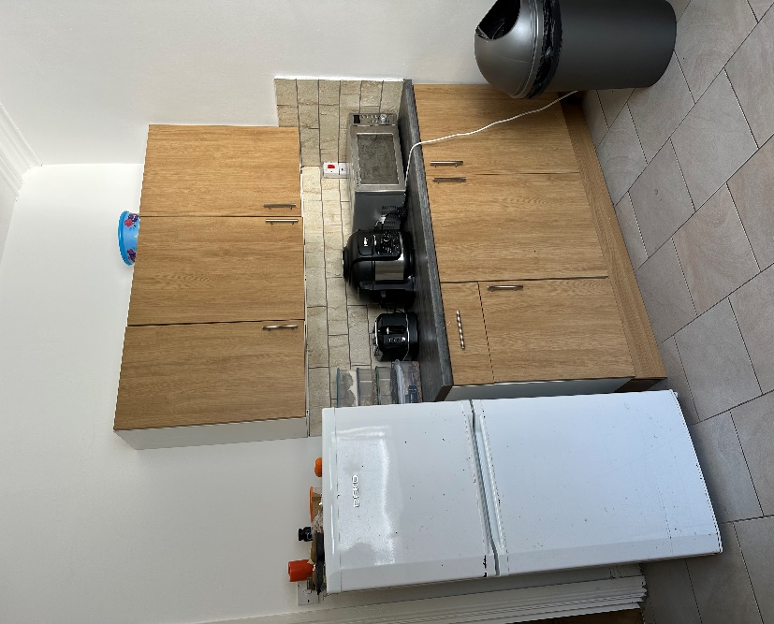

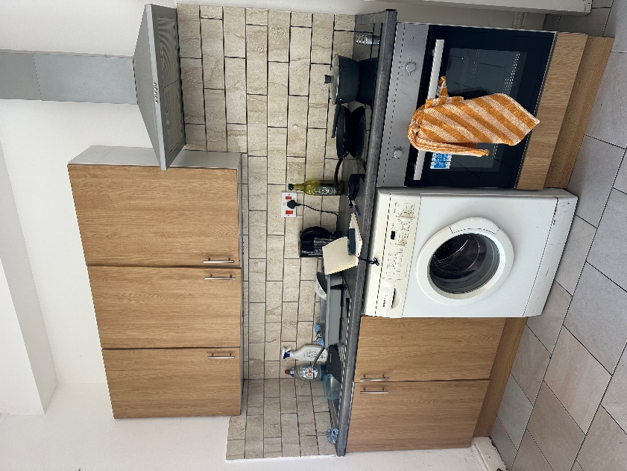

Removal of Old Kitchen to make way as Office/Study Area

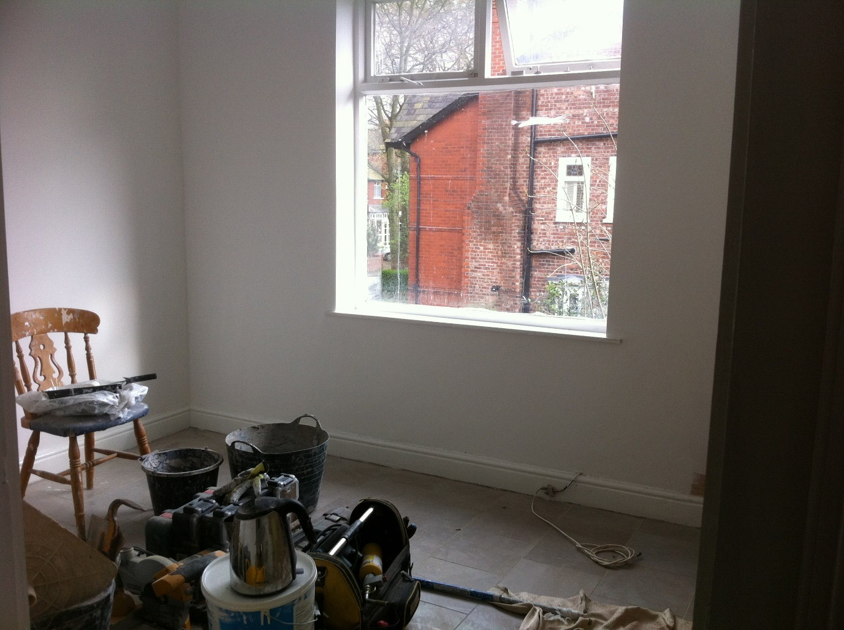
To make it like this with no kitchen, it was previously updated renovated by my late Father in 2017, just to give you an example.
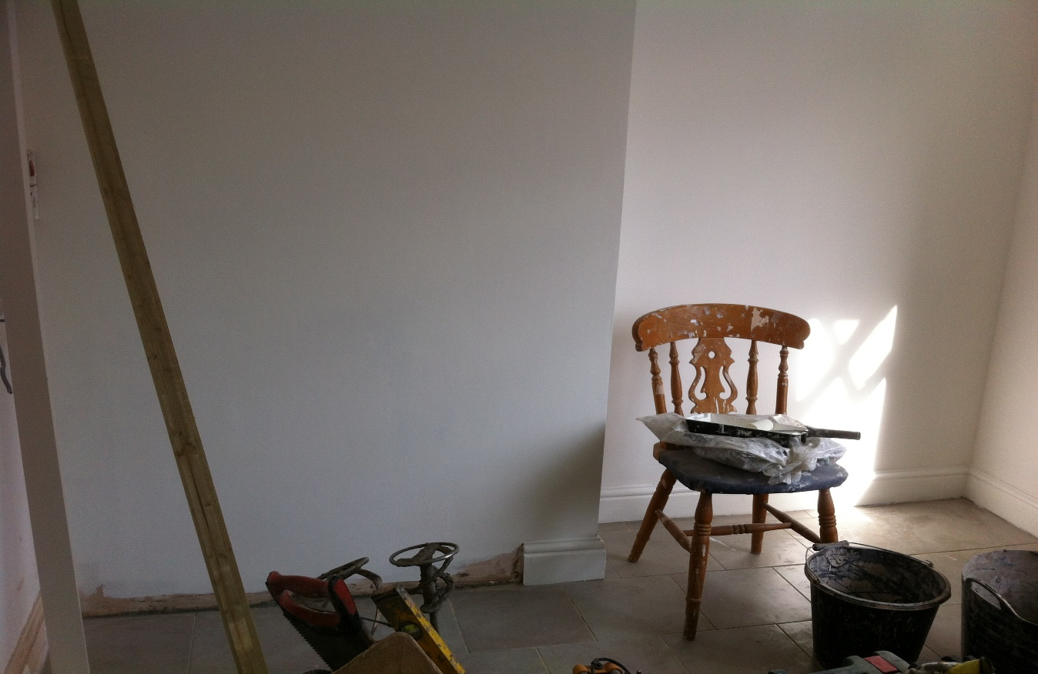
Number ‘4’ Fire Door and what’s inside to be Bedroom 2
It is very dated, and will need updating it, I am happy to remove old kitchen and use it extra storage room
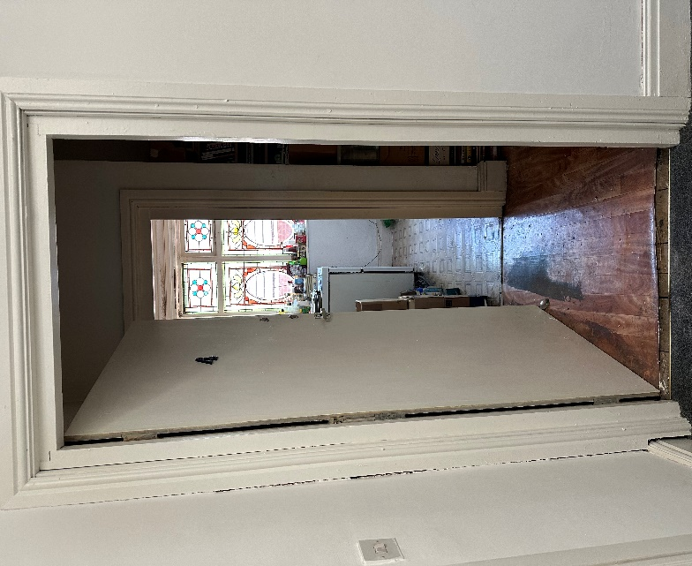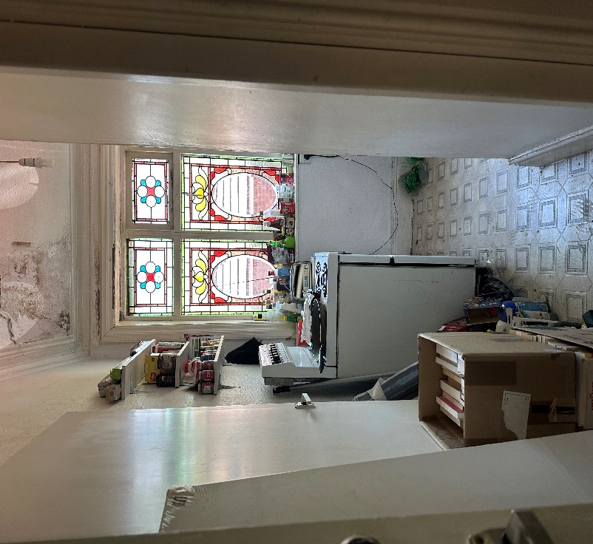
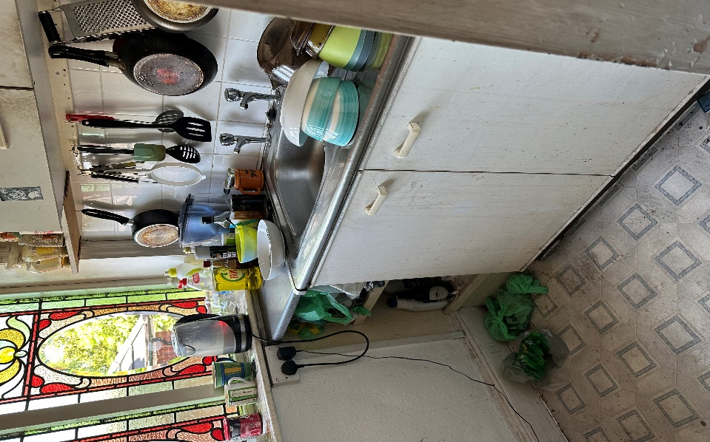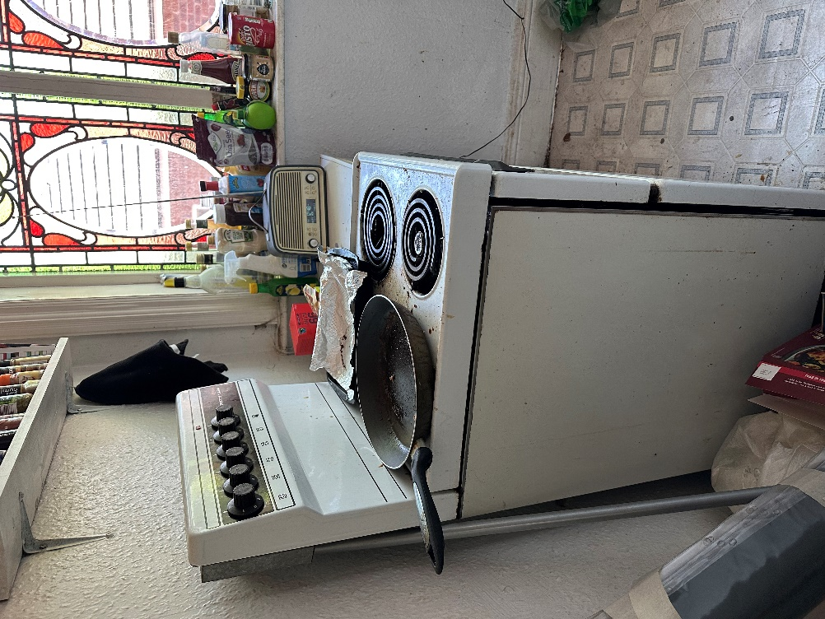

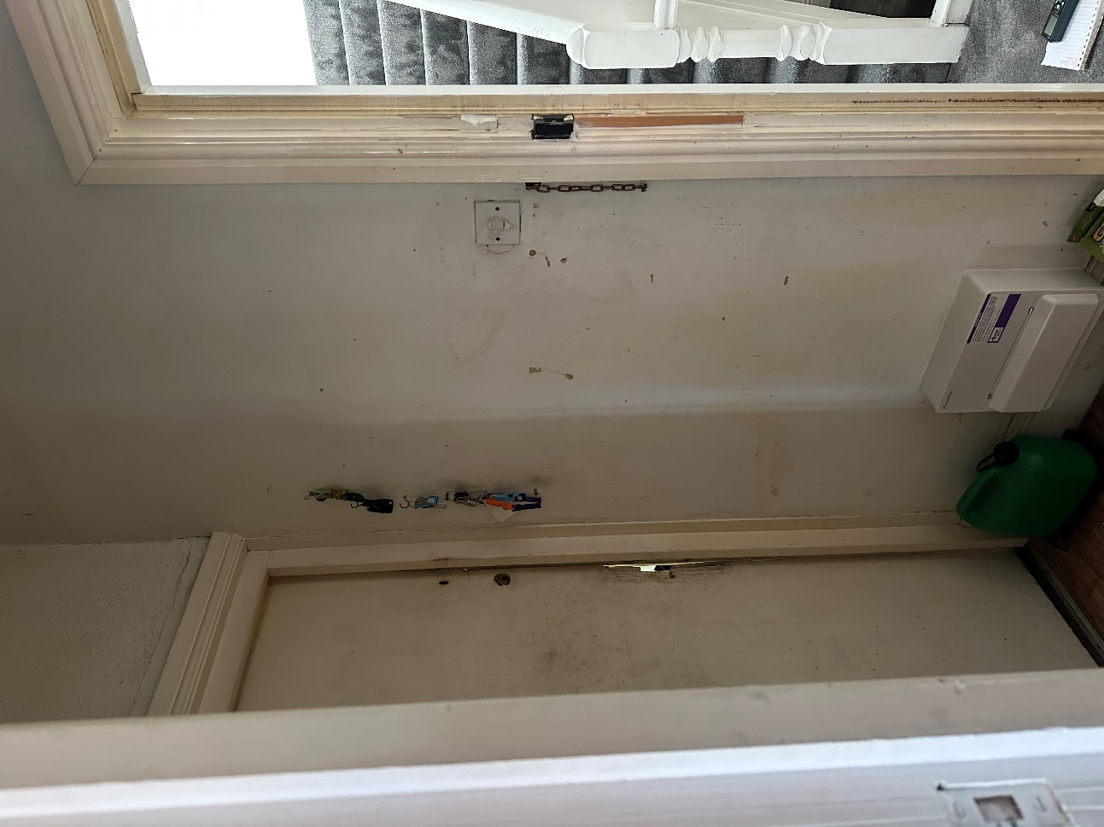
Bedroom 2 Door on left corner

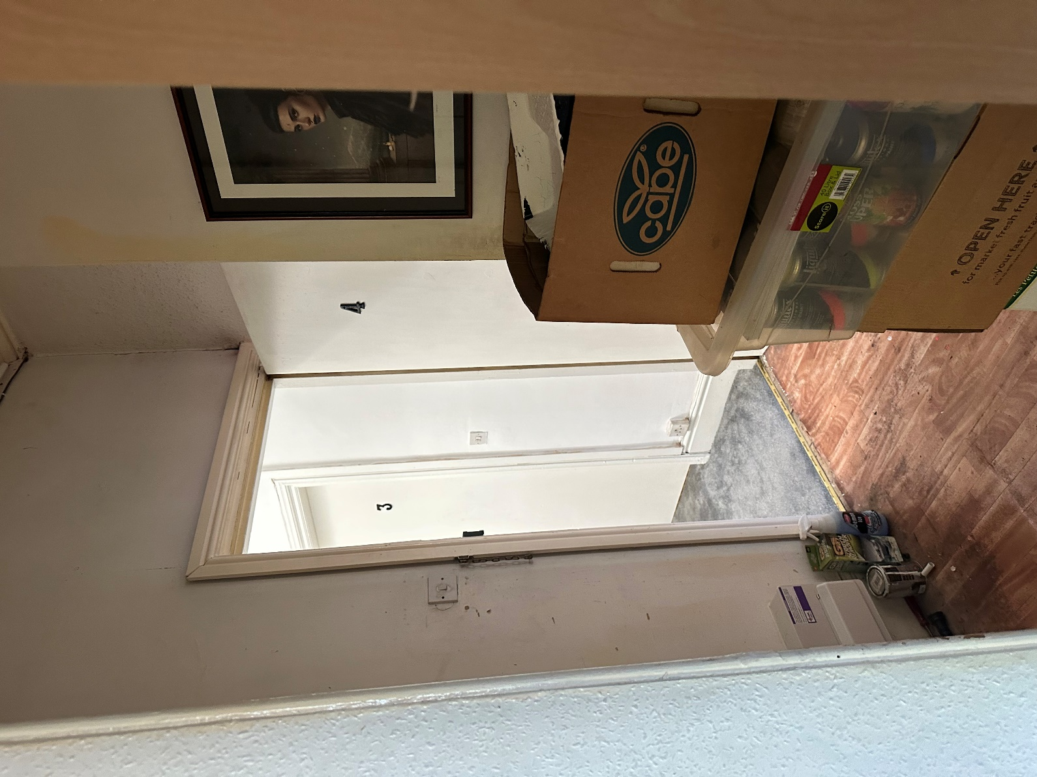

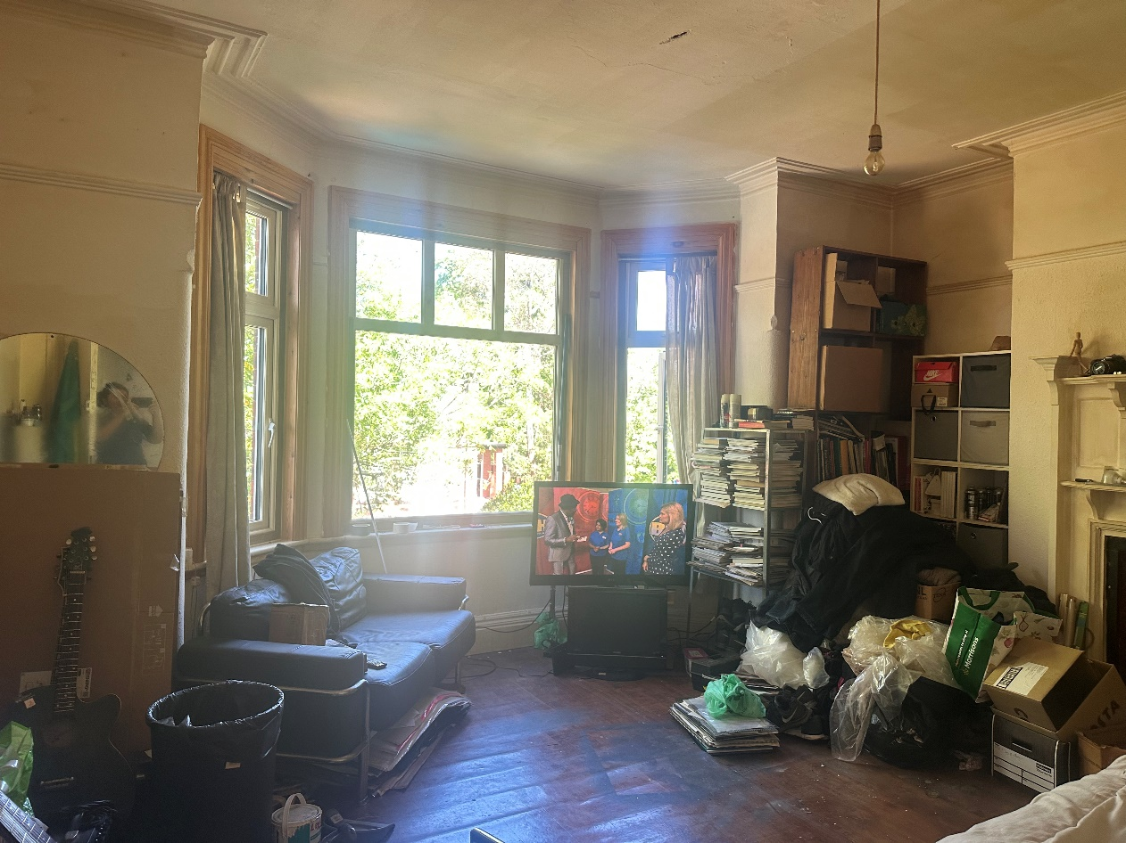
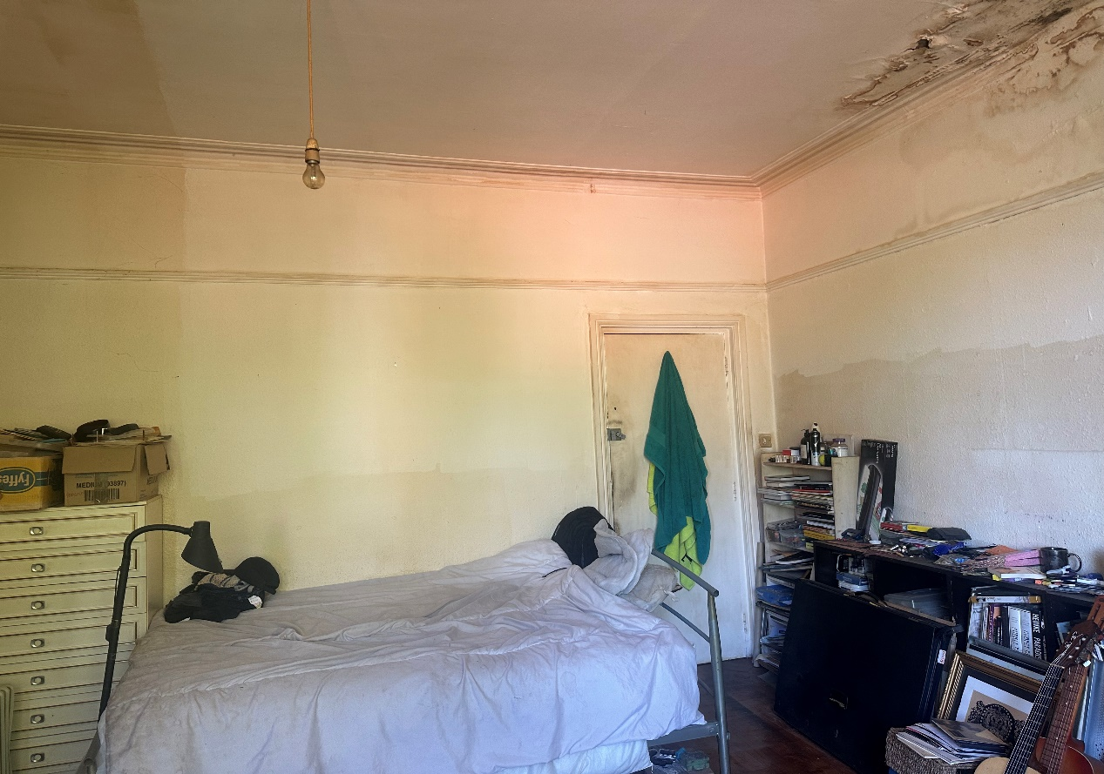
Bedroom 2, will be updating this room, as it’s been neglected, and plan for my mother to live here as her own room once renovated and done.
Second Floor – Proposal Changes
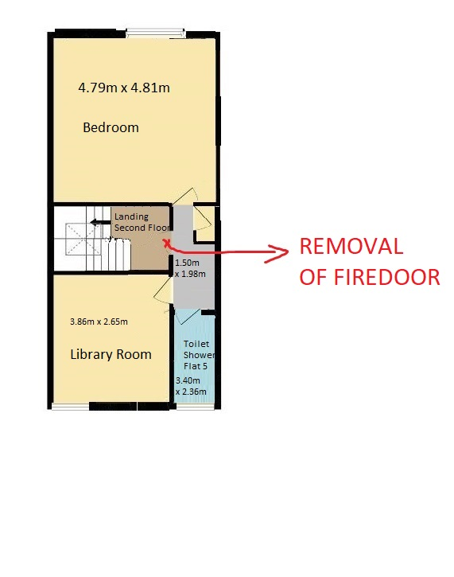
This will be additional extra bedroom and removal of Fire Door to open up as dwelling house and removal of kitchen to become Library Room.

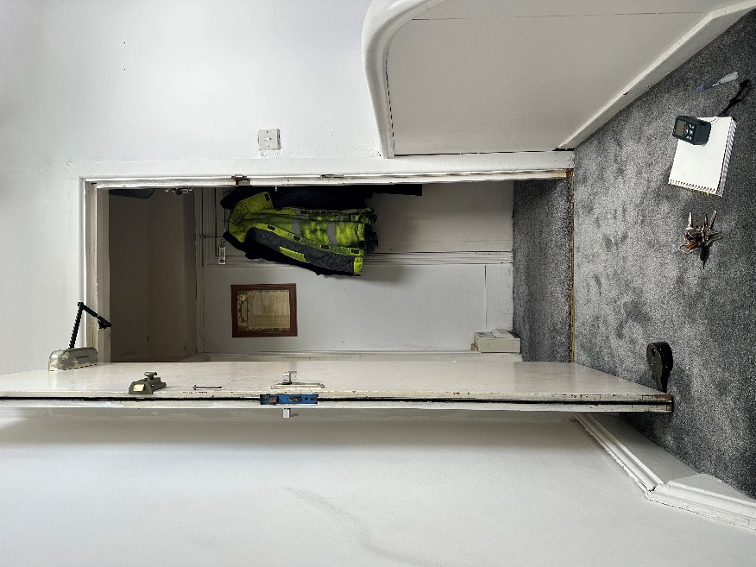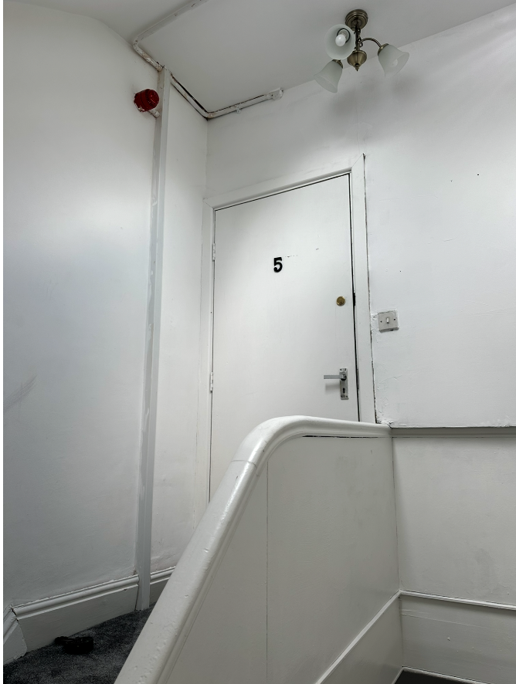
Removal of Fire Door to open up as single dwelling house.

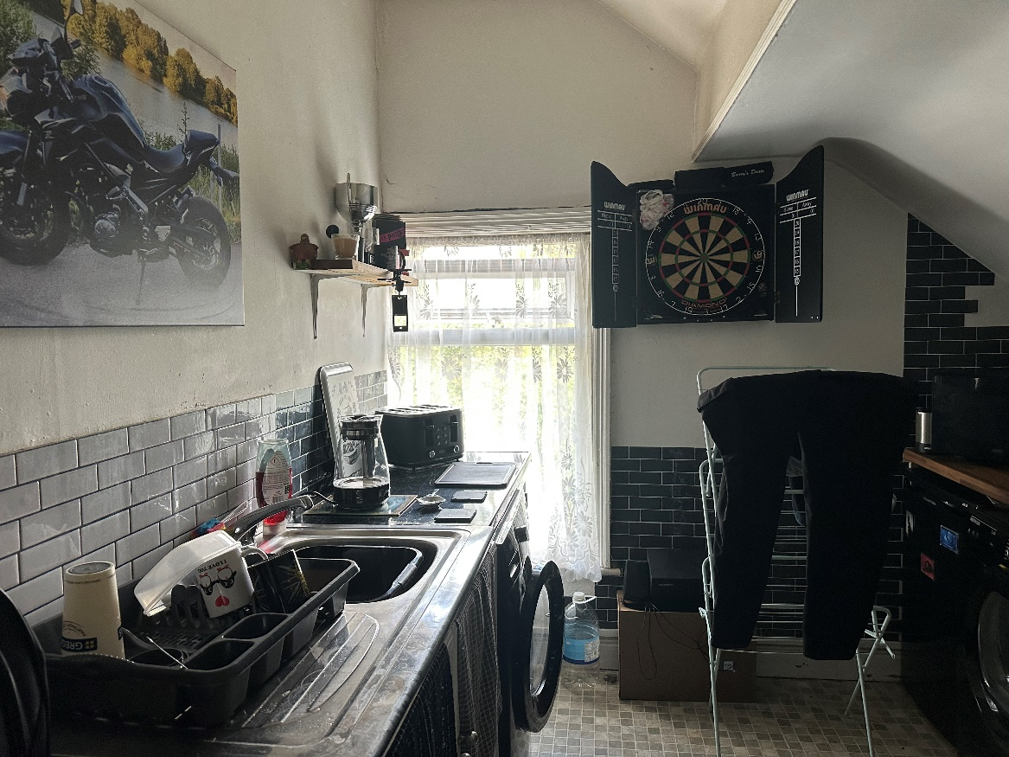
Removal of Kitchen as Library Room
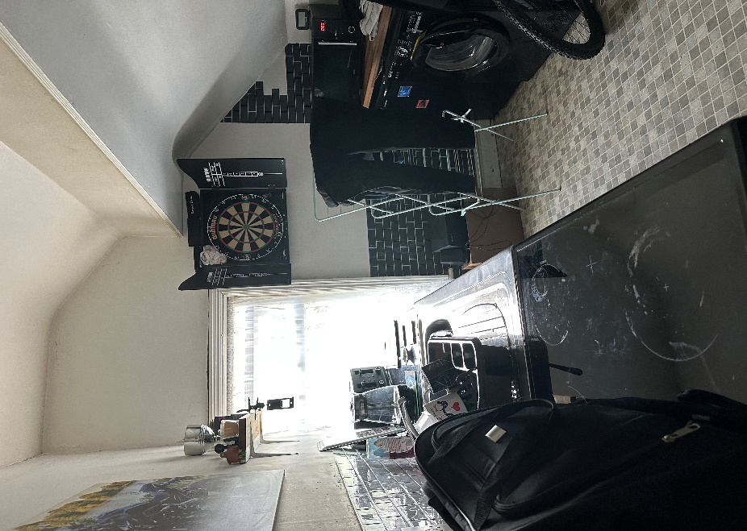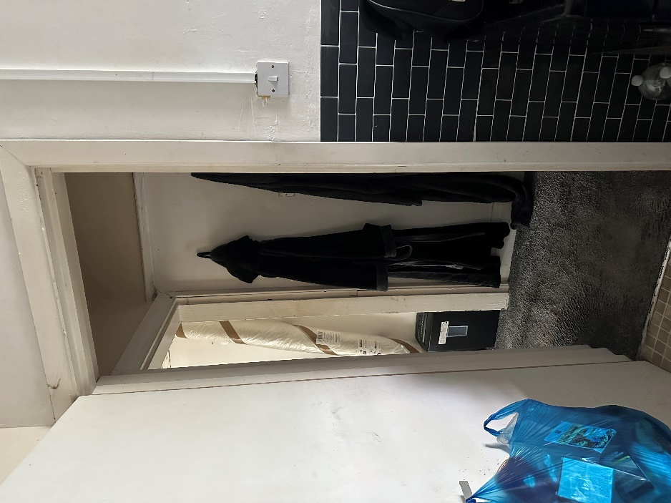
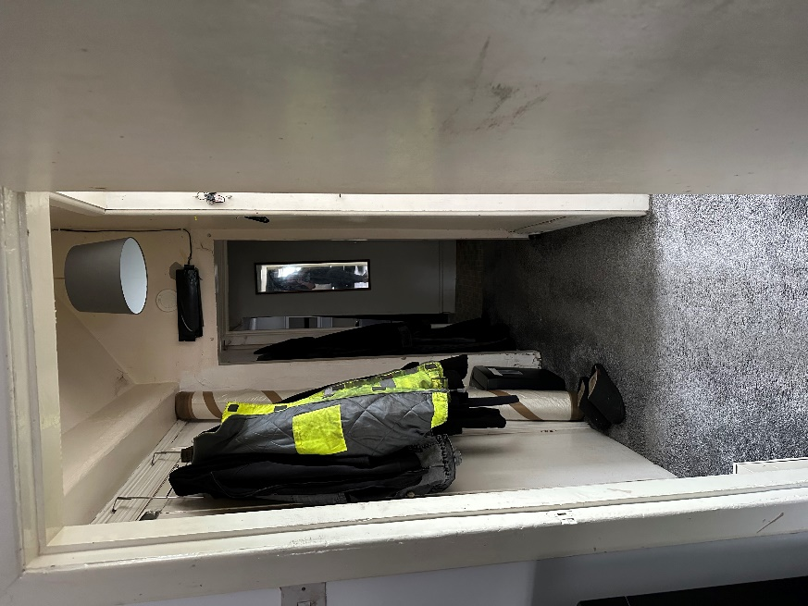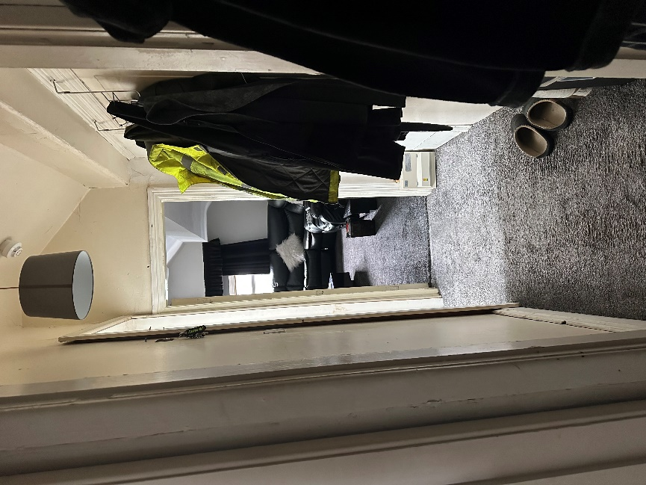

The Bedroom
