Project
Manchester University NHS Foundation Trust
Manchester Royal Infirmary
Project RED
Document
Project Execution Plan
(Incorporating the Construction Phase Plan)
Rev 38
Document Control
Issue / Revision Description: |  | Rev 38 |  |  | Date: | 19.05.25
Approval / Acceptance Status
 | Title & Company |  | Name [Print] | Signature |  |  | Date
Author: | Construction Manager |  | Ashley Atkinson | A Atkinson |  |  | 16/02/2023
Reviewed: | Project Manager |  | Richard Slater | A Brownsell |  |  | 19/05/2024
Approved: | Contracts Manager |  | Richard Slater | R J Slater |  |  | 10/05/2024
3rd Party Approved:  (If Applicable) | N/A |  | N/A | N/A |  |  | N/A
The master copy of this document is retained on the Document Management & Collaboration Database.
Copies produced from the master, by whatever means, are deemed uncontrolled.
You must confirm that you hold the latest version, before using this document for its intended purpose.

Revision History
This document, together with any associated documents, should be reviewed at regular intervals during the project and whenever there is a significant change to the site conditions such as a change in scope, site area, construction methods being used.
This document should be reviewed at least every month or as agreed by the HSEQ advisor to maintain its effectiveness.
Record the details of any changes made because of these reviews in the table below.
Rev: | Date: | Reason for Review: | Nature of Changes: | Prepared by: | Checked by:
0 | 25.03.2021 | DRAFT |  | J Jackson | J Fowler
1 | 16.04.2021 | Updated to incorporate trust comments | See rev. 1 | J Jackson | J Fowler
2 | 06.05.2021 | Updated to incorporate trust comments |  | J Jackson | J Fowler
3 | 07.07.2021 | Updated to incorporate the modular cabin installation | Modular cabin details added | J Jackson | J Fowler
4 | 06.09.2021 | Monthly review |  | J Jackson | J Fowler
5 | 19.03.2022 | Reviewed prior to commencement on site |  | J Jackson | J Fowler
6 | 27.04.2022 | Updated following Trust review & comments | Updated following Trust review & comments | J Jackson | J Fowler
7 | 22.06.2022 | Monthly review | Section 4.2 - Subcontractor list updated | J Jackson | J Fowler
8 | 11.08.2022 | Monthly review | 4.6 environmental requirements | R greaves | J Fowler
9 | 09.09.2022 | Monthly review | IHP Staff change/organigramme updated | J Jackson | J Fowler
10 | 10.10.2022 | Monthly review | No change required | J Jackson | R Greaves
11 | 11.11.2022 | Monthly review | Section 3 updated to reflect document distribution | J Jackson
12 | 15.12.2022 | Monthly review | IHP organigramme updated | J Jackson
13 | 04.01.2023 | Updated for RS arrival | Organogram updated | R Slater
14 | 16.02.2023 | Changed to new template | Information copied across and updated | A Atkinson | R Slater
15 | 21.03.2023 | Monthly review | No changes required | R Slater | R Slater
16 | 23.04.2023 | Monthly review | Project Team and key dates updated. | R Slater | R Slater
17 | 23.05.2023 | Monthly review | Organogram updated | R greaves | R greaves
18 | 13.06.2023 | Monthly Review | Organogram updated | R greaves | R Slater
19 | 04.07.2023 | Monthly review | Other Risk documents referenced | R Greaves | R Slater
20 | 14.08.2023 | Monthly review | Other Risk documents referenced | R Greaves | R Slater
21 | 15.09.2023 | Monthly review | Updated org chart to capture Ward 7&8. | R Slater | R Slater
22 | 16.10.2023 | Monthly review | Updated org chart to capture T.Dougan | R Slater | R Slater
23 | 06.11.2023 | Monthly review | Updated org chart to capture A. Wertylo | R Slater | R Slater
24 | 19.12.23 | Monthly Review | Minor amendments to car parking arrangements.  Daily briefings added to 3.6.  Modular cabins reference removed. Organogram Updated. | Tony Dougan | R Slater
25 | 25.01.24 | Monthly Review | Reviewed no change | Tony Dougan | -
26 | 04.03.24 | Monthly Review | Consultation meeting added to 3.7 | Tony Dougan | -
26 | 04.03.24 | Monthly Review | Ward 7 and 8 added to scope of works 2.1 | Tony Dougan | -
27 | 09.04.24 | Monthly Review | Organogram Updated.  Ward 7 +8 scope updated  EIW description changed to include energised systems  Permit section amended to include Energy Centre | Tony Dougan | -
28 | 10.05.24 | Monthly Review | Organogram Updated. | R.Slater | -
29 | 10.06.24 | Monthly Review | Organogram Updated | A. Lynch | -
30 | 11.07.24 | Monthly Review | Reviewed no change | - Lynch | -
31 | 22.07.24 | Changes required by IHP H&S | COSHH Appointment | - Lynch | -
32 | 16.09.24 | Organogram Updated | Rachael V added | - Lynch | -
33 | 14.10.24 | Monthly review | Reviewed no change | - Lynch | -
34 | 14.11.24 | Monthly review | No Change | A Lynch | -
35 | 12.12.24 | Monthly Review | Updated Organogram | A Lynch | -
36 | 27.01.25 | Monthly Review | No Change | A Brownsell
37 | 11.04.25 | Phase 2 underway revision | Phase 2 commenced | A Brownsell
38 | 19.05.25 | Monthly Review | Hybrid Confirmed / Included | A Brownsell

Contents

1. Introduction and Scope 4
2. Project Overview 4
2.1 Description of the Project 4
2.2 Location of the works 6
2.3 Contract Documentation 9
2.4 Contract Review 9
2.5 Key Project Dates 9
2.6 Key Members of the Project Team 9
3. Arrangement for the Management of the Work 11
3.1 Project Health and Safety Objectives 11
3.2 Client KPIs 12
3.3 Project Quality (Building Division Guide to HSEQ Management on Site reference 2.4) 12
3.4 Passive Fire Protection (PFP) 12
3.5 Site Rules 13
3.6 Arrangements to ensure cooperation between project team members and coordination of their work 13
3.7 Arrangements for involving workers 14
3.8 Site Induction Arrangements 14
3.11 Welfare Facilities 14
3.12 Fire and Emergency Procedures 14
4. Specific Site Risks 15
4.1 Schedule 3 Risks Error! Bookmark not defined.
5. Additional Requirements 15
5.1 Permit Systems 15
5.2 Asbestos 16
5.3 Health Risk Management 16
5.4 Lone Working Error! Bookmark not defined.
5.5 Environmental Risk Control 16
5.6 Site Waste Management 16
5.7 Excavated Material 16
5.8 Water 16
5.9 Section 61 16
5.10 NRMM 16
5.11 Site Boundary 16
5.12 Stakeholder management 16
5.13 Digital Deliverables (Digital Engineering Management Procedure) 17
6. References 17

Introduction and Scope
This document is the project specific Construction Phase Plan (CCP) for the construction phase of the Project RED scheme. It will be reviewed every month as the project progresses. It will be made available to all parties involved in the works.
The plan details the management of Health and Safety in accordance with The Construction (Design and Management) Regulations 2015. The individual sections are based on headings detailed in L153, Managing Health and Safety in Construction.
This plan should be read in conjunction with ‘The Building Division Guide to Health, Safety, Environment and Quality Management on Site’

Project Overview

Description of the Project
Project RED consists of a multiphase, three-storey new build extension to the Manchester Royal
Infirmary Emergency Department, including administration and theatre accommodation and associated plantrooms. The new building will be directly adjacent to the existing PFI owned Hospital, connected via several breakthrough links. The scheme also includes a phase of drainage diversions and the demolition of several single-story buildings prior to the commencement of the new building.

Ground Floor Level

Adult’s Emergency Department is a 1460m2 extension to the Ground Floor Emergency Department comprising of.
- New Triage / RAU with Ambulance Handover,
- New Resus Bays,
- New Minors Bays,
- New Majors Bays
- Supporting ancillary facilities and areas

Level One
The First-Floor space will provide.
- Administration Accommodation to support up to 50 members of staff
- Staff change area to support the ED.
- Plantroom to serve the ground floor ED

Level Two
Second Floor facilitates.
- 5 new UCV Theatre Suites (3 new UCV and 2 Hybrid) – Following CE instruction
- Dedicated Recovery Areas
- Supporting Theatre ancillary areas and accommodation.

Level 3 & Roof Level
- Plantroom (serving theatres directly below) & Rooftop Plant with AHU.

The existing ED department will also be refurbished post the completion of the new build scheme and the departments will provide the combined services.
A new substation is currently under review to provide the Electrical Infrastructure to the new build scheme along with the existing building.
Further scope has been instructed to include:
1. Demolition of WIC, MIU, Star ship and existing Resus currently sat in the footprint of the new build.
2. Drainage Diversion
3. Hybrid Operating Theatres #04 & #05 (2) from area previously planned for UCV Theatres 4, 5, & 6.

Electrical Infrastructure Works (Complete and handed over)
Design and Construction of a new electrical infrastructure building including.
- New/diverted HV supplies & HV transformer to provide LV supplies to the new Project RED and Refurb schemes.
- Project RED Phase 1/2 Chillers backup generation
- The Energy Centre HV and LV have been energised in some areas. Access to HV Rooms only via ENW permit an agreement.

Ward 7 +8 Refurbishment

- Refurbishment of ward 7 and 8 commence during this reporting period.
- Scope of works full strip out and refurbishment of 2 wards at first floor level.
- Install Hot melt overlay to existing roof membrane
- Site access provided via access scaffold from EIW area.

Location of the works
The Location of the planned RED main scheme of works will be located in its’ pre-existing position on the North Road frontage of the Manchester Royal Infirmary, adjacent to the existing Emergency Department and NWAS station, off Upper Brook Street. See red line below.

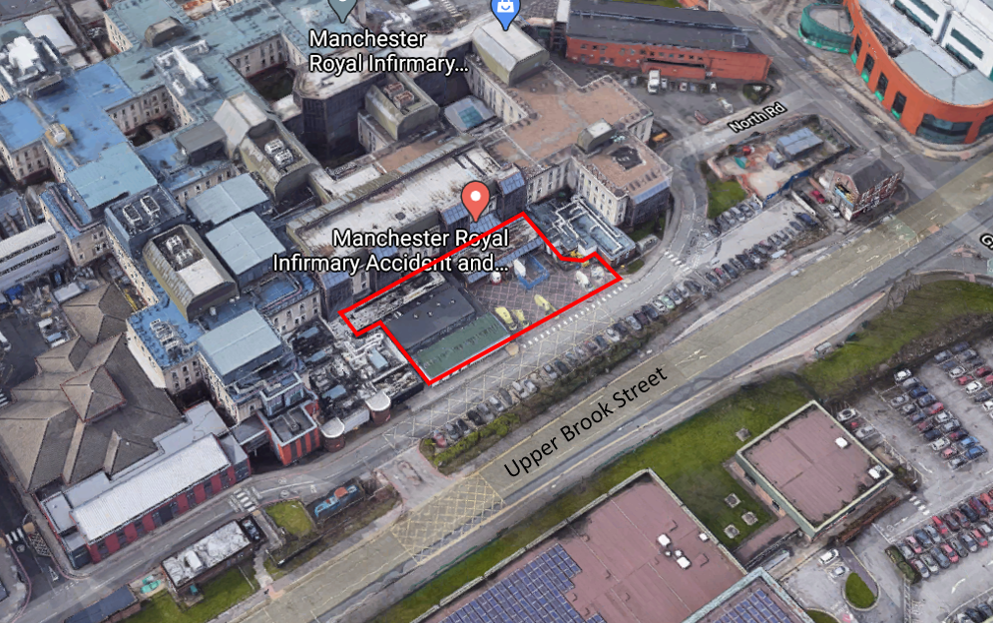
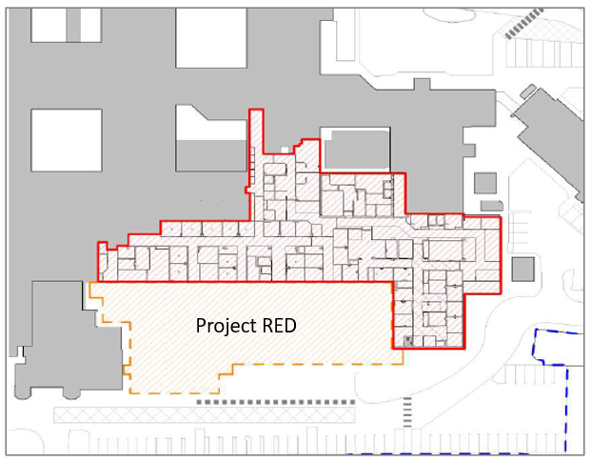

Site Address:
Integrated Health Projects
Manchester Royal Infirmary
North Street Via Grafton Street
Manchester
M13 9NZ

Electrical Infrastructure Works
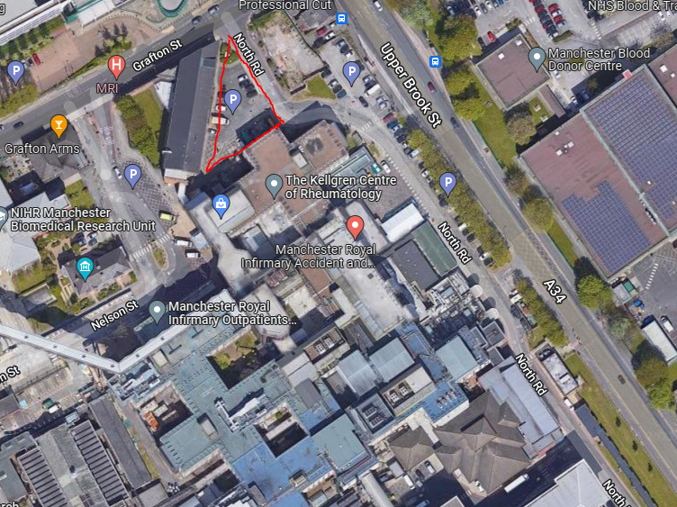

Contract Documentation
Contract documentation is stored in Viewpoint for projects & Fieldview

Contract Review
The Build it in a Day presentation and Adjudication were undertaken prior to the commencement of the main scheme and undertaken to the Electrical Infrastructure works at a later date. The project operates under an NEC contract administered via Sypro. The team are experienced in administering an NEC contract and the use of Sypro. There is a list of clarifications amended to the contract with the client that show the risks which are backed off with the client and the subcontract agreements will mirror these clarifications.

Key Project Dates
- The project is a NEC type C with the programme being updated and issued to the Trust for acceptance monthly via Sypro.
- The programme includes the following key milestones.
  - Project completion
  - Key Trust & PFI interface dates- Handing over boundary rooms and services.
  - Phase 1 completion
  - Phase 2 completion
  - Power on
  - Water on
  - Building watertight

- Progress will be monitored weekly by the production team and reported to IHP project planner who will report back to the regional office.
- The production team will produce and maintain detailed short term construction programmes for their individual sections of work.

Key Members of the Project Team

The Principal Contractor
IHP - VINCI Construction UK Ltd
Integrated Health Projects
Astral House
Imperial Way
Watford
WD24 4WW

IHP Organisational Project Structure

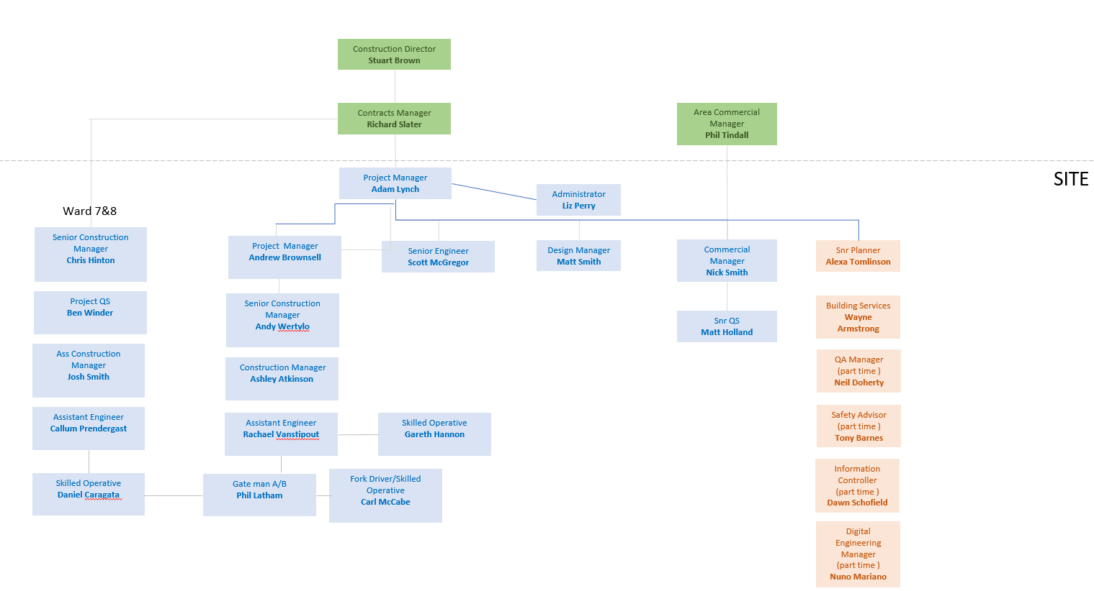

The Client

Manchester Foundation Trust
Trust Headquarters,
Cobbett House
Oxford Road,
Manchester
M13 9WL

Employer’s NEC P22 Supervisor
Actua Chartered Surveyors
Suite 305-306
Cotton Exchange
Bixteth St
Liverpool
L3 9LQ
0151 227 4024

Employers NEC P22 Project Manager
Jack Davenport
Trust Headquarters,
Cobbett House
Oxford Road,
Manchester
M13 9WL

Employer’s Financial Adviser
Chris Baxter
Arcadis
Suite 1a
1st floor
No 4 Piccadilly Place
M1 3BN
Manchester
UKenquiries@arcadis.com
+44 161 245 8700

The Principal Designer
Integrated Health Projects
Astral House
Imperial Way
Watford
WD24 4WW

The Architect
Luke Irlam
DAY Architectural
77 Deansgate Manchester
M32BW
07585 127 443
luke@day-architectural.com
07813 005 256

Arrangement for the Management of the Work
The ‘Building Division Guide to Health, Safety, Environment and Quality Management on Site’ (also known as the Site HSEQ Manual) sets out the standard arrangements for the management of works on all VCUK Building Division projects. Additional requirements due to the project specific risk and contractual requirements are detailed in this section.

Project Health and Safety Objectives
- Over 7 day Accident Frequency Rate of less than 0.11
- Lost time AFR of less than 0.35
- Zero environmental incidents
- Implement and promote best practice
- Promote close call and positive intervention reporting from site, with a min of 10 per trade per week
- 100% CSCS card qualified operatives
- Project to achieve a minimum of Green rating from internal HSEQ audits

Client KPIs
The client is asked to provide a score out of ten on a monthly basis which is inputted onto the P22 club website.

Project Quality (Building Division Guide to HSEQ Management on Site reference 6)
VCUK manages Quality in accordance with the requirements of the company business management system ‘The Way We Work’. This system is the companies Quality Plan – it details what activities are to be undertaken, by whom, when and by what method/what documentation. It includes the activities that contribute to the required product delivery both in terms of operational (Project site) and organisational (ISO9001) quality management. Key hierarchy documents include:
- Manage Quality Process Map, Integrated Management Standard’s (IMS), Divisional Quality Standard’s (DQS), Quality Policy, Building Division Guide to HSEQ Management on Site (Section 6 Quality)
Key deliverables that are required on this Project for Quality are:
- Quality Champion Appointment
- Risk and Opportunity Register (Quality section completed)
- ITP Quality Risk Rating Schedule
- ITPs
- Checksheets with associated records e.g. test results/certificates
- NCRs completed fully with evidence attached and closed in timely manner
- Quality task completion in a timely manner
- Product training log (recording CPD sessions)
- 3rd party visits recorded on “record of third party inspection”
- Ensure Company Quality Alerts are checked against/toolbox talked
- Be aware of and check against the “Tips for getting it right first time” document
- Instrument Test Log, Instrument Test Record/Total Station Test Record
- Community Contact and Complaints Record
- Client Satisfaction Survey
- Handover Plan with associated documents including Handover Deliverables

Passive Fire Protection (PFP)
In line with the Trusts Fire management and Passive fire protection requirement, the Bolster
system will be used to record the installations and trust access arranged. The selected fire
stopping contractor will be FIRAS accredited.

Site Rules
(Building Division Guide to HSEQ Management on Site reference 2.4)

Site rules have been developed which are specific to this project. A copy of the site rules will be displayed on the site Notice Board and will be included in the site-specific induction.

General rules
- All operatives, visitors and staff must attend a site induction (visitor induction where appropriate) prior to entering the site area.
- All operatives, visitors and staff must report their attendance to site to their supervisor or the site management team and sign in and out using the biometric system.
- Mobile phones NOT to be used whilst in control of any plant or machinery.
- The site canteen and welfare facilities are there for all to use. Please look after them. Any vandalism or misuse will result in the person being removed from site and any associated cost charged to the relevant contractor.
- Food is only to be consumed in the site welfare canteen areas
- The Hospital canteen facilities are NOT to be used.
- No radios or music playing devices are allowed to be used on site
- Smoking is NOT permitted on the hospital grounds. Anyone smoking on hospital grounds will be dismissed from site.
- Pedestrian access is only permitted as stated on the site logistics plan and as displayed on the site notice board. All persons on site or the welfare area must enter and leave via the turnstile
- IHP are to be notified of all planned deliveries 3 days in advance and deliveries must be booked in using the delivery planner
- No deliveries are to be brought onto the Hospital site grounds until agreed with the IHP logistics team. The delivery holding zone is to be used until site is ready to accept a delivery.
- Operatives to follow the site & welfare COVID 19 operating procedures to ensure safe distancing, cleanliness.
- Parking – No vehicles are permitted to be parked on site unless agreed prior with the IHP management. Parking is available at the Grafton street and Hathersage Road Multi story carpark.
- Under no circumstances can vehicles park or wait on the hospital roads. Any vehicles found will be asked to move on and persistent offenders will be banned form site.
- All Trades (supervisor only) are to attend the morning daily site briefings, where any additional day to day site information will be briefed.

Arrangements to ensure cooperation between project team members and coordination of their work
(Building Division Guide to HSEQ Management on Site reference 9)

The following coordination routes will be used on this project:
- Prestart Health and Safety meetings
- Communication and collaboration on the Risk Control Schedule
- Regular progress meetings
- Daily Briefings morning and afternoon
- An Open-door policy for all VCUK managers.

Project Review Meetings
(Building Division Guide to HSEQ Management on Site reference 8.7)

An internal VCUK project team meeting will be held on a weekly basis
Individual Subcontractor/VCUK meetings will be held on a weekly basis

Monthly Client Progress
(Building Division Guide to HSEQ Management on Site reference 8.8)

A monthly client progress report will be produced

Arrangements for involving workers
(Building Division Guide to HSEQ Management on Site reference 9)

The following 2-way Communication routes will be used on this project:
- Company Induction
- Site Specific Induction
- Site Specific Orientation
- Prestart Health and Safety meetings
- Communication and collaboration on the Risk Control Schedule
- Task Briefings
- Toolbox talks
- Close Calls / Positive interventions reporting
- Regular progress meetings
- Health and Safety Consultation meeting monthly
- General communications to Supervisors
- An Open-door policy for all VCUK managers.
Relevant statutory notices such as “Health and Safety Law” poster and a current version of the Employers Liability Insurance Certificate, Form 10 will be displayed on the notice board. Other communication media will be found on topic specific notice boards

Site Induction Arrangements

(Building Division Guide to HSEQ Management on Site reference 2.5)

All personnel entering the works are will attend an online company induction, online site induction and an onsite orientation session, introduced by the SSR.
Visitors will attend a visitor induction and be accompanied at all times.

Welfare Facilities
(Building Division Guide to HSEQ Management on Site reference 2.3)

The welfare facilities and security arrangements are detailed in the Logistics Plan for the project.

Fire and Emergency Procedures
(Building Division Guide to HSEQ Management on Site reference 3)

The relevant VCUK appointed roles and any relevant subcontract appointed roles are organised into the following reporting structure:

The local fire brigade will be contacted and offered an orientation session on the site.
The following response/evacuation drills will be conducted regularly:
- Fire
- Evacuation
Records of these drills will be included in the Daily Site Diary (or on a Fire Drill Log for fire).
An Emergency Response Plan will be displayed in prominent positions.
The following will be regularly inspected:
- Fire Alarm System
- Fire Extinguishers
- Emergency Lighting Systems
First Aid resources will be periodically checked for date of expiry and condition.
Spill kits will be available in close proximity to any stored fuels and oils and plant will have drip trays and plant nappies available.
The project has been allocated a fire risk level of MEDIUM. The project has been identified Medium risk due to the closeness of the existing buildings and project value.
A Site Fire Risk Assessment has been completed by the site team.
A site Fire Plan has be developed which details specific control measure for fire for the project.

Specific Site Risks
(Building Division Guide to HSEQ Management on Site reference 2.6)

The Project Risk Control Schedule (RCS) will identify the controls for the significant risks related to the current activities being carried out on the project. The RCS will be reviewed monthly basis or in line with the Construction Programme, and incorporate risks identified by Subcontractors. The reviewed document will be shared with all Subcontractor on the project to ensure they can Plan, Manage, Monitor and Co-ordinate their site teams in line with the current risk profile.
A Risk and Opportunity Register has been prepared in pre-construction; this is maintained by the SSR.
Other documents; Noise and vibration, environmental management plan, aspergillus risk control schedule for prevention and control, site logistics plan.

Additional Requirements

Permit Systems

(Building Division Guide to HSEQ Management on Site reference 4.2)
The following permit systems will be implemented on this project
- The VCUK Hot Works Permit
- The VCUK Permit to Dig
- The VCUK confined space permit
- Electrical Substation EIW Energy Centre.

Asbestos
(Building Division Guide to HSEQ Management on Site reference 4.5)
There have been involved asbestos investigation reports on this project
Information regarding the arrangements for management of asbestos is included in the Risk Control Schedule and the Site Specific Induction
VCUK should not undertake removal of asbestos or transportation.
How to manage when unexpected asbestos identified is detailed in the Emergency Response Plan

Health Risk Management

(Building Division Guide to HSEQ Management on Site reference 4.15)
The main health risks for the project and the arrangements for managing them are detailed in the Risk Control Schedule.
These will be managed through Risk Assessment for the specific work activity

Environmental Risk Control
(Building Division Guide to HSEQ Management on Site reference 5.1)

An Environmental Management Plan has been produced for this project.

Site Waste Management

(Building Division Guide to HSEQ Management on Site reference 5.2)

A Site Waste Management Plan has been produced for this project VB-ENV-PL-0001-0001 Rev 1

Excavated Material
(Building Division Guide to HSEQ Management on Site reference 5.3)

Excavated material will be managed by: Bora Groundworks which is managed by Senior Engineer Scott MacGregor.
All excavated will be removed from site.

Water
(Building Division Guide to HSEQ Management on Site reference 5.4)

The Environmental Management Plan details how to manage surface water.

Section 61
(Building Division Guide to HSEQ Management on Site reference 5.4)

There is a planning restriction with regards to the working hours.
Site Working hours and noise constraints are detailed in the Site Induction

NRMM
(Building Division Guide to HSEQ Management on Site reference 5.8)

This project will be NRMM compliant to Stage IIIB of EU Directive 97/68/EC

Site Boundary
(Building Division Guide to HSEQ Management on Site reference 7.2)

The Site Boundary is checked as part of the Weekly Site Inspection.
Boundary hoarding relocated for Phase 2 from Monday 14/04/25.

Stakeholder management
(Building Division Guide to HSEQ Management on Site reference 9.2)

The following methods shall be used to communicate project activities with stakeholders (including neighbours):
- Poster boards

Digital Deliverables (Digital Engineering Management Procedure)
The project has been allocated VCUK Digital Engineering Scenario DS1

COSHH Management Ashley Atkinson Co-Ordinator & Andrew Brownsell Deputy

Dust Management and Miscellaneous
o Regular communication with the Trust, client representatives and relevant stakeholders is maintained through weekly lookahead meetings, with a focus on any activities interfacing with the existing hospital.
o Emergency contact numbers are displayed across the site hoarding and vehicular gates to site.
o Wheel washing provision is in place at both gate A and B, a boot wash facility is also available for site personnel.
o Regular dust monitoring is being carried out within the live wards and at various locations across the site.
o Phasing and quantification/classification of vehicular activity is managed through the MSite system.
o Types and frequency of vehicular demands - Routing strategy and swept path analysis; A one way delivery system is implemented through the site in line with the project logistics plan.
o Parking for construction vehicles and staff; allocated parking is available off site at the Hathersage and Grafton Multi storey car parks.
o Vehicles carrying waste such as skips and muck away are sheeted over prior to leaving site as further dust mitigation
o The erection and maintenance of security hoardings where relevant; All hoardings are erected by a competent fencing contractor in line with the temporary works design and are inspected weekly as part of the temporary works checking protocol.
o Details of how access to adjacent premises would be managed to ensure clear and safe routes into buildings are always maintained; The newly finished A+E resus area (Phase 1) is continually accessible for ambulances and emergency response staff. This is clearly detailed on the site logistics plan.
o Pedestrian management proposals: The access route to site ensures pedestrians are fully segregated from the ambulance / vehicular routes and a designated crossing point to the turnstile is being implemented.
o Loading and unloading of plant and materials is within a fully segregated area within the site compound and is carried out via site forklift or Hiab in line with the site lifting plan.

References
The ‘Building Division Guide to Health, Safety, Environment and Quality Management on Site’
The Construction (Design and Management) Regulations 2015
L153, Managing Health and Safety in Construction
Digital Engineering Management Procedure

VB-IMS-PR-0001-0003
VB-COM-FR-XXXX-0016
VB-HAS-FR-0007-0006
VB-IMS-PL-0004-0001
VB-HAS-FR-0007-0004
VB-HAS-FR-0007-000
VB-HAS-FR-0007-0003
VB-HAS-FR-0007-0007
VB-HAS-PL-0007-0001
VB-HAS-FR-0008-0003
VB-HAS-FR-0008-0003
VB-HAS-FR-0008-0014
VB-IMS-PL-0004-0001
VB-ENV-PL-0001-0001
VB-BIM-PR-XXXX-0101

