D&A
Proposed Installation of LED Sign for Advertisement
158 Cheetham Hill Road, Manchester, M8 8LQ
Local Planning Authority: Manchester City Council

1. Introduction
This Planning Statement is submitted in support of a planning application for proposed Installation of LED Sign for Advertisement at 158 Cheetham Hill Road, Manchester, M8 8LQ.
The signage is for the advertisement of the upcoming construction.

2. Site Context and Existing Features

2.1 Location and Setting
The site is located on the corner of Cheetham Hill Road and Derby Street, in the north of Manchester, with a total of 1103. 57m².

2.2 Existing Site Features
The site is currently vacant and has remained so for over 30 years.

3. Planning History
The site used to be the original location of the United Synagogue, which was built in the 1870s, designed by Nathan Solomon Joseph (1834-1909), then was demolished in the 1980s.
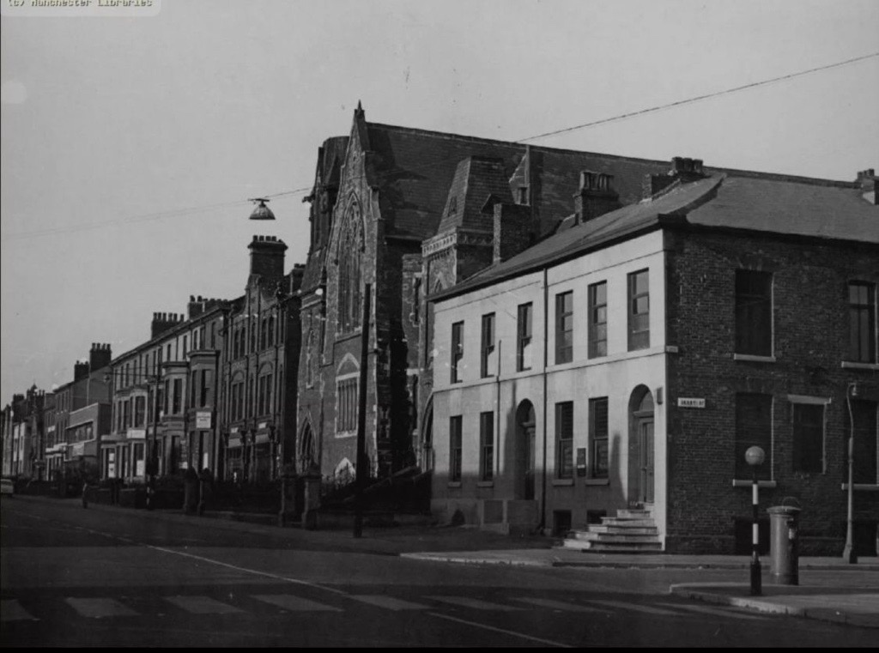
The United Synagogue, 1959
Since then, the site has remained vacant. As shown in Google Map, two pre-existing signage was displayed on site (approximately 2.5m*15m), and was then demolished in 2014.
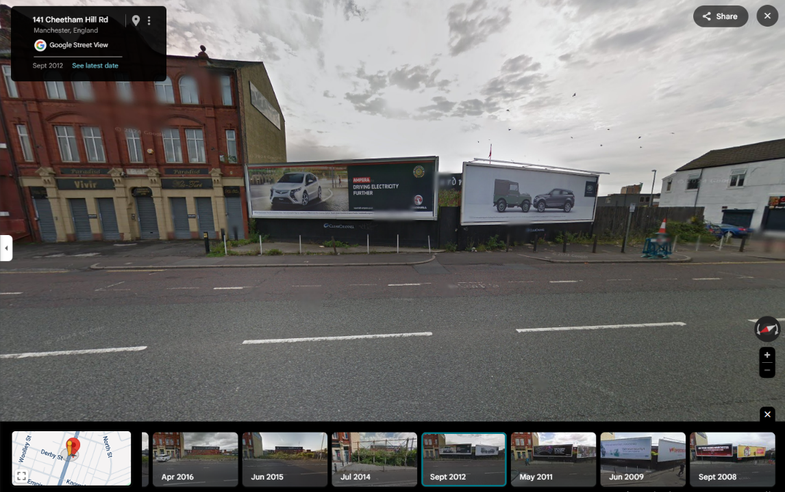
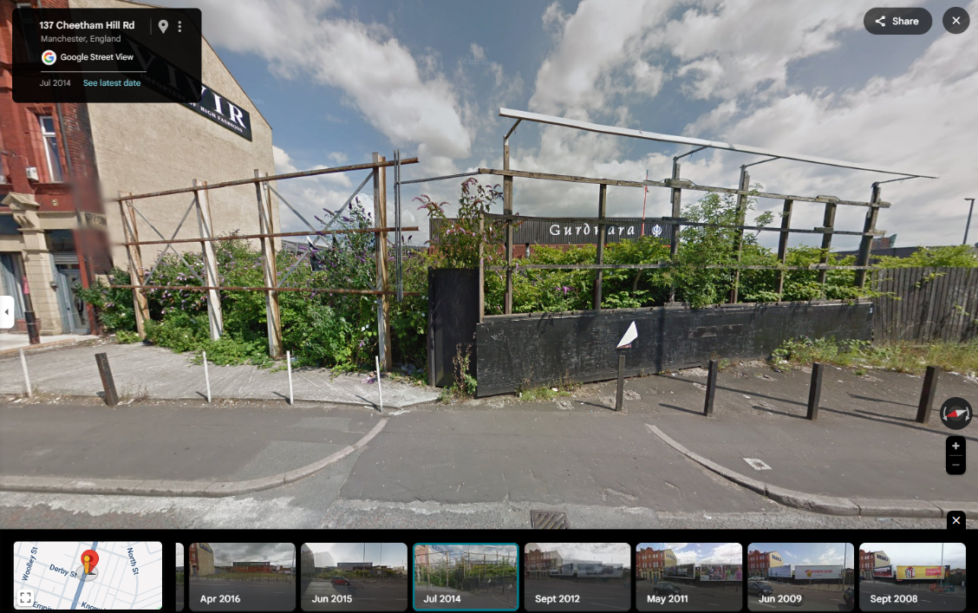

4. Proposal
Two signs will be located on the corners of the site facing Cheetham Hill Road, (see proposed drawings).

The proposed LED signage is a total of 8m, including a 2m poll as foundation and a 6m tall, 3.8m in width LED screen.

5. Conclusion
The proposed alterations at Cheetham Hill Road represent a sensitive and well-considered enhancement of the site, aligning with all relevant planning policies and exemplify good design practice. We respectfully request the council's support for this application and remain available to provide any further information required.

