SITE SPECIFIC SUPPLEMENTARY INFORMATION

- Site Details

Site Name: | 1 Kelso Place | Site Address: | 1 Kelso Place  Manchester  M15 4LE
NGR: | E: 382702 N: 397423 | Site Address: | 1 Kelso Place  Manchester  M15 4LE
Site Ref Number: | NTQ 30309 | Site Type: Macro | Roof Top

- Pre-Application Check List

Site Selection

Was an LPA mast register used to check for suitable sites by the operator or the LPA? |  | No
If no explain why:

After a phone call to the LPA, it was felt that the industry database was a more up to date source of information.

Was the industry site database checked for suitable sites by the operator: | Yes
If no explain why:

N/A

Pre-application consultation with LPA

Date of written offer of pre-application consultation: | 2nd June 2025
Was there pre-application contact: |  | Yes
Date of pre-application contact: | 13/06/2025
Name of contact: | Sam Elliott  Assistant Planner
Summary of outcome/Main issues raised:

The points were made below by the LPA prior to submission however; it is not possible to mount the antenna centrally due to clipping on the building (clipping is significantly reduces the coverage capabilities of the equipment). The antenna has been mounted as far away from the roof edge. If the equipment is moved closer to the roof building, then the height of the antenna would need to be significantly increased.

Looking at the initial proposal for the proposed telecommunications infrastructure, there is concern given the site's location within a conservation area and visibility from the elevated tram line. It is appreciated that there are restrictions with respect to locations for these improvements, and we would be willing to review options for the scheme in this location that mitigate the prominence of the infrastructure.

If you send us options altering the siting of the equipment on the roof and provide corresponding concept renders, we can form a position on the visual impact of the antenna as to where it may be least harmful. In particular, we'd be looking for the options to explore a siting away from the parapet, a more central location, siting on the south side of the roof etc. Regardless of the option, we'd also request that the infrastructure is colour-matched to reduce the visual impact.

Thank you for your time,

Sam Elliott
Assistant Planner
Planning, Building Control and Licensing
Growth and Neighbourhoods
E-mail: sam.elliott@manchester.gov.uk
Telephone: 0161 219 2856

Ten Commitments Consultation

Rating of Site under Traffic Light Model: | Green

Prior to the submission of this application the applicant initiates pre-consultation discussions with the local planning authority. This provides an opportunity for the LPA to discuss development proposals and identify site specific issues. Further consultation has also been carried out with the Hulme Ward Councillors.

Summary of outcome/Main issues raised:

No responses had been received at the time of submission.

School/College

Location of site in relation to school/college:

There are no schools in close proximity to the site.

Outline of consultation carried out with school/college:

N/A

Summary of outcome/Main issues raised:

N/A

Civil Aviation Authority/Secretary of State for Defence/Aerodrome Operator consultation

Will the structure be within 3km of an aerodrome or airfield? |  | No
Has the Civil Aviation Authority/Secretary of State for Defence/Aerodrome Operator been notified? |  | No
Details of response:

N/A

Site Provider Letter

Copy of Site Provider Letter enclosed? | Yes
Date served: | 15th June 2025

- Proposed Development

The proposed site:
It is important to note that the proposed site is a replacement for an existing installation and is not a new additional installation. The existing site is located at the Salford Grosvenor Casino (NTQ 24185). The need for this Rooftop installation stems from MBNL having been issued with an NTQ (Notice to Quit) on their existing site and thus this new installation is urgently required to maintain coverage. The proposed site is at 1 Kelso Place, Manchester, M15 4LE. The proposed site is on the rooftop of 1 Kelso Place.

The proposal is for the installation of is for the installation of 2 No. antennas on Valmont tripods at both sides of the rooftop. The new antennas will provide continued and improved coverage for EE, H3G LTE and ESN for this area of Manchester when the existing site is decommissioned. The proposed new facility will require the installation of a number of equipment cabinets; these will be located on the rooftop.

The location is strategically positioned to enhance mobile network coverage in the area, addressing signals and providing reliable connectivity for businesses, residents and visitors and will support local businesses by ensuring seamless communication. The demand for mobile data and connectivity is continuously increasing. The Kelso Place rooftop provides a suitable location that minimizes visual disruption and integrates well with the environment. Stronger network coverage enhances the reliability of emergency calls and communication during critical situations, contributing to public safety. The strategic location of Kelso Place makes it ideal for businesses seeking connectivity while maintaining the benefits of a suburban setting.
As previously stated, this is not a new additional installation but is a replacement for an existing installation that is to be removed. The proposed installation is necessary for the continued and improved wireless connectivity and capacity for local businesses, residents and visitors to this busy area of Manchester.

Site Location

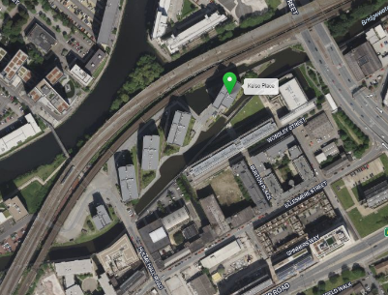

Site Elevation

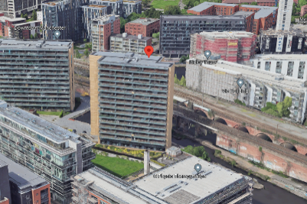

Streetview
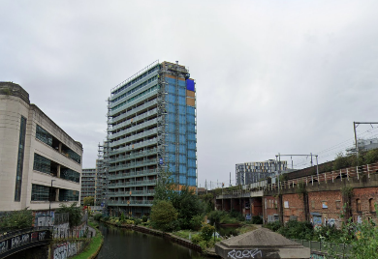
This planning statement has been prepared in support of the proposal for a telecommunications roof top installation at the site located at 1 Kelso Place Manchester. The proposed development seeks to enhance and upgrade the existing telecommunications infrastructure, contributing to improved mobile phone coverage and network reliability in the surrounding area. The proposal is made in accordance with the relevant planning policies and regulations, and the design of the antennas has been carefully considered to minimize visual impact and maintain the character of the surrounding area.
The overall impact of the proposal will be minimal on the visual and physical fabric of the surrounding area, as the works are confined to the roof area and will be designed to blend in with the existing structure.

Planning Policy Considerations
This application has been assessed in accordance with national and local planning policies, and the following key documents are relevant:
National Planning Policy Framework (NPPF)
The NPPF provides national guidance on telecommunications development. Relevant sections include:
- Paragraph 119 Advanced, high quality and reliable communications infrastructure is essential for economic growth and social well-being.

Design and Impact
The roof top upgrade has been designed to minimize visual impact and preserve the integrity of the building. The following measures have been adopted:
- The new telecoms equipment will be discreetly positioned on the rooftop, ensuring it is as unobtrusive as possible from ground level and surrounding viewpoints.
- The equipment will be of a neutral colour to blend with the existing building and the natural environment.
- Careful consideration has been given to the scale and massing of the proposal to ensure that it complements the existing architecture without dominating or detracting from the building's appearance.
The overall visual impact will be minimal, particularly when viewed in the context of the surrounding area and the scale of the existing infrastructure.
The proposed rooftop installation seeks to minimise its impact on the surrounding area but will maintain significant 5G connectivity benefits. The sharing of base stations between multiple operators is one of the key strategic policy principles contained within the NPPF. H3G and EE have a network sharing agreement and thus these installations are fully compliant with the NPPF.

The applicant appreciates that the site is located on the building rooftop, the alternative to utilising this site is a new standalone large 5G installation in the immediate area. Utilising the proposed rooftop site is from a sequential site selection process the optimum planning solution. A new mast in the area would be contrary to policy.

Central Government attaches great importance to the design of the built environment and outlines this within Section 12 (para. 131) of the National Planning Policy Framework. It states:

“Good design is a key aspect of sustainable development, creates better places in which to live and work and helps make development acceptable to communities.”

In keeping with the National Planning Policy Framework (NPPF). guidelines of using: “high quality communications” (Section 10),

"Use of existing masts, buildings and other structures for new electronic communications capability (including wireless) should be encouraged."

The design of the proposed equipment is considered to be the least visually intrusive option available given the level of equipment required for 5G.

As stated above the National Planning Policy Framework advocates site sharing, and as such we believe that there are no sequentially preferable locations within the defined site search area.

The design of the proposed equipment is considered to be the least visually intrusive option available and would not detract from the character of the area in which the proposal sits.

Although it is accepted that there will be telecommunications equipment visible, it is felt that any potential visual issues would be outweighed by the immense benefits of the new 5G connectivity.

Any other proposal to satisfy the identified requirement would result in the addition of a separate ground based column elsewhere in close proximity to the existing structure. In our opinion, such a proposal would, in this instance, unnecessarily add to the clutter in the streetscene and result in a greater visual impact.

Site Ref: | NTQ 30309 | Site Address: | 1 Kelso Place, Manchester, M15 4LE

Local Planning Authority: Manchester City Council

Development Plan: Manchester Core Strategy (2012) / Manchester UDP
(saved policies) / Places for Everyone Joint DPD (2024)

Fig.1: LP Plan Extract (Reference Only):

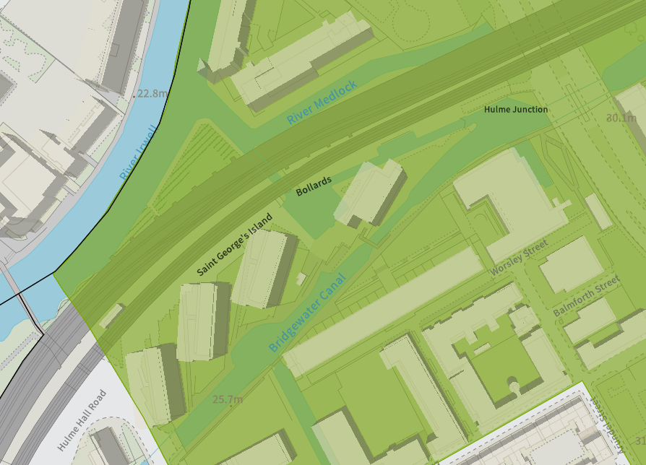

Site and its surrounds

Policy Relevant to the Development Site:

The site is designated as being within the settlement boundary, with urban uses to the north, east, south, and west. The site is in the Castlefield Conservation Area and the designation is a material consideration.

Manchester Council does have a specific telecoms policy. This, together with the NPPF is of relevance. The National Planning Policy section of this supporting statement goes into detailed analysis of why this site is in compliance with the NPPF.

Policy Analysis:

Policy DC17.1 reads:

“Applications for telecommunications developments will normally be approved if the

Council can be satisfied that the development has been sited and designed to minimise its impact on residential amenity and in environmentally sensitive areas. Wherever possible, the Council will expect the potential of existing buildings and masts, including the sharing of such facilities, to be fully explored before agreeing to additional separate development.”

Policy EN3 reads:

“Heritage

Throughout the City, the Council will encourage development that complements and takes advantage of the distinct historic and heritage features of its districts and neighbourhoods, including those of the City Centre.

New developments must be designed so as to support the Council in preserving or, where possible, enhancing the historic environment, the character, setting and accessibility of areas and buildings of acknowledged importance, including scheduled ancient monuments, listed buildings, registered parks and gardens, conservation areas and archaeological remains.

Proposals which enable the re-use of heritage assets will be encouraged where they are considered consistent with the significance of the heritage asset.

Also, paragraph 215 of the NPPF 2024 is relevant. It reads:

“215. Where a development proposal will lead to less than substantial harm to the
significance of a designated heritage asset, this harm should be weighed against the
public benefits of the proposal including, where appropriate, securing its optimum
viable use.”

In addition, the following objective is important:

“Objective 9: Ensure access to physical and social infrastructure. We will:

- Improve the capacity and network coverage of digital, energy, telecoms, transport
and water in key growth locations.”

The proposed development at this site is required to deliver the requisite level of electronic communication service on a single installation that is to be adapted to accommodate multiple users (so enable future site sharing opportunities), yet seeks to minimise its impact or change to the character of this location (being utilitarian in appearance, in an elevated rooftop position). The form and design of the proposed configuration would not appear out of context in this location, so according with wider Development Plan policy and would ensure the appearance and character of the area is fully maintained.

In addition to the above, Paragraph 119 of the NPPF (2024) states:

Advanced, high quality and reliable communications infrastructure is essential for
economic growth and social well-being. Planning policies and decisions should
support the expansion of electronic communications networks, including next
generation mobile technology (such as 5G) and full fibre broadband connections.
Policies should set out how high-quality digital infrastructure, providing access to
services from a range of providers, is expected to be delivered and upgraded over
time; and should prioritise full fibre connections to existing and new developments
(as these connections will, in almost all cases, provide the optimum solution).

The LPA should look to support this proposal as the equipment will bring “reliable communications” to the area.

Paragraph 122 states that

c) for a new mast or base station, evidence that the applicant has explored the
possibility of erecting antennas on an existing building, mast or other structure
and a statement that self-certifies that, when operational, International Commission guidelines will be met.

The discounted options section of this planning statement fully illustrates that all other potential masts, roof tops and other locations have been investigated. The proposed site is the optimum location from a planning and coverage perspective.

In this case, the rooftop installation, seen in context with host building, would result in less than substantial harm to the wider heritage asset, with the public benefits materially outweighing any perceived detrimental change to the location (so ensuring accordance with para. 215 of the NPPF 2024).

The public benefits of a greatly enhanced communications network for businesses, residents and visitors alike in this location would qualify as a substantial benefit with near benign change or impact on amenity.

The enhanced digital service would very much accord with the objectives of the Development Plan policy.

The proposal fully accords with the requirements of the NPPF.

Enclose map showing the cell centre and adjoining cells:
This can be emailed to the LPA upon request.

Type of Structure
Description:

Top of proposed antennas +50.50m AGL
C/L of proposed antennas +50.50m AGL

Proposed 2No antennas on Valmont tripod on 3No new concrete plinths c/w underslung ladder.
Proposed 1No Ø600 dish on extension post on Tripod.
Proposed 1100 high freestanding handrail 2m each side of tripod and tied into tripod corner posts.
Proposed 2No antennas on Valmont tripod on new grillage.
Proposed steel grillage fixed on 4No new concrete plinths c/w decking, kick plate, handrail and access ladder. Proposed 2No EE cabinets, 1No H3G cabinet and 1No shared Mk5B Link/AC cabinet.
Proposed 1No Ø600 dish on extension post on Tripod.
Proposed 1100 high freestanding handrail tied into grillage handrail

Overall Height: N/A
Height of existing building |  | +46.75m AGL
Equipment Housing:
Length: |  | See drawings
Width: |  | See drawings
Height: |  | See drawings
Materials
Tower/mast etc – type of material and external colour: | See drawings
Equipment housing – type of material and external colour: | See drawings

Reasons for choice of design:
The proposed installation is an EE Ltd and H3G LTE rooftop upgrade which will house both EE and H3G LTE. The sharing of base stations between multiple operators is one of the key strategic policy principles contained within the NPPF.

- Technical Information

ICNIRP Declaration attached  ICNIRP public compliance is determined by mathematical calculation and implemented by careful location of antennas, access restrictions and/or barriers and signage as necessary. Members of the public cannot unknowingly enter areas close to the antennas where exposure may exceed the relevant guidelines.  When determining compliance the emissions from all mobile phone network operators on the site are taken into account. | Yes

- Technical Justification

Reason(s) why site required
The National Planning Policy Framework clearly states that authorities should not question the need for the service, nor seek to prevent competition between operators. Notwithstanding this fact, the Applicant considers it to be important to explain the technical justification for the site and how the facility fits into the overall network.

Notwithstanding this fact, the Applicant considers it to be important to explain the technical justification for the site and how the facility fits into the overall network.

The site is required to provide new 5G coverage for EE Ltd in order to improve coverage in the M15 area of Manchester. The cell search areas for 5G are extremely constrained with a typical cell radius of approximately 250m meaning that it would not be feasible to site the installation outside of this locale.

- Site Selection Process – alternative sites considered and not chosen

Discounted Options
In accordance with the sequential approach outlined in the National Planning Policy Framework (NPPF) following search criteria have been utilised. Firstly, consideration is always given to sharing any existing telecommunication structures in the area, secondly consideration is then given to utilising any suitable existing structures or buildings and thirdly sites for freestanding ground-based installations are investigated.

This sequential approach is outlined below:

- Mast and Site Sharing
- Existing Buildings Structures
- Ground Bases Installations

In compliance with its licence and the sequential approach outlined in the NPPF all attempts to utilise any existing telecommunication structures where they represent the optimum environmental solution have been employed. The Ofcom Site Finder mast register is always examined prior to the submission of an application.

Site | Address | NGR Reference | Reason Discounted
D1 | McDonalds | E: 382477, 397657 | Site is likely to be demolished and redeveloped
D2 | KFC | E: 382533, 397683 | Site is likely to be demolished and redeveloped
D3-RT | Sainsbury’s | E: 382331, 397818 | Rooftop not tall enough to provide the required coverage
D4 | Regent Retail Park Delivery Yard | E: 382545 , 397974 | Site would be too close to an existing mast. Also within H&S distance to train tracks.
D5 | Vista Tower | E: 382693 , 397747 | Building currently under construction so not suitable at this time.
D6 | Hotel Campanile | E: 382585 , 397759 | Pitched style Rooftop would be unsuitable for telecoms equipment.

If no alternative site options have been investigated, please explain why:

N/A

- Additional Relevant Information

Background to the Proposal
This specific proposal forms part of an integral requirement for EE Ltd, ESN and H3G LTE to expand their respective 5G telecommunications network across Manchester specifically in this instance to enhance 5G coverage levels and network capacity within the M15 area.

This partnership has resulted in the development and production of an array of “dual user” structures and cabinets, which have the ability to accommodate both operator’s antenna systems and radio equipment.

Mobile phone base stations operate on a low power and accordingly base stations therefore need to be located in the areas they are required to serve. Increasingly, people are also using their mobiles in their homes, and this means we need to position base stations in, or close to, residential areas.

A further limiting factor is that the position has to be one that fits in with the existing network. Sites have to form a patchwork of coverage cells with each cell overlapping to a limited degree with the surrounding base stations to provide continuous network cover as users move from one cell to the other. However, if this overlap is too great unacceptable interference is created between the two cells.

DEVELOPMENT PLAN POLICY.

Development plan considerations have a special significance in law and re-iterated in Section 38 of the Planning and Compulsory Purchase Act 2004, it is stated that:

“If regard is to be had to the development plan for the purpose of any determination to be made under the planning Acts the determination must be made in accordance with the plan unless material considerations indicate otherwise.”

NATIONAL PLANNING POLICY

The Government remain committed to promoting telecommunications and place emphasis on the importance of telecommunications to the wider economy. The National Planning Policy Framework (NPPF December 2024) sets out the Government’s planning policies for England and how these are expected to be applied at the Local level. It provides a framework within which local people and their accountable Councils can produce their own distinctive local and neighbourhood plans, which reflect the needs and priorities of their communities.

The purpose of the planning system is to contribute to the achievement of sustainable development. There are three dimensions of sustainable development, each of which give rise to the need for the planning systems to perform a number of roles including: -

- economic objective – to help build a strong, responsive and competitive economy
- social objective – to support strong, vibrant and healthy communities
- environmental objective – to protect and enhance our natural, built and historic environment.
The NPPF contains at its core a presumption in favour of sustainable development which runs through both plan-making and decision-making processes. The NPPF recognises the vital importance of high-quality telecommunications and dedicates a whole chapter to this. Chapter 10 of the NPPF outlines the Governments support for high quality communications. The paragraphs below clearly outline the overarching support from Central Government for telecommunications and how Local Planning Authorities should embrace this vital infrastructure:

NPPF Paragraph 119 states:

“Advanced, high quality and reliable communications infrastructure is essential for economic growth and social well-being. Planning policies and decisions should support the expansion of electronic communications networks, including next generation mobile technology (such as 5G) and full fibre broadband connections. Policies should set out how high-quality digital infrastructure, providing access to services from a range of providers, is expected to be delivered and upgraded over time; and should prioritise full fibre connections to existing and new developments (as these connections will, in almost all cases, provide the optimum solution).”

It continues in Paragraph 120:

“The number of radio and electronic communications masts, and the sites for such installations, should be kept to a minimum consistent with the needs of consumers, the efficient operation of the network and providing reasonable capacity for future expansion. Use of existing masts, buildings and other structures for new electronic communications capability (including wireless) should be encouraged. Where new sites are required (such as for new 5G networks, or for connected transport and smart city applications), equipment should be sympathetically designed and camouflaged where appropriate.”

Operators always follow the sequential site selection process. Where an existing site can be shared or upgraded this will always adhered to before a new proposal is put forward for consideration.

The support for telecoms and the need not to constrain Operators is laid out in Paragraph 123:

“Local planning authorities must determine applications on planning grounds only. They should not seek to prevent competition between different operators, question the need for an electronic communications system, or set health safeguards different from the International Commission guidelines for public exposure.”

Conclusion

We consider that the development is compliant with the council’s policy and that in accordance with Section 38 (6) of the Planning and Compulsory Purchase Act 2004 permission should be granted for the installation.

We consider the development complies with both central government and local planning policy guidance where the underlying aim is to provide an efficient and competitive telecommunication system for the benefit of the community while minimising visual impact.

Taking into account the factors of technical constraints, available sites and planning constraints we consider that this site and design clearly represents the optimum environmental solution.

On the basis of a recognised need to expand and promote telecommunications networks across the region, it is considered that the proposal fully accords with the requirements of the National Planning Policy Framework and Council’s Local Plan Policies.

Guy de Rose
Planning Manager
Email: g.derose@whptelecoms.com

Contact Details

Name: (Agent) | Guy de Rose | Telephone: | Emailed on request
Operator: | EE and H3G LTE | Fax no: | N/A
Address: | WHP Telecoms Ltd  1a Station Court Station Road Guiseley  LS20 8EY | Email Address: | g.derose@whptelecoms.com
Signed: |  | Date: | 19th June 2025
Position: | Planning Manager | Company:  (on behalf of above operator) | WHP

