

Segregation Statement
Location: WS101

Compiled on behalf of:
The Casey Group
Benchill Rd,
Wythenshawe,
M22 8LF

DHI Excavations Ltd, 11-13 Church St, Farnworth, Bolton, BL4 8AG
Method of Segregation Statement 12th June 2024
Site Address: Benchill Rd, Wythenshawe, M22 8LF.

Contaminated hotspots on site.
WS101 – Classified as Hazardous by Hydrocarbons

Segregation of WS101.
Location WS101 is not part of the current excavations. WS101 is location right on the boundary on the SE corner of the site (see drawing one). Current excavations are at the northern boundary (see drawing two).
Once any excavations commence around location WS101 then this location will be segregated and disposed of to a licenced hydrocarbon treatment facility.
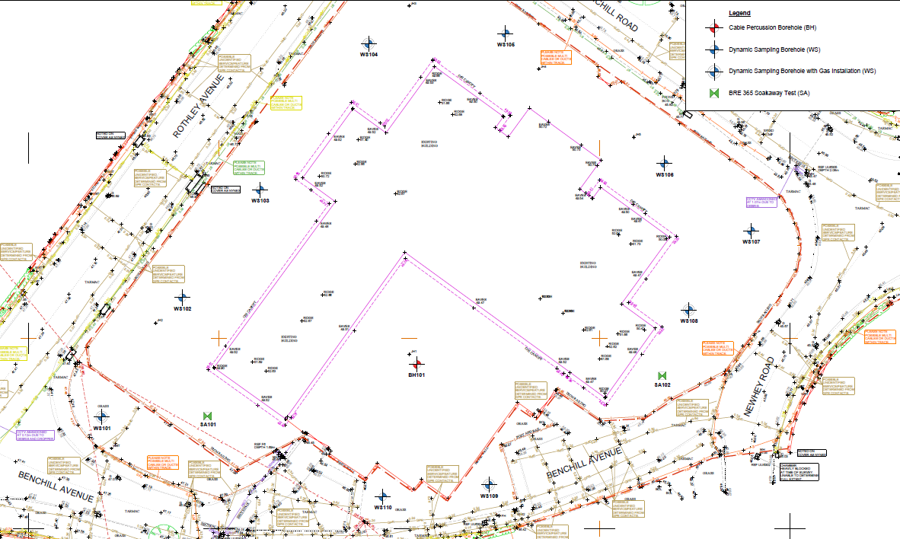

Location WS101

Benchill Rd, Wythenshawe Drawing One

WS101 Segregation & Disposal.
On 6th and 7th June 2024 location WS101 was marked out and excavated down to natural clay strata. The material from the excavation was transported to a hazardous treatment facility at Maw Green Landfill.
There was 4 x 8w loads excavated and disposed of over the 6th and 7th June 2024. See pictures below and disposal paperwork.

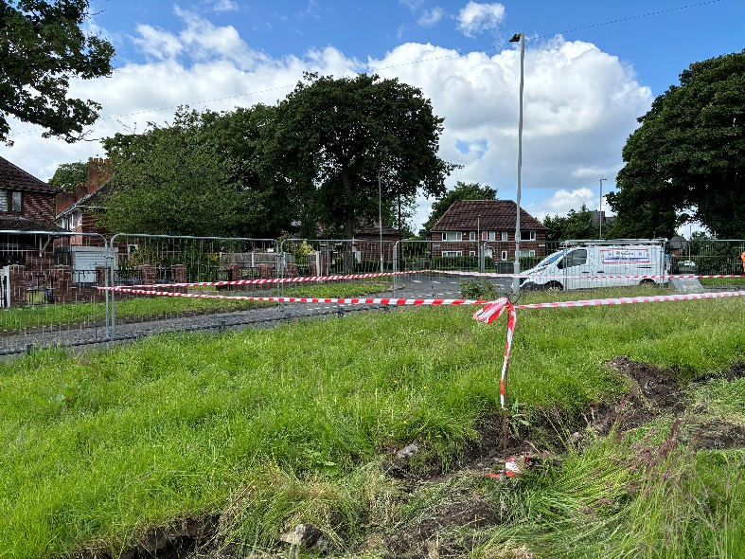
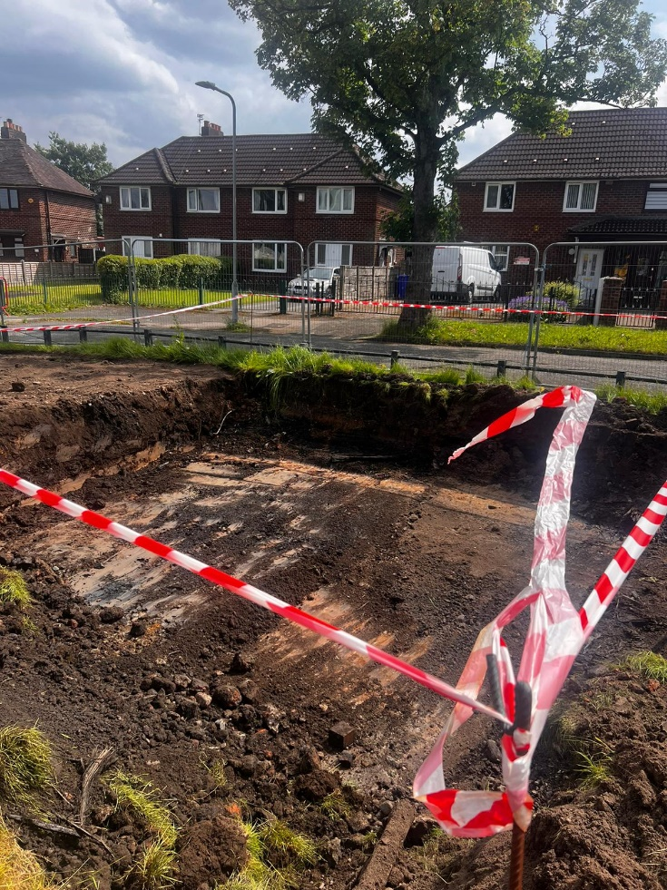

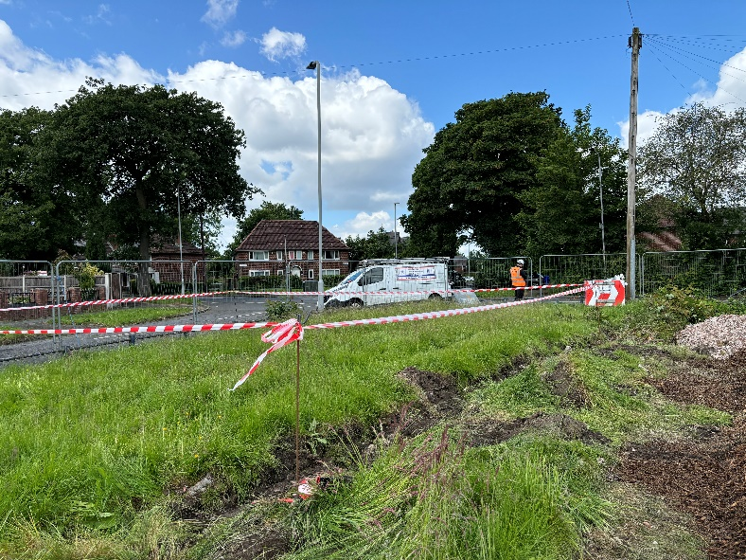

Pictures of location WS101 marked out and excavated to natural clay strata.

Hazardous Waste Consignment notes for disposal of WS101.
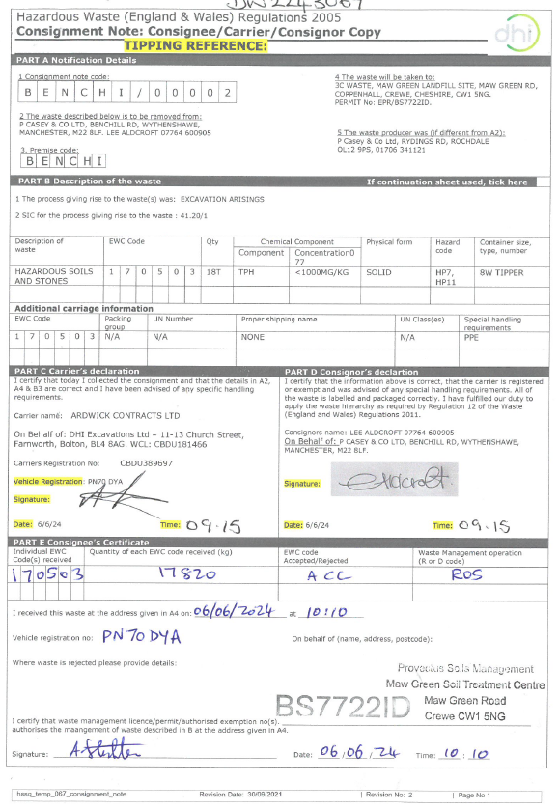
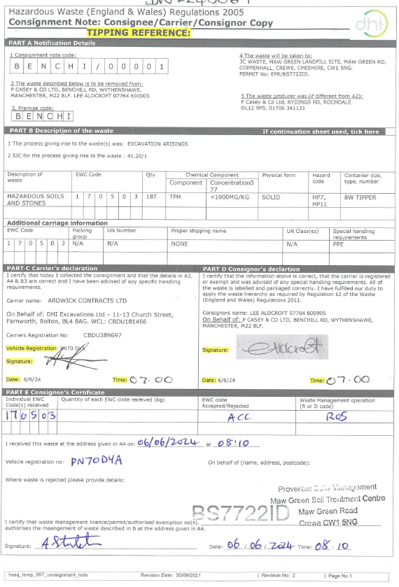

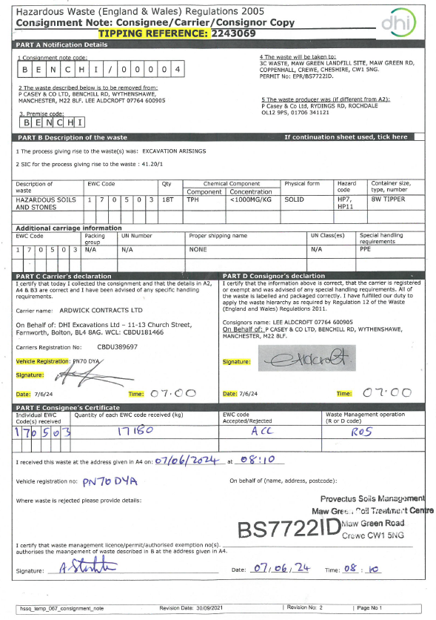
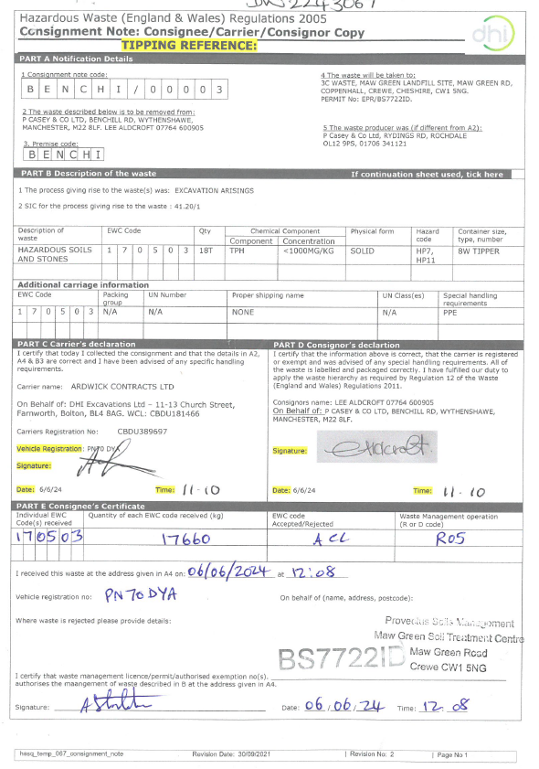

Producer: Casey Group Ltd.
Producer Representative: Jonathan Mills
Haulier: DHI Excavations Ltd
Haulier Representative: Sean Kingston.
Disposal Company: Provectus c/o 3C Waste Ltd.
Disposal Address: Maw Green Landfill Site, Maw Green Rd, Coppenhall, Crewe, CW1 5NG.
Permit Ref: EPR/BS7722ID.

Segregation statement compiled by:
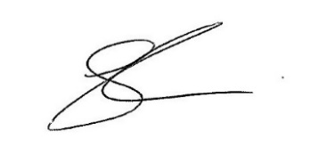
Sean Kingston

