1.0 – Transport & Delivery of Materials
- Materials will be delivered to the site by a flatbed delivery vehicle.
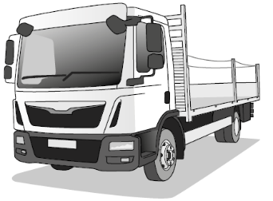

- Melbrooke Services Ltd to provide safe access to the work area for the delivery vehicle to offload materials, adjacent to our work area.

- LPG Scaffolding Ltd will provide a banksman for any vehicle movements around the work area.

- Materials will be unloaded via manual handling.

2.0 – Method of Handling Materials
- Raising or lowering by hand to hand within a designated safe lifting bay.  - Rope & Wheel in line with NASC SG9 & SG6 (Current Edition) | 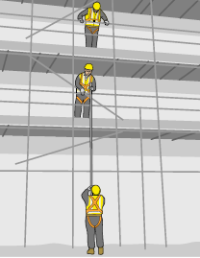
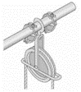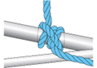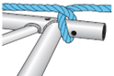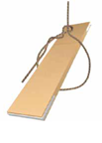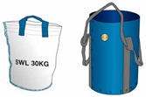
- Walked to the workface manually, using lifting aids where possible
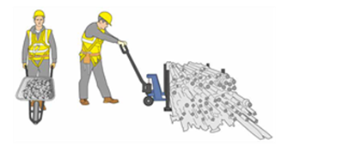
- Materials will not, under any circumstances be thrown, dropped, or “bombed”.

3.0 – Operatives & Required Competence
No. of Operatives Involved: - | 2-3
- All Operatives to work under the direct supervision of an LPG Scaffolding Supervisor
- All Operatives will carry a CISRS card of the relevant grade to the tasks they are performing.



- Scaffold Inspectors will hold either a CISRS Advanced Scaffolders card or a CISRS Advanced Scaffold Inspection card.

4.0 – Personal Protective Equipment
All operatives will wear a minimum of:

- Safety helmets (BSEN 397)  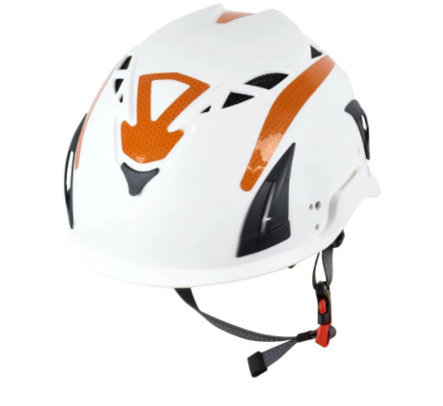 | - Hi-Vis Vest (EN 471)   | - Gloves (BSEN 420 & BSEN 388)  
- Eye Protection (EN166/EN160) Only when required by risk assessment and/or site rules.   | - Boots with steel toe cap and steel mid-sole (EN20345 S3)   | - Full body harness & Twin Tailed Lanyard (EN361): worn by Scaffolders and Trainee Scaffolders used in line with NASC guidance SG4: Current Edition    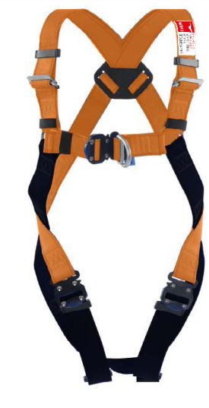

4.0 – Personal Protective Equipment (Site Specific) Check as required
 | Flame retardant Coveralls |  | Hearing Protection |  | Face Sheild |  | Respiratory Protective Equipment

5.0 – Scaffold Specification
The scaffolds will be built in accordance with the attached TG20 Compliance Sheets.

The scaffolds are a tube & fittings TG20 Compliant Independent Scaffolds.
All operations will be carried out in line with the following technical and safety guidance notes at their latest revision.  - TG20 - Technical Guidance for Scaffolding with Tube & Fitting  - TG4- Anchorage Systems for Scaffolding  - SG4 - Preventing Falls in Scaffolding Operations  - SG16 - Management of Fall Protection Equipment  - SG19 - Safety Harness Rescue Procedures  - SG34 - Guidance on Protection of the Public  - All other NASC safety publications | 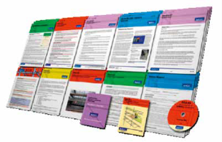

6.0 – Scaffold Materials
The scaffolds will be constructed of scaffold tubes, prefabricated transom units, fittings, timber scaffold boards & ladders.
- All materials will be in accordance with a relevant British Standard or their equivalents:
- Scaffold tube (BSEN 10219).
- Proprietary fittings to current standard BS 1139 (BSEN74).
- Ladders (BSEN 131 and/ or manufacturers standards).
- Scaffold 225mm x 38mm (BS 2482:2009) from certified sustainable source (i.e. PEFC/ FSC).
- System Scaffold (BSEN 12810 & manufacturers standard)

(Purchased through recognised national suppliers and will comply with all relevant British Standards).
Standard Scaffold Materials Added Measures Prior To use
- Scaffold tubes will be straight, free from any grease and any visual damage.
- Scaffold fittings will be free from visual damage with free running nuts.
- Scaffold boards will be free from visual damage or warping and will be complete with nail plates or end bands.
- Ladders will be free from visual damage.
- Materials will be visually inspected before use by the operative, defective materials will be segregated to prevent use.

6.1 - Tools & Equipment
- Scaffolders will use standard scaffolding hand tools (e.g. 7/16 lap spanners/250mm boat levels).
- Battery-powered reciprocating saws
- Anchor ties to be installed using battery-powered portable hand drills, nylon anchors, and eye bolts.
- Impact wrenches able to achieve the required 50n/M of torque required to secure scaffold fittings.
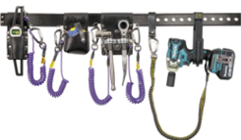

7.0 – Scaffolder User Requirements
PRE-ERECTION: Melbrooke Services Ltd must provide a firm and level base for the scaffold and ensure the work area is clear and capable of withstanding any imposed loads from scaffold.
PRE-USE CHECKS: Every user must check the structure before use as per Regulation 13 of the Work at Height Regulations 2005.
SCAFFOLD USE: Scaffold users are responsible for ensuring that the structure is used only for its intended purpose and within its specified loading limits.
INTERFERENCE: Modifications to scaffolding must only be carried out by competent scaffolders.
MELBROOKE SERVICES LTD is responsible for ensuring that scaffolding is not interfered with, e.g. overloaded with materials, removal of ties, guardrails or scaffold boards, etc.
GAPS IN PLATFORMS: Where platforms have inside boards, Melbrooke Services Ltd is to be aware this will create a 50mm gap between the main platform and the inside boards. Unless specifically highlighted as a risk by Melbrooke Services Ltd, this gap will be in place on all scaffold lift levels.  Melbrooke Services Ltd is to ensure that their own risk assessment in place highlighting this gap to all users of the scaffold, and all people whom it may concern. Internal service gaps of up to 225mm will be considered acceptable as per TG20: Current Edition Internal edge protection or a safe system of work may be implemented as per Melbrooke Services Ltd requirements if identified as necessary following risk assessment. | 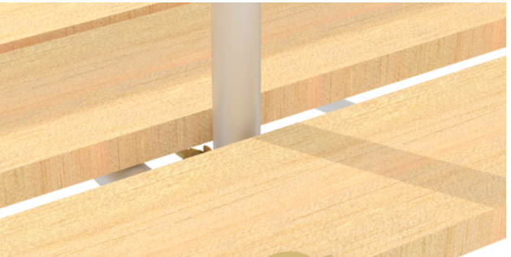
 | 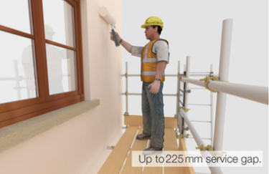
SCAFFOLD INSPECTION: Melbrooke Services Ltd is to ensure statutory inspections are carried out and recorded by a competent person per the requirements of the Work at Height Regulations 2005.
WELFARE & FIRST AID: Melbrooke Services Ltd to provide welfare and first aid facilities for operatives. |  | 
PROXIMITY HAZARDS: Melbrooke Services Ltd must notify us of any information that may affect scaffolding works (e.g. overhead lines, underground services, etc.). |  | 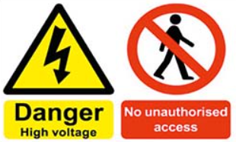
QUERIES: Any queries or concerns relating to the use of the scaffold should be raised with the Site service manager or Manager responsible for the project.

8.0 – Standard Safe System of Work – SG4: Current Edition
STEP 1  Erect base lift of scaffold, ensuring that a guardrail is installed 1m above ground level. | STEP 2  Unfold the Scaff-Step ladder, taking care to avoid placing fingers in a trap area.
STEP 3  Connect Scaff-Step to guardrail ensuring that the claws are fully engaged.  Place the ladder carefully on the boarded lift, making sure that the ladder is at the correct angle (75°) and that the feet are placed squarely on the platform  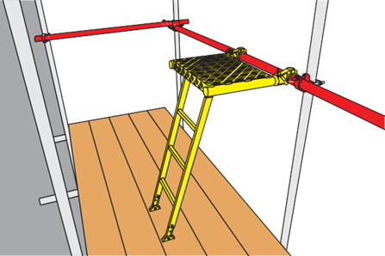 | STEP 4  Connect lanyard to the back ledger at the 2m level on the opposite side.  Grip either the transoms or ledgers overhead or the step-up body and ascend the step-up  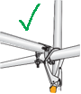
STEP 5  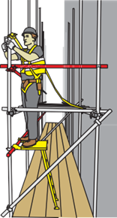  Install intermediate transoms either side of the working position to prevent sideways falls. Install upper and lower guardrails to the next level whilst standing on step-up, relocating as necessary to make any horizontal joints that may occur in the middle of a bay. | STEP 6  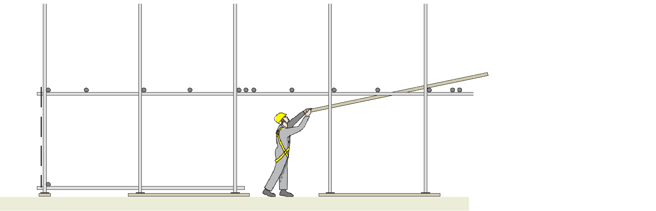  Reposition the step-up (release claws) and continue progressively installing guardrails on the lift above for the full length of the scaffold. Board out platform from below to complete the lift.

9.0 – Independent Scaffold Erection Procedure
- Scope: This methodology covers the erection, adaption and dismantling of tube and fitting Independent Scaffolds.

- MELBROOKE SERVICES LTD must give permission to commence work, following a site induction and ensure that the foundations which will be supporting scaffolds are structurally capable of supporting the scaffolds weight and use.

- Before scaffolding work can commence, Site Supervisors/ Charge Hand/ MELBROOKE SERVICES LTD to check all operatives are provided with the correct PPE and protective clothing, and that this is being worn correctly. Establish and control a suitable exclusion zone, with physical barriers and warning signage, at or underneath the work area to segregate work from pedestrians, the public, plant and vehicles to reduce and/ or remove the risk from falling objects. |  | 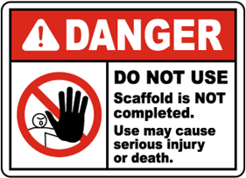
- Materials are to be carried to the workface and stored neatly in a segregated area with sufficient space for persons to pass safely, with no emergency routes to be impeded at any time.

- Base out the scaffold with standards placed centrally on base plates and sole boards where required orientated in a direction which does not cause tripping hazards, on a firm & level surface.

- Connect a ledger to the standards using right angle couplers, either as a kicker lift at ground level or at a height not exceeding 2.7m where site access is required through the base of the structure. Level the ledgers, ensuring that the scaffold is suitably stabilised throughout.

- Transoms may be connected using either putlog couplers or right angle couplers (subject to site conditions). These can then be levelled across the width of the scaffold in order to set the height of the opposite ledger, which is to be installed on right angle couplers.

- When the 1st bay of the scaffold is erected an “incomplete” scaffold sign or similar will be displayed on the scaffold. unauthorised access will be restricted by physical barriers.  - Standards will be spaced as per the compliance sheet and will be staggered,  ensuring no more than three sleeves per bay.  - Ledgers must also be staggered ensuring no more than two sleeves per bay. If this cannot be achieved, the connection must be spliced |  |  |  | 
- Erect diagonal bracing within 300mm of a node point, connected with swivel couplers attached to the standards or right angle couplers secured to structural transoms.

- Ledger bracing will be fixed at alternate pairs of standards where required, and at the ends of each elevation unless the scaffold returns around a corner (provided there is a façade brace within 6 bays)

- The safe system of work shown in section 8 will be used to reduce risks from working at exposed edges. Scaffolders must be clipped on when working outside of a Safe Zone.

- Erect guard rails on the next lift using Scaffolders Step-Up. Guardrail to be left in position on all lifts (include non-working as per SG4: Current Edition Install guardrails on all sides of the scaffold where there is a risk of a fall, i.e. gap > 225mm between the scaffold and a building façade.

- Ties will be installed progressively in accordance with the attached TG20 Compliance Sheet, with any testing carried out before erecting the next level of scaffolding.

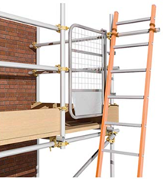 | - Erect a ladder access from the base of scaffold (as early as possible during erection). Ensure ladder that the erected at 4:1 angle, lashed securely to scaffold, with a self-closing gate fitted. |  | 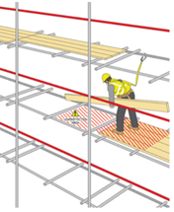
 | - When raising scaffolding boards to the next lift scaffolders will use personal fall arrest equipment and work progressively back towards the ladder access bay.
- On finished working platforms, double guardrails and toe boards erected as per the Work at Height Regulations (e.g. no vertical gaps greater than 470mm, handrail is min 950mm high).

- Every toe board must be fixed with a minimum of two fittings. This may necessitate the installation of a sacrificial ‘Dead Man’ tube. If so, this tube must be connected with load bearing couplers with the upper right angle coupler inverted to denote it’s position.

- Prevent access to unauthorised persons by physical means such as double guardrails or similar and display clear ‘Do Not Use’ signage.

- Attach high visibility foam tube covers and ensure all sharp edges and protruding bolts are covered

- On completion of the task all excess materials must be cleared away

- Competent person to inspect scaffold and ensure it is fit for use.

- Dismantle exclusion zone and warning signage.

10.0 – Handover & Inspection
- On completion, the charge-hand Scaffolder will inspect the scaffold to ensure it is built to the agreed specification and requirements and will show the scaffold to Melbrooke Services Ltd.

- Once both parties are satisfied with the works, a handover certificate will be issued to Melbrooke Services Ltd with both parties signing in acknowledgment and acceptance of works completion.

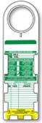

- Once handed over, control of the scaffold has been passed over to Melbrooke Services Ltd who will be responsible for scaffold’s security and use.

- The appointed Scaffold Inspector will inspect the scaffold in accordance with The Work at Height Regulations 2005 and record the findings in the schedule 7 inspection register at periods not exceeding every 7 days, after adverse weather or following significant alteration.

- Records of inspection must be kept on-site and for at least 3 months following the completion of the site.

11.0 – Dismantle Procedure
- The Contractor will ensure that all lifts are clear of loose debris or materials prior to work commencing and the scaffold is safe to dismantle.

- If the scaffold is not safe to dismantle inform your Site service manager/Manager. Do not start work until you have contacted your Site service manager/Manager.

- Prior to dismantling the scaffolding will be inspected to ensure safety (in particular the ties and bracing), and any required repairs will be done prior to commencing work.

- When working at height, loose materials must never be left in a position where they could fall or get knocked over.  - Stillage’s bins or bags must be utilised whenever possible to store equipment in a safe manner. Work areas must be inspected before leaving it to ensure the area is left in a safe and tidy condition.  Typically, the dismantling procedure will be the sequential reverse of the erecting procedure | 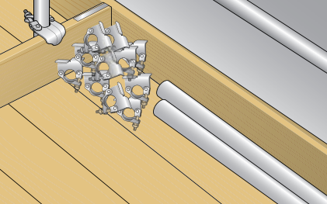
- Site Supervisor/ the Contractor to ensure exclusion zone is in place and that no workers are on scaffold lifts where dismantling is to take place. Access to incomplete scaffolds to be prevented by providing barriers and signage.  - Whenever possible, materials will be transferred from the scaffold to designated storage areas by mechanical means, e.g. crane, lorry loader. | 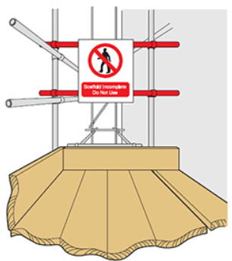
- If no mechanical means of moving materials is available, materials to be manually passed down through the scaffold before being stored neatly in an area agreed with the Contractor. Materials will not be thrown from the scaffolding.

- Scaffolders must create a ‘Safe Zone’ as a priority (as per SG4: Current Edition)

- Scaffold boards/toeboards or platforms may be removed from the top platform to the lift below, working progressively back towards a ladder access provided a maximum gap of one board is not exceeded.

- Guardrails and standards to be progressively removed from the top lift using the Scaffolders Step-Up and passed down to lift below.

- Ledgers, transoms, and bracing will then be dismantled and stored on the lifts below or passed hand to hand to ground level.

- The removal of ties or bracing will only be done after ensuring that any required additional ties or bracing are in place lower down.

- All dismantled scaffolding materials to be passed down through the scaffold and only stored directly on the scaffold where no alternative at ground level is available, with the weight evenly distributed to avoid over-loading.

- Materials to be stored in an agreed area or directly onto the delivery vehicle. Any operative working on the trailer must be protected from the risk of falling with (edge protection).

- On completion of the task, all excess materials must be cleared away and the fully loaded vehicle will be removed from site. The lead scaffolder will then check the area immediately surrounding the dismantled scaffold in order to ensure that dismantling or works carried out from the scaffold have not resulted in any additional hazards.

- If hazards are identified, then scaffolders will segregate the area where possible/necessary and report immediately to Melbrooke Services Ltd

12.0 – Rescue Plan – Type 1 – Pull Suspended Operative onto Working Scaffold
Prior to commencing work ensure that there is sufficient scaffold material available, to hand, to affect a 'Pull onto Boards/Cantilever rescue (Boards/Tubes/Hop Ups and Ladders).

Check that all lifts are free from obstructions such as sheeting, ranch boarding etc. or other obstructions, which may hinder a rescue.

Fallen operative suspended within or adjacent to scaffold structure on Common Scaffold (independent, birdcage, tower etc.).

If conscious, can the suspended person recover himself or assist in their own rescue by climbing back onto the platform. Can they support themselves on part of the structure, so their harness does not solely support them?

Raise the alarm to the Emergency Services, Supervisor, Site Manager. Ensure that the Emergency Services are given the correct location of the incident and the condition of the suspended person. The Emergency Services may offer advice on how to rescue the suspended person if they are badly injured.

If the suspended person is badly injured it may be safer to erect a cantilever to allow the suspended person to stand on or be rested on until the Emergency Services arrive on site.
.
- Scaffolders in the team may gain access to the suspended person via the nearest lift. If the lift is not boarded, scaffolders will work to SG4: Current Edition guidance, to create a safe platform.

- The rescue team must remain clipped on to a secure anchor point, wherever possible in a work restraint position.

- Once safe to do so, the fallen person may be pulled onto the lift and the post rescue actions in Section 12.1 can be carried out

- One of the lanyard clips will be relocated to an anchor point if using twin tail lanyards where the casualty is resting. Only when this is done can the supporting / second clip be relocated. The harness/lanyard shall remain attached until safe access and egress can be created or until the first aid team arrive.

- Before allowing the emergency services access to the scaffold at height, the structure must be assessed, and the emergency services advised of any known hazards.

- If the casualty is not suffering any obvious injury, they must still be taken to hospital for checks regarding possible internal injuries.

- The Contracts/Site Manager must initiate an incident investigation promptly.

- The harness and lanyard that was involved in the incident must be retained by the company.

RESCUE PLAN GUIDE

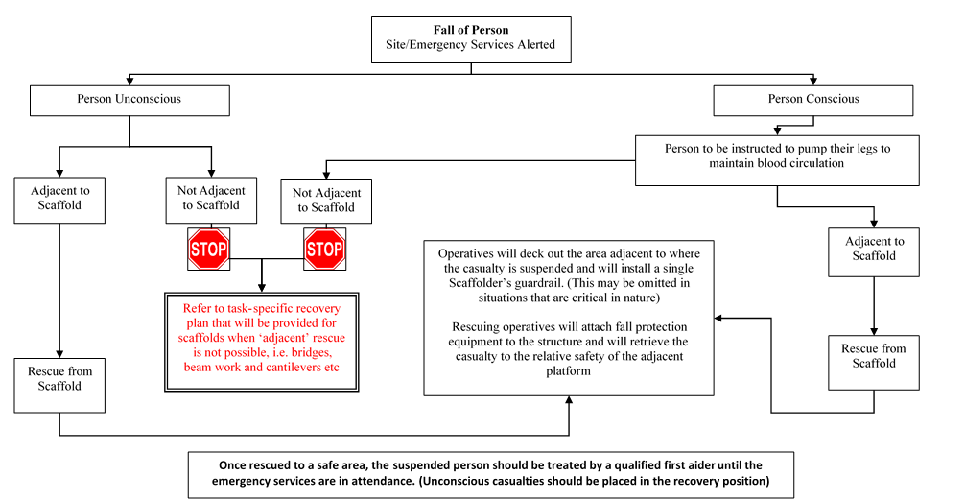

12.1 – Post Rescue Action
Anyone suspended in their harness must be treated by a medical professional (even if they feel OK). First aid treatment alone will not suffice.
All casualties are to be initially assessed by competent First Aider, following the standard First Aid treatment (ABC Management), as below:
- First Aider to provide standard First Aid treatment (ABC Management)
- A & B – Assess casualty’s airway and breathing condition
- C – Check casualty’s pulse/ signs of bleeding
- D – Assess the level of consciousness using AVPU scale

A – Are they alert? Are their eyes open? Do they respond to questions?
V – Do they respond to Voice? Do they answer questions/ obey commands?
P – Do they respond to Pain? Do they open their eyes or move if pinched?
U – Are they unresponsive to any stimulus (i.e. unconscious)?
Conscious Casualties:
If the casualty is conscious then the following process should be followed:
- Casualty should be encouraged to remain in an upright position and walk around if possible
- First Aider to remain with the casualty and accompany them to hospital for medical assessment
- First Aider should encourage the casualty to remain hydrated until reaching hospital. NB. This does not include diuretics such as tea and coffee; water is the preferred option.
Unconscious Casualties:
If the casualty is unconscious, then the following process should be followed:
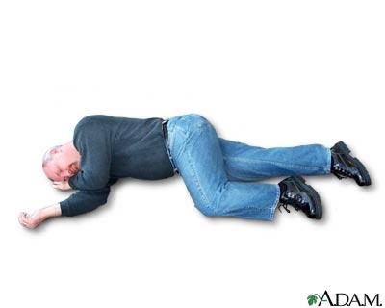

- First Aider to place patient in the traditional recovery position (as pictured) until the emergency services are in attendance.
- Advise the ambulance service that the patient needs to be treated for orthostatic shock or intolerance, which should be treated similarly to crush injuries.
Important Note: Following a fall, any fall protection equipment should be quarantined and retained for inspection as part of the incident investigation process.
The scaffold must be inspected before work can continue on the structure.

13.0 – Environmental Impact & Waste Management
- Scaffold materials will be removed from site on completion of the work. Packaging materials will be segregated into the on-site waste disposal bins/ skips.  - Hazardous/ COSHH substances will be disposed of in the designated waste disposal units. It is not anticipated that any hazardous materials shall be used during this operation.  - Materials will be subject to good housekeeping by stacking materials safely, securely, neatly, tidily and away from access/ egress routes.  - Noise levels will be kept to a minimum where possible. | 

14.0 - Operative Acknowledgement
- By signing below, I confirm that I have been briefed on and fully understand the contents and requirements of this scaffold plan.
- I agree to fully comply with the stated requirements and will take all reasonable precautions at all times to safeguard the Health, Safety and Welfare of myself and others.

15.0 - Operatives Information & Acknowledgement
Name: | Qualifications: | Signature: | Date:

Task/Activity | Ref | Assessor | Date of Assessment | Review Date
Independent Scaffolds |  | Isaac Morrison | 15.10.2025 | 15.10.2026

Who is at Risk?
LPG Scaffolding Operatives | Other Operatives | Public
A | B | C

Key to Risk Assessment
Severity | Likelihood | Risk Factor (Severity x Likelihood)
1. Minor Injury | 1. Unlikely | Low = 1-4
2. 1 to 7 Day Accident | 2. Possible | Medium = 6-9
3. RIDDOR Reportable | 3. Probable | High = 12-16
4. Fatality/Disability | 4. Certain

Hazard | Hazardous Effect | Persons Effected | Severity x Probability = Risk |  |  | Control Measure | Residual  Risk
Hazard | Hazardous Effect | Persons Effected | S | P | R | Control Measure | Residual  Risk
Work at height | Falls from height, resulting in Fatality, Major Injuries | A | 4 | 2 | 8 | - All Operatives to be issued with fall arrest equipment.  - Line-management to ensure compliance with NASC Guidance Note SG4: Current Edition  - All operatives to receive training in the use of fall arrest equipment in line with SG4: Current Edition  - Line-management to monitor operations to ensure compliance, as required by the procedure.  - Management to consider the hierarchy of control measures within the Work at Height Regulations 2005 when formulating methods of work. | 4x1  4
Work at height (Falls of materials) | Impact injuries  Fatality, major injuries  Damage to equipment, property etc. | A & B | 4 | 2 | 8 | - Post warning signs and segregate the area below in general or public access areas.  - All raising and lowering of materials to be carried out in a controlled manner i.e. Hand to hand, by light-line and fitting bags, gin wheel and rope, mechanical winch etc.  - Never throw materials or allow them to drop (Bombing).  - Materials to be stored in a safe and secure manner, to prevent them accidentally falling or being knocked off the working platform when at height.  - Long tube to be stored horizontally and only positioned upright immediately before use. When positioned up right always rest into a corner to help prevent falling.  - Correct hitches used and tube only raised or lowered in 1’s or 3’s.  - PPE – Wear head protection | 4x1  4
Handling Materials by hand | Manual Handling Injuries | A | 3 | 2 | 6 | - Carry out a risk assessment as required by the Manual Handling Operations Regs. 1992, to minimise the risks involved.  - Kinetic handling training provided for all scaffolding operatives.  - Operatives to use the correct manual handling techniques.  - PPE – Use suitable hand & head protection and safety footwear. | 3x1  3
Slips, trips & falls at the same level. | Cuts, bruises, sprains and strains. | A & B | 3 | 2 | 6 | - Maintain high standards of housekeeping.  - Line-management to monitor housekeeping standards.  - Keep access and egress routes clear and segregate the work area from others and vehicles in access areas.  - PPE - Use suitable safety footwear.  - Report any tripping hazards to Melbrooke Services Ltd | 3x1  3
Incorrect erection. | Full/partial collapse/structural failure. Fatality(s), Major injury(s), damage to equipment, property etc. | A & B | 4 | 2 | 8 | - Scaffolding operatives to be trained through the CISRS, to the appropriate level for the task.  - Supervisors to ensure that the work is allocated to competent Scaffolders.  - Line-management to ensure adequate levels of imposed supervision and monitoring.  - Scaffolds constructed to the relevant British/European Standard BSEN 12811 TG20: Current Edition  - TG20 Compliance sheets to be followed for routine erection of structures included within TG20: Current Edition and the e-guide.  - Pre-start briefing to be given to all operatives, covering the safe system of work and any specific control measures.  - Ensure adequate ground support for the ground conditions to support and spread the loads.  - Seek design input for non-routine, complex, special purpose, support, scaffolds etc. in line with the Design Input Guide  - Scaffold to be inspected prior to being taken into use for the first time by a competent person. Handover certificate to be issued or ScaffTag completed, as applicable, highlighting any restrictions. | 4x1  4
Component failure | Full/partial collapse/structural failure. Fatality(s), Major injury(s), damage to equipment, property etc. | A & B | 4 | 2 | 8 | - All components to comply with the relevant British and European standards.  - All materials to be subject to a thorough inspection when returned to the yard and general visual inspection before use by the scaffolding operatives. | 4x1  4
Overloading | Full/partial collapse/structural failure. Fatality(s), Major injury(s), damage to equipment, property etc. | A & B | 4 | 2 | 8 | - Agree specification of scaffolding with Melbrooke Services Ltd before erecting.  - Specify the purpose, max loads and other restrictions on Quote/Tender, Design, Handover Certificate or ScaffTag, as appropriate.  - During erection, alteration or dismantle do not overload platforms with material. Only store minimum amounts at height.  - Install and remove ties and braces progressively. | 4x1  4
Working in adverse weather conditions.  High winds, extreme temperature, snow, hail, frost and heavy rain. | Falls from height/ Falls of materials. | A | 4 | 2 | 8 | - Do not work at height in adverse weather conditions.  - Workforce to be empowered to cease work when they believe local weather conditions may adversely impact on safety.  - Wear appropriate clothing including weather protection clothing.  - Remain well hydrated in warm weather by increasing water breaks | 4x1  4
Work in public access areas. | Collision, slips, trips and falls resulting varying degrees of injuries | A, B & C | 4 | 2 | 8 | - Carry out a specific risk assessment and method statement. Control measures to be considered include: -  - Segregate loading/unloading area.  - Protection canopy and fans etc. as appropriate.  - Position warning signs  - Ensure adequate clearances (i.e. 2.7m high pavement gantry).  - Provide adequate illumination, highlight standards and tube padding, barriers etc.  - Carry out checks following dismantle & report any hazards created. | 4x1  4
Working adjacent to traffic routes or the highway. | Collision with scaffolds or operatives. | A, B & C | 4 | 2 | 8 | - Consult Melbrooke Services Ltd or local authority and agree controls.  - Carry out a specific risk assessment and method statement. Control measures to be considered include: -  - Segregate loading/unloading area.  - Protection canopy and fans etc. as appropriate.  - Position warning signs  - Use timber balks or concrete Kelly blocks to protect the structure from vehicle impact.  - Ensure clearances are maintained i.e. Buses, Lorries etc.  - Illuminate scaffolding.  - Pavement and road closure licences, as appropriate.  - Use signs, cones and barriers as required by the New Streets and Road Works Act and COP. | 4x1  4
Work near overhead electric power lines | Contact or arcing to metal scaffolding components, resulting fatality or major injuries. | A | 4 | 3 | 12 | - Carry out specific risk assessment and method statement. Control measures to be considered, include: -  - HSE Guidance Note GS6 – ‘Avoidance of Danger from Overhead Power Lines.  - Seek advice from Electricity Authority, Melbrooke Services Ltd and Safety Advisor.  - See Risk Assessment GRA Work near overhead electric power lines.  - Refer to LPG Scaffolding assessment for Work Near or Under Overhead Power Lines. | 4x1  4
Poorly specified ties/incorrectly installed ties | Scaffold Collapse | A & B | 4 | 2 | 8 | - Follow a progressive system of work ensuring any stability measures such as returns, buttressing, loading towers, ladder access bays or stair towers are completed before installing the subsequent lift  - Ties to be installed (and tested) in  accordance with TG4: Current Edition – ‘Anchorage Systems for Scaffolding)  - Test results to be documented.  - Operatives to be briefed on manufacturer’s instructions for anchor installation and to provide signatures to acknowledge briefing. | 4x1  4
Installation of drilled scaffold anchors. | High vibration levels, resulting in Hand/arm vibration syndrome resulting in conditions such as HAVS | A | 4 | 2 | 8 | - Use the drill for a maximum of 15min trigger time per day.  - Drill to be maintained and serviced to ensure that it operates to maximum potential.  - Operative to wear gloves when drilling  - Extra care to be taken when hands are cold and wet. Ensure hands become dry and warm prior to operating drill  - Drill bits to be changed at regular intervals to reduce vibration exposure time. | 4x1  4
Installation of drilled scaffold anchors. | High noise levels, resulting in Noise induced hearing loss & tinnitus etc | A & B | 4 | 2 | 8 | - Operatives to wear hearing protection when operating drills with a SNR (Single number rating) of a minimum of 20-35. (At the ear level to be kept at or around 70)  - Operatives using drills and those close by to wear hearing protection. | 4x1  4
Installation of drilled scaffold anchors. | Production of silica dust/asbestos particles, resulting in Mesothelioma, cancer occupational asthma silicosis, COPD. | A & B | 4 | 2 | 8 | - When Extraction Units are Not Fitted: -  - Operators to be wear P3 rated RPE.  - Operators to be face fit tested for the mask they are wearing.  - Confirm tie locations are suitable with Melbrooke Services Ltd before installation. | 4x1  4
Impact Wrench | Vibration  Noise  Wrench falling from height | A & B | 4 | 2 | 8 | - Impact wrench to be used for a maximum of 15min trigger time per day. (Equates to approximately 500 bolts to be tightened or loosened per day)  - Impact wrench to be fully maintained and serviced to ensure that it operates at its maximum potential as detailed in the manufacturer’s instructions. It is able to secure fittings to a minimum of 50Nm of torque.  - Scaffolders to check fitting occasionally (15 fittings or so) with a scaffold spanner to ensure impact wrench is working as intended.  - Operatives to wear hearing protection when operating wrench with a SNR (Single number rating) of a minimum of 25-35  - Operatives using the impact wrenches and those working within the working vicinity to wear hearing protection when in use.  - If used within 2m of an open edge, it is to be secured to the Scaffolder with a suitable tool lanyard. | 4x1  4

