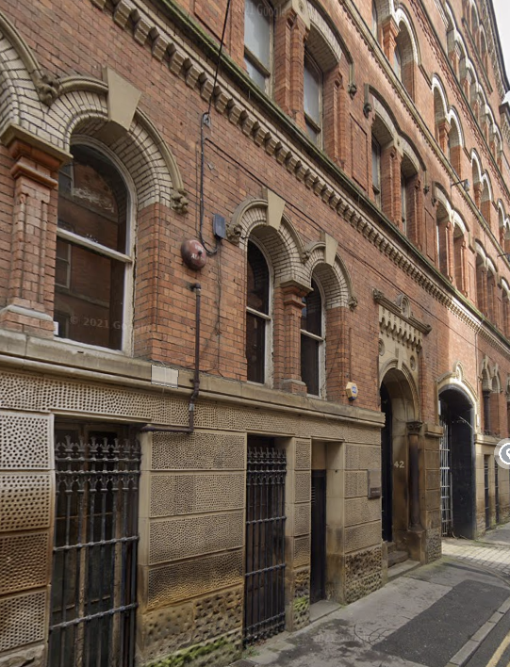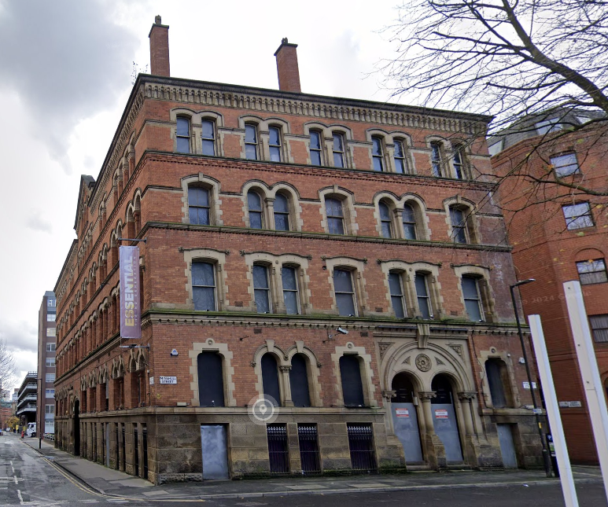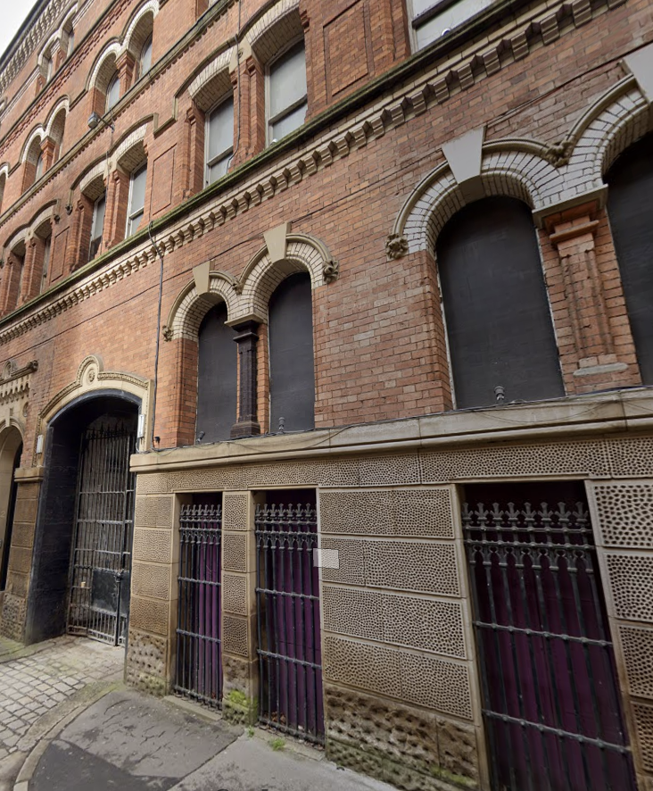

Construction and Environmental Management Plan
42 Bloom Street
8 Minshull Street
Manchester M1

March 2025
MSLSF 002 [CEMP] REV01

Contract number
E19

MSLSF 002 [CEMP] REV01

Document Reference

05-02-25
Date
Ian Russell
Prepared by

28-02-25
Date
Nick Wiggins
Checked by

Date
04-05-25
Shujaat Rasool
Approved by

Revision | Revision date | Status | Author/editor | Required review date | Comments
01 | 24-01-25 | draft | Ian Russell | 1st issue | Awaiting reports
02 | 05-03-25 | Final draft | Ian Russell | Addition of reports
03 |  |  |  | Post building empty and phase 1 strip out clearance
04 |  |  |  | Inclusion of planning conditions
05 |  |  |  | Post final strip out
06 |  |  |  | Review 3 months into build
07 |  |  |  | Completion of build
08

CONTENTS
1.0 | Introduction
2.0 | Regulatory framework & planning conditions
3.0 | Site Location & Project Description
4.0 | Construction programme
5.0 | Roles and responsibilities
6.0 | Information for contractors and visitors
7.0 | Environmental assessment
8.0 | Ecology
8.1 | Bats
8.2 | Badgers (not used)
8.3 | Reptiles
8.4 | Great Crested Newts (not used)
8.5 | Birds
8.6 | Trees and woodland (not used)
8.7 | Invasive plant species
8.8 | Injurious plant species
9.0 | Air quality
10.0 | Dust
11.0 | Site Waste Management Plan (SWMP)
12.0 | Heritage
13.0 | Water use
14.0 | Pollution Prevention & Hazardous Materials Storage
15.0 | Soil and geology
16.0 | Construction lighting
17.0 | Noise and vibration
18.0 | Security
19.0 | Incident response
20.0 | Internal communications
21.0 | External communications
22.0 | Other commitments

1.0 Introduction
1.01 The aim of the Construction and Environmental Management Plan (CEMP) is to set out the responsibilities with regard to compliance with legislation and to implement any mitigation measures.
1.02 This CEMP details management measures to minimise environmental impact from the construction phase of the development, whilst also providing details of how the proposed scheme will be managed during the construction.
1.03 It provides a framework within which the measures will be implemented throughout the project.
1.04 The CEMP provides project-specific management measures and is a dynamic document which should be reviewed if activities or conditions onsite change that may influence management measures.
1.05 This document has been developed to avoid, minimise and mitigate against any construction effects on the environment and surrounding community. It should be considered a living document with reviews being undertaken at set intervals and new information added as appropriate. See front page for review dates.
1.06 For the purposes of this document, the working area is defined as any area where there will be a requirement for temporary or permanent works to facilitate the construction of the development. This includes areas required for access, temporary construction and temporary storage areas.
1.07 A Construction Phase Plan is required by the CDM 2015 Regulations for any construction work carried out by contractors. This CEMP will be prepared to satisfy these regulations and will form the basis of the Construction Pahes (Health and Safety) Plan (CPP). The CPP will be enforced by the Contracts/Project Manager on receipt of client pre-construction information.
1.08 The CEMP and CPP will be checked by the client team or his appointed Principal Designer for accuracy and robustness before commencement of site works. Following agreement of the Plan, this will be issued to the construction team and be updated/maintained on site by the site manager.
1.09 The objectives of the CMP are to:
- Provide information on any environmental and sensitive local receptors relating to the construction of the development and associated infrastructure;
- Set out actions required to manage the specified environmental risks, through consideration of design requirements, monitoring schemes and appropriate method statements.
- Define the requirements for communication of the CEMP to the project team, environmental training and awareness, stakeholder liaison.
- Define the processes for updating the CEMP - management reviews, incident reporting and investigation, etc. The key function of the CEMP is to highlight and manage the specific environmental effects of the construction phase and to ensure that the significant negative effects are mitigated, and where practicable that additional environmental enhancements are delivered through completion of the proposed works.

2.0 Regulatory Framework & Planning Conditions
2.01 Reference planning application XXXXXX, the proposed scheme will create new homes (apartments) within the vacant grade II listed warehouse building known as 42 Bloom Street and 8 Minshull Street , Manchester M1
2.02 The primary requirements of the planning consent are the implementation of this core document; the Construction and Environmental Management Plan (CEMP). The CEMP is required to encompass environmental controls when required with due consideration to relevant environmental legislation. It also ensures that the construction activities are thoroughly planned and will ensure that all health and safety legislation and guidance are complied with and influence all construction activities.
2.03 The CEMP provides the framework for which any requirements of planning conditions can be realised. The CEMP outlines the contractors’ approach to construction and environmental management throughout the planning and construction phases with the primary aim of reducing any adverse impacts from construction on local sensitive receptors.
2.04 The Planning Permission conditions with environmental implications applicable to the Bloom, Minshull project are given below, however we will be reflecting this as best practice in the general construction and environmental management principles;
(Numbered as per planning confirmation letter)
Planning conditions to be inserted when received and the CEMP updated in line with such.

2.05 For the purpose of this CEMP, Development refers to any of the following works;
  - Any work or demolition or site clearance
  - Installation of services
  - Earthworks
  - Drainage/ Flood attenuation works
  - Roadworks
  - Landscape maintenance measures
  - Construction access
  - Construction activities
  - Site investigations
  - Ecological Management Measures
  - Archaeological Investigations
  - Mineral Investigations and extraction
  - Survey works

3.0 Site Location & Project Description
3.01 This CEMP has been produced on behalf of Greybean Limited and with reference to planning application XXXXX
3.02 The site extents of the scheme are shown below, and the land is within the ownership of Greybean Limited
Figure 1: Site Location.

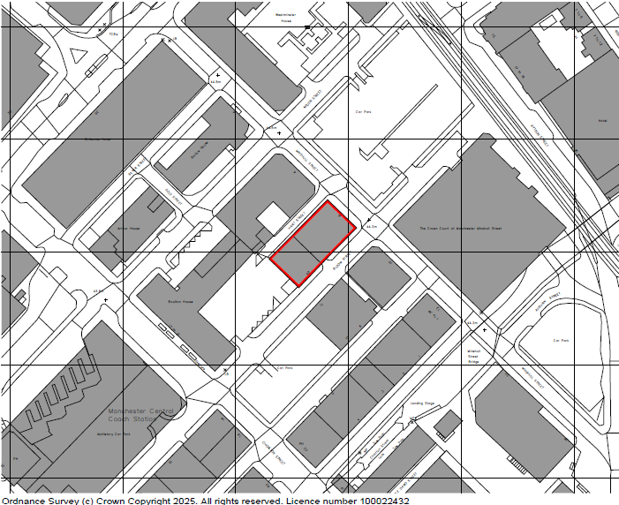
24029-HFR-AV-00-DR-A-9000-P03-Site Location Plan

Overview of site location.
Figure 2: Aerial image of the footprint of the development
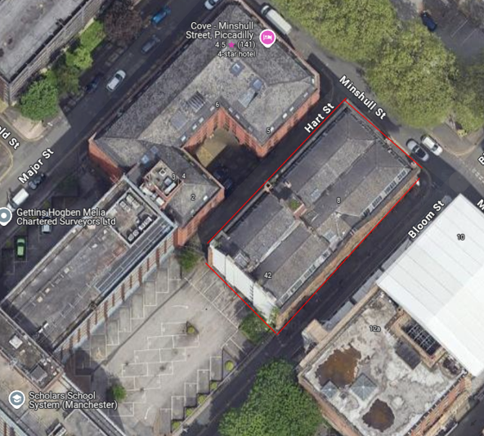

3.03 The site measures approximately XXXXX sqm in area and centres on approximate National Grid Reference (NGR)53º 28’N, 2º 14’W
3.04 The surrounding area is a mix of offices, hotels, car parks and municipal buildings.
3.05 The westerly boundary looks over Hart Street towards the rear elevations of the Cove hotel.
3.06 The Northerly boundary looks over Minshull Street towards the car park off Major Street.
3.07 The easterly boundary looks over Bloom Street towards a building presently undergoing renovation and conversion into flats.
3.08 The southerly boundary abuts the car park servicing the office buildings to the south and west and further looks south to Kaire car parking at 5 Bloom Street Yard.
3.09 There are no schools, hospitals or care homes within 200m of the development boundary.
3.10 The site is dominated by buildings.
3.11 The project entails the creation of accommodation units within the curtilage of the existing building; basement to 4th floor.
3.12 There are no landscape areas within the property boundaries
3.13 The scheme wishes to include the installation of bird and bat boxes (roof areas), subject to listed building consent.
3.14 The works include:
• restoration of facades and windows
• restoration of the roofs and roof lights

3.15 The works comprise of:
- Building contents (stock and goods) removal
- Phased strip out
- Fencing & Hoarding Systems
- Drainage and service ducts
- Internal alterations and additions
- Statutory Undertaker’s service connections
- Temporary site accommodation works

3.16 Site Hours of Work:
08:00 - 18:00 Monday to Friday
08:00 – 13:00 Saturday (when required)
- No construction will take place on Sundays and Bank Holidays
- In order to maintain these working hours, contractor(s) will require a period of 30 minutes before and at the end of the working shift to start up and close down the works activities.
3.17 During the construction period it may be necessary, in exceptional circumstances, to work outside the prescribed working hours. Should this occur, the hours and duration of these works will be subject to consultation with Manchester City Council.

4.0 Construction Programme
4.01 The detailed Construction Programme will be made available for review in the site office.
4.02 The key dates presented in the programme are as follows:
Key milestones | Date
Project start | Q2 2025
Site access - Bloom Street, Hart Street and Minshull Street | Q2 2025 to  Q4 2027
Set up site compound - Anticipated as sharing the road closure at Bloom Street and use of internal areas for site welfare | Q2 2025
Preparing for completion – removal of fencings, hoardings, site set up. | Q4 2027
Project completion | Q4 2027

4.03 A full copy of the up-to-date construction programme will be available from the site manager.

5.0 Roles and Responsibilities
5.01 The Construction Manager is responsible for:-
• Ensuring that the CEMP is developed & held on site and that it is implemented throughout all phases of the project. Ensuring the CEMP details are updated as and when relevant information is provided by the stakeholders associated with each section of the CEMP; e.g. further consent conditions, pre-construction surveys, etc.
• Maintaining the CEMP and ensuring that all contractors and visitors comply with it.
• Ensuring that environmental issues identified within the Pre-Construction Information and the pre-construction site surveys and relevant information gathered from agencies, local councils etc are addressed.
• Producing environmental project specific controls for all significant risks identified and implementing control measures to minimise the risk of damage to the environment.
• Communicating the CEMP and other related documents to employees, contractors and client representatives.
• The Contracts Manager shall nominate and appoint an experienced Environmental Advisor.

5.02 Contractors and visitors to the project will be responsible for:-
• Ensuring that the control measures identified from environmental surveys are implemented as they are relevant to their work / visit.
• Ensuring that the project management team are notified of any nonconformance of control measures or environmental incident where the environment has been put at risk.

5.03 The Site Manager is responsible for:
• Ensuring the site and all stored materials and chemicals are safe and secure;
• Ensuring the F10 notice is correct and displayed, and all signage is in place, especially indicating where and whom visitors should report to is clearly displayed.
• The site is kept in a tidy and orderly fashion. Waste will be managed in compliance with the Site Waste Management Plan (SWMP).
• Controlled access arrangements as so those entering site may avoid hazards.
• Emergency egress arrangement so those leaving site in the event of a pollution or spillage incident may do so safely.
• There are First Aid Facilities and appropriately trained First Aid staff are on site; spill kits are available, and appropriately trained staff are on site.

Ensure all those that work on site:
• Have a Site Induction including briefing on environmental issues pertinent to the project and relevant toolbox talks.
• Understand and obey the Site Rules.
• Are made aware of the Emergency egress arrangements, Muster points, First Aid facilities and First Aiders, spill and clean up procedures.
• Read and understand the site hazard board.
• Have current certification for activities as required.
- Are aware of all environmental matters which arise on site.

Ensure the activities on site:
• Are carried out under Client Operational Safety Rules .
• Have, task specific risk assessments and method statements (RAMS) in place identifying any environmental issue which may be applicable.
• Are carried out in accordance with the requirements of any associated RAMS.

5.04 The site HSEQ Advisor is responsible for:
Ensuring work is carried out:
• In a safe manner
• In accordance with any manufacturers’ instructions etc. and good standards of workmanship.
• Ensure site staff are working in accordance with agreed Risk Assessments and Method Statements (RAMS) particularly where activities have the potential to cause environmental harm.
• To complete the site waste management plan and ensure it is followed.
• Ensure that the CEMP is implemented throughout all phases of the project.
Monitoring HSEQ issues by:
• Carrying out daily checks on site to ensure the site is secure and tidy
• Weekly checks and “toolbox talks” carried and recorded. Weekly site audits.
• Consulting workers on the effectiveness of measures to reduce risk to the environmental, reviewing and improving conditions or methods/procedures where appropriate.
• Keeping records of and reporting any accident, incidents and near misses.

5.05 The Environmental Advisor shall ensure work is carried out:
• In accordance with legislation & consents, objectives, targets and the Construction Environmental Management Plan with regards to any Environmental activities on site.
• Ensure site staff operates in accordance with agreed Risk Assessments and Method Statement (RAMS) and in accordance with the xxx induction and toolbox talk training with regards to environmental risk.

Monitor/Report Environmental Issues by:
• Ensuring compliance with Environmental legislation & consents, objectives, targets and the Construction Environmental Management Plan.
• Carrying out Inspections, Audits and Non – conformance reporting.
• Responsible for delivering environmental training.
• Environmental Advisor to liaise with Health and Safety advisor to complete the site waste management plan and ensure it is followed.
• Environmental performance data reporting.
• Ensure work is carried out in accordance with the Environmental Statement.
• Compliance with environmental legislation, consents, objectives.
• Targets and other environmental commitments

5.06 The Public Contact Officer (may be the site manager who is often best placed to liaise with neighbours) is responsible for:
• Acting as the first point of contact for members of the public.
• Arrange and manage public forums and open days for the project and address any concerns. Ensure all local residents and stakeholders are kept informed of progress and key issues.
• Establish and maintain relationships with key stakeholders.
• Responsible for the dissemination of the construction programme to all interested parties including any work generating high levels of noise, large vehicles/traffic disruption etc.
• Carry out door-to-door home visits with local residents, as appropriate
• Coordinating work, questionnaires, providing works information, dealing with queries, responding to complaints and resolving concerns.
• Production of newsletters, bulletins, posters etc. and display of same throughout site offices and the local area on a regular basis to raise awareness of current issues both within the project team and throughout the local community.

5.07 The Project Manager will be responsible for
- monitoring communications between all relevant parties to the project ensuring that all environmental matters to the project are discussed and managed and observation of the communications will be documented in the weekly site meetings and sent by e-mail. In addition, a copy of all correspondence will be held in this file.
- Relevant site layout and location plans/ CDM drawing detailing the location and construction of the site compound, storage locations and car parking are to be displayed on an information board at the site entrance.

6.0 Information for Contractors and Visitors
6.01 All contractors and visitors to the site will be made aware of the Environmental policy and the controls applicable to their presence and activities on site including but not limited to:
• Method statements
• Risk Assessments
• Site induction which includes Environment briefings
• Toolbox talks.

7.0 Environmental Surveys and Assessment
7.01 A habitat survey (ecological survey) was carried out by Rachel Hacking Ecology on the 3rd of February 2025 to assess existing flora and fauna, and habitat. The survey advises on recommendations, mitigation and enhancement measures. RHE.4461 Preliminary Ecological Appraisal at 42 Bloom Street, Manchester 2025 REV.A
7.02 The CEMP reflects the information within the reports and provides information to assist in the preparation of RAMS to each work activity to be undertaken and the potential for them to impact on the environment.

8.0 Ecology
8.01 Desktop and Field surveys of the site have been completed by qualified and experienced ecologists. All habitats within the proposed works area and immediately adjacent to the proposed scheme footprint were noted, and the potential for protected or otherwise notable species was assessed. Where any incidental sightings or indirect evidence of species presence were seen, this was recorded.
The site is located in Manchester City Centre and is immediately surrounded by commercial properties, car parks, and ongoing development. Occasional scattered trees are present adjacent to the northeast and south. Rochdale Canal is present within 70m of the site. The site and its surroundings will be subject to high levels of artificial light.
8.1 Bats
8.1.1 All bat species, their breeding sites and resting places are fully protected by law, namely the Conservation Regulations 2010 (as amended), Wildlife & Countryside Act 1981 (as amended), Natural Environment & Rural Communities Act 2006 (NERC).
8.1.2 The site comprises a large former warehouse building. No other habitats are present. The site offers low potential to support roosting bats. (Evidence of previous use by Feral Pigeon was recorded).
8.1.3 One emergence survey should be undertaken between May and September (bat survey season) to establish the status of roosting bats.
8.1.5 Incorporation of bat bricks/boxes within the development is proposed by the developer
8.1.7 If bats are encountered during construction, contractors are to be advised to stop work immediately and contact the consultant ecologists for advice and the production of a suitable revised method statement.
8.1.8 Risk assessments & method statements (RAMS) from contractors will be scrutinised and authorised before work commences to ensure the requirements above are understood, factored into working methods and adhered to.
8.2 Badgers
8.2.1 Badgers and their Setts are protected by the Protection of Badgers Act (1992) and as such it is an offence to intentionally kill or injure a badger or to damage or destroy their setts or sett entrances.
8.2.2 The site offers no habitat for badgers
8.3 Reptiles
8.3.1 The project surveys have shown no suitable habitat for Reptiles
8.4 Great Crested Newts (GCN)
8.4.1 Great Crested Newts (Triturus cristatus) are protected by the Conservation Regulations 2010 (as amended), Wildlife & Countryside Act 1981 (as amended) and Natural Environment & Rural Communities Act 2006.
8.4.2 There are no ponds within 500m of the site and great crested newts are considered to be absent.
8.5 Birds
8.5.1 All birds, their nests and eggs are protected by Wildlife and Countryside Act (1981) under which it is an offence to intentionally kill, injure, disturb or take any wild bird. This legislation and its requirements should be highlighted in staff inductions, toolbox talks and signed by all contractors, operators and sub-contractors.
8.5.2 Signs and/or evidence of nesting birds were searched for within the interior space of the building. Evidence of previous use by Feral Pigeon was recorded.
8.5.3 Feral Pigeons can nest at any time of year. This species can be controlled under a general licence. It is recommended that a suitably qualified pest control contractor is commissioned if nesting pigeons are encountered.
8.6 Trees & Woodland
8.6.1 Occasional scattered trees are present adjacent to the northeast and south of the site. These will not be affected by the development works
8.7 Invasive & Injurious Plant Species
8.7.1 Section 14(2) of the Wildlife and Countryside Act 1981 (WCA 1981) states that “…if any person plants or otherwise causes to grow in the wild any plant which is included in Part II of Schedule 9, he shall be guilty of an offence”.
8.7.2 The site is occupied by buildings over the entire footprint and the ecological survey does not therefore refer to Invasive & Injurious Plant Species.

9.0 Air Quality
An air quality assessment was carried out by Redmore environmental on the 18th of February 2025 to,
- Assess potential impacts associated with fugitive dust emissions during the construction phase of the proposed development;
- Assess potential impacts associated with road transport emissions during the operational phase of the proposed development;
- Assess the risk of exposure of future residents to any existing air quality issues; and,
- Identify any requirement for relevant mitigation measures.
9.01 It is recognised that a key concern for the local community and the surrounding areas will be any disturbance to air quality caused by traffic generated during the construction stages and the building processes used in converting the disused warehouse.
9.02 There are no schools, hospitals or care homes within 200m of the development boundary.
9.03 There are residential properties within 200m of the site
9.04 In terms of the construction phase of the project, mitigation measures will be implemented as part of a construction Traffic Management Plan.
9.05 The construction Traffic Management Plan (TMP) considers the effect of:
• Vehicular activity generated by the construction process
• Public Traffic accessing the surrounding streets during the construction process
• Designated haul routes and restricted routes for construction traffic.
9.06 The site management team will be based on-site during the construction period to ensure all contractors and material suppliers are safely implementing the TMP.
9.07 All sub-contractors, operatives and suppliers will be made aware of the TMP.
9.08 It also lays out the Traffic Management Principles and areas of storage and construction vehicles.
9.09 The site compound plan also highlights main site offices, skip locations, storage areas and vehicle parking.
9.010 In addition, the following traffic management principles should be observed:
i. To reduce vehicular movements, deliveries will be made, wherever, whenever possible, direct to the work zone to mitigate double handling and double vehicular movements.
ii. Delivery vehicles whenever practical will avoid ‘peak public traffic hours’ to reduce traffic congestion and nuisance to the existing road and highway network.
iii. To avoid construction traffic congestion and nuisance to the surrounding area all suppliers and contractors will be made aware of traffic routes.
iv. Site entrances will be maintained and kept clean and clear. There will be a road sweeper in operation when required and in line with the works activities to ensure no mud is left on the live highway as a direct result of the works.
v. All materials deliveries will be coordinated to ensure that they can be located within the site compound/boundary of the working zone as quickly as possible to minimise congestion.
vi. For environmental and road safety all materials containers leaving site will be appropriately covered to avoid soiling of the roads and highway.
vii. Engines of all vehicles, mobile and fixed plant on site are not left running unnecessarily and will be low emission vehicles and plant fitted with catalysts, diesel particulate filters or similar devices and using ultra-low sulphur fuels in plant and vehicles where possible.
viii. Plant will be well maintained, with routine servicing of plant and vehicles to be completed in accordance with the manufacturer’s recommendations and records maintained for the work undertaken.
ix. All project vehicles, including off-road vehicles, will hold current MOT certificates, where applicable and where required due to the age of the vehicle and that they will comply with exhaust emission regulations for their class.
x. Ensure all vehicles switch off engines when stationary - no idling vehicles.
xi. Avoiding the use of diesel, or petrol-powered generators and using mains electricity or battery powered equipment where available.
xii. All commercial on road vehicles used in construction must meet the European Emission Standards pursuant to the EC Directive 98/69/EC (commonly known as Euro standards) of Euro 3 during any works.
9.011 A construction traffic co-ordinator will be employed during the construction period to monitor heavy goods vehicle deliveries and collections of construction materials to and from the site to ensure compliance so far as practicable by contractors with the above requirements.
9.012 Only a limited number of car and HGV construction movements typically occur during the peak hours. The working hours of most operatives would not coincide with the network peak, construction processes would be programmed to avoid reliance on deliveries of concrete and bituminous materials during the more congested periods and delivery drivers would wish to avoid being on the network at congested times of the day when drivable hours used are disproportionate to the quantities of goods deliverable.
9.013 A list of Plant to be used on site is provided below:
- It is anticipated that only small tools and perhaps a small mixer will be required for the construction works.
9.014 Only trained, certified, competent operatives will be allowed to operate the plant machinery. A record of all operatives’ certificates should be kept in the site office.
9.015 All plant should come to site with a current and up to date record of service and an annual inspection sheet. An onsite weekly inspection will be carried out by the Site Agent of all operated plant and recorded. All plant maintenance is to take place in the site compound only. Refuelling of all plant is to take place in the compound and drip trays are to be employed during the fuelling process .
10. Management of Dust
The application of standard dust control measures included in the British Research Establishment guidance (Building Research Establishment, 2003) are normal working practice on all well managed construction sites in the UK. Standard measures will be applied to the construction areas within the Site and will be agreed with the local authority air quality/pollution control officer or Environmental Health Officer if required.
10.01 Staff will be trained in the control of dust and will ensure the site is monitored for levels of surface dust. Should dust build up this will be damped down with hosepipes.
10.02 Record all dust and air quality complaints, identifying cause(s), take appropriate measures to reduce emissions in a timely manner, and record the measures taken.
10.03 Record any exceptional incidents that cause dust and/or air emissions, either on- or offsite, and the action taken to resolve the situation in the logbook.
10.04 The access roads into and out of the site will be monitored and maintained for excessive dust build up.
10.05 The name and contact details of person(s) accountable for air quality and dust issues will be displayed on the site boundary. This may be the environment manager/engineer or the site manager.
10.06 No bonfires and burning of waste materials is permitted on site.

11.0 Site Waste Management Plan
11.01 All construction projects will comply with the current and applicable waste regulations.
11.02 The Construction Site Waste Management Plan (SWMP) will be made available to all personnel on site and the overarching content will form part of the site induction and refer to specific environmental conditions and processes.
11.03 Other industry guidance such as the CIRIA Waste Minimisation in Construction will be utilised as required. This is available online at www.ciria.org.
Construction and Demolition Waste
11.04 Quantities of general construction and demolition wastes are made up of waste such as wood, packaging, metals, plastics, bricks, blocks, canteen waste, hazardous waste (e.g. oils, paints and adhesives), site clearance and residual waste which are generated during the construction phase.
11.05 A review of these wastes including their respective European Waste Catalogue (EWC) Codes are outlined below:
(*) An asterisk at the end of a code means the waste is hazardous.
 | Waste status | Waste code
Insulation containing asbestos | Hazardous | 17-06-01*
Other insulation containing hazardous substances | Hazardous | 17-06-03*
Other insulation materials | Non-hazardous | 17-06-04
Other construction materials containing asbestos | Hazardous | 17-06-05*
Concrete | Non-hazardous | 17-01-01
Bricks | Non-hazardous | 17-01-02
Tiles and ceramics | Non-hazardous | 17-01-03
Concrete, bricks, tiles and ceramics (alone or in mixtures) containing hazardous substances | Hazardous | 17-01-06*
Concrete, bricks, tiles and ceramics in mixtures, containing no hazardous substances | Non-hazardous | 17-01-07
Wood - untreated | Non-hazardous | 17-02-01
Glass - uncontaminated | Non-hazardous | 17-02-02
Plastic - excludes packaging waste | Non-hazardous | 17-02-03
Treated wood, glass, plastic (alone or in mixtures) containing hazardous substances | Hazardous | 17-02-04*
Bituminous mixtures containing coal tar | Hazardous | 17-03-01*
Other bituminous mixtures | Non-hazardous | 17-03-02
Coal tar and tarred products | Hazardous | 17-03-03*
Copper, bronze and brass | Non-hazardous | 17-04-01
Aluminium | Non-hazardous | 17-04-02
Lead | Non-hazardous | 17-04-03
Iron and steel | Non-hazardous | 17-04-05
Tin | Non-hazardous | 17-04-06
Mixed metals | Non-hazardous | 17-04-07
Metals containing hazardous substances | Hazardous | 17-04-09*
Cables containing oil, coal tar and other hazardous substances | Hazardous | 17-04-10*
Waste electrical and telecommunications (non-WEEE) cable | Hazardous | 17-04-10* and 17-04-11
Soil and stones containing hazardous substances | Hazardous | 17-05-03*
Other soil and stones | Non-hazardous | 17-05-04
Dredging spoil containing hazardous substances | Hazardous | 17-05-05*
Other dredging spoil | Non-hazardous | 17-05-06
Gypsum materials containing hazardous substances | Hazardous | 17-08-01*
Other gypsum materials | Non-hazardous | 17-08-02
Un-used or un-set cement | Hazardous | 17-09-03*

11.06 The Waste Hierarchy which should be implemented on site is as follows:
• Prevention/Reduction:
• Re-use: Products and material can sometimes be used again, for the same or a different purpose.
• Recycling and composting- Resources can often be recovered from waste.
• Energy recovery- Value can also be recovered by generating energy from waste.
• Disposal- Only if none of the above options offer an appropriate solution should waste be disposed of.
11.07 The appointed site manager will ensure compliance within any permits and record keeping. This includes maintaining records of waste transfers.
11.08 The site manager will ensure all controlled waste is managed in accordance with the following Duty of Care requirements:
• Ensure all waste is correctly assessed and categorised;
• Prevent the illegal deposit or handling of controlled waste by any other person;
• Prevent waste material from escaping our control;
• Only transfer controlled waste to an “authorised person” (Waste Collection Authority, the holder of an Environmental Permit, Registered Water Carrier or Waste Disposal Authority).
• Ensure that non-hazardous waste is transferred under a Waste transfer Note which must be retained for two years.
• Hazardous waste is moved under a waste consignment note that provides a clear description of the waste material. The consignment note must be retained for three years.
• The waste is the responsibility of the company until it has been fully recovered or finally disposed of.
11.09 All suppliers on the approved supplier list will have undergone an initial desktop duty of care audit and will be risk rated. Risk is determined based on spend with any one supplier and local knowledge or expertise. Higher risk suppliers will then be subject to site audit and sample inspections. Group HSEQ will maintain an audit plan for suppliers and will undertake audits on suppliers.

Roles and Responsibilities
11.10 Site manager, and their appointees, responsibilities include:
• Maintaining records of waste transfers for the operations under their control.
• Written Information/Waste Transfer Notes (non-hazardous waste) – two years under environmental legislation but up to six years under commercial requirements.
• Consignment Notes (hazardous/special waste) – three years
• Maintaining records required for the Waste Stream Assessment and Environmental Plans
• Maintaining compliance with any exemptions/permits for their sites
• Ensuring all wastes are stored securely
• Communicating requirements to direct staff and subcontractors
• Checking this information during subcontractor reviews and audits
• Only using waste suppliers from the preferred supplier list (where this is not possible inform procurement who will provide suitable options)
• When transferring waste to companies not on the approved supplier list ensure that duty of care checks have been carried out and recorded
• Ensuring Purchase Orders for waste service procurement require fully completed waste records to be provided
• Will notify Group HSEQ if a site requires hazardous waste premises code
Waste Segregation
11.11 Wherever possible, different types of waste should be segregated as they are produced to allow for correct disposal. Each type must be stored separately and securely to prevent pollution and cross-contamination, and each waste container should be clearly labelled. Waste limits include:
• Waste must not be stored for longer than 3 months
• No more than 50 cubic metres of non-liquid waste can be stored at any one time
• The total quantity of liquid waste must not exceed 1,000 litres at any one time.
11.12 Waste Electrical and Electronic Equipment (WEEE) includes battery powered items and must be recycled by an authorised recycling centre. Some WEEE can be considered hazardous and must be moved under hazardous waste such as fluorescent tubes and Lithium batteries.
Re-use
11.13 Possibilities for re-use of clean non-hazardous excavation material as infill on the site or in landscaping works will be considered following appropriate testing to ensure material is suitable for its proposed end use.
11.14 In the event of excavation material which may not be re-used being found, the sub-contractor will endeavour to send material for recovery or recycling so far as it is reasonably practicable. The sub-contractor will ensure that any off-site interim storage facilities for excavated material have the appropriate waste licences or waste facility permits in place.
Material Management
11.15 The amount of waste material on site will be reduced as far as reasonably practicable, through waste-minimisation, re-use and recycling. This shall be implemented by the following measures:
• Storage- material shelf life is not exceeded, damage and contamination are prevented including loss, theft and vandalism.
• Delivery- Damage during unloading, delivery to the correct location on site, acceptance of materials and components only in accordance with the order
• Handling- Materials and components are handled using correct methods, in minimal fashion
• Protection- Damage is avoided by provision of temporary protection where applicable.

Waste Auditing
11.16 The contractor will record the quantity in tonnes and types of waste and materials leaving the development site during the construction phase. The name, address and authorisation details of all facilities and locations to which and materials from the construction phase are delivered will be recorded along with the quantity of waste in tonnes delivered to each facility. Records will show material which is recovered and disposed of.
Waste Types
Excavated clay, soil and stones
11.17 This will be loaded directly to vehicles for use within the project as appropriate. Where short term temporary storage is unavoidable topsoil will be stored separately from other soil types and where possible clay mounds will not be more than two metres in height as they may damage the soil structures and limit its future use.
Concrete
11.18 Waste is to be sent back to the supplier for re-use. Where this is not possible, the concrete may be crushed and screened out and used within the project such as in the sub-base. The necessary permission for any crushing and screening activities required will be discussed within the environmental department of the local authority prior to any works being undertaken.
Metals
11.19 One of the primary sources of metal waste is rebar and this will be reduced by ordering made to measure rebar from the manufacturer and detailed scheduling of all Reinforced Concrete (RC) structural elements. Skips will be provided for metal recycling and when full will be sent to a metals recycling facility.
Timber
11.20 This will be stored separately as it is readily contaminated by other wastes. Pallets will be returned to the supplier for re-use. Off cuts and trimmings will be used in formwork where at all possible. A container for waste wood will be covered by a waste contractor who will forward it to a wood recycling facility for chipping.
11.21 Treatment of timber with chemicals and the overuse of nails will be minimised and avoided as this will make it difficult to reuse/recycle the timber afterwards. The utilisation of reclaimed timber products will also be investigated.
Packaging and Plastic
11.22 Double handling will be avoided by segregating packaging wastes immediately after unwrapping. It is intended that were possible materials with recycled packaging will be purchased. Waste packaging will be segregated and stored in separate containers, preferably covered for collection and /or returned to the supplier.
Blocks, Bricks and Tiles
11.23 The most likely wastes produced will be off-cuts, trimmings and waste arising from breakages. Every effort will be made to use broken bricks and off cuts. Final quantities of these wastes generated will be stockpiled (possibly crushed and/or screened) and used at the site as subbase material for roads, hardstanding etc. or sent off site for recycling.
Hazardous Wastes
11.24 Hazardous wastes will be identified, removed and kept separate from other construction and demolition waste materials in order to avoid cross contamination. Specific method statements detailing the necessary mitigation measures required during demolition, excavation, handling, transportation and disposal of hazardous wastes encountered on the site will be prepared as required.
11.25 The likely disposal/treatment options for any hazardous wastes will depend on the nature of the material and the concentration of parameters of concern.
Hazardous Liquids
11.26 Oils, paints, bitumen, adhesives and chemicals will be kept in a separate contained storage area which will be locked when not in use. Lids will be kept on containers in order to avoid spillage or waste by evaporation. These will be stored in a containment tray with a capacity to contain 110% of the volume of the largest container.
11.27 Fuels and chemicals will be stored in double skinned containers or within a bund i.e. an impervious structure with the capacity to contain 110% of the volume of the largest tank stored within it. All containers will be carefully labelled.
Canteen Wastes
11.28 Staff canteens have the potential to generate food waste and packaging waste. Designated receptacles will be provided at the canteen to allow for the segregation and storage of individual waste streams. These will include receptacles for food waste (e.g. brown bin for waste foods, peelings etc.) dry recyclables (e.g. green bin for packaging, plastics, metals, wood, paper, cardboard, tetrapack, etc) and residual bin (e.g. black bin for mixed food and packaging waste). Separate receptacles for the recyclable fractions may be provided such as plastics, metals, glass.
Other Wastes (Residual)
11.29 This waste is normally made up of residual non-recyclable waste such as soiled paper, cloth, cardboard or plastics as well as canteen waste to include food as above and general waste found on the sites including plastic bottles, bags, cans etc. Given the heterogeneous nature of this material, it is most important that residual waste is kept separate from the other waste streams to avoid contamination. This material will be stored in a dedicated container in the Waste Segregation Area.
11.30 Container size and collection frequency will be assessed with waste management contractors as works proceed. All residual wastes will be dispatched to a suitably licensed facility for disposal. Other construction and demolition waste material will be collected in receptacles with mixed construction and demolition waste materials for subsequent separation and disposal at a segregation facility.

12.0 Heritage
12.01 The buildings are Grade 2 listed and as such all works are subject to approval by the Heritage & Urban Design Manager, Planning, Building Control & Licensing, Growth & Development Directorate, Manchester City Council.

13.0 Water Consumption
13.01 Effective construction management can deliver major savings in water use and the associated costs of energy, water supply and wastewater treatment. This can be achieved without compromising the performance and user acceptability of the project.
13.02 Typically, the use of water will take place in the following areas.
13.03 Dust suppression
• Vehicular dust suppression
13.04 Cleaning
• Road sweepers
• High pressure washing
13.05 Domestic and Welfare facilities
• Toilets
• food preparation
• canteens
• offices
• Drinking water

13.06 Construction
• Mortar mixing
• block work / brick work
• screeding
• plastering
13.07 The project will, where appropriate, utilise the following examples of best practice, or equivalent.
- Enable monitoring of water use: e.g. install meters which are easy to read, e.g. pulsed meters for connecting to a Building Management System; or submetering (pulsed) of areas of major water consumption.
- Ensure all areas of site water consumption are quantified.
- Consider splitting welfare and “site-based” water consumption.
- Record site water consumption on a regular basis for review at project progress meetings
- Regular meter readings should be taken from all meters, submeters and metered standpipes (weekly is recommend
- Reduce the risk of uncontrolled water use: e.g. sensor-actuated devices (such as infra-red actuated taps and occupancy sensors).
- Minimise the risk of leakage: leak detection equipment (including pulsed meters for regular monitoring); ensure valves and overflows are visible for early detection of water loss and easy to access for maintenance.
- Influence user behaviour: Creating a culture that changes attitude and behaviour to accepting ownership of water efficiency is fundamental to improving the use of water in an efficient manner.
- Good housekeeping (e.g. reporting/repairing leaks, turning off taps which are not in use, and generally using water in an efficient manner) can assist the site reduce its overall water use. The provision of information on appropriate use of fittings and appliances; awareness raising of the costs and environmental importance of water efficiency via Toolbox Talks; guidance on processes for identifying and reporting water leakage / poorly performing fittings; method for providing feedback to building occupants on water.

14.0 Pollution Prevention and Hazardous Material Storage
14.01 Chemicals and hazardous materials such as fuels and lubricants are to be stored on site during the construction phase of the project.
14.02 These include but are not limited to:
- Fuels
- Oils
- Lubricants
- Paint and Coating
- Adhesives and resins
- Solvents
- Compressed gases
- Cements and binders
14.03 Measures will be developed, implemented, maintained and monitored in order to comply with the Water Resources Act (1991) section 85 and associated regulations.
14.04 The site layout plan (available from the site manager) will show the storage location of the bunded fuel bowser and the store for small volume packaged chemicals and materials.
14.05 The following list shows measures that will be put in place to prevent pollution and would conform to the best practice policy proposed by the Environment Agency (EA) via the Pollution Prevention Guidelines (PPGs):
i. the handling, use and storage of hazardous materials to be undertaken in line with the EA’s Pollution Prevention Guidelines (e.g. PPG2 Above Ground Oil Storage Tanks);
ii. adequately bunded and secure areas with impervious walls and floor for the temporary storage of fuel, oil and chemicals on site during construction;
iii. drip trays to collect leaks from diesel pumps or from standing plant; iv. oil interceptor(s) fitted to all temporary discharge points and for discharge from any temporary oil storage/ refuelling areas;
v. development of pollution control procedures in line with the EA’s Pollution Prevention Guidelines, and appropriate training for all construction staff;
vi. Provision of spill containment equipment such as absorbent material on site.
14.06 Surface Water Management - The perceived risks to surface water in the form of silt will be managed:
i. Notes to be added when details of roof works are available
ii. Notes to be added when details of façade repairs are available
iii. Notes to be added when details of façade cleaning are available

14.07 There is a potential that hazardous waste will be stored on the site and therefore it must be stored in accordance with the Environment Agency Pollution Prevention Guidance (PPG2) so as not to cause any further water/land contamination.
14.08 Pollution Prevention Guidelines (PPGs) are based on relevant legislation and reflect current good practice. The project construction phase will adhere to the following Environment Agency Pollution Prevention guidance listed below.
- PPG2: Above ground oil storage tanks: Provides information about storing oil in above-ground storage tanks, for new installations and existing tanks. The guidance is for small to medium size commercial oil storage. It gives advice on choosing, installing, using and maintaining oil tanks and how to deal with spills.
- PPG3: Use and design of oil separators in surface water drainage systems: provides information about choosing and using oil interceptors to comply with environmental law and prevent pollution. It gives information about choosing, installing and maintaining an oil separator. Oil separators can be fitted to surface water drains to protect the aquatic environment.
- PPG7 Refuelling facilities: It includes guidance on planning, designing, operating and maintaining refuelling facilities, plus information on storing other related, non-fuel products and dealing with environmental incidents.
- PPG13: Vehicle Washing & Cleaning: provides information on how to comply with the law and prevent pollution when washing and cleaning vehicles. It includes advice on dealing with effluent, waste management and storing and using chemicals.
- PPG26 Drums and intermediate bulk containers: gives information to store and handle drums and intermediate bulk containers (IBCs). It provides advice on choosing drums and IBCs, designing storage areas, delivery and handling, maintenance, dealing with spills and waste management.
The Pollution Prevention Guidelines are available to view on http://webarchive.nationalarchives.gov.uk/20140328084622/http://www.environment-agency.gov.uk/business/topics/pollution/39083.aspx

14.09 All contractors will be familiar with and apply the relevant best practice listed in the above guidance documents. It is recommended that copies are available in the site office.

15.0 Soil & Geology
15.01 Whilst no excavations are anticipated as being required for the development, should such become necessary, then testing of substrates and soils will be carried out.
15.02 Contamination – refer to the remediation method statement in the appendices of future reports.

16.0 Construction Lighting
16.01 In determining the lighting arrangement on site, consideration will be given to residents and other sensitive receptors that may experience a nuisance by light.
16.02 Where appropriate, measures will be implemented to reduce obtrusive light.
16.03 Where possible a daylight only construction schedule will be adopted to minimise adverse lighting. It is unavoidable that construction work may require work during the hours of darkness in consideration of shorter daylight availability during winter months.
16.04 Where appropriate the following measures will be considered for implementation
• Dim or switch off lights where it is safe to do so
• Use specifically designed equipment
• Position lights sensibly
16.05 It is not anticipated that any construction works will be carried out at night
16.06 there are no habitats on site suitable for commuting and foraging bats. In general, The UK Bats and the Built Environment Series –guidance should be observed.
16.07 Security lighting will be reduced to a minimum and will ensure that the height of the lighting towers and light pollution guidelines are adhered to.

17.0 Noise & Vibration
Acoustic & Engineering Consultants Limited (AEC) carried out noise surveys in January and February 2025 and whilst the reports were issued for planning purposes, the records of background noise within the document provide a baseline of the existing soundscape. Sound monitoring will be further employed if the anticipated construction methods to be used will increase the levels of noise in the existing soundscape.
It is however anticipated that, as the works will be predominantly within the existing buildings, no increase in noise levels will occur.
17.01 Noise and vibration statutory nuisance are controlled under the Environmental Protection Act 1990.
17.02 Noise and vibration from construction traffic
i. Construction traffic will follow the Traffic Management Plan
ii. refer to 9.010, 9.011 and 9.012 for standards regarding road-based construction traffic.
iii. traffic management will be in place to ensure site deliveries and removals do not coincide with school times and bin collections etc.
iv. the traffic management system will ensure that there is no overlap of deliveries and waiting vehicles.

17.03 Noise from construction plant
i. The contractor will comply with the recommendations set out in BS 5228-1:2009 + A1: 2014,Code of practice for noise and vibration control on construction and open sites - Part 1: Noise and Part 2: Vibration
ii. The contractors will also be required to comply with other relevant provisions of the Control of Pollution Act 1974.

17.04 Muffling should be in accordance with the recommendations set out in BS 5228-1:2009 part 1, Code of practice for noise control on construction and demolition sites:
• compressors should be fitted with properly lined and sealed acoustic covers, which should be kept, closed whenever in use
• pneumatic percussive tools should be fitted with mufflers or silencers of the type recommended by the manufacturers
• machines in intermittent use should be shut down in the intervening periods between work or throttled down to a minimum
• care should be taken when loading or unloading vehicles or dismantling scaffolding or moving materials etc. to reduce impact noise

17.05 The contractor will follow best practicable means to reduce the noise effect on the local community including the following:
i. Materials will be handled with care e.g. material such as scaffolding and steelwork will be placed rather than dropped.
ii. Drop heights of materials from lorries and other plant will be kept to a minimum.
iii. With regards to the piling of foundations, to ensure where possible, that noise and vibration effects during these works are minimised.
iv. Fixed and semi-fixed ancillary plant such as generators, compressors and pumps liable to create noise and/or vibration whilst in operation will, as far as reasonably practicable, be located away from sensitive receptors.
v. The use of barriers to absorb and/or deflect noise away from noise sensitive areas will be employed where required and reasonably practicable.
vi. All plant used on site, paying particular attention to the integrity of silencers and acoustic enclosures will be maintained in good and efficient working order and operated such that noise emissions are minimised as far as reasonably practicable.
vii. As far as reasonably practicable, any plant, equipment or items fitted with noise control equipment found to be defective should not be operated until repaired.
viii. Where reasonably practicable, fixed items of construction plant should be electrically powered in preference to diesel or petrol driven.
ix. Vehicles and mechanical plant, where reasonably practicable, will be fitted with effective exhaust silencers and will be maintained in good working order and operated in a manner such that noise emissions are controlled and limited as far as reasonably practicable.
x. Machines in intermittent use should be shut down or throttled down to a minimum during periods between works.

17.06 Foundation design.
Not applicable

18.0 Housekeeping and Security
18.01 The Bloom Street elevation is protected by a road closure. Doorways and windows to the Hart Street and Minshull Street elevations (as well as those on Bloom Street) will be kept closed and, where necessary, boarded and locked.
18.02 All entrances will be monitored by security personnel to ensure no extraneous access is permitted.
18.03 Pollution Prevention Guidelines by Environment Agency set out basic environmental management guidance regarding housekeeping and will be used to set up stores etc.
PPG 6: Construction and Demolition Sites:
Section 4 Materials storage, stockpiles & exposed ground.
• Must prevent stockpiles on exposed ground from generating pollution as water run-off or dust.
• Locate stockpiles away from watercourses and on level ground to prevent any run-off from entering drains, ditches or watercourses.
• Contaminated material must be stockpiled on an impermeable surface, in a bunded area, at least 10m from a watercourse.

Section 9 Chemicals and hazardous substances.
• Store all chemicals and hazardous substances away from watercourses and drains in a contained, bunded area on an impermeable surface.
• Store all chemicals and hazardous substances away from areas where there is risk of damage from impact or collision e.g. site traffic.
• Ensure all chemicals and hazardous substances are labelled, containers are sealed when not in use and inspected regularly and fit for purpose.
• Dispose of any damaged/ old containers in line with the duty of care requirements; these may be considered hazardous waste.
• Train staff in use of spill kits/emergency procedure.
• Ensure there is a designated 'responsible person' on site at all times.
• Lock storage facilities when not in use.
18.04 Risk Assessments and Method Statements (RAMS) from contractors will be scrutinised and authorised before work commences to ensure the requirements above are understood, factored into working methods and adhered to.

19.0 Incident Response
19.01 All environmental incidents should be reported directly to the project manager, site manager or a responsible person. The site team will notify head office and the HSEQ manager as soon as reasonably practicable.
19.02 An environmental incident can be:
i. A fuel or chemical spillage onto ground, into drains or a watercourse;
ii. Damage to the habitat of protected species or nesting birds;
iii. Damage to protected species, either plants or animals;
iv. Incidents involving waste, such as fly-tipping or the illegal transfer of waste.
19.03 As a minimum, contractors will be required to complete a risk assessment in order to assess requirements for spillage equipment and pollution prevention storage. Any equipment should be clearly labelled, readily available in the area it is likely to be required – the locations and how the equipment is to be used should be detailed in an environmental Toolbox Talk to all contractors.
19.04 Where necessary in the event of a pollution incident the Environment Agency (EA) will be contacted and Client Environmental Project Manager notified. The EA pollution hotline number is 0800 807060. In addition, there may be the need to contact Natural England.
19.05 If a workplace hazard is spotted a ‘close call’, or ‘near miss’ must be raised to prevent any incidents or activity that could be potentially harmful to the environment or the community.
19.06 If an incident or event is likely to give rise to public concern and adverse media attention or involves significant spills, leaks of toxic substances, or pollution then senior management must be notified who will in turn notify the client and ensure that all agencies, including the council, are aware.
19.07 The nearest urgent care facility is Manchester Royal Infirmary. 2.2 miles, 12 minutes’ drive.

20.0 Internal Communication & Training
20.01 The CEMP will be distributed to the project team, including subcontractors, to ensure that the environmental requirements are communicated effectively.
Key activities and environmental sensitive operations will also be briefed to staff and subcontractors. Project, client and company environmental polices shall be displayed on site.
20.02 A schedule of meetings will be developed to include weekly Safety, Health and Environment meetings, where any issues or incidents will be raised for the attention of the client, along with proposed remedial action and additional control if required. An environmental register must be signed and updated to confirm toolbox talks, training and weekly meetings by the environmental team.
20.03 During the construction phase, internal communication will include reporting on the following:
Inspections, audits and non-conformance, Environmental performance data including any incidents, near misses and progress on reaching targets. Group HSEQ and the account director will be informed of any visits by external bodies and the outcome or feedback from them.
20.04 Site staff will be competent to perform tasks that have potential to cause environmental impact. Competence is defined in terms of appropriate education, training and experience. Where project specific training is required, training will be appropriate to the role and seniority of staff.
20.05 Environmental awareness and training shall be achieved by:
• All managers and supervisors being briefed on the CEMP. All sub-staff and operators are to undergo an environmental induction and toolbox talks, and the CEMP will be signed and updated on the Environmental Register.
• Site inductions, including relevant environmental issues, such as waste management, working near watercourses, noise & dust management and ecological risks;
• Emergency preparedness and response briefings, including communication and reporting of incidents, use of spill kits and other equipment, learning lessons;
• Method statement and risk assessment briefings including reference to environmental risk;
• Toolbox talks to cover specific task related matters of environmental risk
• Key project specific environmental issues and briefings.
20.06 Meetings provide the Project Manager and the team an opportunity to exchange information and receive immediate feedback.

21.0 External Communications
21.01 It is considered most important to keep the neighbours and public informed. The public contact officer (likely the site manager and or project manager) is responsible for:
• Acting as the first point of contact for members of the public.
• Arrange and manage public forums and open days for the project and address any concerns. Ensure all local residents and stakeholders are kept informed of progress and key issues.
• Establish and maintain relationships with key stakeholders.
• Responsible for the dissemination of the construction programme to all interested parties including any work generating high levels of noise, large vehicles/traffic disruption etc.
• Carrying out, door-to-door home visits with local residents, as appropriate
• Coordinating work, questionnaires, providing works information, dealing with queries, responding to complaints and resolving concerns.
• Production of newsletters, bulletins, posters etc. and display of same throughout site offices and the local area on a regular basis to raise awareness of current issues both within the project team and throughout the local community.

21.02 All complaints or information requests will be made aware to the Project Manager and will be logged promptly. A copy of the complaints log will be made available to SCC.
21.03 Noise may be a key subject of complaint where construction works take place close to a residential area. Working hours, plant types, construction methods and noise mitigation measures may be subject to Section 61 consent, under the Control of Pollution Act 1974 granted by the local authority. Close liaison with the local authority environmental health team may be required to develop mitigation measures.
21.04 The local authority environmental health team may also be a first point of contact by residents affected by noise or dust and may require to be kept appraised of progress, programme and upcoming phase of works that may give raise to disturbance in order that they can respond to complainants. The site team will work closely with the LAEH team as required.
21.05 Careful monitoring of complaints received, including recording details of the location of the affected party, time of the disturbance and nature. This is to assist with managing the works to reduce the likelihood of further complaints.
21.06 Further external communication may arise or be initiated with the following consultees:
Organisation | Location | Contact no. | Role
Environment Agency |  |  | Advice on environmental regulation
Environment Officer |  |  | Advice on environmental regulation
Local Authority / Council |  |  | Local environmental health and planning conditions.
Environmental Officer
Natural England Local Office |  |  | Permits and advice on the natural environment.
Natural England |  |  | Permits and advice on the natural environment.

22.0 Other Commitments
22.01 In addition to the mitigation measures, we will maintain we will work with the whole of our supply chain to ensure all knowledge is shared, ensuring that all can complete risk assessments and method statements as required to an excellent standard and upon which operatives will be briefed.
22.02 This CEMP will be updated regularly, and as new information feeds in from the development of the project and all changes will be circulated to the whole supply chain.
22.03 All briefings will be updated in line with changes to this CEMP

