Construction Environment Management plan.
PLANNING CONDITION 6

Planning application number:- 141786/FO/2024
Project Name:- VITA Student 9B (VS9B)

Revision D – 2nd October 2025



Construction Environmental Management Plan (Planning condition 6)

1.0 Introduction
This document describes the proposed management strategy for construction and the programme duration for key activities to be carried out on the site at VS9B
The main aim throughout the build is to minimise impact on the surrounding residential properties and businesses and on the local highway and public space around the development.
The following narrative explains in detail this strategy and timescales envisaged at the time of planning prior to more detailed liaisons with specialist subcontractors as and when they are procured. This detailed proposal will describe our approach to Project Management, Health and Safety, Human Impact, Environmental management, security, site waste management, logistics and traffic management.
2.0 Community consultation strategy.
During the construction of the development Renaker will ensure that signs are located on the site hoarding and on the main gates, displaying an emergency 24 hr a day telephone number. This number is 0845 076 6405. Details of the call will be handled by our trained and briefed customer care call centre, and the appropriate Renaker Build Ltd member of staff will be notified, a response to the complainant will be provided within 12 hours. All calls are recorded and logged by the care centre and on our internal incident reporting system, these complaints are reviewed by Senior Management who then agree the appropriate action, an important part of this process is the constant engagement with the complainant to ensure all parties are satisfied with the actions taken and that the complaint is resolved. Items raised on this system are reviewed at our monthly Directors Project Meeting to act as a lessons learnt and to enable sharing across our Projects.
Local residents will be engaged firstly through a mail drop, explaining the development, initial works, impending logistics around the site, and advising our intent to setup a neighbour’s forum. The neighbour’s forum will be created at the start of the Project and will include the following as a minimum: - Macintosh Mills, Cambridge Street and the recently completed House of Social and Square Gardens. Regular presentations and meetings will be held throughout the duration of the Project and updates for the scheme will be provided via these forums and regular newsletters.

3.0 Location, removal and recycling of waste.
Renaker will develop a scheme for the recycling and disposal (reduced quantities) of construction waste. This will commence at the design stage, with workshops being held to identify means for waste minimisation and material selection which may suit recycling. Renaker will then engage with sub-contractors and suppliers to identify both waste minimisation actions and/or on or offsite re-use or recycling actions. RBL will estimate the volume of waste that a typical trade would produce, e.g. plasterboard and brickwork, we will then put a tracker in place to monitor planned v actual.
Skips will be kept on site and collected on a daily basis by a reputable waste company to be segregated at their transfer station. We will receive monthly reports showing waste diverted from landfill and percentage recycled.
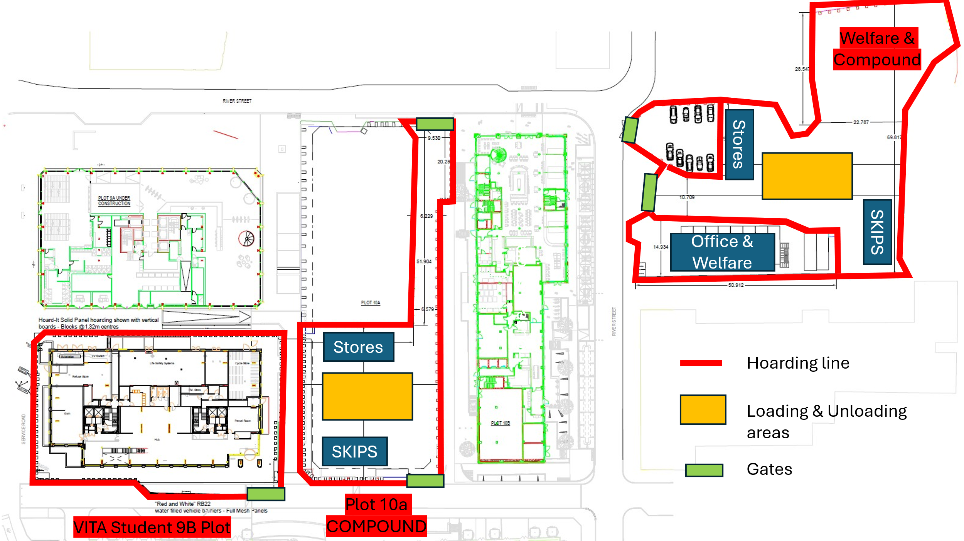

4.0 Construction Phase Dust Mitigation Plan.
Good practice measures will be adopted at VS9B to control the generation and dispersion of dust such that significant impacts on all permanent and transient stakeholders is minimised.
The hierarchy for mitigation will be:
- Prevention
- Suppression
- Containment

A dust management plan has been prepared which is in accordance with the measures set out within chapter 6 of the environmental statement.

The following table provides further detail on the management and monitoring of dust during the undertaking of construction works on site :-
Table 6-1: Construction Mitigation Measures- Site Management
Site Management | Compliance
- Display the name and contact details of person(s) accountable for air quality pollutant emissions and dust issues on the site boundary. | Site signage will be put in place
- Display the head or regional office contact information. | 24/7 number will be displayed on hoarding
- Record and respond to all dust and air quality pollutant emissions complaints. | -
- Make a complaint log available to the local authority. | In place
- Carry out regular site inspections to monitor compliance with air quality and dust control procedures, record inspection results, and make an inspection log available to the local authority. | Regular weekly inspections to be planned from start date
- Increase the frequency of site inspections by those accountable for dust and air quality pollutant emissions issues when activities with a high potential to produce dust and emissions and dust are being carried out, and during prolonged dry, or windy conditions. | Agreed
- Record any exceptional incidents that cause dust and air quality pollutant emissions, either on or off the site, and the action taken to resolve the situation is recorded in the log book. | Agreed
- Develop and implement a stakeholder communications plan that includes community engagement before work commences on-site. | Letter drop to be completed and residents meeting to be set up
- Develop a dust management plan. | Agreed
- Hold regular liaison meetings with other high-risk construction sites within 500 m of the site boundary, to ensure plans are co-ordinated and dust and particulate matter emissions are minimised. | On going (Two meetings already held)

Table 6-2: Construction Mitigation Measures- Preparing and Maintaining the Site
Preparing and Maintaining the Site | Compliance
- Plan site layout: machinery and dust causing activities will be located away from receptors. | Agreed
- Erect solid screens or barriers around dust activities or the site boundary that are, at least, as high as any stockpiles on-site. | Agreed
- Avoid site runoff of water or mud. | Hardstanding to be adopted during construction
- Fully enclose site or specific operations where there is a high potential for dust production and the site is active for an extensive period. | Agreed
- Keep site fencing, barriers, and scaffolding clean using wet methods. | Agreed
- Remove materials that have a potential to produce dust from site as soon as possible, unless being re-used on site. If they are being re-used on-site cover as described below. | Agreed
- Cover, seed, or fence stockpiles to prevent wind whipping. | N/A
- Agree monitoring locations with the local authority. | To be agreed
- Where possible, commence baseline monitoring at least three months before phase begins. | This will be set up as soon as we start on site, 3 months is not possible due to programme
- Put in place real-time dust and air quality pollutant monitors across the site and ensure they are checked regularly. | On going
- Carry out regular dust soiling checks of buildings within 100 m of site boundary and, if necessary, cleaning to be provided. | Agreed
- Consider, if practical, installation of green walls, screens, or other green infrastructure to minimise the impact of dust and pollution. | N/A
Table 6-3: Construction Mitigation Measures- Operating Vehicle/Machinery and Sustainable Travel
Operating Vehicle/Machinery and Sustainable Travel | Compliance
- Ensure all non-road mobile machinery (NRMM) complies with relevant local standards. | Agreed
- Ensure all vehicles switch off engines when stationary – no idling vehicles. | Agreed
- Avoid the use of diesel or petrol-powered generators and use mains electricity or battery powered equipment. | Agreed
- Implement a Travel Plan that supports and encourages sustainable travel (public transport, cycling, walking, and car-sharing). | Agreed
- Produce a Construction Logistics Plan to manage the sustainable delivery of goods and materials. | Agreed
- Impose and signpost a maximum-speed-limit of 10 mph on unsurfaced haul routes and work areas (if long haul routes are required these speeds may be increased with suitable additional control measures provided, subject to the approval of the nominated undertaker and with the agreement of the local authority). | Agreed

Table 6-4: Construction Mitigation Measures- Operations
Operations | Compliance
- Only use cutting, grinding or sawing equipment fitted or in conjunction with suitable dust suppression techniques such as water sprays or local extraction, e.g., suitable local exhaust ventilation systems. | Agreed
- Ensure an adequate water supply on the site for effective dust/particulate matter mitigation | Agreed
- Use enclosed chutes, conveyors, and covered skips. | Agreed
- Minimise drop heights from conveyors, loading shovels, hoppers, and other loading, or handling equipment, and use fine water sprays on such equipment. | Agreed
- Ensure equipment is readily available on-site to clean any dry spillages and clean up spillages as soon as reasonably practicable after the event using wet cleaning methods. | Agreed

Table 6-5: Construction Mitigation Measures- Waste Management Activities
Waste Management | Compliance
- Reuse and recycle waste to reduce dust from waste materials | Agreed
- Avoid bonfires and burning of waste materials. | Agreed

Table 6-6: Construction Mitigation Measures- Demolition Activities
Measurement Specific to Demolition | Compliance
- Ensure water suppression is used during demolition operations. | N/A
- Avoid explosive blasting, using appropriate manual, or mechanical alternatives. | N/A
- Bag and remove any biological debris or damp down such material before demolition. | N/A
- Soft strip inside buildings before demolition (retaining walls and windows in the rest of the building where possible, to provide a screen against dust). | N/A

Table 6-7: Construction Mitigation Measures- Earthworks Activities
Measurement Specific to Earthworks | Compliance
- Consider re-vegetating earthworks and exposed areas/soil stockpiles to stabilise surfaces. | N/A
- Consider the use of hessian, mulches, or trackifiers where it is not possible to re-vegetate or cover with topsoil. | N/A
- Only remove secure covers in small areas during work and not all at once. | Agreed

Table 6-8: Construction Mitigation Measures- Construction Activities
Measurement Specific to Construction | Compliance
- Ensure sand and other aggregates are stored in bunded areas and are not allowed to dry out, unless this is required for a particular process, in which case ensure that appropriate additional control measures are in place. | Agreed
- Avoid scabbling (roughening of concrete surfaces) if possible | Agreed
- Ensure bulk cement and other fine powder materials are delivered in enclosed tankers and stored in silos with suitable emission control systems to prevent escape of material and overfilling during delivery. | Agreed
- For smaller supplies of fine powder materials ensure bags are sealed after use and stored appropriately to prevent dust. | Agreed

Table 6-9: Construction Mitigation Measures- Trackout Activities
Measures Specific To Trackout | Compliance
- Regularly use a water-assisted dust sweeper on the access and local roads, as necessary, to remove any material tracked out of the site. | Agreed, we have a Road sweeper on call
- Avoid dry sweeping of large areas. | Agreed
- Ensure vehicles entering and leaving sites are securely covered to prevent escape of materials during transport. | Vehicles will be covered
- Implement a wheel washing system (with rumble grids to dislodge accumulated dust and mud prior to leaving the site). | Wheel washing system will be put in place within the site boundary (jet wash and sump)
- Record all inspections of haul routes and any subsequent action in a site log book. | Agreed
- Install hard surfaced haul routes, which are regularly damped down with fixed or mobile sprinkler systems and regularly cleaned. | Agreed
- Inspect haul routes for integrity and instigate necessary repairs to the surface as soon as reasonably practicable; | Agreed
- Ensure there is an adequate area of hard surfaced road between the wheel wash facility and the site exit, wherever site size, and layout permits. | Agreed
- Access gates to be located at least 10 m from receptors where possible. | Agreed
- Apply dust suppressants to locations where a large volume of vehicles enter and exit the construction site. | Agreed

5.0 Noise and Vibration

Consideration will be given to noise and vibration at the planning stage for all the various activities involved with constructing the buildings, we will take specialist contractor advice to ensure we minimise excessive noise and vibration, some general considerations include :-

Noise
All construction plant and equipment will comply with EU noise emission limits;
• Machines in intermittent use will be shut down in the intervening periods between work or throttled down to a minimum;
• Proper use of plant with respect to minimising noise emissions and regular maintenance. All vehicles and mechanical plant used for the purpose of the works will be fitted with effective exhaust silencers and will be maintained in good efficient working order;
• Selection of inherently quiet plant where appropriate. All major compressors will be 'sound reduced' models fitted with properly lined and sealed acoustic covers which will be kept closed whenever the machines are in use and all ancillary pneumatic percussive tools will be fitted with mufflers or silencers of the type recommended by the manufacturers;
• Plant and equipment such as flatbed lorries, skips and chutes will be lined with noise attenuating materials. Materials will be handled with care and be placed, not dropped;
• Care should be taken when erecting or striking scaffolds to avoid impact noise from banging steel. All operatives undertaking such activities will be instructed on the importance of handling the scaffolds to reduce noise to a minimum before access is possible;
• All ancillary plant such as generators, compressors and pumps will be positioned so as to cause minimum noise disturbance. If necessary, localised screens and enclosures will be used to reduce noise from particular noisy, static operations;
• Wherever possible, the use of hydraulic attachments or other means of crushing concrete and hard materials will be used in preference to pneumatic breakers. Where the use of impact hammers is necessary, their attachment to larger and heavier excavators often can reduce the level of vibration;
• Deliveries will be programmed to arrive during daytime hours wherever practicable. Care will be taken when unloading vehicles to minimise noise. Delivery vehicles will be routed to minimise disturbance to local residents. Delivery vehicles will be prohibited from waiting on the highway or within the site with their engines running
• Removal of obstructions to piling (e.g. old basement floors, old foundations etc.). Where an unexpected obstruction is encountered, it might be preferable for piling to be halted at that position until the obstruction can be dealt with, rather than attempting prolonged hard driving;
- Training and communication of operatives in correct use of machinery.
- Attitude of operatives to the making of noise to be addressed, to have an understanding that work activities have an effect on those around not just operatives but residents and the public. This will be achieved though toolbox talks and daily activity briefings.
- Hours of operation and activity- consideration to the time of day for particularly noisy activities will be made. E.g. Carry out these activities in the afternoon rather than 1st thing in the morning.
- Use cast in halfen brackets for the cladding in lieu of post drilling into concrete.
- Screens surrounding the concrete slabs and proprietary formwork wrapping the stair and lift core to minimise noise break out from concreting activities
- Acoustic screens used to shield metal pipe cutting or concrete cutting activities on site
- Proprietary acoustic cutting stations for cutting metal wall studs.

Vibration
• Where reasonably practicable, plant and/or methods of work causing significant levels of vibration at sensitive premises should be replaced by other less intrusive plant and/or methods of working;
• To minimize any potential adverse impacts as a result of vibration from stationary plant, equipment immediately adjacent to sensitive receptors could be relocated or isolated using resilient mountings; and
• The characteristics of vibration emissions from each item of plant, and their collective effect, should be assessed during the selection process for the acquisition of plant. Where practicable, plant should be selected which will have the least impact in terms of vibration.

Please see Section 2 for details of our complaints procedure

6.0 Parking of construction vehicles and staff.
We have identified that there is a need to alleviate where possible the parking burden on Manchester City centre, during the construction of VS9B, parking at our Crown Street development will be available for staff and visitors (circa. 20 spaces), we also have a small private carpark adjacent the welfare area for staff members, this provides 10 spaces. All other personnel will be advised to park in the pay and display street parking surrounding the site.
Site personnel who are not allocated a parking space will be encouraged to utilise the extensive array of public transport options available to them. This information will be presented during the site induction.
- Loading and Unloading of plant and materials.
All loading and unloading is planned to be undertaken within the site boundary and compound, we’ll encourage our supply chain to avoid peak periods wherever possible. Materials will be unloaded at designated unloading/loading bays by tower crane or forklifts. There will be no requirement to lift materials outside of the boundary, materials lifted by forklifts can be transported to various storage areas and hoists with only a minimum distance to traverse on the private road between the compound and the site.

We anticipate the following major deliveries (all being unloaded within 10a compound)…
Concrete Frame
- 8no concrete wagons per day (coming from RBL batching plant on Great Jackson Street)
- 3no rebar deliveries per week (45ft arctic flatbed)
Façade
- 4no arctic wagon per week
Fitout
- 6no arctic wagons per week
Other
- Daily visits for smaller deliveries (transit vans)

- Storage of plant and materials.
Material storage for the development will be generally contained in our storage compound opposite site on Plot 10a, within a hoarded and secure area on site. There is a written agreement in place between ASK and VITA confirming the use of Plot 10a throughout the construction phase to facilitate deliveries and material storage.
The site will have 24hr security and plant will be returned close to the security hut at night and will be locked with keys removed and cab guards in place.
- Security Hoarding.
Protecting the public from risks to their health and safety arising from the construction work is a high priority. Every care will be exercised to prevent risk to members of the public and appropriate action, including the erection of perimeter fencing to a specified standard, will be taken.
Vandalism and theft of plant, equipment, materials and fuel is possible throughout the duration of the development. Renaker Build will take appropriate action, as described in previous sections, to ensure the site is secure at all times from unauthorised access. As described previously, the site will have metal turnstile access system controlled by an individual fingerprint system.
We will be utilising the provision of CCTV to cover the perimeter of the site and compound areas to assist in the prevention of unauthorised activities.
The hoarding to the perimeter around the site of VS9B and Plot 10A will be constructed robustly and will stand no less than 2.4m in height. Renaker have a monthly monitoring system which all qualified staff undertake, a hoarding inspection is a weekly check, it is also a temporary works item which is subject to a statutory 7 day inspection. Any findings arising from these inspections are dealt with immediately.
- Routing Strategy
The site will be accessed from a turnstile which is located via an uncontrolled pedestrian crossing point at the bottom of River Street as indicated with Dark Blue arrows.
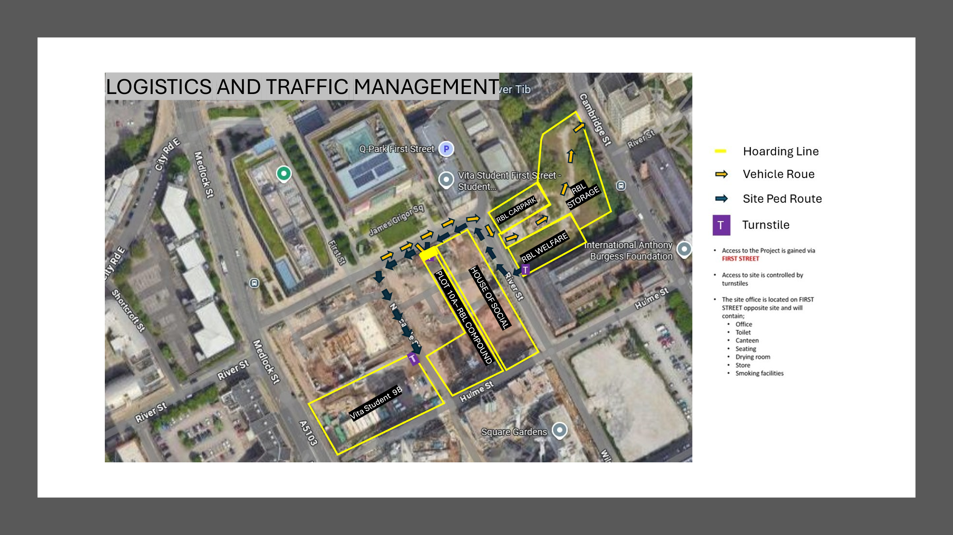
Both the access and egress will be manned gates to prohibit unauthorised access to the site, deliveries will be directed to the unloading area on Plot 10A or to the RBL storage area in the compound (shown on the layout above), materials will be transported from the compound to the site utilising a telehandler / forklift, directed by a trained Banksmen.
The swept path for an articulated lorry has been carried out to ensure we can access the compound / site, this is shown in the apppendices.

