



NS2515 CO-OP LIVE GUITAR PARK

Design Considerations for the

Operating Schedule and Management Plan

July 2025

Table of Contents

1. Project Details 2
1.1. Project Introduction 2
1.2. Installations Overview 3
1.3. Document Purpose 4
2. Design and Engineering Summary 5
2.1. Design Risk Assessments 6
3. Operational Timings 6
4. Maintenance 7
4.1. Important Information 7
4.2. Preventative Maintenance and inspection 9
4.2.1. Steel Structure 9
4.2.2. Decorative Elements 11
4.2.3. LED Lighting 12
5. Security 13
6. Operational Maintenance and Operation Strategy 13

Project Details

Project Introduction

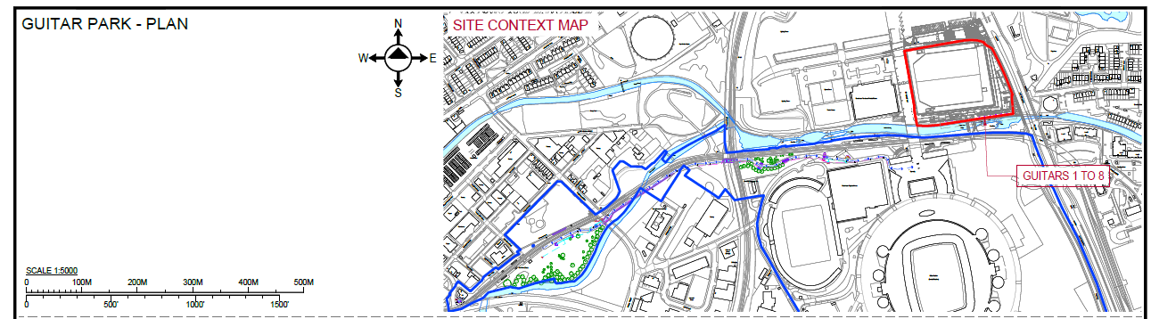
As part of on going works to build upon the success of the Co-op Live arena complex and further activate the outdoor spaces, the proposed addition of a series of sculptural guitars, representing key musical artists is proposed. The purpose of these installations is to both celebrate musical icons linked to the venue, and provide general beautification of and generate visitor interest in an other wise under utilised area of land in the immediate vicinity of the venue’s courtyard and outdoor areas.
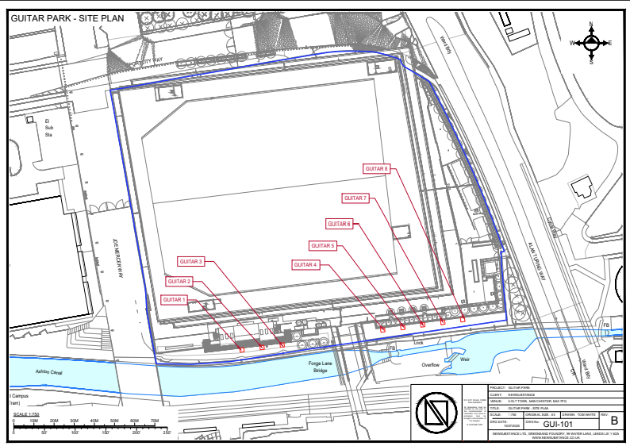

Site Plan

Installations Overview

The following show a typical installation, the series of sculptures will be developed and installed over a period of time, working to a common set of design standards and approaches.

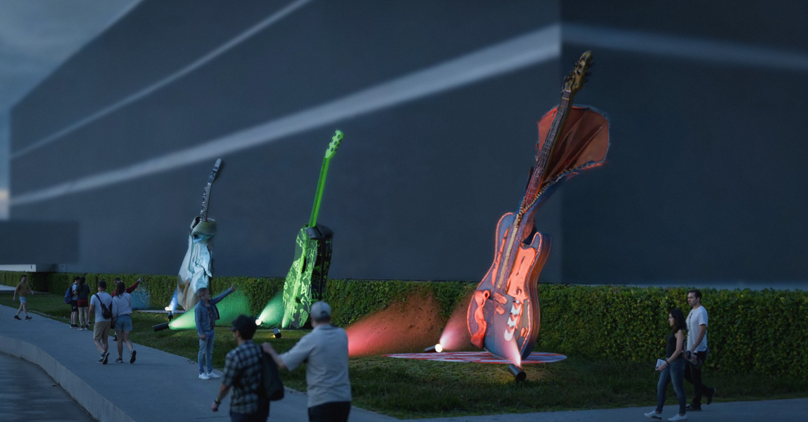

Document Purpose

The purpose of this document is to provide how the installations that comprise this activation can be operated, and to advise what preventive maintenance may be required. NEWSUBSTANCE have been contracted to design, construct and install the features. Our understanding is that once the project has been delivered for the Client the installations will then be handed over to the venue’s management and operational departments, and their appointed maintenance and operating contractors for the ongoing life cycle.
This document should be read in conjunction with the design risk assessments, Health And Safety file for the project, along with any O&M manuals provided as part of the handover process.

It is expected that the contents of this document will inform and feed into the creation of a project-wide Operating and Management Plan by others.

Design and Engineering Summary

NEWSUBSTANCE will collaboratively work with project stakeholders to create the installations described within

All works will comply with where relevant, in accordance with:
● The Management of Health and Safety at Work Regulations 1999
● The Health and Safety at Work Act 1974
● The Personal Protective Equipment at Work Regulations 1992
● Lifting Operations and Lifting Equipment Regulations 1998 (LOLER)
● The Provision of Use and Work Equipment Regulations 1998
● Electricity at Work Regulations 1989
● Working at Height Regulations 2005
● Control of Substances Hazardous to Health Regulations 2002.

Structures will be designed and assessed to the following applicable standards principally;

● Eurocode 0: Basis of structural design (EN 1990)
● Eurocode 1: Actions on structures (EN 1991)
● Eurocode 3: Design of steel structures (EN 1993)
● Eurocode 7: Geotechnical design (EN 1997)
● Eurocode 9: Design of aluminium structures (EN 1999)
● As detailed in EN1990

To achieve adequately durable structures, the following factors will be taken into account during detailed technical design and structural analysis:

1. The intended or foreseeable use of the structure
1.1. Public realm
1.2. Unsupervised
1.3. Specialist events

2. The required design criteria

3. The expected environmental conditions
3.1. Urban / Inner city
3.2. Urban and industrial areas, moderate sulphur dioxide pollution

4. The composition, properties and performance of the materials and products

5. The properties of the soil
6. The choice of the structural system
6.1. Designed to allow maintenance and replacement of damaged components
6.2. Modularity
7. The shape of members and the structural detailing

8. The quality of workmanship, and the level of control

9. The particular protective measures
9.1. Paint finishes and surface preparation
9.2. IP67 Lighting

10. The maintenance during the design working life
10.1. Paint systems that be refinished, repaired in situ
10.2. Proven robust and highly durable materials
10.3. Limited specific or specialist maintenance requirements

11. Human behaviour factors
11.1. Anti climb design / positioning on site
11.2. Anti vandalism
11.3. High impact ratings
11.4. Security / tamper proof fixings

Design Risk Assessments

A full design risk assessment will be carried out for each of the installations, considering design factors such as:

1. Methods of construction
2. Site operations and management during construction
3. Structure Design Life
4. Weather conditions
5. How the public will interact with the structure, including
5.1. Vandalism
5.2. Anti Social Behaviour
5.3. Accessibility
6. Proximity to site hazards; road, rail and tramways
7. Metrolink / venue operational factors
8. Cleaning
9. Maintenance and repairs

A copy of this will be provided in the Project Handover Document

Operational Timings

All the sculptures which include lighting, will be supplied with a Pharos architectural lighting controller that can be managed, operated and integrated within the venues content management system.
This system has the ability to run playback of pre-programmed states either on a regular schedule or to be programmed on an ad-hoc basis. The system will be fitted with an ambient light sensor allowing real-time adjustment in response to local conditions and to minimise energy consumption

General lighting activation is expected to follow the default schedule as follows:

Lighting Start | Lighting End
16.00 | 23.59

However it is expected that the timings of use will vary according to the schedule of events in the Etihad Campus including Co-op Live events, match days, other sporting events in MCC venues, and community engagement events.

All of the features are supplied with remote access, allowing lighting to be altered in response to any issues identified by any stakeholders.

Maintenance

All of the sculptures will be designed to require with maintenance in mind. All features which are equipped with controllers are capable of being remotely monitored and controlled.

Where on-site maintenance is required, this will be undertaken inline with the procedures developed within the design risk assessment, the details of which will be provided in the health and safety file.

Details of preventive maintenance and inspections will also be provided within the health and safety file. Strategies will be developed so as to minimise any residual risk, for example favouring reach and wash systems over cleaning requiring work at height. Consideration will also be given to the proximity of nearby water ways and publicly accessible pathways immediately adjacent to the location

All installations will require periodic regular inspection by competent persons to a schedule to be advised in the project file.

Regular preventative maintenance of vegetation and greenery around some installations will be required as part of the wider estates management regime.

Across all installations the potential for occasional graffiti removal should be considered in the choice of materials and paint finishes

Expected maintenance requirements and information are provided below.

Important Information

• All works must be carried out by trained and competent persons only. Their level of competency,
certification or qualification must cover the nature of works to be undertaken.

• Risk Assessments and method statements (RAMS) must be produced and in place prior to commencing
works.

• Suitable PPE must be worn as identified in work specific RAMS.

• Temporary access equipment must be erected only by trained and competent persons only;
Work at Height Regulations (2005)

• The use of Mobile Elevated Working Platforms (MEWP’s) should be undertaken by trained and
competent persons only Work at Height Regulations (2005).

• Works in publicly accessible areas or on public highways may require permits and approvals to be in
place prior to commencing works.

• Works carried out in proximity to the Metrolink should observe the guidance provided in documents;
Working safely near Metrolink January 2024 Version 1

• Electrical works must be carried out by trained and competent persons only

• Prior to commencing any electrical works, power must be isolated.

• Suitable barriers, hoarding or exclusions zones must be observed during works

• Safe general working practices should be observed at all times.

Preventative Maintenance and inspection
Preventative maintenance, inspection and cleaning must be carried out at the described intervals to ensure the installations continue to function as intended and that decorative and protecting finishes do not prematurely wear or degrade.

Steel Structure
Cleaning must be undertaken the minimum frequency described, but should be increased if inspection deems necessary. Where damage or degradation is identified, maintenance works should be undertaken in a timely manner.

Frequency | Instruction
Weekly | - Check for any visible damage, graffiti, bird fouling and general cleanliness.  - Check for vandalism or other damage to steelwork, Perspex panels, lighting or electrical display components.  - Perform visual check that all lighting is functioning as intended.  GRAFFITI REMOVAL:  - For graffiti removal, use an appropriate solution for the paint system. Please see attached data sheet. It is recommended a test is performed on a small inconspicuous area before use on larger areas.
Quarterly | - Wash down the structure using appropriate apparatus and equipment.  ⚠️Proximity Canal Water way  - AVOID using abrasive cleaners and harsh chemicals that may damage paint finishes.  - AVOID using a jet wash/high pressure water streams to clean the structure as this may cause water ingress.

GRAFFITI REMOVAL:
- For graffiti removal, use an appropriate solution for the paint system. Please see attached data sheet. It is recommended a test is performed on a small inconspicuous area before use on larger areas.
Yearly | - Complete a full visual inspection of structure and finishes.  - Locally repair any paint damage with compatible paint system

Decorative Elements
Cleaning must be undertaken the minimum frequency described, but should be increased if inspection deems necessary. Where damage or degradation is identified, maintenance works should be undertaken in a timely manner.

Frequency | Instruction
Weekly/Monthly | - Check for any visible damage, graffiti, bird fouling and general cleanliness.  - Check for vandalism or other damage to steelwork, decorative elements, lighting or electrical display components.  - Perform visual check that all lighting is functioning as intended.  GRAFFITI REMOVAL:  - For graffiti removal, use an appropriate solution for the paint system. Please see attached data sheet. It is recommended a test is performed on a small inconspicuous area before use on larger areas.
Quarterly / Periodically | - Wash down the surfaces using appropriate apparatus and equipment. Care taken not to scratch or damage the more delicate surfaces or finishes  ⚠️Proximity to canal water way  - AVOID using abrasive cleaners and harsh chemicals that may damage paint finishes.  - AVOID using a jet wash/high pressure water streams to clean the structure as this may cause water ingress.  GRAFFITI REMOVAL:  - For graffiti removal, use an appropriate solution for the paint system. Please see attached data sheet. It is recommended a test is performed on a small inconspicuous area before use on larger areas.

LED Lighting

Frequency/Material | Instruction
Weekly / Periodically | Perform visual inspection of lighting system functionality
Yearly | Complete a full electrical installation test and document findings.

Security

All of the features have been designed in collaboration with all key stakeholders, including the Greater Manchester Police Force. Given the location of the trail, and that it provides access to a major events site, security has been a key design consideration. Considerations include:

- All installations are robust structures, engineered with consideration of the potential need to withstand attempted vandalism
- Using purpose built, vandal proof, electrical pillar boxes, to secure the electrical connections to each feature.
- The elimination of unsecure voids and hatches, so as to reduce the risk of the feature being used to conceal
- Ensuring all installations are not easily climbable.
- Using IK10 rated (vandal impact resistance) components where available

Operational Maintenance and Operation Strategy

The maintenance and operations as detailed above will be added to our schedule of works that supports the exterior building and routine checks. The below details high level operational strategy and maintenance monitoring that will be part of daily, weekly management of the Guitar Park that forms the sculptural gallery or ‘canalary’ adjacent to Co-op Live, next to the canal and opposite the new hotel.

Timings
The Guitar Park will be open for use by the general public at all times.
And illuminated from 4pm until 23:59 but this can be altered in summer months to save energy.
Lighting Start | Lighting End
16.00 | 23.59

Responsibilities

The teams will support the walking route and Canalside area and will be briefed by the FOH team at the start of their shift. This briefing will cover all fan security and safety operations needed for this day, along with anything event specific, such as age and demographic of the fans coming to the venue. We have security 24:7 and will be roaming the Campus and on the walking route/canalside as part of our event day and non-event day footprint. They will be on the lookout for any suspicious behaviour displayed by individuals on the walking route and campus and can managed Antisocial behavior.

Cleaning
The cleaning team will do pre and post event checks of the walking route and Canalside ensuring it is ready to accept fans with a focus on safety and cleanliness. And any graffiti will be removal within 24 hours.

Event Control Room
Event Control Room will log any radio calls from the on the ground teams on 24/7 reporting software. They will if needed deploy additional resources as required.
They will have access to the CCTV on the canalside as well.

CCTV
CCTV will cover this area with additional cameras being installed to support the Canalside café and guitar Park and teams monitor this 24:7.

Camera Locations

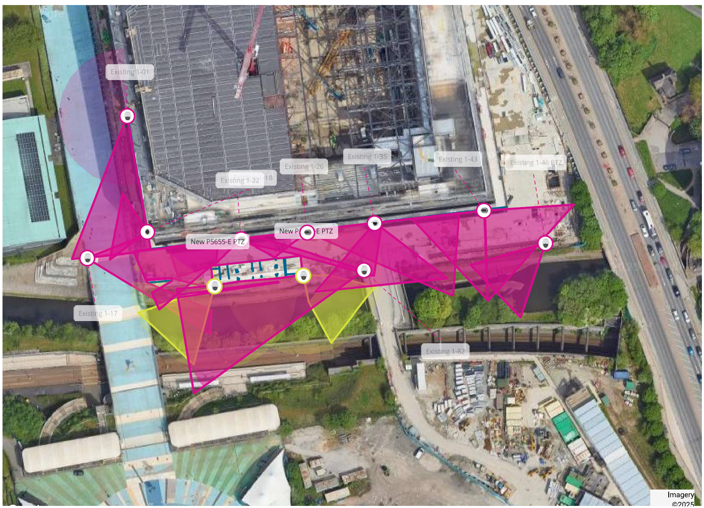
These cameras will be managed by the Control Room and operated 24:7. The Control Room operators will be linked into all teams via radio and will be able to escalate any potential issues if they arise. The cameras labelled PTZs are up to 360 degree and cover in all directions (indicative with the transparent circles on the map).

Comms
The Cleaners, Stewarding and Security teams will have radios so they can contact the Event Control Room to report any issues or ask for assistance. The Event Controller will then log these on 24/7 and allocate additional resources if required.

The roaming teams to support the Canalside Guitar Park will;
- Monitor conditions
- Report hazards
- Engage fans and the local community to promote safe & responsible use of the ‘canalary’
- Address suspicious and anti-social behaviour
- Manage potential conflicts
- Maintain cleanliness along the route

