Construction Management Plan
Bridgewater House
Manchester
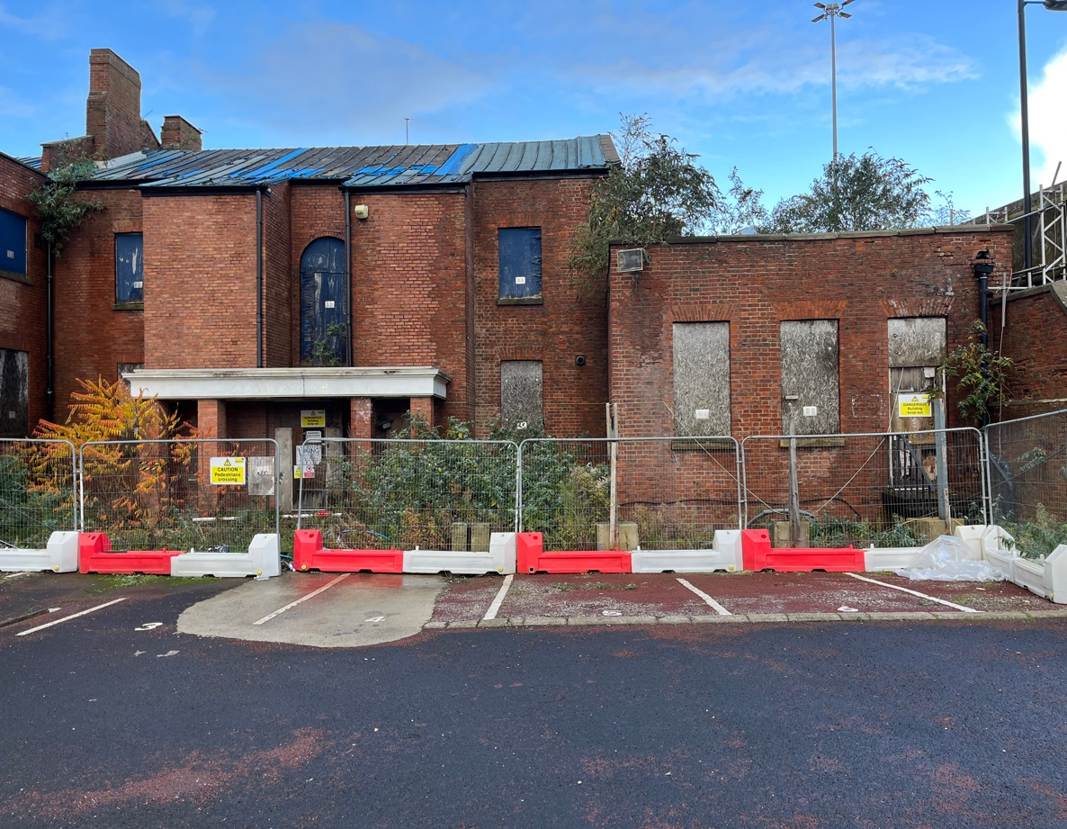

CONTENTS
- Project Description, Programme details, Project Team

- Health and Safety Goals

- Resourcing local labour

- Accident and Incident Reporting

- Site Set up and Security

- Traffic Management

- Construction Methodology

- Risk Assessment Process

- Emergency Procedures

- Health and Safety File

- Risk Register

- Health and Safety Management Structure

- Project Description, Project Details, and the Project Team.

Project Description.
Construction of 32 New build Apartments in the grounds of the listed building Bridgewater House and conversion of Bridgewater House into 21 Apartments.

Programme of Construction Works.
The project is expected to take approximately 24 months.

Project Start; July 2025
Project Completion; June 2026
Construction Duration 24 months.

Site location. Corner of Great Jackson Street and Silvercroft Street

Project Team Details.

Client
Smart Bridgewater Ltd
26 Chorley New Road
Bolton
BL1 4AD

Project Manager/ Contract Administrator
TBC

Principal Designer
Name; JAD Consulting
Contact; James Dean
Tel; 07800521476
Email; james@jadconsulting.co.uk

Architect
Name; Snook Architects
89 Wood St
Liverpool
L14NU
Contact Neil Dawson
Tel; 07910300392
Email neil@snookarchitects.com

Design Engineer
Contact; ADS limited
22 Meetings Industrial Estate
Barrow in furness
LA14 4TL
Contact; Scott Hornby
Tel; 07721850705
Email; scott.hornby@adsconsuly.uk

Temporary Works Co-Ordinator
TBC

Principal Contractor
Melbrooke Services Ltd
116 Duke Street
Liverpool
L1 5JW
2.0 Health and Safety Goals.
Introduction
The Health and Safety Plan is the foundation upon which the health and safety management of the construction phase of a project needs to be based. In line with the duties specified in the Construction (Design and Management) Regulations 2015 (CDM 2015), the Principal Contractor for the project understands the requirements and accepts responsibility for the development of the plan.
In addition to the pre-construction information provided by the Principal Designer, the developed plan covers the following areas:
- The approach to be adopted for managing health and safety throughout the construction phase.
- Assessment requirements under the Management of
Health and Safety Regulations 1999.
(c) Common site arrangements.
(d) Welfare Arrangements as per Schedule 2 of the Regulations.
- co-operation and coordination between contractors (Reg. 5 & 6)
- compliance with H & S rules in plan (Reg. 22(1)(d))
- control of unauthorised persons on site (Reg.22(1)(l))
- display of legally required notices (Reg. 22(1)(k))
- provide required information to Principal Designer.
- bring rules to attention of relevant persons (Reg. 24)
- provide information, instruction, and training (Reg.22 (2))
- provide facility for discussion and consultation (Reg. 24)
- liaise with the Principal Designer on design changes.

Health, Safety and Welfare Objectives
The Company believes that sound health and safety management is the key to providing services which are, so far as is reasonably practicable, free from risks to employees, sub-contractors, the general public and others who may be affected by their operations. As such they aim to construct, complete, and maintain works:

- within specified periods
- in accordance with designs and specifications
- having due regard to welfare of staff
- without putting anyone at significant risk

The immediate Health and Safety goals for the project.

The health and safety goals for the project are to allow construction work to be carried out safely without risk to health, to allow those that maintain the building in the future to do so safely and without risk to health.
The project will be run as an incident and injury free environment, safety will be handled not only by stringent systems but also by the establishment of an environment where people are encouraged to take responsibility for their own and for other colleagues’ safety. This will be accomplished through a community by all to open working relationships where individual concerns can be heard, and safety achievements recognised and use of,

Standards
The health and safety standards for the project shall be, as a minimum, those required by the relevant legislation: -The Health & Safety at Work etc Act 1974

The Management of Health & Safety at Work Regulations 1999

The Construction (Design and Management) Regulations 2015

The Provision and Use of Work Equipment Regulations 1998

The Manual Handling Operations Regulations 1992

The Electricity at Work Regulations 1989
The IEE Regulations, 18th. Edition.
The Control of Substances Hazardous to Health Regulations 2002
The Personal Protective Equipment at Work Regulations 1992
The Lifting Operations and Lifting Equipment Regulations 1998
The Confined Spaces Regulations 1997
The Control of Asbestos Regulations 2012
The Regulatory Reform (Fire Safety) Order 2005
The Health and Safety (First Aid) Regulations 2013
The Control of Noise at Work Regulations 2005
The Reporting of Injuries, Diseases & Dangerous Occ. Regs. 2013
The Work at Height Regulations 2005
The Control of Vibration at Work Regulations 2005
The Hazardous Waste Regulations 2005

Information for Contractors and Employees
Contractors and employees shall be informed of the risks associated with the work and surrounding operations by pre-start induction training and regular ‘on-the-job’ communication.

Selection Procedures
Suitable arrangements shall be put in place to ensure the competence of all employees and sub-contractors (Reg. 4). This will take the form of questionnaires, interviews, examination of current working practices and evaluation of qualifications and experience.
Materials and equipment shall be evaluated by examination of suppliers’ information to ensure safety in use. Training and information shall be provided where necessary.

Communication and Co-operations
Regular site meetings with relevant parties involved in the project shall be convened to ensure adequate liaison and communication of health and safety matters.
Co-operation from all construction workers shall be encouraged by regular ‘on-the-job’ consultation and involvement in day-to-day health and safety activities such as inspections and reviews.
Information and Training for People on Site
Suitable arrangements shall be made to ensure that all construction workers are given health and safety information and training relevant to the project. A check list shall be introduced to facilitate this arrangement. Such information shall include:
- Risk assessment details
- Method statement details
- Relevant parts of the Construction H & S Plan
- Project specific awareness training
- Display of statutory notices (located in the site office and the canteen)
- Site induction
- Toolbox talks from tooling suppliers, Health and safety management team.

Arrangements for Monitoring
Effective monitoring of the health and safety situation throughout the project shall be carried out by:
- Pro-active inspections, samples, and tours to defined rotas.
- Review of any accidents and thorough investigations to ensure
adjustments to procedures to prevent recurrence.
- Inspections as required under Part 4 of these Regulations.
- Monitoring the effectiveness of procedures by regular management
review meetings.
- Monitoring the actual performance of sub-contractors and reviewing
against the expected performance from selection arrangements.
- Examination of health and safety standards achieved against project targets etc.
- Training records and toolbox talks.
- Inspections and audits via CSSS, audit report available.

In addition to the site rules laid down by the Principal Contractor

The longer-term goals to be met.
Safety Aims.
- To establish the responsibilities of all Supervisory Personnel on the project towards Safety Objectives
- To identify the Principal Health and Safety Hazards likely to be encountered during construction.
- To put into place safety initiatives to avoid personal injuries.

Safety Targets.
To achieve by the effective management and supervision of the project, the elimination where it is not reasonably practicable, the control of risks and the prevention of accidents to;

- Principal Contractors employees, trades, operatives, and employed Sub Contractors
- Surrounding occupants and their properties
- Other contractor’s working within the site and within the immediate area

Health and Safety Consultation on Site.
The Principal Designer and the Principal Contractors nominated H&S company will attend and carry out site specific safety audits. These visits will monthly. Findings will be rectified if required. Both will be providing on-going support and training throughout the phase of works.
Structured consultation will take place through regular Health and Safety meetings, sub-contractors co-ordination meetings. This does not preclude the day-to-day consultation.

Selection and control of Subcontractors on Site.
The selection process is carried out using the competence assessment forms for designers and contractors. All new sub-contractors to the Principal Contractor will complete a competence questionnaire before commencement of work on site. Priority will be given to Contractors and Sub Contractors who live and operate with the Greater Manchester area.

Safety issues can be discussed further at pre-construction meetings.

Orders will only proceed with sub-contractors who, in the opinion of the Construction project management team, satisfy all the safety criteria.

Training.
All personnel on entering the site must attend and receive the Site Induction training, consisting of introduction to the Construction Phase Health and Safety Plan paying attention to:-

- Specific Site Rules
- Fire Plan
- Emergency Procedures

The Site Induction will be presented by a member of the Site Management team.

Health And Safety Objectives.
A review of existing user activities/ considerations has been considered with the following issues identified:

All site staff will be trained and competent to complete works as required CSCS minimal requirement for site personnel with SMSTS CITB Site Managers Safety Training scheme completed by our designated Site Manager.

Dust will be controlled as per the site rules and continually reviewed for best practice. Primary control will be via dampening down of hardcore materials if required. Any other construction principals by the nominated sub-contractors, methods will be reviewed prior to commencement.

All site management must take reasonable measures in the execution of site works to ensure that the safety of all individuals likely to be affected,

- Emergency procedures and means of escape.
- Provision and location of fire-fighting equipment.
- Location of First Aid Treatment.

The Principal Contractor shall ensure that all the site entrances/exits are kept clear of materials and safe at all times.
A fire safety plan and suitable firefighting equipment shall be provided and displayed within the site welfare containers for all to view. this will also be presented when receiving the site induction. The site manager will be the appointed fire warden he will also be the nominated First Aider for this Phase of works, along with other members of the management team. They will be identified in the site induction.
The Principal Contractors employees and the nominated subcontractors will be required to be formally inducted into the site rules and procedures, where they will be signed into to state that they have received and understood the rules laid down. Adherence and full compliance to all health, safety and environmental legislation is absolutely mandatory. The Principal Contractor will reserve the right to spot check and carry out inspection’s employees and contractors’ activities/manpower and equipment at any time.
Subcontractors will be inducted by the Site Management Team, then the nominated supervisor for the subcontract companies will present the RAMS written for the works being carried out by them to their staff, signing up all workers to the statements supplied/provided.

The Principal Contractor’s Project Manager will attend brief weekly co-ordination meetings with the Site Manager to ensure mutual awareness and planning of forthcoming activities – the site manager will maintain a daily communication channel with all.

Monthly meetings with the Client, Design team, Principal Contractor, CDM will be arranged as the Project commences. The meeting will cover progress, H&S, reports will be provided by the PC. Design issues will be brought up if any as the design method of construction is set for this phase of works. Issues found prior to these meetings will be communicated via email or telephone calls with the design team and works will cease if a change is required. Works will commence following agreement with the design team.

The Principal Contractor will also make themselves aware of the following issues.
- Working with live mechanical and electrical systems
- Make all reasonable enquiries with the relevant personnel that have carried out the site investigations as may prove necessary to locate any existing services prior to excavation works commencing on-site.
- A permit system will be in place for high-risk works.
- Development of a Fire Strategy to continually allow safe access and egress from the site

Restrictions affecting works.

- Storage will be made available within the site compound confines. Lockable stores will also be available.
- The existing buildings that are adjacent to the site and will be live throughout the construction period, consideration will be given to the staff and occupants for noise levels.
- All waste and debris will be kept to a minimum and the site will be cleaned daily.
- Site cables and temporary wiring shall be positioned so as not to create a trip hazard.
- Contractors must not shout, make any undue noise, play games or indulge in horseplay o any other unseemly behaviour whilst on the premises.
- Noise levels and in-appropriate language and swearing will not be tolerated at any time.
- A good standard of dress should be maintained at all times
- Contractors should work in agreed areas.

3.0 Local Labour Resourcing

Melbrooke Services Ltd is committed to supporting the local economy and community by prioritising the use of local labour where viable on the Bridgewater House construction site. This approach aligns with our corporate social responsibility, objectives and enhances local employment opportunities, skills development, and economic growth.

Objectives
- Target to employ 17-20% of the workforce from the local area (as defined in point 1 below.
- Provide opportunities for apprenticeships, traineeships, and skills development for local residents.
- Promote inclusive employment practices that benefit underrepresented groups within the local community.

Monitoring and Recording Local Labour Use
To ensure transparency and accountability, the following measures will be implemented:

1. Definition of “Local Labour”
Local labour will be defined as individuals whose primary residence is within a 15 mile radius of the construction site or within the boundaries of a Manchester postcode.

2. Labour Tracking System
All workers on site will be required to complete an induction form that includes their address, postcode, and employment status (direct hire, subcontractor, apprentice, etc.). This data will be stored in a secure labour tracking specific spreadsheet.

3. Site Access Logs
All personnel will use an electronic sign-in/sign-out system or sign in and out manually daily sheets which will log working hours and allow verification of individuals’ employment details. This system may be integrated with CSCS card readers or biometric systems, where applicable.

4. Regular Audits and Reporting
The site management team will produce monthly progress reports to our client which will have a section within designated for recording labour levels on site and local labour levels. This will allow us to review local labour statistics and verify compliance with targets. Reports will be submitted to the client and relevant stakeholders.
Conclusion
By proactively employing and supporting local labour, Melbrooke aims to deliver lasting economic and social value to the community. The outlined monitoring and recording systems will ensure that our commitment to local labour is measurable, accountable, and continuously improved.

4.0 Accident and Incident Reporting.

All accidents should be reported to the Site Manager with data inputted in the site accident file. The S/M will carry out an investigation of incidents/n ear misses and complete a report, issuing to the H&S representative for further guidance. Findings will be informed via site weekly meetings or immediately if circumstances required.

Reportable incidents will be reported to the HSE. Absentees from injuries/ illness will be reported to the HSE under RIDDOR regulations.

When seeking First Aid, the First Aider they will advise what treatment will be best. If in case of what is considered serious or could lead to something potentially serious, they will contact the emergency services.

The closest Hospital to the site is;
MRI
Oxford Road
Manchester
M13 9WL

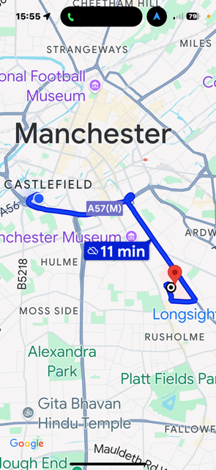
Emergency Services.

Call 999 in case of an Emergency.

5.0 Site Set up and Security.
All personnel and sub-contractors, supervisors will receive a site induction prior to commencing any works on site, training will include.

- Specific site rules
- Fire plan
- Emergency Procedures
- Safe access/egress areas
- Site Restrictions
- Asbestos Awareness and access to the register/survey
- Identification of specific risks/hazards
- Permit to work systems
- Emergency procedures, egress routes Muster point
- Welfare areas
- Requirements for Risk and method statements
- General site rules

Training certificates will be requested and logged, CSCS cards will be requested and logged.

Toolbox and safety talks may be requested to address specific areas. When these are considered to be of benefit, they will be arranged by site management.

Statutory notices will be displayed within the Site Managers Office.
These notices include.
- F10 form
- Health and safety work Act poster
- Copy of insurances.
There will be signs displayed around the site notifying all of safety requirements.
A site sign in area will be used at the pedestrian entrance. Information posters will be displayed on a notice board located in that area.

Welfare and First Aid.
Nominated Qualified First Aid at work operatives will be on site at all times.

The Principal Contractor will provide welfare facilities, these will include;
- Sanitary conveniences, washing facilities, warm and cold running water
- Basin large enough to immerse hands/forearms
- Soap and Hand towels
- Changing rooms/areas
- Storage areas for PPE
- Facilities to rest
- Tables and chairs (with backs)
- Means of providing warm/hot drinks

The proposed site welfare area will be set up to the car park at the rear of the site as shown in the photograph below. Locations of area is positioned approximately.
Site Layout diagram.
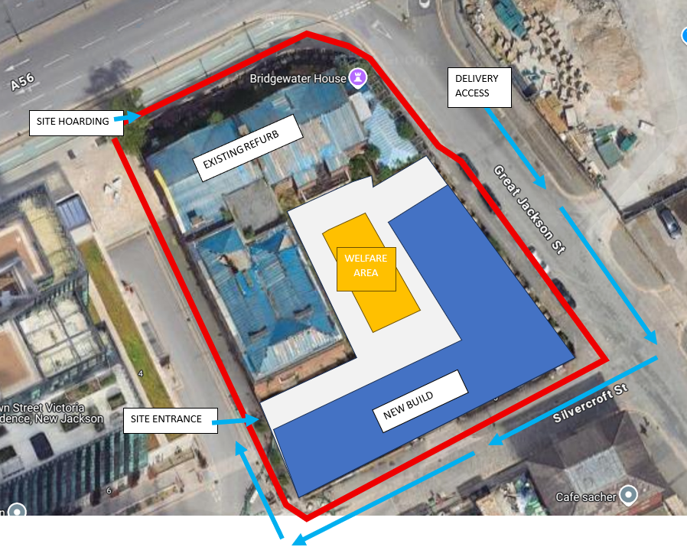

Personnel Security& Hoarding requirements.
Protective barrier fencing will be installed around the perimeter of the building from Chester Road, Great Jackson St Silvercroft St and Crown St.

Compound fencing is to be provided to ensure the safety of all pedestrian traffic whilst carrying out the works. The Principal Contractor will be responsible for maintaining the security and shall ensure the gates/fencing is erected at the end of each working day to maintain security to the site premisses. Security hoarding to be substantial to cope with the waterfront weather conditions.

CCTV and site security will be managed by an outside contractor.

Signage around the site will include all the necessary statutory signage to make the public aware of the construction site and possible dangers associated with this. (see above pic)
A site register and a visitors’ book are to be maintained recording all labour and visitors on a daily basis.

All contractors are required to wear their company identification at all times. The main entrance to the site compound will be secured by physical means and warning notices displayed. Hoarding for security and segregation no further outside is available. Gas bottles and other flammable materials shall not be left in the building overnight.

Working Hours.

The working hours are to be expected to be within normal site working hours. 08:00hrs – 18:00hrs Monday to Friday with Saturday work being undertaken as required by the contract works but within the normal working hours of 08:00hrs to 13:00hrs.
The site will open earlier than the 8am start allowing for trades and employees to access the site.
Noise must be kept within the normal constraints commensurate with the Environmental Health Regulations and the control of pollution act 1974 and control should comply with the code of practice for noise control on construction and demolition sites.
Measures will be taken to choose machines with low noise performance. A sound barrier can be installed surrounding activities generating high noise where possible. Where not then the activities will be programmed to be carried out within normal working hours on weekdays.

Fire and Emergency Procedures.
Procedures in the event of a fire or a dangerous occurrence are laid down in the fire plan. Copies of this will be posted around the site and also the information is provided at attendance of the site induction. This includes the details of evacuation from the works and arrangements of assembly to the Muster point.

The Principal Contractor’s Health and Safety advisor will undertake a formal site fire risk assessment prior to commencing site construction activities. This will be updated as the site progresses. All entrances to the site must be kept clean and safe at all times. There will be a need to ensure that there is a clear escape route at all times. The site access plan will provide details for the fire exit route for use during the contract which should be kept clear at all times.

Fire evacuation, all persons visiting site need to sign in and out so the be accounted for in the event of a fire. All contractors under the direction and control of Principal Contractor must sign in and out of site using the Site daily register. The Site Manager may be required to liaise with other users of the buildings in the surrounding area in the event of an emergency.

Waste removal and Dust prevention within the site boundary.
This must be carried out on a regular basis in accordance with the requirements of the local authorities and the control of Pollution Act 1974 and the Environmental protection act 1990.

The burning of materials or rubbish on site is prohibited

Ensure that non-hazardous materials are disposed of by the approved waste management recycle company employed for on this contract.

Remove all surplus hazardous materials and their containers regularly for disposal by the waste management recycle company employed for on this contract. Do not mix the waste materials.

Public highways to the site will be swept and litter picked.
Any bulk materials leaving site will be covered.
Regular monitoring by the site management team (visual) for air/dust pollution crossing the site boundary.

Waste management.
The Principal Contractor must ensure that the surrounding area is kept clean and tidy at all times. Dust suppression measures will be in force and detailed within the specific method statements and risk assessments.

Materials will be delivered to site via several haulage contractors. It is difficult to arrange the deliveries to a specific time slot due to the nature of the infill process and quantity of material required. Deliveries for the site will be unloaded quickly to avoid traffic congestion.

Waste materials will be removed from the site in the skips provided and taken off site as required to ensure waste is disposed of in a manor beneficial to the environment. Where possible Recycling will be encouraged.

6.0 Traffic Management.
Existing Traffic Systems.
Existing traffic affects the site boundary in the following ways:
- The access to the site will mainly be via Crown St
- Directional signage will be displayed at the site entrance gate. Delivery companies will be informed of a point of contact on the site that will arrange a safe unloading area, access and egress.
All deliveries will be greeted by a Banks person. Deliveries will be timed to be considerate to the surroundings and will be limited to within the working times outlined in the planning permission of 8am – 6pm, no deliveries on Sundays.
- There is no parking on site and any off-site parking will be in accordance with the site arrangements at all times. There is a pay and stay car park positioned close by the site that contractors could use.

Boundaries & access.
Access to the site will be shown on the site location plan within the site office. There will be a site pedestrian gate installed leading to the site off Great Jackson St. A digital coded lock will be installed to the access door with an automated door closer to prevent un-authorised access. The Site Manager will provide the code number at Site Induction. The site Office and welfare area is located as per picture on page 13.

Site access – vehicular/Pedestrian
- Vehicular and pedestrian routes are to be clearly defined by signs and barriers
- The Principal Contractor’s site team will protect the existing roads and footpaths within and adjacent to the site to ensure safe use by users and visitors.
- The Site Manager will continually monitor the cleanliness of site and surrounding access areas.

7.0 Construction Methodology.

The methodology of the construction phase will be adopted by the Site team in accordance with the construction phase program. Following demolition and clearance of any existing site sub structures and utilities the sub structure works will commence to allow for the installation of the load bearing construction 3 story new build accessed form an independent progressive scaffold, PCC floors will be lifted in by a mobile crane and the build progresses. Deliveries will be co-ordinated by the site team with an agreed traffic management plan in place. Proposed delivery route subject to parking bay and TM proposals.
It is calculated that there will be approx.40 number different tradespersons on site when running at full capacity.
Various sub-contractor companies will be employed to carry out the construction phase of the project.
Access externally will be provided by a tube and clip scaffold system with loading bays. Loading out will be carried out externally by a telescopic fork lift or mobile crane.
Internal works will be carried out as per the design drawings provided and to the fit-out program.
All materials used within the project will be as per the agreed designers FF&E specification.
Existing Records and Plans and Utility Drawings.
Existing Records and Plans for the project and surrounding areas will be provided by the Client allowing identification and safe removal of any missed live supplies. These documents will always be kept on site in the Site Managers Health and safety file system or on the site computer.
COMPLETION OF WORK EACH DAY:
- Ensure site work area is clean and tidy of hazards and waste materials.
- All site security fencing is intact and in good condition.
- All access/Egress gates are closed and locked
- The site supervisor will inspect the area at the end of the daily shift.

8.0 Risk Assessment Process.
Where risks can be identified at an early stage, these will be advised and discussed at the pre-construction meetings with the site team.
Regular Health and Safety meetings, concentrating on risk assessment will be held and chaired by a member of the Construction Management team. These meetings will produce written risk assessments that will be circulated to all persons concerned.

Ground Conditions.
A ground investigation survey will be provided detailing sub-strata materials and ground conditions Excavations will be required for the new scheme design. Conditions to be monitored with a watching brief. A pile mat will be required to be in place prior to the structural pile installation.

Adjacent Land Uses.
The site is located at a junction to Great Jackson St, Silvercroft St and Crown St in a mix of residential and commercial properties.

Health Risks arising from Clients Activities.
A PPE risk assessment will be required.

Noise Vibration & Disturbance.
Regular noise monitoring at sensitive receptors Installation of screens or soil berms to reduce noise emissions if necessary/practicable.
Noise dampening measures to be implemented where feasible, e.g. acoustic enclosures, screening.
Subcontractors notified that specified work equipment is CE marked and has a declaration of conformity with respect to noise emissions.
All noisy tasks to be highlighted in RAMS No noisy works before 8am. Regular noise monitoring in place.
Vibration monitoring may be required as notified by the project design structural engineer.

Noise Precautions.
If during the development, the site team identifies that noise and or vibration has the potential for becoming significant then team should consider the following options:
Noise control measures e.g., Silencers, mufflers, acoustic covers etc. are to be fitted to noisy items of plant or machinery when possible.
• Equipment and construction methods employed should be chosen with the objective of minimising vibration.
• Undertake vibration causing activities as far away from sensitive receptors as possible.
• Anti-vibration mountings should be fitted to rotating / impacting equipment where practicable.
• Plant and machinery are operated and maintained in good working order.
• Plant, machinery, and vehicles that are not in immediate use are shut down or idled according to circumstances and where practicable.
• Any Piling works that is to be carried out, the plant is to be fitted with a recognised noise reducing system.
• Access to and from site is only via designated routes.
• Where appropriate all complaints from members of the public are liaised with site for review of necessary actions and for suitable responses.
• A log will be drafted detailing complaints received and how they have been dealt with.
• Noise monitoring is to be undertaken by competent parties using specialist equipment which is calibrated as required in-line with the manufacturer’s instructions if required.
• Contract noise or vibration limits were flagged as a potential issue are adhered to.

Planned Site Monitoring for noise.
The Site Manager will have a Sound Meter which will be calibrated prior to use onsite.
Boundary noise monitoring will be established at key positions where a potential impact on public parties could be considered. Such monitoring will be established on a fortnightly basis at various stages of the relevant week when site activities are completed.
Targeted boundary monitoring will be completed at the start of new packages which are considered medium or high risk for sound levels
Identified and targeted noise monitoring of specific activities and equipment on site to support any necessary review of control measures.
All records of Site Noise Monitoring will be recorded and held on-site within the site managers office.

Existing Services
Plans, drawings will be provided and will be filed in the site H&S file located within the Site Managers office. A Stage II Soil Investigation has been undertaken, as part of this investigation a ground penetrating radar scan was undertaken to identify any services not shown on existing service plans. The scan of the site was clear. A UXO risk assessment was also undertaken showing low risk of ordinance. The full SI is available on site and will form part of the Construction phase plan.

Arrangements for controlling risks from services.
Every endeavour will be taken to identify existing services which are indicated on the utility drawings provided.
Areas will be checked/scanned prior to commencement.

Permit to work systems.
A permit to work system will be in place for high-risk activities, these will be completed in by the trades supervisor and the site manager.

Control of significant site risks
No risk assessments are included in the main body of the Construction Plan and will be developed on site at commencement of the infill phase.

Control of significant site risks
No risk assessments are included in the main body of the Construction Plan and will be developed on site at commencement of the infill phase.

Arrangements for controlling significant site risks.
Safety Risks:
The risks identified are:
Work at Height
All work at height will conform to the requirements of the Work at Height Regulations 2005.
This includes both the erection and use of safe working platforms.
Suitable arrangements will be introduced to prevent unauthorised persons entering the site. A fence will be erected around the site. Site security is to be provided for the out of hours following site closure.
Lifting/Rigging Activities- only trained personnel will be allowed with activities planned in advance and discussed with the Clients Representative.

Temporary works
Works will be carried out following the designs when required from the nominated TWC and the Site Supervisor. Design drawings will be provided for all forms of notified Temporary Works.

Adjacent Services
Area maps will identify services in and around the site area.

Fire or Explosion
All working processes involving hot works will be carried out under a Hot Works Permit.
The site manager will issue these daily.

Manual Handling
Where as much as possible mechanical lifting equipment will be used for heavy items materials/objects. A manual handling risk assessment will be carried out. All work will conform to the Manual Handling Regulations and the relevant risk assessments.

Slips Trips and Falls
The Site Supervisor will carry out routine inspections across the site. Inspections will be recorded with noted actions addressed. All work areas, access and egress areas will be kept clear of debris, and any open areas will be filled in as soon as possible and protected where they may be a risk to site staff.
PPE to be worn always in designated/ site areas, by all staff and trades.
Environmental
The site is located within a semi residential/industrial area. Noise will be kept to a minimal where possible but there will be processes that are noisy. Site will endeavour to complete these at the quickest possible times but will contact the neighbouring businesses if required, and the local council if when these will be occurring.
Any Fuel required will be contained in site within bunded vessels and spill kits will be in proximity.
Health Risks:
Dust and Noise
Levels of both dust and noise will be kept to a minimum. Exposure to employees when generating dust will be controlled by damping down and wearing the correct rated disposable dust masks when required. Wood cutting tools must be fitted where possible with dust collecting extraction systems. Petrol saws will be used within conjunction of an attached water suppression unit when cutting concrete or stone.
Regular monitoring by the site management team (visual) for air/dust pollution crossing the site boundary.
Noise protection will be provided and worn when the work areas where the levels exceed 80Dba. Measures will be taken to choose machines with low noise performance.
A sound barrier can be installed enclosing activities that generate high noise. The site management team will monitor noise levels frequently and keep noise levels to a minimum when works are being carried out near to the residential areas, signage will be in place notifying all when entering in these areas.

HAV/WBV
If there is a use of Cutting/vibratory hammers. Operators will follow the guidelines for exposure times.

Asbestos Containing Materials
If any substance suspected of being asbestos is found in the ground during operations, the work will cease. Reported to the Principal contract and remediation company for further advise for continuation of works.

Site Rules.
Every Operative/Contractor involved is to be provided with a site induction by the Site Manager/Supervisor to cover: -
Management commitment to H&S.
Outline of the project.
Supervisory structure for the project.
Site specific health and safety risks in relation to access, transport,
protection of the public, hazardous substances and manual handling.
Permit requirements, working strictly to agreed method statements and
following risk assessment control measures.
Control measures to be used – site rules, traffic routes, parking areas,
Security, Noise, Manual Handling, Vibration and Dust generation control measures.
Personal Protective Equipment to be worn for specific activities identified and how to use it and maintain it.
Arrangements for materials storage and housekeeping requirements in
both the work and welfare areas.
Emergency procedures for fire, first aid and reporting of accidents/near- miss are in place. All information will be relayed to all at the site induction, with nominated First Aiders and the Fire Marshall identified.
The site management team and the health and safety company/representative will deal with the reporting of incidents and near misses.
Details of training if any, and regularity of toolbox talks and any other consultation or employee involvement measures.
All site personnel have responsibility for theirs and others health and safety, as stated within the Health and Safety Work act 1974 policy.
Company Health and Safety Policy to be posted on site, within the offices and the canteen together with the H&S at Work Notice and a copy of the F10.
All work to be carried out to current Health and Safety legislation.
Public safety precautions notice to be in place and displayed at all times to the site perimeter hoarding.
Tasks to be risk assessed and records retained in the designated Site File system located within the relevant site managers office.
Drugs and alcohol will not be allowed to be taken or brought onto site.
A drink and drugs test may be used if deemed necessary.
Where any employee is on medication then this should be declared to
the Site Management team at the outset. This point will be clearly made at induction.
Anyone deemed to be under the influence of alcohol or drugs will be reprimanded as per the Principal Contractors Policy.

9.0 Emergency Procedures
Reporting and investigation of Accidents and Incidents:
The Principal Contractor shall inform the PRINCIPAL DESIGNER and the Clients HS Manager of all accidents that occur on or immediately adjacent to the site, that are as a result of any aspect of the project.

This is in addition to his duties under the RIDDOR Regs. 1995.

HSE INCIDENT CONTACT CENTRE
Redgrave Court,
Merton Road,
Bootle,
Merseyside,
L20 7HS

Or www.riddor.gov.uk

All incidents shall be investigated to establish the cause with corrective actions established. All site staff will be made aware of any new resulting procedures.
Any serious incidents/dangerous occurrences will be investigated by the Principal Contractors and their respective H&S Consultants providing.

    - Safe systems of work:
All risk assessments and method statements, lifting plans etc will be vetted by the Site Management team.

EMERGENCY PROCEDURES
- Reporting of an injury or dangerous occurrence (as required under the
RIDDOR Regulations 2013)

In the event of an injury or dangerous occurrence (as defined in the Reporting of Injuries and Dangerous Occurrences Regulation 2013), the Site Manager will report the incident immediately to the Managing Director who will if appropriate consult with the Company’s Health and Safety Advisor.

Upon receiving a detailed appraisal of the incident, the appropriate members of staff, as detailed above, will be responsible for the following: -

Reporting via the HSE website or by telephone, the details of the incident to the appropriate enforcing authority. Copies of the relevant forms are retained by the Managing Director.

Ensuring that the following details are entered in the Company accident book:

- Date of incident
- Time of incident
- Location of incident
- Personal detail of those involved
- A brief description of the nature of the incident

NOTE: Every incident is thoroughly investigated by the Company Management team so that the cause of the incident can be established, and preventative measures can be planned and implemented.

- Fire Control Procedures

Fire protection measures and procedures will apply as applicable to the work being undertaken and will be reviewed and updated as the works proceed. The following will be used as a checklist guide to ensure that all fire risks are addressed: -

1 The control of operations using heat generation appliances.
2 The construction, siting and equipping of site buildings, i.e. site huts, welfare facilities, flammable stores, equipment stores etc.
3 Areas where smoking and the use of naked flames are forbidden.
4 The system for storage and disposal of flammable and combustible waste and avoidance of build-up of such waste in areas of operations, especially hot/burning operations.
5 Storage of flammable materials.
6 Availability of water supplies for fire brigade appliances and on-site firefighting equipment.
7 The provision of adequate firefighting extinguishers is stored on every floor level at the staircases according to the fire risk involved.
8 Evacuation procedures in the event of fire, including the liaison of site operative in such procedures.

No employees or sub-contractors will carry out operations using heating / burning equipment without first obtaining permits from the Site Manager, who will ensure that the necessary precautions are taken, and that the workplace and surroundings are safe on completion of activities and particularly at the end of the working day.

Action in the event of a fire

If a fire is discovered on site, the priority is the overall safety of site personnel.

The fire alarm must be sounded. There is a wireless/hard wired fire alarm system installed on all the buildings under construction, with the main sounder unit sited within the Site Managers office. All staff must be evacuated to the site muster point area where they can be accounted for. The muster point is notified to all personnel in the site induction.
Should the fire result from their activities there will be a need for site staff to be informed and evacuated.
Any attempt to fight a fire must only be made if: -

(a) it is safe to do so.

(b) the correct firefighting equipment is available for small fires.

and (c) a safe means of escape is available.

Location of the local fire service is 2m from the site
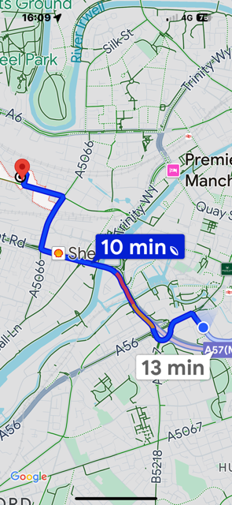

EMERGENCY PROCEDURES

In the event of a fire raise the alarm in the prescribed manner, informing the Site Manager and evacuate the building immediately.

EVACUATE THE AREA & ASSEMBLE AT THE AGREED MUSTER POINT AS INSTRUCTED AT THE SITE INDUCTION.

The register will be called!

It is therefore essential that all personnel sign on and off in the Plant
Register so that a record of personnel on site can be maintained.

A designated Fire Marshall will liaise with the emergency services

Only when it is deemed safe by the site management team or the
emergency services, will personnel be allowed to return to work.

The Principal Contractors designated Fire Marshall will deal with the emergency services only.
If first aid is required? then.

FIRST AID: The first aid box is located within the Site Managers Office.

The First Aider is: notified in the Site Managers Office and at the site induction.

All trained personnel in these roles will be identified within the Site Induction

In.

.

The

In the event of a fire raise the alarm in the prescribed manner, informing the Site Manager and evacuate the building immediately.

EVACUATE THE AREA & ASSEMBLE AT THE AGREED MUSTER POINT AS INSTRUCTED AT THE SITE INDUCTION.

The register will be called!

It is therefore essential that all personnel sign on and off in the Plant
Register so that a record of personnel on site can be maintained.

A designated Fire Marshall will liaise with the emergency services

Only when it is deemed safe by the site management team or the
emergency services, will personnel be allowed to return to work.

The Principal Contractors designated Fire Marshall will deal with the emergency services only.
If first aid is required? then.

FIRST AID: The first aid box is located within the Site Managers Office.

The First Aider is: notified in the Site Managers Office and at the site induction.

All trained personnel in these roles will be identified within the Site Induction

Local Hospital is:
Manchester Royal Infirmary
Oxford Road
Manchester
M139WL

Location of the local Hospital service is approximately 1.1m from the site.

Manchester Royal Infirmary

10.0 The Health & Safety File
The following will be provided to the Principal Designer for them to
produce the project H&S File:

This will identify:
Any residual hazards that remain resulting from this work.
Details of all materials used.
As built drawings, where relevant.
Data sheets for equipment provided.

To be assembled on an ongoing basis by the PRINCIPAL DESIGNER, so as information becomes available it should be passed over.

Please Note; No risk or method statements are included within the Construction Stage plan – items as part of the risk register will be site correspondence.

11.0 Risk register
 | Risk Register | Assessed
Noise | Both as an environmental pollutant and a health hazard to workers, staff. PC will ensure that they comply with the noise at work regulations. | Y
Dust | The effect on workers, staff, and the existing environment. PC will comply with the Control of substances hazardous to health regulations | Y
Vibration | Measures are to be taken to minimise the effect on the existing area. All vibrating equipment should comply with the PUWER regulation and work methods to the Control of Vibration at work Regulation | Y
Lead | PC will where reasonably practicable ensure that the control and management of exposure to Lead. In accordance to the Control of Lead at work Regulations | Y
Asbestos | PC will ensure any asbestos waste found from the existing work area is removed and disposed of correctly in accordance with the Control of Asbestos Regulations | Y
PPE | PC will ensure that all operatives are supplied with and comply with the PPE regulation | Y
Lifting (crane) | PC will ensure that the lifting operations are compliant with LOLER 1998 regulations | Y
Electricity | PC will ensure that all electricity works are carried in accordance with the Electricity at Work Regulations  1989 | Y
Fire Safety | PC will ensure that the fire safety and emergency plans etc comply with the Regulatory reform order 2005 | Y
Welfare | PC will ensure that all welfare complies with the CDM 2015 | Y
Health Risks | PC will ensure that such operations that can obtain health risks comply with the control of Substances hazardous to health regulations 2004 | Y
Gas | PC will ensure that all work is carried out to meet the Gas Safety Regulations 1998 | Y
Work Equipment | PC will ensure all equipment meets the following; Provision of Use of Work Equipment Regulations 1998 | Y
Operatives/general public | PC will ensure all work is carried out in accordance with the workplace regulations 1996 | Y
Waste management | PC will ensure all waste management is carried out in accordance with the Waste Management Regulations 2008 | Y
Environmental | PC will ensure that any environmental problems that occur on site are dealt with in accordance with the Environmental Protection Act. | Y
Confined Spaces | PC will ensure that operatives entering and or working in a confined space must be trained, competent and comply with the Confined Space Regulations 1997 | Y
Permits to Work | PC shall ensure that a permit to work system for High-risk works will be in operation. | Y

11.01 CDM Risk Register; can be found in the site health and safety file

12 Health and safety Management Structure

CLIENT
Smart Bridgewater Ltd

Architect Principal Designer
Snook Architecture JAD Consulting
Neil Dawson James Dean

Clients Project Representative
TBC

Principal Contractor
Melbrooke Services Ltd

H&S Consultants

Site Management team

Project Manager Site Management Team

