

PROCTER YOUNG PEOPLES CENTRE, MANCHESTER

Drain Investigations 4 September 2025



Professional Sportsturf Design (NW) Ltd
Wigan Road
Leyland
Lancashire
PR25 5XW
Tel: 01772 297830

Aim of visit:
To conduct drain investigations to assess outfall for pitch drainage
Procter Young Peoples Centre staff present – Nina (N)
PSD Staff on site – Richard Dyer (RD)
Reference should be made to the information below and video recordings regarding the drain camera investigations
Notes:
- Morning of 04/09 RD arrived on site at 9:45 and met N.
- IC1, IC2 and IC3 covers were lifted and camera was inserted into all pipes.

Shown below are brief descriptions of drain camera footage taken on site, with corresponding video filenames for each description.

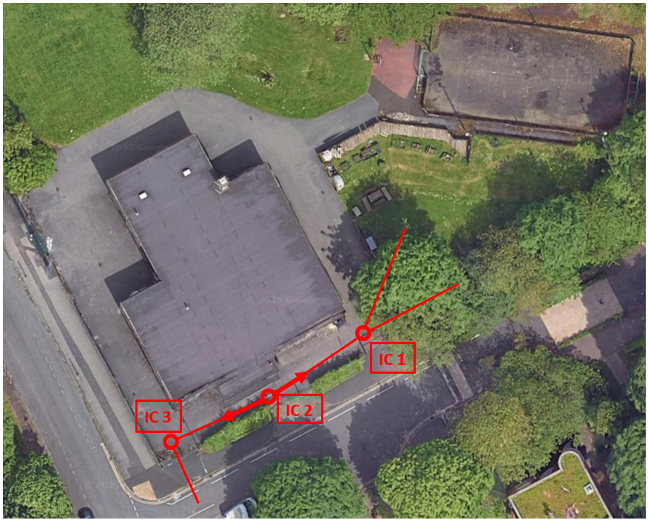
Figure 1: Map of Procter Young Peoples Centre showing IC chamber locations and direction of pipes
Symbol | Definition
 | Chamber investigated using camera

Figure 2: Key
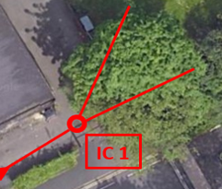
IC 1a
IC 1b
Figure 3: Close up diagram of pipe direction
IC 1
IC 1a - Approx. 100mm red clay pipe.
1st lateral at the top @0.3m.
2nd lateral on the right @8.1m.
3rd lateral at the top @9.9m.
4th lateral on the right @13.3m.
IC 2 reached @21.4m.

IC 1b - Approx. 100mm red clay pipe.
Direction of pipe is towards the proposed PlayZone site.
1st lateral on the left @1.8m.
2nd lateral on the right @6.2m.
3rd lateral at the top @9.5m.
4th lateral at the top @12.4m.
5th lateral on the right @17.8m.
6th lateral on the left @23.4m.
7th lateral on the left @25.8m.
Unknown IC reached @30.4m.

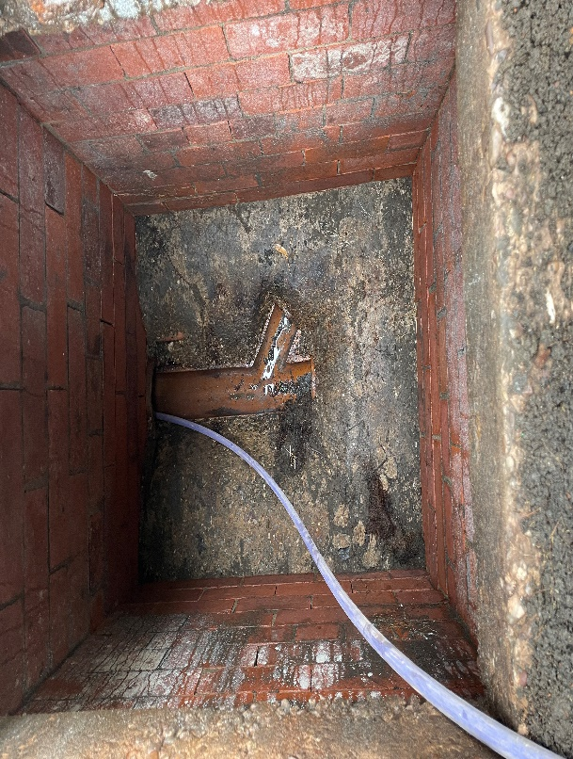 | 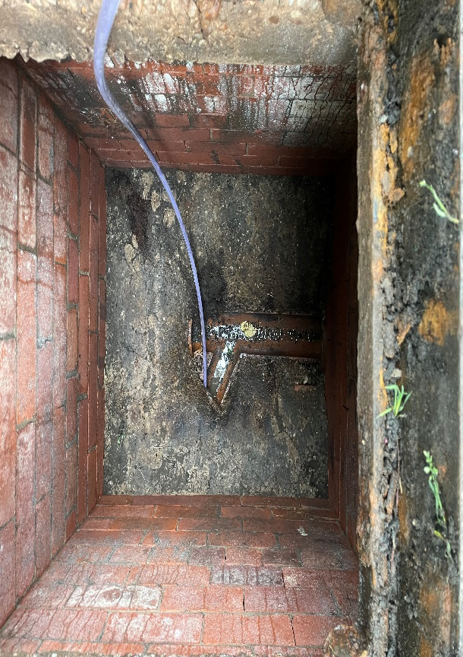
Figure 4: 3no pipes in IC 1, camera down IC 1a | Figure 5: camera down IC 1b
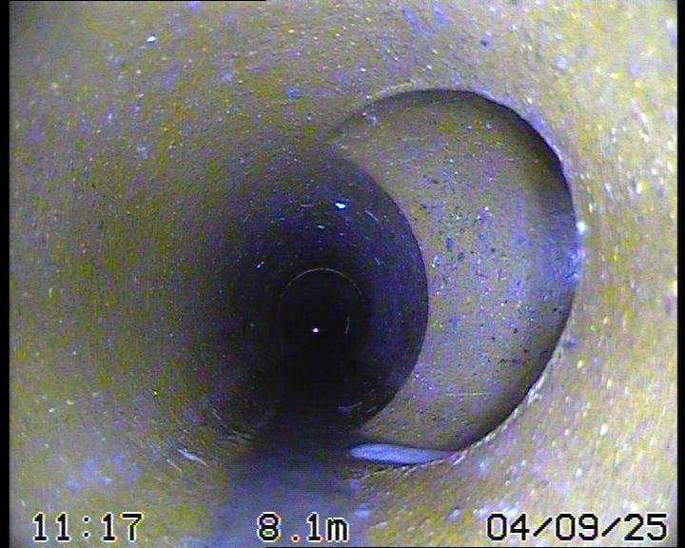 | 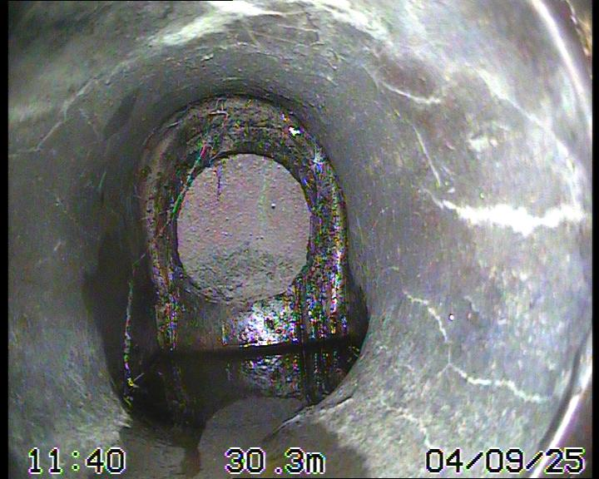
Figure 6: showing 1st lateral entry into pipe IC 1a | Figure 7: showing unknown IC reached @30.4m

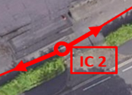
IC 2a
Figure 8: Close up diagram of pipe direction
IC 2a - Approx. 100mm red clay pipe.
1st lateral at the top @0.7m.
2nd lateral on the right @1.5m.
IC 3 reached @6.4m.

IC 2

 | 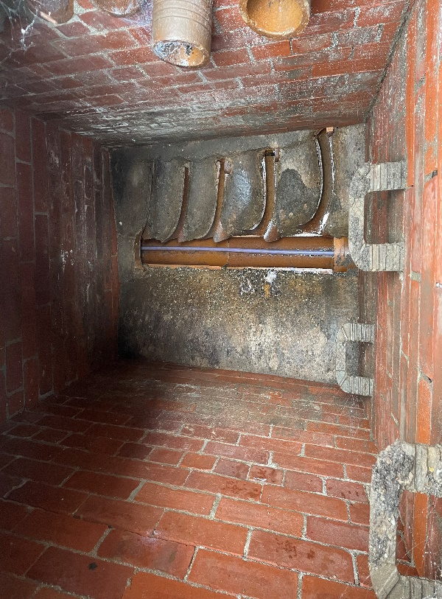 |  | 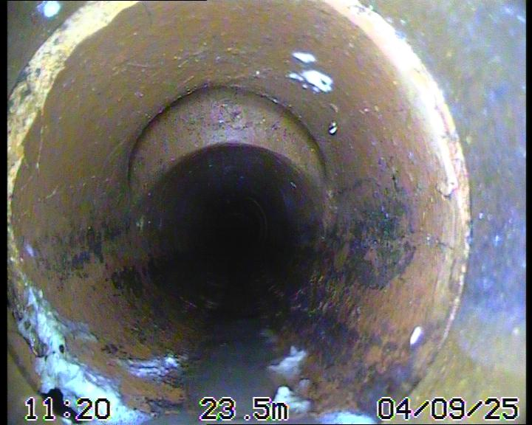
 | Figure 9: 10no pipes in IC 2, camera down IC 2a |  | Figure 10: showing 1st lateral entry into pipe IC 2a
 | 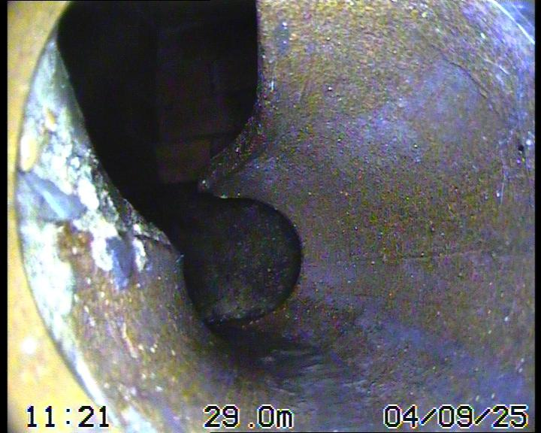
Figure 11: showing IC 3 reached @29.0m

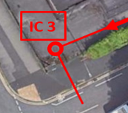
IC 3a
Figure 12: Close up diagram of pipe direction
IC 3a - Approx. 100mm red clay pipe.
Pipe falls @7.9m.
Sewer reached on Hulme Street @8.8m.

IC 3

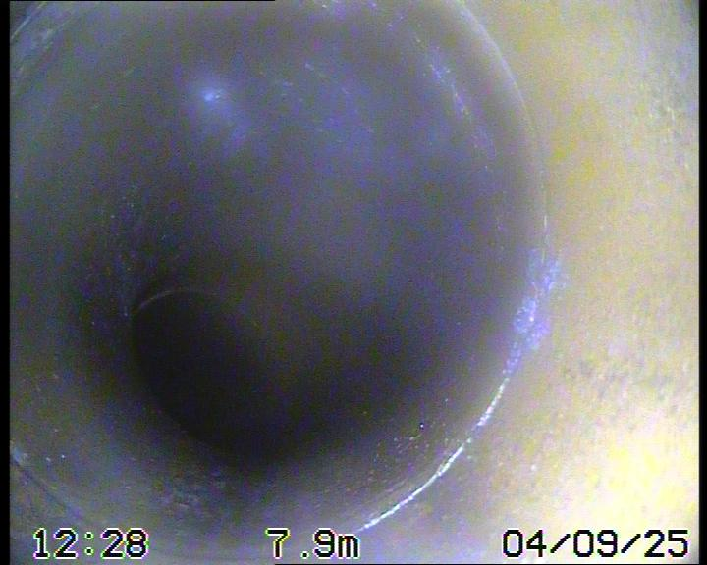 | 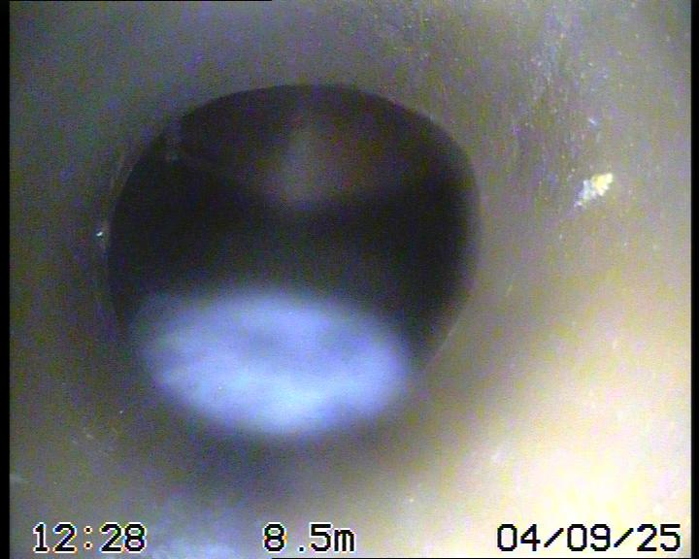
Figure 13: showing pipe fall @7.9m | Figure 14: Outfall into sewer on Hulme Street

