DPM Transport Consulting Ltd

11/01/2018
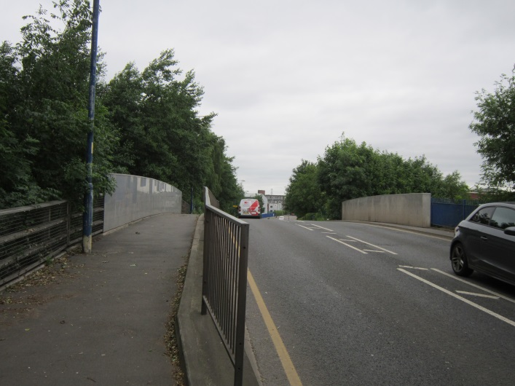
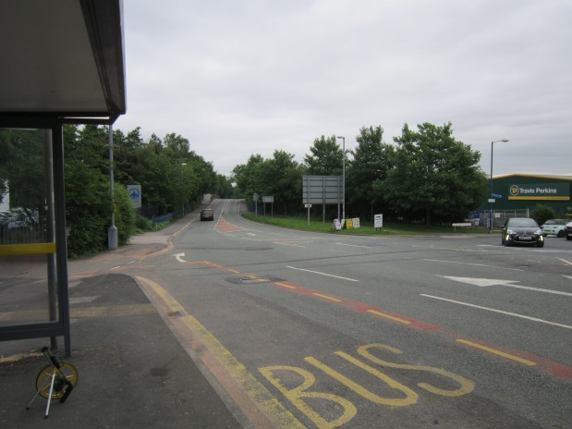
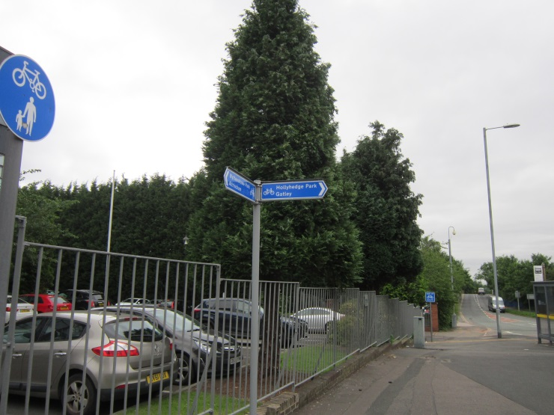
Transport Statement to Support Redevelopment of a Recycling Centre, Sharston Industrial Estate, Wythenshawe
Document Control
Project Title: | Sharston WTS
DPMTC Project Number: | TC\Oakbay\Sharston\001
Document Type: | Final Report
Directory & File Name: | Dpmtc\Oakbay\Sharston\SharstonTS.doc

Distribution
Issue | Date | Distribution | Comments
1 | 22/06/2017 | Oakbay Design Ltd | Draft for comment
2 | 11/01/2018 | Oakbay Design Ltd | Final Report
3

DPM Consulting Ltd prepared this report on behalf of P.P O’Connor Ltd. in accordance with conditions which were specified at the time of appointment with the client. DPM Consulting Ltd shall not be responsible for use of the report or its contents for any purpose other than those for which it was produced. Opinions and information provided in the report are on the basis of DPM Consulting Ltd using due skill, care and diligence in the preparation of the same and no explicit warranty is provided as to their accuracy. It should be noted that and it is expressly stated that no independent verification of any of the documents or information supplied to DPM Consulting Ltd has been made.

Contents
1 Introduction 4
1.1 The Study 4
1.2 Structure of the Report 4
2 The Local Highway Network 6
2.1 Sharston Industrial Estate 6
2.2 The Site and Adjacent Highways 6
2.3 Bus Services 7
2.4 Cycling 8
2.5 Road Accident Records 8
3 The Development and Associated Highway Impact 10
3.1 Introduction 10
3.2 Redevelopment of the Site 10
3.3 Operational Conditions 12
3.4 Future Traffic Volumes 12
3.5 Mitigating Measures 13
3.6 Management of Worker Traffic 14
4 Summary and Conclusion 17
4.1 Summary 17
4.2 Conclusion 17

Introduction

The Study
    - In June 2017, DPM Transport Consulting Ltd was commissioned by P.P. O‘Connor Ltd to produce a Transport Statement to support a planning application regarding proposed future on-site activities and an associated traffic management arrangement at an existing waste facility. The site is located at The Old Railway Station, Longley Lane, Sharston Industrial Estate, Manchester, M22 4SS.
    - The site is located off Longley Lane on the established Sharston Industrial Estate, Wythenshawe situated to the south of Manchester. The waste facility has been in operation since 1996, as a non-special waste transfer station. The proposed land-use is in keeping with the former land-use and thus will be compliant with current local and national planning policies. Figure 1.1 shown at the end of this chapter, shows the approximate location of the site in relation to the adjacent area’s road network.
    - Vehicle access and egress from the local road network is possible via existing site entrances served off either Longley Lane or Sharston Road.
    - Full details regarding the associated planning history and the current application (including associated drawings) are detailed in the supporting information as produced by Oakbay Design Ltd.

Structure of the Report
    - Following this introductory chapter, the structure of the report is as follows:
- Chapter 2 - The Local Highway Network
- Chapter 3 - Proposed Development and Associated Highway Impact;
- Chapter 4 – Summary and Conclusions.

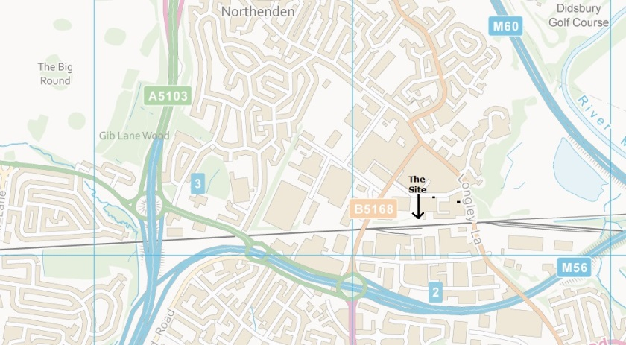
Contains Ordnance Survey data © Crown copyright and database right 2017
Fig 1.1
Site Location

The Local Highway Network

Sharston Industrial Estate
    - The site is located on Sharston Industrial Estate, which is a well-established industrial area, situated in Wythenshawe. Numerous companies are located on the industrial estate, providing a wide range of activities including warehousing, logistics, manufacturing, recycling, storage, off-site parking (serving Manchester airport) and retail for example. The estate generates a wide range of vehicle types including both HGVs and private cars. Most of the businesses have dedicated off-highway parking provision, though on-street parking is also present (where permissible) on several of sections of the local road network.
    - The industrial estate has excellent connections to both the local and trunk road network. It has direct access to the A560 (Altrincham Road) which provides connections to the M56 (for traffic movements to/from the south of the area), to A5103 providing connections to the M60 (for traffic generated to/from the north of the site) to the M56 Junction2 (for traffic movements to/from the east).
    - The area has an associated pedestrian network, some cycling facilities e.g. a toucan crossing at the A560 roundabout and has access to good public transport (bus) facilities.

The Site and Adjacent Highways
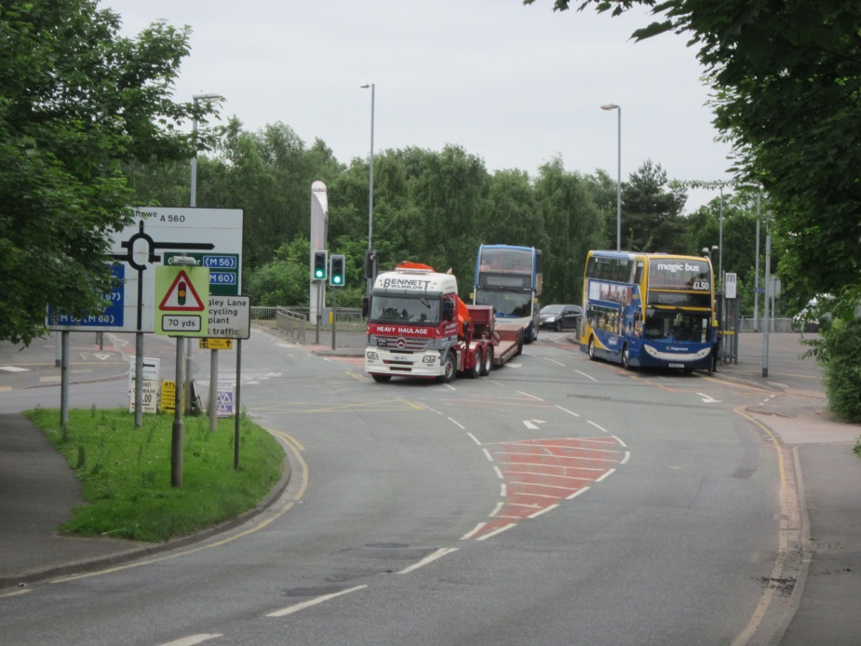
    - The site is on land located immediately north of the operational railway line, and is bounded by Sharston Road (B5168) to the west and Longley Lane (B5166) to the east. To the north it is bounded by existing industrial premises which are accessed off Harper Road. The site has a direct access off Sharston Road though the connection to Longley Lane is via a relatively short length of service road.
    - Sharston Road is a two-way highway which runs north from the A560/Junction 2 M56 to its junction with Longley Lane. It acts as a distributor road, providing access to Leestone Road, Bradnor Road and Harper Road, all of which are part of the industrial estate’s road network. It is some 7.5m wide, has street lighting, adjacent footways, a 30mph speed limit and is part of a major bus route. On-street parking restrictions in the form of single yellow lines (Mon – Fri, 8am – 6pm) are present along the majority of the road, though on-street unrestricted parking is available on the eastern side, north of the junction at Harper Road.
Sharston Road looking north towards the junction to Leestone Road and beyond to A560
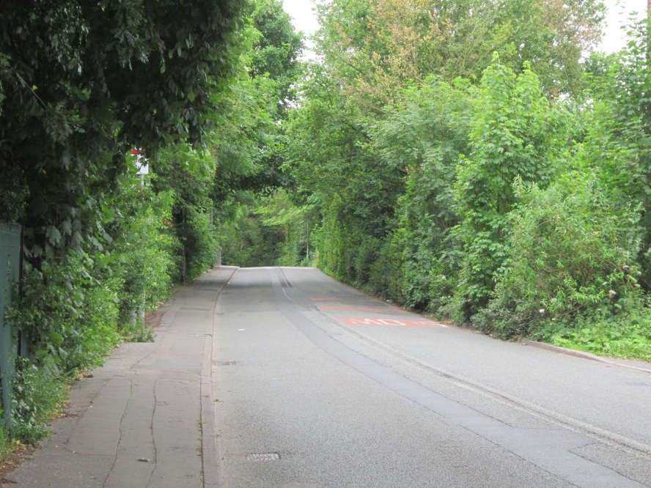
    - Longley Lane runs in a north – south direction, connecting with the A560 in the south and the B5167 (Palatine Road) to the north. It is a two-way single carriageway road, some 7.5m wide and restricted to a 30mph speed limit. Traffic regulation orders prohibiting overtaking are in place in relation to the section of road between the junctions of Leestone Road and Harper Road (the section of road bridging the railway).
Longley Lane looking south on approach to the railway bridge
    - A footway on this section over the bridge is only present on the eastern side. Street lighting is present.
    - Longley Lane provides access to the industrial area to the west via Leestone Road, Harper Road and Sharston Road. Land-use to the east of the Longley Lane, north of the junction with Harper Road is predominantly residential in nature.

Bus Services
    - Sharston Road has bus stops (on both sides of the road) located to the north of the A560 and to the north of the junction with Harper Lane. The bus stops are within 200m of the site entrance and are served by the following services:
- 43 Manchester Airport – Manchester. Operates over 24 hours with frequencies of 30 minutes (periods at start and end of the day) and 10 minutes. Reduced service provision on Saturdays and Sundays;
- 102 Wythenshawe Hospital – Manchester. Operates between 0600 – 2400 hours with 30 minute frequency. Reduced service provision on Saturdays and Sundays;
- 103 Manchester Airport – Manchester. Operates between 0600 – 2400 hours with 30 minute frequency. Reduced service provision on Saturdays and Sundays;
- 278 Reddish – Manchester. Operates between 0700 – 1800 hours with 60 minute frequency. Reduced service provision on Saturdays and Sundays;
- X5 Stockport – Trafford Centre. Operates between 0600 – 1900 hours. Reduced service on Saturdays, no Sunday service.
    - The review of existing public transport provision has identified that the industrial area is served by several bus services, offering frequent and quite extensive services, providing access to substantial residential areas located between Wythenshawe and Manchester city centre. Full details of the respective bus services can be obtained from TfGM’s website via the following link:
http://www.tfgm.com/journey_planning/Pages/bus_times_leaflet_library.aspx

Cycling
    - The industrial estate does not have many existing cycling facilities, though a toucan crossing is provided at the junction with Sharston Road and the A560. The industrial estate is within cycling distance of the Manchester – Manchester Airport cycle route (Nos 85) In addition, identified cycle routes are provided near the A560 to the following destinations:
- Wythenshawe Park;
- Altrincham;
- Holy Hedge Park; and
- Gately.

Road Accident Records
    - A review of the recorded road accidents was undertaken by reference to the Crashmap database to establish if any significant number of road accidents had occurred on the local highway network which serves the site. The analyses of the accident records (which involve personal injury) included data for the most recent five year period. The area considered and the resulting accidents locations are shown in Figure 2.1 at the end of this chapter.
    - Accidents are classified by the severity of injuries incurred by those involved. The result of the review identified that during the 5 year period, no ‘fatal’ accidents had occurred, two ‘serious’ accidents were recorded, and 11 ‘slight’ accidents had occurred. Brief details of the two ‘serious’ accidents are as follows (further information is contained in Appendix A):
- Harper Road/Sharston Road junction, Monday 28th September 2015 at 0851 hours, collision occurred between a car and a motorbike resulting in two injuries, one classified as ‘slight’, one as ‘serious’;
- Sharston Road/Longley Lane, Monday 9th March 2015 at 0745 hours, collision occurred involving one car and a bicycle resulting in one injury, classified as ‘serious’.
    - With reference to the results of our review of the data from the Crashmap database, it can be seen that no accidents occurred in the vicinity of the site accesses or that any of the ‘serious’ accidents involved HGVs. In addition, the severity and number of accidents recorded in the area are well below the usual intervention thresholds. Therefore, it is considered that the highway network operates in a satisfactory manner and we have not identified any specific concerns which we feel require further consideration in relation to the proposed development.
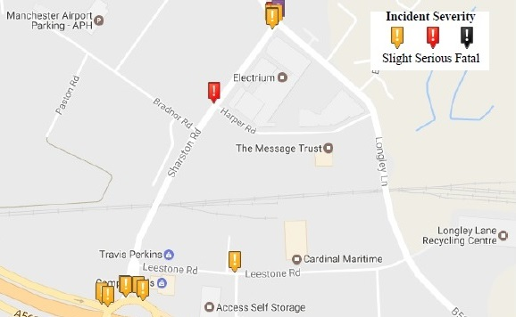

Fig 2.1 Recorded Accidents

The Development and Associated Highway Impact

Introduction
    - As identified in paragraph 1.1.1, this Transport Statement has been produced to support the associated planning application which seeks permission for future waste processing activities and the re-configuration of the internal layout of the former recycling facility. The main objective of the proposed development is to increase efficiency in relation to the loading and unloading of materials and to improve the access and egress of HGV generated traffic flows. The proposed access and egress arrangements will also reduce the amount of distance travelled by HGVs on the adjacent road network, thus reducing potential the associated impact of the generated traffic.
    - The proposed development also includes for some on-site improvements which will provide greater storage capacity for materials and provide more space for the efficient and safe storage of differing types of materials. Details of the proposed layout of the site are shown in in the Drawings Nos Z310.001 and .003 (located at the end of this chapter) as produced by Oakbay Design Ltd.

Redevelopment of the Site
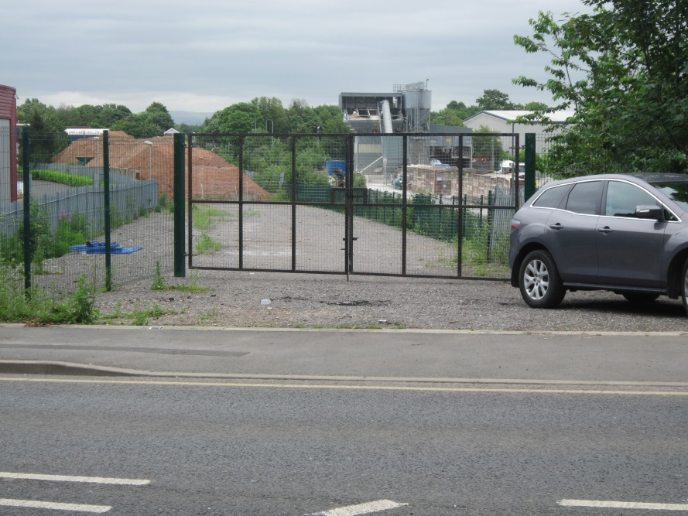
    - The physical size and layout of the site is linear in character as it runs between Sharston Road to the west and Longley Lane to the east, and is sandwiched between the operational railway line to the south and existing commercial businesses to the north. The amount of available on-site space is constrained and thus it is important to have an efficient internal processing arrangement in order maximise operations and to safely undertake the recycling processes, hence the proposals to have a dedicated entry and exit only traffic management system.
    - The proposed on-site traffic management system does not require the need for any new connections with the highway network as it is intended to utilise the existing arrangements. The majority (if not all) of generated HGV traffic will approach the site via Sharston Road from the direction of the A560 or M56 Junction 2. Therefore, it is proposed that entry to the site will be from Sharston Road, via the existing site access. The majority of the HGVs entering via this entrance are anticipated to be turning right off Sharston Road. Improvements will be made at this entrance, including the introduction of kerbed radii, dropped kerbs and tactile crossing. The actual details to be agreed with the Highway Authority.
Existing entrance off Sharston Road
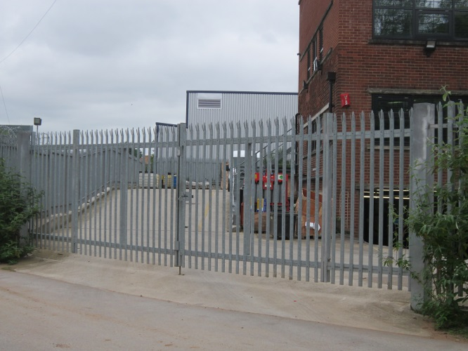
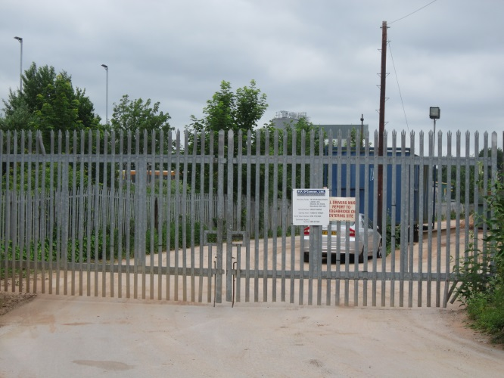
    - The exit from the site will be via the eastern gate utilising the local service road to access Longley Lane. Previously, this entrance was the main point of access and egress for the site. It is also noted that an existing factory (Howells Group plc) also have factory gates in advance of the entrance to the recycling site. Anecdotal information from an employee at Howells Group explained that HGVs (deliveries and collections) access their site from Harper Road and exit via the service road.
Egress from Howells to service road
Entrance from service road
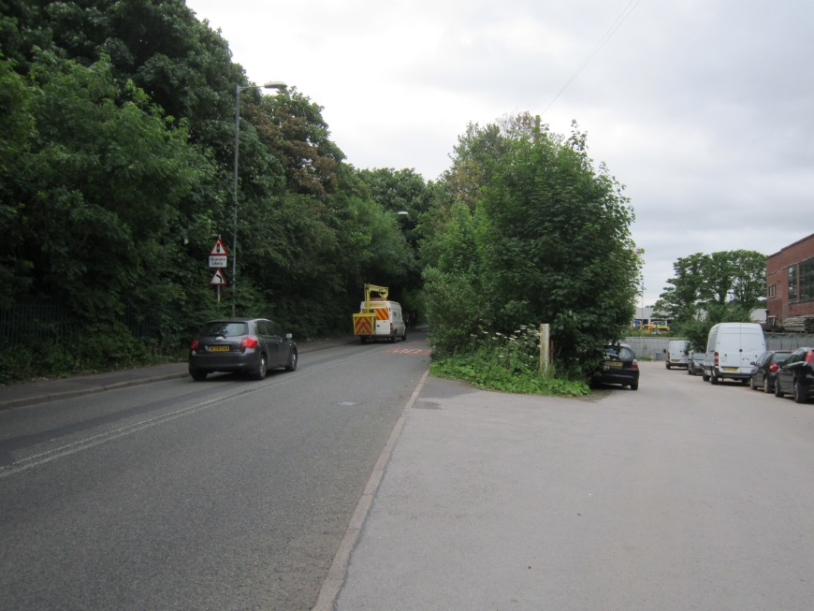
    - Ownership of the service road is not known. No parking restrictions, footways or street lighting are present on the service road. The presence of existing car parking on this road effectively reduces the available road width and subsequently, insufficient space remains to facilitate two-way traffic movements. In addition, the alignment of the service road on its approach to the Longley Lane junction, combined with the presence of parked vehicles, means there is insufficient space to practically and safely accommodate left turning traffic in and right turning traffic out manoeuvres at the junction.
Junction at Longley Lane, showing acute angle for right- out and left- in turning manoeuvres and presence of parked vehicles on service road
    - HGVs when exiting the recycling site will be instructed to turn left from the service road to access Longley Lane and then to turn left at the junction with Sharston Road. Once on Sharston Road, HGVs will have direct access to the A560 and M56 Junction 2.
    - It is proposed, subject to agreement with the Highway Authority that the existing vegetation at the Longley Lane/service road junction be cut-back in order to improve visibility splays for vehicles when exiting. Though it is noted that the service road is currently used by HGV and car traffic and no accidents have been recorded at this junction.
    - If the Highway Authority has safety concerns regarding the visibility for vehicles when exiting the site, then the site’s proposed entry/exit arrangements could be reversed. i.e. HGVs would be instructed to approach the site via Longley Lane, turning right into the site and exiting the site directly on to Sharston Road.

Operational Conditions
    - Proposed operational periods are as follows:
- Monday – Friday, operational period 0800 – 1800 hours;
- Saturday, operational period 0800 - 1800 hours;
- No waste acceptance or operations on Sundays or Bank Holidays.

Future Traffic Volumes
    - Future traffic volumes generated by the proposed recycling development will reflect conditions as experienced in the general economy, and consequently demand will fluctuate in response to markets, though the associated variation in hourly traffic flows is unlikely to be that substantial. In addition, any increases in demand usually only results in an intensification of traffic over a relatively short period of time. However, even in such instances, the associated number of vehicles is unlikely to have any significant impact on the operational capacity of the local highway network.
    - Former recycling activities at the site previously generated car and HGV traffic and thus vehicle movements to/from the site are already established. Future traffic volumes are likely to be similar to those previously generated and thus the resulting traffic impact is likely to be neutral. Operations at the site are only capable of accommodating a maximum number of vehicles per day and the respective numbers will be scheduled accordingly throughout the duration of the working day.
    - Fundamentally, the proposed alterations to the site are to increase operational efficiency, improve existing on-site traffic management facilities and remove any potential conflict in traffic movements for HGVs when approaching and leaving the site.
    - A significant proportion of the volume of generated HGV traffic will actually be owned by P.P.O’Connor Ltd thus ensuring more direct and accountable control over driver behaviour, scheduling and routeing.
    - The site is anticipated to be capable of processing up to 200,000 tonnes of waste material per year and thus it is estimated that some 300 HGVs per week, carrying payloads ranging from 10 – 25 tonnes will be generated. It is estimated that average operational conditions are expected to generate only 100 HGV movements per day (50 in and 50 out). The nature of the operational processes undertaken at the site is likely to result in generated HGV traffic being relatively evenly distributed throughout the daily operational period. Therefore, the generation of 100 HGV movements distributed over a 10 hour operational period will only produce some 10 HGV trips per hour (5 in and 5 out). Therefore, the generation of such low volumes of traffic are unlikely to have any significant impact on the operational capability of the adjacent highway network.
    - Whilst the aforementioned traffic movements represent ‘average’ trip numbers generated by the site, daily numbers do vary in accordance with demand. However, the associated HGV volumes are extremely low and subsequently will not have any significant impact on the operational capacity of the adjacent highway network.
    - In addition to HGVs, the site will also generate trips by car by employees and visitors. However, the site will not employ significant numbers of staff and thus associated generated traffic volumes will not prove significant. In addition, the operational shift working patterns as deployed at the site will mean that the majority of employee generated traffic flows will not be coincidental with the traditional peak hour traffic periods on the local highway network. On-site car parking spaces will be provided to accommodate vehicles generated by operatives and visitors, and spaces will be identified for use by any mobility impaired drivers. In addition, provision will be made for the safe storage of cycles should any employees choose to cycle to work.
    - The generation of such low traffic volumes will not have any significant impact on highway capacity as the daily variation in background traffic volumes is likely to be greater than the numbers generated by the site.

Mitigating Measures
    - The proposed re-configuration of the site will improve the existing traffic management regime and reduce highway impact. In addition, supporting traffic management measures to ensure safe and efficient on-site operations and to reduce any potential conflict with other road users are currently in place and include:
- 10 mph on-site speed limit;
- Identification of designated highway routes for HGVs when approaching and leaving the site. HGV drivers will be instructed not to utilise satellite navigation devices as such systems may identify routes to the site which are not compliant with the identified route;
- Informing drivers of the need to comply with speed limits, to be considerate to other motorists and to pay particular attention to the more vulnerable road users e.g. pedestrians, cyclists;
- Warning signs indicating the presence of turning traffic in advance of the site entrance could also be erected where appropriate;
- Removal of vegetation at junction on Longley Lane to improve visibility splay;
- Ensuring that all contractors are fully aware of the need to comply with the site’s operational traffic management regime. The requirement for compliance is made an integral part of their contracts.

Management of Worker Traffic
    - The development will not employ a significant number of operatives and thus will not generate a significant number of private car trips. Whilst the introduction of a formal Travel Plan would be inappropriate given the low employee numbers, the operator is keen to encourage use of sustainable transport modes and thus measures will also be introduced to manage and reduce the impact of traffic generated by employees. Initial proposals (some common to HGV movements) include:
- Car sharing to reduce vehicle numbers will be encouraged;
- Secure cycle parking facilities will be provided;
- On-site showers and individual storage facilities will be provided;
- Bus timetables regarding local bus services will be displayed on staff notice boards; and
- The operator will ensure that all drivers will be informed of the requirement to drive safely and within the prevailing speed limits on all approaches to the site.
    - It should be noted that the above proposals/mitigating measures are initial suggestions. P.P. O’Connor Ltd would welcome further discussions with the local highway authority if considered necessary. In addition, liaison with the highway authority is expected to continue throughout the course of the project, providing the opportunity to identify and quickly resolve any problems that might occur.

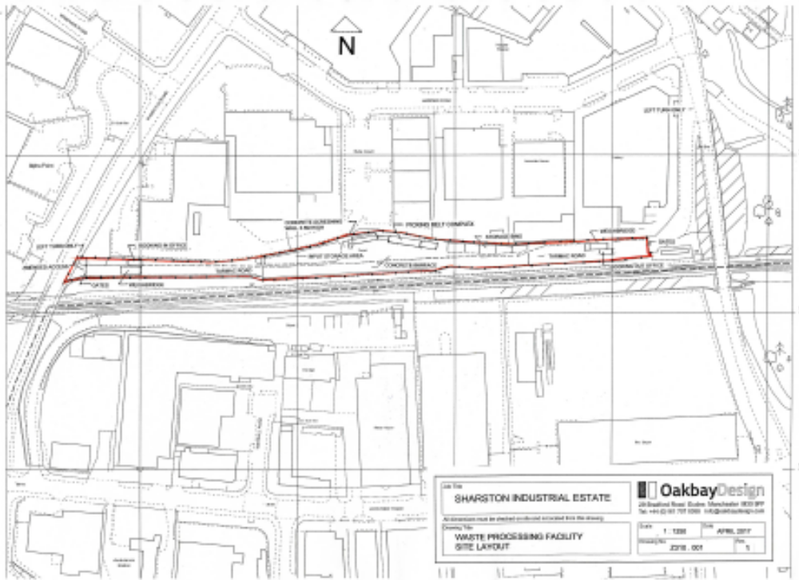
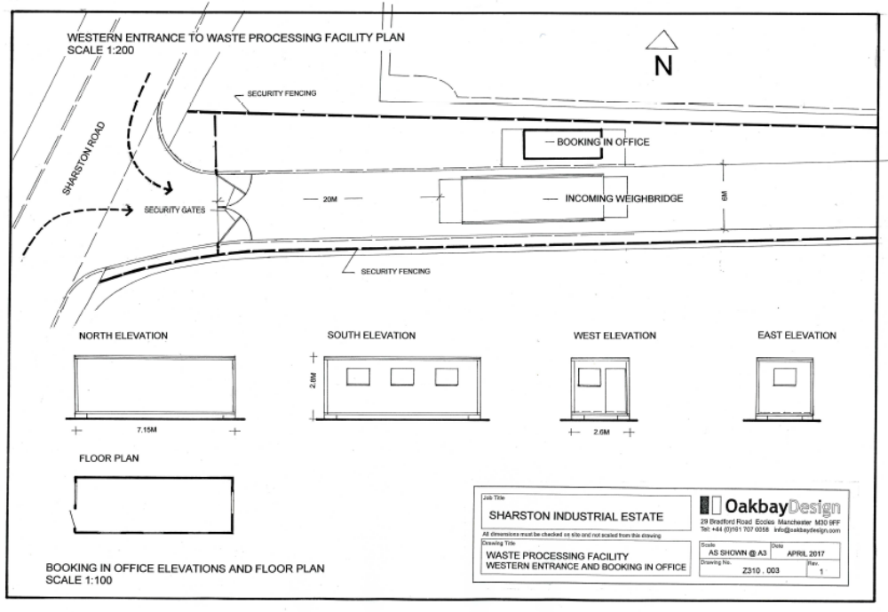

Summary and Conclusion

Summary
    - Waste processing (including skip hire) activities has been undertaken at this locality for numerous years and thus the generation of traffic, including HGVs, from the site is already established. The proposals are required to improve the efficiency of on-site operations, particularly in relation to access and egress by HGV traffic and will also reduce the impact of HGVs on the adjacent highway. In addition, the improved on-site management system which effectively introduces a one-way system, will remove the need for on-site turning facilities which will produce a safer and more efficient environment for employees.
    - The site is located on a purpose built industrial estate and operations generated by P.P.O’Connor Ltd are consistent with the intended land-uses. Neighbouring land-uses in the area also generate HGV traffic and thus the suitability of the highway network to accommodate such vehicle types is proven.
    - The proposed on-site activities are similar in nature as previously undertaken and thus future traffic flows are likely to be consistent with those previously generated and thus are unlikely to have any adverse impact on the operational capability of the existing highway network. In addition, generated HGV movements are distributed throughout the site’s daily operational period, thus minimising any potential highway impact.

Conclusion
    - HGV and car traffic generated from the existing site are already well established and the proposed reconfiguration of the site is to improve traffic management efficiency.
    - Overall, the amount of traffic the site previously and is anticipated to generate is minimal, and is likely to be substantially less than the variation in daily traffic volumes on the adjacent highway network and associated junctions.
    - Based on the information provided it is evident that there are no highway grounds on which to oppose the associated planning application.

