Triangle 3 x Camera replacement

Overall plane showing 3 x camera locations marked in blue.
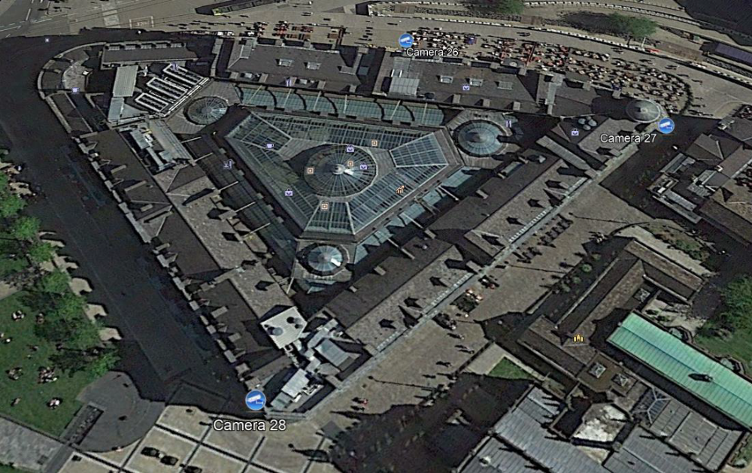
Camera 26 Triangle Shopping Centre above Exchange Square Entrance
Older Dome type camera approx. 14 inches in diameter excluding bracket. Weight approx. 18Kg.
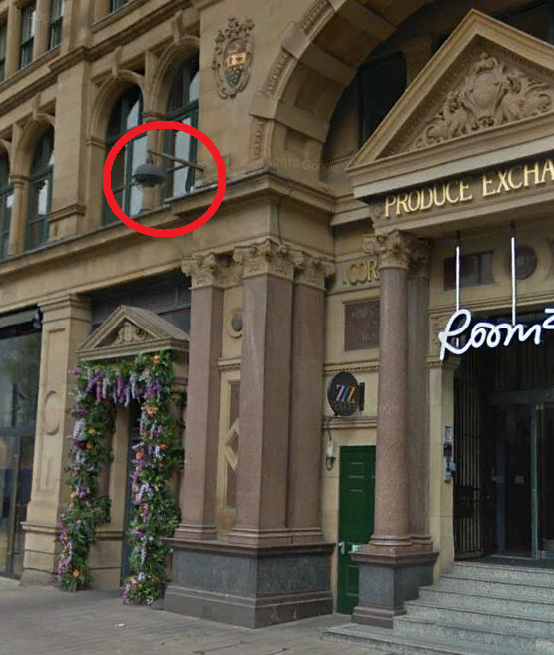

Camera 27 Triangle Shopping Centre corner of Exchange Square and Cathedral Street Corner.
Older Shoe box type camera approx. 18 x 7 inches excluding bracket. Weight approx. 25Kg
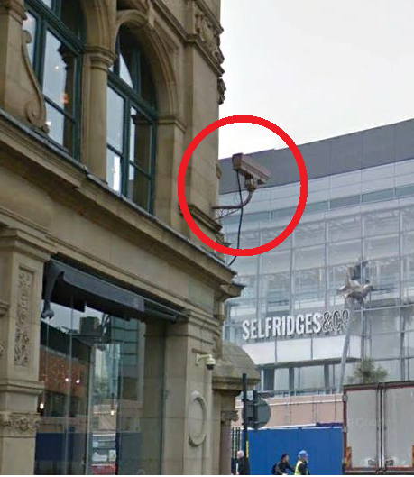
Camera 28 Triangle Shopping Centre, Fennel Street/Cathedral Street Corner on roof overlooking Urbis Gardens
Older Shoe box type camera approx. 18 x 7 inches excluding swing out bracket. Weight approx. 25Kg
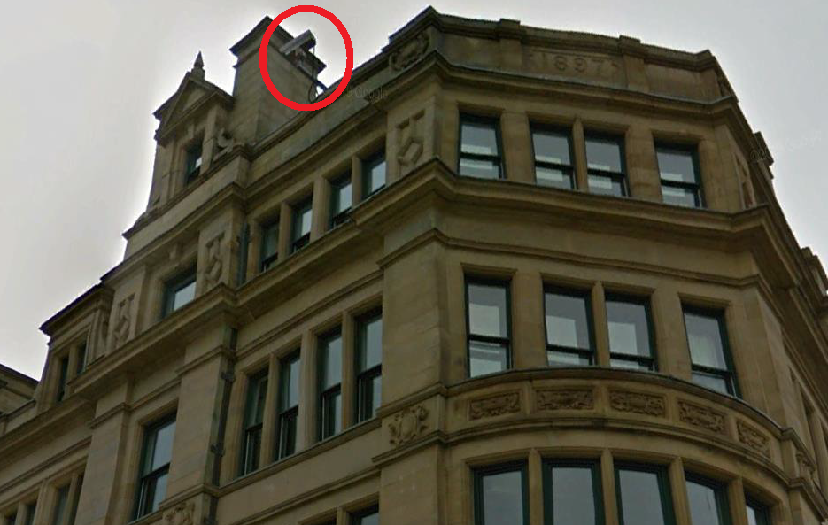

Proposed Camera replacements are unobtrusive 360 Vision manufactured in the UK the model is the Invictus sizes and weights are as follows:
Weight 8.1Kg
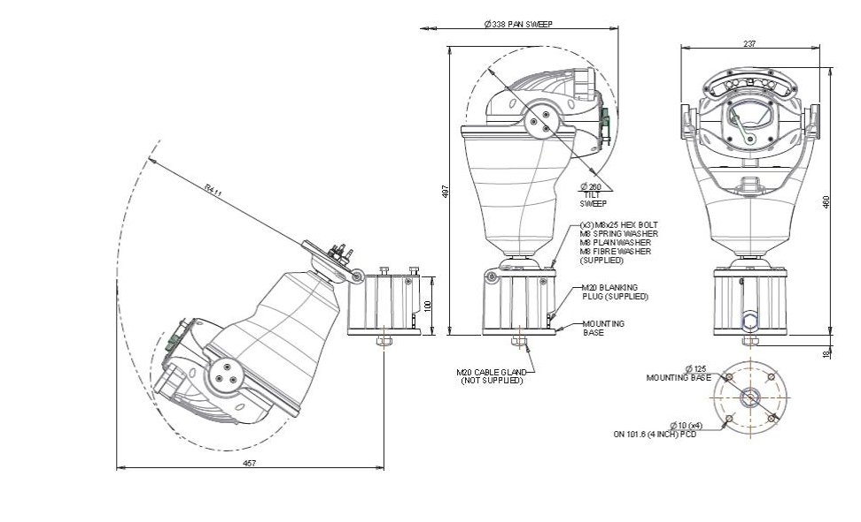
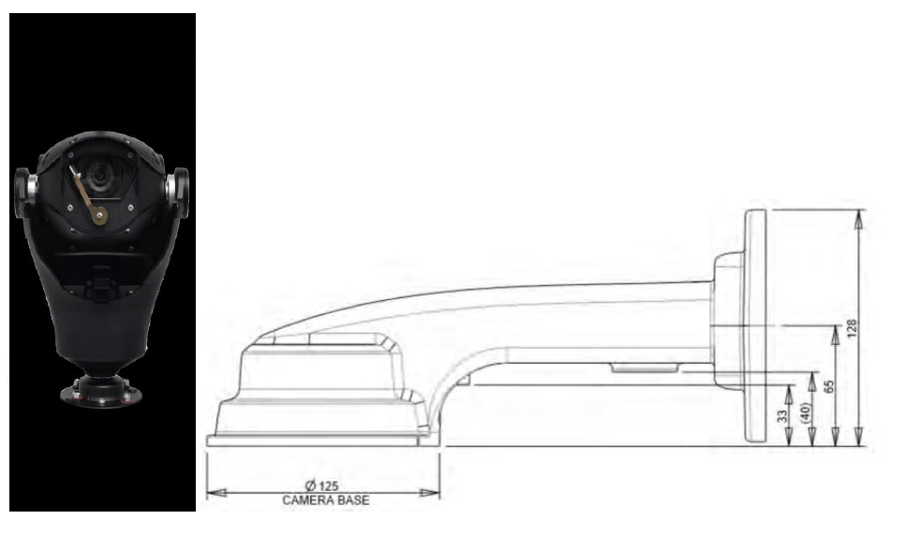
Example
