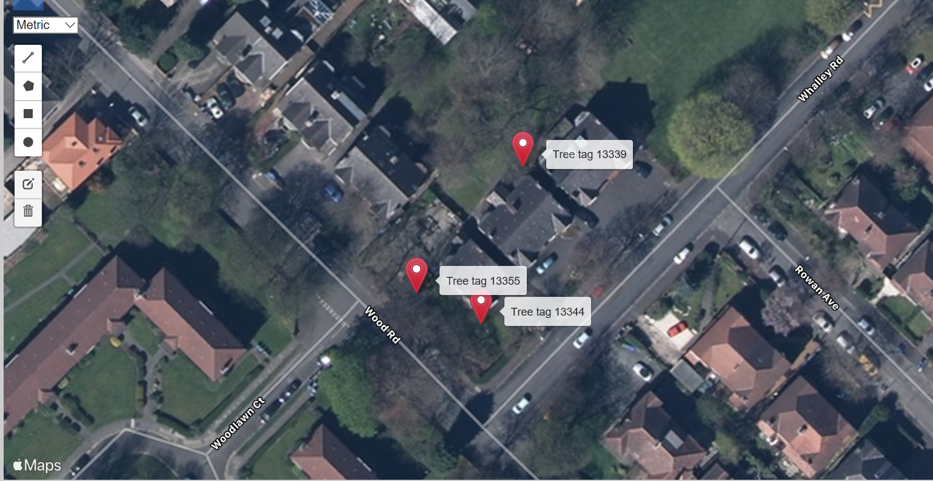
164 – 156 Whalley Rd- Whalley Range – Manchester

Tree tag 13339 – Lilac (Syringa reticulata) - Crown reduce/lift to achieve 1m clearance from the building.
Tree tag 13344 – Hungarian oak (Quercus frainetto) - Crown reduce/lift to achieve 1m clearance from the building.
Tree tag 13355 – Common ash - (Fraxinus excelsior) – Fell, grind stump. (Allow repairs to wall, tree has caused significant damage to the wall).

